Satellite Observations of Variability of Precipitable Water over Arabian sea

Aswathy Suresh Babu
Department of Physics
Amrita Vishwa Vidyapeetham
Amritapuri, Kerala, India
aswathy96sb@gmail.com
Jini Susan Ninan
Department of Physics
Amrita Vishwa Vidyapeetham
Amritapuri, Kerala, India
jini.susan.ninan@gmail.com
Dhanya Madhu
Department of Physics
Amrita Vishwa Vidyapeetham
Amritapuri, Kerala, India
dhanyam@am.amrita.edu

Abstract— Study of atmospheric water vapor content is important to understand the climate of a region. Remote sensing provides a very valuable tool in observing and evaluating the atmospheric moisture variability over the whole globe with good amount of accuracy. The present study attempts to provide an overview of how the atmospheric precipitable water varies over the Arabian sea with seasons and years. It is found that there are significant variabilities observed in the amount of precipitable water found over the region. This has potential applications in understanding the climatic variability of India, especially over the west coast of India. Further detailed analysis is necessary to bring out accurate inferences for the same.
Keywords—precipitable water vapor, satellite remote sensing

Introduction
The study of the amount of moisture present in the atmosphere is important for various reasons. Socioeconomic aspects of life in India are highly dependent on both the intensity and distribution of summer monsoon rainfall [8]. Because of the growing need and current interest, more detailed information regarding the distribution of water vapor present at any moment in different air layers of the atmosphere is of fundamental importance in meteorological, hydrometeorological and electromagnetic wave propagation studies [10]. The quality of the humidity analysis depends critically on the quality of the moisture data [6]. Under the assumption of constant relative humidity, the Clausius-Clapeyron relationship yields a ratio between changes in water vapor and changes in temperature that depends solely on temperature [2]. A relation between precipitable water and mixing ratio is needed to apply satellite data in air-sea interaction studies [9].
Water vapor in the atmosphere affects the atmospheric radiation and thus atmospheric thermal equilibrium. It attenuates electromagnetic propagation through the atmosphere and, therefore, it is important in the remote sensing of the earth from space [9]. Remote sensing of atmospheric moisture variables helps in studying about Earth’s climate and weather systems and extreme weather events [11].
Atmospheric water vapor is defined in different ways using different terms like specific humidity, relative humidity, precipitable water etc. The total water vapor contained in a vertical column of air between any two specified levels is called precipitable water. The area of cross-section of the column is assumed to be 1 unit. It is also termed as total columnar water vapor. It is usually expressed in terms of the height to which a column of water would stand if the moisture is completely condensed.
The strong absorption of water vapor in the infra-red region makes it a significant greenhouse gas, along with Carbon dioxide. The amount of water vapor therefore influences the Earth’s climate. The nature of the outgoing long wave radiation from the Earth’s surface can be explained using the behaviour of greenhouse gases like water vapor [4].
The present study details the preliminary analyses conducted using satellite observations of precipitable water. The paper introduces the important concepts behind water vapor absorption spectrum and the remote sensing of atmospheric water vapor. A brief analysis of the variability of precipitable water over Arabian sea is performed here.

satellite remote sensing of atmospheric water vapor
The precipitable water amount in atmosphere is measured using various techniques. Radiosondes help to obtain precipitable water with high accuracies, with uncertainty of the order of a few mm only. Another technique for obtaining the amount of precipitable water in the atmosphere is through the use of Global Positioning System (GPS) signals. This technique utilizes the time delay experienced by the signal when it passes through the atmosphere and use mathematical relations to obtain the value of various parameters. Space based monitoring of atmospheric water vapor is a highly effective method. It provides a global view of variations in the precipitable water content, with good accuracies.
Satellite based sensors are of two types – (1) active sensors like RADARs which send out an electromagnetic pulse and measure the time it takes for the signal to reach back and (2) passive sensors which do not emit signals on their own, but use radiation emitted from the Earth, after its passage through the atmosphere.
When radiation travels through the atmosphere, it gets absorbed by the various gases present. The radiation also undergoes scattering and reflection due to particles like aerosols present.
Water vapor molecule absorbs electromagnetic radiation due to three types of transitions. (i) molecular rotations – water molecule has an asymmetric top structure. The vapor form is a very light weight molecule. Absorption in the range from far-infrared to milli meter wavelengths can be explained using the rotational transitions of the water vapor molecule (ii) molecular vibrations – Vibrational transitions account for the absorption spectrum in the infra-red region of the electromagnetic spectrum. The vibrational and rotational transitions of the molecule occur together, giving rise to the vibration-rotation spectrum of water vapor [1]. (iii) Electronic transitions where the molecule absorbs energy and move up to a higher energy state. For water vapor, these transitions occur in the vacuum ultra violet region. Water molecule, in its liquid state absorbs weakly in the visible region of the electromagnetic spectrum. The differences in the absorption characteristics in the different spectral regions make it important in atmospheric remote sensing as well as in astronomical observations.

Data used
Moderate Resolution Imaging Spectroradiometer (MODIS) provides observing capability for land, atmosphere and ocean[12]. It is carried by Terra and Acqua satellites. Terra was launched in 1999 and Acqua in 2002. The twin systems are configured to obtain cloud-free images optimally. MODIS observes every point on Earth every 1-2 days. 36 spectral bands are available in the instrument, in wavelengths in the range 0.4-14.0 μm.
MODIS data products are available in three resolutions – 200 m, 500 m and 1 km. The accuracy of MODIS precipitable water data is estimated to be 5-10% [3]. Since the data is collected in the infrared region of electromagnetic spectrum, observations can be collected during both day and night times. Observations using IR and near-IR wavelengths are used to produce the precipitable water product.

STUDY AREA

It has been established that the Arabian sea influences the activity of monsoon over India [5],[7]. In the present study, we have considered a rectangular region over the Arabian sea between 5ºN-17ºN, 60ºE-75ºE as shown in the Fig 1 below.
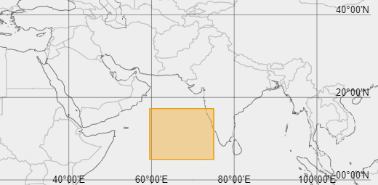

Fig 1 Study area

results and discussions

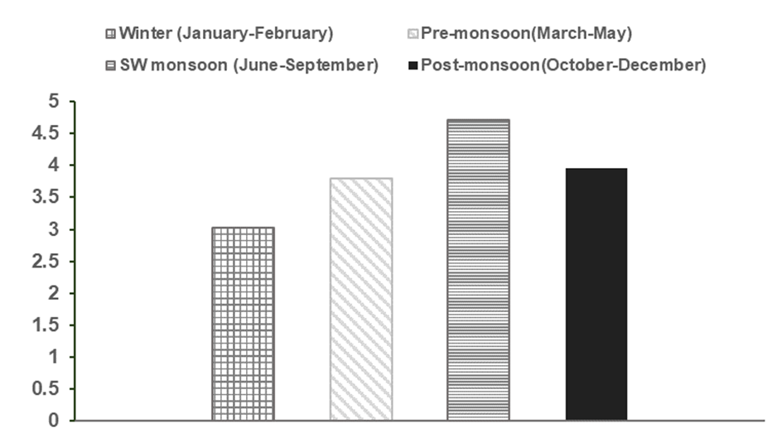
Fig. 2 Long term average of precipitable water vapor over Arabian sea during the different seasons

The Indian subcontinent experiences four seasons as per the definition of India Meteorological Department (IMD). They are winter during January-February, pre-monsoon during March-May, South West monsoon during June to September and post-monsoon during October to December. The broad characteristics of atmospheric water vapor during these different seasons are expected to be different. Fig. 2 shows the seasonal average values of total precipitable water over the box over Arabian sea. The average is calculated for 16 years from 2003 to 2019. The season-wise variations are analyzed because the atmospheric characteristics vary according to seasons. The variability within each season is neglected in the current study assuming that the large scale characteristics are almost uniform. The fig.2 indicates that average precipitable water over Arabian sea is minimum during winter season and maximum during south west monsoon season. Pre-monsoon and post-monsoon seasons have similar amount of precipitable water over Arabian sea region.

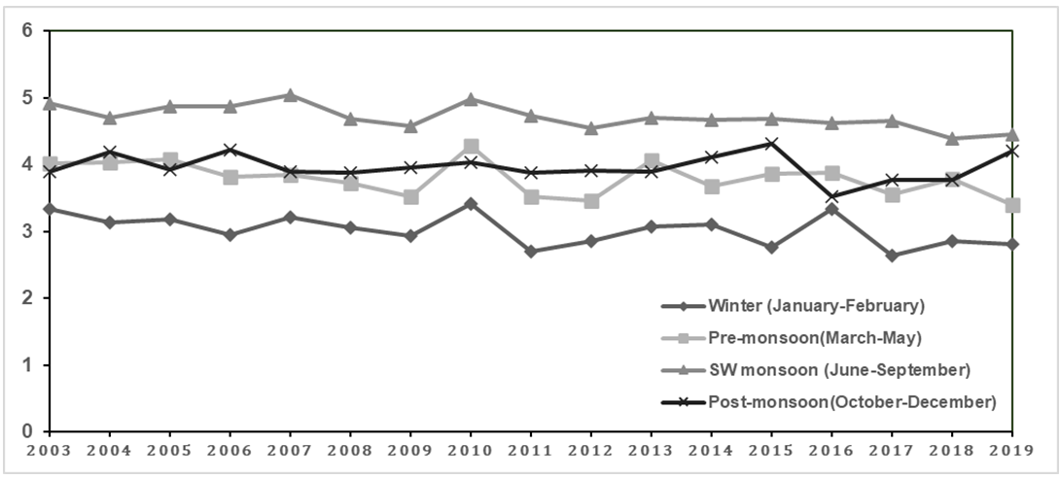
Fig 3 Yearly variation of seasonal average of precipitable water vapor over Arabian sea

The rainfall and temperature characteristics can vary year-by-year also. Fig 3 explores the variability in the amount of precipitable water year-wise in each season. It is seen that even though the average values of precipitable water during pre-monsoon and post-monsoon are similar, the yearly variations of precipitable water during pre-monsoon is more pronounced than that during post-monsoon season. The reason for the variability year-wise can be assumed to be related to variations in rainfall over the peninsular India. However, further extensive research is required to identify the exact nature of these variabilities and their interconnections if any.

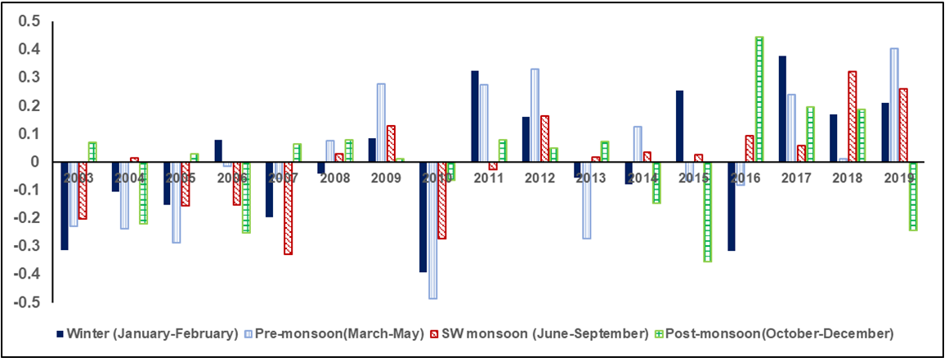
Fig 4 Seasonal anomaly variation over time

In analyzing variability of atmospheric parameters, it is often useful to analyze the anomaly rather than the actual values. Anomaly indicates a departure from the normal values. In the current study, the difference of seasonal average of precipitable water of each year is subtracted from the seasonal average of long-term mean. Fig 4 explores the variability in the anomaly over the different seasons in each year. Anomaly being positive(negative) indicates that the mean precipitable water in a season in that particular year is lower(higher) than the long-term average value. The graph clearly shows that even for a season, the anomaly of precipitable water varies year-wise. However, the anomaly is too small for many years. Hence, we may assume that for most of the years, precipitable water average in the region that we considered have not changed much. The large variability as seen by the larger anomaly values in some of the years have to be investigated further to understand the causes and effects.
The current study presents a brief analysis of variability of precipitable water over Arabian sea in a climatological perspective. The paper presents a brief overview of satellite remote sensing of precipitable water. Further detailed analysis will be attempted in future to quantify the relation between precipitable water over Arabian sea region and the rainfall over west coast of India.

Acknowledgment
Analyses and visualizations used in this study were produced with the Giovanni online data system, developed and maintained by the NASA GES DISC. The authors thank Amrita Viswa Vidyapeetham (deemed University) for providing a platform to carry out the research studies. We also acknowledge the MODIS mission scientists and associated NASA personnel for the production of the data used in this research effort and the NASA GEC DISC team for the system.

References

- Bernath PF. “The spectroscopy of water vapour: Experiment, theory and applications”. Physical Chemistry Chemical Physics. 2002;4(9):1501-9.
- Carl A. Mears, Benjamin D. Santer, Frank J. Wentz, Karl E. Taylor, and Michael F. Wehner. “Relationship between temperature and precipitable water changes over tropical oceans”. Geophysical Research Letter, Vol. 34, L24709, 2007.
- Gao BC, Kaufman YJ. “Water vapor retrievals using Moderate Resolution Imaging Spectroradiometer (MODIS) near‐infrared channels”. Journal of Geophysical Research: Atmospheres. 2003 16;108(D13).
- Koll DD, Cronin TW. “Earth’s outgoing longwave radiation linear due to H2O greenhouse effect”. Proceedings of the National Academy of Sciences. 2018 Oct 9;115(41):10293-8.
- Levine RC, Turner AG. “Dependence of Indian monsoon rainfall on moisture fluxes across the Arabian Sea and the impact of coupled model sea surface temperature biases”. Climate dynamics. 2012 1;38(11-12):2167-90.
- Lodovica, “The quality of satellite precipitable water content data and their impact on analyzed moisture fields”. Tellus, 41A, 1989, 319-337.
- Sahana AS, Pathak A, Roxy MK, Ghosh S. “Understanding the role of moisture transport on the dry bias in indian monsoon simulations by CFSv2”. Climate dynamics. 2019 Jan 24;52(1-2):637-51.
- V.Rakesh, “Impacts of Satellite-Observed Winds and Total Precipitable Water on WRF Short-Range Forecasts over the Indian Region during the 2006 Summer Monsoon”. Weather and Forecasting, Volume 24, 2009.
- W.Timothy Liu. “Statistical Relation between Monthly Mean Precipitable Water and Surface-Level Humidity over Global Oceans”, 1989.
- Y. Viswanadham, ”The Relationship between Total Precipitable Water and Surface Dew Point. Journal of Applied Meteorology” Vol. 20, No.1, 1980.
- Satapathy J, Jangid BP. “Monitoring a local extreme weather event with the scope of hyperspectral sounding”. Meteorology and Atmospheric Physics. 2018 Jun 1;130(3):371-81.
- Krishnakumar K, Satapathy J. “Influence of Aerosol on Cloud Dynamics: A Regional Case Study using MODIS”. In2019 IEEE 5th International Conference for Convergence in Technology (I2CT) 2019 Mar 29 (pp. 1-4). IEEE.

