Automatic Anesthesia Using Controller

Dipika Khot1 , Chiranjeevi Biradar2, Ashwini Kudtarkar3 , Jyoti Waykule*

1,2,3, UG Students Dept. of Electronics & Telecommunication, SGI Atigre, Shivaji University, India

*Asst. Professor, Dept. of Electronics & Telecommunication, SGI Atigre, Shivaji University, India

1dipikakhot888@gmail.com

2chirubiradar12@gmail.com

3ashwini.r.kudtarkar@gmail.com

*waykule.jm@sginstitute.in

**Abstract** — For any operation, anaesthetic is given to the patient. During medical procedure, the patient won’t feel any pain using anaesthetics. The impact of anaesthesia should be there until the operation goes on for specified time interval. What will happen if it is not administered at a particular time interval? This will create serious health problem to the patient. To overcome such unfavourable condition the project automatic anaesthesia using PIC is design. Using the switch panel, system is turned ON the start signal is received by PIC it controls all the system which sends signal to motor , motor turns on & start infusing anaesthesia. Before the system turns ON, the patient parameters like heart rate, temperature, blood pressure is checked and the signal id given to PIC , if its normal system turns ON & anaesthesia is injected to the patient . If the patient parameters are not normal then the system is switched off. The parameters like heart beats, temperature, blood pressure are checked by sensors & module

Keywords —  **Anaesthesia, infusion, module, PIC, sensor**

1. **Introduction**

Surgeries are mainly performed to remove or reconstruct the damage parts in the human body. During these surgeries losing blood and pain takes place. Therefore its necessary to remove the pain and reduce the blood loss. Anaesthesia takes major role in the painkilling. So it is necessary to give anaesthesia. If surgery taking longer time , like for 4 or 5 hours so we cannot give anaesthesia in single dose. It may cause the death of the patient. Suppose less amount of anaesthesia is injected, due that patient may wake up at the mid of surgery. In other case if excess dose to the patient may lead to critical situation.

To minimize this problem the designing of automatic surgery of anaesthesia machine based on a microcontroller is helpful. Anaesthesia plays important role in performing painless surgery ,so automatic use of anaesthesia is required to get successful surgery. In this design ,PIC processor is used for controlling various biomedical parameters such as temperature ,heart rate ,blood pressure etc.

ANESTHESIA definition is – loss of sensation with or without loss of consciousness. Anaesthesia a way to control pain during a surgery. It may help to control the breathing and blood pressure , heart rate of the patient. But all type of anaesthesia cannot make the patient unconscious. Anaesthesia can be injected to the various parts of the body.

The aim of the project is to control the drug injection speed depending on the patient’s state during the surgery. The manually given dosage by the doctor during the operation may vary from standard value, it may causes the effects on the patient. In order avoid such a problems automatic anaesthesia is helpful.

1. **Hardware requirements**
2. PIC16F877A

The Pic Microcontroller PIC16f877a is one of the most renowned Microcontrollers in the industry.This controller is easy to use and also easy to coding or programming. The main advantages of this PIC16f877a is that uses the write-erase as many times possible because it uses flash memory technology.It has total 40 number of pins.Due to presence of EEPROM in the PIC16f877a Microcontroller, the information can be stored permanently like transmitter codes and receiver frequencies and some related data.

1. Blood pressure and Heartbeat module

Blood pressure and Heartbeat are shown on display with serial output.With the help of LCD display the systolic,diastolic and pulse readings can be shown. The design is easy to use wrist style eliminates the pumping. The main advanatge is that, it does not require external power supply.

1. 16X2 LCD:

It displays 16 characters per line and there are 2 such a lines. And also each character is diplayed in 5X 7 pixel matrix. The LCD consist of 2 registors such as command and Data.The command register stores the command instruction and Data register store the data to be displayed. A command is an instruction in given to LCD to do predefined task such as intialising LCD,clearing the screen,setting the cursor position,controlling display.

1. Relay:

Relay is electrically operated switch. It consist of input and set of operating terminals. The input terminals is for single or multiple control signals. The conventional form of a relay uses an electromagnet to operate the contacts.When an electric current is flows through the coil it creates magnetic field that activates the movable contact either makes or breaks a connection with a fixed contact.

1. Relay Driver [ULN2003]:

The ULN2003 is high voltage, high current darlington transistor arrays. Each array consists of seven NPN Darlington pairs that provide high voltage outputs. In single Darlington pair, the collector current rating is 500 mA. For higher current capability,the Darlington pairs can be paralleled. ULN2003 device have 2.7k ohm series base resistor. This driver IC is used when we require to drive high current loads using digital logic such as Op-amps,Timers, Gates, PIC etc.

1. LM35:

LM35 temperature sensor which is a semiconductor based sensor.LM35 is an integrated analog temperature sensor whose electrical output is proportional to degree centigrade.It does not require external calibration to provide accuracies.The LM35’s low output impedance, linear output, and precise inherent calibration make interfacing to readout or control circutry easy.

1. Syringe pump:

Syringe pump is a small infusion pump used to insert small amount of fluid to patient or can be used in chemical and biomedical research.It is used for people living with terminal illness.It is also useful for delivering IV medications over several minutes

1. **Block diagram**

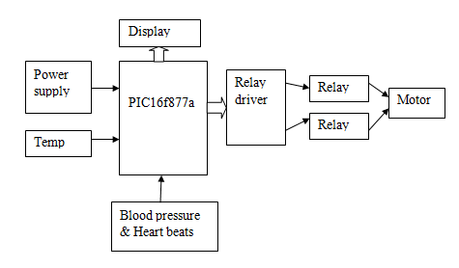

Fig.1 Block Diagram intelligence Anesthesia

1. **Working**

In this system microcontroller PIC16f877a is used which is the central part of our system.The analog inputs like heartbeats, blood pressure, & temperature connected to it.Heartbeat sensor is used to calculate the rate of heartbeat per min. of patient.The blood pressure module uses an air pump to inflate a cuff surrounding an upper arm or a wrist with sufficient pressure to prevent blood flow in local artery.This pressure is then released gradually using digitally controlled solenoid valve until the moment that blood begins to flow through artery. The blood pressure measured by a pressure sensor at this point determines the systolic pressure.Pulse rate is also sensed at this time.The measurement taken when the blood flow is no longer restricted determines the diastolic pressure.The signal from the prrssure sensor is conditioned with an instrumentation amplifier before data conversion by an ADC.The systolic ,diastolic pressure & pulse rate measurements are displayed on LCD ,time stamped and stored in non volatile memory.This values will give input to microcontroller .On the board, the anesthesia dosage is set which can be alterd using increment decrement button.The heatbeats, temperature, blood pressure and dosage will be indicated on the display.Whenever the situation arises, the system provide anesthesia by pressing start button,then the dc motor turns ON which is connected to syringe tube that start injecting anesthetics.

The motor drives in bidirectional i.e forward and reverse direction. If the displayed parameters are abnormal the system will not work until it get to normal. In contradictory, when the parameters gets normal the system works & the patient is injected with anesthetics. The utilization of automatic anesthesia control system increases patient safety, and comfort the anesthesiologist.The system will calculate the initial dose to be injected thenafter the parameters of patient are continuosly monitored by the device

1. **Flowchart**

Start

LCD Initialization

Serial Initialization

Display Project name

Delay 1sec

Reset analog channel 0 of PIC

Display temperature on LCD

Receive Heartbeat & Blood pressure Data from module serially

Display on LCD

Temp, HB and BP in normal

**NO**

**YES**

Start motor of injection assembly for 1sec

Chart.1 Flowchart of project

1. **Result**

By observing temperature, blood pressue and heartbeats of patient from that ,if the condition is normal then anesthetics can be injected to the patient and if the condition is not normal then the system is hinded.

1. LCD initialization:

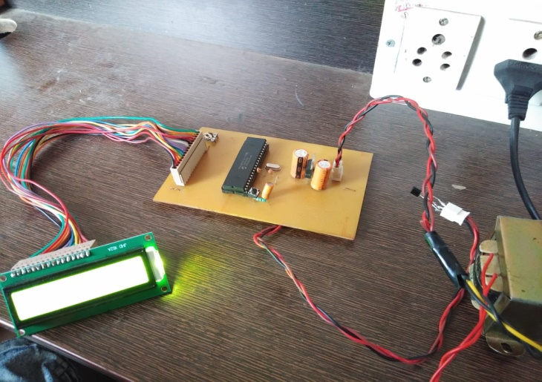

Fig.2 Practical implementation of LCD initialization

From the above image we are showing the LCD interfacing.This is the initial step of our project, which displays the proper high blood pressure, low blood pressure and heartbeat from the blood pressure module .And in this image, we only interfaced temperature sensor, which will display the temperature of patient.

Normal condition for High blood pressure is in range of 100-140, for low blood pressure it is range of 65-100,and for heartbeat it should be in the range of 65-90.

B**.** Motor of injection assembly

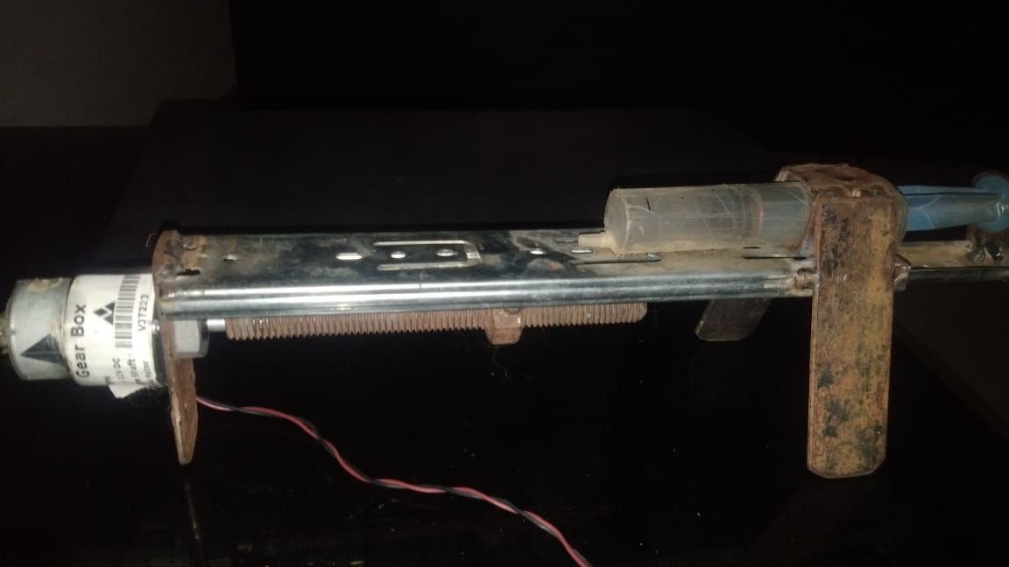

Fig.3 Image of injection assembly

This is injection assembly, which operates on the condition

which is define in the program. And according to the given condition the above motor will work only for normal condition.This motor will turn on for only 1 sec in our project.This can be increase by changing the time in program.

1. **Conclusion**

In this project we have monitored various parameters of the patienrt like body tmperature,heartbeats,blood pressure.The complete system is developed by using PIC controller and relay driver circuit for the motor attached to the insertion assembly.

This system is definitely a great solution for the doctors while requiremenrt of the anesthesia given to the patient at the time of operation

**References**

1. N. Manikandan, S. Muruganand, and K. Vasudevan. “Low Cost Anesthesia Injector Based on Arm Processor”, International Journal of Advanced Research in Computer and Communication Engineering, Vol. 2, Issue 7, pp. 2810-2813, July 2013.
2. Sushma Polavarapu, Kranthi Madala and Sri Hari Nallamala, “Anesthesia Regularization using Heart Beat Sensor”, International Journal of Engineering, Education and Technology Science & Research, Vol. 4, Issue 3, pp. 164-173, March 2017.
3. Teena Bansal & Sarla Hooda “Anesthetic Considerations in Pediatric Patients”, International Medical Science Academy, Vol. 26, Issue 7, pp. 127-131 April - June 2013.
4. Gokilavani.R, Gokulapriya. M, Jasmine Christy.A.R, and Jeeva. R, “Anesthesia Control System With Multi Sensor Using Arduino”, International Journal of Innovative Research in Advanced Engineering, Vol. 6, Issue 3, pp. 86-90, March 2019
5. L. Salim, A.Thomas, Akshay M, A. Alias, and M. Irshad, “Microcontroller based Anesthesia Injector”,International Research Journal of Engineering and Technology, Vol. 06, Issue 3, pp 826-829, June 2019.
6. S. Krishnakumar, J. Bethanney Janney, W. Antony Josephine Snowfy, S. Joshin Sharon, and S. Vinodh Kumar, “Automatic anesthesia regularization system (AARS) with patient monitoring modules”, International Journal of Engineering and Technology.
7. C. Punitha, D. Bhavithira, S. Hemapriyanga, C. Kaviyazhiny. “Automated Tranquilizer”,International Journal for Research in Applied Science and Engineering Technology(IJRASET), Vol. 06, Issue IV, April 2018.