Analysis Of Air Pollution In Three Cities Of Bangalore Using Air Quality Index

Hima K Sugathan , Parvathy , and Rijas K M ,

Department of Physics

Amrita Vishwa Vidyapeetham

Amritapuri,Kerala

***Abstract***-**Air pollution causes a lot of injury to the environment which may become remediless if the pollution rate increases in the current rate for another few years. Surprisingly the air pollution rate has leaped into higher levels in most of the major cities in India. In this analysis, air pollution in Bangalore is analyzed using the parameter air quality index mainly in three cities which are Whitefield (industrial), Silk Board (commercial), and Jayanagar (residential) during 2019. Analysis of seasonal variations in these cities is also studied. The following are the observations: 1)PM10 concentration determines air quality in these cities 2) the Air Quality Index is high in Silk board(commercial) followed by Whitefield(industrial) and Jayanagar (residential) 3)quality of air is better in the monsoon than summer and winter.**

***Index Terms* – Air pollution, Air Quality Index, PM 10**

1. INTRODUCTION

One of the five elements of nature is made up of is air. Air pollution is fundamentally the presence of a foreign substance in the air such as dust, smoke, gases, mist, etc. and change in the composition of the atmosphere[1]. There are man-made (from industries, vehicles) and natural (volcanic eruption) cause for air pollution[2]. But almost 80% is man-made. It affects the environment very badly and is a threat to everyone around the globe. The level of air pollution is high in cities than in any other place due to industrialization and urbanization. The major pollutants in the city are Sulphur dioxide (SO2), Nitrogen oxides (NOx), ground-level ozone (O3), particulate matter (PM10 and PM2.5), and Carbon monoxide (CO). Air pollution affects human health and will cause health diseases, including lung cancer, respiratory infections, etc. In cities, PM10 causes heart diseases and reduce the life expectancy of people living there[3]. The major step or the first step we should take to prevent pollution is by analyzing the quality of the air in those places so that we can try methods to clean the air wherever needed so that we can prevent the future increase in air pollution. The Air Quality Index (AQI) helps to analyze the quality of air in each place. AQI gives public awareness of how polluted the air is around them.

1. AREA OF STUDY

We analyzed 24 hours averaged values of the pollutants(SO2, NO2, PM10) throughout the year 2019 for three cities in Bangalore – a) Whitefield, a major hub for Indian technological industry b) Silk Board, a commercial area which is tagged as one of the seven worst traffic junctions in India c) Jayanagar, where eight out of ten blocks are residential areas. Bangalore has well defined dry and wet seasons as it has a tropical savanna climate. Bangalore has a stable and pleasant climate throughout the year as it is very high from sea level. There are four seasons in Bangalore namely summer (Mar-May), winter (Dec–Feb), south-west monsoon (Jun-Sept), and north-east monsoon (Oct-Nov).

1. MATERIALS

The data of the pollutants sulfur dioxide, particulate matter10 (PM10) and nitrogen dioxide for the three cities Whitefield, Silk Board, Jayanagar was collected from the Karnataka State Pollution Control Board. The concentration was in micrograms per cubic meter. Monitoring stations details given in TABLE Ⅰ

TABLE Ⅰ

DETAILS OF MONITORING STATIONS

|  |  |  |  |  |
| --- | --- | --- | --- | --- |
| **City** | **Station**  **name** | **Category** | **Latitude** | **Longitude** |
| Whitefield | ITPL, White Field | Industrial | 12°59'17.9"N | 77°43'09.9"E |
| Silk Board | Central Silk Board, Hosur Road | Commercial | 12°55'00.5"N | 77°37'21.2"E |
| Jayanagar | Indhira Gandhi Children Health Care Centre | Residential | 12°56'15.1"N | 77°35'32.3"E |

1. METHOD

In this analysis, for the calculation of AQI, we used the National Air Quality Index. The method involves finding the sub-indexes of each pollutant and then the maximum of it gives the AQI of that area. That value is then compared with the standard AQI values. There are six types in line with Indian conditions. The six types are - Good, Satisfactory, Moderately polluted, Poor, Very Poor, and Severe (TABLE Ⅱ). Based on linear segmented principle[5] we can find the sub-index (In) for pollutant concentration (Cn) by using the equation(1):

$$I_{n}=\left[\left\{{\left(I_{HI} - I_{LO}\right)}/{\left(B_{HI} - B_{LO}\right)}\right\}×\left\{C_{n}- B_{LO}\right\}\right]+I_{LO}$$

*Cn* = Actual ambient concentration of pollutant ‘n’.

*BHI* = Upper-end breakpoint concentration greater or equal to given *Cn.*

*BLO*= Lower-end breakpoint concentration smaller or equal to given *Cn.*

*IHI* = The sub-index or AQI value corresponding to the breaking point *BHI*

*ILO* = The sub-index or AQI value corresponding to the breaking point *BLO*

*In*  = AQI for pollutant ‘n’ / sub-index for pollutant ‘n’

AQI = Max (*In*) (where; n= 1, 2..., m)

m = the number of pollutants

TABLE Ⅱ

AQI RANGE,TYPE AND HEALTH EFFECTS[5]

|  |  |  |
| --- | --- | --- |
| **AQI Range** | **Type** | **Health impact** |
| 0-50 | GOOD | Minimum impact |
| 51-100 | SATISFACTORY | Slight breathing discomfort |
| 101-200 | MODERATELY SATISFACTORY | Children, elderly and heart patients may suffer breathing problem |
| 201-300 | POOR | Long time exposure may cause considerable breathing problems |
| 301-400 | VERY POOR | Long time exposure causes respiratory illness, people with heart disease and lung diseases may face more severe health situation |
| 401-500 | SEVERE | Respiratory illness on healthy people |

1. RESULTS AND DISCUSSION

Data on the concentration of the pollutants’ sulfur dioxide, particulate matter10 (PM10), and nitrogen dioxide in Whitefield, Silk Board, and Jayanagar were plotted and analyzed. The Air Quality Index (AQI) and seasonal averages of these cities were also calculated and plotted.

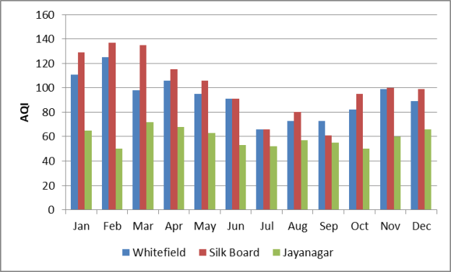

Fig. 1. AQI values in 2019

In Whitefield, which is an industrial area, the AQI was high during Jan-Feb(winter season) and April(summer season) than other months and their value were above 100 which fall in the moderately satisfactory type which causes breathing problem to children, elderly and people with heart disease and lung disease. Even though AQI values decrease during the south-west monsoon, their value still resides in the satisfactory type, which causes minor discomfort in breathing. Then the value increases during north-east monsoon Oct-Nov and it reaches near 100, but still belong to a satisfactory type.

In Silk Board, which is a commercial area, the AQI value was high during Jan-Feb (winter season) and Mar-April (summer season). Their value was between 101-140 which is very high and falls in the moderately satisfactory type. The south-west monsoon brings a decrease in the value which is followed by an increase during north-east monsoon which is near to 100 and is of satisfactory type.

In Jayanagar, which is a residential area, AQI values are comparatively lower than both Whitefield and Silk Board. Mar- April (summer season) months showed higher AQI values than other months and they belong to a satisfactory type. During Feb and Oct, the value was 50 and it falls in good type. The AQI value during the monsoon was also satisfactory even though it increased slightly during the north-east monsoon.

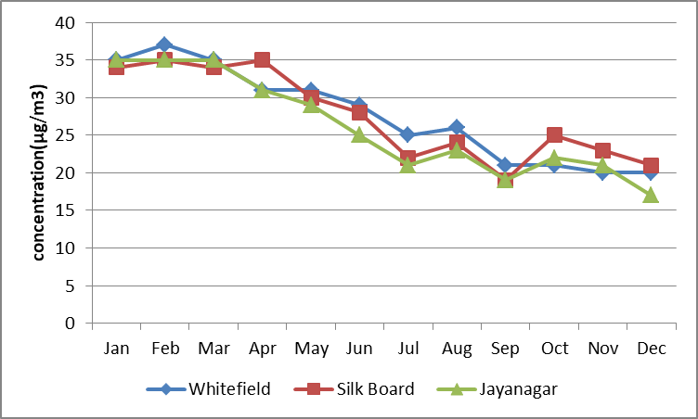

Fig. 2. Concentration of NO2 vs Month

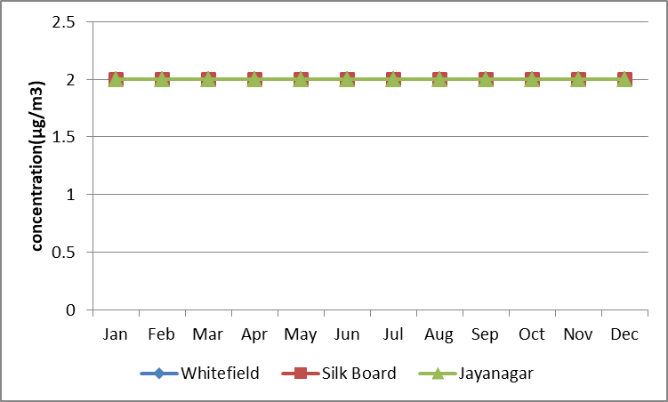

Fig. 3. Concentration of SO2 vs Months

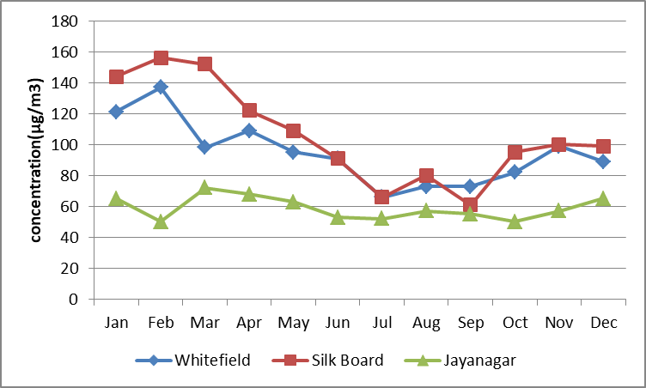

Fig. 4. Concentration of PM10 vs Months

The concentration of NO2 was almost the same in the residential, commercial, and industrial areas even though there is a minor increase in the industrial area during summer and commercial areas during winter. SO2 concentration remained the same in all areas throughout the year. PM10 was very high in the commercial area followed by industrial and residential areas during summer. The difference became very close during the rainy season in all areas and then increased slightly during the winter in the same pattern as in summer.

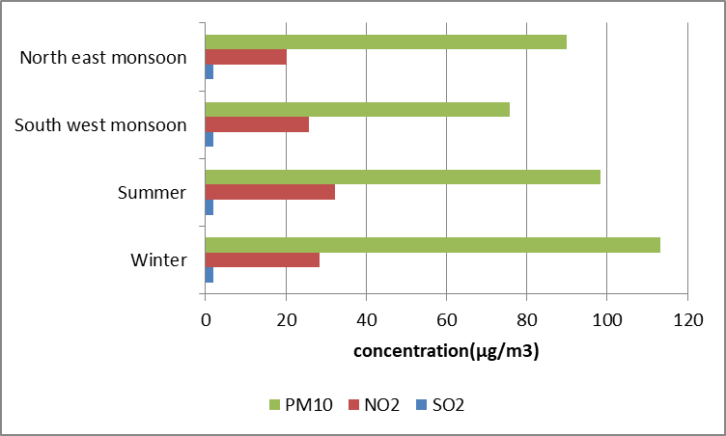

Fig..5. Seasonal variations of pollutants in Whitefield

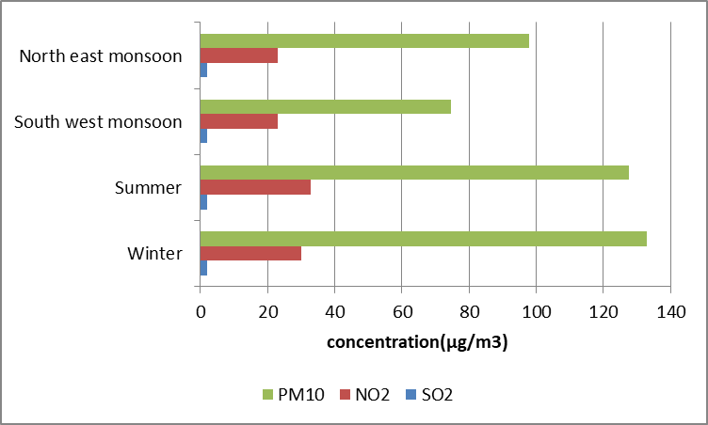

Fig. 6. Seasonal variations of pollutants in Silk Board

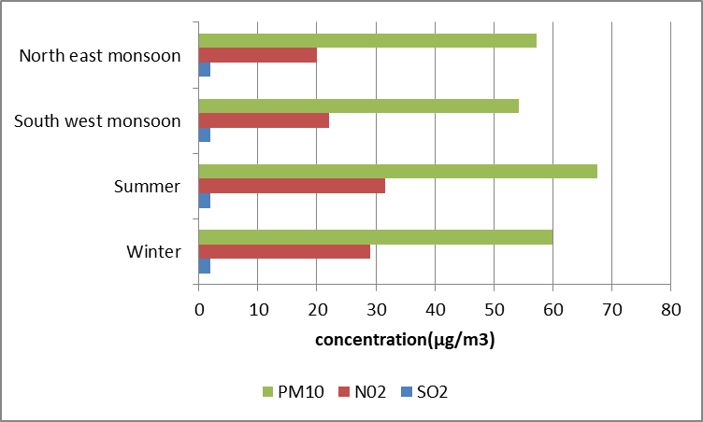

Fig. 7. Seasonal variations of pollutants in Jayanagar

In all the cities NO2 has higher concentration during the summer season and PM10 has higher concentrations during winter except in Jayanagar. SO2 values remain the same during every season in every city.

TABLE Ⅲ

AQI TYPES FOR CITIES DURING 2019

|  |  |  |  |
| --- | --- | --- | --- |
| **Month** | **Whitefield** | **Silk Board** | **Jayanagar** |
| Jan | moderately satisfactory | moderately satisfactory | satisfactory |
| Feb | moderately satisfactory | moderately satisfactory | good |
| Mar | satisfactory | moderately satisfactory | satisfactory |
| Apr | moderately satisfactory | moderately satisfactory | satisfactory |
| May | satisfactory | moderately satisfactory | satisfactory |
| Jun | satisfactory | satisfactory | satisfactory |
| Jul | satisfactory | satisfactory | satisfactory |
| Aug | satisfactory | satisfactory | satisfactory |
| Sep | satisfactory | satisfactory | satisfactory |
| Oct | satisfactory | satisfactory | good |
| Nov | satisfactory | satisfactory | satisfactory |
| Dec | satisfactory | satisfactory | satisfactory |

1. CONCLUSION

The concentration of NO2 and SO2 was almost the same for three cities even though there was a slight decrease in NO2 in Jayanagar. PM10 concentration showed more variation in these cities. It was higher than the standard amount given by the Central Pollution Control Board that is 100 µg/m3 during summer and winter seasons. During the monsoon season, they get diluted or dispersed due to rainfall which causes a decrease in its concentration. Silk Board has the highest concentration followed by Whitefield and Jayanagar. Silk board is one of the busiest traffic junctions in Bangalore[7]. The major source of PM10 is vehicular pollution, unpaved roads, and road dust. The higher concentration of PM10 can cause severe respiratory diseases in people who have daily exposure to these traffic junctions. Whitefield is surrounded by industries and the pollution from these industries has made PM10 level high.

Air pollution in Bangalore may increase steadily in the future if we don't take proper steps now to reduce it. Awareness should be spread among people about air pollution and health effects which will affect them. Public transport should be supported and cities which have heavy traffic should try to bring metro service to avoid it.

REFERENCES

[1] W.M. Sweileh, S.W.Al-Jabi, S.H. Zyoud, and A.F. Sawalha, "Outdoor air pollutions and respiratory health: a bibliometric analysis of publications in peer-reviewed journals(1900-2017),” *Multidisciplinary Respiratory Medicine*, Vol.13, No.15, Jun.2018

[2] Dr. M. Choudhary and V. Garg, (2013, Aug). Causes, Consequences, and Control of Air Pollution. presented at. *All India Seminar On Methodologies for Air Pollution Control*.[English]. Available: <https://www.researchgate.net/publication/279202084_Causes_Consequences_and_Control_of_Air_Pollution>

[3] A. Ebenstein, M. Fan, M. Greenstone, G. He, and M. Zhou, "New evidence on the impact of sustained exposure to air pollution on life expectancy from China’s Huai River Policy,” *Proceedings of the National Academy of Sciences*, Vol. *114*, No.39, pp.10384-10389, Sept.2017

[4] S. N.Jyothi, K. Kartha, A. Mohan, J. Pai, and G. Prasad,” Analysis of Air Pollution in Three Cities of Kerala by Using Air Quality Index,” *Journal of Physics: Conference Series*, Vol. 1362, No. 1, pp. 012110, Nov.2019

[5]”Silk Board among seven worst traffic spot, ”THE NEW INDIAN EXPRESS, Jan.12,2017.