Weed Detection in Farm Crops Using SSD Object Detection Method

# Raksha1, Preethi N Rao2, Sharadhi Shetty3, Shreekari4 and Yashaswini Jogi Department of computer Science and Engineering

Shri Madhwa Vadiraja Institute of Technology and Management, Bantakal

***Abstract*— The weed is an unwanted plant that is found in the field. They can do some harm to the main crop, which can reduce their nutrition. There are many ways to kill weeds, such as man power, herbicide spraying etc. Each of these techniques failed to find an appropriate way to eliminate weeds. Such approaches have one or more disadvantages such as time consuming man power, spraying herbicides can harm the real crops. The level of herbicide usage increased day by day to reduce the weeds. Herbicide use causes the crop yield to decline. To address these disadvantages, we aim to propose a system that uses the SSD object detection method to detect weed in farm crops. The solution being suggested works in real time by taking images of farm crops as input. SSD speeds up the process by eliminating the need of the region proposal network. The image is captured in real time and is processed by raspberry pi. To process the image, we have used the OpenCV programming library and deep learning. This method is efficient for detection of weeds when compared to YOLO and faster R-CNN method.**

***Index Terms*— object detection, OpenCV, raspberry**

**pi.**

1. INTRODUCTION

The agricultural sector plays an important part in contributing to the Indian economy. Many countries are working on agricultural development that results in sustaining agricultural production. But weed is the only crop threat that shrinks production rates. Weeds are particularly hazardous to farming and crop production. Those are the plants growing along with crops that interrupt the necessary field growth. These have seeds that have survived at the soil seed bank for several years. These weeds compete with the main crop, for water, nutrients, space, etc. They cause damage to total crop yield if not managed. These undesirable plants not only have an effect on crop growth but can also yield efficiency.[3]

Each year, weed development leads to massive losses in agricultural production worldwide, although vast amounts of labor and herbicides were used. Manual labor is the standard method for marijuana extraction. Through checking each and every spot in the field they can detect the plant. They would then pluck them with their fingertips manually. Since

technological progress, farmers have started to use herbicides to control weed growth. Nevertheless, they do use manual monitoring in many parts of the world to detect the weeds [4]. Herbicides play a key role in weed removal and it also yields a good initial result, but later the weeds dominate the area. These herbicides were used to spray them into the region as a whole. Yet the over-use of these chemicals affects the crop [3]. Those have a negative influence on both crops and nature, contributing to well-being concerns for people using those goods. In addition to the dangerous effects such as negative impacts on trees, soil and underground aquifers, vast quantities of herbicides would be wasted, as only certain areas of the field are filled with weeds. We certainly should agree that the presence of these deadly poisons may contaminate our water supply. No selective herbicides are needed even for certain weed conditions [1].

For an increasing population we need to increase the farming productivity to meet the demands. Improved demand for increased herbicide use that has resulted in harm to the environment. Its important to choose an alternative technique to lower man’s power. It is in urgent need of non-chemical automatic weeding equipment [4]. Automation plays a vital role in generating Quality production in each and every sector with reduced manpower. Robotic mechanical weeding is a potential way to reduce the environmental burden of agrochemicals in conventional agriculture and to replace hand weeding in organic farming [5]. To reduce herbicide use, SSD object detection techniques have been used which can classify the weeds with their positions in the captured image and we use OpenCV programming library for this processing. SSD detects various artifacts inside the image in one isolated strike. Make use of VGG16 to extract the quality representations. It detects weeds using Conv4 3 layer. This method is effective for detecting weeds compared to YOLO and R-CNN method is quicker since it speeds up the process by eliminating regional network plans and boundary boxes predicted and groups in one single pass, directly from feature maps.

1. TYPES OF WEEDS
2. Monocotyledons

It is called monocotyle. This is a special type of

flowering herb. They’ll have a single seed. This is composed of some 60,000 animals. These are typically linear and small. Within those veins a equal- like pattern is formed. These roots in this root die soon after germination, beginning with tap root, and replaced by other fibrous roots. So, it will have a fibrous root. Only one leaf will be formed upon germination. Monocot shows the parallel venation. The floral portion of monocotype is a multiple of 3. The monocotype contains no changum tissue. Similarly, stomata are present in the lower and upper leaf epidermis. They are distributed in specific structures throughout this vascular tissue. It is not present in cortex and stele monocotype.

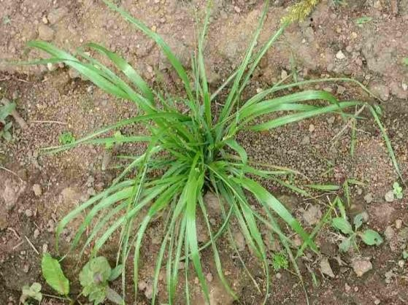

Figure 1: Monocot plant

1. Dicotyledons

It's termed a dicot. It is a special kind of flowering plant. It will have two cotyledons, covering more than 175 000 plant species – from annual to trees. These leaves are generally small. Those veins are arranged like patterns in a network. In such vascular bundles the arrangement is in rings. Floral components are multiples of four or five. In dicots the vascular systems are divided into a cortex and a stele. Dicot leaves are dorsiventral, and have two top and bottom surfaces. The Dicotyledons' seed germination is epigeal, or hypogeal. The Dicotyledons have system of tap root. The number of individual flower pieces is equal to or multiplied by four or five.

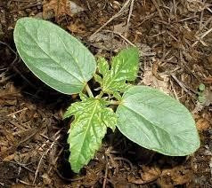

Figure 2: Dicot plant

1. LITERATURE SURVEY

The main goal of this research paper is to use SSD object detection techniques to classify weeds in farm crops. Weeds interfere with a number of human activities, and various strategies to reduce or eradicate them have been created.

In [1] the author focused on using image processing techniques to build automated weed detection and maize field robots for herbicide spray. Under the natural light conditions, the image acquisition process was performed via a webcam. Using Excess Green (ExG), the green parts of the picture were emphasized. This approach extracts the hue plane of the image so as to minimize the effect of light changes. And the clustering process was applied to hue plane, followed by some morphological activity. Corn plants were used as crops because they had a larger leaf than weed leaves with smaller and narrower leaflets and the extraction process was followed. A vision-based guidance method was presented to guide a robot platform driven along crops planted in the agricultural sector. However, the flaws in this technique are for two or more types of weeds, the threshold value must be less than the minimum edge frequency and the small weeds are present in the field separately, so that they cannot be detected due to small threshold conditions.

In [2] paper, agricultural weeds are eliminated by applying herbicides only to sites in the field affected by weeds. Such weeds can be graded according to the frequency of shape and edge. In this paper, weed between crops and weed between rows was considered. The two cases are Inter Row Weed Detection and Inter Crop Weed Detection approaches. These weeds are removed by being detected through the detection phase of column weeds. The processing is carried out using 25 image frames. Edge detection and Color Segmentation should be considered during processing. It has undergone the filtering phase following the detection phase of Edge and Color segmentation. In this paper, the Corn crop is considered to be a narrow leaf crop and its edge frequency is lower when compared to weed. Stimulation is performed with the help of MATLAB software. The main objective of our paper is to reduce the use of herbicides and human resources in agriculture. The output of the image processing can be interfaced with robots or other external devices, and the herbicide is sprayed only on the affected weed area in the field.

In [3] this paper they executed a simple picture processing method in which the weeds are identified by analyzing the clicked images. To process the taken picture they have used the design finding which is commonly used for the object detection in the picture with the many objects. Raspberry pi model is used to

process the image and classify it into weeds and main crops. Then the gray image will match the template.

In paper [7] the author says Improving agriculture field efficiency will increase food capital in response to the world’s high population. We face many ch allenges in the fields, such as grasses and plant diseases. We should spot and remove the weeds. Nowadays we don’t get enough manpower to work in the fields. In recent years, the application of tool learning methods such as convolutional neural networks on agriculture has been gaining enormous interest. We use convolutionary neural networks to rank the plants. Automatic plant type identification processes may be of great assistance for pesticide application, pollination and on-time collect more number of plants in order to magnify the production method of the food and drug industries. This will slash employ costs. Convolutional Neural Network planning is employed to extract image features after the preprocessing step.

The key goal in [8] was segmentation and classification based on a technique of region thresholding. Median filter is used to minimize the amount of data in the gray image (as it's easy and fast to process). And Otsu 's system was used for binarization. Then watershed segmentation method is used to divide the different regions for binarized image Under area threshold classification system, it is observed with the five steps namely, Excess green gray transformation, Segmentation, image labelling, elimination of unnecessary data and, ultimately, field threshold classification. To identify weed plants and crop plants the threshold value is selected. So, weeds are detected when there is less than threshold value in the object areas. This technique is appropriate when the plants are separated in the image, because the results have been shown to be better with the lighting conditions.

Promissory findings on automatic weed detection were obtained using a form of image processing. Another approach to collecting field images using a CCD camera mounted on a tractor. With the popularity of digital cameras, personal computers, image processing software and global positioning systems, machine vision systems could be an option for reducing the cost of precision farming data collection. It may be possible to detect spatial variation on weed distribution by georeferencing the data and allow site-specific control, using patch spraying where herbicides are applied only in areas where the weed population provides economic justification for the application. Another option is to vary the herbicide so that weed control is maximized. The marijuana maps may also be used to aid in the identification of management zones. This research is focused on the hypothesis that the use of methods of image processing can promote data collection and

identification of spatial weed variability [7].

The author had stated in paper [10] that the aim of this project is to detect the weeds in the farmland for proper distribution of herbicide sparing in the farm. The crops are distinguished by their color and appearance characteristic from the weeds. In that case weed features are extracted using HSV color space process, generating higher precision compared to RGB color space model. For more accurate results compared with SVM or BP methods, the extracted feature is compared with the trained data in Neural Networks. For a more specific value, NN separates the images into pixels. Compared to other approaches it can achieve a maximum accuracy of 95 percent.

1. DEPLOYMENT OF HARDWARE AND SOFTWARE

We favored using raspberry pi due to its smaller size which makes it mobile. Nowadays, raspberry pi actually plays a central role in IOT or Internet of Things. This is because of its capacity to provide a platform for a wide variety of programming languages [3]. We have used Raspberry Pi 3 model b+, because of its faster response time and faster Ethernet. Raspberry pi needs around 5V, 2.5mA to power it up. Here we have used a power bank for powering up the Raspberry Pi 3 Model B+ and USB web camera for capturing real time images. It is a high-quality, custom-designed 8-megapixel image sensor add-on board for Raspberry Pi, featuring a fixed focus lens. This camera module can be used to take high- definition video as well as still photographs. The camera operates with all Raspberry Pi 1, 2, 3, and 4 models.



Figure 1: Raspberry Pi

When it comes to deep learning there is quite a lot of software available. We have used image labelers to interactively label pixels and export label data for training. It can also be used to label rectangular regions of interest (ROIs) for object detection, scene labels for image classification. We have used google

colab tool to train the image. Google Colab is a free to use research tool. With Colab we can import an image dataset, train an image classifier on it, and evaluate the model with a few lines of code. We utilized OpenCV tools in our project. It is a free open source library which is used to process images in real-time. This is used for processing images, videos and even live streams. OpenCV (Open Source Computer Vision Library) makes the code easy for organizations to use and adapt. It is free to download and is available for C, C++, Java, Python, Windows, Linux, Mac OS. It is open source, and easy to install and use [9]. Python is a programming language that we have used, and it is the most widely used language. The reason for using Python to detect weeds is due to its ease of hardware implementation; which in this case is Raspberry Pi [10].

1. PROPOSED APPROACH

The proposed work is to focus on the detection of weeds in the farms. It can detect weeds and detection is represented using bounding boxes. An autonomous weed detection system is developed and it brings many promising benefits to the agriculture field such as avoidance of herbicides spraying all over the fields and its impacts on environment and humans, solution to 1the shortage of labours, helps to save time and money. The overview block diagram of the automatic weed detection in farm crops will be shown in figure 2

1. Block Diagram

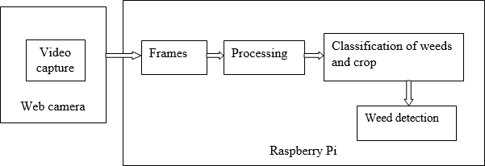

Figure 2: Block Diagram

The Figure 2 represents the basic ideology of our project. Initially video is captured using a USB web camera which is mounted on the Raspberry Pi. The video must be captured in broad daylight. The video that has been taken is converted to various frames. Each frame is then undergone with processing and based on SSD object detection technique which uses VGG16 feature map and convolution filters Conv4_3

layer, the weeds are being detected. All this processing methods on the images is done within the raspberry pi. Out of all profiles choosing the capturing or recording of video with a top view will be the best option since it covers all the weeds that are to be eliminated along with the crop plants. After processing the image which has been obtained from the camera, weeds and crops are distinguished with the help of bounding boxes that are drawn over weed that is present in the image for easy understanding of the user. Then the necessary action or methods like plucking or cutting can be done over this weed detected part.

1. SSD object detector

The SSD approach is based on a feed-forward convolutional network that produces a fixed-size collection of bounding boxes and scores for the presence of object class instances in those boxes, followed by a non-maximum suppression step to produce the final detections. It composes of 2 parts: Extract feature maps, and apply convolution filters to detect objects. SSD uses VGG16 to extract feature maps. Then it detects objects using the Conv4_3 layer. This network is able to deal with objects of various sizes by combining predictions from multiple feature maps with different resolutions. Furthermore, SSD encapsulates the process into a single network, avoiding proposal generation and thus saving computational time

1. Design Flow

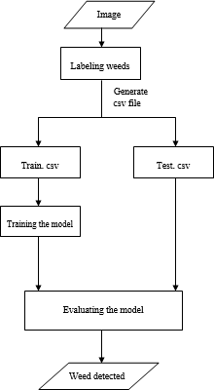

Figure 3: Data flow diagram

1. Data Collection

Dataset contains images with different kinds of weeds with associated crops. In this system we consider crops as Ragi. Some of the weeds of different sizes were collected for the above crop by taking images using any USB web camera or pi camera or any else.

1. Image annotation

Image annotation is the task of automatically generating description words for a picture. It is a key component in various image search and retrieval applications. But in this system, we manually annotate the areas of every image containing the weed with a bounding box and class.

Annotation process might be able to label the class and location of the weed in the image. The outputs of this step are the coordinates of the bounding boxes of different sizes with their corresponding class of weed.

1. Splitting Data

Now that we have a large amount of data, this dataset is splitted into train and test sets. Training set is a subset of data to train the model. Test set is a subset of data to test on our trained model. We divide the dataset into 80% of it has training data and 20% of it has testing data from the dataset.

1. Image Analysis

Our system's main goal is to detect and recognize the class weed in the image. We need to accurately detect the object, as well as identify the class to which it belongs.

SSD object detection:

SSD generates anchors that select the top most convolutional feature maps and a higher resolution feature map at a lower resolution. Then, a sequence of the convolutional layer containing each of the detection per class is added with spatial resolution used for prediction. Thus, SSD is able to deal with objects of various sizes contained in the images. A Non-Maximum Suppression method is used to compare the estimated results with the ground-truth.

1. Training the model

The model is trained using a 2 layered LSTM network and by setting our GPU. We are saving checkpoints of our model to 10000 steps, and training it up-to 50000 steps. We can also increase or decrease the number of training steps and change various hyper parameters during the training.

1. Translating the Output

Now, we have a model which is trained and it can predict on new data and you should be able to see the output on screen while running.

1. RESULTS

The subsequent samples are divided into three different scenarios: weed size is larger than crop size, weed and crop are overlapping, maximum crop sample.

1. Scenario 1: Weed size is larger than crop size This is a situation in which the size of weeds is

larger when compared to that of crop. So, in this case the bounding box appears to only those weeds whose size is larger. Almost the entire weed is detected. Such a case is shown in Figure 4.

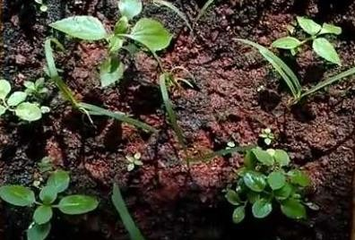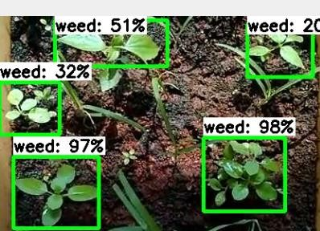

Figure 4: scenario 1: weed size is large

1. Scenario 2: Overlapping

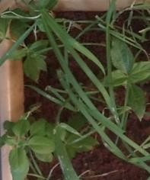Overlapping includes the situation when the leaves of Ragi crop are too close to the weed, hence the shape of each leaf will not be prominent. Overlapping change the actual shapes of leaves and that results in complex detection. Such a case is shown in Figure 5.

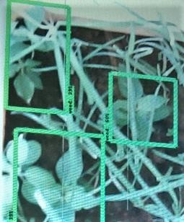

Figure 5: scenario 2: overlapping

1. Scenario 3: Maximum crop sample.

This is a situation in which crop is in abundance with respect to the weed. Due to the maximum presence of crop, the specified algorithm will detect weed intelligently. An example of scenario 3 is shown in Figure 6.

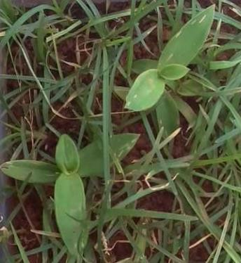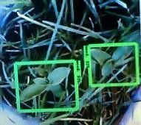

Figure 6: scenario 3: Maximum crop sample.

1. CONCLUSION

In our proposed method, an approach has been made to help farmers to reduce labour cost and improve productivity by using SSD object detection technique. The proposed solution presents an end to end system which works in real time by taking images of farm harvest as input and produces a set of bounding boxes for the weed located area in the picture as output directly. In this we have taken three cases like when weeds are dense, when weed length is larger than the crop size and when weed length is smaller than crop size. The system automatically extracts features from the image without any need of human assistance and finally weed is detected. This system shows an much

effective and reliable classification of images captured by a camera. This process is cost effective.

The above approach can be used by parallel image processing technique, and can be used for detection, identification of weeds for different crops which will be fast processing when compared to our current method. The detected weed can be removed by using a machine with the help of a plucking tool.

REFERENCES

1. G.Sowmya and Srikanth , “ Automatic Weed Detection And Smart Herbicide Spray Robot For Corn Fields”, International Journal of Science, Engineering and Technology Research (IJSETR) Volume 6, Issue 1, January 2017.
2. Karthik K and Vivek C “Weed Remover in Agricultural field through image processing”, International Journal of Pure and Applied Mathematics Volume 118 Special issue May 2018.
3. R.Anirudh Reddy and G.Laasya “Design of A Weed Detection System For Cotton Field” Journal of Image Processing and Artificial Intelligence Volume 3,Issue 3,January 2017.
4. Ajinkya Paikekari, Vrushali Ghule, Rani Meshram and V.B. Raskar “Weed Detection Using Image Processing” International Research Journal of Engineering and Technology (IRJET) Volume: 03 Issue: 03 | March-2016.
5. Li Nan, Zhang Chunlong, Chen Ziwen, Ma Zenghong, Sun Zhe, Yuan Ting, Li Wei, Zhang Junxiong “Crop positioning for robotic intra-row weeding based on machine vision “International Journal of Agriculture & Biol Engg Vol. 8 No.6 December, 2015.
6. Prof.Michelle Araujo E Viegas, Mr.Avinash Kurian,Mr Victor Joshua Rebello and Mr.Niraj Mangaldas Gaunker “Weed Detection using Image Processing” International Journal for Scientific Research and Development Vol.4,Issue 11,2017
7. Mrs. R. Dhayabarani, Aravind K,Gowtham M “Detection of Weed using Neural Networks “International Journal of Engineering Research & Technology (IJERT),ISSN: 2278-0181 Published by, [www.ijert.org](http://www.ijert.org/) RTICCT - 2018 Conference Proceedings.
8. Su Hnin Hlaing and Aung Soe Khaing “Weed and Crop Segmentation and Classification Using Area Thresholding “International Journal of Research in Engineering and Technology (IJRET) Volume: 03 Issue: 03 | Mar-2014.
9. Krupali Mistry, Avneet Saluja, “An Introduction to OpenCV using Python with Ubuntu,” International Journal of Scientific Research in Computer Science, Engineering and Information Technology Volume 1, Issue 2, 2016.
10. S. Jeba Priya, G. Naveen Sundar, D. Narmadha, Shamila Ebenezer “Identification of Weeds using Hsv Color Spaces and Labelling with Machine Learning Algorithms “International Journal of Research in Engineering and Technology (IJRET), ISSN:2277- 3878, Volume-8, Issue-1, May 2019.
11. Sadia Murawwat, Armish Qureshi, Saleha Ahmad, Yousaira Shahid “Weed Detection Using SVMs” Engineering, Technology & Applied Science Research, Vol. 8, No. 1, 2018, 2412-2416.
12. Wei Liu, Dragomir Anguelov, Dumitru Erhan, Christian Szegedy, Scott Reed, Cheng-Yang Fu, Alexander C. Berg “SSD: Single Shot MultiBox Detector” International Research Journal of Engineering and Technology (IRJET), Dec 2016.