Face Recognition Student Attendance System Using Deep Learning

Niraj S Shetty, Akhilesh Rao U, Mahesh Bhat MN, Chetan R

***Abstract:*** As we all know nowadays in any academic organization recording a student attendance plays a very important role in judging a performance of each students. Current biometric methods for attendance system is too impertinent to follow, as labour involved in this method is time consuming. So to overcome this problem this paper as introduced stress-free non-intrusive way of taking attendance in the class using face recognition technique. This system consists of 2 phases that is enrollment and verification phase. During enrollment, a camera was used to acquire facial images that were stored in a database. During verification, facial features extracted from acquired face images and stored picture were compared using HOG algorithm. After successfully recognizing the student face the proposed system will update the attendance of that particular student in csv file. So this system helps in maintaining time management in a successful way by eliminating manual calling, marking and entry of attendance.

Niraj S Shetty: Dept. Electronics and Communications, SMVITM, Udupi. ([niraj1998shetty@gmail.com](mailto:niraj1998shetty@gmail.com)).

Akhilesh Rao U: Dept. Electronics and Communications, SMVITM, Udupi. ([akhidk97@gmail.com](mailto:akhidk97@gmail.com)).

Niraj S Shetty: Dept. Electronics and Communications, SMVITM, Udupi. ([maheshbhatmn61@gmail.com](mailto:maheshbhatmn61@gmail.com)).

Chetan R: Dept. Electronics and Communications, SMVITM, Udupi. ([Chetan.ec@sode-edu.in](mailto:Chetan.ec@sode-edu.in)).

I. INTRODUCTION

Many Organizations use attendance systems to record when student start and stop to work, and the department where the work is performed. Some organizations also keep detailed records of attendance issues such as who calls in sick and who comes in late. An attendance system provides many benefits to organizations. There was a time when the attendance of the students and employees was marked on registers. When it comes to schools and universities, the attendance monitoring system is a great help for parents and teachers both. Parents are never uninformed of the dependability of their children in the class if the university is using an attendance monitoring system. The registers could easily be exploited by students and if information was mailed to the parents, there were high chances that mails could be made to disappear before parents even saw them. With the monitoring system in place, the information can easily be printed or a soft copy can be sent directly to parents in their personal email accounts [8].

Typically, a good biometric system has two phases; the enrolment phase and the recognition phase. Enrolment involves obtaining the biometric trait of an individual, storing the features in a database as well as an identifier to enable the trait to be associated with the individual [3]. The recognition phase involves acquiring the biometric trait, extracting the identifier and checking the database to see if there is any match. Face recognition has numerous merits above other biometric methods. Most of the other biometric forms need some form of action by the user. However, face recognition can be done without the involvement of the user due to the fact that face images can be acquired from a distance by a camera. In the end, face recognition is totally non-intrusive and so does not expose the user to germs that may be prevalent in a system that has multiple user.

During the enrollment process, the image sample of each student is taken and minimum of 5 picture sample should be taken in different angle to get maximum accuracy and train this picture sample using SVM , Finally this sample pictures are stored in data base. During the verification process, video of all the students is taken and face of each student is detected and compared with the sample pictures stored in data base using HOG algorithm [4].

II.METHODOLOGY

The system consists of a camera that captures the images of the students and sends it to the image enhancement module. After enhancement the image comes in the Face Detection and Recognition modules and then the attendance is marked on the database server. At the time of enrolment, templates of face images of individual students are stored in the Face database. Here all the faces are detected from the input image and the algorithm compares them one by one with the face database. If any face is recognized the attendance is marked on the server from where anyone can access and use it for different purposes.

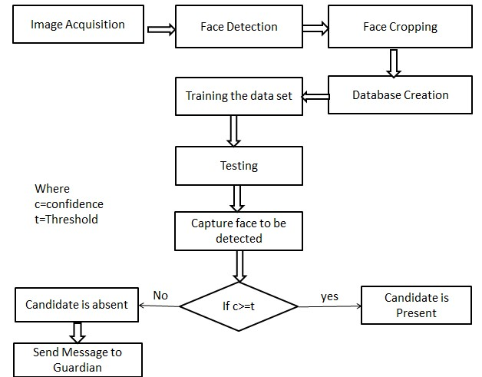

Figure1: Methodology of attendance system

**A. Histogram of Oriented Gradients**:

The histogram of oriented gradients (HOG) is a feature descriptor used in computer vision and image processing for the purpose of object detection. The essential thought behind the histogram of oriented gradients descriptor is that local object appearance and shape within an image can be described by the distribution of intensity gradients or edge directions. The image is divided into small connected regions called cells, and for the pixels within each cell, a histogram of gradient directions is compiled. The descriptor is the concatenation of these histograms [5].

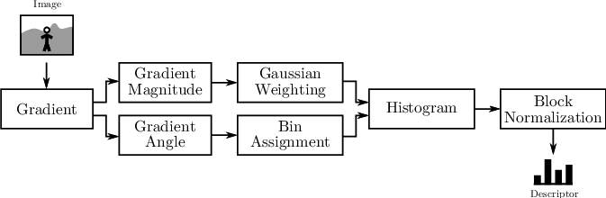

Figure2: Block diagram of HOG-SVM algorithm

**1. Gradient computation**: The first step of calculation in many feature detectors in image pre-processing is to ensure normalized color and gamma values. The most common method is to apply the 1-D centered, point discrete derivative mask in one or both of the horizontal and vertical directions. Specifically, this method requires filtering the color or intensity data of the image with the following filter kernels [4]:

[-1, 0, 1] [-1, 0, 1]T

**2. Orientation binning:** The second step of calculation is creating cell histograms. Each pixel within the cell casts a weighted vote for an orientation-based histogram channel based on the values found in the gradient computation. The cells themselves can either be rectangular or radial in shape, and the histogram channels are evenly spread over 0 to 180 degrees or 0 to 360 degrees, depending on whether the gradient is “unsigned” or “signed [4].

**3. Descriptor blocks:** The HOG descriptor is then the concatenated vector of the components of the normalized cell histograms from all of the block regions. These blocks typically overlap, meaning that each cell contributes more than once to the final descriptor. Two main block geometries exist: rectangular R-HOG blocks and circular C-HOG blocks. R-HOG blocks are generally square grids, represented by three parameters: the number of cells per block, the number of pixels per cell, and the number of channels per cell histogram. Circular HOG blocks (C-HOG) can be found in two variants: those with a single, central cell and those with an angularly divided central cell. In addition, these C-HOG blocks can be described with four parameters: the number of angular and radial bins, the radius of the center bin, and the expansion factor for the radius of additional radial bins [6].

**4. Block Normalization:** Inventors Dalal and Triggs explored four different methods for block normalization. Let *v* be the non-normalized vector containing all histograms in a given block, ||*v*||k be its k-norm for k=1, 2 and *e* be some small constant (the exact value, hopefully, is unimportant). Then the normalization factor can be one of the following:

**L2-norm**: $\frac{v}{\sqrt{{{|\left|v\right||}_{2}}^{2}+e^{2}}}$ (1)

**L2-hys:** L2-norm followed by clipping (limiting the maximum values of v to 0.2) and renormalizing (2)

**L1-norm: $\frac{v}{\sqrt{{|\left|v\right||}_{1}+e}}$**  (3)

**L1-sqrt: $\sqrt{\frac{v}{{|\left|v\right||}_{1}+e}}$** (4)

HOG descriptors may be used for object recognition by providing them as features to a machine learning algorithm. We used HOG descriptors as features in a support vector machine (SVM) [6].

**B. Support-Vector Machine:** The Support-vector machine constructs a hyperplane or set of hyperplanes in a high- or infinite-dimensional space, which can be used for classification, regression, or other tasks like outliers detection. Intuitively, a good separation is achieved by the hyperplane that has the largest distance to the nearest training-data point of any class (so-called functional margin), since in general the larger the margin, the lower the generalization error of the classifier. Classification of images can also be performed using SVMs. Experimental results show that SVMs achieve significantly higher search accuracy than traditional query refinement schemes after just three to four rounds of relevance feedback. This is also true for image segmentation systems, including those using a modified version SVM that uses the privileged approach [2].

**C. Convolutional Neural Network:** In deep learning, a convolutional neural network (CNN, or ConvNet) is a class of deep neural networks, most commonly applied to analyzing visual imagery.

A CNN is trained to detect and recognize face images, and a LRC (Logistic regression classifier) is used to classify the features learned by the convolutional network. Applying feature extraction using CNN to normalized data causes the system to cope with faces subject to pose and lighting variations. LRC which is a discriminative classifier is used to classify the extracted features of face images [1].

**Working:** Feature extraction of the image is done by HOG-SVM. Dividing the image into small connected regions called cells, and for each cell compute a histogram of gradient directions or edge orientations for the pixels within the cell. Discretize each cell into angular bins according to the gradient orientation. Each cell's pixel contributes weighted gradient to its corresponding angular bin. Groups of adjacent cells are considered as spatial regions called blocks. The grouping of cells into a block is the basis for grouping and normalization of histograms. Normalized group of histograms represents the block histogram. The set of these block histograms represents the descriptor [7].

Using this algorithm in deep learning technique we train each students face and creating database of each student using his or her name or USN (University Seat Number). That images are converted in to pixel value vector. After the training of input data i.e. student face data now the faces should be recognized in the input video of the classroom. Video is made up of numbers of frames. So here considering the frames for the face recognition. Here we take at-least 25 frames in each second of the video and we apply face testing algorithm. Here all the student faces are compared with the trained vector data. If matching occurs then the recognized student name or USN will update in the csv file and attendance is recorded.

We got around 82-85% of accuracy using this technique and there is no face recognition of unknown person.

III. RESULT

We are comparing our result with the PCA and LBPH algorithms which is also a good algorithms for face recognition. Here S1-S6 are the original trained images of students. Second and third column indicates the recognized faces using different algorithms. Third column indicates the recognition using HOG-SVM algorithm. S5 is not recognized using the implemented algorithm and also in other two algorithm. There is an improvement of 8.75% face recognition rate using the implemented algorithm when compared with PCA and LBPH based face recognition algorithm.

Table1: Comparing with other methods

|  |  |  |  |
| --- | --- | --- | --- |
| Original student face data | PCA | LBPH | HOG-SVM (CNN based) |
| S1 | S1 | S1 | S1 |
| S2 | S2 | S2 | S2 |
| S3 | S1 | S2 | S3 |
| S4 | S4 | S3 | S4 |
| S5 | S6 | S3 | S6 |
| S6 | S6 | S6 | S6 |

Firstly, Training the student faces using deep learning technique and then comparing with the input classroom video frames for the recognition of student.

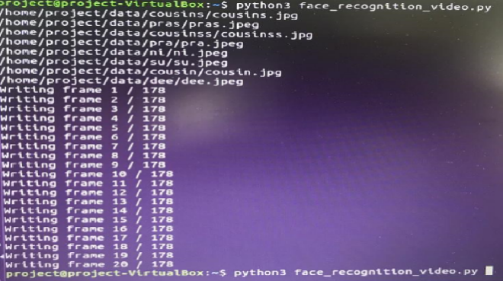

Figure3: Training of faces

In below figure there are 5 students are present to the class. So we are obtaining 5 recognized student faces with their names or USN (university seat number). Also their attendance is updated in the csv file. We obtained around 85% accuracy in attendance.

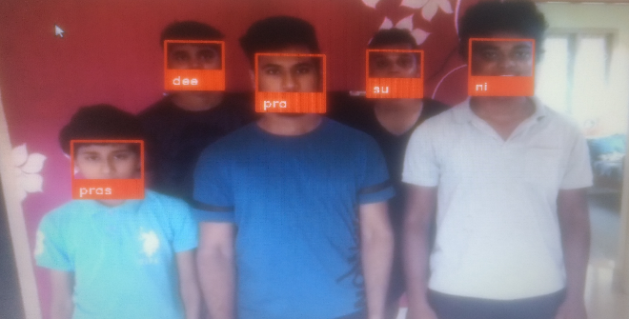

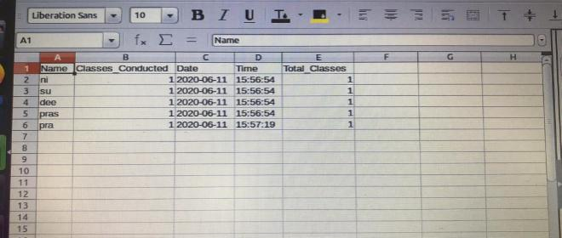

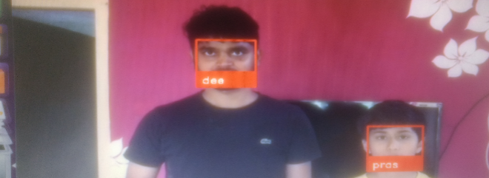

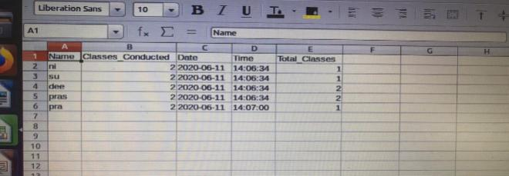

Figure4: Face recognition attendance system result

IV.CONCLUSION AND FUTURE WORK

We came to realize that there are extensive variety of methods, for example, biometric, RFID based and so on which are tedious and non-productive. So to defeat this above framework is the better and solid arrangement from each keen of time and security. Hence we have accomplished to build up a solid and productive participation framework to actualize an image handling algorithm to identify faces in classroom and to perceive the confronts precisely to check the attendance [3].

The same project can be utilized for several security applications where authentication is needed to access the privileges of the respective system. It can be used in recognizing guilty parties involving in unauthorized business. Face recognition algorithm can be improved with respect to the utilization of resources so that the project can recognize more number of faces at a time which can make the system far better. Many variants of the project can be developed and utilized for home security and personal or organizational benefits. For security reasons, we can use detection & recognition system. To identify culprits on bus stations, railway stations 7 other public places, we can use this system. This will be helping hand to the police.

REFFERENCES

[1] Valueva, M.V.; Nagornov, N.N.; Lyakhov, P.A.; Valuev, G.V.; Chervyakov, N.I. (2020). "Application of the residue number system to reduce hardware costs of the convolutional neural network implementation". Mathematics and Computers in Simulation.

[2] Navneet Dalal and Bill Triggs, INRIA Rhone-Alps,655 avenue de l’Europe, Montbonnot 38334, France, “Histograms of Oriented Gradients for Human Detection”.

[3] Atuegwu Charity, Kennedy Okokpujie, Noma-Osaghae Etinosa, “A Bimodal Biometric Student Attendance System”, 2017 IEEE 3rd International Conference on Electro-Technology for National Development (NIGERCON)

[4] Harihara Santosh Dadi, Gopala Krishna Mohan Pillutla, “Improved Face Recognition Rate Using HOG Features and SVM Classifier”, IOSR Journal of Electronics and Communication Engineering (IOSR-JECE)e-ISSN: 2278-2834,p- ISSN: 2278-8735.Volume 11, Issue 4, Ver. I (Jul.-Aug .2016), PP 34-44

[5] Marko Arsenovic, Srdjan Sladojevic, Andras Anderla, Darko Stefanovic,University of Novi Sad, Faculty of Technical Sciences, Novi Sad, Serbia,” FaceTime – Deep Learning Based Face Recognition Attendance System”

[6] Marko Arsenovic, Srdjan Sladojevic, Andras Anderla, Darko Stefanovic, “FaceTime – Deep Learning Based Face Recognition Attendance System”, SISY 2017, IEEE 15th International Symposium on Intelligent Systems and Informatics, September 14-16, 2017, Subotica, Serbia, September 14-16, 2017

[7] Priya Pasumarti1”, P. Purna Sekhar2, “Classroom Attendance Using Face Detection and Raspberry-Pi”, 2018, IRJET

[8] C.B.Yuvaraj, M.Srikanth, V.Santhosh Kumar, Y.V.Srinivasa Murthy, and Shashidhar G. Koolagudi,“An Approach to Maintain Attendance using Image Processing Techniques”, Proceedings of 2017 Tenth International Conference on Contemporary Computing ( IC3), 10-12 August 2017, Noida, India.

AUTHOURS PROFILE

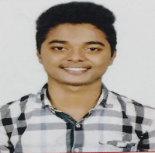 Akhilesh Rao U, student in the Department of Electronics and Communication Engineering at Shri Madhwa Vadiraja Institute of Technology and Management, Bantakal.



Akhilesh Rao U, student in the Department of Electronics and Communication Engineering at Shri Madhwa Vadiraja Institute of Technology and Management, Bantakal.

Mahesh Bhat MN, student in the Department of Electronics and Communication Engineering at Shri Madhwa Vadiraja Institute of Technology and Management, Bantakal.

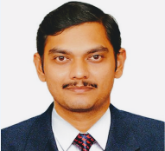

Mr. Chetan R, Assistant Professor in the Department of Electronics and Communication Engineering at Shri Madhwa Vadiraja Institute of Technology and Management, Bantakal.