Early Flood Detection and Avoidance System Using IoT

Shwetha Shivaji Ghorpade, Nithesh, Vinaya, , Deepthi G Pai

## *Department of Computer Science and Engineering*

*Shri Madhwa Vadiraja Institute of Technology and Management, Bantakal, Udupi, India*

***Abstract*— Flooding is one of the biggest natural disasters occurring in various parts of the world. Flood disaster usually occurs due to improper irrigation method in a housing area or the sudden increase of water volume in a river or dams. It often causes loss of property, damages and lives. Well Developed sensors are used to identify the level of water present in dams, rivers, lakes and heavy storage areas. Thus, this project is about designing about the system that can measure the speed of the rise of the water level at the potentially flooded area. This paper intends to understand the security necessity and security design of Internet of things innovation for urban flooding avoidance the executive's framework, what's more, talked about the interest and by and large plan of flooding anticipation the executive's framework. The Internet of Things or IOT gives the capacity for human and machines to communicate from billions of things that incorporate sensors, administrations or other Internet associated things.**

*Index Term--- Dams, Flood disaster, Internet of Things, Urban flooding avoidance, Rivers, Sensors, Security, Water level.*

# INTRODUCTION

Nowadays, floods have become one of the most dangerous hazards. This is either man-made or naturally occurring disasters. They can be completely disturbing the human life and economy of the country. Main drawbacks of the flood include pollution of clean drinking water, a large number of causalities, landslides which leads to epidemics and diseases, leads to spreading of water Bounce diseases, loss of entire harvest and Economic hardships. Floods cannot be prevented but proper precautionary measures can be incorporated to reduce the loss of lives. The proposed model is very much utilized for monitoring flow variations in rivers and the water level in the river and dams. Flood-limited water level is the parameter to manage between the flood control and

conservation, from that the annual maximum value is determined. FLWL is mainly determined by reservoir regulation using the annual design flood or annual design storm. A flood happens when water floods from the waterway, lake or substantial precipitation and it can occur whenever of the year. Flooding can be exceptionally risky, when floods occur in a zone that individuals live, the water conveys along with objects like houses or buildings, vehicles, furniture and even individuals. It can take away the properties, trees and a lot of increasingly overwhelming things. Of every single catastrophic event, the floods are generally visited (46%) and cause most human torment and misfortune (78% of populace influenced by cataclysmic events). They happen twice to such an extent and influence around three-fold the number of individuals as tropical violent winds. It causes substantial progression of traffics. In this manner, flood checking and identification framework are essential to limit flood harm costs because the expense of harm brought about by the floods is associated intimately with the time of caution given before the flood occasion happened. In the course of the most recent few decades, the IoT has been in a steady condition of development, on account of fast advances in basic advancements. Most of the Internet clients will comprise of semi-clever gadgets, supposed installed frameworks. Therefore, the Internet of Things can be characterized as the arranged interconnection of omnipresent, setting mindful gadgets that are installed with sensors, programming, gadgets and actuators that empower surrounding knowledge. Floods can't be forestalled yet appropriate prudent steps can be joined to diminish the loss of lives.

# RELATED WORK

For this project, we have referred some IEEE papers and what we have studied in these papers is shortly described as follows:

A paper dependent on the plan of ZigBee based remote sensor arrange for early flood checking and cautioning framework is structured. The Flood ready

framework guarantees to give the water level data to the general population in their portable application even without organize network and help them arrive at a more secure spot through put away images.[1]

Displays a neuro-fuzzy controller based on flood observing framework utilizing remote sensor arrange. The disseminated sensor hubs utilized IEEE 802.15.4 convention, to gather sensor data, for example, water level information from the waterway. The Sensor data is send to disseminated cautions focus by means of Arduino microcontroller and Xbee Transceiver. At the disseminated alarm place, XBee handset and Raspberry pi microcomputer are utilized to produce flood alert dependent on sensor data and to distinguish flood information and this information are put away in database. This isn't practical framework. What's more, execution likewise feeble as contrasted with our framework. [2]

An IoT approach that known as flood alarms framework with Android application to screen the potential waste typically happen flooding and offer the information progressively to individuals close by. Other than that, this framework needs to overhaul the UI configuration to make progressively intelligent and furthermore user friendly to end client. Also, assortment information utilizing propelled sensor is expected to guarantee a high exactness of information measure[3]

A framework for versatile android application will have the option to help the drivers know where the overflowed territories are so as to evade those courses so they won't get stranded on a overwhelmed region incase their vehicle can't deal with the stature of the flood. The proposed framework points not exclusively to help the vehicle drivers, yet additionally have the option to help government offices distinguish overwhelmed zones for them to concoct an answer for traffic and flood [4].

A defensive and dependable model which helps in alarming regular citizens during streak floods is structured. The principle reason behind advancement of flood ready framework is the insinuation of flood well ahead of time with the goal that human misfortunes can be controlled by departure of individuals to safe spots and furthermore ensures important properties.[5]

To build up A Real Time Solution to Flood Monitoring Utilizing IoT and Wireless Sensor Network, we proposed a flood cautioning framework which expects thoughtfulness regarding three fundamental components: Data assortment through

gaging, information handling, furthermore, the equipment and programming required, and the scattering of flood notice data. While robotized flood cautioning frameworks are frequently shockingly economical to actualize, the essential factor deciding cost for any such framework is the quantity of gage site locations.[6]

Castillo-Effen proposes a design for a framework, yet is vague on the bowl qualities and no equipment subtleties are recommended. [7]

De Zoysa talked about a versatile sensor arrange for street checking in Sri Lanka. Genuine development and utilization of the proposed framework had not happened at the hour of the paper for this application in spite of the fact that tests toward that objective had happened. The versatility of the framework alongside defer resilience of the information don't make it fundamentally the same as our venture, in spite of the fact that both do share necessities because of the decision of a creating nation and enormous geographic district to screen. [8]

A paper portraying the rising job of the Global Flood Association (GFP), a worldwide system of researchers, clients, private and open associations dynamic in worldwide flood chance the board which offer outcomes from their tests, created to anticipate and screen where and when flooding is occurring in close to ongoing and furthermore give integral data to help and improve current worldwide flood chance administration for huge scale calamities [9].

Proposed an IoT based water checking framework that measure water level progressively. The model depends on thought that the degree of water can be significant parameter when it goes to the flood occurrences especially in calamity inclined territory. A water level sensor is utilized to distinguish the ideal parameter and in the event that the water level arrives at the parameter the sign will be liberated progressively to interpersonal organization like Twitter. A cloud server was arranged as information store. The estimation of water level are shown in remote dashboard. The proposed arrangement with incorporated tactile framework that permits internal checking of water quality. Alarms and applicable information are transmitted over the web to a cloud server and can be gotten by client terminal possessed by purchaser. The result of water estimation is shown in online remote dashboard. [2] [10][11]

# METHODOLOGY

This system aims to develop a single platform for monitoring and modelling river flood. Water level data of the river will be collected using sensors to produce real-time alerts. Once data collection is done, data will be pre-processed. All these data analyses will be done using different techniques like image processing, data mining, etc.

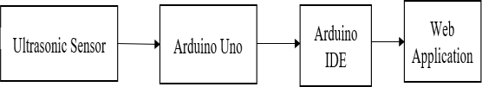

Fig 2.1 Simple block diagram of the system

For the short-term prediction, The water level sensor is fixed along with the Arduino to the dam of the river which continuously monitors the water level from the mean sea level. These values will be recorded in the server. If there is no rise in water level, with the help of the regression formula the short term flood can be predicted with help of the topographical elevation data. It is also possible to predict how much area will be affected by the flood.

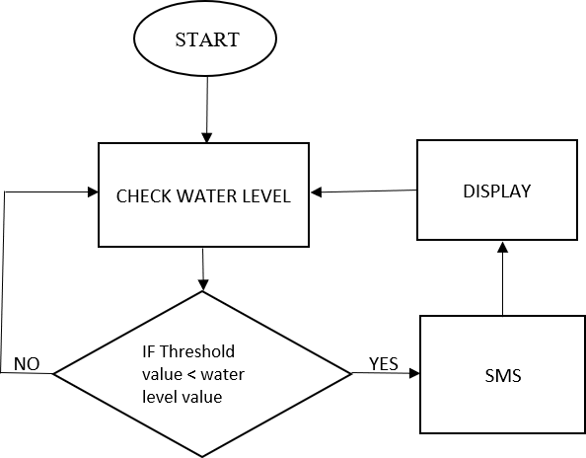

Fig 2.2 Flow-chart of our model Identifying the water level of the river during a flood

will be collected using a sensor like ultrasonic to produce a real-time warning when the water level crosses the threshold value. Sensors are placed near the water bodies that are under the bridges. As the water level increases it will sense the data. The sensor will collect the data and send it to Arduino. The data will be processed and will be converted to pixel form. The below figure Figure 2.3 depicts the flood prediction using the ultrasonic sensor.

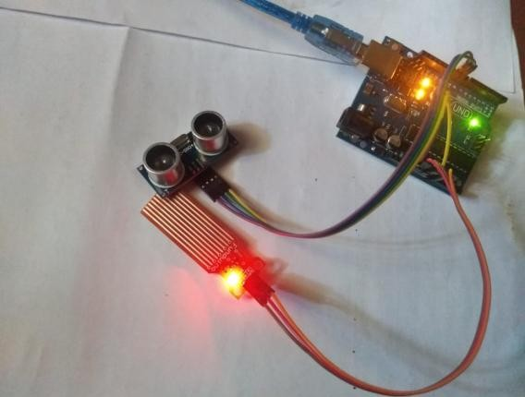

Fig 2.3 Flood prediction using the ultrasonic sensor

# PROPOSED SYSTEM

Proposed system contains of the following elements

:

* 1. Hub- hub is the autonomous flood observing which is furnished with vital sensors and network modules.
  2. Sensors
  3. Controller
  4. Wi-Fi interface- used to transfer the data on the server.

At first the information from different sensors are gathered by the Event-Stream Processing and then it is figured and transferred on the server. The information transferred on the server is put away on the database which is then steered to the front-end web applications and portable applications.

In the proposed system 1 sensor is used to discover the four distinct parameters. One is the ultrasonic sensor which is utilized to discover the water level of a dam.

The ultrasonic sensor will give the precise separation with the least mistake conceivable. It comprises of four pins namely VCC, GND, TRIG, ECHO pins. It expects 5v to work and it ranges is up to 5 meters from the sensor. The reverberation pin of the ultrasonic sensor is associated with D3 pin of nodeMCU. D4 pin of nodeMCU is associated with a trig pin of the ultrasonic sensor. The ultrasonic sensor discharges the sound waves which are at high frequencies that a human can't hear. When the discharged sound waves are hit by any article or impediment the sound waves get reflected back to the ultrasonic sensor. The ultrasonic sensor will ascertain the time span among transmitted and reflected sound waves and with that time it can give an idea to the user about the distance at which item or obstruction is found.

# RESULT

The water level sensor is placed in the top of the dam and the real time water level is compared with threshold level by using Arduino Uno. To check the status of the water level, web application can be used. The red colour dot in Figure 4.1 represents the dam region whose water level is above the threshold value.

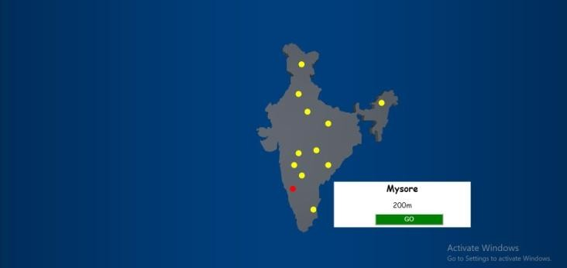

Figure 4.1 Starting page of Web page

Dam gates are opened to avoid the overflow and are closed when the water level is decreased. The figure

4.2 shows the animation of a completely filled dam.

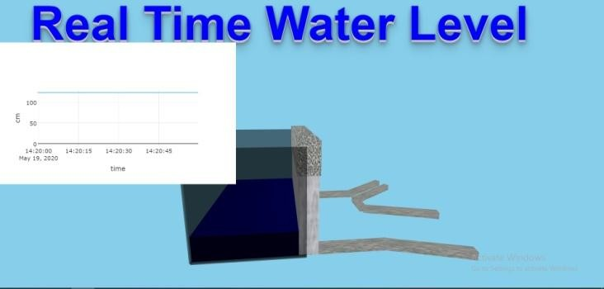

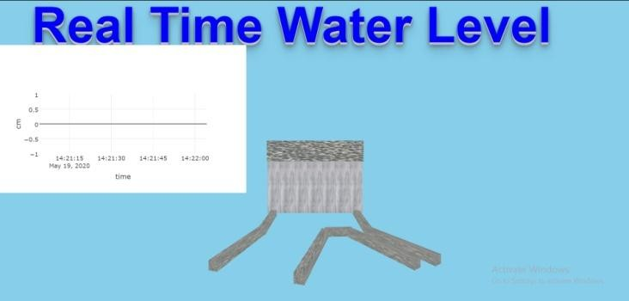Figure 4.2 Animation of full filled dam

Figure 4.3 Animation image of dam and river path The proposed system also sends an alert via Email

when the water rises to the predetermined level. A quick notification through Email is vital since the system is aimed at alerting people and authorities.

After resolving the flood situation the web page is updated with new image which is shown in Figure 4.4.

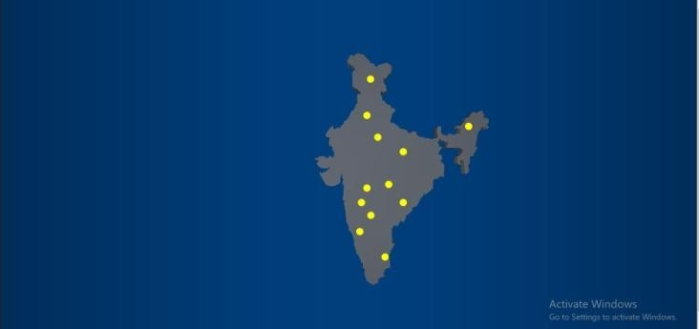

Figure 4.4 Web page after resolving flood situation

# CONCLUSION

Calamities, by their very definition, release a ruin on countries essentially. Making countries experience a ton of more horrible obliteration than developed, in any case, and are less arrange to deal with deferred results of these disasters. Foreknowledge of the calamity could in this manner bolster all, yet better guide making countries by offering time to check the property and clear. Developing early exhortation systems is a tangled issue, with various angles to the structure necessities when inside a making country. This paper depicted these complexities, focusing on the use of conduit flooding, and investigated a potential response for the issue of stream flooding. Through field tests in Honduras, the issue and course of action have been clarified and refined, with various activities got the hang of during the methodology. As India went up against continuous destroying flood in Kerala, there rises a need for capable flood watching systems. Flood evaluating and giving of flood makes are incredible methodologies aware of diminishing hurt. The proposed structure will be capable of considering the way that it has better coordination of watching, correspondence and transmission progressions which are flexible to establishment coordination. The proposed system on like manner ensures extended accessibility to the assessment of emergency conditions and updates feasibility and capability in responding to catastrophic scenes. In once-over, the proposed structure would be beneficial to the system for dynamic and flight orchestrating purposes, an all-out system despite everything doesn’t exist inside Honduras, yet stir continues developing this structure and makes a close-by test arrange. Shortly, we will plot a point by point system configuration, complete the process of testing on portions of the 900MHz distinguishing structure, and develop a quantifiable gauge computation utilizing the system data on the conduit. We intend to verify the people of Honduras during the storm and ocean whirlwind time of 2018, with expansion to various countries soon to follow.

# REFERENCES

[1]R. Rq, Q. Lq, J. Dqg, H. Ri, and H. Ri, “Wireless Sensor Network for early Flood Monitoring and Warning system,” pp. 5–9

[2]<https://ieeexplore.ieee.org/document/5993451> [3]M. N. Napiah, M. Y. I. Idris, I. Ahmedy, and M.

Asri Ngadi, “Flood alerts system with android application,” 6th ICT Int. Student Proj. Conf. Elev. Community Through ICT, ICT-ISPC 2017, vol. 2017– Janua, pp. 1–4, 2017.

1. G. A. Amagsila and M. E. Cabuhat, “A Framework for Mobile Application of Flood Alert Monitoring System for Vehicle Users using Arduino

Device,” pp. 1–6, 2017.

1. S. Jayashree, S. Sarika, A. L. Solai, and S. Prathibha, “A novel approach for early flood warning using android and IoT,” Proc. 2017 2nd Int. Conf. Comput. Commun. Technol. ICCCT 2017, pp. 339– 343, 2017.
2. <https://www.fondriest.com/>

[7]M. Castillo-Effen, D. H. Quintela, R. Jordan, W. Westhoff, and W. Moreno, “Wireless sensor networks for flash-flood alerting,” in Proceedings of the Fifth IEEE International Caracas Conference on Devices, Circuits and Systems. IEEE, Nov 2004, pp. 142–146.

[8] K. D. Zoysa, C. Keppitiyagama, G. P. Seneviratne, and W.

W. A. T. Shihan, “A public transport system based sensor network for road surface condition monitoring,” in NSDR ’07: ACM SIGCOMM Workshop on Networked Systems for Developing Regions, August 2007.

[9]L. Alfieri et al., “A global network for operational flood risk reduction,” Environ. Sci. Policy, vol. 84, no. December 2017, pp. 149–158, 2018.

[10][https://iopscience.iop.org/article/10.1088/1757-](https://iopscience.iop.org/article/10.1088/1757-899X/79/1/012023/pdf) 899X/79/1/012023/pdf [11[]https://iotworld.co/2017/12/flood-monitoring-](https://iotworld.co/2017/12/flood-monitoring-detection-system-using-internet-of-thing-iot/) detection-system-using-internet-of-thing-iot/