Towards Intelligent and Rush Free errands using an Intelligent Chariot

**Afrooz Ahamed1, Hrishikesh R Patkar2, P Sreenidhi3, Avinash N J4**

1,2,3Dept. of Electronics and Communication Engineering, Shri Madhwa Vadiraja Institute of Technology and Management, Bantakal-574115, (Karnataka), India

5Assistant Professor, Dept. of Electronics and Communication Engineering, Shri Madwa Vadiraja Institute of Technology and Management, Bantakal-574115, (Karnataka), India

**Abstract**— **A supermarket or a mall is a place where customers come to purchase products and pay for that, so there is a need to calculate how many products are sold and generate the bill for the customer. When people go to shopping mall, it is hectic to stand in line for billing all the goods. Hence, there is a proposal to develop a smart shopping system that will keep the track of purchased products and also online and offline transaction for billing. This project is done to simplify the shopping methods and reduce long queue during the process of billing. In the previous models they did not make use of application for shopping. Also in a paper it was proposed that RFID scanner should be used in every trolley for reducing the queues which becomes more expensive. So basically there was no application created for shopping and scanning products in alternate way other than RFID scanner was not introduced in malls. In few models they also made use of Ardinuo boards, load cell, smartphones and even tabs. In this system, every product in Mall will have RFID tag or barcode and user or customer with smartphone is made to scan the product. There will be a centralized system for the recommendation and online transaction. Devices that are used in this prototype are laptop with webcam and load cell. Final product can be replicated in raspberry pi. The objective of this project is to have an application which can scan the products, and even register the user details and store it in the database of the server.**

Index Terms—Android studio, Ardinuo board HX711, load cell, MySQL, Raspberry pi, XAMP.

I.INTRODUCTION

This paper is about the shopping method with the help of an application which is named as “SHOP KARO”. The application developed lets the user or customer to buy the products. Only thing the user should do is to scan the products and add the product to the cart. If new products are available. Then the user will be notified in the application. He/she needs to check for the list of products along with is cost. Once the user is done with the list he/she needs to take the products present in the shopping trolley and place it over the weighing machine or the load cell. If the weight of the product and the weight present in the application is approximately same then the customer is allowed to bill.

The shopping mall should provide ‘n’ weighing machine where the customer can bring the trolley with products for weighing process. Weighing machines are kept close to the billing counter so that the customer approved for billing can bill both offline and online as per his/her convenience.

II.METHODOLOGY

The load cell operates like resistance strain gauge. when the load or weight is applied on the load cell there is a change in the resistance, in turn there is change in voltage. This voltage is sent to HX711. Here the voltage is converted to digital value and sent to the raspberry pi. HX711 is an ADC (analog to digital converter).

Once the registration/login process is done the user can scan the product, set the required quantity and add to the cart. If the product is expired, then a pop-up window will appear saying that it is expired. The user can make changes in the cart. After the user makes sure about the products listed he/she can go for weighing the product by placing the trolley over the weighing machine (Load Cell).

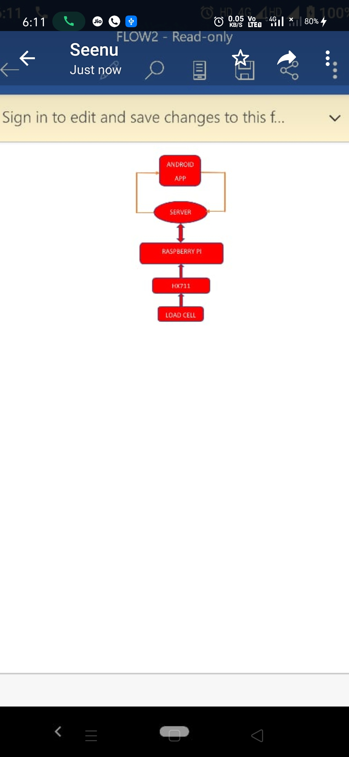

Fig. 1. Flow of information.

If the total sum of weight of scanned product is equal to the actual weight of the product measured by the load cell then the user is allowed to make payment else the process is repeated until the weights are found to be same.

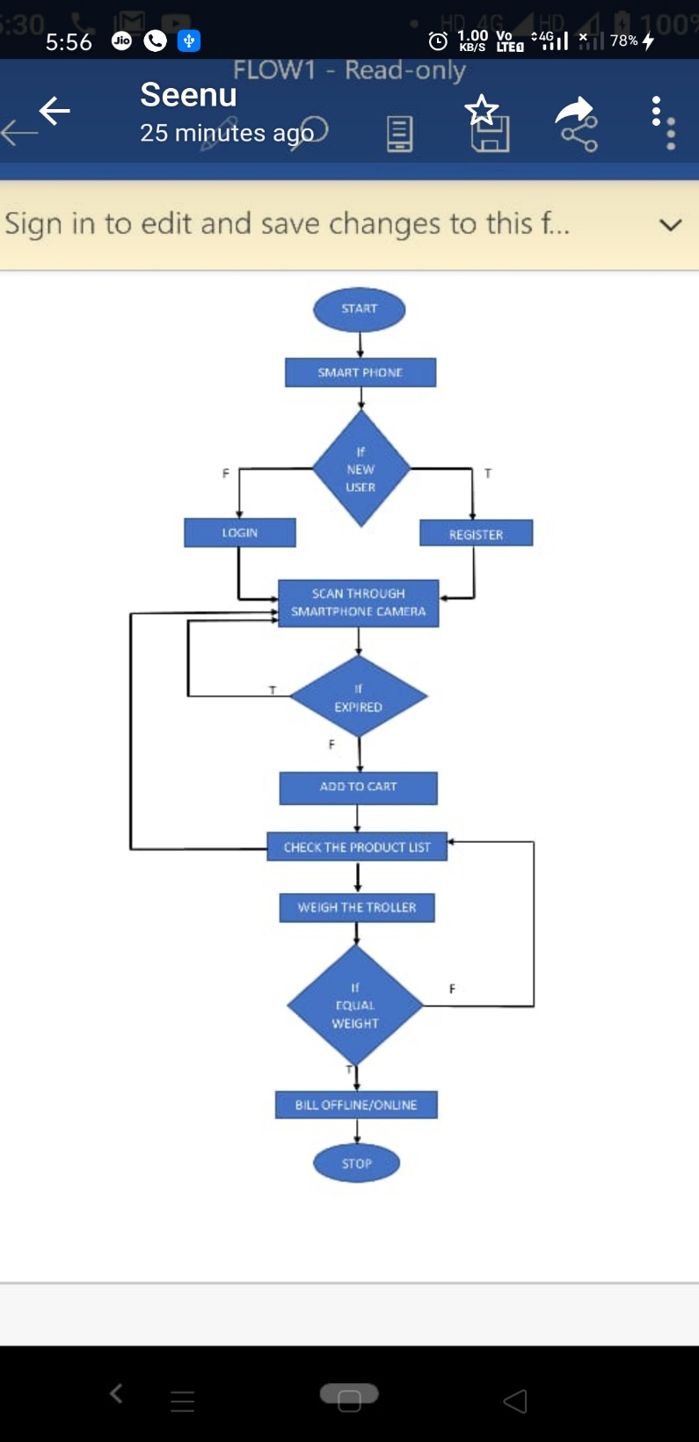

Fig. 2. User end flow chart.

III.RESULTS

Here we have observed that, in database server the list of products purchased by the customer is stored in the database and recommendation for new products and by products is shown as notification in the application. The amount present in the e-wallet is deducted after the purchase. History of the registered user can be viewed and even the new products for recommendation can be added on the admin side.

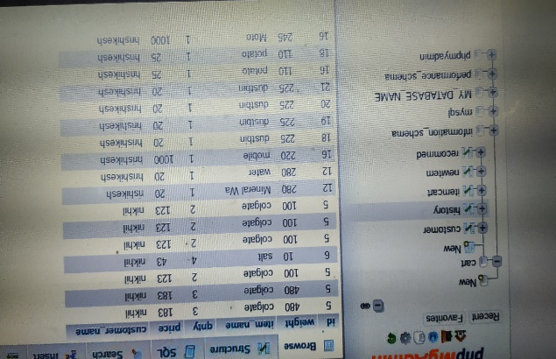

Fig. 3. Product history of customers.

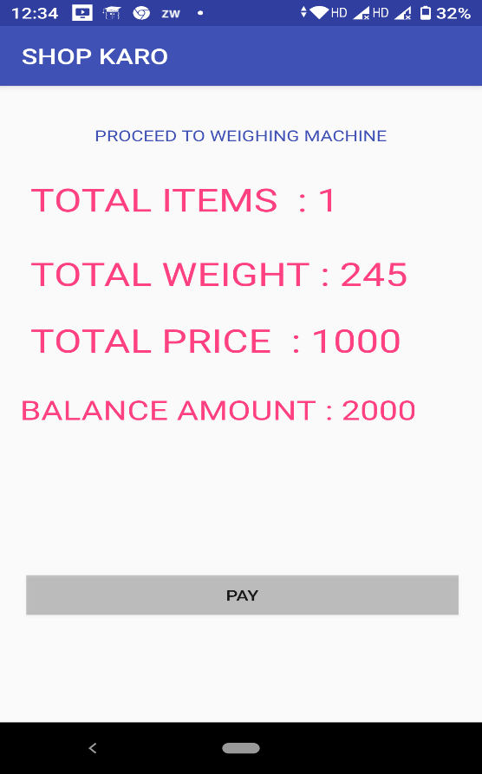

Fig. 4. Payment page of the application.

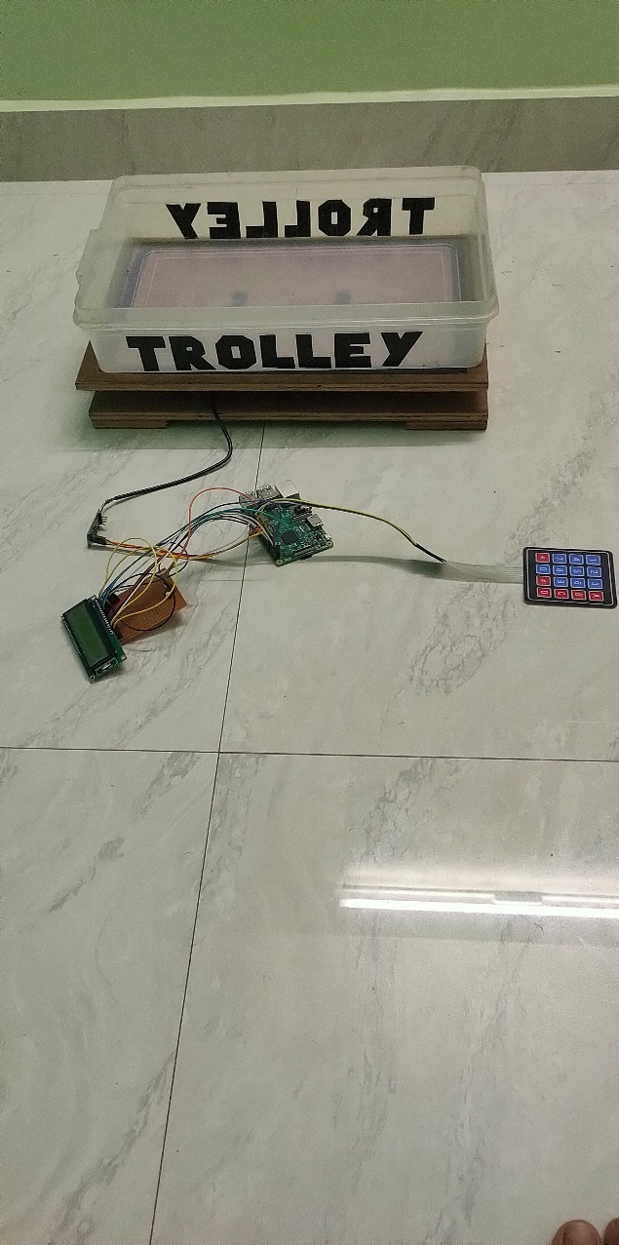

Fig.5. Hardware setup.

The fig.5 contains load cell connected to raspberry pi which is in turn connected to the keypad and LCD.

IV.CONCLUSIONS AND FUTUREWORK

The application can be made use for online shopping by further programming so that all the shopping list will be available in the cloud in one place. The project can be extended by adding further aspects of recommendation.

REFERENCES

1. Chandrasekar.P Sangeetha.T “ Smart shopping cart withautomatic billing system through RFID and Zig-Bee “ Information Communication and Embedded Systems (ICICES), 2014 International Conference on Year 2014..
2. J. Suryaprasad, B. O. P. Kumar, D. Roopa and A. K. Arjun, "A Novel Low-Cost Intelligent Shopping Cart," Networked Embedded Systems for Enterprise Applications (NESEA), 2011 IEEE 2nd International Conference on, Fremantle, WA, 2011, pp. 1-4.
3. Udita Gangwal, Sanchita Roy, Jyotsna Bapat ” Smart Shopping Cart for Automated Billing Purpose using Wireless Sensor Networks” in The Seventh International Conference on Sensor Technologies and Applications 2013.
4. C. Shih, B. c. Liang, C. z. Lin, N. L. Hsueh and P. A. Hsiung, "An automatic smart shopping cart deployment framework based on pattern design," Consumer Electronics (ISCE), 2011 IEEE 15th International Symposium on, Singapore, 2011, pp. 121-127.
5. Khan, P. Varshney and M. A. Qadeer, "E-commerce: From shopping carts to credit cards," Communication Software and Networks (ICCSN), 2011 IEEE 3rd International Conference on, Xi'an, 2011, pp. 81-85.
6. MurulidharaN1,SreeRajendra2“Automated shopping and Billing with product Inventory Management System” International Journal of Innovative Research in Technology July 2015 IJIRT Volume 2 Issue 2 ISSN: 2349-6002.
7. Satish Kamble, Sachin Meshram, Rahul Thokal, Roshan Gakre, “Developing a Multitasking Shopping Trolley Based On RFID” Technology”, International Journal of Soft Computing and Engineering (IJSCE) ISSN: 2231-2307, Volume-3, Issue-6, January 2014.
8. Zeeshan Ali, Reena Sonkusare, “RFID Based Smart Shopping and Billing”, International Journal of Advanced Research in Computer and Communication Engineering Vol. 2, Issue 12, December 2013
9. Vedat Coskun,”A Survey on Near Field Communication(NFC) Technology”,IsikUniversity,August 2013,1-38.
10. [2] Zeeshan Ali & Reena Sonkusare, ” RFID Based Smart and Billing”, International Journal of Advanced Research in Computer and Communication Engineering Vol, India, December 2013,1-4.
11. Galande Jayshree, Rutuja Gholap & Preeti Yadav,” RFID Based Automatic Billing Trolley”, International Journal of Emerging Technology and Advanced Engineering, Ahmednagar, March 2014,1-4.

AUTHORS PROFILE

**Afrooz Ahamed,** student in the department of Electronics and Communication Engineering at Shri Madhwa Vadiraja Institute of Technology and Management, Bantakal.

**Hrishikesh R Patkar,** student in the department of Electronics and Communication Engineering at Shri Madhwa Vadiraja Institute of Technology and Management, Bantakal.

**P Sreenidhi,** student in the department of Electronics and Communication Engineering at Shri Madhwa Vadiraja Institute of Technology and Management, Bantakal



**Avinash N J,** Assistant Professor, Department of Electronics and Communication Engeering, 7.5 years teaching experience, 1year industrial experience, Shri Madhwa Vadiraja Institute of Technology and Management, Bantakal.