Early Flood detection and avoidance system
using IoT
Shwetha Shivaji Ghorpade, Vinaya, Nithesh, Deepthi G Pai
Shri Madhwa Vadiraja Institute of Technology and Management, Bantakal
Abstract
—
Flooding is one of the biggest natural
disasters occurring in various parts of the world.
Flood disaster usually occurs due to improper
irrigation
method
in
a
housing
area
or
the
sudden increase of water volume in a river or
dams . It often causes lost of property, damages
and lives. Well Developed sensors are used to
identify the level of water presented in dams,
rivers, lakes and heavy storage areas. Thus, this
project is about designing about the system that
can measure the speed of the rise of the water
level at the potential flooded area. To diminish
the difficulties that the urban communities face,
for
example,
shortage
of
vitality
sources,
flooding counteraction, social insurance, lodging
water and falling apart framework, making a
city 'Brilliant' is rising. This paper intends to
understand the security necessity and security
design of Internet of things innovation for urban
flooding
avoidance
the
executives
framework
what's more, talked about the interest and by
and
large
plan
of
flooding
anticipation
the
executives framework. The Internet of Things or
IOT gives the capacity for human and machines
to
communicate
from
billions
of
things
that
incorporate
sensors,
administrations
or
other
Internet associated things.
Index
Term---
Dams,
Flood
disaster,
Internet
of
Things , Urban flooding avoidance, Rivers, Sensors,
Security, Water level.
I.
INTRODUCTION
Nowadays, floods have become one of the most
dangerous
hazards.
This
is
either
man-made
or
natural occurring disasters. They can be completely
disturbing
the
human
life
and
economic
of
the
country. Main drawbacks of the flood includes :
pollution of clean drinking water, a large number of
causalities,
Landslides,
Lead
to
epidemics
and
diseases,
leads
to
spreading
of
water
Bounce
diseases, Shortage of crops due to loss of entire
harvest,
Economic
hardships.
Floods
cannot
be
prevented but proper precautionary measures can
be incorporated to reduce the loss of lives. The
proposed
model
is
very
much
utilized
for
monitoring of the water level, flow variations in
rivers and the same will be used for measuring of
the
water
levels
at
Dams
or
reservoirs.
Flood-
limited water level, is the parameter to manage
between the flood control and conservation, from
that
the
annual
maximum
value
is
determined.
FLWL is mainly determined by reservoir regulation
using the annual design flood or annual design
storm. Flood happens when water floods from the
waterway,
lake
or
from
substantial
precipitation
and it can occur whenever of the year. Flooding can
be exceptionally risky, when floods occur in a zone
that
individuals
live,
the
water
conveys
along
objects
like
houses
or
buildings,
vehicles,
furniture’s and even individuals. It can take away
the
properties,
trees
and
a
lot
of
increasingly
overwhelming things. Of every single catastrophic
event the floods are generally visit (46%) and cause
most
human
torment
and
misfortune
(78%
of
populace influenced by cataclysmic events). They
happen
twice
to
such
an
extent
and
influence
around
three-fold
the
number
of
individuals
as
tropical
violent
winds.
It
causes
substantial
progression
of
traffics.
In
this
manner
flood
checking and identification framework are essential
to limit flood harm costs in light of the fact that the
expense of harmed brought about by the floods is
associated intimately with the time of caution given
before the flood occasion happened. In the course
of the most recent few decades, the IoT has been in
a steady condition of development, on account of
fast
advances
in
basic
advancements.
Most
of
Internet
clients
will
comprise
of
semi-clever
gadgets, supposed installed frameworks. Therefore,
the Internet of Things can be characterized as the
arranged
interconnection
of
omnipresent,
setting
mindful
gadgets
that
are
installed
with
sensors,
programming, gadgets and actuators that empower
surrounding knowledge. Floods can't be forestalled
yet
appropriate
prudent
steps
can
be
joined
to
diminish the loss of lives. For this project, we have
referred
some
IEEE
papers
and
what
we
have
studied
in
these
papers
is
shortly
described
as
follows: [2] displays a neuro-fuzzy controller based
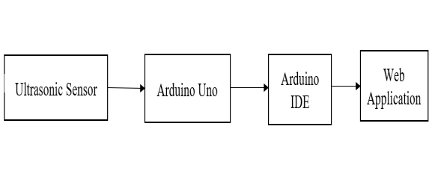
on
flood
observing
framework
utilizing
remote
sensor
arrange.
The
disseminated
sensor
hubs
utilized IEEE 802.15.4 convention, to gather sensor
data, for example, water level information from the
waterway. The Sensor data is send to disseminated
cautions
focus
by
means
of
Arduino
microcontroller
and
Xbee
Transceiver.
At
the
disseminated
alarm
place,
XBee
handset
and
Raspberry pi microcomputer are utilized to produce
flood
alert
dependent
on
sensor
data
and
to
distinguish flood information and this information
are
put
away
in
database.
This
isn't
practical
framework. What's more, execution likewise feeble
as contrasted with our framework. A framework for
versatile android application will have the option to
help
the
drivers
know
where
the
overflowed
territories are so as to evade those courses so they
won't get stranded on a overwhelmed region incase
their vehicle can't deal with the stature of the flood.
The proposed framework points not exclusively to
help the vehicle drivers, yet additionally have the
option
to
help
government
offices
distinguish
overwhelmed zones for them to concoct an answer
for traffic and flood [4]. To build up A Real Time
Solution to Flood Monitoring Utilizing IoT and
Wireless
Sensor
Network,
we
proposed
a
flood
cautioning
framework
which
expects
thoughtfulness
regarding
three
fundamental
components:
Data
assortment
through
gaging,
information handling, furthermore, the equipment
and programming required, and the scattering of
flood notice data. While robotized flood cautioning
frameworks are frequently shockingly economical
to actualize, the essential factor deciding cost for
any such framework is the quantity of gage site
locations.[6] De Zoysa [8] talked about a versatile
sensor arrange for street checking in Sri Lanka.
Genuine
development
and
utilization
of
the
proposed framework had not happened at the hour
of the paper for this application in spite of the fact
that tests toward that objective had happened. The
versatility
of
the
framework
alongside
defer
resilience
of
the
information
don't
make
it
fundamentally the same as our venture, in spite of
the fact that both do share necessities because of
the decision of a creating nation and enormous
geographic
district
to
screen.
Castillo-Effen
[7]
proposes a design for a framework, yet is vague on
the bowl qualities and no equipment subtleties are
recommended.
An
IoT
approach
that
known
as
flood alarms framework with Android application
to
screen
the
potential
waste
typically
happen
flooding and offer the information progressively to
individuals
close
by.
Other
than
that,
this
framework needs to overhaul the UI configuration
to make progressively intelligent and furthermore
user
friendly
to
end
client.
Also,
assortment
information utilizing propelled sensor is expected
to
guarantee
a
high
exactness
of
information
measure[3]
A
defensive
and
dependable
model
which
helps
in alarming regular citizens during
streak floods is structured. The principle reason
behind advancement of flood ready framework is
the insinuation of flood well ahead of time with the
goal that human misfortunes can be controlled by
departure
of
individuals
to
safe
spots
and
furthermore
ensures
important
properties.[5]
A
paper
dependent
on
the
plan
of
ZigBee
based
remote sensor arrange for early flood checking and
cautioning
framework
is
structured.
The
Flood
ready framework guarantees to give the water level
data
to
the
general
population
in
their
portable
application even without organize network and help
them arrive at a more secure spot through put away
images.[1] A paper portraying the rising job of the
Global
Flood
Association
(GFP),
a
worldwide
system of researchers, clients, private and open
associations dynamic in worldwide flood chance
the board which offer outcomes from their tests,
created to anticipate and screen where and when
flooding
is
occurring
in
close
to
ongoing
and
furthermore give integral data to help and improve
current worldwide flood chance administration for
huge scale calamities [9]. [2] [10][11] proposed an
IoT based water checking framework that measure
water level progressively. The model depends on
thought that the degree of water can be significant
parameter when it goes to the flood occurrences
especially in calamity inclined territory. A water
level
sensor
is
utilized
to
distinguish
the
ideal
parameter and in the event that the water level
arrives at the parameter the sign will be liberated
progressively
to
interpersonal
organization
like
Twitter.
A
cloud
server
was
arranged
as
information store. The estimation of water level are
shown
in
remote
dashboard.
The
proposed
arrangement with incorporated tactile framework
that
permits
internal
checking
of
water
quality.
Alarms and applicable information are transmitted
over the web to a cloud server and can be gotten by
client terminal possessed by purchaser. The result
of
water
estimation
is
shown
in
online
remote
dashboard.
II.
METHODOLOGY
This system aims to develop a single platform for
monitoring and modelling river flood. Water level
data of the river will be collected using sensors to
produce the real time alerts. Once data collection is
done, data will be pre-processed. All these data
analysis will be done using different techniques
like image processing, data mining, etc .
Fig 2.1 Simple block diagram of the system
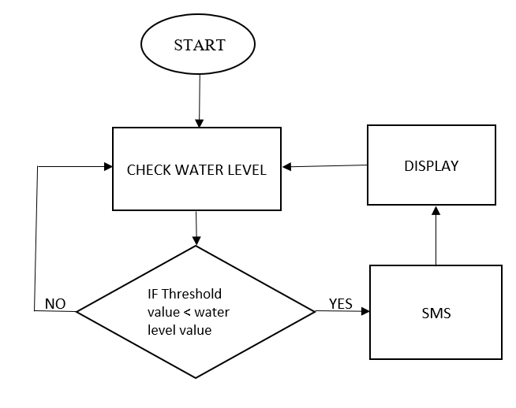
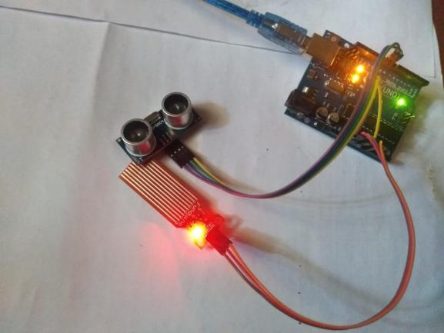
For the short-term prediction, we fix the water level
sensor along with the Arduino to the dame of the
river which continuously monitors the water level
from
the
main
sea
level.
These
values
will
be
recorded in the server. If there no continues rise in
water level, with the help of the regression formula
the short term flood can be predicted with help of
the topographical elevation data it is possible to
predict how
much area
will be affected by the
flood.
Fig 2.2
Flow-chart of our model
Identifying the water level of the river during flood,
The water level data of the river will be collected
using sensor like ultrasonic to produce the real time
warning
when
water level crosses the threshold
value. Sensors are placed near the water bodies that
are under the bridges. As the water level increases
it will sense the data. Sensor will collect the data
and
send
it
to
Arduino.
It
will
process
it
and
convert it to pixel form. If the nearest land area of
water bodies also has change to cover with water
bodies, then that will processed as pixel and give
alert message to people. The below figure depicts
the flood prediction using ultrasonic sensor.
Fig 2.3 Flood prediction using ultrasonic sensor
III.
PROPOSED SYSTEM
Proposed system 1. There will be a hub. 2. This
hub
is
the
autonomous
flood
observing
hub
furnished with vital sensors and network modules.
3. It has three significant stages, Including Sensors,
Controller, Wi-Fi interface to transfer the data on
server. 4. Information from different sensors are
gathered
by
the
ESP
and
is
then
figured
and
transferred
on
the
server.
5.
The
information
transferred on server is put away on the database. 6.
The put away information is then steered to the
front-end
web
applications
and
portable
applications. b. Right now are utilizing four sensors
to discover the four distinct parameters. One is
ultrasonic sensor which is utilized to discover the
water level of a dam and other is water stream
sensor which is utilized to decide the stream pace
of the dam. For sending the SMS to nearby people
groups to caution the circumstance during flood
times we are utilizing Wi-Fi Module. Ultrasonic
Sensor: Figure 10. Ultrasonic Sensor The ultrasonic
sensor will give the precise separation with least
mistake
conceivable.
It
comprises
of
four
pins;
those
are
VCC,
GND,
TRIG,
ECHO
pins.
It
expects 5v to work and it ranges is up to 5 meters a
long way from the sensor. In our undertaking so as
to discover the water level of a dam we utilize this
ultra-sonic
sensor.
The
reverberation
pin
of
ultrasonic sensor is associated with D3 pin of our
nodeMCU and D4 pin of nodeMCU is associated
with trig pin of ultrasonic sensor. The ultrasonic
sensor discharges the sound waves which are at
high frequencies that a human can't hear. At the
point when the sound waves are discharged and
when they hit any article or impediment then the
sound waves get reflected back to the ultrasonic
sensor. The ultrasonic sensor will ascertain the time
span among transmitted and reflected sound waves
and with that time it can tell at what separation the
item or obstruction is found.
IV.
EXPERIMENTAL DATA AND RESULT
The water level sensor is placed in the top of the
dam and the real time water level is compared with
threshold level by using Arduino Uno. When the
water level increased above threshold level gates
are
opened,
and
when
the
water
level
was
decreased, gates are closed. To check the status of
the water level web application can be used. The
system able to send an alert via SMS when the
water rises to the pre-determined level. A quick
notification through SMS is vital since the system
is aimed at alerting people and authorities.
V.
CONCLUSION
Calamities, by their very definition, release a ruin
on
countries
essentially.
Making
countries
experience a ton of more horrible obliteration than
developed, in any case, and are less arrange to deal
with
deferred
results
of
these
disasters.
Foreknowledge
of
the
calamity
could
in
this
manner
bolster
all,
yet
better
guide
making
countries by offering time to check property and
clear.
Developing
early
exhortation
systems
is
tangled issue, with various angles to the structure
necessities
when
inside
a
making
country.
This
paper depicted these complexities, focusing on the
use of conduit flooding, and investigated a potential
response for the issue of stream flooding. Through
field tests in Honduras, the issue and course of
action have been clarified and refined, with various
activities got the hang of during the methodology.
As India went up against continuous destroying
flood in Kerala, there rise a need of capable flood
watching systems. Flood evaluating and giving of
flood makes are incredible methodologies aware of
diminish
hurt.
The
proposed
structure
will
be
capable
considering
the
way
that
it
has
better
coordination
of
watching,
correspondence
and
transmission
progressions
which
are
flexible
to
establishment coordination. The proposed system
on like manner insures extended accessibility to
assessment of emergency conditions and updates
feasibility
and
capability
in
responding
to
catastrophic
scenes.
In
once-over,
the
proposed
structure
would be beneficial to the
system
for
dynamic and flight orchestrating purposes, an all-
out
system
in
spite
of
everything
doesn’t
exist
inside Honduras, yet stir continue developing this
structure and make a close by test arrange. In the
near future, we will plot a point by point system
configuration, complete the process of testing on
portions of the 900MHz distinguishing structure,
and
develop
a
quantifiable
gauge
computation
utilizing the system data on the conduit. We intend
to verify the people of Honduras during the storm
and ocean whirlwind time of 2018, with expansion
to various countries soon to follow.
REFERENCES
[1]
R.
Rq,
Q.
Lq,
J.
Dqg,
H.
Ri,
and
H.
Ri,
“Wireless
Sensor
Network
for
early
Flood
Monitoring and Warning system,” pp. 5–9
[2]
https://ieeexplore.ieee.org/document/5993451
[3] M. N. Napiah, M. Y. I. Idris, I. Ahmedy, and M.
Asri
Ngadi,
“Flood
alerts
system
with
android
application,” 6th ICT Int. Student Proj. Conf. Elev.
Community
Through
ICT,
ICT-ISPC
2017,
vol.
2017–Janua, pp. 1–4, 2017.
[4]
G.
A.
Amagsila
and
M.
E.
Cabuhat,
“A
Framework for Mobile Application of Flood Alert
Monitoring System for Vehicle Users using Arduino
Device,” pp. 1–6, 2017.
[5] S. Jayashree, S. Sarika, A. L. Solai, and S.
Prathibha,
“A
novel
approach
for
early
flood
warning using android and IoT,” Proc. 2017 2nd
Int.
Conf.
Comput.
Commun.
Technol.
ICCCT
2017, pp. 339–343, 2017.
[6] https://www.fondriest.com/
[7] M. Castillo-Effen, D. H. Quintela, R. Jordan,
W.
Westhoff, and W. Moreno, “Wireless sensor
networks for flash-flood alerting,” in Proceedings
of
the
Fifth
IEEE
International
Caracas
Conference
on
Devices,
Circuits
and
Systems.
IEEE, Nov 2004, pp. 142–146.
[8]
K.
D.
Zoysa,
C.
Keppitiyagama,
G.
P.
Seneviratne, and W. W. A. T. Shihan, “A public
transport system based sensor network for road
surface condition monitoring,” in NSDR ’07: ACM
SIGCOMM Workshop on Networked Systems for
Developing Regions, August 2007.
[9]
L.
Alfieri
et
al.,
“A
global
network
for
operational
flood
risk
reduction,”
Environ.
Sci.
Policy, vol. 84, no. December 2017, pp. 149–158,
2018.
[10]https://iopscience.iop.org/article/10.1088/1757
-
899X/79/1/012023/pdf
[11]https://iotworld.co/2017/12/flood-
monitoringdetection-system-using-internet-of-
thing-iot/
[12] Jianguo, M. Internet-of-Things: Technology
Evolution and Challenges. In Proceedings of the
2014
IEEE
MTT-S
International
Microwave
Symposium (IMS2014), Tampa, FL, USA, 1–6 June
2014; pp. 1–4.
[13]
Gubbi,
J.;
Buyya,
R.;
Marusic,
S.;
Palaniswami, M. Internet of Things (IoT): A vision,
architectural
elements,
and
future
directions.
Futur. Gener. Comput. Syst. 2013, 29, 1645–1660.
[CrossRef].
[14] JaymalaPatil, Anuja Kulkarni.Wireless Sensor
Network Using Flood Monitoring, IJCSMC, Vol. 2,
Issue. 11, November 2013.
[15]
RaihanUl
Islam.
Wireless
Sensor
Network
Based Flood Prediction Using Belief Rule Based
Expert
System,
Luleå
University
of
Technology
2017.
[16] ThinagaranPerumal, Md Nasir Suleiman, C.
Y. Leong. IoT Enabled Water Monitoring System
IEEE Explore, 2015
[17] D. Christin Iot Based Disaster Detection And
Early Warning Device, IEEE Explore, 2014.
[18] Syed Nazmus, Sakib M. Shamim, Kaiser. An
intelligent
Flood
Monitoring
System
for
Bangladesh
using
Wireless
Sensor
Network,
ResearchGate, May 2016.
[19] Edward Udo, EtebongIsong.Flood Monitoring
and
Detection
System
using
Wireless
Sensor
Network,
ResearchGate,
and
January
2014.
[20]JagadeeshBabuMallisettyand
Chandrasekhar
V.Internet
of
Things
BasedReal
Time
Flood
Monitoring and Alert Management system, May
2012.

