[1]

FINITE ELEMENT ANALYSIS OF FRICTION STIR PROCESSING

Pavan Kumar P1, Govindraj Tantri2, Amith Suvarna3, Abdul Musafir4, Lingaraj Ritti5

*Shri Madhwa Vadiraja Institute of Technology and Management, Bantakal, Udupi.*

*Abstract*—Friction stir processing is modified process of friction stir welding technique which was invented by The Welding Institute (TWI) in 1991. Friction stir processing (FSP) is a solid-state process used for joining materials and as a tool for material processing (i.e., surface machining). Although the melting temperature of the material is never reached during FSP, severe plastic deformation occurs at extreme temperatures. The process is performed by traversing a rotating tool through fixed base material along a desired path. Friction stir processing (FSP) has recently become an effective microstructural modifications technique. In the present work, the FSP process simulation is carried out in ANSYS workbench. In the simulation, the Aluminium 6061 alloy is used as base metal and H13 tool steel is used as a tool material. The analysis is carried out at travelling speed of 20 mm/min at a constant tool rotational speed of 1500 rpm. The shear stresses and the normal stresses induced during the plunging phase and travelling phase are much more than the yield strength of the Al alloy base metal, hence the base material undergoes plastic deformation and grain refinement takes place at the surface level which improves the surface properties of the processed material.

*Index Terms*—Friction stir process (FSP), FSP tool, Aluminium alloy base metal, Travelling speed, Rotational speed

# INTRODUCTION

F

riction Stir process is derived from friction Welding process. The main difference between FSW and other elevated temperature metal working process is that in FSW process, the work pieces to be joined are not at preheated condition. The work pieces are at ambient temperature in the beginning. Friction Stir welding process is divided into

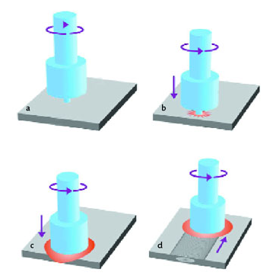

Fig. 1. Schematic of FSP process

plunging phase and travelling phase as shown in Fig 1. a) rotating tool prior to contact with the plate; (b) tool pin contacts plate creating heat; (c) Shoulder of tool contacts plate restricting further penetration while expanding the hot zone; (d) plate moves relative to rotating tool creating a fully recrystallized, fine grain microstructure.

During the plunging phase, the tool and the base metals are at ambient temperature, once the rotating tool pin plunges into the base metal chipping is created by the rubbing action between the pin and the base metal. The tool is held in the same position for short duration and moved in the desired direction when there is a sufficient amount of heat to plastic deformation. In travelling phase the tool is moved in the desired direction, the processed surface of the base metal undergoes grain refinement which improves the surface properties such as hardness, wear resistance of the material.

The FSP process is used to produce surface composites by using suitable reinforcement strategy and reinforcement type with the tool parameters like tool shoulder diameter, pin diameter and different pin profiles and process parameters like rotational speed, travelling speed, plunge depth. The optimized tool and process parameters are used to fabricate defect free surface composites.

Akshansh Mishra et al studied the heat generation during friction stir processing of similar joints of AA6061-T6 is carried out. A three dimensional (3D), transient, a non-linear thermal model was developed using ANSYS 16.2 software to simulate the heat generation profile during Friction Stir Processing of similar Aluminium plates. The results showed that the observed temperature rise in the model shows that heat generated during the second and third load steps is due to friction between the tool shoulder and workpiece, as well as plastic deformation of the workpiece material. It was also observed that friction is responsible for generating most of the heat needed, while the contribution of heat due to plastic deformation is less significant. Because the tool-penetration in the workpiece is shallow, the heat generated due to tool pin is ignored and the plastic heat generated is small compared to frictional heat.

Sanjeev et al. carried out Finite Element Simulation of Friction Stir Welding (FSW) in ABAQUS. FSW is a problem involving large deformations and is often difficult to solve using the classical Finite Element Method (FEM). Large mesh distortions and contact problems can occur due to the large deformations such that a convergent solution cannot be achieved. Since in ABAQUS, a Coupled Eulerian Lagrangian (CEL) approach has been developed to overcome the difficulties with regard to FEM and large deformation analyses. In this work investigated its capabilities in simulating FSW process. FSW is a mechanical process whereby solid-state welding is performed using heat generated from the friction of a rotating tool and plastic deformation of weld material.

Fadi Al-Badour et al. studied a 3-dimensional localized finite element model (FEM), developed to predict likely conditions that result in defect generation during friction stir welding (FSW). The workpiece is modeled using Eulerian formulation, while the tool is modeled using Lagrangian. Coulomb’s frictional contact model is adopted to define the tool workpiece interaction, while the welding speed is defined by material inflow and outflow velocities. The numerical results show that the coefficient of friction has a major effect on void formation; the lower the friction coefficient is applied, the larger the void is formed. Furthermore, welding using force control (FC) at lower welding speed results in smaller void size and wider plastic zone, leading to higher quality weld.

Bahman Meyghani, et al. worked on a three-dimensional finite element analysis of the friction stir welding (FSW) process of 6061-T6 aluminium alloy. The analysis investigates the temperature distribution and the fundamental knowledge of the process with respect to temperature difference in thematerial to be welded. HyperMesh and HyperView solver have been used from Altair Hyperworks to analyze the process.

Different traverse and rotational speeds have been applied in the model. The results of the study create a better understanding for peak temperature distribution. In addition, the results illustrate that the peak temperature during welding increases as the rotational speeds rises and the effect of the transverse speed on the temperature is found to be insignificant. Finally, comparison with some published papers has been done in order to compare the results of the different finite element packages and summarize the advantages and disadvantages of the each software.

Elhadj Raouache, et al. was developed a three dimensional finite element to study the transient thermal analysis of friction stir welding (FSW) for different tool geometries and different process parameters. The objective of the work was to investigate and analyze the temperature distribution of tool and work piece during operation using COMSOL MULTIPHYSICS. The model incorporates the mechanical reaction of the tool and the thermo mechanical process of the welded material. The heat source incorporated in the model involves the friction between the material, the probe and the shoulder. The results obtained from the analysis are satisfactory compared with those the specialized literature.

Chen et, al. was used a three-dimensional model based on finite element analysis to study the thermal history and thermo-mechanical process in the butt-welding of aluminum alloy 6061-T6. The model incorporates the mechanical reaction of the tool and thermo-mechanical process of the welded material. The heat source incorporated in the model involves the friction between the material and the probe and the shoulder. In order to provide a quantitative framework for understanding the dynamics of the FSW thermo-mechanical process, the thermal history and the evolution of longitudinal, lateral, and through-thickness stress in the friction stirred weld are simulated numerically. The X-ray diffraction (XRD) technique is used to measure the residual stress of the welded plate, and the measured results are used to validate the efficiency of the proposed model. The relationship between the calculated residual stresses of the weld and the process parameters such as tool traverse speed is presented. It is anticipated that the model can be extended to optimize the FSW process in order to minimize the residual stress of the weld.

Haitao et, al. was established The finite element model of the FSW process. The axial force and the spindle torque of the welding process were collected through experiments. The feasibility of the finite element model was verified by a data comparison. The temperature field of the welding process was analyzed hierarchically. It was found that the temperature on the advancing side is about 200C higher than that on the retreating side near the welding seam, but that the temperature difference between the two sides of the middle and lower layers was decreased. The particle tracking technique was used to study the material flow law in different areas of the weld seam. The results showed that part of the material inside the tool pin was squeezed to the bottom of the workpiece. The material on the upper surface tends to move downward under the influence of the shoulder extrusion, while the material on the lower part moves spirally upward under the influence of the tool pin. The material flow amount of the advancing side is higher than that of the retreating side. The law of material flow reveals the possible causes of the welding defects. It was found that the abnormal flow of materials at a low rotation speed and high welding speed is prone to holes and crack defects. The forming reasons and material flow differences in different regions are studied through the microstructure of the joint cross section. The feasibility of a finite element modeling and simulation analysis is further verified.

Fadi Al-Badour et, al. developed A thermo-mechanical finite element model based on Coupled Eulerian-Lagrangian method to simulate the friction stir welding of dissimilar Al6061-T6 and Al5083-O aluminum alloys using different tool pin profiles. The model is validated using published measured temperatures and weld microstructure. The finite element results show that maximum temperatures at the weld joint were below the materials’ melting point. Placing the harder alloy (Al6061-T6) at advancing side led to a decrease in maximum process temperature and strain rate, but increased tool reaction loads. Featured tool pin produced better material mixing resulting in enhanced joint quality with reduced volumetric defects.

Md. Parwez Alam et al. investigated the Numerical simulation of the temperature distribution of friction stir welding of aluminium alloy. A finite element code using ANSYS APDL software package has been developed for modelling of friction stir welding. Thermal physical properties of the material aluminium alloy are considered as temperature dependent in the present work. The cooling effect caused by the free convection in ambient air, backing plate and clamped bar is taken into account. It was observed that the peak temperature is not uniform along weld line, inhomogeneous temperature distribution along thickness.

Nikola Sibalic et al. carried out the numerical simulation of the Friction stir welding (FSW) process by using the DEFORM 3D software. Numerical simulations are based on experimental research, welding of aluminum alloy AA6082-T6 by FSW method, which has the thickness of 7.8 mm. The aim of this paper is to determine the reliability of numerical simulations in the FSW process, which is followed by large deformations, where influential geometric and kinematic parameters are varied. Numerical research was done on the basis of the adopted five-phase orthogonal experimental plan with a variety of factors on two levels and repetition at the central point of the plan for four times. The parameters varied in the experiment are: Welding speed v mm/min, a rotation speed of tool ω rpm, angle of pin slopes α0, a diameter of the pin d mm, diameter of the shoulder D mm. During the performing of the FSW process, forces were measured in three normal directions: Axial force Fz, longitudinal force Fx and side force Fy, as well as the temperature in the adopted measuring positions of the workpiece. The experimental results obtained in this way were compared with the numerical experiment in the same adopted measuring positions, i.e., in the work an analysis and comparison of the obtained experimental and numerical data of the measured forces and the generated temperature field were made.

# Finite element model of friction stir process

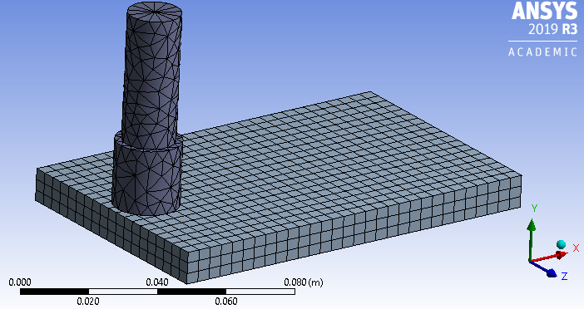

Fig. 3. FSP meshed model

To perform the finite element analysis of FSP process in plunging phase and travelling phase, a 3-D solid model of the tool shoulder diameter of 20mm and the base metal thickness of 10 mm are modeled using ANSYS workbench as shown in Fig 2. The material properties used for the tool and the aluminium alloy base metal are shown in Table 1.

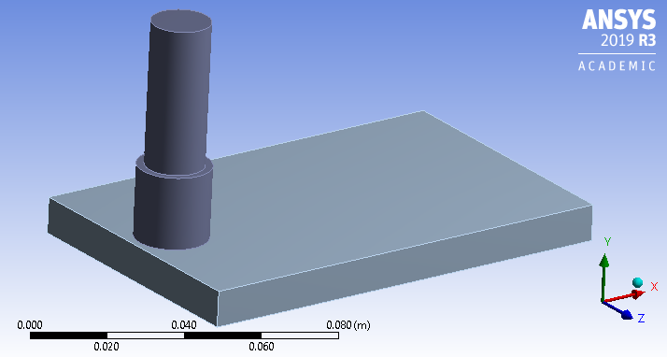

Fig. 2. FSP ANSYS model

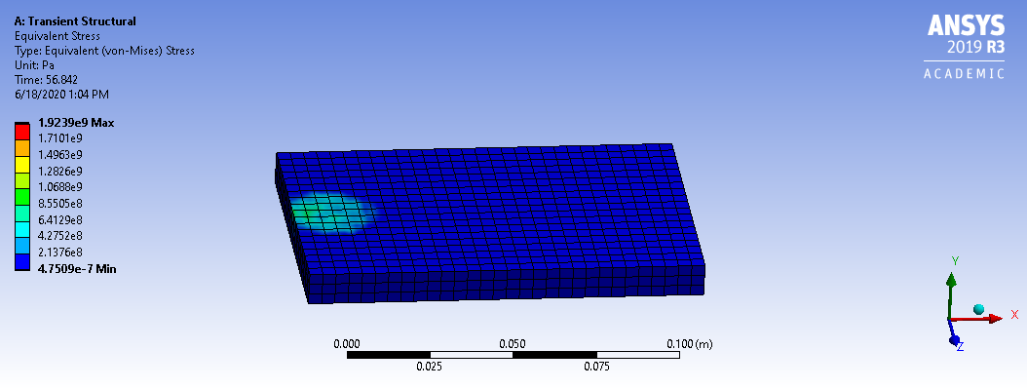

Fig.4. Normal stress distribution in FSP process during plunging phase

TABLE I

Material Properties

|  |  |  |
| --- | --- | --- |
| Particulars | H13 tool steel | Aluminium alloy |
| Density  (kg/mm3) | 7850 | 2770 |
| Modulus of elasticity  (GPa) | 215 | 71 |
| Yield strength  {MPa} | 1660 | 280 |
| Ultimate strength (MPa) | 1990 | 310 |
|  |  |  |

The connection between the tool and the base metal was defined by the solid contact regions with frictional co-efficient of 0.45 with asymmetric behavior. The model is meshed with 3-D solid element of size 4 mm as shown in Fig 3. The created meshed model has 1449 elements and 10500 nodes.

## Transient structural analysis of FSP in plunging phase

During the plunging phase tool penetrates into the base metal for short time is analyzed by transient structural analysis with the tool rotational velocity of 157.08 rad/s (1500 rpm) and the tool displacement of 0.1 mm along the x-axis, i.e. along the direction of FSP process over a time period of 60 seconds.

## Transient structural analysis of FSP travelling phase

The simulation of the FSP process in travelling phase is carried out by using transient-structural analysis with tool rotational speed of 1500 rpm and the transverse speed of 20 mm/sec and with the tool displacement of 100 mm along the FSP direction for 360 seconds.

# results and discussions

The FSP process is carried out in plunging phase and travelling phase, in the plunging phase the rotating tool compress the base material and the friction between the tool and the base metal generates the heat and there is a rise in temperature in between the contact surface of the tool and the base metal in certain time period. Once there is a rise in temperature between the contact surface of the tool and the base metal, the tool is moved along the desired direction, which makes the base metal soft and it undergoes plastic deformation which intern makes grain refinement and there is an enhancement in the surface properties of the base metal.

## Transient structural analysis of FSP in plunging phase

During plunging phase the rotating tool slowly makes the contact with the base metal over a time period of 60 seconds, the normal stress induced in the FSP process is shown in Fig 4, and Fig 5.It is clear from the stress plot that the normal stress induced during the plunging phase is 982MPa at 60 seconds which is greater than the stress induced in the remaining phase. The shear stress induced in XY plane during the plunging phase is varying from 92MPa to 225MPa over a time period of 1 sec to 61 sec as shown in Fig 6, and Fig 7 The stresses induced during this phase are of grater magnitude, since the tool impact on the base metal induces the normal stress and the force due to the rotational torque induces the greater magnitude of shear stress.

## Transient structural analysis of FSP in travelling phase

Soon after the plunging phase the tool is moved in desired direction to process the base material. During the travelling phase there is a rise in temperature due to frictional heat in between the contact surface of the tool and the base metal, which makes the base metal soft and undergoes plastic deformation. The normal and the shear stresses induced during the travelling phase are shown in Fig 5, and Fig 7, respectively. The normal stress in travelling phase is varying from 747MPa to 847MPa over a time period of 60sec to 348sec. the shear stress vary from 340MPa to 380Mpa over time period of 60sec to 350 seconds. The normal stress and the shear stress induced in the travelling phase of the FSP are greater than the yield strength of the aluminium alloy base metal; hence the base metal undergoes plastic deformation and which makes the grain refinement in the surface of the base metal. The normal stress increases rapidly at the end since there is a partial/zero contact of the tool shoulder with the base metal.

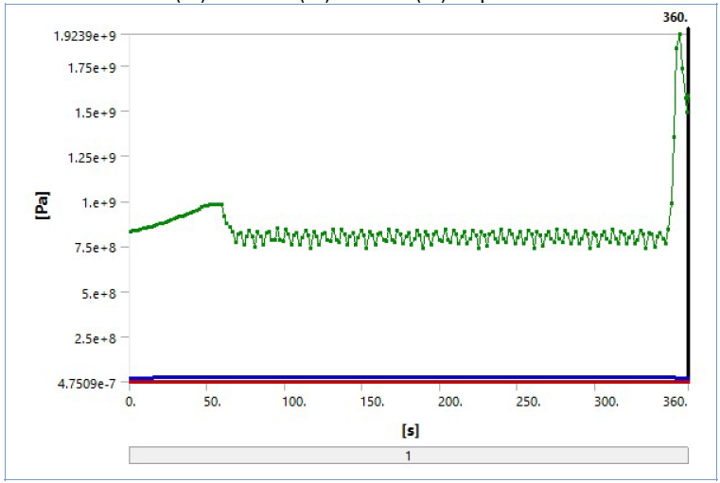Fig. 5.Normal stress vs. Time for FSP process

# conclusions

The finite element analysis of FSP process is carried out in plunging phase and travelling phase successfully by using transient structural analysis with frictional contact in ANSYS workbench. From the analysis results the following conclusion are made.

1. The normal stress intensity is of 982MPa in plunging phase and in the travelling phase the stress intensity varying from 747MPa to 847MPa. The stress intensity is more in plunging phase compared to stress in travelling phase.
2. The shear stress intensity is low at plunging phase and increases has the tool moves in the FSP direction, i.e. vary from 92MPa to 225MPa.
3. The normal stress and shear stress are almost constant and there is a small variation in the magnitude of the stresses in travelling phase has the tool moves in the FSP direction.
4. The induced normal and shear stresses are of grater magnitude than the yield strength of the Al alloy base metal, hence the surface of the base material undergoes plastic deformation at certain thickness, which makes the grain refinement and enhance the surface properties like hardness and wear.

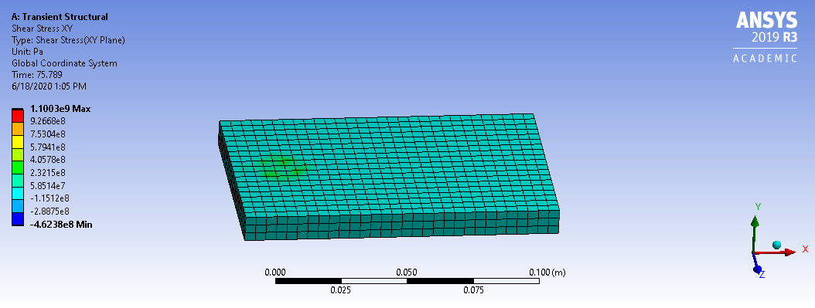

Fig.6. Shear stress distribution in FSP process during plunging phase

1. The FSP process can be conducted experimentally and one can verify the surface properties of the processed material in future.

# References

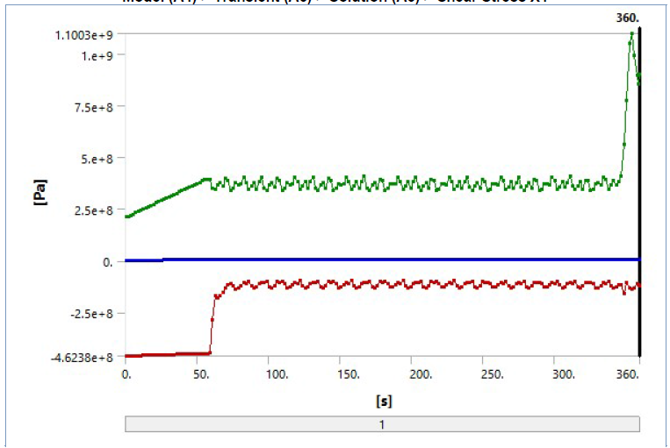

Fig. 7.Shear stress in XY plane vs. Time for FSP process

1. Mishra A, Sharma AK. Analysis Of Heat Generation During Friction Stir Processing of Aluminium Similar Joints. *J Adv Res Mech Engi Tech* 2017; 4(4): 3-8.
2. Sanjeev N K, Ravikiran B P,” Application of Coupled Eulerian Lagrangian Approach in Finite Element Simulation of Friction Stir Welding”, 2015 SIMULIA Community Conference [www.3ds.com/simulia](http://www.3ds.com/simulia) 1062-1079.
3. Fadi Al-Badour, Nesar Merah, Abdelrahman Shuaib, Abdelaziz Bazoune “Coupled Eulerian Lagrangian finite element modeling of friction stir welding processes”, Journal of Materials Processing Technology 213 (2013) 1433– 1439
4. Bahman Meyghani and Mokhtar Awang “Developing a Finite Element Model for Thermal Analysis of Friction Stir Welding (FSW) Using Hyperworks”, *Advances in Material Sciences and Engineering, Lecture Notes in Mechanical Engineering,2020,619-628.*
5. Elhadj Raouache, Zied Driss, Mohamed Guidara, Fares Khalfallah.” Effect of the Tool Geometries on Thermal Analysis of the Friction Stir Welding”, International Journal of Mechanics and Applications 2016, 6(1): 1-7
6. C.M. Chen, R. Kovacevic,”Finite element modeling of friction stir welding—thermal and thermo-mechanical analysis”, International Journal of Machine Tools & Manufacture 43 (2003) 1319–1326.
7. Haitao Luo, Tingke Wu, Peng Wang, Fengqun Zhao, Haonan Wang and Yuxin “Numerical Simulation of Material Flow and Analysis of Welding Characteristics in Friction Stir Welding Process”, Metals 2019, 9, 621.
8. Fadi Al-Badour, Nesar Merah, Abdelrahman Shuaib, Abdelaziz Bazoune, ”Thermo-mechanical finite element model of friction stir welding of dissimilar alloys”, Int J Adv Manuf Technol (2014) 72:607–617.
9. C Chen, R Kovacevic,”Thermomechanical modelling and force analysis of friction stir welding by the finite element method”, Proc. Instn Mech. Engrs Vol. 218 Part C: J. Mechanical Engineering Science 509-519.
10. MD. PARWEZ ALAM, AMAR NATH SINHA
11. Md. Parwez Alam, Amar Nath Sinha “Nonlinear Finite Element Simulation of Friction Stir Welding of Aa7075 T651 Aluminium Alloy”,International Journal of Mechanical and Production, Vol. 8, Issue 5, Oct 2018, 271-280.
12. Nikola Sibalic * and Milan Vukcevic, “Numerical Simulation for FSW Process at Welding Aluminium Alloy AA6082-T6”, Metals 2019, 9, 747 pg 1-10.
13. friction-stir-processing-creates-aluminum-alloy-super plasticity https://www.industrialheating.com/articles/84092



Pavan Kumar P, Student,

Department Of Mechanical Engineering,

Shri Madhwa Vadiraja Institute Of Technology and Management.



Govindraj Tantri, Student,

Department Of Mechanical Engineering,

Shri Madhwa Vadiraja Institute Of Technology and Management.



Amith, Student,

Department Of Mechanical Engineering,

Shri Madhwa Vadiraja Institute Of Technology and Management.



Abdul Musafir, Student,

Department Of Mechanical Engineering,

Shri Madhwa Vadiraja Institute Of Technology and Management.



**Lingaraj Ritti.** Born on 04 March, 1987 in Ranebennur, Karnataka India. Completed BE in Mechanical Engineering in 2009, and obtained M.Tech in Design Engineering in 2012 from Visvesvaraya Technological University. Belagavi.

From 2013 to till date working as an Sr, Assistant Professor in the Department of Mechanical Engineering at Shri Madhwa Vadiraja Institute of Technology and Management Bantakal Udupi. Research interests are topology optimization, finite element analysis, design and manufacturing and currently doing research work on surface Nano-composites by friction stir process.

1.