Charithra1, Dhanik S Shetty2, Nagarjuna S G3, Safaa Kulsum4, Deepika B V5

*1,2,3,4 Students, 8th semester, Department of Civil Engineering, Shri Madhwa Vadiraja Institute of Technology and Management, Bantakal*

*5 Assistant professor, Department of Civil Engineering, Shri Madhwa Vadiraja Institute of Technology and Management, Bantakal*

[1]

INTEGRATED SOLID WASTE MANAGEMENT – A CASE STUDY ON SHIRVA PANCHAYAT

*Abstract***— Solid waste management is of prominent concern and very much required to lead a healthy life. Solid waste management and handling rules is about systematic method for the collection, segregation, treatment and disposal of solid waste. In the present study, Shirva panchayat is considered as a study area for the proposal of solid waste management. Shirva is a village situated in Udupi district of Karnataka State which falls in India. The geographical coordinate’s latitude and longitude of Shirva is 13.357215 and 74.798355 respectively. The total area of Shirva is 32km2 and it is the second biggest village by area in the sub district which is facing problem in waste management. The Shirva Panchayat indicates that there is an unpredictable rise in the population intern the solid waste generation is also being increased. Unscientific handling due to negligence in collecting waste, inadequate standards of transportation, storage, treatment and disposal which causes risk to surroundings, health of people and social issues. There is no systematic way of managing the solid waste. The present study gives the methodology for well-organized collection, treatment and disposal of solid waste for the panchayat.**

*Key Words: Solid waste management; collection; treatment; disposal*

# I.INTRODUCTION

A rapid growth in population, economic development, urbanization and industrialization have effected in increasing the urban waste generation rate. Impulsive handling due to negligence in collecting waste, inadequate standards of waste carriage, storing, handling and improper method for disposal has made waste management an important issue in developing countries. In India, the collection, carriage and arrangement for safe disposal of solid waste is not good. The waste generated due to different actions of the society and scattered disposal of wastes lead to environmental pollution resulting into bad impact on human health and also contamination of soil, air, water etc.

Understanding the source of generation of waste and its disposal and the condition of surrounding environment of a particular region are the main reason for developing an effective system for management of waste. Solid Waste Management (SWM) is one part among public health and sanitation, according to our Indian Constitution, SWM is the part of basic essential services provided to keep our region clean by the municipal authorities.

Integrated Solid Waste Management (ISWM) refers to the planned outlook to manage solid waste in a sustainable manner covering different details such as waste generation, segregation, transfer and sorting of waste, handling and safe disposal in a combined manner by maximizing resource use efficiency and also by protecting human health and nature.

# II. Study Area

Shirva village is located in Udupi district in Karnataka, India as shown in Fig 1. It is situated 20km away from Udupi. The latitude 13021l25.97ll and longitude 74047l54.08ll are the coordinate of the Shirva. The total area of Shirva village is 32km2. It has a total population of 13390 peoples. There are about 3183 houses in Shirva village. Agriculture is the main occupation of this village. Under this study area there are about 350 shops, 20 industries, 7 Temples, 5 Mosques and 4 Churches. There is currently no systematic approach to waste management in Shirva Panchayat jurisdiction. Census is carried out for understanding the solid and liquid waste management. According to that census, 90% of the total number of families burn plastic which cause environmental problems. Garbage is carelessly dumped by the people along the road side, river, stream, pond etc which results in contamination of water and also threat to wild life.

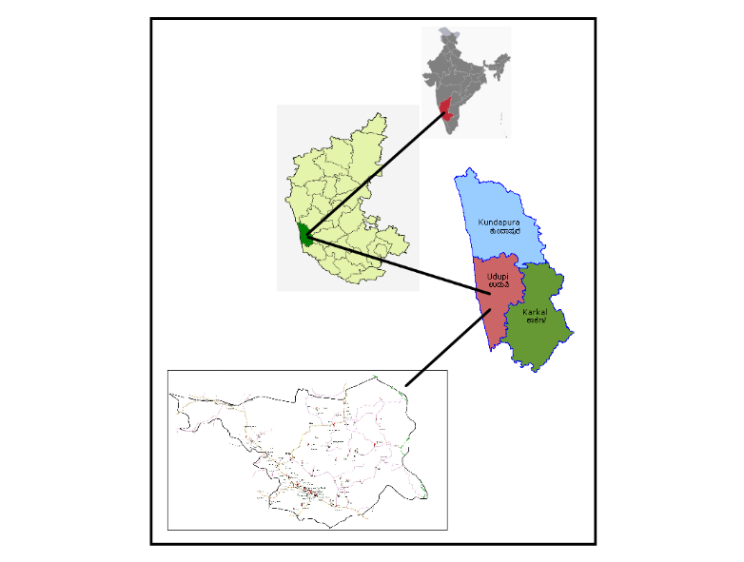

Fig 1: Shirva Map

# III. Methodology

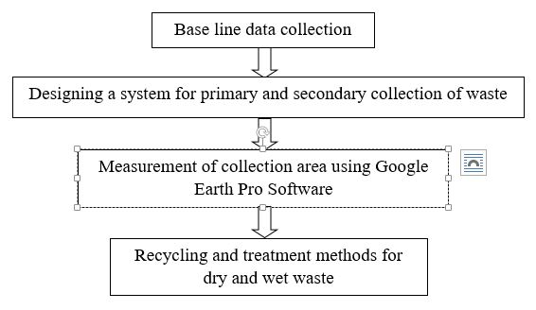

Fig 2: Proposed Methodology

The required data had been collected from the panchayat like total population, number of auto tippers, number of houses, present route map etc.

**Design Period**

The forthcoming period or the total number of years for which the given facility is available to meet the demand is referred as design period. Design period is provided because, it is very difficult or impossible to provide frequent extent. It is cheaper to provide a single large unit rather to provide a number of small units.

**Population Forecasting**

Computation of some future events as a results of studying the obtainable records or data is that the population forecasting. Some of the methods are used when the design period is small, and some are used when the design period is large. The various methods which are generally adopted for estimating future populations by Engineers are described below. However, none of these methods are exact, and they are all based on the laws of probability and thus, only approximate estimates for the possible future population can be made.

Following are some of the important methods of population forecasts,

1. Arithmetical increase method
2. Geometrical increase method
3. Incremental increase method
4. Decrease rate of growth method
5. Graphical comparison method
6. Master plan method
7. Zoning method
8. Logistic curve method
9. **Arithmetical Increase Method**

* This method is based on the assumption that the rate of change of population with the time is constant.
* This method is suitable for giant and old city with considerable development. If it's used for little, average or comparatively new cities, it'll give lower population estimate than actual value.
* In this method the typical increase in population per decade is calculated from the past census reports. This increase is added to this population to seek out out the population of subsequent decade.
* Population after nth decade will be Pn = P0 + n x̅

Where,

Pn = Forecasted population after ‘n’ decades.

P0 = Present population (i.e. last known census)

n = No. of decades between now and future.

x̅ = Average of population increase in the known decades.

1. **Geometrical Increase Method**

* In this method the percentage increase in population from decade to decade is assumed to be remain constant.
* Geometric mean increase is employed to seek out the longer term increment in population.
* Since this method gives higher values and hence should be applied for a replacement industrial town at the start of development for less than few decades.
* Pn = P0 * [1+(r/100) n]

r = t √ (r1*r 2)

Where,

r = geometric mean

P0 = Present population

n = No. of decades

**Computation of Waste Generation**

The population of the study period 2001 and 2011 is collected from the Panchayat as per the records of 2001 and 2011 census. The base year 2001 and 2011 is selected for the calculation of solid waste generation. As per Solid Waste Management (SWM) rules, 2016 which falls under the purview of the Union Ministry of Environment, Forests and Climate Change (MoEF&CC), the per capita waste ranges between 0.17 Kg/capita/day to 0.62 Kg/capita/day for smaller and large cities respectively.. The average waste generation rate in Shirva village is taken as 0.45Kg/capita/day.

Quantity of waste generation,

Waste generation = Population * Per capita waste generation

**Design of Primary Collection**

The carriage of waste from point of generation either to communal bins or transfer points, where other automobiles are then used in the secondary collection process.

Types of residential collection service for upward push detached dwelling includes

1) Curb

2) Alley

3) Setout-setback

4) Setout service

1. **Curb** is used, the owner of a house is answerable for putting the packing containers to be emptied at the decrease on series day and for returning the empty bin to their garage location till the next collection.
2. **Alley** are a part of the basic format of a metropolis or a given residential area; alley storage of box used for strong waste is common.
3. **Setout-Setback** service, bins are set out from the homeowner’s belongings and set back after being emptied with the aid of extra crews that operating conjunction with the collection crew responsible for loading the collection vehicle.
4. **Setout service** is basically same as setout-setback service, besides that the homeowner is accountable for returning the containers to their storage location.

**Collection of Solid Wastes**

Waste collection is the part of the process of waste management. It is the carriage of solid waste from the point of use and disposal to the point of treatment or landfill.

**Primary Collection**

Primary collection of waste is the second major step of solid waste management. Primary collection system is required to ensure that waste stored at each house is collected daily and it is not thrown on the streets, drains, water bodies etc.

1. Collection of waste from each house through tricycle/push carts using segregated bins.
2. Containers positioned on streets and it can be collected through auto tippers, lorries, dumper placer and compacters.

**Tools & Equipment’s for Primary Collectiom**

1. Auto Tippers
2. Push Carts
3. Tricycle

Primary collection is done by following aspects,

* For slums and BPL settlements
* Collection from commercial establishments
* Collection from Bulk waste generators
* Recyclable waste collection from houses
* Collection through community bins

1. **Auto Tippers**

* The stop for auto tipper will be at every 50m.
* The segregated green waste is to be brought by the residents to the vehicle either on move or stationery, at 50m distance intervals.
* Time taken at every stop is 3minutes.
* At least 10 houses must be completed at each stop.
* Time for collection from 500 houses before 1st transfer of waste to secondary container =2½-3hours
* Time duration for collection from 1000 houses = 6hours. (6:30am-1:30pm) with 1hour break in between.

1. **Push Carts**

* 160 houses can be covered in one push cart in a shift.
* In one trip it can collect waste from 40 houses.
* Time taken for a trip will be 90minutes.
* In a shift 160 houses can be covered.
* One person is needed for the waste collection.

1. **Tricycle**

* 240 houses can be covered in one tricycle in a shift.
* In one trip it can collect waste from 80 houses.
* Time required for one trip will be 2hours.
* In a shift 240 houses can be covered.
* One person is needed for the waste collection.

**Primary collection:**

Systematic design for primary and secondary collection of waste is done. The design is done by considering the design period of 10 years by determining the population using arithmetical increase method and geometrical increase method. Calculation of number of auto tippers, number of tricycles, number of pushcarts and number of secondary containers are also done so that whichever is easy and efficient for them to adopt, they can implement it.

**Landfill site**

Some of the criteria’s for landfill site includes,

* Landfill site must be within 200m of any lake or pond.
* Landfill should not be constructed within 100 m of a navigable river or stream. It can be reduced in some situations for non- meandering rivers however it should not be less than 30 m.
* Landfill should be 200m away from state or national highway.
* A landfill site have to be at least 500 m away from habituated area.
* Landfill should be constructed within 300 m away from a public park.
* Landfill should not be built inside wetlands.
* A landfill should not be built in where water table is less than 2 m below the ground surface.
* A liner must be provided at the base and sides to prevent migration of leachate or gas to the surrounding soil.

The present landfill site of shirva village is located in Mattar is shown in below figures, where the whole waste collected from the houses are dumped. This site is just 50m away from the river and very much closer to the road. This site doesn’t contain bottom liner which is very much essential. According to CPHEEO rules, the present landfill site doesn’t satisfy many of the conditions. Therefore this landfill site cannot be used.

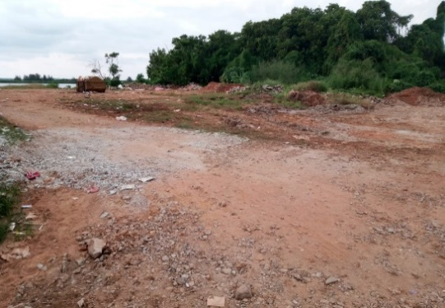

Fig 3.1: Present Landfill Site at Mattar

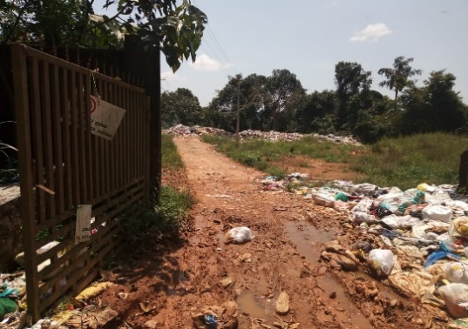

Fig 3.2: Present Landfill Site at Mattar

### 

## 

## Fig 3.3: Present Landfill Site at Mattar

**Recycling and treatment**

* Proposal for recycling and treatment is given were waste is divided into two divisions,

1. Dry waste
2. Wet waste

* Dry waste is classified into recyclable waste and non-recyclable waste based on this.
* Recyclable waste includes, plastic covers, paper cups, tetra packs, glass bottles etc can be separately packed and sold to the recycling industry.
* Non-recyclable waste includes, silver coated covers, laminated plastic covers, cloth items, leather, rubber etc can be used as alternatives like cloth items can be used to make carry bags, tyre and rubber items can be used in road construction etc.
* For Wet waste, composting is suggested.
* Proposal for household food waste treatment is done, especially for the houses in the remote places were auto tippers cannot travel daily like,
* Public awareness program is done to understand the methods in the better way.
* Composting of food waste, which can be used as manure instead of any other chemicals or fertilizers.
* Since it is a small waste treatment method, composting can be easily adopted in remote places.

## Bokashi is an anaerobic composting powder which can be used for fast composting and for getting the result earlier.

Procedure:

It is an anaerobic process

* Take 2 buckets, one with 10 to 15 holes at the bottom of the bucket and placing it over another bucket.
* Top bucket is added almost all type of vegetable and food waste in 2 to 3 layers by adding bokashi powder in each layer.
* Then put on the lid and make sure that it is be air tight, since it is anaerobic.
* After one week, drain off bokashi tea which is collected at the bottom bucket.
* After 2 weeks of anaerobic process, bury the waste in soil. And start checking the result after 2 weeks.

# IV. results and discussions

Following are the information collected from the Panchayat,

Total population in 2001 = 11856, total population in 2011 = 13390, total number of houses = 3183, number of auto tipper = 1, number of workers = 5, number of tricycle and pushcarts = 0, number of secondary containers = 0.

**Design Period**

In the present study to meet the demand of the given facility the design period is taken for 10 years from 2021 to 2031. This design period is taken for further calculations such as population forecasting, number of houses, quantity of waste generation etc.

**Population Forecasting**

Computation of some future projection size and characteristics with the available data is population forecasting. With the data of previous 2 census as given by the Panchayat, population for the year 2001 was 11856 and for the year 2011 was 13390.

**Table 1:** Population forecasting for the year 2021

|  |  |  |
| --- | --- | --- |
| Year | Population | Increase in Population |
| 2001 | 11856 | 1534 |
| 2011 | 13390 |

## x̅ = 1534

**Arithmetical Increase Method**

Arithmetic Increase Method is given by,

Pn = P0 + n x̅

P2021 = 13390 + (1*1534)

P2021 = 14924

**Geometrical Increase Method**

Geometric Increase Method is given by,

Pn = P0 * [1+(r/100) n]

r = √ (P2/P1) – 1

r = √ (13390/11856) – 1

r = 6.27%

P2021 = 13390 * [1+ (6.27/100)1]

P2021 = 14230

Therefore, in our study for calculating future population for the year 2031, population for the year 2021 is considered as 14924 as per the result obtained in AIM.

**Table 2:** Population forecasting for theyear 2031,

|  |  |  |
| --- | --- | --- |
| Year | Population | Increase in population |
| 2001 | 11856 | 1534  1534 |
| 2011 | 13390 |
| 2021 | 14924 |

x̅ = 1534

**Arithmetical Increase Method**

Arithmetic Increase Method is given by,

Pn = P0 + n x̅

P2021 = 14924 + (1*1534)

P2031 = 16458

**Geometrical Increase Method**

Geometric Increase Method is given by,

Pn = P0 * [1+(r/100) n]

r = t √ (r1*r 2)

r = 2√ (12.94*11.46)

r = 12.18%

P2021 = 14924 * [1+ (12.18/100)1]

P2031 = 16742

Thus, in our study population forecasting for the year 2031 is taken as 16500 as per the result obtained in Arithmetic Increase Method.

**Quantity of Waste Generated**

The average waste generation = 0.45Kg/capita/day

Waste Generation = Total Population * Per capita waste generation

= 16500 * 0.45

= 7.43tonnes/day

**Collection System**

For carrying of waste from waste producing point in residential collection service, Curb method of door to door collection system is adopted, in which the home owner is responsible for placing the containers to be emptied on collection day and for returning the empty container to their storage location until the next collection.

**Collection of Solid Waste**

Waste collection is one of the major of the waste management process. It is the process of collection of waste from every house and disposed off to the treatment site or landfill.

.

**Primary Collection**

Primary collection system is required to ensure that waste stored at each house is collected daily and it is not thrown on the streets, drains, water bodies etc.

Tools and Equipment’s used:

1. Auto Tippers
2. Push Carts
3. Tricycle

**Number of Houses**

Assuming the average of 5 members in each family or house

Number of houses = Total Population in 2031

Average Members in family

= 16500

5

= 3300 houses

Total number of houses in present decade (2011) = 3183 houses.

Calculation of number of tools or equipment’s required,

**Number of Auto Tippers**

Number of stops = Total number of houses

Number of houses in each stop

= 3300

10

= 330 stops

Time required for all the stops: 3min @ each stops

= 330 * 3

= 990 min

= 16.5hrs

Time taken for the first transfer of waste to secondary containers by auto tippers for collection from 500 houses is 2½ - 3hrs.

If 500 houses required 2½hrs then 3300 houses required 16.5hrs.

If 500 houses required 3hrs then 3300 houses required 19.8hrs.

If we consider 2½hrs to complete 500 houses, we can complete 1000 houses in a shift. Therefore, at least 3 Auto Tippers are required to collect waste from 3300 houses.

Time taken to collect waste from 1000 houses is 6hrs (6:30 AM to 1:30 PM) including 1hr break.

**Number of Push Carts**

One Push Cart completes 160 houses in a 6hr shift.

In a trip of 90 min 40 houses can be completed. Hence it requires 4 trips/day.

Number of Push Carts = Total number of houses/ Number of houses that can be completed in one Push Carts

= 3300

160

= 21 Push Carts

Total number of trips = 21 * 4

= 84 trips

1 person is needed for the waste collection.

Therefore 21 Push Carts required 21 persons.

**Number of tricycles**

One tricycle completes 240 houses in a 6hr shift.

In a trip of 120 min 80 houses can be completed. Hence it requires 3 trips/day.

Number of Tricycle = Total number of houses/ Number of houses that can be completed in one Tricycle

= 3300

240

= 14 Tricycle

Total number of trips = 14 * 3

= 42 trips

1 person is needed for the waste collection.

Therefore 14 Tricycle required 14 persons.

**Measurement of Collection Area**

The total distance of about 250Km was obtained by Google Earth software to collect waste from shirva village. From the above calculations for the collection of waste from each house, 3 auto tippers or 21 pushcarts or 14 tricycles were obtained. Depending upon the fund availability panchayat can implement the required one. Since the time available is 6hrs per day we suggest auto tippers for the collection of waste from every house.

The whole area is divided into 3 divisions with one auto tipper each. Each auto tipper will get an average of 84Km. After all the boundary calculations each auto tipper will get 87Km, 80Km and 84km respectively.

**Recycling and Treatment**

Bokashi is an anaerobic composting powder which can be used for fast composting and for getting the result earlier.

## 

## Fig 4.1: Anaerobic Bokashi Composting Powder

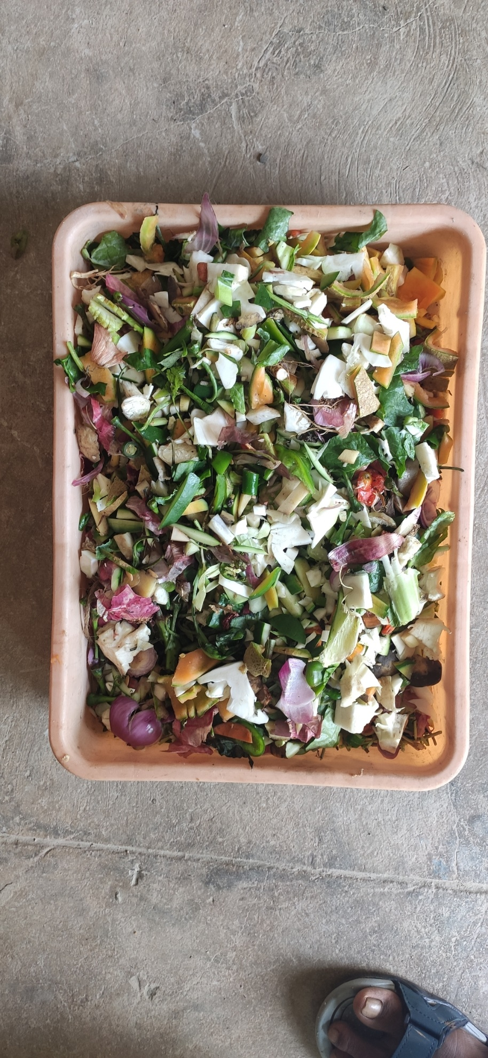

Fig 4.2: Vegetable Waste

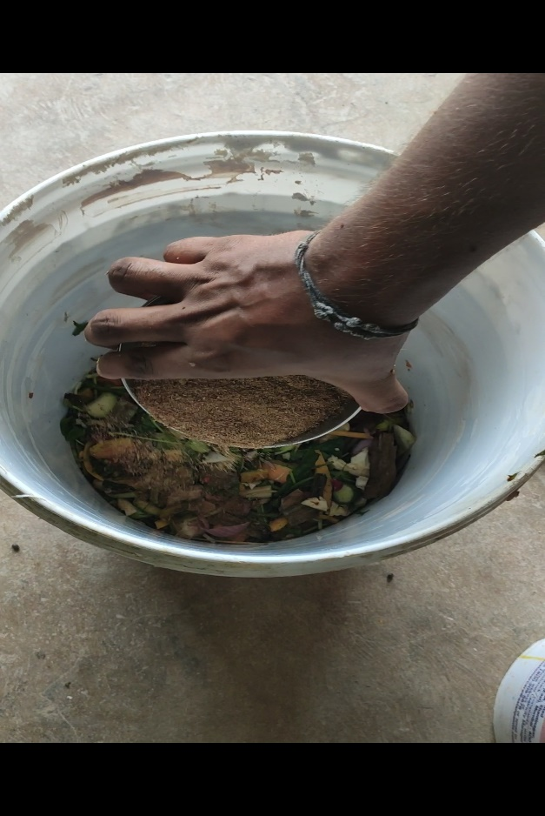

Fig 4.3: Adding bokashi to Waste

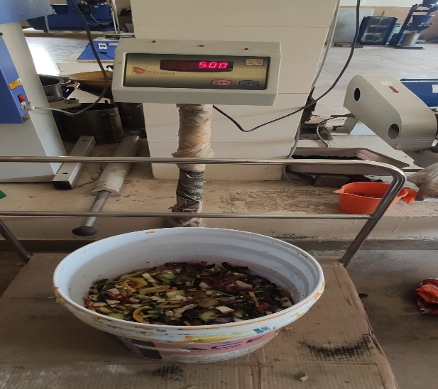

Fig 4.4: Total quantity of waste

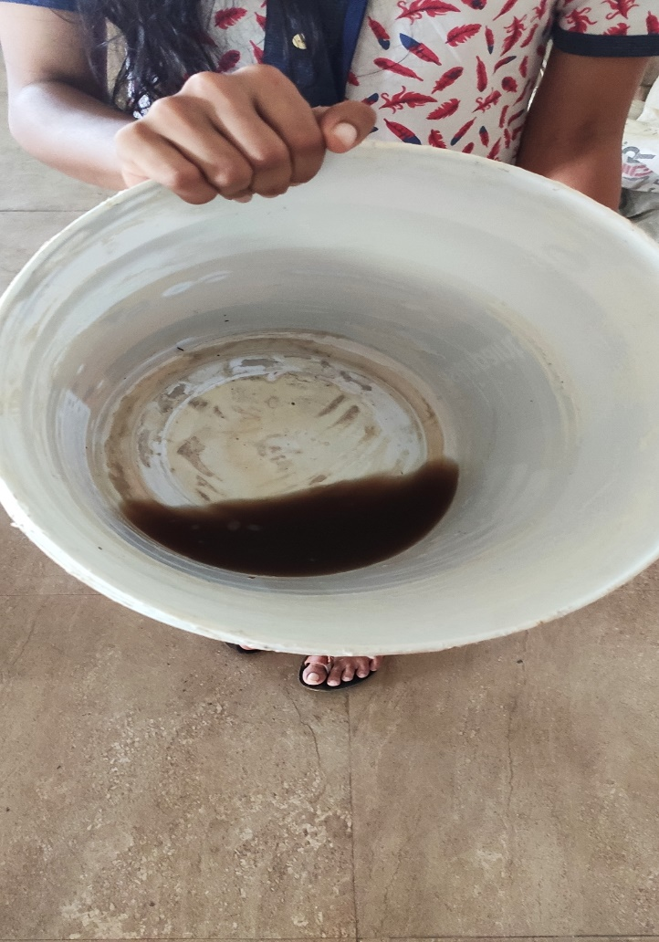

Fig 4.5: Bokashi liquid after 1 week



Fig 4.6: Transfering to soil after 2 weeks

# V. Conclusion

1. Primary and secondary collection system which we have designed is very much helpful in effective collection of solid waste from each house.
2. Measurement of routes of collection area using Google Earth Pro software which helps in calculating the total distance for collection of waste from each house.
3. Composting not only reduces the problems associated with landfills and incinerators but the finished compost add beneficial humus and nutrients to soil.
4. By providing separate buckets to each houses and informing people to separate dry and wet wastes at house will help in mixing up of waste.
5. After collection the dry waste can be recycled and wet waste can be composted.

# “VI. references

1. Sunday A. Owalabi, Daniel Mmereki, Andrew Baldwin and Baizhan Li, ***“A comparative analysis of Solid Waste Management in developed, developing and lesser developed countries”*** 2016 Dec,Vol 5, No. 1, 120-141
2. Rajkumar Joshi and Sirajuddin Ahmed**, “*Status and challenges of municipal solid waste management in India: A review”*** 2016, 2: 1139434
3. Ashenafi Yimam Kassaye, **“*Contemporary Institutional Solid Waste Management practices of Haramaya University(HU), Eastern Ethiopia*”** 2018 Apr
4. Yash Pujara, Pankaj Pathak, Archana Sharma and Janki Govania**, “*Review on Indian Municipal Solid Waste Management practices for reduction of environmental impacts to achieve sustainable development goals”*** Journal of environmental management 248(2019) 109238
5. Kadir Sezer and Osman Arikan, **“*Waste characterization at mixed municipal solid waste composting and recycling facility units”*** Desalination and Water Treatment, 2012 Aug, 26:1-3, 92-97
6. Abdelhadi Makan, Dimitri Malamis, Omar Assobhei, Maria Loizidou and Mohammed Mountadar, **“*Solid Waste Management: Case of collection and vehicle routing problem in the city of Azemmour, Morocco*”** International Journal of Manage Science and Engineering, 2013 May, 6:4, 247-255
7. C.A. Pettigrew, G. A. Rece**,** M. C. Smithand L. W. King, **“*Aerobic Biodegradation of Synthetic and Natural Polymeric Materials: A component of Integrated Solid-Waste Management”*** Journal of Macromolecular Science, Part A: Pure and Applied Chemistry, 2006 Sep, 32:4, 811-821
8. Umar Musa Umar and Ali Ibrahim Naibbi, **“*Analysis and suitability modelling of Solid Waste disposal site in Kano Metropolis, Nigeria*”** Geocarto International2019 Aug.”

1.