Smartphone Based Attendance System for Staff

**Carol DSilva, Lavanya, Manisha S Jogi, Prajna, Ms. Shashikala R**

***Abstract:*** ***A traditional attendance system requires a cumbersome and time consuming process requiring unnecessary paper work and higher maintenance efforts. We are in the age, where we have to think about sustainable development of an institute or a country. The other method of maintaining the attendance of the staff is by implementing the fingerprint based sensor device placed at one position. This will eliminate the proxy of attendance. But the disadvantage is that the person has to wait in a long queue until his turn comes. This is very time consuming. Designing a better attendance management system for staff so that records are maintained with ease and accuracy was an important key behind motivating this project. The application will be installed on the user’s android phone. Initially the user can register himself/herself using his phone number only once. The smartphone of the user can be accessed only through college Wi-Fi while marking the attendance in attendance system so that no cheating takes place. By using this system the employee can avoid standing in a queue and save his/her time by using their smartphone.***

***Keywords: Wi-Fi, android application, MySQL database, android phone, android studio.***

1. **INTRODUCTION**

Attendance system has been known since antiquated time. Every organization whether it be an educational institution or business organization, it has to maintain a proper record of attendance of students or employees for effective functioning of organization. Designing a better attendance management system for staff so that records are maintained with ease and accuracy was an important key behind motivating this project [1]. After visiting some organizations, it was discovered that there is no proper system to monitor the Staff attendance. Some companies still use log book to keep track of the employees' attendance. These attendance records are not precise. Besides, the company still uses the paper-based system to keep track of the records of the staff. This method is not secure because the records may be lost. It is also hard to find certain records using paper-based system. With the paper based system, the employee can also manipulate the time of signing in and out. The paper based system also waste a lot of time in signing in and out. The other method of maintaining the attendance of the staff is by implementing the fingerprint based sensor device placed at one position. This will eliminate the proxy of attendance. But the disadvantage is that the person has to wait in a long queue until his turn comes. This is very time consuming. The most important thing in having the system is to maintain an accurate and precise time management to track the attendance of the employees [2].

We are providing a solution to every disadvantage and flaw present in traditional attendance system by implementing the use of mobile’s device number and phone number to identify individuals and Wi-Fi technology to provide connectivity to a database where the entire system data can be stored and accessed easily. The mobile application would require connecting to the database using Wi-Fi technology. Our project is an efficient and user friendly technology. The application will be installed on the user’s android phone. It intends to provide an interface to the management who will require minimal details to input for marking of attendance of a particular employee. The portal for the employee will open as soon as he enters the campus; the employee’s mobile with the android application installed on it will mark the attendance using fingerprint as a button if it is in the range of the Wi-Fi. Employee will login to the phone application and get connected to the server. After login, they will take attendance with their mobile phone and this data will be stored in the database [3].

The developed system can trace the attendance of the employees so as to know when they are coming and leaving from work. This system can save time and minimize the manpower for manual management. Besides, the employees’ records are more secured which are saved into the database. This system helps to reduce clerical cost such as papers, files and stationery [2].

1. **METHODOLOGY**

User authentication is one of the major factors in the proposed system. Every lecturer is authenticated based on his/her unique mobile device number. This device number along with other information is also saved in the lecturer’s device. Fig.1 depicts the overall methodology of the system.

|  |
| --- |
| Save attendance in database  User Login  Wi-Fi  User  Marking of attendance |

Fig.1: Block diagram of the proposed system

When the user gets the application, initially he/she needs to register himself/herself. This can be done only within the specified range of the college Wi-Fi. When the user is connected to the Wi-Fi, he/she opens the application. Initially a pop-up will be displayed asking for the permission to access the device number. The user needs to give allow to continue with the further process. Next page displayed is the login page which contains a provision to enter the mobile number if he/she is the registered new user. If the user needs to register himself/herself, then he/she needs to click on the register now button at the bottom of the screen. This will take the user to the register page where he/she needs to enter his/her name, email id, mobile number and click on the register button. An OTP is sent to the mentioned user’s mobile number. This OTP is entered in the OTP page. Then the user needs to enter his/her mobile number in the login page if he/she is the new user. After successfully logging in, he/she can give his/her attendance. After this he/she becomes a regular user. Hence, next time whenever the user is connected to the college Wi-Fi, the server will identify the device number. When the device number is identified in the database, the mobile number specified for that device number will be automatically entered in the login page. Hence the user cannot change his/her mobile number. If he/she needs to change his/her number, then either he/she needs to change it in the database or needs to migrate it.

**Software/ Hardware requirements**

We have used Android Studio software for the generation of application in JavaScript language. Android Studio is a development environment completely open source and it is an IDE for all environments. It is available for all the main operative systems such Windows, Mac OS and Linux. The IDE environment mainly contains two basic parts: Editor and Compiler where former is used for writing the required code and later is used for compiling and uploading the code.

The layouts of the UI design are taken care of by Extensible Markup Language (XML) which is a markup language that defines a set of rules for encoding documents in a format that is both human-readable and machine-readable. We have used the android platform to develop the whole development system in Android Studio. We have also used Java for the development purpose which is the official language of Android development and is well supported by Android Studio.

We have used MySQL database, the most widely used open source server to store employee’s information and the timing of arrival and departure. After registration of the employees into the system, their identity is tracked by a unique key in MySQL server and we considered that as the device id. In the MySQL server, several rows have been allocated for different employees where they have information like name, device id, phone number, email id etc.

1. **RESULTS**

Below Fig.2 shows login for staff, it is provided with phone number where the user has to enter his/her registered phone number.

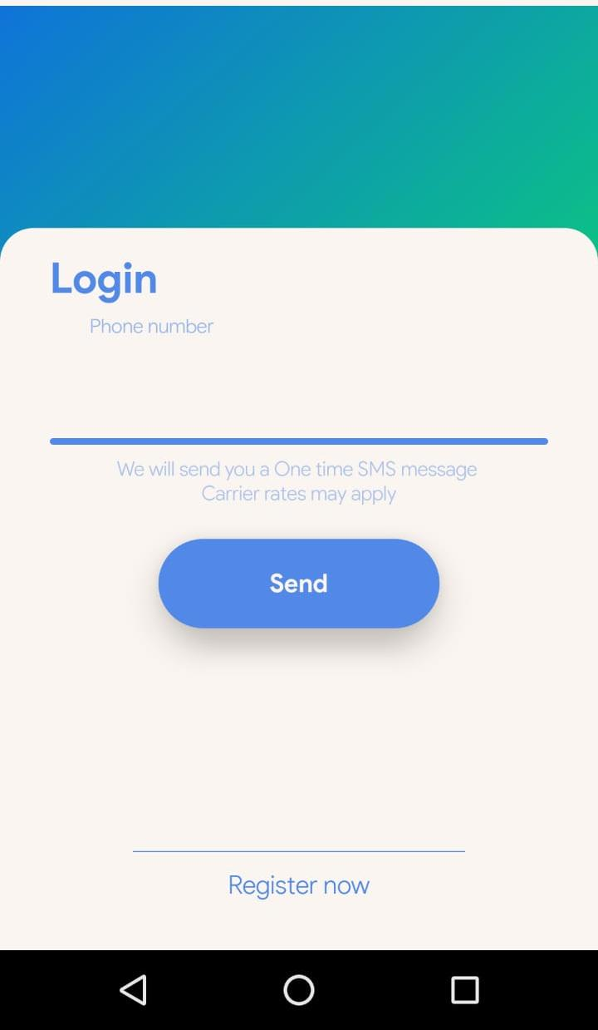

Fig.2: Login page

Fig.3 shows the register page where the user has to register himself/herself with name, phone number and email id.

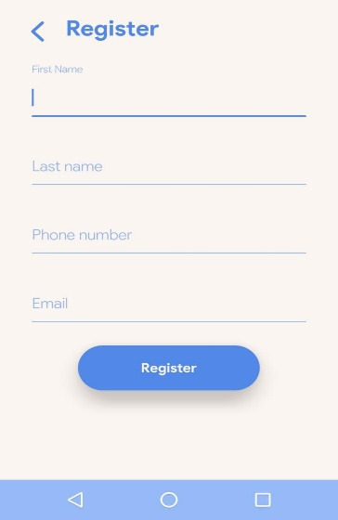

Fig.3: Register page

Fig.4 shows OTP page where OTP sent to the registered phone number is entered to get the device id.

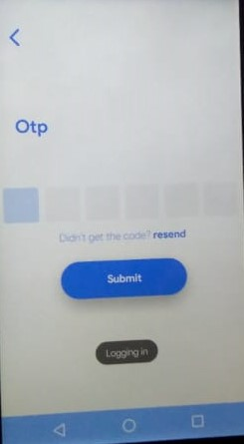

Fig.4: OTP page

Fig.5 shows the page where the attendance is marked. It will show the login, logout time and date.

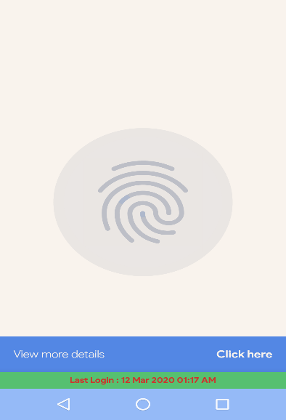

Fig.5: Marking the attendance page

The details of the staff who have registered themselves in the application are stored in the server database as shown in Fig.6.

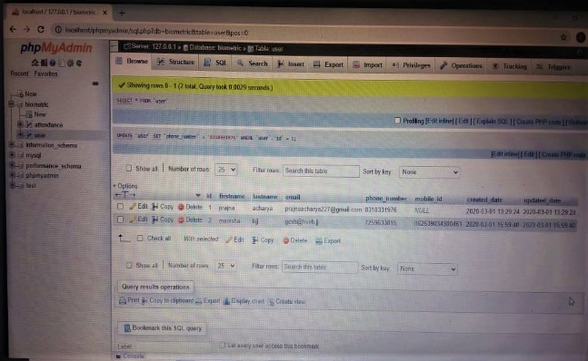

Fig.6: Registered staff list saved in database

The attendance marked by the staff in their smartphone is stored in the main database of the college. The database will contain the login, logout time of each staff member as shown in below Fig.7.

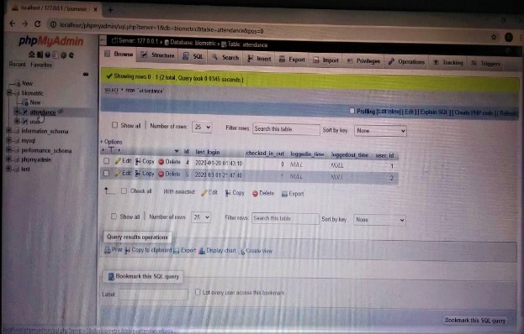

Fig.7: Login-logout details saved in database

This data can be accessed only by the authorized person. Hence it is very secure. Since the phone number and device number are fixed for a user, he/she cannot change their phone number. If they need to change it, then either they have to convey it to the authorized person or need to mitigate it.

1. **CONCLUSION**

Smartphone based attendance system has its own advantage compared to other attendance system. This system will provide an android based application for attendance marking of staff. It saves a lot of time since it is an application which will be installed on user’s smartphone and hence the user need not stand in a long queue to mark the attendance. It is also cost effective i.e., the user need not pay for this application. It also saves the use of pen and paper and thus the record of attendance will be safe and updated. Thus it eliminates errors and provides reliability.

**REFERENCES**

1. Rishabh Mishra and Prashant Trivedi, “Student Attendance System Based On Fingerprint Recognition and One-to-Many Matching”, Department of Computer Science and Engineering,National Institute of Technology RourkelaRourkela-769 008, Orissa, India.
2. M. Olagunju Department of Computer Science, Federal University Oye-Ekiti, Oye-Ekiti, NIGERIA, A. E. Adeniyi Department of Computer Science, Landmark University, Omu-Aran NIGERIA,T. O. Oladele Department of Computer Science, University of Ilorin, Ilorin,NIGERIA, “Staff Attendance Monitoring System using Fingerprint Biometrics”, International Journal of Computer Applications (0975 – 8887),Volume 179 – No.21, February 2018.
3. Siddhi S. Narvekar, Vrushali D.Patil, Swapnil Waghmare,“RemoteBiometric Authentication System using Android Phone”, Pillai HOC College of Engineering & Technology Mumbai University, International Journal of Computer Applications (0975 – 8887),Volume 180 – No.33, April 2018.
4. Suraj Suryawanshi1, Prasad Jagtap1, Abhishek Nadgire1, Diksha Mutha1, Nivedita Kadam2,B. E Students, “ Advance Wireless Attendance System Using Fingerprint”. 10.15680/IJIRCCE.2017. 05032248, Vol. 5, Issue 3, March 2017.
5. Hamim Adal, Nawsheen Promy, Sanjana Srabanti, Mahbubur Rahman, “Android Based Advanced Attendance Vigilance System Using Wireless Network with Fusion of Bio-metric Fingerprint Authentication”, International Conference on Advanced Communications Technology(ICACT), ISBN 979-11-88428-01-4, ICACT2018 February 11 ~ 14, 2018 IEEE paper
6. Benfano Soewito, Fergyanto E. Gunawan, Indra Permana Rusli, “The use of android smart phones as a tool for absences”, 4th International Conference on Computer Science and Computational Intelligence 2019, (ICCSCI), 12-13 September 2019 , www.sciencedirect.com.
7. Praveen kumar Hiremath M.Tech (IT), Naveen Mirajkar, Dept. of ISE, “Biometric Authentication Based Attendance System using GPS for Smart Phone”, International Journal of Engineering Research & Technology (IJERT), ISSN: 2278-0181,Published by, www.ijert.org ,NCESC - 2018 Conference Proceedings.