Solar hybrid energy water pumping system for agricultural irrigation

Prathik Chandrakanth Shenoy1,Srinidhi Udupa A2,Sharath Kumar E3,Abdul Ahad4 and Ganesh R Kalagi5

1,2,3,4 M.E students,Shri Madhwa Vadiraja Institute of Technology and Management,Bantakal,Udupi

5 Senior Assistant Professor,Shri Madhwa Vadiraja Institute of Technology and Management,Bantakal,Udupi

## *Abstract-* This paper throws light on development procedure of an embedded system for solar based OffGrid irrigation system. Solar power is absolutely perfect for use with irrigation systems. Using Solar Panel, the sun energy will converted to electrical power and is saved into batteries. The objective of our project is to reduce this manual involvement by the farmer by using a smart irrigation system whose purpose is to enhance water use for agricultural crops. The inspiration for this project came from the countries where economy is based on agriculture and the climatic conditions prime to shortage of rains & scarcity of water. The farmers are only dependent on the rains and bore wells for irrigation of the land. Even if the farm land has a water- pump, manual involvement by farmers is required to turn the pump on/off when needed.The project is intended to cultivate an smart irrigation system which controls the pump motor ON/OFF on sensing the moisture content of the soil. The advantage of using this technique is to reduce human intervention and still certify proper irrigation. This paper presents the controlling and monitoring the level of the water and detecting the soil moisture content.

***Key Words:* Smart irrigation system, Solar panel, Soil moisture sensor**

# Introduction

Solar power is an abundantly available energy which can easily be trapped using suitable devices.Solar power can be used for various purposes with water supply systems being one of its use. The most common applications out of those are for household water supplies and agricultural and livestock needs. Solar PV pumping systems has been viewed as one of the most viable options for future energy secured agriculture and a significant progress has been made in states like Rajasthan and Gujarat. Normal water irrigation pumps commonly apply manual operations involving switching on and switching off as per the convenience. But this requires the physical presence of the operator at the location. This becomes inconvenient when the operator cannot be present at the location at the right time. Not only that, the uncalled power cuts create problems when the equipment needs to be operated at specific times when there is a power cut in that region. With all that, the operator also needs to take care of the amount of water to be discharged to the field so that there is efficient growth of the crop. For all of these reasons, the presence of a skilled operator having good knowledge of the crop must mandatorily be present at the location of the System. With all these problems looked into with serious considerations, a suitable system eliminating such hassles will prove beneficial to the society. This is where we

have developed interest and started working on.

# Objectives of Study

* + To Design and Fabricate cheaper and energy friendly hybrid pumps incorporated with Solar PV.
  + To develop auto controlled mechanism for both Solar PV.
  + To reduce overall water usage conventional irrigation system.
  + To develop sensor base irrigation system based on soil moisture.
  + Facilitate continues water supply (24x7) to maintain soil moisture and structure.
  + To reduce human interference and facilitate smooth uninterrupted operation.

# Definition of Problem

Nowadays, even though irrigation systems are used in agricultural field to reduce dependency of rain, most of them are either regulated manually or having time based automation. In these types of system water is applied to field on the basis of fixed intervals which required high manpower for monitoring and also it reduces the field efficiency. In addition, this fixed interval operation leads to over irrigation than the actual plant requirement and under irrigation when plants required more water in their peak periods. Retardation of crop growth rate, late flowering and reduction of the yield are the major events caused due to water deficiency. Moreover, over irrigation in the root zones leads to ill health of the root zones and vegetation, additional cost for farmer, wasting of water and time wastage. Also salinity of the soil can be increased by continuous supply of excess water. For operation of irrigation system, electricity is required. So use of solar energy for power generation is essential to tackle current energy crisis. One of the major weaknesses of the fixed panel solar system is that due

to rotation of the sun, it is not able to extract maximum energy from the sun.

# Proposed Methodology

* The project involves use of 4 12v batteries each of 42Ah capacity, a 0.5HP AC water pump, a 100W 12V solar pannel,an Inverter of 2250Va capacity with 24v rating, a charge controller,9 diodes of 7- 10amps rating each, thick guage wires,Arduino UNO board, 4 soil moisture sensor probes, solenoid valves,relays,2 water tanks with 200-400litres volume capacity and required piping and valves.
* The fabrication process begins with connecting any 2 12v 42Ah batteries in series as to obtain a 24v supply line which is to be connected to the 2250Va 24V inverter to operate. The other 2 batteries are connected in parallel to the series batteries as to obtain a total current rating of 168Ah.
* The positive connection of the solar pannel of 100W 12V capacity is connected to a 10Amps rating diode as to limit the reverse current
* The positive line and the negative line from the solar panel is then connected to the positive and negative terminals respectively of the charge controller as to avoid access current flow from the panel during high intensity of incident solar radiation. The positive and the negative lines are then drawn out from the charge controller from the ba+ve and ba-ve terminals of the charge controller.
* The positive lines and negative lines are then split up to 4 individual lines with 4 7-10Amps rating forward diodes in positive lines each and 4 7-10Amps rating

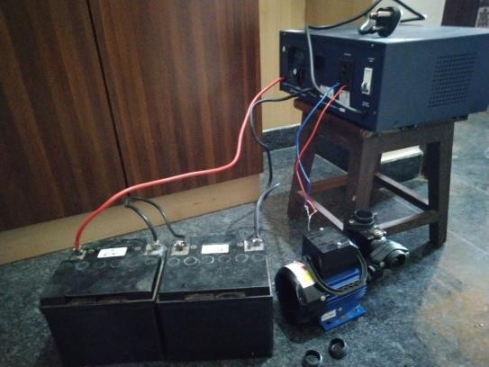reverse diodes each of the 4 split up negative lines.

* The hence resulting individual positive lines and negative lines are connected to positive and negative terminals of individual batteries.
* The soil moisture sensor probes are buried near the roots of the plants to be cultivated and are set to a predetermined optimal soil moisture content required as to ensure optimal plant growth.
* The individual soil moisture sensor probes are connected to the programmed Arduino UNO board which is then connected to the pump to regulate automatic switching of the water pump.
* The Arduino UNO board receives its operating current and voltage through any one of the batteries used in the setup.

# Components used

* Solar pannel -100w,12v
* Charge controller- 10a rating
* Battery-42ah,4 units
* Water motor pump-0.5hp domestic water motor
* Arduino uno board
* Soil moisture sensor probe
* Inverter-2250va capacity
* Relays diodes
* Solenoid valves pipes of various diameter
* Pipe fittings
* Heavy guage wires
* Miscelleous accesories

# Project overview & Calculations

## Block diagram of energy flow:

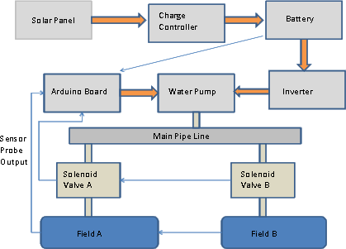

1. **Block diagram of solar pumping module:**

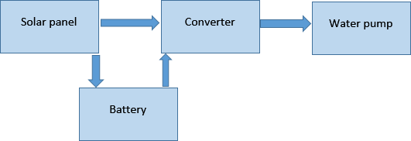

1. **Block diagram of automatic irrigation module:**

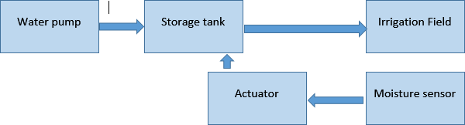

1. **Pump actuation circuit:**
2. **PV battery charging circuit:**

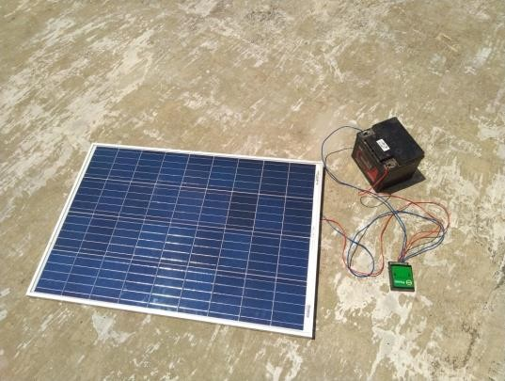

* 1. **Solar Panel**:

To charge a battery, panel voltage must be higher than battery, i.e. for a 12V battery, the panel voltage must be in range of 15V- 22V.

For 0.5HP pump,

Power=746/2 =373watt Considering losses of about 30%,

30% of 0.5HP is 0.15HP,

thus 0.65HP=0.65*746=485watt (Running at full load)

Starting current of the pump is high, so to start a pump, wattage must be 3 times higher than the motor to start it.

Hence, a 500W capacity solar panel is sufficient to run 0.5HP pump.

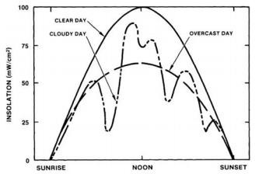

**Figure6.1Typical daily variations in solar radiation**

## Battery Charging Time:

Charging Time;

tc= (Ah)/A Where, tc – Time in hour

Ah- Ampere hour of battery A – Ampere

Charging current should be at least 10% of Ah rating. 10% of 100Ah =10A.

Considering losses in battery charging 12A is required.

Therefore, Charging time,

tc = (100)/12=8.3 hrs.

And also considering 40% loss in the battery,

tc= (140/12)=11.66 hrs

## Inverter Capacity:

V*A*Power Factor

Power Factor is generally 0.8.

Power consumed by water pump per hour

= 500 Watt

=(500/0.8)

=625 VA

For Safe conditions it is better to use 1kVA inverter.

## Piping:

Based on output from 0.5 HP pump, pipe size should be around 1/2 inch to ¾ inch.

* 1. **Soil Moisture Sensor Probe:** sensing probe with dimension 60*30 mm

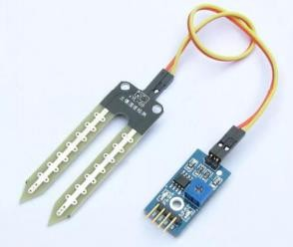

# Solar energy

Solar power is the alteration of energy from sunlight into electricity, either directly by means of photovoltaics (PV), or indirectly by means of intense solar power. Solar energy is most abundant source of energy in world. Photovoltaics is an effective approach for using solar energy.

# Soil moisture

Soil moisture is a vital component in the atmospheric water cycle, both on a small agricultural scale and in large-scale

modelling of atmosphere interface. Vegetation and crops always be contingent more on. Water budgeting for irrigation planning, as well as the actual preparation of irrigation action, requires local soil moisture data.Soil water contented is an expression of the mass or volume of water in the soil, though the soil water potential is an expression of the soil water energy status. The relation between content and potential is not general and depends on the features of the local soil, such as soil density and soil texture

# Advantages

The main advantages of this proposed system are as follows.

1. By using soil moisture sensors in the field, this system provides water for plants according to the crop water requirement and operates according to the soil moisture condition of the root zone of the plant. This leads to saving of water by avoiding excess irrigation.
2. The system has designed to operate using solar energy; hence it could be used for the areas where the electricity is not available. Further, use of this renewable energy does not affected by the energy crisis. This renewable energy produces little or no waste products such as carbon dioxide or other chemical pollutants, so it has minimum impact on environment.
3. The proposed system controls amount of water use for irrigation in the agricultural fields. Thus it reduces excessive pressure on farmers to pay additional water tariff on water. In addition to this controlled irrigation also save additional cost for water pumping, reduces the conveyance and distribution losses in the field level. Moreover, energy consumption on water pumps could be reduced by efficient water allocation based on the crop water requirement.
4. This solar powered smart irrigation system does not require man power for operation. This intelligent system can detect the soil moisture conditions and

perform automatically based on predefined moisture conditions.

1. This system reduces run off from over watering saturated soils, avoid irrigating at the wrong time of the day, which will improve crop performance by ensuring adequate water and nutrient balancing. Further, it prevents Salinity of agricultural lands which cause for poor productivity and land degradation.

# Applications

By implementing proposed system, there are various benefits to both government as well as farmers. For the government solution to energy crisis and water shortage is proposed. Main application of the proposed system is for irrigation of agriculture fields. Even we can apply this system in agriculture research stations, greenhouses where high precision soil moisture control is required. Use of solar energy in the proposed system allows us to use this system in remote areas where electricity is not available. Irrigation can be completed in fields, gardens, farms etc. It is effective for diversities of crops. This application can be used for patient monitoring. The software application developed for this system can be used for domestic works such as tank storage. This system can be functioned automatically as well as manually.

# Conclusion

In this paper, a solar powered sensor base smart irrigation model is proposed. Our purpose was to design a model considering low cost, reliability, alternate source of electric power and automatic control. As the proposed model is smart controlled, it will help the farmers to properly irrigate their fields. The model always ensures the sufficient level of water in the soil. Thus, this system avoids over irrigation, under irrigation, top soil erosion and reduce the wastage of water. Solar power provides sufficient amount of power to drive the system. To overcome the necessity of

electricity and ease the irrigation system for our farmers, the propose model can be a suitable alternative.

# Final discussion

The project completed as per the instructions and methodology adopted would prove beneficial to a normal farmer or a household garden with a requirement of a smart system to regulate water supply to the plants as per the soil moisture level and hence thereby decrease over consumption of water as in normal water irrigation. The human interference would be considerably reduced as the system would operate on signals received by the sensors buried under the soil near the roots of the plants and upon any decrease in water level, would activate the sensor and thereby send signals to the programmed system as to operate the pump automatically and pump water to a tank and thereby water the plants under drip irrigation method. The sensing and activating system required no inputs from the household mains supply as the whole system runs using solar energy trapped by radiant sunlight into batteries to which the individual systems are connected.

# Future Scope

Rain water harvesting can be done and this harvested water can be used to moisten fields. Hooters can be used so that it gives siren at various occasions such as interruption detection, floods etc. Using IR sensors any object passing into fields can be detected and warned.

# References

1. Anuraj A and Gandhi R, ‘Solar Tracking System Using Stepper Motor’, International Journal of Electronic and Electrical Engineering, Volume 7, Number 6: 561-566, 2014.
2. Sanjukumar and Krishnaiah R V, ‘Advance Technique for Soil Moisture Content Based Automatic Motor Pumping for Agriculture Land Purpose’,

International Journal of VLSI and Embedded Systems - IJVES, Volume 4, Article 09149, September 2013.

1. Luthra S K, Kaledhonkar M J, Singh O P and Tyagi N K, ‘Design and development of an auto irrigation System’, Elsevier Science B. V. - Agricultural Water Management, Volume 33: 169-181, 1997.
2. Harishankar S, Kumar R, Sudharsan K P, Vignesh U and Viveknath T, ‘Solar Powered Smart Irrigation System’, Advance in Electronic and Electric Engineering, Volume 4, Number 4: 341- 346, 2014.
3. Gutiérrez J, Villa-Medina J F, Nieto- Garibay A and Porta-Gándara M A, ‘Automated Irrigation System Using a Wireless Sensor Network and GPRS Module’, IEEE Transactions on Instrumentation and Measurement, 2013.
4. Seal B, Shirke O, Shewale S, Sirsikar A and Hankare P,‘Solar Based Automatic Irrigation System’, International Journal of Research in Advent Technology, Volume 2, Number 4, April 2014.
5. Garg, H.P. 1987. Advances in solar energy technology, Volume 3. Reidel Publishing, Boston, MA.
6. Prakash Persada, Nadine Sangsterb, Edward Cumberbatchc, AneilRamkhalawand andAatmaMaharajh, "Investigating the Feasibility of Solar Powered Irrigation for Food Crop Production: A Caroni Case," ISSN 1000 7924 The Journal of the Association of Professional Engineers of Trinidad and Tobago, Vol.40, No.2, pp.61-65, October/November 2011.