**SENTIMENTAL ANALYSIS USING SPEECH STREAMS**

Elein Jisha Lewis, Akshatha B Bhat K ,Branda, Amitha Kundar, Laxmi Shetty

***Abstract:*Sentimental analysis has evolved over past few decades, most of the work in it revolved around textual sentiment analysis with text mining techniques. But audio sentiment analysis is still in a nascent stage in the research community. In this paper, sentimental analysis is performed on speaker discriminated speech transcripts or data to detect the emotions of the individual speakers. VADER algorithm is analysed in order to perform sentimental analysis.**

**Understanding the mood of a person can be very useful in many instances. For example, computers that posses the ability to perceive and respond to human non-lexical communication such as emotions. In such a case, the machine after detecting humans’ emotions could customize the settings according to his or her needs and preferences.**

I.INTRODUCTION

In this paper of sentimental analysis, it is the study of a person’s emotion or feelings or attitude towards a conversation on various topics, events or in general. Understanding the mood of a person is helpful in many instances.Sentiment analysis aims at determining the attitude of a speaker concerning some topics or

**Elein Jisha Lewis,** Electronics and Communication, SMVITM, Udupi (email: eleinlewis@gmail.com)

**Akshatha B Bhat K,** Electronics and Communication, SMVITM, Udupi (email:[akshatha.bhat619@gmail.com](mailto:akshatha.bhat619@gmail.com))

**Branda ,**Electronics and Communication, SMVITM,Udupi(email:brinda.sherigar12@gmail.com)

**Amitha Kundar ,**Electronics and Communication, SMVITM,Udupi (email: amitaengs@yahoo.com)

**Laxmi Shetty,** Electronics and Communication, SMVITM, Udupi (email: [laxmishetty.ec@sode-edu.in](mailto:laxmishetty.ec@sode-edu.in))

the overall sentiment polarity of a text, such as positive or negative. For a machine to understand the mindset/mood of the humans through a conversation, it needs to know who is interacting in the conversation and what is spoken, so here speaker and speech recognition system is implemented first and then perform sentiment analysis on the data extracted from prior processes.

Automatic speech recognition (ASR) of natural audio streams is difficult and the resulting transcripts are not very accurate. The difficulty stems from a variety of factors including i) noisy audio due to non-ideal recording conditions, ii) foreign accents, iii) spontaneous speech production, and iv) a diverse range of topics. The capability of detecting the sentiment of the speaker in audio can serve two basic function i) it can enhance the retrieval of particular audio in question, increasing its utility, and ii) the combined sentiment of a large number of audios on a similar topic can help in establishing the general sentiment**.**

VADER (Valence Aware Dictionary for sEntiment Reasoning) algorithm is used to interpret the emotional aspects or sentiments of a person categorizing into positive, negative or neutral. It uses a combination of sentiment lexicon , a list of lexical features which are generally labelled according to their semantic orientation as either positive or negative. VADER not only tells the positivity and negativity score but also gives us the estimation of the sentiment.

The objective of sentiment analysis is evaluating the sentiments and opinions of a speaker, one topic domain or multi-topic domain. It calculates the aggregate sentiment polarity of speech based on sentiment classification levels, such as positive or negative. The approach investigates the challenges and methods to perform audio sentiment analysis on audio recordings using speech recognition and speaker recognition. Speech recognition tools is used to transcribe the audio recordings and algorithms to obtain the sentiment analysis result. Further, sentiment analysis is performed on the speaker-specific speech data which enables the machine to understand what the humans were talking about and how they feel.

II.METHODOLOGY

READ FROM FILE

CONVERT TO TEXT

GET AUDIO

CONVERT TO TEXT

GET SCORES FOR TEXT

DECISION MAKING

OUTPUT RESULT

**Fig1. Block diagram of the sentimental analysis process**

In this paper of sentimental analysis, here the sentiment of the speaker is analysed over a question and answer format. This process consists of several steps: i) Reading the questions from a file, ii) Converting the text format to audio, iii) Getting the answers in the form of audio, iv) Converting the audio into text using speech recognition, v) Processing the scores of the text using VADER, vi) Decision making and finally vii)Obtaining the desired output.

**2.1 Reading from file and its conversion**

Firstly, a file is created containing the questions used to determine the sentiments of the person . These questions are the basis at which the answers of the speaker are taken into account for the analysis. The prepared set of questions are in textual form , this is further converted into audio . The library pyttsx3 in python is used for this conversion .The parent library of pyttsx3 is sapi5 in windows which is developed by Microsoft. Similarly, nsss on Mac OS and espeak on Ubuntu and others. This is such a library that works offline too, with no or very little delay in getting a response and it is both compatible with python 2 and 3 for the TTS( Text-To-Speech) conversion.

**2.2 Getting input audio and conversion to text**

After the TTS conversion the answers in audio form are received by the machine.This is the input voice of the speaker for the analysis. The audio form is converted to text for the machine to understand using speech recognition[8]. The first component of speech recognition is, of course, speech. Speech must be converted from physical sound to electrical signal with microphone, and then digital data with analog to digital converter. Once digitized, several models such as Hidden Markov Model (HMM) can be used to transcribe audio to text.

**2.3 Evaluating scores for text**

Now,it is required to get scores for the converted text , which means how much positive , negative and neutral content is present in the text. The algorithm used for the process is VADER[9][10]. Valence Aware Dictionary for sEntimentReasoning algorithm is used to interpret the emotional aspects or sentiments of a person categorizing into positive, negative or neutral. It uses a combination of sentiment lexicon, a list of lexical features which are generally labelled according to their semantic orientation as either positive or negative. VADER not only tells the positivity and negativity score but also gives us the estimation of the sentiment. Vader= SentimentIntensityAnalyzer() is the initialization of text analysis to obtain scores.

**2.4 Decision making and output**

After the scores are calculated by VADER,it is the time to decide the sentiment. In testing phase, a set of about 20 questions were collected and the answers by speaker for each were received in the audio form and the analysis was done over it. The scores are obtained as negative, positive, neutral and compound. This is furthermore sorted in the ascending order to make it simpler for decision making .

Here is when the conditions were compared to obtain the output. If the neutral value is the highest, the compound value is considered, if the value in compound is negative then the sentiment is negative and if it is positive the sentiment is also positive otherwise if the value is 0 it is considered as neutral itself.

If the compound value is the highest, the positive and negative values are checked and the result is determined considering which is the highest value whether positive or negative.

If either positive or negative value is the highest then it is considered the same. The decision will be either positive or negative respectively. After this comparison and decision obtained , the control goes to the next question in the file and the process continues.

Thus, the final result i.e, the sentiment of the person is determined based on the analysis made.

III.RESULTS

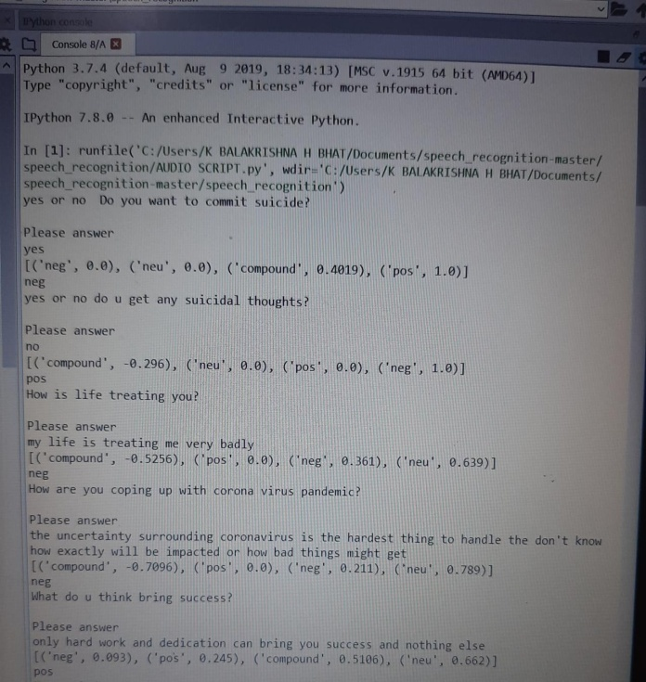**Fig2. Output of the sentiment analysis sample 1**

Fig2 represents the output obtained for the first few questions asked to the speaker. The answers having highest value of positive and negative are considered positive and negative respectively.

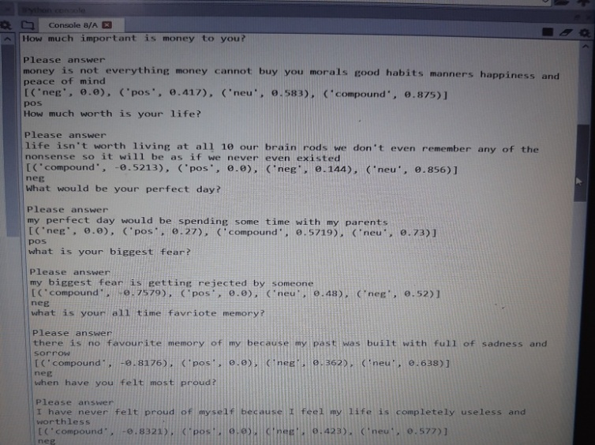Fig3. Output of the sentiment analysis sample 2

Fig 3 represents the outputs for the next set of questions asked to the speaker.For answers having highest value as compound the positive and negatives values are checked and the highest of them is considered.

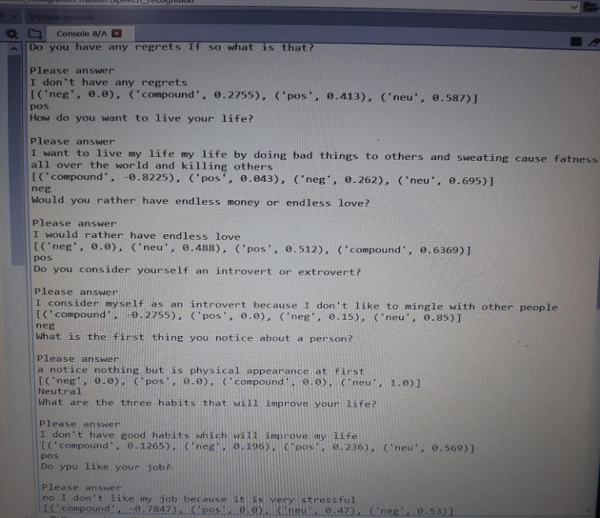Fig4. Output of the sentiment analysis sample 3

Fig4 represents the outputs for the next set of questions asked to the speaker. For answers with highest neutral value, the compound value is considered. If the compound value is positive(+) then the sentiment there is positive.

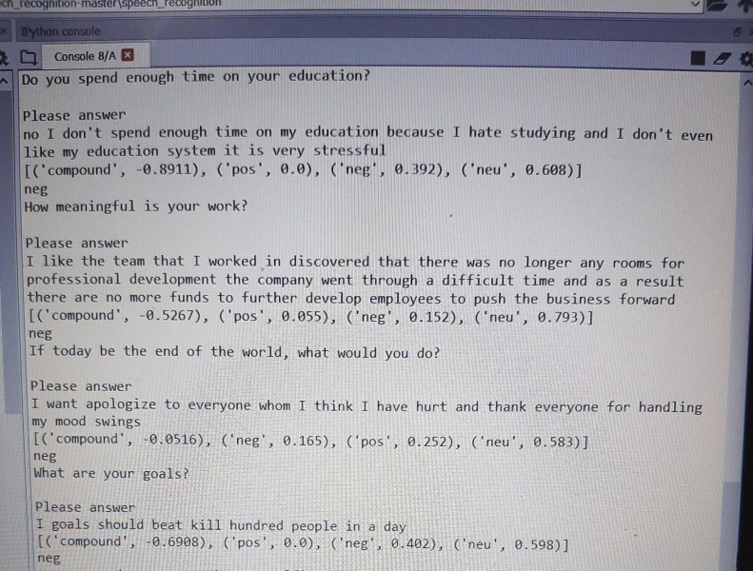

**Fig5. Output of the sentiment analysis sample 4**

Fig5 represents the outputs for the next set of questions asked to the speaker. For answers with highest neutral value, the compound value is considered. If the compound value is negative(-) then the sentiment there is negative.

The figures above show the results of the sentimental analysis performed over couple of questions asked to the speaker. If the speaker gives a positive answer to the question then the sentiment is considered to be positive, negative answer corresponds the negative sentiment and neutral answer corresponds to neutral sentiment. Compound is normalized sum value of positive and negative ranging from -1 to 1.

These results give us the sentimental analysis of a particular any person purely depending on how he answers the questions which in turn helps to know his emotional condition or his sentiments. This process is also termed as opinion mining.

IV.CONCLUSIONS AND FUTURE WORK

This paper gives us the sentimental analysis of the speaker depending upon the answers he gives to particular questions asked. It is the study of a person’s emotion or feelings or attitude towards a conversation on various topics, events or in general. Understanding the mood of a person is helpful in many instances.Sentiment analysis aims at determining the attitude of a speaker concerning some topics or the overall sentiment polarity of a text, such as positive or negative.

In the research speaker was asked questions to a one at a time and the answer they present in the form of audio is converted to text and the analysis is done over it . VADER algorithm is used in order to analyse the text where it gives the scores for the text analysis and determines the negative positive neutral and compound values. These values are then considered to make a decision whether the sentiment shown by the speaker is positive, negative or neutral.

Though the system is accurate in comprehending the sentiment of the speaker in one way format, it suffers some flaws, right now the system can handle the question and answer at a given time, it cannot understand if two people are talking simultaneously i.e, if the audios from different speakers overlap. The future work will address these issues and improve the accuracy and scalability of the system.

REFERENCES

1. Rabi Narayan Behera and Sujatha Dash, ***“Emotion based classification of human voice using optimized machine learning approach”*** ISBN 978-93-81693-07-3, 11-12 November 2016.
2. LakshmishKaushik, AbhijeetSangwan, John H. L. Hansen, ***“Sentimental extraction from natural audio streams”***, 978-1-4799-0356-6/13 2013 IEEE.
3. Chris Nicholas, Fei song, ***“Improving sentimental analysis with parts of speech weighting***”, 978-1-4244-3703-0/09 2009 IEEE.
4. AtulTyagi, Nidhi Chandra, ***“A proposed approach with analysis of speech signals for sentimental detection”***, 978-1-4799-1797-6/15 2015 IEEE
5. Lie lu, hong-jiangzhang, “***Content analysis for audio classification and segmentation***” IEEE Vol 10 No. 7, October 2002
6. Yu Song, Wen-Hong Wang, Feng-Juan Guo, “***Feature extraction and classification for audio information in news video***”, 978-1-4244-3729-0/09 2009 IEEE.
7. Neha Sharma, ShipraSardana, ***“A real time speech to text conversion system using bidirectional Kalman filter in matlab”***, 978-1-5090-2029-4/16 2016 IEEE.
8. JianliangMeng, Junwei Zhang, Haoquan Zhao, “***Overview of speech recognition technology***” 978-0-7695-4789-3/12 2012 IEEE.
9. <http://comp.social.gatech.edu/papers/icwsm14.vader.hutto.pdf>
10. <http://medium.com/analytics-vidhya/simplifying-social>-media-sentiment-analysis-using-vader-in-python-f9e6ec6fc52f

AUTHORS PROFILE

**Elein Jisha Lewis,** student in the department of Electronics and Communication Engineering at Shri Madhwa Vadiraja Institute of Technology and Management, Bantakal.

**Akshatha B Bhat K,** student in the department of Electronics and Communication Engineering at Shri Madhwa Vadiraja Institute of Technology and Management, Bantakal.

**Branda,** student in the department of Electronics and Communication Engineering at Shri Madhwa Vadiraja Institute of Technology and Management, Bantakal

**Amitha Kundar,** student in the department of Electronics and Communication at Shri Madhwa Vadiraja Institute of Technology and Management, Bantakal

**Laxmi Shetty,** Assistant Professor (Senior) in the department of Electronics and Communication at Shri Madhwa Vadiraja Institute of Technology and Management, Bantakal