Food wastage prevention and donation

**Abstract**

Our country facing some common problems like food wastage.it is very crucial as it develops our environmental and economic sustainability.To reduce this wastage of food we have introduced mobile application on android platform.This android mobile application helps to donate remaining foods and leftovers from restaurants,house and other mediums to the people who are in need of it.Our app allows users to register, login, view items, add items, add items to the cart, remove an item from the cart and log out. The user can add all donated food images and add them to the cart.

Food-sharing mobile apps are becoming increasingly popular, but little is known about the new social configuration of people who use them, especially apps that serve as voluntary intermediaries in supply chains. This study focuses on longitudinal social network data from 54,913 food-sharing events in 9054 people and is 10 months and vasoactive. Current challenging theories of mutual sharing (mutuality, relative selectivity, tolerance and costly signaling) suggest that donor-recipient reprimanding and costly signaling are not sufficient.The findings have important implications for managers

**Introduction**

Food wastage is common at weddings,restaurants and gatherings. Large amounts of food are produced on a regular basis, resulting in excessive food. Whenever we attend a wedding or event, we see people throwing away food left without much thought. While many of us don’t question what is being done to the excess food at such events, there are a few people/organizations who come and pick up the excess food.[1]

Like food, we can also donate or share other life commodities such as books, garden plants, pet animals, clothes etc to needy people. Excess books or read books, excess gardening plants and used quality clothes can be distributed or shared with people who need or with NGOs. At present, we don’t have any system which facilitates the people to distribute the excess things and which facilitates consumers to buy these commodities. Due to this, people are not eager to donate their excess commodities which will result in wastage of valuables. By keeping this scenario in our mind, we have decided to develop an Android application that allows the common person either to sell excess commodities or to buy the excess commodities from others.

Android is a powerful operating system and it supports a large number of applications on smartphones. These apps are more convenient and sophisticated for users. ARM architecture supports Android software. Android is an open source operating system, which means it's free and anyone can use it. The popularity of smartphones makes it easy to reach the maximum number of people around us.

**1. Theoretical background and research reference**

**1.1 Motivation Driver of Food Sharing**

Food distribution is sometimes called association(literally: when eating same table), the general behavior implemented by primates (javagi and Gurwen, 2013; Jaggi & van Scheck, 2011), sharing the food with eukaryotic insects, social predators (lions, wolves, wild dogs), hardy and vampire bats and more is a problem unlike any other human. (Kaplan and Gurwen, 2005). Humans learn to share food as children (Birch and Billman, 1986), primarily as an organism dependent on milk;Followed by religious food division, and so on relationships become bi-directional as they give and take in the adolescent and adult years. Archaeological records show the distribution of food and storage methods varying frequently,but they have been a constant feature of human socialization for thousands of years (Enlow, 2003). Today's anthropological records reveal a wide variety of similar foods..Worldwide partnership arrangements are evolving and evolving between countries, industrial and forest dwellers inside and outside the nuclear family group.[1]

Historical analysis suggests that food sharing hierarchical among social classes in Britain has been repeated, with religious meals regularly occurring since the feudal period (Goody, 1982). Interhouse food sharing in equilibrium societies has been shown to reduce the risk (Hegemon, 1991). In fact, food transfers beyond immediate family have been widely documented. Humans and other species but to some extent intercourse have been described in a competitive account (Stevens and Gilby, 2004). Because of the four ultimate motivations, people are regularly cited in anthropological literature for food sharing, including: mutual donations, family choice, expensive gestures; And as unsolicited given (Curwen, 2018).

Food is usually shared in the context of the family (Jegi & Gurwen). (2013a, b), still in the case of OLIO the relative choices are clearly not playing first a large number of people interact unknown. The idea that people should eat food is a shout of patience.

Giving to others and giving something irrespective of this behavior moderately accepted (Gurwen, 2004). Although the question of tolerant scrambling is questioned (Brown, 2004), it is often pushed as a reasoning of behaviorists, but it is argued that this is an important social and symbolic practice (Peterson, 1993) in contrast to demand sharing, where participation creates a social reputation. Social sharing food is one example.It is an expensive sign that the person is sacrificing his money.

Sharing gives evolutionary benefits by presenting it to their relatives fitness. The logic of tolerant screening and costly signaling in relation to OLIOs, such as relative choice, is not sufficient to explain the diet.Customers are not asked to share the food shared

donors start out generous when it comes to strangers rather than people.

Jaggi and Gruven (2013b) suggest that interdependence can be explained by food.Independent of family choice or tolerable scrubbing. Mutual philanthropy provides a mutual arrangement for sharing food amongst non-relatives in their environment. This altruistic behavior increases their chances of survival (Kruse, 1971).

Social exchange and interactions have been widely used to explain. Given that content exchange is fundamental and necessary for social exchange, partnerships are the underlying motivations for the economy (C201, 2018; Kumar, Lahiri, & Dogan, 2018). It has been described as generalized (after Sahlins, 1979), but it is not.

**1.2 U.K Waste and poverty are the determinants of food sharing in India**

The use of accommodating food banks in Britain has increased lively in the last two years. Decade (Lansley and Mack, 2015). Only Trussell Trust is distributed. Between April 2016, 1,182,954 emergency 3-day food supplies. And March of 2017 (Trussell Trust, 2017). It is not a shocking increase.Only those who are in financial trouble by the lack of occupation.Most of the people facing poverty at work grow. The use of food banks has increased as salaries have failed to meet basic expenses. But with previous research, many still do not want to visit the foodbank.

It shows that experiences are often accompanied by wrong feelings. exhaustion or tediousness (Garhwaite 2016a and 2016b).Increasing of crisis of food in Britain has sparked a cross party. That's right, the most recent reports are "Feeding Britain, Ready".

By all-party parliamentary inquiry about hunger of the United Kingdom, a significant number of people have been found to be hungry.The dreadful idea is that hunger is here until we all react to J. Harvey, and others.

The demand for alternative food facilities has increased.The difference of programs that redistribute and distribute food items by chain supply chains. This is most evident in re-drawing the supply.

Bundled high wastage of food, especially regular supermarkets.

Daily occupations that can be redirected and rebuilt. For example, the UK company responsible for collecting shares and distributes a variety of charitiesFood surpluses such as ‘Pay What You Think’ and ‘Social Eating’ Cafe. According to Baron et al. (201 Important, p. 1) 3 ")" This is an important operation: In 2014, more than 5,000 voluntary organizations received food from Group Share. About 25 million meals served 12,000 tonnes of processed food. “Political Care.[1]

**2.Research based on the food production and usage of excess food**

**2.1 Canteens providing Real Time information of Food Wastage**

The present food wastage which executives framework utilizes notices and infographics to make a feeling of mindfulness among the clients about nourishment wastage. More often than not these infographics get unnoticed. The following are a portion of the infographics that were utilized in the bottle of SAP Labs Bengaluru, India.A people survey was also conducted in which the opinion of people was asked about food wastage if they see the real time statistics of food waste. The survey was conducted upon 20 individuals. The following is the assessment of 5 individuals.Different procedures have been applied till date to fight sustenance waste. From scholarly messages in cups/bistro, for instance, "STOP FOOD WASTAGE", "Love nourishment" and so on to pictorial portrayals indicating the results of nourishment wastage, organizations are doing their part in conferring the information on wastage of nourishment in their customer's mind. A couple of individuals are moreover working independently to help spare more nourishment. One of those individuals is Secret Freegan. Mystery Freegan is a Phoenix occupant who recuperates nourishment from supermarket dumpsters and gives it to those out of luck. Propelled by the 2/28/08 scene of Oprah, Secret Freegan has been recouping nourishment for destitute families and different sanctuaries since March of 2008. In that time, she appraises she has given $45,000 worth of nourishment to the hungry. Korean government has additionally begun an activity to battle nourishment wastage. The legislature has set up another compensation as-you-toss nourishment squander the board framework.The new framework will see Radio Frequency Identification Reader (RFID) receptacles introduced all things considered trash houses by one year from now. Structured by SK Telecom, Korea's biggest remote bearer, the RFID canisters ascertain the heaviness of nourishment waste to the closest gram and consequently forms the installment and charges it to the resident's individual RFID card [3]. Gauge the Waste Raises Awareness of Food Waste on Campus by Knox school is additionally doing likewise of bringing issues to light among individuals by making a visual portrayal of the nourishment squander Knox College understudies produce more than multi week.[6]

**2.2 Second hand products market in India**

According to the Associated Chamber of Commerce and Industry of India (ASSOCHAM), the market for second-hand and reused items in India at Rs 80,000 crore ($12,814), is up from Rs 69,000 crore ($1,1027m) in 2012. The report additionally assessed that the market would cross Rs 1, 15,000 crore ($18,379m) by 2015. The market has recorded a development of 15 percent for every annum. It isn't simply vehicles, books and hardware individuals are purchasing utilized nowadays; we're likewise perusing through another person's contraptions, garments and gems. Ladies are bound to purchase used books, extravagance merchandise things, clothing while men are bound to purchase recycled CDs, DVDs, utilized vehicles, motorbikes and so forth., includes the paper. In settling on a decision between purchasing new or utilized, 18-multi year olds are the well on the way to choose recycled DVDs and CDs as a first decision, while the over-55s want to purchase these new. As of June 2014, there were 243 million asserted Internet clients in India out of which 192 million are dynamic Internet clients who get to the Internet in any event once per month (IAMAI report). Every one of these clients are potential contender for recycled items shopping.As the recycled vehicle advertise creates, we are confronting two squeezing issues. Initially, the clients have little space to pick, and the administration clients served are not methodical and far reaching at the equivalent. The principle explanation behind this circumstance is a result of as of now working recycled vehicle dispersed discontinuity. In the event that the trade-in vehicle organizations consolidate, we can incorporate the current recycled vehicle organizations, with the goal that the administrations of a recycled vehicle step by step go to the efficient and marking course. To guarantee the nature of the League framework, the individuals must be chosen from the recycled vehicle sellers that who have strong money related quality, propelled idea of client care, Strong administration abilities. The endorsers can not just share the exchange data, and at last arrive at the wellspring of recycled vehicle share trade, yet in addition can share the exchanging brand of the League of recycled vehicle in China through endeavors.[7]

**3.Multicompartment, multiconstrained, roll-on**

**roll-off scheduling, systems analysis, waste collection, waste separation.**

**3.1Smart and green urban solid waste collection**

Urban strong waste age increments with quick urbanization and populace growth.This paper gives an exhaustive writing audit of the streamlining plans for squander assortment and vehicle routing,followed by an exhibition of an agent two-arrange squander assortment framework to show the most elevated multifaceted nature of its sort over all current urban strong waste assortment plans. This framework shows that every single contemporary headway of existing advancement procedures can be all around composed to give savvy and green arrangements. The curiosity of this paper is the consideration of different requirements in hub steering and multi compartment vehicle directing with move on move off directing plans.

The directing productivity is thought about in incredible profundity among cocollection and separate assortment. This sort of directing plan permits split conveyances for assortment hubs as well as for every one of the waste streams to improve steering effectiveness. This paper at long last clarifies the cutting edge perspectives on savvy and green urban strong waste assortment frameworks as for future viewpoints.[11]

**3.2 Motivation for second-hand consumption:**

Clients today prefer to get more incentive from their assets and sell their products through various on the web and disconnected 'repurchase' channels (Trendwatching 2011). Since recycled exchange is picking up fame, it is vital for retailers to comprehend these elective types of utilization. However, the wonder of recycled utilization has not been examined much by different analysts before (Weight 2013a). To the best of the writer's information, just one book has been distributed on resale culture on the Internet in Germany (Behrendt et al. 2011), yet it centers exclusively around chances for manageable utilization through eBay. Other book and paper look are not especially broad, except for, for instance, Behrendt et al. (2011), Gregson and Crewe (2003) or Franklin (2011).Williams and Windebank (2002) recommend that shoppers go to recycled utilization since they can't manage the cost of new products and have been prohibited from customary retail channels as 'barred buyers'. The analysts call for increasingly elective retail spaces, for instance, formal and non-formal recycled markets where these barred customers can gain merchandise. Williams and Windebank (2002) recognize that there is minimal quality control, particularly for the electrical family unit machines that are exchanged. Besides, they recommend that these elective retail frames don't represent a risk to standard retailers. However, meanwhile the professionalization of recycled retailers, for example, Ubup has occurred, and, since they duplicate retail.[12]

**FOOD WASTAGE APPLICATION**

**A.Singapore's food waste application**

Tan Jun Yuan Singapore Food Stall Hacker. A lot of bad guys thought everyone wasted a lot of food this year. He has seen several vendors with food left over per day. The volume served to customers every day is 10 to 15 bowls, including pork ribs. He has seen it too. 35 percent above of the food you eat on a regular basis is discarded. Therefore, he made an app called the 11th hour. The app offers half-left and never used food. They are the original price before the restaurant closes. Then the app was created in 20000 after this.[2]

**B. Application of food waste reduction from the Netherlands**

It was developed by August de Watch, a Netherlands citizen. Application leads to decrease the quantity of wastage of food. The Application cooperates with supermarkets. People may be aware of the most depleted foods Soon. It helps users upload Grocery supplies, it will be out soon.They can be bought and used at cheaper prices that require food. The Helps prevent excessive food waste. 20000 and above people have realised this app to be usable and this has been decrease the quantity of wastage of food in the Netherlands.[2]

**C. Britain and Ireland application control over wastage of food**

This app has been announced as a useful food scattering application in the United Kingdom as well as in Ireland. This application informs supermarkets about their surplus. Food can therefore be reduced by voluntary associations to collect them. The chance of wasting food. This app works as an Intermediate serving and managing food type.It collects and stores food. According to that voluntary society can collect food their needs.1200 business and above that the hub and 3000 Societies of accommodating operate in this app. Providing additional food items to the homeless.[2]

**D.Africa’s application on reducing the wastage of food**

There are some researchers at Twenty University. Developed this app to reduce the number of food waste in Africa. Various fruits and vegetables are found due to bad road loss of efficiency.Conditions, low cooling in Africa. This application before they decompose and collect that food distribute to the people of Africa's poorest malnutrition. he Dutch Foreign Ministry has assisted researchers in developing the app. Increasingly, farmers and food carriers are using the app and this has helped them reduce their chances of getting bribed in Africa. The public version of the app is expected to be released next year.[2]

**E. Indian Food Wastage Reduction Application**

There is no Indian wastage of food application in India. To stay informed about restaurants, food stalls and parties extra leftovers so that they can be collected as needed for use.The app collects the foods and distributes them to the homeless and to the slum and to orphanages, as well as to nursing homes.. Users can show hunger points and tell them too they distribute food there. Only necessary They only make food two hours in advance.These apps change the use of artificial intelligence by giving food to those in need.This taken as one of the good uses of software. However, wasting food is still not a good habit. People need to be more careful when making or ordering food cannot be eaten by many people around the world because of food.Consumption of food wastes significantly this app,but people have to be careful to be more gentle and create a better world without food in vain.[2]

**APPLICATION OF e-BUSINESS MARKETING**

**A. Provide Real time analytics of Canteen/Cafe**

This approach is to give constant examination screens in containers/bistro so it can create a duty factor and a feeling of mindfulness in customers about squandering nourishment with the goal that they can squander less nourishment. For this we are utilizing IoT Analytics. IoT examination is the utilization of information investigation apparatuses and methods to acknowledge an incentive from the gigantic volumes of information created by associated Internet of Things gadgets . Our goal is to gather the information that was not getting utilized as of not long ago and afterward perform investigation over that information. In our venture, from examination we can know x how much information is getting squandered every day x which is the day of the week wherein more nourishment is getting squandered (Smart Insights) x how much nourishment should the kitchen chief request This methodology has been picked on the grounds that measurements have constantly demonstrated to be better at passing on the message obviously and properly to the crowd. At the point when we see that we are adding to the misuse of nourishment as an ongoing detail, this makes an awareness of others expectations in us that at last will lead us to take less nourishment when we eat.[6]

**B. Fabricating a Customer-Centric Marketing thought**

Changes in advertising reasoning, reflected in a promoting model is to make makers, administrators, purchasers, government and society to profit by the procedure of changes. Furthermore, the key of advertising thought is client driven. Recycled vehicle deals model of e-business ought to be the center of the idea of "client focused, regard for clients, worry for clients, the comfort of our clients for the clients purpose of sympathy, and genuine in helping clients", and the benefit is only an outcomes after we have addressed the necessities of the clients. At the point when a business, with an idea like this, creating showcasing techniques, it will think about the premiums of all, focus on the developments of clients and better recognize and take advantage of market lucky breaks, and it will remain in a powerful situation in e-business condition.

**C. Building a** **Marketing Organization**

Information based economy, data systems and innovation are the attributes of the contemporary time. This makes the showcasing that modern culture sorted out so humiliated. Just careful complete change, would it be able to adjust to the 21st century showcasing condition. So as to adjust to the prerequisites of the occasions, fabricate a promoting association, it ought to be founded on showcase arranged to limit the administration level, to accomplish fast reaction, clear correspondence, both inside and interior and outer coordination and communication. The conventional framework level showcasing associations will be supplanted by the advertising associations with the attributes of the occasions. Notwithstanding differentiated administrations like recycled vehicle advertise, utilized vehicle administrators, recycled vehicle marks,, the primary recycled vehicle deals in China additionally t pull in sell off, rent, trade, chain and other new kinds of showcasing models, having essentially made the great Situation that an assortment of business substances and exchanges exist together.[7]

**D.WorldTrade Organization to lift bans on the import**

The advancement of these Internet markets for utilized products reflects the carport deal wonder that created during the 1960s and 1970s in the United States, which additionally gave new chances to purchasers to sell their used goods (Ratcliffe 1966; Why carport deals are clearing U.S. 1974). Also, during the 1980s and 1990s various state ecological organizations upheld the advancement of waste trades and materials trades. The U.S. EPA upheld the improvement of a "recyclables trade" at theChicagoBoardofTrade.Manyofthesewaste trades failed,othersﬂourished,and the overall idea can be thought of as forerunner of Internet barters (U.S. EPA 1994; DePietro 1994; Parris 1996). Endeavors toward worldwide exchange advancement are reducingthebarrierstosecond-handmarkets.Venezuela disallows the import of trade-in vehicles, utilized dress, and utilized tires; be that as it may, Ecuador has focused on the WorldTrade Organization to lift bans on the import of utilized attire, autos, and tires. Hungary, in preparation for joining the European Union, lifted limitations on utilized vehicle imports.[8]

**E.Online marketing facilities**

As of June 2014, there were 243 million guaranteed Internet clients in India out of which 192 million are dynamic Internet clients who get to the Internet at any rate once per month. There has been a predictable development in the quantity of Internet clients in the course of recent years. (IAMAI). OLX (OnLine eXchange) works as a national online classifieds commercial center for utilized products, for example, furniture, instruments, outdoor supplies, vehicles, children and infant things, bikes, cameras, cell phones, property and considerably more. It is open through the web and through local applications on PDAs. OLX has a nearness in more than 106 nations with workplaces and neighborhood tasks in Angola, Argentina, Brazil, Colombia, India, Indonesia, Portugal, Romania, Switzerland, South Africa, Kenya, Nigeria, Thailand, Philippines and others.[9]

**F.Changing the second hand economics**

This methodology reverberates with the 'public activity of things' viewpoint related with Arjun Appadurai. Over the span of their stream, items may go through a few systems, during which their worth might be questionable, or they are rethought and either discarded or given new use and trade esteem. or on the other hand, as in systems of worldwide reusing, they interface various systems of significant worth, including a few littler administrators and operators instead of huge transnational corporations.6 Also, used articles don't constantly cross worth systems, however might be in limbo, anticipating the expulsion of their past lives or be recommodified for new trades.[10]

**Application of smart and green urban waste collection**

**A.Undifferentiated Waste Collection**

Daily Waste Collection: The two-stage waste collection

system.employs two types of vehicle, each of which initiates and terminates its work at the same depot. Thestart time of the second collection is later than that of the first collection, and the vehicles are required to have two working shifts per day. In the first stage, a light truck collects filled bins from collection point to collection point and when fully loaded will visit the nearest open transfer station to transfer the waste into large containers. Each transfer station has one to several large containers. The empty light truck then starts another collection trip and finally ends its working shift at the depot. During the second stage, hook-lift trucks transport filled containers from the transfer station to a treatment plant or disposal site. Every hook-lift truck is restricted to delivering one container at a time. A trip that delivers the empty container back to its original location of the transfer station is referred to as around-trip mode, and a trip that delivers the empty container to another transfer station is referred to as exchange-trip mode.The exchange-trip mode is more efficient than the round-tripmode but needs unified management and deployment.[11]

**B.Second-hand consumption as a lifestyle choice**

Customers today like to get more value from their possessions and sell their goods through different online and offline ‘buy-back’ channels. Because second-hand trade is gaining popularity, it is necessary for retailers to understand these alternative forms of consumption. Yet, the phenomenon of second-hand consumption has not been investigated much by other researchers in the past. To the best of the author’s knowledge, only one book has been published on resale culture on the Internet in Germany, but it focuses solely on chances for sustainable consumption through eBay. Other book and paper searches are not particularly extensive, with the exception of, for example, Behrendt et al.[12]

**C.Application of second hand goods**

We focused on the behavior of far-sighted, environmentally conscious, and or highly educated consumers. What is common among these three types of consumers is that they increase with economic development in general. From the review of the results, we saw that far-sighted and/or environmentally conscious consumers have stronger preference for secondhand products. And, environmentally conscious and highly educated consumers are less enthusiastic about imported products compared to environmentally unconscious and low educated consumers. In general, consumers classified into these three categories are easily able to access information on quality and environmental aspects of products. Combining these points, it can be said that the removal of import restrictions itself does not lead to serious environmental pollution because the users of those secondhand products are likely to care about the environmental aspects of products in the consumption stage.[13]

**D.Application of SHC Consumption Behavior**

SHC consumption is unstoppable and as a result of this worldwide trend, SHC has changed the clothing purchasing landscape significantly. Scholars believe that SHC consumption has positive impacts on society. Haggblade argues that SHC positively contributes to the local economy through improving the local employment rate. In his comparative study of several developing African countries, the author found that SHC enhances local income through establishing different type of employment . This includes the sorting out and grading of SHC, selling SHC as a street vendor ,or being a distributor for SHC.To Hansen, such new job opportunities help individuals to improve their career, offer an alternative income and new skills, and also contribute to the development of their country by paying tax. Hansen (1999) also notes that SHC triggers creativity.[14]

**E.Application of reuse goods shop in japan**

In Japan there are strict rules as to the disposal of waste, garbage is basically separated into combustible, noncombustible and recyclable items, and the collection is done as per collection schedule, i.e. day and time. The disposal of large sized items like furniture, bicycles and electric appliances is handled by a special collection service against a fee, usually on an appointment basis. Thus this Eco Reuse Factory has become very helpful for people to get rid of old and unused goods (waste). They undertake:

Buying and selling all kinds of old and used goods.

They follow policy 4R’s-Reduce, Recycle, Reuse and Refuse.

Reduce- reduce consumption of new products, by so doing fresh and potentially useful raw materials usage can be reduced.

→Recycle- recycling old goods to make them appear new with little additions to some category of goods like sofas, beds, toys, leather products, etc. It helps in low energy usage,pollution and waste disposal.

→Reuse- reuse goods, which in turn helps in reduced consumption of raw materials.

→Refuse- refuse worthless goods, which absolutely cannot be repaired and those which are likely to be rejected by the customers.[15]

**Food wastage prevention techniques**

The technique "Food waste reduction app" has two logins; user login and restaurant login.

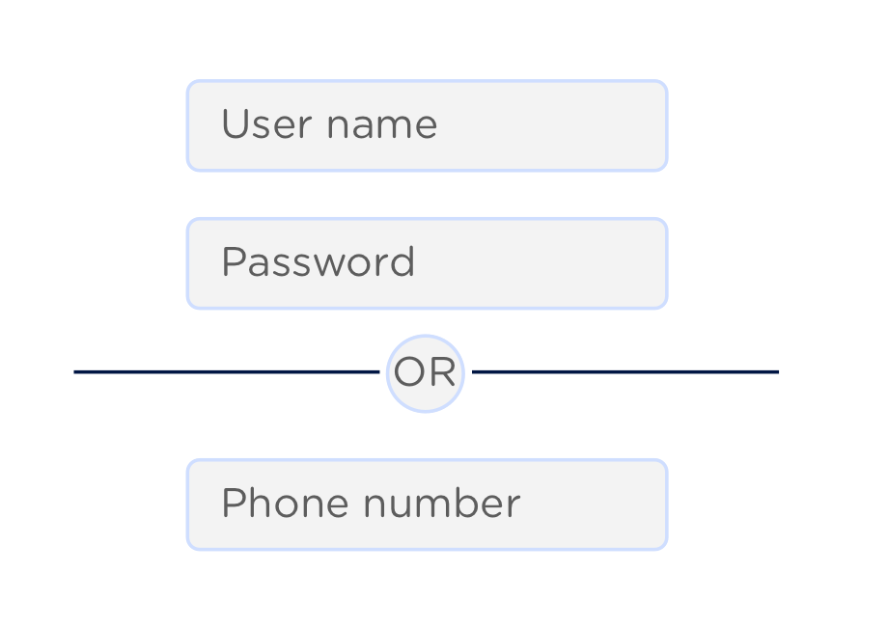

Figure1: User login Prompt

This app allows the user to create his or her account using Firebase Email and Password Authentication. Both customers need to register using restaurants and food login Page. During registration, some information about users are saved for real-time databases like age, name, and the like gender under the unique user idicreated by Google Firebase. Hence, each user profile informationiis saved in the databaseiand

when the user is logged he or she can get it using the user profile id and unique user id

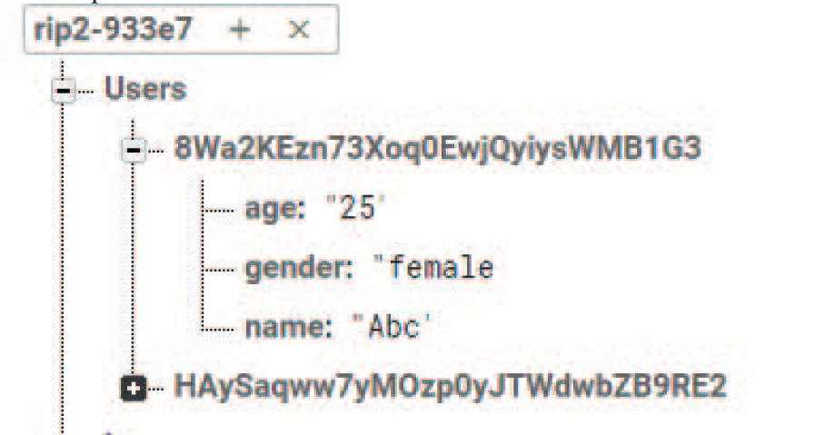

Figure 2: User information saved in Google firebase

User id and password of restaurant and user will be authenticated in firebase authentication.

The app user chose to log in as a restaurant user as a consumer of donating food or receiving food to someone.[2]

**Online business of goods used for resource efficiency**

**1. Internet based used goods business from a subjective perspective**

In social sciences sustainability researchers believe that environment-based features to the lesser rate the favourable attitude towards surroundings and acceptance by awareness about the surroundings. However, repeated, population’s surveys representative give proof of the difference between increased environmental disaster and concern knowledge of its consequences, as well as the environment and environment features which is consistent with same kind awareness on another. This can be happen to find collection of people who exhibits surrounding favourable features but doesn’t have a consistent attitude towards the surroundings (e.g., single older lady) is a group of high-performing individuals rate of environmental knowledge, but whose feature is non-environmental oriented (for example, families with environmentally friendly behavior can be managed to hover, but they still exist driving a family cars). Three bunch of attributes which affect stability of ways utilization research appeared: home social status (socio-demographic) features and time processing), user preferences (related to subjective preferences), choice of commodity and features, and real utilization features. Social Population properties which affect dissimilarities in terms of continual utilization forms along with women, age, education level, gender, maritalistatus andiincome, well-educated people included, and parents striveifor consistencyiof behavior and behavior.

West Berlin studied and conveyed that for the goods business used just like a particular region of utilization buying and selling used items is significantly associated with environmental goals.. Practical reasons for sales of used items are often mentioned, for example "make room" or "get rid of things".In contrast, financial goals are very important when buying used goods.The amount of mens buying and selling used items is slightly greater than that of women's.Average age is 36 years.. Two-thirds have jobs in the second-hand market. 10% of housewives and students are vendors, 5% are unemployed and pensioners each.Vendors frequently stay in many people’s homes in addition to smaller amounts frequently solo. Among buyers of secondary items, 29.4% were aged 19 to 25 and 35.7% of 26 for a group of 35 years. Many people have a job (61%), and students make buyers up to 15%, which is much higher than the ratio of vendors. The amount of education is greater than median, and so is the proportion of people staying in many family homes. Further step, it is important to explain how to divide an internet-based business item. A learning of vending-based traditions in addition to the aim of finding Internet-rooted capability. Ebay has started using the merchandise in Germany and the analysis is very different. The current trend is related to people's attitude towards the use and management of their goods.

If beliefs are uming, fewer and fewer services will be provided to secure the futures of individuals stabilizing the current. Short-term production phases with the "yearning for high quality" He found that items with premium labels contributed to this growth. Product "New" as well as "used" features are least necessary in terms of wished growth grade of living. This propensity to grow the grade of living through the consumption of items used is explained using the word "upgrade", high-grade items seem to be highly wishes. This development has been promoted by significantly less inherent scientific states (Internet-rooted marketing). It takes time and effort to demand particularly utilized items (for example, time to go to secondhand shops and shipments, antique stores, etc.) and for purchase transactions. In college, stretching is more important in people's lifestyle. Business relationships, social, emotional, are becoming constrained over time and support the modern plan of ​​"temporary ownership."Society, "Auction Culture" (beginning in 2000) Cumulative ”(1950 to 1970s) and“ social institutions ”(1980 and 1990)

“These types of auctions vary not only in terms of socio-demographics, but also in relation to them Purpose of buying used items. For example, "the auctioneer participates wholeheartedly" (Underage, high proportion of men, highly educated, jobbing), they use the Internet Surprise and being fond of selling and buying utilized products, deep and active on eBay, The Motivations of "open-minded second-hand shoppers" higher knowledge, frequent working non-full-time, they make use of internet more often,still do business There are very few times on eBay that make sense and practicality, as well as a logical proposal to worth as a search for personal belongings.[3]

**2. Online Trading and Sustainability**

By taking the case of eBay,the following topics will be addressed:

**2.1 Policy and goals for the environment EBay Consumer Attitudes About Trade:**

The first question concerns the relevant eBay consumer environment. Results: A large percentage of consumers exhibit environmentally sensitive behavior (Figure 1).

Figure 1. Ebay Consumer Environmental Scenario. Can we agree with the following statements about environmental protection? The percentage of responses that agree or strongly disagree is the (n) value. Source: Authors' calculations are valid n = 2,404; N = 107 does not exist; Total n = 2,511.

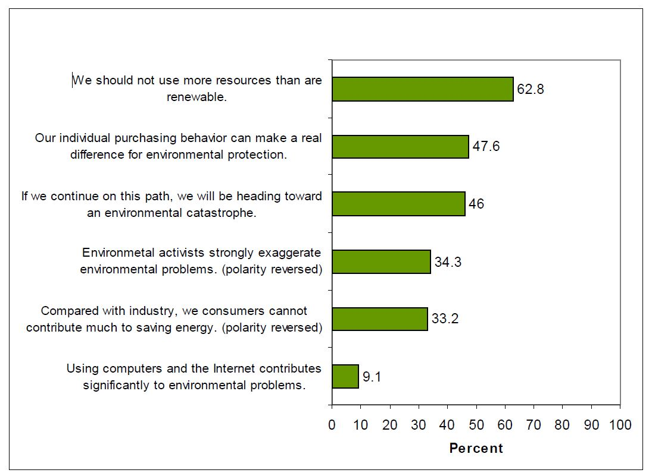

Figure 1. Environmental attitudes of eBay users.

However, most eBay users do not combine details and broadcasting usage technology in addition to surrounding issues.users of only 9.1% - regardless of gender the interview is that computer and internet usage contributes most environmental issues.[3]

**2.2 Used Products and Management of Used Products on eBay.**

Figure 2 ..The method of reordering used items. Can you agree with the following statements about redesigning used products? Percentage of people who answer the question, agree or strongly agree. Six possible responses level; Source: Authors Count Valid n = 2,410; N = 101 does not exist; Total n = 2,511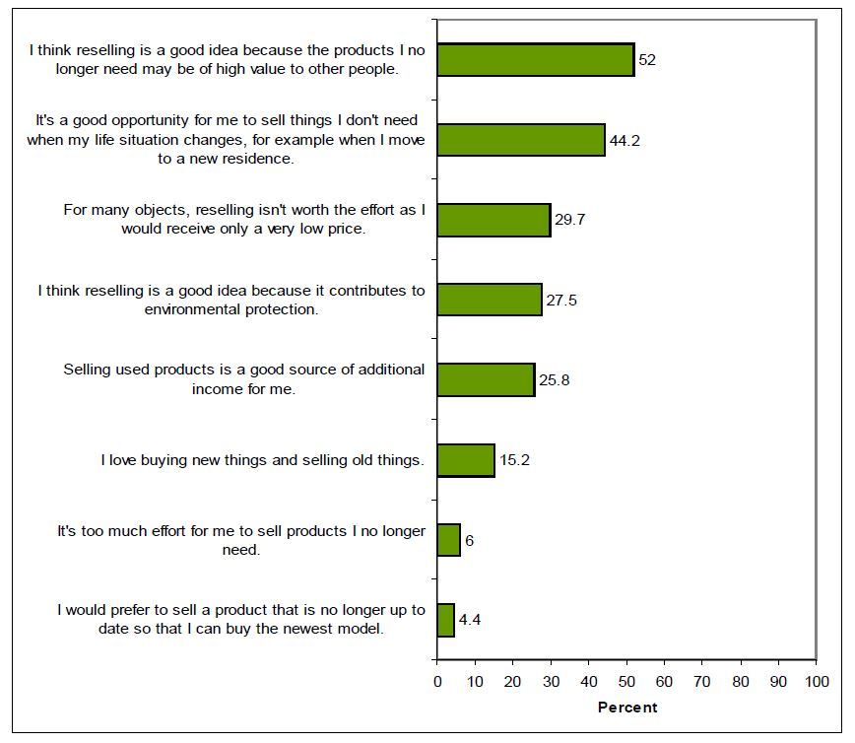

Figure 2. Attitudes toward reselling used goods.

The outcomes give the different factors that play an precious role in rearranging utilized goods. To look over eBay users, the products they use are no longer important to others.necessary opportunities to reuse used products can be life-altering situations (E.g., birth of a child, moving out of a parent's home, change of jobs, etc.). Half of eBay users view it as a good chance to trade unutilized items in their living condition..Anyhow, the reactions also give an starting indication of the current limits for the used business products. Sellers argued that rewriting was not worth the struggle. It is amazing that the many respondents accept or completely accept the assertion are older than those considered reselling is a better supplemental origin of wages. One will be able to assume,there are at least some collection of items here that will not meet predictions of commercial gain.[3]

**2.3 A type of user sample of eBay users is obtained from the data.**

The cluster examination was done here. The important outcomes of the examination is that the "reality" of internet marketing of goods utilized on eBay will be explained with the five consumption forms. They are: person who like to take recent things; Person who does not want to market goods; Encouraged by the prices of buyers and sellers of utilized products; Buyers as well as sellers of used goods are motivated by their environmental direction;And so-called prosecutors, who buy (qualitatively superior) goods for the purpose of selling look at them again and so they are not yet a particular environmental trend.[3]

**2.4 Advertisement Effect of OLX and Quikr for Used Product on Consumer**

As per the Associated Chamber of Commerce and Industry of India (ASSOCHAM), the market for second-hand and reused items in India at Rs 80,000 crore ($12,814), is up from Rs 69,000 crore ($1,1027m) in 2012. The report additionally evaluated that the market would cross Rs 1, 15,000 crore ($18,379m) by 2015. The market has recorded a development of 15 percent for each annum. It isn't simply vehicles, books and hardware individuals are purchasing utilized nowadays; we're likewise perusing through another person's contraptions, garments and adornments. Ladies are bound to purchase used books, extravagance products things, clothing while men are bound to purchase recycled CDs, DVDs, utilized vehicles, motorbikes and so on., including the paper. In settling on a decision between purchasing new or utilized, 18-multi year olds are the well on the way to choose recycled DVDs and CDs as a first decision, while the over-55s like to purchase these new. As of June 2014, there were 243 million guaranteed Internet clients in India out of which 192 million are dynamic Internet clients who get to the Internet at any rate once per month (IAMAI report). Every one of these clients are potential possibility for recycled items shopping.[9]

**The second hand goods market has played an important role in the prices of escort-hand goods**

Second hand objects are recorded materials reservoirs and consumption areas contain some or all of the original values ​​of goods. It may be useless or simple household goods;Also upgrading of hotels, government agencies and products agencies, institutions. The logjam of a list of items seized by court auctions and execution is also known as second hand items. These objects utilize worth and worth with their main functions and will be able to shift directly or indirectly to the remarketing link.As the value of the product increases, so will the people's great return method for not used items with disposal a logjam of products, lots of valuables are dealt and shipped.

Other key ingredients used by product companies for reprocessing or dealing are taking them into useful parts and then transacting new items directly between the sales and supply of third parties and demand that the parties use these three steps. Gains the worth of second hand products.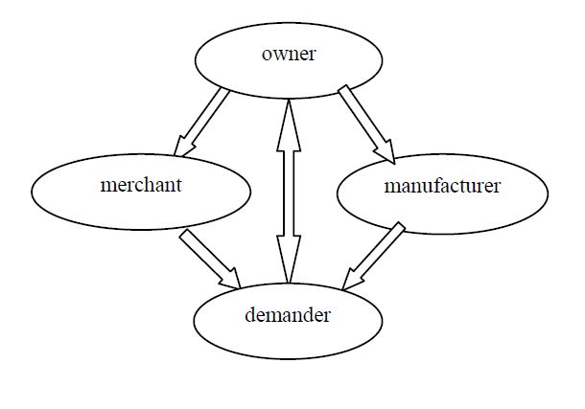

Figure 3: three main methods of second-hand goods

circulation

The three main phases of second hand items spreading as will be seen in figure. 3, Not only is the quality of the second hand items genuine, but recent value made in the second hand items market also absorbs the repair process. Few connected facilities, like investment and logistics testing, signing, estimation, preservation, restore, modification and covering, consume human workers; Value of labor is considered second hand items in circulation. The value and the concluding two steps get the quality of second hand items in real unchanged conditions. Overall, the Second Hand items market has a role. A necessary role in the practice of second hand items.[4]

**Appraisal for second-hand shopping**

This part explores entertainment, sensation as well as affordable encouragement for shopping second hand items. Entertainment motives such as exciting hunting and finding specialized products. With look on to sensation motivations doing a different as well as individual manner with second hand clothing. Ecumenical motivation is related to price sensitivity and financial constraints (Ferraro And others., 2016).[5]

**Recreational motivations**

Volunteer and staffs were asked about the different motivations for them to get customer to buy second hand product.Volunteers at Lions, Alva and, Burt and Astrid Anna at IM - Swedish development partner, and all employees, Eric development partners, Alice in Humana, Andrea and all partners in the Red Cross many customers find that they are inspired by the hunt and are amazed products. Andrea, Anders and Astrid customers are expected to come along often search for special products. This is related to enthusiasm for hunting for refreshment inspirations found by Ferraro et al. (2016). Anna identified that users wish to discover specific items before any other person but second hand shops, second hand shops normally will have a duplicate of each: Each item is different and I will take it before any other person does. - Anna, Eric, Development Partner. Every involved in the customer hub collection Benjamin, 20, BA, 20, Bella 23, Bianca, 19, and Bonnie, 22, are looking for a specific item;There are few things which encourages them to visit a regular store second hand shop. Furthermore, all contestants in the collection hub approved on whether they could, in some ways, be generous with the products. Anyhow, Benjamin, 20 years old, is the good portion of second hand shopping:I guess it's a lot of fun. The good hunk of it (hunting) is that you will be able to go there (at the second hand shop) and get absolutely everything. - Benjamin, 20[5]

**Fashion motivations**

For four workers, Anna at Ellie and Andrea at the Red Cross, Eric as a Development Partner, and Alice at Elena, second hand shopping has become fashionable. He often found people looking for old clothes. Ana trusts that second hand is a type of style: this will be a manner for people to be in their own personality. Each person likes to be specific. - Anna, Eric's development partner.

Andrea as well as her college colleague described when you shop your style second hand compared to H&M shopping, it is easy for many people to buy their clothes. You can actually make your own style here (Second Hand Shop). - Ally, Lol Cross.

**Economical motivations**

Volunteers as well as staff were questioned whether they believed the financial factors there will be a motorists for second hand shopping. This is the purpose of asking a connected question financially since shopping at a second hand shop is less compared to the shopping items in the general shop. Anders, a Lions volunteer, believes it is financial motivation is more important compared to moral elements. Andrea, employee of the Red Cross rather recognizing the economic encouragement is necessary. It depends upon what position in the customer's life. She claimed that for families financial encouragement is necessary for youngsters and children, mainly little ones youngsters build up quickly as well as frequently requires new dress. Along with that, Eric, employee, Anna the development partners recognize that the economy can be tied up you are in life with the state.He thought autos, desks and chairs were popular in the autumn when students had come to Lund to begin university:

In the autumn, students come and buy a sofa, a desk, a chair and perhaps a little table at their studio in Lund. The bed can be too. We now have a great request for desks and beds - Anna, Eric's development partner.[5]

**Complexities in the Environmental and Economic Assessments of Second-Hand Markets**

The environmental assessment literature does take into account the possibility that some new goods may have less environmental impact than older models. This situation can arise for energy consuming products, if most of the environmental impact is from use of the product rather than from manufacturing or disposal and if there have been signiﬁcant improvements in energy efﬁciency.A key example is there frigerator, because chloroﬂuorocarbon refrigerants have been banned and average energy consumption has been reduced by about two-thirds over the past 25 years (U.S. NRC 2001). For many products, however, typical life-cycle assessments indicate that the environmental impact of continuing to use an old product is small compared to the net environmental impact of disposal of the old productandmanufactureanduseofanewmodel of the same product. There has, however, been little theoretical or empirical analysis of the general relationship between the reuse of products and the demand for new products. As shown in ﬁgure 1, environmental life-cycle assessment takes into account the energy and wastes associated with a product’s entire lifecycle (Curran 1996). The drawing and the accompanying framework implicitly assume consideration of a single item,which could either be generated from raw materials or from recycled materials and could be purchased either newly manufactured or reused.[9]

**Motivation regarding canteens providing real time information of food wastage**

The present nourishment squander the executives framework utilizes notices and infographics to make a feeling of mindfulness among the clients about nourishment wastage. More often than not these infographics get unnoticed. The following are a portion of the infographics that were utilized in the bottle of SAP Labs Bengaluru, India.Internet of Things has helped our kin to live better. In view of the nature of the Internet of Things, this paper appeared. The possibility of this paper is to produce mindfulness among individuals when they take nourishment to eat in flasks. The focus on the crowd for this paper are office individuals eating at office bottles and inn understudies eating at inn mess. For this paper a little human overview was likewise led soliciting individuals from their responses when they see nourishment getting squandered in containers.

The instrument of this venture incorporates putting load sensors under the gauging scale (that gathers the squandered nourishment) and bringing the considers along with a database from where they are progressively appeared to a dashboard (visual screen) that is set over the gauging scale. When the client places the squandered nourishment in the receptacle, the perusing in gauging scale changes, that naturally triggers the figures to change in the dashboard. Right now client can realize that he has added to the nourishment wastage and this can create an awareness of other's expectations or mindfulness in him which can drove him to take less nourishment from that point onwards.[6]

**FUTURE WORK**

In the future, mobile apps can be further enhanced by including the some characteristics:

* Expanding the application to make multiple donations.
* Customers from restaurants or companies like a family or individual customer.
* Add place (GPS) feature to these applications.
* Donors must particularize the place of the partnership eats.
* Add the date and time of every food that customers share creating applications supports multiple platforms (Crossplate Recorder App)[4]
* To make non-availability of proper analytics in cafe/canteen/kitchens that leads to wastage of food.
* Information regarding the wastage of food is given to the customer.[6]

The idea of different process of development can be implemented:

* The arrangement and fast advancement of e-business has incredible effect on advertising deal design.
* The deal design dependent on e-business turns into another method for recycled auto deal pattern..
* This promoting design which interfaces with e-business firmly, so it centers around the customers and has more extensive and more disperses advertising associations, supplements to conventional showcasing example and it will inevitably replace customary deal design.[7]

Based on secondhand economics:

* . The broad-based content in this issue also showcases ways in which cultural and economic insight benefit from each other.
* For the most part, studies of secondhand goods focus on objects and materials whose value is ambiguous, shifting, and subjective, even when addressing primarily practical commodities such as automobiles. [10]

There have been second hand stores in recent years Paid much attention. On the other hand users are currently further concentrated in both donating and shopping items in shops, but other related experiments-66 The arm is limited.. networked second hand operates on shops, applications as well as other internet rooted plan of actions. Such as, while studying, it became understandable that applications as well as other internet-rooted plans of actions where Used products are becoming often famous for both selling as well as buying. Since did not mention these applications and other platforms, this may be related to coming time experiments to concentrate on this topic rather than somatic second hand shops. In addition, these contestants in the collection hub included students. Other proposal for coming time experiments is to collect specific knowledge.A collection of individuals, in case of the generation of baby boomers.[4]

**Smart and Green Urban Solid Waste Collection**

**Systems**

Smart and Green Waste Collection Strategies: Future information systems may help perform smart and green waste

collection across the whole process. In such a system, RFID tags are attached to bins and containers, RFIDreaders and GPS are equipped to vehicles, and weighing scales are distributed at transfer stations. All the elements can communicate with each other through sensor networks with the aid of centralized and/or decentralized servers to gather information in real time and dynamically run the proposed MCMC-ROROor similar algorithms. The optimized routing and scheduling strategies can be sent to vehicles with instructions via the smartphone and other terminals. The performance of vehicles and other equipment linked to these communication networks can be monitored and analyzed at all times, and the improvement strategies can be continually generated and reported back to the crew members and mission-control staff. The decision makers,public agencies, collection firms, crew members, and other stakeholders may interactively participate in such sustainable solid waste management plans through these smart and green waste collection systems. For more details about how to perform the integration of system analysis models and information technologies, please refer to the literature.[11]

**Second-hand consumption as a lifestyle choice**

Primarily, these findings have implications for formal and informal second-hand-channel providers. An understanding of the motivational drivers helps fair organisers, second-hand shop managers and individuals who sell in informal channels. Understanding the hedonic motivation could lead second-hand retailers to further focus on nostalgic and social factors, for example, by setting up small areas with benches where interaction between consumers can take place or by explaining to stall owners the importance of social interaction.[12]

**Secondhand Goods and Consumers' Preference in**

**Developing Countries**

We choose five product attributes for motorbikes: price, product age, mileage, brand, type, and origin. In general, price is definitely an important factor for consumers to determine whether they will purchase a product. According to our pre-experimental survey, the prices of new motorbikes ranged from VND 20 to 100 million, and the prices of new motorbikes for the majority of consumers ranged from VND30 to 50 million. Thus, we adopted 10, 30, 50, and 70 million as the price levels for a conjoint analysis.20Product age is the most important attribute for our purpose. A positive product age (non-zero) implies that the product is secondhand. We adopted 0, 2, 4, 6 as product ages. We also considered that instead of product age, mileage may play a key role when consumers purchase motorbikes. Thus, we conducted another series of conjoint questions for mileages. The following four levels are chosen: 0, 20,000, 40,000, and 60,000 kilometers.[13]

**Second hand cloth purchase**

The scholars have extensively investigated the SHC trend. From their significant efforts, an understanding emerged that

SHC is a complex phenomenon and previous scholars have revealed important components of this trend. Although the preceding discussion offered a good understanding of the history, consumption, and disposal of SHC and the impact of SHC on society, there are clearly many questions that still need to be answered. Therefore, based on the discussion, a list of future directions that scholars need to consider is provided

below. The intensive investigation of this study has shown that the extant literature on the SHC phenomenon has been built based on consumers’ perspective and as far as the authors’ best knowledge; there has been limited research on the sellers’ perspective. Therefore, the first recommendation is to fill this gap. For example, why and what makes individuals sell SHC? What are the advantages and disadvantages of selling

SHC products? How do SHC sellers choose their strategy to sell their goods in comparison to new clothes sellers? Is there any differences in selling to high end customers as opposed to ordinary customers? If so, what are they? In addition to the above questions, it is suggested that the SHC investigation be taken to another place.[14]

**Reuse goods shop**

Hardoff corporation is a company mainly engaged in the reuse business,they are located near big business centers and the shops are quiet spacious, clean, brightly illuminated and decorated, with abundant staff welcoming every customer as they enter the store. Goods are neatly placed in shelves and section wise. One can find costly brands like Rolex and Armani watches, Tommy Hilfiger and CDior products, Louis Vitton bags to name few. [15]

**approximating the Environmental reduction from Food Waste**

Evaluate the possible characteristic focal points of decreasing accessible and imaginable accessible sustenance throway from buyers, the thing to express sustenance throway parts from public assessments as remark about. Notwithstanding the creating such examinations, the couple of hindrances to be conquered to grow steadfast nature and proportionality in the middle of, considers. Examples like consolidate nonattendance regular procedure, the gathering which is used for waste, isn't adequately obvious to disengage sustenance throway totaled classes, the difficult of perceiving division like sustenance waste associated with nuclear family waste[16]

The sustenance being wasted can't be portrayed to single direct, however the blend of various practices it improve or lessen the like sustenance which is wasted. Sustenance throway the buyer last which has the best money related, public and impacts which includes lost, open entryway and not continuing people who live in hunger ordinary resources, additionally, various things, for instance, work and essentialness. To decrease sustenance throway, we have to understand the things related to throway land

With respect to understanding client direct, the Theory Planned Behavior (TPB) commonly put in application in settings and given insightful tempers, guidelines, saw power and points to gohead. The TPB, tempers address beneficial or harmful approximations of itself execution of unequivocal lead; passionate address perspective on public loads or material conviction that one or not to continue in view of a correct objective; saw social power shows the correct straightforwardness or inconvenience of continuing view of a correct objective; points address capacity to act in the light of a particular objective; in conclusion that lead which is the perceivable move settled on, stretching out from essential method to exercises that measurable individual or public centrality.

To react to this assessment question, the paper shows three goals: to join present work on customers' sustenance throway the direct. to test tentatively this model information from a nation is liable to outside sustenance imports, provoking creating care about sustenance This showed side of a greater search adventureSAFE-Q Safeguarding Food and Environment in Qatar, which intends to give the sustenance careful attempts in Qatar by constraining throway the transport and usage of sustenance, consequently the natural condition of sustenance supply chains Qatar. This usage point of view, battling that important factors affecting sustenance waste assistance increase our perception of sustenance waste direct, thusly exhorting plans for restricting sustenance waste and adding to cool sustenance security.[17]

**Food Waste Management: Study of Indian Hotel Industry**

Housing industry is seeing a monstrous advancement in India. The report of WTTC which shows "Travel and Tourism Economic Impact 2017 India" India is presenting 6.9 % to the world GDP. In this way, the count of worldwide people in motel factories started the undertaking in the nation. Beside different openings motel industry is going up against a couple of issues, throway of sustenance on of the big level..The levels of sustenance throway lodgings and hotels are charming importance and is frequently handled and not a real way prompts additional normal impacts. Present paper is an undertaking to take scientists and hotel people careful about the sustenance throway the board housing industry in nation by amassing the open things and collecting responses from business sustenance handled by field area survey.

Motel and bistro factory is the huge player in improvement of Travelling the places with everything taken into account in India, since hotels use large normal things from essentialness to sustenance and it is necessitated that attainable routine must be grasped and handling the enormous proportions of throway made is one of the critical importance.. In a motel huge bit of pay is delivered from kitchens from different areas which indicates a great deal of sustenance throway is in like manner created. The age of this waste and regulating it isn't only a budgetary issue anyway environmental issue also. Since the throwaway made here is food digested in environment and require large area to throw a lot of things got used to a comparative which basically improves the cost supervising it and takes a cost for the earth by making methane gas that is a contributor in nursery sway, likewise the obliteration to other vegetation in the near to zones by virtue of the toxins leaves by this throway. During the of time spent passing on best organizations and having benefits, the factory is constrained to give large bore and measuring sustenance sections to bear the test which is finally going to waste as making first rate sustenance for keeping and tasting the, huge proportion of sustenance is throwayed at the same time and comparably when the people left the plate on account of large portion or some other clarification sustenance to throway.there are various speeches where sustenance dustbin is created there is cost included for instance, expulsion and transport of waste and work money. The housing business wants to examine beneficial ways which can take save assets to cost caused and helping the throway the officials.HVS "Gauging Hotel Room Requirement by 2021" includes in their report that there is a normal need of 343000 lodgings constantly 2021. It truly says that the gigantic enthusiasm of motels in the future days.That kind of essential besides assembles the large throway from the lodgings. Lodgings are the large client of benefits and produce a large proportion of waste out of these benefits. The sustenance related waste is one of the huge challenges for motel factories too for the overall population as well. Due to the nonappearance of authentic guidelines and setting up the sustenance waste is transforming into an expanding issue for the accomplices. It is an undertaking to show the members careful about the distinctive waste organization practices which can be grasped by the housing business. It won't simply decreases their benefit money at this point what's more work for the sensible progression.[18]

**Gardening Waste Management**

Throw away are unwanted for human life moreover as resolute bit of every system realized various divisions for instance, agriculture and developing. Cultivation in Iran makes over 80% of the nation sustenance supplied; in like manner, this is one of the major producers of the unwanted things. It shows the hugeness of cultivating Losses and unwanted things the officials. Along these lines, a relevant investigation in Tehran locale was coordinated to perceive the issue and to propose appropriate responses for thorough waste organization in planting sub portion. In the underlying advance, the portrayal examining procedure is used to evaluate the present condition in formation of the cultivating wastes. The outcome of this assessment showed 45% yields mishaps in developing zones. In a manner to mull over the present condition, more emphasis was put on loose constraining procedures as the standard organization procedures, for instance, extraordinary green practices reliant on sorts of things. Among waste the administrators procedures were inspected on reuse, reuse and excrement according to the particular kind of unwanted thing. In any case, all kinds of solid unwanted, if they pass the major criteria, can be used in animals, cellulose adventures or changes the excrement manures. Improper thought on sustenance prosperity can change our sustenance into unappetizing unwanted things. Restricting of disasters and provincial waste organization in relationship with growing created grounds or age capability is an undeniably organized and broad procedure for getting sanitation.

Biological variety, rich supplies, work with ease and fast yield, and near points of interest in generation and fare of the items are the abilities of the farming segment. This segment supplies greater than 80% of the nation's nourishment. Be that as it may, high pace of misfortunes and wates is one of the most significant issues, which causes disappointment in upgraded usage of all potential right now. This examination with reviewing the creation procedure of the planting items and squanders in Tehran region as a case study is looking for social occasion and offering the arrangements so as to diminish in misfortunes with motivation behind development[19]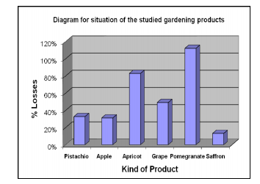

The Codex Alimentarius (Latin = "sustenance law" or "sustenance code") it is the combination of widespread measures for sustenance prosperity , purchaser security .losses of pomegranate and apricot under the considered things are greater than the others, in such a way that the hardships of pomegranate are essentially greater than 100% (the pace of lessening in thing that already gathering is also included), which is broad. The condition of mishaps in grapes is about half, which furthermore is a mind boggling aggregate. The situation of setbacks in pistachio and apple is generally in proportional conditions. At the present time, saffron has negligible mishaps due to being very significant and accurate the administrators. Weight ordinary of the mishaps in inspected developing things or then again X %45 Distinction of the models or S2= 541 Hence, it is enrolled a conviction between time comparable to 27% - 63% for the hardships of the whole sub section by 95% assurance list. By and by, it is possible to test typical models as shown by the preliminary hypothesis delineated in the part of reasoning. Consequently, invalid hypotheses (ordinary of the mishaps linked to the universe of the planting under territory is 30% or low) can be expelled. At long last, it is essential to acknowledge the quality as production of prosperity sustenance into thoroughly considered the sum as decrease in disasters and unwanted things, and to see that not thought of this characterization makes risks for what's come of country region.[19]

**Waste to Wealth:**

Sustenance wastage is a tremendous issue rising in the present world. It became a significant problem in our overall population a few years back that impacts "poor and rich countries' ' essentially and as demonstrated by the Agriculture Affiliation for all intents and purposes half message of conveyed sustenance are not used. By this unwanted things sustenance we in like manner unwanted things the "time and essentialness" that we used to make the sustenance additionally, too our "trademark resources" and "limited open rustic land" will be spent that will be dealt with in an enormously improved and viable way. Moreover,unwanted things have a strong fiscal condition and impacts the earth adding the general nursery air that is gas release. To avoid each and every such condition to complete IOT Based Smart Garbage and Waste Collection canisters (SGWC). We thought relies upon making a social regard for decline sustenance unwanted things through evaluating and demonstrating the proportion of sustenance wasted and reusing the wasted sustenance using embedded systems. The Food waste evacuation machine (FWDM) used here reuses the unwanted sustenance to have excrement at growing.

**Incentive and Backdrop**

Present sustenance unwanted things the board, close by governments regulate sustenance waste by sending sustenance waste containers and using different pickup associations for sustenance waste collection. Regardless, the present sustenance waste the administrators methodology relies upon a level of, like, a worth structure that pays a singular no changes in the cost, which occurs common issues and extends waste that leaves considering there is no confinement on overpowering creators of sustenance unwanted thing and no propelling powers for lighter creators. Since sustenance unwanted things producers do whatever it takes not to have a prompt load of cost for delivering waste, it is hard for their waste to be capable of being diminished. Likewise, the low resolute nature of estimations on sustenance waste has raised a ruckus in changing and managing discharge aggregates in light of the fact that a close by government secures diverse pickup associations for waste collection, and all of them uses a unmistakable evaluating method. To deal with these issues in existing sustenance waste the board, a volume-rate squander removal system which is used introduced. Three sorts of volume-rate squander removal structures, that is, good plastic rubbish sacks, and RFID-based refuse information which is collected structures, are starting at now which is used..[20]

**CONCLUSION**

There are multiple several reactions, both financially as well as socially. Anyhow we can avoid food waste or the use of ministerial orders along with that technology has decreased. Mobile application automation for food waste is advantageous management. The application targets to promote good management of food. Our proposed solution is to cut down on food dispersed by allowing food to be shared within the used mobile of community of UAE. This is the initial stage of the work creating a good set-up to decrease daily wastage of food.

The survey results indicate that surrounding elements perform a small character for the greater number. EBay surveys customers when they trade used products. Especially when it comes to his motivations, other factors remain necessary for date: empirical as well as monetary inspections, as well enjoy doing business on Ebay. Business opportunities on Ebay are increased in surroundings favourably in giving knowledge about the surroundings value of utilized materials, directly, at Ebay Step. Also, a wide range of eBay that offers a good start points for the formation of alliances of intentions that link environmental factors with other aspects of use. The option of providing an opportunity for climate-neutrality is a definite strategic intervention transferring on the eBay plan of actions,along with that eBay customers suggest greater wishes to utilize like an choice.[2]

Exploring drive and encourages users to buy second hand items. After five interviews with volunteers and staff and a collection hub having five students who always take second hand, it describes that there are different inspirations and drivers for second hand trading..[3]

This examination endeavors to give a top to bottom investigation of purchaser conduct. According to the investigation publicizing affects shoppers' buying conduct i.e they not just influence their observation for recycled items however Global Journal of Multidisciplinary Research and Development additionally make a brain to buy recycled items. Customers do offer significance to commercial be it through T.V just as informal gestures of recognition. Promotions on web assume a crucial job in purchasing the items. Curiously, from one perspective individuals accept that commercials of recycled items increment their deal yet then again individuals feel that such ads don't give a genuine image of the item showcased.

Ongoing visual examination is utilized to acquire continuous insights and figures of information to give to the crowd. Right now, screens will be introduced in the containers that are connected to the scales estimating the waste nourishment (that individuals drop after their dinner). This paper finishes up with a thought of how insights would permit individuals to squander less nourishment as realizing the amount we are adding to the nourishment squander makes an awareness of other's expectations and mindfulness in our psyche which will at last lead us to take less nourishment and waste less nourishment. The paper likewise helps in getting brilliant bits of knowledge from those insights that will likewise help in deciding strides to follow before requesting nourishment for that organization/lodging. The thought isn't just to urge container proprietors to arrange less nourishment materials yet to make an awareness of other's expectations among individuals to spare nourishment.[6]

In customary exchange of recycled autos, purchasers and venders deals with one another the situation being what it is holding unbalanced data. The e-business showcasing example of recycled vehicles can understand the blend of customary examples and present day ones superbly. It makes the exchange of second – hand vehicles helpfully and opportune, guarantees the purchasers, lessens the operational costs, ensures the assessment and after-deal administrations, makes the benefits increasingly impartial and keeps the undertakings' advancement perpetual. In any case, we have to represent that the e-business promoting design be the supplement and improvement to the exist ones. Thusly, all the showcasing designs that we can apply and apply legitimately now don't repulse with this new one. That is, every one of these examples can be applied.[7]

The development of any recycled market builds in general monetary welfare (as deﬁned in the financial matters writing), whether or not these business sectors invigorate interest for new products. For this reason,economic and social policy might extensively favor the advancement of recycled markets. The monetary motivation for exchange progression suggests support with the expectation of complimentary activity of recycled markets. Then again, in spite of the fact that there is an inclination to consider used markets as little scale, nearby, rummage sale-style exercises, various recycled markets are in reality worldwide, enormous scale monetary powerhouses. As recycled markets keep on developing, they will progressively contend with inefﬁcient makers of new products, including those in creating nations. Recycled markets are probably going to proceed to grow through both trade liberalization and the improvement of data innovation. These business sectors are progressively universal, and they Will have signiﬁcant environmental implications, just as social and monetary ramifications. In some cases,these developments will reduce overall material utilization. Indeed, even in these cases, in any case, nitty gritty investigation is expected to assess the net natural effects, considering ecological contrasts among new and utilized items, just as transportation impacts.[8]

Another fascinating truth is that individuals recall the main recycled item advertisers' (e.g OLX and QUIKR) promotions most extreme because of their climaxes. The requirements of individuals have duplicated yet the salary isn't expanded with that pace. With regards to customer things, the ascent in salary may not be proportionate to the ascent in want and these unfulfilled wants are driving them to the recycled market to fill the hole. For youthful experts in metropolitan urban communities, who would prefer not to bargain their status, the recycled market offers a progressively helpful and monetarily reasonable methods for shopping to these buyers.[9]

Used items bounce all through view, submerging as junk and afterward returning as used, utilized, vintage, collectible, or some other momentarily esteemed classification. As the articles right now illustrate, used items were rarely fringe, however covered with and added to by and large monetary improvements, reflecting and influencing changes in them. This, they despite everything do. In view of this common association, the utilization of used items and materials isn't generally or fundamentally connected to social and natural motivation or endeavors to diminish utilization, yet may even empower more, not less, direct consumption.39 this has suggestions for the manner by which we comprehend the job of used utilization in the full connection among creation and utilization as the twenty-first century unfolds.[10]

We coordinated a cautious composing review on the improvement of urban solid waste combination structures and dense four trademark insufficiencies of the present assessments regarding supportable waste organization. Since the present examinations disregarded nearby complexities in waste collection and related improvement plots among making and made countries, we analyzed the differences between the urban zones of making and made countries. The two-compose variety contrive considered as a standard urban solid waste collection plot in China falls under the center point coordinating issue just as the proceed onward get off guiding issue in systems analysis.As a presentation, such a structure in Shenzhen, China, was picked for showing analysis.[11]

There has been a development in reused use in various formal and easygoing movement channels. As opposed to as of late disseminated investigations, there is confirmation that German buyers are not overwhelmingly controlled by budgetary expectations and don't give off an impression of being driven by common manners of thinking either. The disclosures recommend that German clients are logically impelled to participate in reused use for social and nostalgic reasons, which proposes that lifestyle accept an essential activity in the decision to purchase second-hand. The outcomes have recommendations for reused retailers and sensible facilitators, similarly as standard retailers, who can use this information to make an atmosphere wherein these two motivations are supported.[12]

We had gone into the intrigue side of utilized things by using field test data finished in the northern bit of Vietnam. In particular, we reviewed if the enthusiasm for utilized things is colossal in Vietnam, what sorts of clients have more grounded tendency for utilized product, and if imports of utilized items are really connected with biological and medicinal issues. We gained a ton of entrancing results on the association between thing qualities and solicitation

(ii) the association among thing and individual qualities.

Those results give noteworthy methodology proposal on trade and the environmental pieces of utilized things. In spite of the way that it is possible that the condition on tendency for utilized things contrasts across countries, we acknowledge that the noteworthiness of looking at the issue of utilized things to the extent both intrigue and supply is verified.[13]

The SHC fragment has formed into a noteworthy fiscal factor which gives a living to more than a hundred thousand people. The composing shows that a general SHC design has progressed and changed after some time and merits a full assessment. Inside this assessment, it was found that specialists have concentrated their examinations on three noteworthy sections: a foundation set apart by SHC, utilization and evacuation of SHC, and the impact of SHC. Notwithstanding the way that these estimations have given extraordinary leads and some understanding, the revelations from these investigations don't offer a full picture of the SHC marvel. This assessment is among the first to screen and substance separate the SHC composing. The revelations of this assessment give clearness on is' opinion of this miracle and even more basically they give clear future research headings. As the SHC use design continues growing, a strong assortment of research is truly expected to outfit neighborhood governments and business specialists with heading in dealing with this phenomenon.[14]

As needs be, this ECO RECYCLE FACTORY with imaginative fix and cleaning structures isn't simply growing the life of the things yet likewise help in reducing waste expulsion into the earth realizing less pollution and decreasing the use of new unrefined materials. Right now, stores are help not solely to buyers and sellers of items yet furthermore to nature. It decreases the proportion of waste land filled. In a country like India, with goliath masses generally fiscally increasingly delicate regions these reuse shops will help them with using development effortlessly. Since this kind of development needs colossal space and staff with specific aptitudes (to grasp fixes), any immense business house can acknowledge this as an open entryway for business extension, and offer a motivating force to used items. Further research can be made industry shrewd, the openness of used product in India, and affiliations overseeing reuse items in different bits of the world.[15]

Stresses around sustenance protection and its close by relationship with environment brief reevaluate concerning sustenance unwanted things, and expressly regarding the areand how it happens all through characteristic hierarchies.[17]

Large scale assembling of sustenance waste from housing industry is such a significant test, so there is a tremendous essential to develop a widely inclusive framework for waste the board. In housing industry most of the sustenance wastes are compostable. The present examination is an undertaking to show that a practical waste organization not simply urges the relationship to work for an eco-obliging condition yet moreover has any kind of effect them to gain advantage out of it. Waste the board is such a troublesome issue which needs the thought of open too government experts. The present examination not simply urges the lodgings to grasp a reasonable waste organization yet moreover makes the experts work in the stress field.[18]

• Culture making, for instance, creators getting ready for progression and affirmation of watching creation benchmarks, transport, backing and scattering of agrarian things, which is successfully open to masters.

• Nowadays, among assurance of the agrarian equipment is the proportion of mishaps, and government ought to bring this factor into thought while moving such advances.

• For any circumstance, watching a masterminded course of action for course of action of creating model in Iran reliant on distinctive provincial locations to change the point of confinement of the stock items linked to rustic things including storage facilities and so on (as demonstrated by their location) additionally, making of a particular thing in a district for evasion of other disturbance in traveled charges warehousing can be practical to reduce in setbacks moreover, unwanted conveyed later assemble.

• the thought on lowering in agricultural disasters moreover, unwanted things is as an ensured course in order to gain the cultivating and sanitation's thing.[19]

sharp IOT based garbage the officials structure helps in IR sensor, microcontroller likewise, Wi-Fi module. The structure ensures the dustbins very fast. when the refuse stage of lands at its generally outrageous. In case the dustbin isn't clear in express time, by then the information is sent to the more huge position office who can make fitting move against the imported work brief specialist. The decreases the total number of trips of rubbish variety motors and in this manner lowers the general utilize related with the rubbish the information. It finally useful with keeping discipline in the society. Thusly, the adroit junk the officials structure makes the rubbish collection dynamically capable. Such structures are frail against ravaging of sections in the structure in other ways which ought to be tackled. The grandstand system helped to make the care about the sustenance waste to the human. The reusing methodology is used to change over the unwanted sustenance to make fertilizer at growing.[20]

**References**

1. Food sharing, redistribution, and waste reduction via mobile applications: a social network analysis “John Harveya,, Andrew Smitha, James Gouldinga, Ines Branco Illodob<https://doi.org/10.1016/j.indmarman.2019.02.019> Received 8 April 2018; Received in revised form 13 February 2019; Accepted 27 February 2019
2. A Food Wastage Reduction Mobile Application “Ayesha Anzer, Hadeel A. Tabaza, and Wedad Ahmed”2018 IEEE DOI 10.1109/W-FiCloud.2018.00030
3. Contribution of Online Trading of Used Goods to Resource Efficiency: An Empirical Study of eBay Users “Jens Clausen 1,*, Birgit Blättel-Mink 2, Lorenz Erdmann 3 and Christine Henseling 3” DOI:10.3390/su2061810ISSN2071-1050 www.mdpi.com/journal/sustainability
4. Implementing Circular Consumption by Means of Second-hand Goods Market “Hong-yan XUE Dong-hong YANG”978-1-4244-5326-9/10/$26.00 ©2010 IEEE
5. Drivers and motivations for second-hand shopping”Frida Haraldsson and Sonja Peric”International Business and Marketing Spring 2017
6. Visual screens in Canteens providing Real Time information of Food Wastage” Shivani Dalmia” Email : shivani.dalmia@sap.com
7. The Research on e-business Marketing Pattern of Second-hand car “Wenshan Wang The Youth league committee of Hubei University of Automobile Technology Hubei University of Automobile Technology,HUAT Shiyan, China wangwenshan1979@163.com
8. Demand and Dematerialization Impacts of Second-Hand Markets ”Valerie Thomas“ Princeton Environmental Institute Princeton University 28 Guyot Hall Princeton, NJ 08544, USA vmthomas@princeton.edu Volume 7, Number 2,www.princeton.edu/vthomas
9. Advertisement Effect of OLX and Quikr for Used Product on Consumer of Northern India “Yogesh Kumar “Research Scholar, Punjabi University Regional Centre for Information Technology and Management, Phase-VII, Mohali-160062, Punjab, India.
10. Changing Secondhand Economies “Karen Tranberg Hansen & Jennifer Le Zotte”To cite this article: Karen Tranberg Hansen & Jennifer Le Zotte (2019) Changing Secondhand Economies, Business History, 61:1, 1-16, DOI: 10.1080/00076791.2018.1543041 To link to this article: <https://doi.org/10.1080/00076791.2018.1543041>
11. Smart and Green Urban Solid Waste CollectionSystems: Advances, Challenges, and PerspectivesJia-Wei Lu, Ni-Bin Chang, Senior Member, IEEE, Li Liao, and Meng-Ying Liao
12. Second-hand consumption as a lifestyle choice Prof. Dr Adrienne Steffen (Germany) |Hochschule für Internationales Management – International University Heidelberg
13. Demand for Secondhand Goods and Consumers’ Preference in Developing Countries: An analysis using the field experimental data of Vietnamese consumers1 HIGASHIDA Keisaku School of Economics, Kwansei Gakuin University Nguyen Ngoc MAIFaculty of International Economics, Hanoi Foreign Trade University
14. THE INCREASING PHENOMENON OF SECOND-HAND CLOTHES PURCHASE: INSIGHTS FROM THE LITERATURE Halimin Herjanto1,Jean Scheller-Sampson1, Elisabeth Erickson1 1 McKendree University School of Business, McKendree University 701 College Road, Lebanon, IL 62254 Correspnding author; Email: [hherjanto@mckendree.edu](mailto:hherjanto@mckendree.edu)
15. A Study on Customer Attitude towards Reuse Goods Shop A Case Study with Respect to Hard off Corporation, Japan Dr. V. Krishna Mohan Professor, Department of Commerce and Management Studies,Andhra University, Visakhapatnam, Andhra Pradesh, India [E-Mail-vkmohan1958@gmail.com](mailto:E-Mail-vkmohan1958@gmail.com) P.l.Padmaja Research Scholar, R&D,JNTUK, Kakinada, Andhra Pradesh, India [E-Mail-padmajaglster@gmail.com](mailto:E-Mail-padmajaglster@gmail.com).
16. Wasting Food, Wasting Resources Potential Environmental Savings Through Food Waste Reductions Arkaitz Usubiaga ,1 Isabela Butnar,1 and Philipp Schepelmann2 1UCL Institute for Sustainable Resources, London, United Kingdom 2Wuppertal Institut fur Klima Umwelt Energie GmbH, Wuppertal, Germany Address correspondence to: Arkaitz Usubiaga, UCL Institute for Sustainable Resources, Central House, 14 Upper Woburn Place, London, WC1H 0NN, UnitedKingdom.Email: [arkaitz.usubiaga.15@ucl.ac.uk](mailto:arkaitz.usubiaga.15@ucl.ac.uk) © 2017 The Authors. Journal of Industrial Ecology, published by Wiley Periodicals, Inc., on behalf of Yale University. This is an open access article under the terms of the Creative Commons Attribution License, which permits use, distribution and reproduction in any medium, provided the original work is properly cited.DOI: 10.1111/jiec.12695
17. A consumer behavioural approach to food waste © Emel Aktas, Hafize Sahin, Zeynep Topaloglu, Akunna Oledinma, Abul Kalam Samsul Huda,Zahir Irani, Amir M. Sharif, Tamara van’t Wout and Mehran Kamrava. Published by Emerald Publishing Limited. This article is published under the Creative Commons Attribution (CC BY 4.0) licence. Anyone may reproduce, distribute, translate and create derivative works of this article ( for both commercial and non-commercial purposes), subject to full attribution to the original publication and authors. The full terms of this licencemaybeseenat<http://creativecommons.org/licences/by/4.0/legalcode>
18. Food Waste Management: Study of Indian Hotel Industry 1Dr. Dilbag Singh, 2Mr. Amandeep 1, 2Assistant Professor, Department of Tourism and Hotel Management, Central University of Haryana © 2018 IJCRT | Volume 6, Issue 1 February 2018 | ISSN: 2320-2882
19. Gardening Waste Management - Case Study: Tehran - Iran Homayoon Fakhim Ahmadi, Environment and Sustainable Agriculture office, Ministry of Agriculture Iran Email address: fakhim.ahmadi@gmail.com Qolamreza Miraki Environment and Sustainable Agriculture office, Ministry of Agriculture,Iran Arash Rezaee University of Applied Science and Technology Tehran's Municipality 2010 International Conference on Chemistry and Chemical Engineering (ICCCE 2010)
20. Waste to Wealth- A Novel Approach for Food Waste Management K.Jayalakshmi S.Pavithra C. Aarthi Department of ECE Sengunthar Engineering College Tiruchengodeshri.jaymails@gmail.com,pavithrasivasubramanian@gmail.com, [anuarthi@gmail.com](mailto:anuarthi@gmail.com) 2017 International Conference on Electrical, Instrumentation and Communication Engineering (ICEICE2017)