SMART ASSISTANT

**Swathi Kindre1, Priyadarshini P2, Pratiksha R3, Ashwini4, Ramyashree5**

Department of Computer Science and Engineering

Shri Madhwa Vadiraja Institute of Technology and Management, Bantakal,Udupi

[1swathi.16cs097@sode-edu.in](mailto:1swathi.16cs097@sode-edu.in), [2priyadarshini.16cs064@sode-edu.in](mailto:2priyadarshini.16cs064@sode-edu.in), [3pratiksha.16cs061@sode-edu.in](mailto:3pratiksha.16cs061@sode-edu.in), [4ashwini.16cs015@sode-edu.in](mailto:4ashwini.16cs015@sode-edu.in), [5ramyashree.cs@sode-edu.in](mailto:5ramyashree.cs@sode-edu.in)

***Abstract*--- The Blind stick system is capable of operating in user friendly manner, so that the blind person can walk independently without getting help from others. This system assists the blind to navigate on their own. In case of emergency situations such as high traffic density or the person feels unsafe and is in need of help, the location of the member is shared with the family members. The prototype model consists of a stick and a hand glove with vibrator motor. The stick with sensors deployed can detect obstacles in front with sensors and it will produce vibration on a finger depending upon the direction. The vibration would alert the user. The Blind stick system is equipped with in built GPS and GSM equipment, so that if the blind person needs help from the family he can press the emergency button which is present on the stick and then his location will be shared with his family. By trial and error method the system can detect obstacles such as pedestrians, objects with greater accuracy. This system is very user friendly and safety as well.**

# **I. INTRODUCTION**

Leading a blind life is one of the greatest challenges in the world. As soon as they wake up in the morning, till they sleep at the night they are dependent on others.

Physiological, anatomical or neurological malfunctioning are the causes of Blindness. Human eyes are the most important unit of an organism. But according to world Health Organization approximately 285 million people are estimated to be visually impaired worldwide[11]. Among them 39 million people are blind and 82% of the blind people are above the age of 50. And 90% of these visually impaired people belong to the developing countries. According to a recent survey, India is the home for more than 15 millions[11] Physical movement friendly, easily is very risky for these people. The conventional walking stick used by them is only used as a body support and watch dogs are not reliable. They are dependent on others in one or the other way. There are various devices emerged to help out these blind people. But unfortunately, all these devices contain one or other disadvantages. Visually impaired people faced so many difficulties in their day-to-day life. One of such problems which they face is physical movement and self-navigation in the environment which is new to them. Also when they walk in a highly populated area they may find it very difficult. One of the existing problems of already available walking sticks with hearing aids is that it may not be useful when the blind is travelling in a noisy area. It is very difficult for a normal and healthy person to reach the destination within the time constraint. But for unfortunates like the blind people finding a location becomes extremely tough task. They will be in need of continuous guidelines and companionship until they

reach their desired destination. In the increasing complexity of day-to-day life, blind people are not coming outdoors due to risk factors. Walking indoors is also very difficult when they are new to the particular place[12]. Not only travelling independently ,they also face problems to read any text or messages. It is very difficult for them to visualize the real world. Hence to help such people we are doing this project. The main aim of our project is to provide a smart blind stick to blind people. Then the stick alerts the user by vibrations whenever it encounters an object. To make sure that the stick is user maintainable at a reasonable cost.

# **II. BACKGROUND**

The paper [1] consists of a walking stick based on ultrasonic sensors. To detect the objects in the path of a blind person, an ultrasonic sensor module, HC-SR04 is used. To make the person alert when any obstacles are detected, a buzzer is used. But using buzzers may irritate the user and even cause noise pollution to some extent. To overcome this, we are using vibrator motor placed inside the gloves which the user will be wearing. This will be very effective means to alert the user in case of any obstacles. The main aim of this system in paper [2] was to design an artificial navigation system. This system can be used both indoors and outdoors. Reflection properties of ultrasound are used to detect any type of upcoming obstacles and potholes. In paper [3] the blind stick is made of a pvc pipe. It consists of ultrasonic sensors 2 in front, one on left and right side. They have placed a magnetometer which estimates the heading directions in degrees. The GPS receiver was been placed to collect the latitude and longitude co- ordinates. Paper[4] contains an electronic

Walking stick which provides assistance to the blind users. They also have used two infrared sensors to cover the near distance i.e., between 2-10 cms. The stick consists of a button in case of emergency or worst condition. On pressing that button, message will be sent to the saved mobile numbers. Successfully tested by both blind-folded and blind persons. A small injury to the portion of the eyes may lead to temporary or permanent vision blindness. Every day there are a lot of problems faced by the visually impaired people such as navigation for a blind ,to avoid these problems the researches are been carried out with all the new technologies. This system is been designed for the navigation and been implemented into a walking stick for a blind person to walk or travel individually. This system consist of hardware components such as, Arduino nano for processing the received data and identifies distance of object.IR Sensor for the detection of the presence of the obstacle, Voice playback module for providing the voice message alert for the blind in order to prevent the collision of the obstacles, it also uses GPS and GSM modules for the location tracking and to send the alert messages to the parent of the blind to the predefined contacts if blind person needs an immediate help blind can press the button mounted on the device which will initiates the GSM to send the message. In addition to this a moisture sensor is been added to avoid the slippery areas which are been covered in the blinds path .All these components are been mounted on a single stick[6].

# **III. METHADOLOGY**

The main aim of our project is to provide assistance to visually challenged people

without depending on others, so that they can navigate with ease using advanced technology. In this technology controlled world, people would like to live independently. This project suggests that an innovative stick with all integrated facilities for blind people , help them gain personal confidence. Since this is very nominal and not bulky, one can make use of it very easily. The paper describes ultrasonic blind stick with GPS tracking system. The aim of this paper is to help visually impaired people using a stick to find out if any obstacles are present in front of them. The ultrasonic blind walking stick is way more advanced than the traditional walking stick as the use of sensors makes object detection easier.GPS gives the latitude and longitude by which current location can be traced.

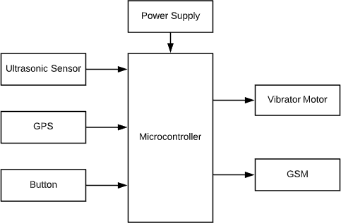

**Fig. 1 Block diagram of the system.**

A.COMPONENT DETAILS

1.ULTRASONIC SENSOR WORKING MODULE:

The ultrasonic sensor works on the principle of SONAR and RADAR system which is used to determine the distance to an object. An ultrasonic sensor generates the high-

frequency sound (ultrasound) waves. When this ultrasound hits the object, it reflects as echo which is sensed by the receiver as shown in below figure.

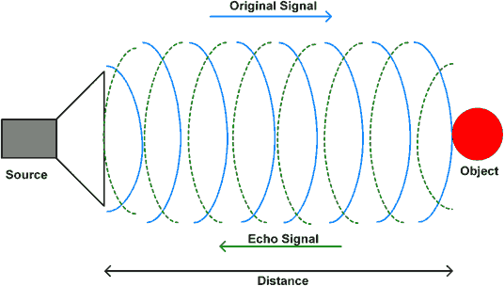

**Fig. 2 Diagram of UltraSonic Working Principle.**

By measuring the time required for the echo to reach to the receiver, we can calculate the distance. This is the basic working principle of Ultrasonic module to measure distance.

2. HC-SR-04 ULTRASONIC MODULE

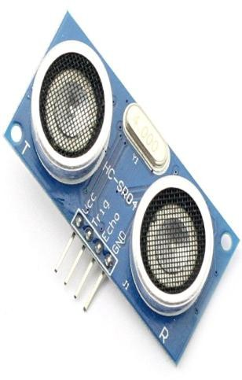

Fig. 3 Ultrasonic Module

HC-SR-04 has an ultrasonic transmitter, receiver and control circuit. In ultrasonic module HCSR04, we have to give trigger pulse, so that it will generate ultrasound of frequency 40 kHz. After generating ultrasound i.e. 8 pulses of 40 kHz, it makes echo pin high. Echo pin remains high until it does not get the echo sound back. So the width of echo pin will be the time for sound to travel to the object and return back.

Once we get the time we can calculate distance, as we know the speed of sound. HC-SR04 can measure up to range from 2 cm - 400 cm.

Distance= Speed*Time

The speed of sound waves is 343 m/s. So,

Total Distance=343*Time/2

Total distance is divided by 2 because signal travels from HC-SR04 to object and returns to the module HC-SR-04.

3.ARDUINO UNO MICROCONTROLLER

In figure it is showing an Arduino board is an open source platform used for building electronics projects. Arduino is a programmable circuit’s board which we can write a program based on our projects. Arduino program will be uploading with IDE (Integrated Development Environment) software that runs on your computer, it is used to write and upload computer code to the Arduino physical board. Arduino language is merely a set of C/C++ functions that can be called from your code.

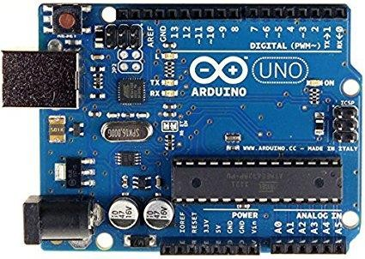

**Fig. 4 Arduino Uno Microcontroller**

4. NEO GPS 6M

The NEO-6M GPS module is shown in the figure below. It comes with an external antenna, and doesn’t come with header pins. So, you’ll need to get and solder some.

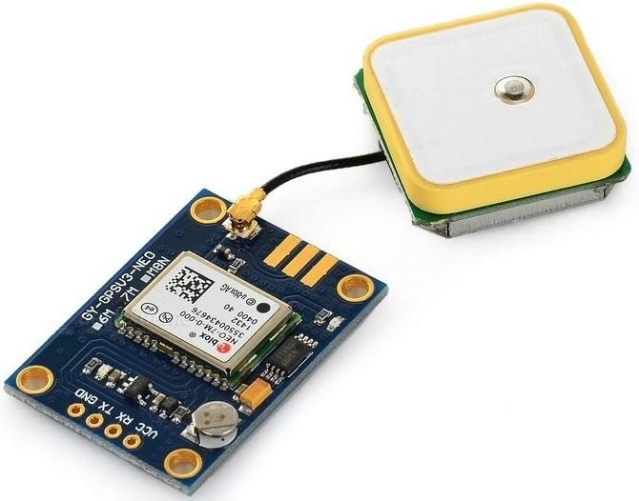

**Fig. 5 NEO GPS 6M**

* + This module has an external antenna and built-in EEPROM.
  + Interface: RS232 TTL
  + Power supply: 3V to 5V
  + Default baud-rate: 9600 bps
  + Works with standard NMEA sentences. The NEO-6M GPS module is also compatible with other microcontroller boards.

5. VIBRATOR MOTOR

Vibration motor is a coreless [DC motor](https://www.elprocus.com/dc-motor-basics-types-application/) and the size of this motor is compact. The main purpose of this motor is to alert the user from receiving the call by without sound/vibrating. These motors are applicable for different applications like pagers, handsets, cell phones, etc. The main

feature of this motor is, it has magnetic properties, lightweight, and motor size is small. Based on these features, the motor performance is highly consistent. The configuration of these [motors](https://www.elprocus.com/different-types-of-servo-motors-dc-servo-motor-and-ac-servo-motor/) can be done in two varieties one is coin model and another one is a cylinder model. The vibrator motor specifications mainly include type, max operating torque, max. centrifugal force, weight range, rated current and output.

VIBRATION MOTOR DESIGN AND WORKING:

The construction of these motors can be done in two varieties one is coin model and another one is the cylinder/ bar model.

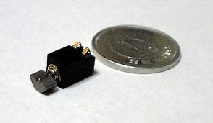

**Fig. 6 vibrator-motor**

1). Coin Type Vibrator Motor

The coin type motor can be built with a case, bearing, rotor, shaft, magnet, bracket, FPC, counterweight, brush, coil assembly, lead wire, & adhesive UV. The commutation points get in touch with brushes end. It will strengthen the coils within the rotor. Stimulating the coils generates a magnetic field & it is well-built to cooperate with the ring magnet incorporated into the stator to cause rotation. Because of the magnetic field, a force can be generated which causes the weight to move. The frequent dislocation of the weight generates an unstable force called as vibration. Motor’s commutation points can be used to change the pairs of polarity, so that when the rotator moves, then the electrical coils are continually overturning the polarity.

**WORKING**

This system consists of three ultrasonic sensors and three vibrator motors which are placed on thumb finger, fore-finger and middle-fingers of hand gloves. If object is detected by front of the blind person then vibrator placed in the forefinger will vibrate. Same way if the object is detected on the left side of the user then the fore-finger vibrator motor will vibrate and if the object is detected on the right side of the user then the middle-finger vibrator motor will vibrate. This is how the person will come to know in which direction obstacles are detected. There is an emergency button in a blink stick system. If blind person needs any help in the case of emergency then he can press the button and then stick will send a message to the numbers that are been saved on the stick with the location of the blind person through GPS and GSM.

# **IV.CONCLUSION**

The implementation of a wearable glove to aid visually impaired people is presented. The proposed system uses ultrasonic sensors to detect obstacles and uses haptic(vibration) feedback to find the location and distance of the object. Three ultrasonic sensors are used instead of one so the user can detect obstacles from front, left and right directions. Since the system uses haptic feedback deaf people can also use this prototype. The components used are small and hence lightweight compared to other devices. In the future, additional modes can be added to improve the performance. A rainwater protection cover can also be developed to protect the circuit.

# **REFERENCES**

1. Naiwrita Dey, Ankita Paul, Pritha Ghosh, Chandrama Mukherjee , Rahul De Sohini Dey “ Ultrasonic Sensor Based Smart Blind Stick” , International Conference on Current Trends toward Converging

Technologies,2018,Coimbatore,India.

1. Arnesh Sen, Kaustav Sen, Jayoti Das,” Ultrasonic Blind Stick For Completely Blind People To Avoid Any Kind Of Obstacles”, Dept. of Physics, Jadavpur University, Kolkata, India.
2. Nishant Banat James,Ashish Harshola,” Navigation Aiding Stick for the Visually Impaired”, *International Conference on Green Computing and Internet of Things.*
3. 1Shashank Chaurasia, 2K.V.N. Kavitha,” *AN ELECTRONIC WALKING STICK FOR BLINDS”,* International Conference on Information Communication & Embedded Systems.
4. Monther M. Al-Shehabi, Mustahsan Mir, Abdullah M. Ali, and Ahmed M. Ali,” An Obstacle Detection and Guidance System for Mobility

of Visually Impaired in Unfamiliar Indoor Environments”, *International Journal of Computer and Electrical Engineering, Vol. 6, No. 4.*

1. Ambika R, Dr .Sarika Raga ,”VOICE ASSISTIVE SMART WALKING STICK FOR BLINDS USING GPS AND GSM

TECHNIQUES”, International Journal of Research and Analytical Reviews, Volume 5,Issue 3,July 2018.

1. Suchita Wankhade , Mrunali Bichukale,Shruti Desai, Shraddha Kamthe, Archana Borate, ”Smart Stick for Blind People with Live Video Feed, “International Research Journal of Engineering and Technology, Volume: 04, Issue:03, Mar-2017.
2. Syed Rizal Alfam Wan Alwi, Mohamad Noh Ahmad, “Survey on Outdoor Navigation System Needs for Blind People,” 978-1-4799-2656- 5/13/$31.00 ©2013 IEEE.
3. Asha G. Hagargund, SharshaVanira Thota, MitadruBera,Eram Fatima Shaik, “Image to Speech Conversion for Visually Impaired,” International Journal of Latest Research in Engineering and Technology, Volume 03,Issue 06, June 2017.
4. Akhila .S, Disha M Rani, Divyashree

.D,Varshini.S.S, ”Smart Stick for Blind Using Raspberry Pi”, International Journal of Engineering Research & Technology, Volume 04,Issue 22,Special Issue 2016.

[11].Alshbatt,AbdelIlahNour, “Automated Mobility and Orientation System for Blind or Partially.”INTERNATIONAL JOURNAL ON SMART SENSING AND INTELLIGENT SYSTEMS,568-582,2013.

1. World Health

Organization.(2013),”Universal eye health:a global action plan “,2014-2019.

1. Osama Bader AL-Barm International Journal of Latest Trends in Engineering and Technology(1JLTETJ).

[14].Bradley,N.A.; Duniop,M.D. An experimental investigation into wayfinding directions for visually impaired people.pers.Ubiquitous Comput.2005,9,395-403.

1. Durette,B., Louveton,N., Alleysson,D.,and H’erault,J,2008.visuo-auditory sensory substitution for mobility assistance:testing The VIBE.In Workshop on Computer Vision Application for the Visually Impaired,Marseille,France.
2. Rabia Jafri, Rodrigo Louzada Campos, Syed Abid Ali and Hamid R Arabnia, “Visual and infrared sensor data-based obstacle detection for the visually impaired using the google project tango tablet development kit and the unity engine,” IEEE Feb 14,2017.
3. Deepthi Jain B, Shwetha M Thakur and K V Suresh, “Visual Assistance for Blind using

Image Processing,” International Conference on Communication and Signal Processing, April 3- 5,2018.

1. Akhilesh Krishnan, Deepakraj G, Nishanth N and Dr.K.M.Anandkumar, ”Autonomous Walking Stick For The Blind Using Echolocation And Image Processing,” 978-1- 5090-5256-1/16/$31.00 ,2016 IEEE.
2. S.Jeya Anusuya, S.Venkat, P.Nagasree, R. Soniya and P.N.Srilekha, “Smart Indoor and Outdoor Guiding System for Blind,” International Journal of Innovative Research in Science, Engineering and Technology, vol

.8,Special issue 2, March 2019.

1. Abhishek Bhokare, Amrutha Amberkar, Anvesh Gawde, Pratham Kale and Abhijeet Pasi, “Ultrasonic Blind Walking Stick,” International Journal on Recent Innovation Trends in Computing and Communication, Vol.4, Issue:1