[1]

**Improving Functional Properties of Mg-4Zn-1Sr alloy using Cryo Ball** **Burnshing Technique**

Rakshith Kotian1a, Akashraj 1b, Chirag Nayak1c, Bhaskar M2d, Gajanan Anne1e, Aditya Kudva S1f

*Department of Mechanical Engineering*,

*Shri Madhwa Vadiraja Institute of Technology and Management, Bantakal*

*Project Assitant, Department of chemistry;*

*IIT Madras*

*Abstract*— Cryogenic ball burnishing was carried out for Mg-4Zn-1Sr alloy. The alloy was homogenized at 300˚C for 24 hrs. Cryogenic ball burnished material were characterized using optical microscope and the result showed significant reduction in the grain size (up to 7.6µm) when compared with that of cast alloy (260µm) . The best surface roughness of 38.5 nm was achieved by the depth of press-0.6 mm, feed-450 mm/min, no of pass-1(DFN641) sample. Maximum micro hardness of 114±6 HV was achieved for depth of press-0.6mm, feed-450 mm/min, no of pass-1 (DFN641) sample which was about 1.9 times higher in comparison with that of cast alloy 58±3 HV. Corrosion test of the alloy was investigated in SBF solution using immersion test. The corrosion rate of depth of press-0.6mm, feed-450 mm/min, no of pass-2 (DFN642) sample improved (1.33 mm/year) 5.74 times in comparsion with that of cast Mg-4Zn-1Sr alloy (7.65 mm/year) due to fine grain structure.

***Keywords***­- Cryogenic ball burnishing, Mg-4Zn-1Sr, Micro structure, Vickers hardness, Corrosion, Immersion test.

15-06-2020

*Corresponding author.

E-mail address: a*([raksith.16me041@sode-edu.in](mailto:raksith.16me041@sode-edu.in)),

b ([akashraj.16me011@sode-edu.in](mailto:akashraj.16me011@sode-edu.in)),

c ([chiragnayak.16me027@sode-edu.in](mailto:chiragnayak.16me027@sode-edu.in)),

d (bhaskar_bmt@yahoo.co.in)

e ([gajanan.mech@sode-edu.in](mailto:gajanan.mech@sode-edu.in)),

f ([kudva.mech@sode-edu](mailto:kudva.mech@sode-edu).in).

1. INTRODUCTION

Metallic materials play an important role as biomaterials to assist with the repair or replacement of bone tissue that has become diseased or damaged due to their combination of high mechanical strength and fracture toughness [1]. Some of the currently used implant materials are Stainless steel, cobalt-chromium alloys, Ti and Ti alloys. However, the limitations of current metallic biomaterials in orthopedic applications are the unmatched elastic modulus with that of natural bone tissue and release of toxic metallic ions and/or particles through corrosion or wear processes [2,3]. Moreover metallic biomaterials remain as permanent fixtures which must be removed by a second surgical procedure after healing [4]. Due to which there is a need for new metallic material for temporary orthopedic applications. Polymers have wide acceptance for orthopedic applications. Mostly used polymers are ultra-high molecular weight polyethylene or high-density polyethylene. Polymeric materials are used in medical application for osteosynthesis but are limited in their load-attitude capacity and mechanical strength [5,6]. The role of biodegradable implants is to support tissue regeneration, heal the speciﬁc trauma and ﬁnally disappear through degradation in biological environment [7].

Compared to the commonly used metallic biomaterials, Magnesium (Mg) alloys have outstanding advantages including being essential to human metabolism, biocompatibility and the possibility to eliminate a second operation for implant removal [8]. Mg was ﬁrst reported for medical application in 1878 as ligatures. The physician Edward C. Huse used Mg wires to stop the bleeding vessels of three patients in 1878 [9]. Magnesium is the fourth most abundant cation in the human body. The mechanical properties of Mg and its alloys such as Young’s modulus of elasticity (E=41-45GPa) and density (1.784-1.84 g/cm³) are similar that of bone (E=15-25GPa) and density (1.8-2.1 g/cm³) respectively [10]. Mg ions are common metabolites in the body with a daily consumption range of 250-300 mg/day and are naturally stored in the bones [11]. Despite many advantages, the major limitation of Mg based alloy as biomedical application is their high corrosion rate [12]. Due to which the mechanical properties of Mg based alloy decreases. There are certain strategies like alloying, surface modification through coatings which have been used to improve the corrosion behavior and biocompatibility of magnesium.

Alloying is one of the most effective method to improve various properties of metals including mechanical and chemical properties. The metals like Al, RE, Zn, Ca, Mn, Si, Sr etc. are used as alloying elements for magnesium for orthopedic application. Severe plastic deformation (SPD) techniques such as equal channel angular pressing (ECAP), Multi Directional Forging (MDF) and ball burnishing are effective ways to improve the strength of materials [13]. The SPD techniques leads to grain refinement of materials, resulting in strengthening based on the Hall- Petch relationship [14, 15]. SPD is used to induce large strain so that the ultra-fine grain structure is obtained. Moreover, it was reported that grain refinement attributed to the SPD techniques contributed to the improvement in corrosion resistance of some materials such as AZ31 Mg alloy [16], Mg-Li-Ca alloy [17], and Mg-4Y-3Nd alloy [18]. Burnishing is a SPD process to induce high strain and strain rate for the purpose of improving the surface integrity [19].Burnishing has improved corrosion resistance of AZ31 by refining grains and forming strong basal texture in the surface layer [19]. In some of the study it is reported that low plasticity burnishing can provide a layer of compressive residual stress with sufficient depth to increase the fatigue life of many materials [20] .Cryogenic machining has been shown to offer improved tool life across a wide range of materials, and the ability of cryogenic coolants such as liquid nitrogen to carry away the heat generated during machining offers to precisely engineer the surface characteristics of the material [21]. The key benefit of using cryogenic machining is the elimination of secondary cleaning process usually necessitated to wash off contamination from flood coolant (water/oil emulsion) [21]. The aim of this project is to improve the mechanical integrity and corrosion resistance of Mg-4Zn-1Sr using cryogenic ball burnishing for orthopedic application.

## EXPERIMENTAL METHOD

* 1. Material preparation

The Mg–4Zn-1Sr binary alloy with percentages of Zn (4 wt.%) were cast using high purity magnesium (≥99.9 wt.%) ingots, zinc (≥99.9 wt.%) and strontium (>99.2 wt.%) granules as raw materials. The casting is conducted at 750–800 °C under control of 99% CO2 in an electrical resistance furnace and mechanical agitation was carried out throughout the process to minimize the impurities in molten alloy. Homogenization was carried out at 300ᵒC for 24 hrs in a muffle furnace.

|  |  |  |  |
| --- | --- | --- | --- |
| **Alloys** | **Zn** | **Sr** | **Mg** |
| Mg-4%Zn-1Sr | 4.08 | 1.08 | Bal |

Table 1- Chemical composition of Mg-4%Zn-1%Sr

* 1. Cryogenic ball burnishing

Cryogenic ball burnishing was carried out using liquid nitrogen in FANUC CNC milling machine. The material was kept inside the container, which was immersed with 200ml of liquid nitrogen. Infrared thermometer was used to observe the temperature at the start and end of the machining process.

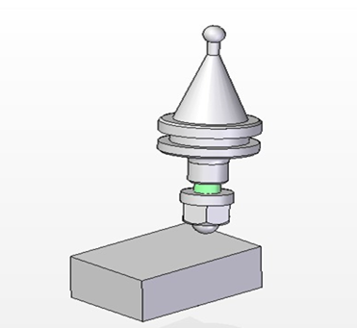

BT40 holder

Tungsten carbide ball

Homogenised sample

Fig 1- Ball Burnishing Tool

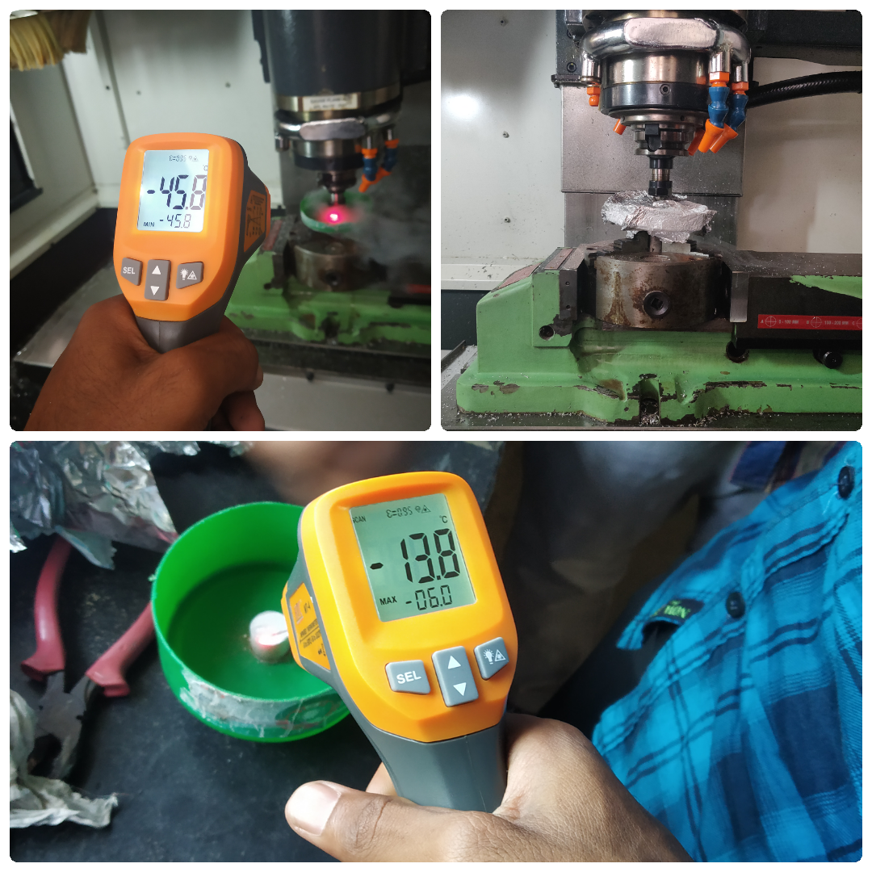

Fig 2- Cryogenic Ball burnishing Process

* 1. Characterization

2.3.1 Optical microscope

The microstructural examination was done for cast and ball burnished sample to study the dimensional changes, bonding quality and grain refinement. Metallographic specimens were cold mounted with the help of acrylic powder and resins. The specimens were polished up to 2000 grit SiC paper and final polishing was done with the help of cloth using 0.25μm diamond paste. For microstructure analysis, chemical etching was performed in order to visualize grain boundaries. Polished samples were etched with acetic-picral solution (4.2 gm picric acid, 70 ml ethanol, 20 ml glacial acetic acid and 20 ml distilled water) solution and then dried in hot air.

* 1. Mechanical Properties

2.4.1 Micro hardness

The Vickers hardness test can be performed on both micro-macro scales with a maximum test load of 10 grams. Applying controlled pressure for a standard length of time, but a square-based diamond pyramid indenter. The diagonal of the resulting indention is measured under a microscope, then this measurement and the test load are used in a specific formula to calculate the Vickers hardness value. Vickers hardness test for homogenized and Cryogenic ball burnished Mg-4Zn-1Sr alloy samples will be carried out using Omni-tech micro hardness machine.

Vickers number (HV) = 1.854(F/D2)

F being the applied load (measured in kilograms-force), D2 being the area of indentation (measured in square millimeters).

* 1. Corrosion study

2.5.1 Immersion study

Immersion testing is used to determine the resistance of material to an aggressive, aqueous environment. Standard laboratory corrosion coupons are utilized to determine weight loss due to corrosion. The test method normalizes corrosion rates to units of time, typically in mm/yr or mils per year. The terms vary, but results can usually be obtained within a 10 or 20 day exposure cycle. Immersion corrosion test will be conducted according to ASTM G31-72 standard. Samples will be ﬁnely polished and then it will be immersed in simulated body fluid solution at room temperature for 7 days. Hydrogen evolution and pH of the solutions will be recorded during immersion test.

PH =3.65 (Δ w /ρ)

Where, PH = corrosion rate through hydrogen evolution (mm/ year), ρ = metal density (g/cm3), and Δ w = weight loss rate (mg/cm2/d).

One mol (24.31 g) of Mg metal corrodes for each mol (22.4 L) of hydrogen gas production.

Therefore, the hydrogen evolution rate, VH (ml/cm2/d), is related to the metallic weight loss rate.

Δ w= 1.085VH

Where, VH= hydrogen evolution rate (ml/cm2/d).

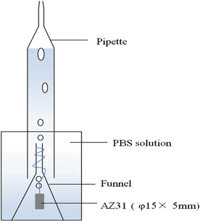

Fig 3- Immersion Test Apparatus

1. Results and Discussion

### 3.1 Optical microscope

The optical microscope of cast sample and Mg-4Zn-1Sr for depth of press 0.6, feed 450, no of passes 1, was obtained. Cast sample microstructure consists of primary phase and secondary phase. The primary phase is α-Mg phase and secondary phase consist of Zn and Sr phases, which is distributed in the grain boundary as shown in fig 4.The grain size for the cast alloy was found to be 260µm. Fig 5 shows the microstructure of the cryogenic ball burnished sample, were in ball burnished effect upto 7.6µm which revealed fine grain structure due to grain refinement during the cryogenic ball burnishing process.

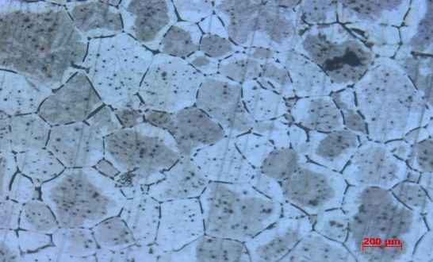

Fig 4- OM image of cast alloy

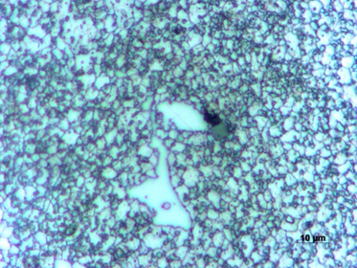

Fig 5- OM image of DFN641 sample

|  |  |  |  |  |  |
| --- | --- | --- | --- | --- | --- |
| **Exp. no** | **Sample Code** | **Depth of press**  **(mm)** | **Feed Rate**  **(mm/min)** | **Number of pass** | **Micro hardness** |
| - | - | As cast | - | - | 58±3 |
| - | - | Homogenized | - | - | 49±4 |
| 1 | DFN211 | 0.2 | 150 | 1 | 72±4 |
| 2 | DFN212 | 0.2 | 150 | 2 | 76±3 |
| 3 | DFN231 | 0.2 | 300 | 1 | 74±4 |
| 4 | DFN232 | 0.2 | 300 | 2 | 76±3 |
| 5 | DFN241 | 0.2 | 450 | 1 | 75±3 |
| 6 | DFN242 | 0.2 | 450 | 2 | 80±4 |
| 7 | DFN411 | 0.4 | 150 | 1 | 84±4 |
| 8 | DFN412 | 0.4 | 150 | 2 | 89±3 |
| 9 | DFN431 | 0.4 | 300 | 1 | 86±4 |
| 10 | DFN432 | 0.4 | 300 | 2 | 92±3 |
| 11 | DFN441 | 0.4 | 450 | 1 | 88±3 |
| 12 | DFN442 | 0.4 | 450 | 2 | 96±4 |
| 13 | DFN611 | 0.6 | 150 | 1 | 103±3 |
| 14 | DFN612 | 0.6 | 150 | 2 | 102±3 |
| 15 | DFN631 | 0.6 | 300 | 1 | 107±4 |
| 16 | DFN632 | 0.6 | 300 | 2 | 106±4 |
| 17 | DFN641 | 0.6 | 450 | 1 | 114±6 |
| 18 | DFN642 | 0.6 | 450 | 2 | 109±4 |

* 1. Micro Hardness Test Result

Micro hardness of cast Mg-4Zn-1Sr sample was found to be 58 HV and homogenized sample was found to be 49±4 HV. After Cryogenic Ball burnishing the micro hardness increased to 75±3 HV for depth of cut of 0.2mm, number of passes 2, feed rate of 450 mm/min which can be attributed to strain of the material. For depth of cut of 0.6 mm, number of passes 1, feed rate of 450 mm/min, the micro hardness increased to 114±6 HV, which can be attributed to the combined effect of strain hardening and grain refinement.

Table 2- Microhardness Results

Fig 6- Microhardness Plot

3.3 Atomic force microscopy

The AFM image of the unpolished sample is shown in the figure 7. The surface roughness of the Mg-4%Zn-1%Sr (depth of press- 0.6, feed-450, no of pass-1) sample was found to be 38.5. The increase in depth of press leads to increase the surface roughness of the alloy. From the surface topography it is clearly evident that, there is no much lay, waviness in the cryogenic ball burnished sample. It is observed from the topographic map that cryogenic ball burnishing produces better surface property, inducing residual compressive stress at the surface.

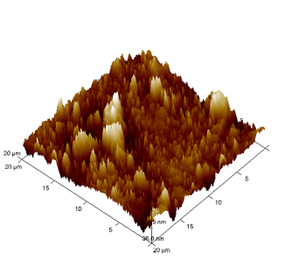

Fig 7- Surface topography for DFN641 Sample

* 1. Immersion study

|  |  |  |
| --- | --- | --- |
| **Sample** | **Hydrogen evolution rate VH**  **(ml/cm2/d)** | **Corrosion rate**  **PH**  **(mm/ year)** |
| As cast | 1.6 | 7.65 |
| DFN241 | 1.2 | 3.56 |
| DFN641 | 0.6 | 2.66 |
| DFN642 | 0.9 | 1.33 |

Table 3- Immersion Test Results

The corrosion rate was calculated by immersion test which showed that the corrosion rate of cryogenic ball burnished Mg-4Zn-1Sr (DFN642) alloy (1.33 mm/y) decreased by 5.74 times as compared to that of cast sample (7.65 mm/y). From the graph it can be observed that there is a decrease in the corrosion rate of the cryogenic ball burnished alloy compared to the cast alloy.

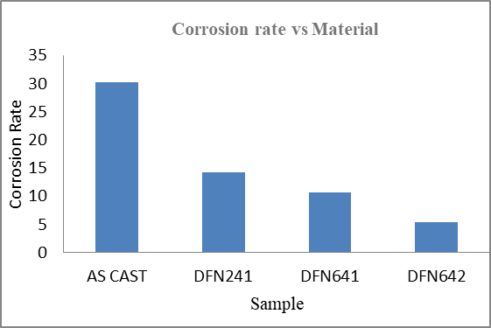

Fig 8- Corrosion Rate Plot

1. Conclusion

Mg-4Zn-1Sr alloy were exposed to homogenization heat treatment process at 300°C for 24 hours. Thus obtained Mg alloy was subjected to Cryogenic ball burnishing process. The results are as below:

* Grain size of Mg-4Zn-1Sr alloys reduced to 7.6μm , for a depth of press of 0.6 mm, feed rate of 450 mm/min and number of passes 1 when compared to cast alloy 260μm which can be attributed to dislocation and grain subdivision.
* Micro hardness value 114±6 HV for Mg-4Zn-1Sr alloy was found to be maximum for depth of cut of 0.6 mm, feed rate of 450 mm/min and number of passes 1, which can be due to the combined effect of strain hardening, grain refinement and textural changes.
* Lower surface roughness value 38.5 nm is obtained at 0.6 mm depth of press, number of pass: 1, feed rate 450 mm/min for Mg-4Zn-1Sr respectively.
* Corrosion rate of Cryogenic ball burnished Mg-4Zn-1Sr alloy (1.33mm/y) decreased by 5.74 times as compared to that of cast sample (7.65 mm/y).
* Improved corrosion resistance is due to grain refinement and higher residual stress.

ACKNOWLEDGMENT

The author gratefully appreciate the support of department of mechanical engineering NITK, Suratkal for providing various testing facilities for our work.

*REFERNCES*

[1] B. Ratner, A. Hoffman, F. Schoen, J. Lemons, Biomaterials Science: An Introduction to Materials in Medicine, third ed., Elsevier, (2013) 209-222.

[2] D.A. Puleo, W.W. Huh, J. Appl. Biomater. 6 (1995) 109‒116.

[3] J.J. Jacobs, J.L. Gilbert, R.M. Urban, J. Bone Joint Surg. A 80 (1998) 268‒282

[4] M. Niinomi, Metall. Mater. Trans. A 33 (2002) 77‒486.

[5] A.Gupta, V.Kumar, New emerging trends in synthetic biodegradablepolymers–Polylactide: acritique, Eur.polym.J.43 (2007)4053–4074.

[6] W.-J.Li, J.A.Cooper, R.L.Mauck, R.S.Tuan, Fabrication and characterization of six electrospunpoly(α-hydroxyester)-basedfibrous scaffolds for tissue engineering applications, Actabiomaterialia2(2006)377–385.

[8] Junxio Chen, Lili Tan, Xiaoming Yu, Iniobong P.Ehim, Muhammed Ibrahim, Ke Yang. Mechanical properties of magnesium alloys for medical application (2018).

[9] N.I.Saris, E.Mervala, H.Karppanen, J.A.Khawaja,A.Lewenstam,Clin.Chim Acta 294(2000)

[10] Huse, E, A New Ligature.Chic.Med.J.Exam.(1872)172.

[11] M.P.Staiger, A.M.Pietak, J.Huadmai, G.Dias ,magnesium and its alloys as orthopedic biomaterials: a review ,Biomaterials 27 (2006) 1728-1734.

[12] J.Walker, S.Shadanbaz, T.B. Woodfield, M.P.Staiger, G.Dias magnesium biomaterials for orthopedic applications :a review from a biological perspective, J.Biomed mater.Res.14 (1980)225-237.

[13] Y.zhao, G.Wu, J.Jiang, H.M.Wong, K.W.Yeung, P.K.chw, Improved corrosion resitance and cytocompatibilty of Magnesium alloy by two stages of cooling in heat treatment, corros,sci 59(2012) 360-365.

[14] R. Z. Valiev and T. G. Langdon, Principles of equal-channel angular pressing as a processing tool for grain refinement, Prog. Mater Sci., 51 (2006) 881-891.

[15] E. O. Hall, The Deformation and Ageing of Mild Steel: III Discussion of Results, Proc. Phys. Soc. Sect. B, 64 (1951) 747-753.

[16] N. J. Petch, The Cleavage Strength of Polycrystals, J. of the Iron and Steel Inst., 174 (1953) 25-28.

[17] Z. Pu, S. Yang, G. L. Song, O. W. Dillon Jr., D. A. Puleo and I. S. Jawahir, Ultrafine-grained surface layer on Mg–Al–Zn alloy produced by cryogenic burnishing for enhanced corrosion resistance, Scripta Mater., 65 (2011) 520-523.

[18] R. C. Zeng, L. Sun, Y. F. Zheng, H. Z. Cui and E. H. Han, Corrosion and characterisation of dual phase Mg–Li–Ca alloy in Hank’s solution: The influence of microstructural features, Corros. Sci., 79 (2014) 69-82.

[19] Skalski K, Morawski A, Przybylski W. Analysis of contact elastic-plastic strains during the process of burnishing. Int. J. Mech. Sci.(1995); 37:461-472.

[20] Prevey P, Cammett J, Low cost corrosion damage mitigation and improved fatigue performance of low plasticity burnished 7075-T6, J.Mater. Eng. Perform.(2001),10:548-55.

[21] I.S.Jawahir, D.A. Puleo, J. Schoop, Cryogenic machining of biomedical implant materials for improved functional performance, life and sustainability, Procedia CIRP 46 (2016)7-14.

1.