**RETRACTABLE STABILIZER WHEEL SUPPORTED BICYCLE**

**Pranav Mohan1, Sachin Salian2, Sharan3, Dr Sudarshan Rao K 4**

*1 Students, Department of Mechanical Engineering, SMVITM, Bantakal, Karnataka, India*

*4 Professor & Head, Department of Mechanical Engineering, SMVITM, Bantakal, Karnataka, India*

-------------------------------------------------------------***---------------------------------------------------------------

**Abstract -** The present work relates to the design and fabrication of stabilizer wheel supported bicycle. Rider operable and retractable stabilizer wheels are designed to be used as a rider’s assistance to support weight of the rider during impending, slowing and stopping the bicycle. The rider engages support wheels to obtain assistance while seated. To engage and constrain the mechanisms manually, hand-lever mechanism is used. The retractable wheels are mounted on the stand, with a provision of raising and lowering the wheels as per requirement.

***Key Words*: Retractable stabilizer wheel, hand-lever mechanism.**

1. **Introduction**

A bicycle is a pedal driven vehicle having two wheels which are attached to a frame one behind the other. It is one of the most efficient modes of transportation in terms of energy applied and the output. Cycling is and has been used extensively in India. It provides various benefits in the form of no dependence on any energy sources, zero pollution and improved fitness. India has an increase in population, urbanization and economic growth over the years. Due to this there is increased traffic jam, difficulty in driving and increased pollution. In the present generation most of the youth and adults are obese and the main reason for this is they don’t find time for exercising due to their heavy workload and stress.

Currently the technology of using a stabilizer wheel is restricted to kids and the designs are fixed structures which are removed once the kid learns to ride the bicycle. The literature review reveals that several patents have been done in stabilizing a bicycle [1-6].

David Willman (1991) [1] have patented a retractable stop support wheels for a motorcycle by using hydraulic cylinders for actuation which gives stability during start and stop operation. Salvio Plana (2000) [2] have patented a side wheel attachment for a bicycle by providing a coil spring structure replacing a single structural rod this can increase stability but only to a certain extent.

There are also studies which show usage of vertical spring loaded strut assemblies [3] to improve stability and vertical positioning of the bicycle. At present there is increased research on stability of autonomous vehicles [4-5] as well as stability analysis on stationary bicycles [6] but there is a lacunae in the domain of usage of stabilizer wheel supported bicycles for adults in India.

Therefore the aim for the study was to provide retractable stabilizer wheels supported bicycle to improve the stability of a conventional bicycle, also increase its usage in India among both children and adult.

1. **Methodology and fabrication techniques**

This work consists of retractable stabilizer wheel which is manually operated using a hand lever mechanism. In the first phase, the design of the chassis was done using CATIA V5 and the material selected was mild steel, due to easy availability and less inexpensive compared to other materials. Further static analysis of the chassis is done using ANSYS 14.5 to determine the total deformation, Elastic strain and Von Mises stresses. Then, the prototyping of the shock absorber was done. The shock absorber has four main parts namely, outer cylindrical shell, suspension spring, stopper plate with connecting rod and a threaded cover.

Further U shaped mild steel brackets were built for the wheels. This is done by cutting and welding to get the required shape. Two sets of mild steel top plates and bottom plates were fabricated. A fulcrum will be in place to join the top and bottom plates together to form a foldable joint. Shock absorbers are then attached between the top and bottom plates of each wheel setup. This completes the wheel setup, then the brackets are welded to the bottom plates. The wheel setup will be mounted on another fulcrum prepared on the swing arm of the bicycle. This will allow motion during actuation and retraction. Lever setup for actuation and retraction has been constructed using a metal plate and a metal lever. Metal plate acts as guide path for the lever. Lever will be attached to the fulcrum enabling to and fro movement. Using twisted metal cables lever connected with the stabilizer wheels on either side.

Finally, calibrated the cable tension and the cable lever play according to the wheel actuation and retraction that is needed and test its performance manually by riding the fabricated bicycle.

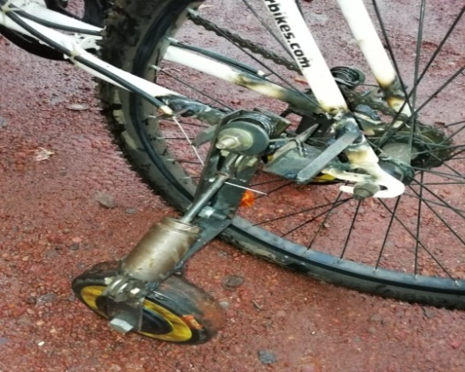

Figure 1: Fabricated stabilizer wheel assembly with shock absorber and brackets

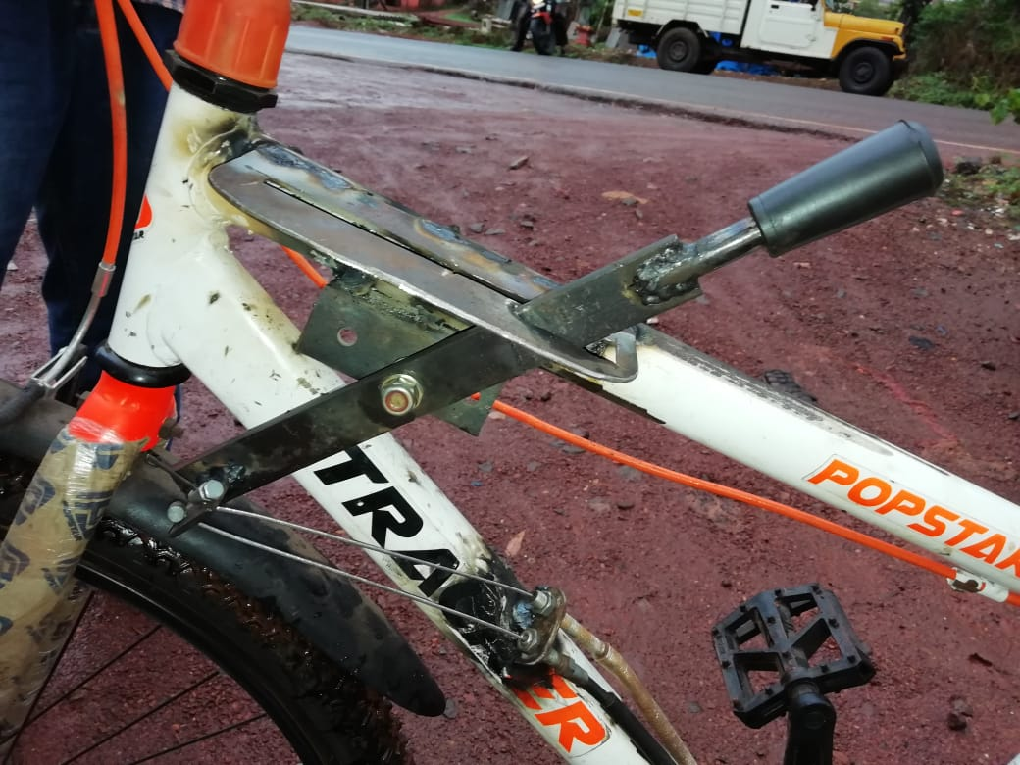

Figure 2: Lever Assembly

1. **Results and Discussions**

It is found that by providing stabilizer wheels for a bicycle, the stability is increased considerably and with the addition of the shock absorber the stability of the bicycle is further increased this is in consensus with the study done by Eisenmann (2001) [3] which explained the usage of vertical spring loaded strut assembly.

The second major findings done is this design for the bicycle is cost effective when compared to other studies which used complex systems like gyroscope and electrical drives, thus making it affordable for the public. It is also found that due to reduced complexity in the design, the system is less bulkier compared to the other studies in review of literature.

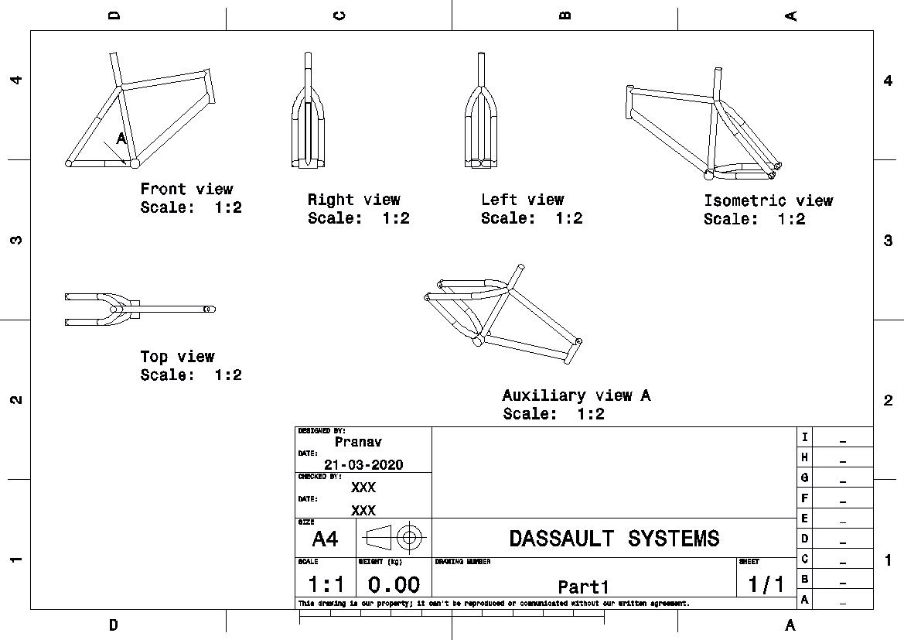

Figure 3: Different views of designed chassis using CATIA software

Table 1: The total deformation, Equivalent Elastic Strain and Stress of chassis of the designed bicycle when 800N load is applied

|  |  |  |  |
| --- | --- | --- | --- |
| **Definition** | | | |
| Type | Total Deformation | Equivalent Elastic Strain | Equivalent (von-Mises) Stress |
| **Results** | | | |
| Minimum | 0. m | 6.5645e-013 m/m | 4.8307e-002 Pa |
| Maximum | 2.1867e-008 m | 5.7508e-010 m/m | 113.73 Pa |

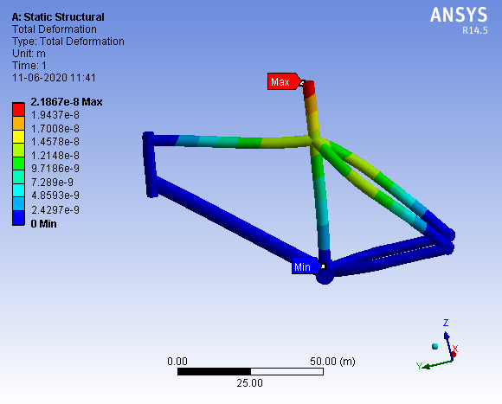

Figure 4: Total Deformation of Chassis of the designed bicycle

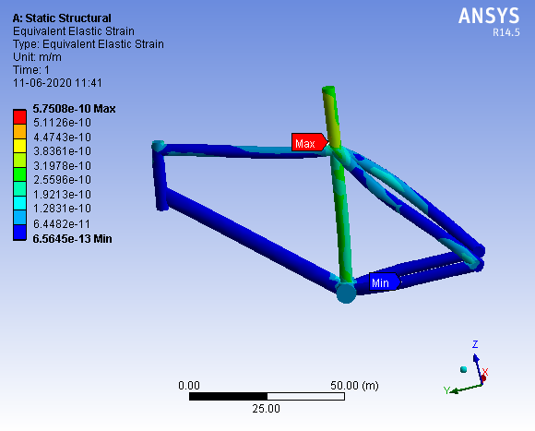

Figure 5: Equivalent Elastic Strain of Chassis of the designed bicycle

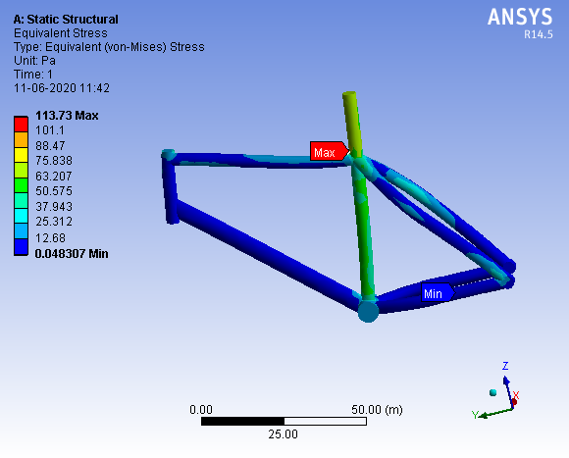

Figure 6: Equivalent Elastic Stress of Chassis of the designed Bicycle

From figure 4, the region shown in red depicts maximum total deformation taking place; which is at the region where the saddle is placed. The region shown in blue depicts the region where there is minimum deformation taking place since these regions are fixed supports the deformation is zero. Similarly in figure 5 and figure 6 the region from blue to red depicts the range of equivalent strain and stress from minimum to maximum value.

As depicted in table 1 and figures 4, 5 and 6 the analysis of the chassis shows that as per the design, the range of total deformation is 0m to a maximum of 2.1867e-008m, the range of equivalent elastic strain is 6.5645e-013m/m to 5.7508e-010m/m and the range of equivalent Von Mises stresses is 4.8307e-002Pa to 113.73Pa when a load of 800N is applied.

**Conclusion**

Retractable stabilizer wheel supported bicycle helps to attain proper balance during riding and helps the rider to run the bicycle comfortably thereby reducing the risk of falling or any other accidents caused due to imbalance. It motivates people to prefer bicycles thereby making people prefer bicycle for travelling short and long distances.

This bicycle can be accessed by both children and adult and also benefits people who have a shorter height and for the population who have difficulty in judging due to some neurological problems. This study can be further developed in future by inculcating electrical actuation for the stabilizer wheels.

**Acknowledgement**

We would like to express our gratitude to our university and college for giving this opportunity to conduct research in this domain. We would like to thank Mr Shishir for supplying the necessary parts and material for our study.

**References**

1. Willman, D.M., Willman David M, 1991. Retractable motorcycle stop-support wheels. U.S. Patent 5,029,894.
2. Plana S, Brevets Futek MSM Ltee, 2000. Stabilizer training wheel for bicycle. U.S. Patent 6,113,122.
3. Eisenmann, I.A.A. and Yatron, P.J., Eisenmann and li Al A., 2001. Bicycle training wheel assembly. U.S. Patent 6,331,012.
4. Cerone, V., Andreo, D., Larsson, M. and Regruto, D., 2010. Stabilization of a riderless bicycle [applications of control]. IEEE Control Systems Magazine, 30(5), pp.23-32.
5. Garcia, M.R., Mantaras, D.A., Alvarez, J.C. and Blanco, D., 2018. Stabilizing an urban semi-autonomous bicycle. IEEE Access, 6, pp.5236-5246.
6. Soudbakhsh, D., Zhang, Y. and Yi, J., June 2012. Stability analysis of human rider’s balance control of stationary bicycles. American Control Conference (ACC), IEEE, pp. 2755-2760.

|  |
| --- |
|  |
|  |  |