[1]

**Spine Diseases Detection Using Image Processing.**

Jyoti Waykule1, Swaliha Maindergi2, Prajkta Patil3, Pramodini Kanase4

**1Assistant Professor of Electronics & Telecommunication Department,SGI, Atigre, Shivaji University,Kolhapur,India.**

**2,3,4 Student of B.E. Electronics & Telecommunication Department,SGI, Atigre,Shivaji University,Kolhapur,India.**

2[**smaindergi786@gmail.com**](mailto:smaindergi786@gmail.com)

3[**prajaktapatil364@gmail.com**](mailto:prajaktapatil364@gmail.com)

4[**pramodinikanase444@gmail.com**](mailto:pramodinikanase444@gmail.com)

*Abstract*— In this project we are going to use HOG(Histogram of Oriented Gradients) and SVM(Support Vector Machine) for boundary regression for biomedical image segmentation. Here we will use MATLAB for computation of HOG and SVM. MATLAB image processing toolbox will be extensively used for reading, processing, visualising and saving the images.

**Keywords :-** HOG: Histogram Oriented Gradients, SVM: Support Vector Regression, NFS: Neural Foramina Stenosis, CT: Computer Tomography, MRI: Magnetic Resonance Image.

# INTRODUCTION

Neural Foramina Stenosis(NFS) is narrowing of the small openings between each vertebral in the spine call foramina which nerve roots pass through the nerve roots that exist the spinal column through neural foramina may become compress leading to pain numbness, weakness of the arm hand, leg problem with waking and balance. The risk of neural foramina stenosis increases with age as we age discs in the spine lose height begin dry out. More than 80% people are affect due to NFS. For this NFS segmentation HOG method are used for detecting its proper area and analysis.

MRI and CT imaging are used to display the stenosis for diagnosis and treatment manual segmentation method by physician is to be used for neural foramina image because of size, shape, appearance varation. Segmentation is the process of automatic detection of boundries.

**A] HOG THEORY:**

HOG is a feature descriptor used to detect object in image processing and computer vision. A feature descriptor is a representation of an image or an image patch that simplifies the image by extracting useful information and throwing away extraneous information

Typically, a feature descriptor converts an image of size width*height*3(channels) to a feature vector/array of length n. In case of HOG feature descriptor ,the input image is a size 64*128*3 and output feature vector is of length 3780.HOG descriptor can be calculated for other sizes, but above numbers presented in the original paper so one can easily understand the concept with one concrete example.

In the HOG feature descriptor, the distribution (histogram) of directions of gradients (oriented gradients) are used as features. Gradients (x and y derivatives) of an image are useful because the magnitude of gradients is large around edges and corners (regions of abrupt intensity changes) and we know that edges and corners pack in a lot more information about object shape than flat regions.

**B] Block Diagram :**

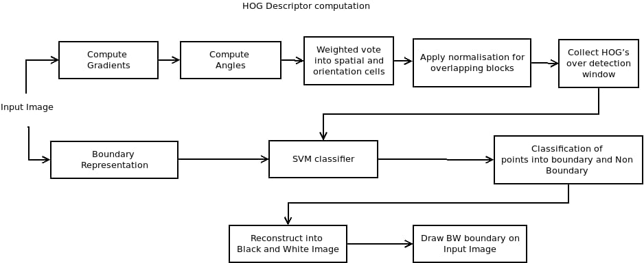

**Fig.1.** Block diagram

**Calculate the Gradient Images:**

To calculate a HOG descriptor, we need to first calculate the horizontal and vertical gradients; after all, we want to calculate the histogram of gradients. Gradient of the image is calculated in both “x” and “y” direction (Figure 2.c. and Figure 2.d.). For calculation in x direction 2D filter [-1 0 1] is taken. The filter then calculates the difference between next and previous pixel and stores the result into present pixel as “dx”. For calculating gradient in y direction , 2D filter transpose of [-1 0 1] is taken. The transpose forms a vertical array and calculates differrence between vertical pixels and stores reult in “dy”.

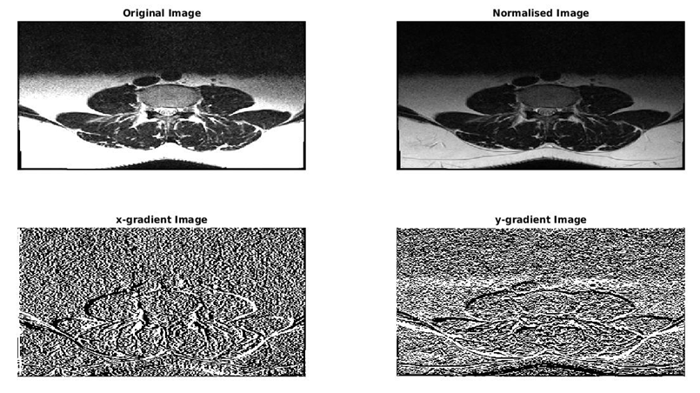

Figure 2. a – d. Output images of each stage

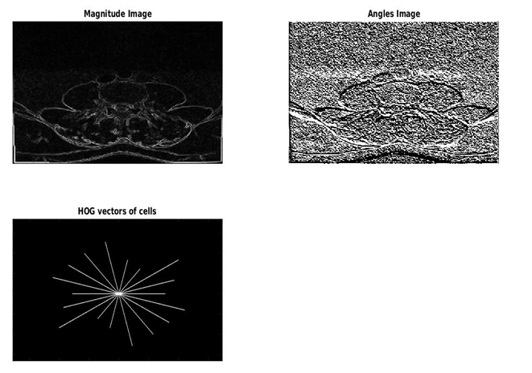

**Fig.2.**e – g. Output Images of each stage

Then angle (Figure 2.f.) and magnitude (Figure.2.e.) of the gradients are calculates using following two Equations:

**Angle=tan-1(dy/dx)**

**Magnitude=√dx^2+dy^2**

The angle and magnitude of gradients is then used for HOG calculations.

**Calculate Histogram of Gradients in 8×8 cells:**

In HOG feature extractor, the input image is divided into small parts called cells, normally 8x8 pixels. Then the gradient in both horizontal and vertical direction is calculated for each pixel within the cell as given in previous point. Now the values of angles and magnitude in each cell(64 of angles and 64 of magnitudes) are to be formed into histogram of 9 bins making it 9 values for each cell.

The bins on x axis of the histogram are the angles of gradients calculated above. The angles are divided into 9 values ranging from 0 – 180 degrees in steps of 20 degree each. Thus the 9 bins are [0, 20, 40, 60, 80, 100, 120, 140, 160] (180 is not a part of this array as in angular graphs highest will is similar to zero). Then the angles between the bin values are seperated into left portion and right portion. The left portion is contribution to nearest bin value less than the angle and right portion is contribution nearest bin value greater than the angle. The magnitude of the portion is difference between the angle and the bin.

Now the gradient magnitudes corresponding to the bins are added and the histogram is formed (Figure.2.g.).

**Block Normalization (Contrast):**

Gradients of an image are sensitive to overall lighting. If you make the image darker by dividing all pixel values by 2, the gradient magnitude will change by half, and therefore the histogram values will change by half. Ideally, we want our descriptor to be independent of lighting variations. In other words, we would like to “normalize” the histogram so they are not affected by lighting variations.

**Calculate the HOG feature vector:**

All the descriptors given by block normalization will be divided into bins according to their contribution forming matrix of size m x n x 9 (where m and n are number of vertical and horizontal cells). The matrix is now converted into single array of cellwise histogram values. And this will give final HOG feature vector.

**SVM classifier:**

Support Vector Machine(SVM) is supervised machine learning technique that is used for classifying data into two classes (binary classification). SVM classifier is basically a hyperplane which divides the data in two parts. The bins divided by the previous block are classified into two parts (boundary and non-boundary).

**Boundary Representation :**

Boundary of the image taken for segmentation training is traced using image editing software(GNU Image Manupulation Program here).The traced boundary then divides image into two regions, region inside boundary and region outside boundary. Region outside boundary is filled with Black (Zeros) and region inside boundary is filled with White (Ones). And the image is converted into Boolean.

After converting image into Boolean, the pixels on the boundary are detected.All remaining pixels except the pixels on the boundary are filled with zeros.Image now formed makes labels for SVM classifier. White pixels represent boundary pixels and Black pixels represent non-boundary pixels.

The labels generated are used for training of SVM model used for classification The image is divided into cells.HOG and Gradient magnitudes of each cell are given to SVM model. Corresponding cell is labelled boundary cell if there is boundary pixel in the cell. Otherwise the cell is labelled as non-boundary cell. The cell labels are given to SVM model for training.

**Classification into Boundary and Non-Boundary Pixels :**

Trained SVM models is given with HOG features of the image along with gradient magnitude features. The SVM model gives output array of labels as boundary and non-boundary cells (Ones for boundary pixels and Zeros for non-boundary pixels.)

**Reconstructing Boolean Image from Array of Labels :**

Labels given by SVM are stored into an array. The array is of “n*m” length, where n is number of Horizontal cells and m is number of vertical cell in the image. Matrix of corresponding cell sizes (n*m) is created with all zeros.Now the array of labels is iterated with “m” segments of length “n”. If boundary pixels is found in the array then corresponding element in the matrix ix made one. Then the matrix is converted into Boolean image.

**Draw Segmentation Boundary on Original Image :**

Boolean image obtained from SVM output label array is resizes into size of original image. Original image is taken. Pixels in original image corresponding to ones in the boundary Boolean image are marked with red color.

Result and Disscussion

Spine image segmentation methodology explained in this paper is implemented using Matlab software. Figure 3 shows the results obtained by segmentation of Spine – MRI image using different methods. Figure 3.a. shows segmentation results of HOG – SVM based image segmentation method explained in this paper. The segmentation results are then compared with standard edge detection methods available readily with MATLAB. Prewit image segmentation (Figure 3.b.) gives similar results to our method, but our method removes edges of the image which are out of spine section (advantage of machine learning) and hence is better. Sobel operator (Figure.3.c.) produces same results as of Prewit, with somewhat less fine parts inclusion inside spine image. Canny segmentation (Figure.3.d.) method includes all fine details but also adds high frequency noise.

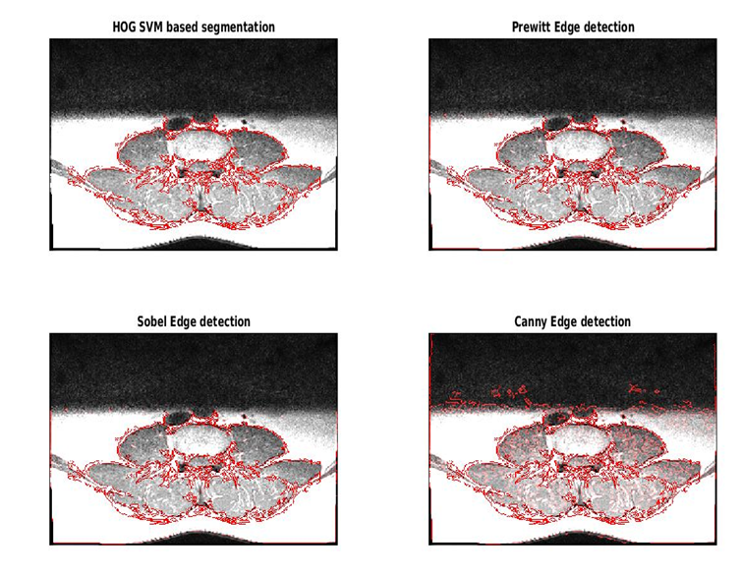

**Fig.3.** Spine MRI image segmentation using different segmentation methods

# Conclusion

HOG – SVM based image segmentation produces better results than that of most of the standard image segmentation methods. Unlike standard image segmentation methods, the method requires a large set of training images for SVM to classify more acuurately, hence cannot be operated on new class of images. SVM gives advantage of more accurate and noiseless boundary regression to the method and hence performs better than that of standard image segmentation methods.

The grading system for foramina stenosis of the lumber spine showed nearly perfect inter observed and intra observer argument and would be helpful for study. Segmentation method is important to diagnosis stenosis.

References

**1.**N. Dalal and B. Triggs, “Histograms of oriented gradients for human detection,” in Proc. IEEE Comput. Soc. Conf. Comput. Vis. Pattern Recognit., 2005, vol. 1, pp. 886–893.

**2.** K. Sakthivel, R. Nallusamy, C. Kavitha, “Color Image Segmentation Using SVM PixelClassification Image”,World Academy of Science, Engineering and Technology International Journal of Computer and Information Engineering Vol:8, No:10, 2014.

**3.**Canny, John, "A Computational Approach to Edge Detection," IEEE Transactions on Pattern Analysis and Machine Intelligence, Vol. PAMI-8, No. 6, 1986, pp. 679-698.

**4.**Sobel, I., Feldman, G., "A 3x3 Isotropic Gradient Operator for Image Processing", presented at the Stanford Artificial Intelligence Project (SAIL) in 1968.

**5.** Prewitt, J.M.S. (1970). "Object Enhancement and Extraction". Picture processing and Psychopictorics. Academic Press.

1.