[1]

Advances in Computer Numerical Control (CNC) Machines

Harshit Mathuriya, Dr. Kailash Chaudhary

*Department of Mechanical Engineering, MBM Engineering College Jodhpur (Rajasthan), India*

*harshitmathuriya13@gmail.com*

Abstract—The objective of this paper is to review the Computer Numerical Control (CNC) machines. This paper includes the numerous processes of CNC machines like drilling, boring, cutting, finishing, and knurling. CNC machines are used to decrease the cycle time and increase the production rate within the manufacturing field. This paper also contains the security features and critical functions of CNC machines. CNC programming is used to form the model. Many functions of the CNC machine are controlled by the computer automatically. CNC machines are widely used in various industries like metal removal industries, medical, defense, petrochemical, aerospace, and other industries. Electrical Discharge Machining (EDM) machine is employed to burn off unwanted material. The CNC machine uses the G code, M code, and N code for creating the model.

Keywords: CNC, drilling, knurling, production rate, manufacturing field, metal removal industries, EDM, safety features.

# INTRODUCTION

1. CNC machine is a machine that is controlled by computer and operation is performed by feeding the program in it.

2. A CNC machine is a motorized maneuverable tool that is controlled by computers according to specific input instructions.

3. First, make the 2D and 3D design in CAD software than convert this design in part programming by CAM software.

4. MATLAB software is also used for changes in the part programming. Changes by MATLAB software is easy to compare to cam software.

5. The job piece is placed in the vice of the CNC machine. Jaws must be tightened up alertly. If the jaws are loose, the job piece can come outside from the vice between the operations.

6. The operation is performed by the CNC machine. The job piece is removed from the vice after the operation is complete. The total time of the simple design is 15 minutes. [3]



A computer is not directly connected to the CNC machine.

# CNC MACHINE- INPUT, PROCESS, AND OUTPUT

A CNC machine has three-piece of equipment:

***Computer***

A computer is used to design the 2D and 3D models by the CAD software.CNC machine cannot use to direct a picture. The computer software must convert the design in part programming. The part programming has the coordinates of operation. The CNC machine uses these coordinates to cut the material.

***Interface***

A computer is not directly connected to the CNC machine. There is an interface between them. An interface is a process that converts the computer signal into a digital signal that is understood by the CNC machine.

***Machine***

Digital signals control the motors of the CNC machine which controls the movement of vice in x, y, z (horizontally, vertically, and depth). The signal also controls the rate of a cutting tool. [6]

# CNC Control Panel

A CNC machine is controlled by a computer. This is an automatic process, but most of the CNC machines have a control panel for manual operation. A control panel increases the quality and specification of the CNC machine. A control panel has the following controls:

*Reset Button*

The reset button is the most important control button. When the CNC machine started, the reset button is pressed by the machine operator. The reset button makes all x, y, z values zero. The reset button moves the cutting tools to the corner, above the work table. If the reset button is not pressed, the CNC machine may cut the material from the wrong position.

*Manual control*

The tool can be controlled manually. There is X, Y, Z buttons for control the position of the tool. The X and Y buttons control the horizontal position. The Z buttons control the depth and up/down movement.

*Stop button*

Most of the control panel has a stop button. The machine stops quickly when it is pressed. The stop button is an emergency button [2].

# SETTING UP THE CUTTING TOOL TO A CORRECT LENGTH

One of the most important operations in the CNC machine is to change the cutting tool. Each CNC machine has a range of cutting tool. On the basis of setting up the cutting tool, cutting tool are three types:-

a) Preset tool

b) Qualified tool

c) Semi qualified tool

*Preset tool*

The setting of tools beforehand at an area far away from the machine or offline, in special holders, is understood as preset tools. A presetting device is used to the preset axial and radial position of the tooltip on the tool holder.

*Qualified tool*

The tool which inserts into a location on the machine, where its leading edge is accurately positioned within close limits relative to a specified datum on the tool holder or slide is known as a qualified tool.

*Semi qualified tools*

The qualified tools which may be adjusted to the size by using several adjustable buttons on the tool shank are referred to as semi-qualified tools.

If a detailed design is being manufactured, it is necessary to change the cutting tool at least one-time during processing. It is also important to set up the cutting tool properly in the collets. If the setup is not correct, the machine cut the material at incorrect depth. A special depth gauge is used to set up the cutting tool correctly.

A pair of spanners is required to lose the collets and locking nut. The cutting tool can be removed, and the new tool put in the position. The depth gauge is used to check the length of the cutting tool tighten the locking nut and the collets.

# CNC MACHINE AND SAFETY

The CNC machine is very safe because it is designed to be as possible. CNC machine is much safe than manually operated machines.

CNC modern machines are using guard. The cutting tool will not start unless the guard is a position. When the cutter is cutting the material, the guard is locked automatically by the CNC machines. The guard can open if the cutter has stopped.

A CNC machine has an emergency stop button. This stop button is used to stop the machine instantaneously. The button is located on the handheld unit and the control panel of the machine. A soundproof casing is useful to reduce the emission of sound by the operating section of the machine. It also protects the machine operator from the risk of flying objects.

The CNC machine has a residual circuit breaker. The electrical supply for the machine comes through an RCB. If there is any type of fault, RCB will cut off the electrical power supply.

One must have complete knowledge about CNC before using a CNC machine and take care of precautions. [8]

# PROGRAMMABLE FUNCTIONS

A programmer must know about what functions in CNC are programmable. Low-cost CNC machines have manually operated functions. The manually operated functions are spindle speed, the motion of cutting tool in axis, coolant control, and tool changes. On the other hand, all CNC machines are programmable, and the operator may only be required to load and remove the workpiece from the vice. Once the machine started, the operator may free to do some other work. Here is a list of programmable functions in CNC.

*Spindle speed*

“S” word is used to shows the spindle speed (In RPM for machining center). For standard machines, the range of “S” lies from 1 to 9999 (S1 to S9999). An M03 is used to turn the spindle in a clockwise direction. M04 turns the spindle in an anticlockwise direction. M05 is used to turn off the spindle.G96 calls for constant surface speed. The unit of constant surface speed in feet per minute (or meters per minute). [5]

*Automatic tool changer*

“T” word is used to tell the machine which tool is placed in the spindle. M06 is also used for tool change. A four-digit “T” word is used for tool change.

The first two digits of the T-word show the tool number and the second two digits show the offset number to be used with the tool. Example: -T0101, the first two digits 01 is the turret station and another two digits 01 is the offset number.

*Coolant control*

To turn mist coolant in CNC, the program is M07.

To turn flood coolant in CNC, the program is M08.

It is always ok to use any command for a requirement.

*Automatic pallet changer*

Generally, the M60 command is used to change the pallet. [4]

*Forms of compensation*

All types of CNC machine tools require some form/s of compensation. Though applied for various reasons on different machine types, all sorts of compensation allow the CNC user to permit for unpredictable conditions associated with tooling because the program is developed. Before discussing how compensation applies to CNC usage, let us check out compensation generally terms. Compensation is employed in many facets of lifestyle. The pilot must catch up on wind velocity and direction as a heading is about. The racer driver must catch up on the weather and track conditions as a turn is negotiated. A bowler must catch up on the spin of the ball because the ball rolls down the alley. A marksman firing a rifle must catch up on the space to the target. The marksman analogy is amazingly almost like what happens with many sorts of compensation on CNC equipment.

*Offsets*

All sorts of compensation work with offsets. You will consider CNC offsets as like memories on an electronic calculator. If your calculator has memories, you recognize you will store a continuing value into each memory to be used during a calculation. This keeps you from having to enter the amount over and once again with redundant calculations. Just like the memories of an electronic calculator, offsets within the CNC control are storage locations into which numerical values are often placed. Even as the worth within the memory of a calculator has no meaning until referenced by its use within a calculation, neither does the worth within an offset of the CNC control have any meaning until it's referenced by a CNC program. From the marksman analogy, you'll consider the values stored in CNC offsets as just like the amount of adjustment required on the sight of the rifle necessary to catch up on the space to the target. Confine mind that the rifle only needed adjustment for one purpose, to regulate for space to the target. With most CNC machine tools, there's a requirement for a minimum of one offset per tool.

1. CNC PROGRAMMING

CODE EXPLANATION OF CODE

N Sequence Number

G Rapid Traverse

X, Y, Z For tool motion about X, Y, Z direction

S Spindle Speed

F Feed Rate

T Tool Number

M Miscellaneous Function

EOB End of Block

A, B, C For angular direction in X, Y, and Z direction

CNC Turning:-

ⱷ = Diameter

ⱷ=21

ⱷ=22

ⱷ=20

20 10

40

N01 M03 S2000

N02 G00 X22 Z2

N03 G01 X21

N04 Z-20 F80

N05 G00 X22 Z0

N06 G01 X20

N07 Z-10 F80

N08 G00 X22 Z2

N09 M30

Step Turning:-

X-axis

ⱷ=30

ⱷ=25

Z-axis

20

N10 G90 G21 G94 F100

N20 G28 X0 Z0

N30 M06 T01 D01

N40 M03 S1000

N50 M07

N60 G00 X32 Z2

N70 G01 X29 Z-20

N100 G00 X32 Z2

N110 G01 X27 Z-20

N120 G00 X32 Z2

N130 G01 X26 Z-20

N140 G00 X32 Z2

N150 G01 X25 Z-20

N160 G00 X32 Z2

N170 G28 X0 Z0

N180 M05

N190 M09

N200 M30

Taper Turning:-

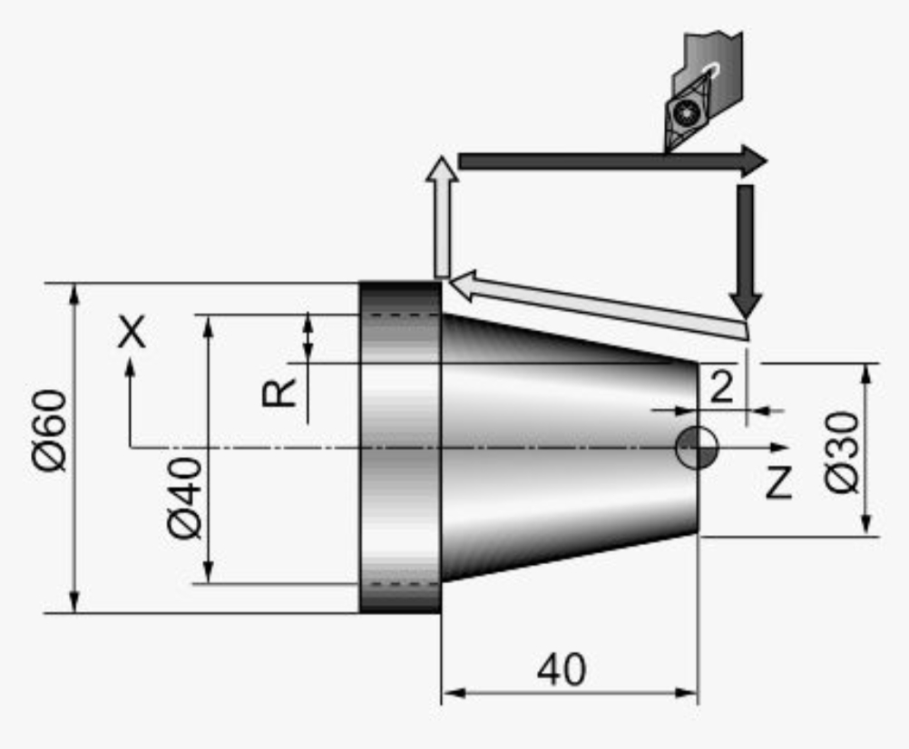

G30 U0 W0

G50 S2000 T0100

G96 S200 M03

G00 X61.0 Z2.0 T0101 M08

G90 X55.0 W-42.0 F0.25

X50.0

X45.0

X40.0

Z-12.0 R-1.75

Z-26.0 R-3.5

Z-40 R-5.25

G30 U0 W0

M30

1. APPLICATIONS

*Metal Removal Industries*

CNC machines are extremely useful in metal removal industries like automotive industries, aerospace industries, and in making jewelry. This technology removes excess metal from raw materials to achieve the desired outcome. CNC machines also continuously shaped products within the manufacturing industries, which can include threaded, rounded, rectangular, square, or maybe three-dimensional products.

*Industries for Fabricating Metals*

Several industries need thin metal plates like steel plates, to make end products. Several metal fabrication tasks like drilling precision holes, flame or plasma cutting, welding, and shearing are made easier with CNC machines. There are several industries for fabricating metals that might enjoy CNC machines, for instance:

Electronics: Computers and motherboards have brains with many tiny parts that have got to be made with precision.

Firearms: CNC machines are wont to create barrels, ammunition clips, pins, triggers, and some other components of the gun.

*Electrical Discharge Machining (EDM) Applications*

The EDM machines generate sparks that burn off unwanted metal. Through CNC automation, EDM machining is often wiped out two ways; Vertical EDM that needs an electrode with an identical size and shape as that of the cavity that's to be carved out, and Wire EDM that's wont to create the punch also as die combinations for the dies set, which are utilized in metal fabrication industries.

CNC machines are also used in woodworking industries, lettering, and engraving systems, electrical industry, the pharmaceutical industry, food, and beverage industry, and far more. Whatever industry you're in, you will find some sort of CNC machine that suits your needs. [7]

1. CONCLUSION

The study of computer numerical control machines is extremely useful to increase the production of components in the manufacturing field. The CNC machine reduces the cyclic time and increases the production rate. CNC programming is a way to operate the CNC machine. The part program has the coordinate of a tool path for making the component by the job piece.

The CNC Lathe machine is mostly used for cutting or turning processes. It is also used for shaping and finishing processes. The cost is the only drawback of the CNC machine because the CNC machine is expensive. However, CNC machines are economical for a large amount of production for industrial purposes and are not suitable for small scale industries because of their higher initial cost.

1. REFERENCES

[1] Venkata Ramesh Mamilla, Srinivasulu M, and Mani Prasad N “Study on computer numerical control (CNC) machines” International Journal of Advanced Scientific Research ISSN: 2456-0421 Volume 1; Issue 1; April 2016; Page No. 13-17.

[2] Jayson P. Rogelio and Renan G. Baldovino, “A PC- Based controller for the computer numerically- controlled (CNC) LASER machine “International multiconference of Engineers and computer scientists 2015 Vol. 1, IMECS 2015, March 18-20, 2015, Hong Kong.

[3]S. Bharthi Raja and N. Baskar “Optimization technique for machining operations: retrospective research based on various mathematical models” International Journal of Advanced Manufacturing Technology (2010) 48:1075-1090

[4]Chaldkorn Chitsaart, Suchada Kianmora, Mann Rattana-Arreyagon,WutichaiNamjaiprasertb“Automatic Generating CNC-Code for milling machine” world academy of science, Engineering and Technology International Journal of Industrial and Manufacture Engineering Vol:7, No: 12, 2013.

[5] CNC Programming Handbook by Peter Smid, 3rd edition 2020.

[6] PAS da Rocha R. Diogne de Silva e Souza, M E. de Lima Tostes, Prototype CNC machine design, 9th IEEE/IAS International Conference on Industry Applications (INDUSCON), 2010, 1-5.

[7]Tony Schmitz, Matthew Davis, Brian Dutterer, John Ziegert “International Journal of Machine Tools & Manufacturing 41 (2001) 1209-1228. 10 March 2000.

[8]N.P. Sheeny and A.J. Chapman “The Safety of CNC and Robot Technology “Journal of Occupational Accidents, 10 (1988) 21-28 Elsevier Science Publishers B.V., Amsterdam - Printed in the Netherlands” 20 January 1988 10:21-28.

1.