Additive Manufacturing: Classification, Development and Applications

Arpit Vijaywargiya, Dr. Kailash Chaudhary

Department of Mechanical Engineering, MBM engineering college Jodhpur (Rajasthan), India

arpit.vijay98@gmail.com

*Abstract*—As Additive Manufacturing technology is rapidly developing; designers are being enabled to make better products faster and cheaper. Additive Manufacturing techniques offers major advantages due to the fact that they adapt to compact design and geometrical complexity of product to be manufactured. The following may also be attained according to Scope of application; multimetal product, lighter weight products, lower tool investment costs, fewer assembly errors and, therefore lower associated costs, an optimised use of materials, a combination of different manufacturing processes and a more sustainable manufacturing process. Additive Manufacturing is seen as being one of the major industrial revolutionary process of the next upcoming years. This paper reviews the various types of additive manufacturing technologies, development of additive manufacturing technology with an emphasis on its impact on the design process and how it is moving from prototyping into production. There will also be a focus on applications of additive manufacturing in automotive sector. The outcome of this paper show that the use of additive manufacturing in product development is necessary for companies to compete with industry standards, future aspects of additive manufacturing technology are also explored.

Keywords—additive manufacturing, automotive industry, 3D printing, rapid prototyping.

# Introduction

Additive manufacturing (AM) was first developed in 1980’s by Charles Chuck Hull [1], is formalized term of rapid prototyping, is defined as “a process for rapidly creating part or system representation before its final release or commercialization, the focus is on creating something rapidly and output is a prototype from which final product is created” [2]. Synonyms- layer based manufacturing, 3D printing, freeform fabrication and additive fabrication.

The parts produced by AM technologies have same anisotropy in a particular direction due to stacking layers. Anisotropy can be reduced by selecting the appropriate orientation during the manufacturing of the parts [3].

AM involves a number of steps that move from the virtual Computer Aided Designing (CAD) description to physical resultant part [2].

## Computer Aided Designing (CAD):

All Additive Manufacturing parts must start from a software model that fully describes the external geometry. This can involve the use of any professional CAD, Solid Modelling Software (such as ProE, Solidworks) but the output must be 3D solid or surface representation. Reverse engineering equipment (such as laser and optical scanning) can also be used to create this representation.

## Conversion to Standard Tessellation Language (STL):

All Additive Manufacturing machine accepts the STL file format, which has become a current scenario standard, nowadays nearly every CAD system can output such a file format. This file describes the external closed surfaces of the original CAD model and forms the basis for calculations of layers.

## Transfer to Additive Manufacturing Machine and STL file manipulation:

STL file defines the part must be transferred to the Additive Manufacturing machine. There may be some general Manipulations of the file so that it is of correct size, position and orientation for building.

## Machine setup:

Additive Manufacturing machine must be properly set up prior to the build process. Such settings would relate to the build parameters like material constraints, energy source, layer thickness, timings etc.

## Build:

Building part is an Automated process and the machine can largely carry on without supervision. Only superficial monitoring of machine needs to take place at this time to ensure no errors have been taken place like running out of material, power or software glitches.

## Removal:

Once AM has completed build, the parts must be removed. This requires interconnection with the machine, which may have safety interlocks to ensure (for example- the operating temperatures are sufficiently low or that there are no actively moving parts).

## Post Processing:

Once removed from machine, parts may require an amount of additional cleaning up before they are ready for use. Now at this stage parts may be weak or they may have supporting features which must be removed. This therefore requires time, care and experience manual manipulation.

## Application:

Parts are now ready to be used. However, they may require additional treatment before they are acceptable for use (for example-they may require painting and priming to give needed surface finish and texture).

This paper reviews the applications of AM in automotive world, vehicle manufacturers are at the forefront of executing AM technology. This is also among the former uses of the technology, with some large automobile manufacturers having basis modelled parts with 3d printers for more than 20 years. Apart from prototyping automotive manufacturers are now bringing more and more it into use for actual production. In current years, AM technologies has rapidly transformed our way to design, develop and manufacture new products.

# Classifications

According to American Society of Testing and Materials (ASTM) F42 and International Organization for Standardization (ISO) TC261 additive manufacturing processes are classified into seven categories.

## VAT photopolmerization

Photopolymers were developed in the late 1960s, the process involves vat of liquid polymer exposed to UV light precisely directed by controllable mirrors under safelight conditions [4]. Most commonly the exposed liquid polymer solidifies through cross-linking driven by the addition reaction in between carbon double bonds in acrylates. Polymerization reaction occurs when photopolymers are exposed to light and photopolymers contain chromophores, otherwise, the addition of molecules that are photosensitive are utilized to react with the solution to begin polymerization. Polymerization of monomers head to cross-linking, which develops a polymer. Through these covalent bonds, the property of the solution is changed. The build plate then moves down in small increment and the liquid polymer is again exposed to the light. The process continues until the part has built (Fig. 1). The liquid polymer is then drained from the vat, leaving the solid part [5]. Several techniques make the term VAT photopolymerization.

#### Stereolithography (SLA): SLA printing is an early and commonly used 3D printing technology. In the early 1980’s Japanese researchers Hideo Kodama first invented the modern layered approach to SLA by using by usinhg UV light to cure photosensitive polymers [6][7]. However, the word stereolithography was coined in 1984 by Charles Chuck Hull when he filled patent for the process [8]. SLA success in automotive industry allowed 3D printing industry status and technology continues to find innovative uses in many fields of study.

#### Digital Light Processing (DLP): DLP technique was Originally developed in 1987 by Larry Hornbeck of Texas instruments, the technique uses a digital projector screen for flashing a single image of each layer covering entire platform at once as projector uses a digital screen, therefore image for each layer is composed of square pixels, resulting in layers formed from small rectangular blocks [9]. The Envision TEC perfactory is an example of a DLP rapid prototyping system.

#### Continous Liquid Interface Production (CLIP): This technique was invented by Alexander, Joseph Desimone, Nikita Ermoshkin and Edward T Samulski and was originally owned by EiPi systems, but is now developed by Carbon. The process begins with a pool of liquid photopolymer resin part of the pool bottom is transparent to UV light. An UV light beam shines through the window, illuminating the precise cross-section of the object. The light causes the resin to harden. The object rises slowly enough to permit the resin to flow under and continues contact with the bottom of the object [10]. An oxygen-permeable layer lies below the resin, which creates “dead zone” (persistent liquid bond) preventing the resin from attaching to the window (photopolymerization is constrained between the window and the polymerizer) [11].

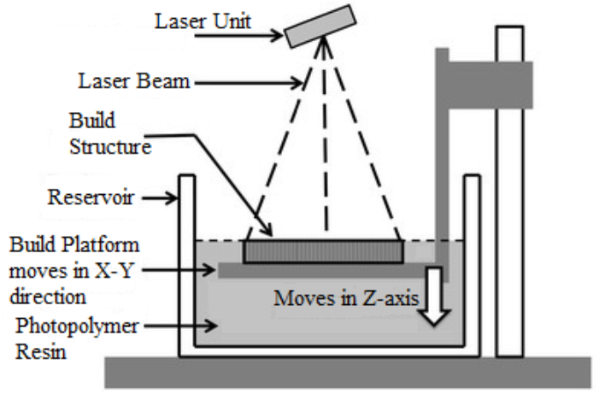

Fig. 1 VAT photopolymerization process

## Power Bed Fusion (PBF)

PBF is an AM process involving selective fusion of materials in a granular bed. The process fuses parts of layers and then proceed upward in an active area, adding another layers of particles and further repeating the process until the part has built up. The fusion between powder particles is induced by one or more thermal sources. The process uses the unfused media to carry overhangs and thin walls in part being build which reduces need for temporary additional supports for parts [12]. Several techniques of power bed fusion.

#### Selective Laser Sintering (SLS): SLS technique was developed by Dr. Carl Deckard and Dr. Joe Beaman in mid-1980’s, is defined as a technique that uses laser as a power source to sinter powdered material, focussing the laser at points in space defined by a 3D model (Fig. 2), binding materials together to create a solid structure. The final solid structure is enveloped in loose powder which is then cleaned by brush and pressurized air [13].

#### Direct Metal Laser Melting (DMLM): The technique was started in 1995 at the Fraunhofer institute ILT in Aachen, Germany. The ASTM F42 standards committee has grouped DMLM into the category of laser sintering, although this is a misnomer because the process completely melts the metal into a solid homogenous mass, unlike SLS which is a true sintering process [14].

#### Electron Beam Melting (EBM): This technique involves metal powder or wire as a raw material placed under a vacuum and fused together from heating by electron beam, process is known to operate at higher temperatures up to 1000ᵒC which can show differences in phase formation through solidification and solid state transformation [15].

#### 

Fig. 2 Selective laser sintering machine

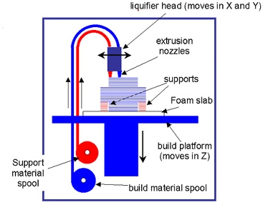

Fig. 3 Scheme of extrusion-based system

## Extrusion Based System

## Extrusion based system also known as Fused Filament fabrication or Fused Deposition Modelling (FDM), was invented by Scott Crump in late 1980’s and was commercialized in 1990 by Stratasys. After the expiration of patent, a large open source development community developed, and both commercials and DIY variants employing this type of 3d printer appeared known as the ReRap projects [16].

## In its physical principle the prototype or model is produced by extruding the small streams or beads of material which solidifies immediately to form layers. A filament of thermoplastic or other low melting point material is fed into an extrusion nozzle head, where filament is being heated to its melting temperature and extruded onto a build table. The extrusion nozzle head heats the material and turns the material flow on and off (Fig. 3). Typically, servo motor or stepper motors are utilized to move the extrusion head and adjusts the flow. The printer usually has three axes of motion. A computer aided manufacturing is used to create the G-code that is sent to microcontroller which controls the motors. More recently fused pellet deposition was developed, where particles or pellets replace the need to use filament[17][18].

## Various polymers may be used for material extrusion such as Acrylonitrile Butadiene Styrene (ABS), Polycarbonate (PC), polyphenylsulfone (PPSU), Polylactic acid (PLA) and high impact polystyrene (HIPS). Normally, the polymer is in the form of a filament fabricated from virgin resins. There are various projects in the open-sourced community focussed at processing post-consumer plastic waste into filament. These require machines, used to extrude and shred the plastic material into filament such as recyclebots. Further, fluoropolymers such as polytetrafluoroethylene (PTFE) tubing are used in the process due to the material's ability to withstand high temperatures. This ability is especially useful in transferring filaments [19].

## Material Jetting

The process was developed in 1984 and is often compare to the standard two-dimensional inkjetting process. Utilizing photopolymers, metals, or wax that solidify when exposed to light or heat (in a similar fashion to stereolithography) ensures that physical objects are built up one layer at a time. The material jetting manufacturing process allows for different materials to be 3D printed within the same part.

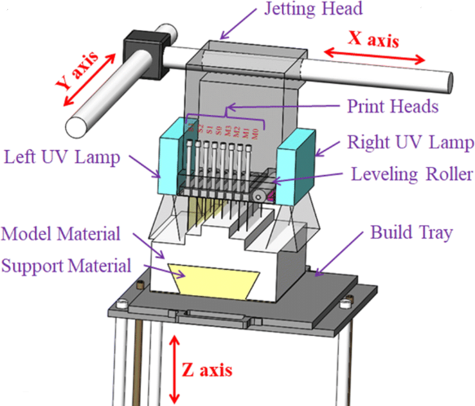

Fig. 4 Scheme of material jetting process

Material jetting dispenses a photopolymer from hundreds of tiny nozzles in a print-head to build a part layer-by-layer (Fig. 4). This allows material jetting operations to deposit build-material in a line-wise fashion, which can be compared to other point-wise deposition technologies that follow a path to complete the cross-sectional area of a layer, also called a slice. As the droplets are deposited to the build platform they are directly cured and solidified using UV light. Material jetting processes require support, which is often 3D printed simultaneously during the build from a dissolvable material. Several techniques that makes material jetting popular [20].

#### Drop On Demand (DOD): DOD printers have two print jets: one to deposit the build material and another for dissolvable support material. Like all AM machines, DOD 3D printers follow a pre-determined path and deposit material in a point-wise fashion to build the cross sectional area of a component. DOD technology is typically used to produce wax-like patterns for investment casting or lost-wax casting and mold making applications, making it an indirect 3D printing technique[21].

#### PolyJet by Objet: PolyJet 3D printing technology was first patented by the Objet company, now a Stratasys brand. The photopolymer materials are jetted in very thin layers onto a build tray in a similar fashion compared to inkjet document printing. Each photopolymer layer is cured by UV light instantly after being jetted. The repetition of jetting and curing steps, layer after layer produces fully cured models that can be handled and used immediately[22].

## Binder Jetting

This technique was first developed and patented by Massachusetts Institute of Technology in 1993 [23]. During the binder jetting 3D printing process, the 3D print head moves over the build platform depositing binder droplets, printing each layer in a similar fashion to 2D printers that print ink on paper. When a layer is complete, the powder bed moves downwards and a new layer of powder is spread onto the build area. The process is repeated layer by layer until all parts are complete (Fig. 5). After printing, the parts are in a green or unfinished state and require additional post processing before they are ready to use. Often an infiltrate substance is added to improve the mechanical properties of the parts. The infiltrate substance is usually a cyanoacrylate adhesive (in case of ceramics) or bronze (in case of metals).

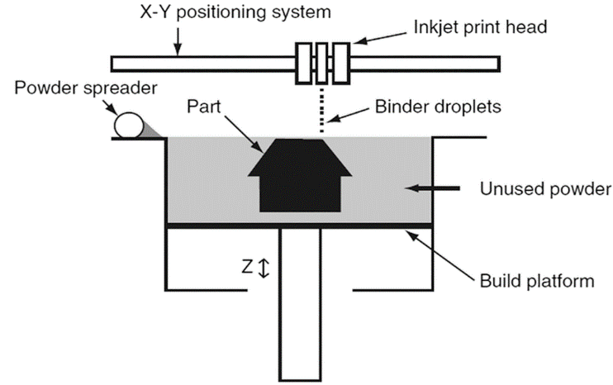

Fig. 5 Binder jetting process

The binder jetting encompasses several techniques such as ColorJet Printing (CPJ) by 3D Systems. ColorJet Printing is a trademark of the company ZCorp, now a 3D Systems company. ColorJet Printing 3D prints are fully colored. The final parts resemble sandstone and exhibit a somewhat porous surface. The sandstone material is inkjet colored and glued together during the 3D printing process. At the end of the 3D printing, an infiltration is required to solidify and bond the part. Hundreds of thousands of colors are available, almost the full CMYK spectrum. The final prints are not intended for functional applications as they remain porous and must be kept away from humidity to avoid discoloration [24].

Binder jetting is great for applications that require good aesthetics and form, such as architectural models, packaging, toys and figurines, also the Metal-based binder jetting parts have relatively good mechanical properties due to the infiltration process and more cost-effective than SLS and DMLM metal parts, but have poorer mechanical properties because the grains of materials do not entirely fuse together.

There are various types of 3D printing binder materials, categorized on basis of specific applications such as furan binder (for sand casting applications), phenolic binder (for sand moulds and cores), silicate binder (environmentally-friendly, for sand moulds and cores) and aqueous-based binder (for metals).

## Sheet Lamination

This AM technique was first developed by Helisys Inc. and was later made popular by Solido, an Israel-based company. Solido 3D printers are based on LOM technology and produce parts made with a combination of PVC (Polyvinyl Chloride) and a proprietary adhesive, which results in rugged, yet inexpensive, models. Later, the Ireland-based company Mcor Technologies Ltd in 2005 developed a different process using ordinary sheets of office papers [25].

In paper-based laminated object manufacturing, the paper material is taken from standard copy paper (Fig. 6). First, the paper goes through a standard inkjet 2D printer in order to be colored. All the colored pages required to build the final part are then stacked in the 3D printer, which uses them one by one. Each page is thereby removed from the stack, glued to the previous one and then precision-cut with a knife, layer by layer the workpiece is completed. The remaining paper can

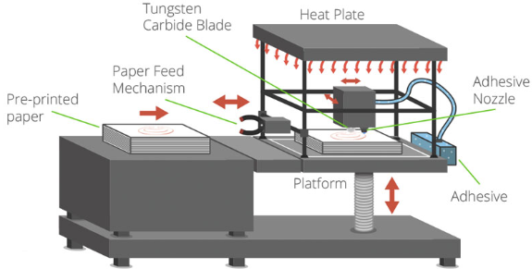

Fig. 6 Sheet lamination

be removed by hand. The precision of the result depends on the thickness of the paper used, a standard sheet of paper has a thickness that ranges between 50 microns and 100 microns. Some common sheet lamination techniques.

#### Selective Lamination Composite Object Manufacturing (SLCOM) by EnvisionTEC: The SLCOM technique uses thermoplastics and woven fiber composites as a base material.

#### Composite Based Additive Manufacturing (CBAM) by Impossible Objects: Impossible Objects, a US based startup, patented the (CBAM) technique. In this technique Fiber-reinforced composites are fused with a thermoplastic to create very strong parts.

## Directed Energy Deposition Process

The Directed Energy Deposition (DED) 3D printing technology, also known as Direct Energy Deposition, creates parts by directly melting materials and deposing them on the workpiece, layer by layer. This additive manufacturing technique is mostly used with metal powders or wire source materials. In addition to the capability to build parts from scratch (often with the hybridation of a mill/turn CNC tool), DED is also capable of fixing complex damaged parts, such as turbine blades or propellers [26].

Most DED 3D printers are industrial machines with very large footprints that require a closed and controlled environment to operate. Therefore, typical DED consists of a nozzle mounted on a multi-axis arm inside a closed frame, which deposits melted material onto the workpiece surface, where it solidifies.

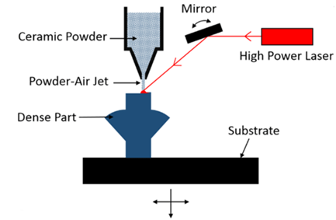

Fig. 7 Scheme of directed energy deposition process

Some common technologies of DED process.

#### Laser Engineered Net Shaping (LENS) Technology: This technology was developed by Sandia National Labs is an example of the powder fed-DED process for 3D printing or restoring metal parts, it uses lasers to build objects layer by layer directly from powdered metals, alloys, ceramics or composites. This keeps the part clean and prevents oxidation. The metal powder material is directly delivered to the material deposition head. Once a single layer has been deposited, the material deposition head moves on to the next layer. By building up successive layers, the whole part is constructed. When complete, the component is removed and can be heat-treated, hot isostatic pressed, machined, or finished in any required fashion [27].

#### Laser Deposition Welding (LDW) and Hybrid Manufacturing: The LDW AM process uses the metal deposition by powdered nozzle, which can be up to 10-times faster than PBF technology. Furthermore, the DMG MORI company has integrated their LDW AM technology into a 5-axis milling machine. This innovative hybrid solution combines the flexibility of the laser metal deposition process with the precision of the cutting process and thereby allows additive manufacturing in milling quality. This combination renders the manufacturing of high-precision metal parts for various sizes possible.

# AM in Product Development

With more and more competitive market, getting products out faster is critical, as longer a product stays in the design cycle, the longer it takes to get it to market, meaning less profit for companies. For that reason, AM has become standard practice for product development across manufacturing sectors and continents. Prototyping is a vital part of the product development and manufacturing cycle required for assessing the form, fit and functionality of a design before a significant investment in tooling is made. Additive manufacturing is an enabler for designers and it is changing the way design is being designed. The process of adding material layer by layer allows designers and engineers to develop complex geometries, which would be prohibitively expensive or physically impossible to produce with other manufacturing methods. The technology is giving designers close to limitless freedom, removing the constraints of traditional manufacturing methods.

Cost savings alone is one of the key reasons AM have managed to get mainstream attention in industry. After Stratasys key patents on FDM expired in 2009, there was an outburst of open-source FDM printers on the market. In a few years the lowest price of an FDM printer dropped from $14 000 to $300 [28]. There is also an environmental benefit to 3D printing due to it being an AM process. This is the opposite of traditional subtractive manufacturing processes, which produce parts by cutting material away from a block to create the desired shape. On-demand production may lead to reduced raw material requirements and a reduction in number of raw materials needed, reduced wastage originating from the process and also cuts in CO2 emissions resulting from the savings in the distribution phase. However, the process of printing is very energy consuming. Research shows that the laser process that either melts or hardens plastics consumes up to 100 times more electrical energy than traditional mass manufacturing to make a part of the same weight. The actual energy consumption per item is very high. The process does not use less energy at the production stage, it´s the material production stage that sets AM apart due to the amount of material saved.

FDM is taking on increased significance as a substitute of manufacturing method for components made in small numbers. Additive components are more than strong enough to be used for extremely stressed load-bearing applications. On paper, metallic additive parts printed with the DMLS technology, have mechanical properties that are superior than cast and getting towards wrought standards. The limitation for expansive use is the lack of agreed standards for material and process quality. Once there will be recognized standards for testing, then people will commit to the technology and start utilizing it for load-bearing applications.

An intersection of great importance is the one between luxury automotive production and AM. Noting that a company like Audi may claim it produces 7 million individual cars and there is an expansion on the possibility for AM to make luxury design more individual and exclusive by allowing customers to create changes in interior design or entertainment components. Traditional manufacturing would make this type of customization too costly for all, but AM can make the process both less expensive and faster.

# Automotive Industry

Supported by the recent developments of design optimization tools and manufacturing abilities, components and parts produced using AM are emerging in the automotive industry, automotive companies are using it to create basis model or prototypes of parts with the goal of checking their form and fit, the technology allows them to create aesthetically pleasant parts.

Automotive manufacturers are among one of the most engaged to develop new applications and develop the technology further. Automotive companies adopting AM techniques are benefitted from reduced lead times, new ergonomics cost and decreased tooling costs. According to Smart Tech’s forecast (Fig. 8) for automotive AM, the market which generated $1.1 million in 2017 will grow to $5.3million in 2023. The predicted growth during the five following years, revenues are expected to climb $12.6 million 2028, an astronomical growth of 1145% during the course of next 10 years [29].

BMW is using AM to enhance both plastic and metal components, the company is working with HP to produce parts on their large scale manufacturing systems such as cooling shaft manufactured from flax fibers for iFE.20 Formula E racer in 2019, comparing to usual carbon materials, flax has greater absorption and greater impact resistance, which is advantageous on the street circuits with their crash barriers and bumps on which Formula E takes place [30].

Ford in February 2019 in collaboration with Ultimaker, Stratasys and GE additives developed a largest metal automotive part for working vehicle in automotive history, using GE additives Laser X LINE 2000R concept, the part was installed in Hoonitruck a 1977 Ford F-150. Also, both Bentley motors Ltd and Jaguar land rover are committing to another technology jetting systems. Their studios are equipped with Object500 and Object30 from Stratasys.

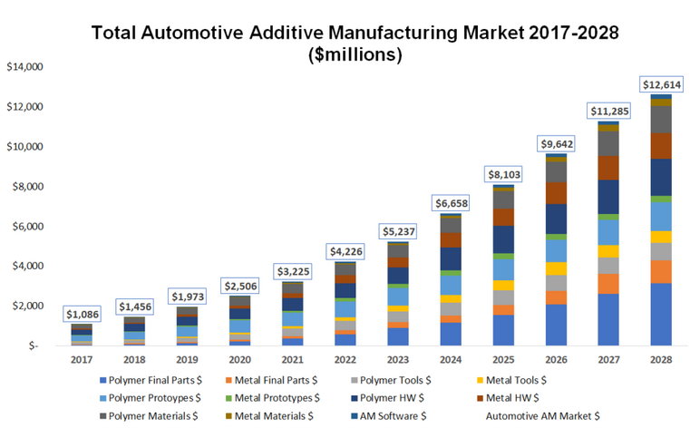

Fig. 8 Graphical representation of growth of additive manufacturing in automotive industry

Utilizing multi-material 3D printers gives Jaguar land   
rover a competitive advantage in the market. To widen their in-house prototyping capabilities, enhance styling and provide better testing, the use of 3D printers became the answer, this resulted in more rapid development of complex multi-material parts. As well as producing working prototypes rapidly in a single process for immediate style, fit and function testing. The technology enables the Bentley design team to simply produce small scale models as well as full size parts, for assessment prior to production on the assembly line. Virtually every part is prototyped in miniature scale. AM has revolutionized the design process, and enables exact simulation of how the car will look. This more or less ensures for no retooling costs [31].

HP Incorporation in September 2018, introduced a new 3D printing technology HP Metal Jet, intended for mass production of steel parts. Volkswagen AG intends to use HP Metal Jet to produce electric vehicles in 2020. Volvo applied AM technology in retooling their articulated haul truck and thus cutting down the cost of prototyping by a tenth. This also allowed them to reduce the time spent from 20 weeks to merely 2 weeks [32].

# Discussion

AM is changing both how and what we can manufacture. It is enabling engineers and designers to create products in a new way. The technology´s impact on the automotive industry is unquestionable. Even so there are challenges and unresolved issues to overcome.

## Cost and Productivity

It is generally believed that cost and faster turnaround are among the primary drivers in industry, as for incorporating 3D printing in the product development process. AM eliminates tooling, and with that the cost and time related to creating it. The amount of material used can also drastically be reduced. While conventional subtractive manufacturing processes frequently remove up to 95% of the raw material to arrive at a final component, AM machines only use the material needed to make the part [33]. The savings in material usage and rapid turnaround cycle saves on additional storage and maintenance costs.

The lowering of and development time and investment cost allows businesses to adapt more faster and easily to the market. This new logistics part where files are getting shipped digitally and manufactured on demand locally close to the end user, allows for fast and fairly risk-free production.

## Prototyping

Research shows that by using AM methods in the design process, designers can quickly get to a point of producing working prototypes. This serves as an effective validation tool both aesthetically and functionally, when before having a part or prototype would be costly early in the process. Being able to produce prototypes increases the possibility of finding flaws in a design during testing, which ensures for a better product and can lead to bigger profits. If these problems were to be discovered later in the process or after-market launch it could be costly or result in product failure. Furthermore, AM can significantly reduce lead times through rapid turn-around cycles between design and production.

The technology allows R&D departments to make alterations quickly, refit or change the design based on digital input. This accelerates the design process by getting products to market faster. An optimized design process with more iterations can help minimize risk of product failure[33].

## Customization

It has been long known that the fashion towards customized products is accelerating. Consumers are looking to have their personal taste reflect in what they are doing and using. For instance, a personal vehicle becomes your avatar, the way you portray yourself to the world around you. This becomes even more true when AM is incorporated into the product development cycle. It is believed that the technology can democratize the luxury of customized design, and make it more individual and exclusive by allowing customers to create variations on elements and design components. AM can make this process both faster and less expensive. This is especially of interest to high-end luxury manufacturers, with a relatively small production volume and demanding customers who want, and are willing to pay that price.

## Complexity

The elimination of tooling also means that designers are freed from the constraints of traditional manufacturing and assembly. By creating layer by layer, the geometrical complexity of printed components is almost limitless. Components that had to be manufactured in hundreds of parts can now be 3D printed into one or several-part components. The technology also allows shapes to be structurally optimized for increased performance.

## Enviromental Impact

It is proven that AM produces less material waste than conventional manufacturing methods, only using material needed for production of parts or components. However, there has been some discussion regarding the energy consumption of 3D printing. As the laser process consumes much more electrical energy than under conventional manufacturing, questions are raised regarding the ecological footprint. It is believed that when material production is factored into the equation, AM is to prefer over conventional methods for the automotive industry, which is under tight environmental and emission regulations.

## Moving Towards Production

Between design and production there are many stages were the utilization of AM can be beneficial. The use of AM is speeding up the design process and getting products to market faster.

The implementation of 3D printed production components in automotive sector proves that AM can move from prototyping to production, and arguably mass-production in the near future. Research shows that AM is producing parts at lighter weights than traditionally manufactured components at equal strengths [34]. Reduction in weight for the transport industry equals more effective shipping, less cost and emissions. On the other hand, 3D printing is known for being a subtle process where the smallest change in production conditions can alter the mechanical properties of manufactured components. The limitation on build size is also a concern for many researchers. However, most believe that it´s a small one that can be solved and should be subsequent to the likes of machine sensitivity.

Users have to be certain that components will perform. Formal types of quality controls and validations have to ensure that parts will function. At present time there are no agreed standards or regulations for material and process quality of additively manufactured parts. Once that will be in place along with general awareness of the technology’s ability, it is believed that its use within production will expand rapidly.

# Future of AM

The futures of AM will likely involve significant sharing of production facilities. As files are moved digitally, production can happen locally as close to the end user as possible. This eliminates global shipping and the damage it brings upon the environment.

In the automotive industry, AM could soon allow for component consolidation. “For example, a single-piece air scoop can be converted into a multi-functional air distribution system,” says Blue. The goal here isn’t to replace components with like components, as that makes for a tough business case for additive manufacturing. Instead, the aim is to reduce part counts and light weighting by removing material.

Transforming essential prototyping equipment into production equipment for the large-volume demands of the automotive industry will require tighter controls. Consider that most AM equipment today works open loop. In the future, closed-loop controls will become more common. Here, systems measure temperature and CAD models are sectioned into say, 100-μm layers while the controls discern their integrity. If the temperature is too low, the system prompts an increase; if larger problems are detected, the machine control nixes the process before the component is built [35].

Some of the best-known benefits of AM align precisely with what automotive OEMs are looking to deliver: faster development cycles, part consolidation, light weighting, new and custom geometries.

Automotive is the industry other industries look to for a glimpse of what the future might bring. AM aligns with the needs of the automotive industry, driving advances in vehicle design. Serial production is a reality today in AM (3-D printing) as the technologies under this umbrella have advanced to a point where end-use parts can be made of both plastic and metal materials, ready to be put to use in real-world environments. The automotive industry has been a major adopter, with automotive Original Equipment Manufacturers (OEMs) among the first to install 3-D printers - some 30 years ago. There are many other examples that show that trends in automotive predict the future, which is reassuring for the AM industry.

Today, 3-D printing is accelerating prototyping and design processes, creating unique tools for each production line, and making an increasing number of end-use parts for standard and customized vehicles, as well as on-demand spare parts manufacture. 3-D printing in automotive manufacturing is on the rise, with big names putting the technology to use for decades and new applications developing in serial production.

# Conclusions

This paper has studied the impact of the rise in additive manufacturing on the design process and within the automotive industry.

As of today, AM is widely used for product development in Research and Development departments across the mentioned industries, throughout all functions and processes. The most common uses include functional prototypes, concept models, tooling and production components. It is rapidly growing into a large-scale industry.

AM gives the flexibility to iterate while facilitating for faster turnaround and eliminates the setting of tools as in traditional manufacturing methods resulting in products arriving the market sooner, while keeping costs down and thus increasing profit.

The role of 3D printing in manufacturing is an important ecological factor. Due to less material prepared and wasted in the process of manufacture, AM is beneficial to the environment when compared to conventional processes. As of today, the process of printing itself is to consuming energy and has to be developed further.

The manufacturing technology´s success and widespread use throughout the automotive industry is inevitable. The technology is producing components with good material properties at lighter weights resulting in more desirable performance. The evolution of 3D printing won´t happen overnight, as there are problems yet to figure out. Today, AM within production is used mainly for non-analytical parts. For the technology to ease the production of load bearing components there has to be developed validation standards for material and process quality. The sensitivity of present machines is an issue and has to be dealt with. When printing a part or component several times the mechanical properties have to be stable from one print to the next.

AM might very well become the de facto method of industrial manufacture in the future. While its historical underpinnings date several decades back it´s only in recent years the technology has been widely implemented in product development, completely altering how and what can be made. The direct connection between manufacturing and designer is re-established. It is believed that we will see a remarkable shift from use limited to prototyping over to production.

##### References

1. A. Bandyopadhyay and S. Bose, “Introduction to Addittive Manufacturing,” in Additive Manufacturing, 2nd ed. New York, NY, USA: CRC, 2020, pp. 1-20.
2. I. Gibson, D. Rosen and B. Stucker, “Introduction and basic principles,” in Additive Manufacturing Technologies, 2nd ed. New York, NY, USA: Springer, 2015, pp. 1-18. [Online]. Available: <http://www.iran-mavad.com.>
3. N. Guo and M. C. Leu, “Additive Manufacturing: Technology, applications and research needs,” Frontiers Mech. Engg., vol. 8, no. 3, pp. 1061-1079, 2011.
4. VAT Photopolymerization, [Online]. Available: <https://www.lboro.ac.uk/research/amrg/about/the7categoriesofadditivemanufacturing/vatphotopolymerisation/>.
5. D. T. Reid and P. F. Jacobs, “Introduction to Rapid Prototyping and Manufacturing,” in Rapid Prototyping and Manufacturing: Fundamentals of Stereolithography, 1st ed. Michigan, USA: Society of Manufacturing Engineers (SME), pp. 1-20, 1992.
6. P. J. Bartolo and I. Gibson, “History of Stereolithography Processes,” in Stereolithography, 1st ed. Boston, MA: Springer, 2011, pp. 37-56.
7. Formlabs, [Online]. Available: <https://formlabs.com/blog/ultimate-guide-to-stereolithography-sla-3d-printing/#sla-systems>.
8. Photopoymers, [Online]. Available: <http://www.photopolymer.com/stereolithography.htm>.
9. Thre3D, [Online]. Available: <https://thre3d.com/how-it-works/light-photopolymerization/digital-light-processing-dlp>
10. D. E. Duzgun, K. Nadolny, “Continous liquid interface production (CLIP) method for rapid prototyping,” Journal of Mech. and Energy Engg., vol. 2, no. 1, pp. 5-12, Mar. 2018.
11. D. Dendukuri, D. C. Pregibon, J. Collins, T. A. Hatton and P. S. Doyle, “Continuous-flow lithography for high-throughput microparticle synthesis,” Nature Materials, no. 5, pp. 365-369, 2006.
12. Thre3D, [Online]. Available: <https://thre3d.com/how-it-works/powder-bed-fusion/selective-heat-sintering-shs>.
13. M. Agarwala, D. Bourell, J. Beaman, H. Marcus and J.Barlow, “Direct selective laser sintering of metals,” Rapid Prototyping Journal, vol. 1, no. 1, pp. 26-36, 1995.
14. P. K. Gokuldoss and K. G. Prasanth “Selective Laser Melting: Materials and Applications,” Journal of Manufacturing and Materials Processing, vol.13, pp. 1-3, 2020.
15. W. J. Sames, K. A. Unocic, R. R. Dehoff, T. Lolla and S. S. Babu, “Thermal effects on microstructural heterogeneity of Inconel 718 materials fabricated by electron beam melting,” Journal of Material Research, vol. 29, pp. 1920-1930, 14 Sept. 2014.
16. Live Science, [Online]. Available: <https://www.livescience.com/39810-fused-deposition-modeling.html>
17. C. K. Chua, K. F. Leong and C. S. Lim, “Solid Based Rapid Prototyping Systems,” in Rapid Prototyping:Principles and Applications, 3rd ed. Toh Tuck link, Singapore: World Scientific, pp. 137-196, 2010.
18. A. L. Woern, D. J. Byard, R. B. Oakley, M. J. Fiedler, S. L. Snakes and J. M. Pearce, “Fused Particle Fabrication 3-D Printing: Recycled Materials Optimization and Mechanical Properties,” Materials, vol. 11, no. 8, Aug. 2108. DOI: 10.3390/ma11081413.
19. M. Mohammed, M. Mohan, A. Das, M. D. Johnson, P. S Badwal, D. Mclean and I. Gibson, “A low carbon footprint approach to the reconstitution of plastics into 3D-printer filament for enhanced waste reduction,” Proceedings of the International Conference on Design and technology, Switzerland, 2017, pp. 234-241.
20. Y. L. Yap, C. Wang, S. L. Sing, V. Dikshit, W. Y. Yeong and J. Wei, “Material jetting additive manufacturing: An experimental study using designed metrological benchmarks,” Precision Engineering Elsivier, vol. 50, pp. 275-285, Oct. 2017.
21. M. Simonelli, N. Aboulkhair, M. Rasa, M. East, C. Tuck, R. Wildman, O. Salomons and R. Hague, “Towards digital metal additive manufacturing via high-temperature drop-on-demand jetting,” Additive Manufacturing Elsiever, vol. 30, pp. 1-9, Dec. 2019.
22. R. Singh, “Process capability study of polyjet printing for plastic components,” Journal of Mechanical Science and Technology, vol. 25, no. 4, pp. 1011–1015, 2011.
23. Autonomous Manufacturing, [Online]. Available: <https://amfg.ai/2019/07/03/metal-binder-jetting-all-you-need-to-know/>
24. 3D Experience Marketplace, [Online]. Available: <https://make.3dexperience.3ds.com/processes/binder-jetting>.
25. RapidToday, [Online]. Available: <http://www.rapidtoday.com/mcor.html>.
26. I. Gibson, D. Rosen and B. Stucker, “Directed Energy Deposition Processes,” in Additive Manufacturing Technologies, 2nd ed. New York, NY, USA: Springer, 2015, pp. 245-268. [Online]. Available: <http://www.iran-mavad.com.>
27. A. M. Beese and B. E. Carroll, “Review of Mechanical Properties of Ti-6Al-4V Made by Laser-Based Additive Manufacturing Using Powder Feedstock,” Journal of Minerals, Metals and Materials Society, vol. 68, pp. 724-734, 2016.
28. MIMS, [Online]. Available:  http://qz.com/106483/3dprinting-will-explode-in-2014-thanks-to-theexpiration-of-key-patents/.
29. Beamler additive manufacturing, [Online]. Available: <https://www.beamler.com/3d-printing-in-the-automotive-industry/>.
30. WEVOLVER, [Online]. Available: <https://www.wevolver.com/article/how.5.major.automobile.manufacturers.use.3d.printing>.
31. K. Baker, “From Tires to Interiors, Bentley designs with 3D printing,” Modelling Luxury Startasys, pp. 1-2. 2013.
32. SME, [Online]. Available: <https://www.sme.org/technologies/articles/2019/august/automotive-industry-warms-to-3d-printing/>
33. Stratasys, [Online]. Available: <http://blog.stratasys.com/2012/06/06/excerpt-1-a-new-mindset-in-product-design/>
34. Thomas, [Online]. Available: <http://www.thomasnet.com/journals/machinin>.
35. Machine Design, [Online]. Available: <https://www.machinedesign.com/3d-printing-cad/article/21830505/the-future-of-additive-manufacturing>.