DEVELOPMENT OF WET FOOD WASTE CONVERTER FOR CLEAN INDIA

MISSION

Fardin Ahamed1, Mohammad Abrar2, Mohammed Affan3, Mohammad Fahim4, Karthik V5

*Shri Madhwa Vadiraja Institute of Technology and Management*

*Bantakal, Udupi, Karnataka, India.*

***Abstract*—Food waste contains high water and organic matters. In addition, it contains a variety of unsaturated fatty acid. The matters are easy to decompose. It is easy to grow bacteria. But after drying, food waste will be good organic fertilizer. It not only reduces health and pollution problems, but also bring economic benefits. General method to make food waste to organic fertilizer: Separation and Dehydration, crushing, drying, pelleting, cooling and package. Food waste water content is more than 80%. After separation and dehydration, the moisture will be less than 60%. It needs to be dried to be organic fertilizer. For drying it more evenly, food waste gets crushed with air delivery system, and it will be delivered to the belt conveyor and sent to drying unit. After the food material reaches cylinder: Firstly, the wet material will be scattered into small pieces by rotary harrow in the process of falling, and then, it is repeatedly & thoroughly grabbed, lift, fallen and beaten. The surface area of the shattered materials increased rapidly, and contact with hot air is sufficient to transfer heat and mass. In the last cylinder of organic fertilizer drying, the temperature is cooler than the first and second cylinders, food waste organic fertilizer cools down, which reduces water content further.**

*Index Terms*— Wet Food Waste, Clean India, Hygiene, Organic fertilizer, Dehydration.

# INTRODUCTION

R

apid increase in volume and types of solid and hazardous waste as a result of continuous economic growth, urbanization and industrialization is becoming a burgeoning problem for national and local government to ensure effective and sustainable management of waste. It is estimated that in 2006 the total amount of municipal solid waste generated globally reached 2.02 billion tones, representing a 7% annual increase since 2003 (Global Waste Management Market Report 2007). The segregation, handling, transport and disposal of waste are to be properly managed so as to minimize the risks of the health and safety of patients, public and the environment. The economic value of waste is best realized when it is segregated.

Waste segregation means dividing waste into dry and wet. Dry waste includes wood and related products, metals and glass. Wet waste, typically refers to organic waste usually generated by eating establishments and are heavy in weight due to dampness.

General method to make food waste to organic fertilizer: Separation and Dehydration, crushing, drying, pelleting, cooling and package. Food waste water content is more than 80%. After separation and dehydration, the moisture will be less than 60%. It needs to be dried to be organic fertilizer. For drying it more evenly, food material will be crushed with air delivery system, and it will be delivered to the belt conveyor and sent to drying unit. After material reaches the cylinder: Firstly, the wet material will be scattered into small pieces by rotary harrow in the process of falling, and then, it is repeatedly & thoroughly grabbed, lift, fallen and beaten. The surface area of the shattered materials increased rapidly, and contact with hot air is sufficient to transfer heat and mass. In the last cylinder of organic fertilizer drying, the temperature is cooler than the first and second cylinders, food waste organic fertilizer cools down, which reduces water content further. There are also special lifting and guiding boards on the cylinders which leads material going in multiloop and dry over 6 times than normal triple-pass dryer. After multiple level drying within three cylinder, the water content in food waste can be reduced to 13% and realizes deodorization function. Then through pelleting, cooling and packing, the food waste will become good organic fertilizer.

TABLE I

DATA ON FOOD BY WEIGHT (in thousands of U.S tons)

|  |  |  |  |  |
| --- | --- | --- | --- | --- |
| Management  Pathway | 2005 | 2010 | 2014 | 2015 |
| Generation | 32,930 | 35,740 | 38,670 | 39,730 |
| Recycled | - | - | - | - |
| Composted | 690 | 970 | 1,940 | 2,100 |
| Combustion with Energy Recovery | 5,870 | 6,150 | 7,200 | 7,380 |
| Landfilled | 26,370 | 28,620 | 29,530 | 30,250 |

# LITERATURE REVIEW

Reference [1] shows, water is the most abundant material in food, and has the most influence on its storability and organoleptic characteristics, and is the most expensive to remove from food. A dry food product is less susceptible to spoilage caused by the growth of bacteria, molds, and insects. Dehydration can improve palatability, digestibility, color, flavor, and appearance of a food. In food dehydration, when hot air is used to transfer heat to the food, the temperature and relative humidity of the air determine the final moisture content to which a food can be dried. If the food is left in contact with air at constant conditions for an indefinitely long time, it will reach equilibrium with the air. The moisture content of the food at equilibrium is known as equilibrium moisture content (EMC).

Reference [2] shows, exponentially increased thermal resistance of pathogenic bacteria at a reduced water activity in thermal treatments. However, information on aw change as affected by food components at high temperatures is limited. The objective of the work was to quantify the influence of major food components on aw changes in low-moisture foods at elevated temperatures.Corn starch, soy protein, coconut, and cheddar cheese powders were selected as high-carbohydrate, high-protein, high-fat, and intermediate products.

Reference [3] shows**,** over the past few years, food waste has intensified much attention from the local public, national and international organizations as well as a wider household territory due to increasing environmental, social and economic concerns, climate change and scarcity of fossil fuel resources. On one aspect, food-processing waste represents a substantial ecological burden. On the other hand, these waste streams are rich in carbohydrates, proteins, and lipids, thus hold significant potential for biotransformation into an array of high-value compounds.

Reference [4] shows, soils are the most complex and diverse ecosystem in the world. In addition to providing humanity with 98.8% of its food, soils provide a broad range of other services, from carbon storage and greenhouse gas regulation, to flood mitigation and providing support for our sprawling cities. But soil is a finite resource, and rapid human population growth coupled with increasing consumption is placing unprecedented pressure on soils through the intensification of agricultural production – the increasing of crop yield per unit area of soil.

Reference [5] shows**,** densification of food waste compost through pelletizing is essential to increase the bulk density, expand its storability, provide ease of transportation, as well as to enable easier handling of the compost. Compost in its natural form takes up a lot of space and has a high powder dispersion rate which makes it less safe and difficult to handle. The compression of these composts into pellet forms will reduce the managing issues associated with the natural compost feedstock. In their study, the pelletizing of food waste compost by adjusting the moisture content and dairy powder waste addition was performed to evaluate the pelletization performance.

Reference [6] shows**,** a process for the conversion of organic materials raw fish waste and other marine plants and animals into a stable powder form, without the use of high heat or cooking. A raw fish waste is initially ground and then hydrolyzed or “enzymatically reduced,” to form a hydrolysate. The hydrolysate is stabilized by adding acid and heated to separate oil and water, to form a product cake. The cake is transferred to a blender for nutrient mixing to form a raw product. The raw product cake is dried in a high velocity air dryer and micronized.

Reference [7] shows**,** the development for recycling food waste by using the microwave/inner-cycle thermal-air drying process.

Reference [8] shows**,** a process for drying organic waste, such as sewage sludge, by contacting the organic waste with hot vapors wherein the dried material is extruded to form compacted granules having good flow characteristics and suitable for application by commercial fertilizer spreader. The invention provides an improved process for drying solid organic wastes by contact with a hot vapour.

# FABRICATION DETAILS

Food waste converter system is designed based on mechanism of four legs stand machine. The material used for fabrication of the system is mild steel. Mild steel is used to fabricate the body by welding process.

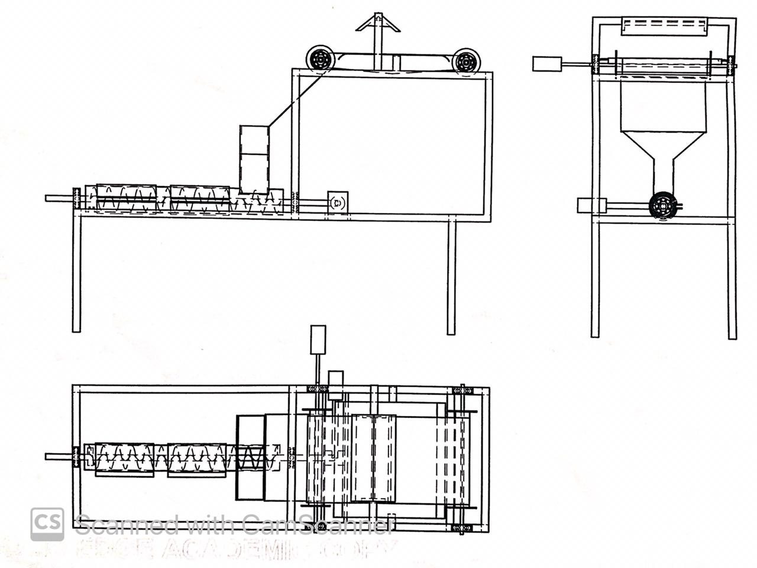

Fig. 1. Solid Edge 2D Model

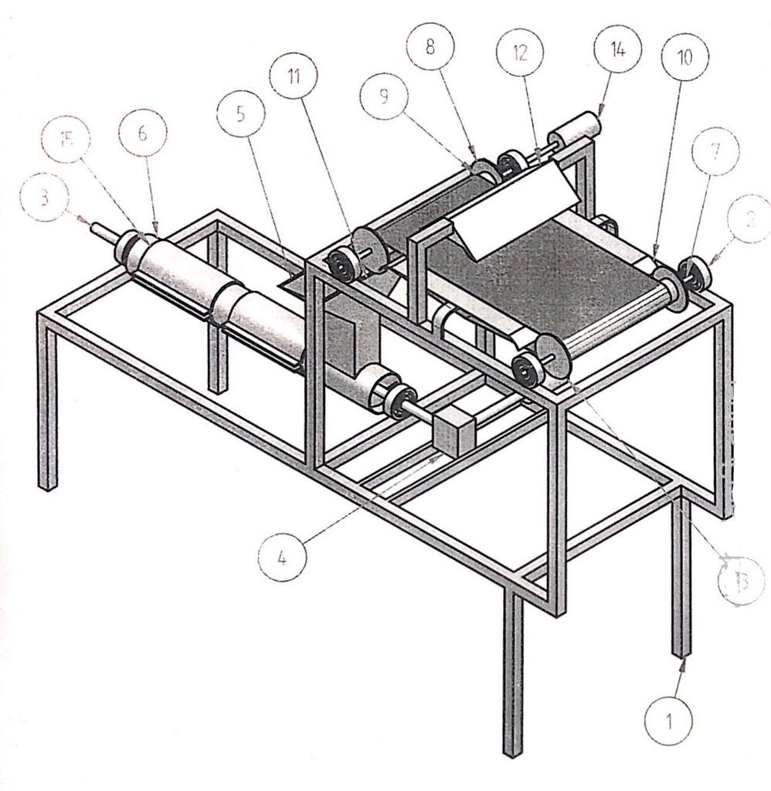

Fig. 2. 2D model with components

TABLE II

COMPONENTS OF THE MODEL

|  |  |
| --- | --- |
| ITEM NUMBER | TITLE |
| 1 | Body |
| 2 | Bearing |
| 3 | Screw Conveyor Shaft |
| 4 | Gear Box |
| 5 | Hooper |
| 6 | Screw Conveyor |
| 7 | Pulley Rod |
| 8 | Pulley Disc |
| 9 | Belt Conveyor |
| 10 | Support Sheet |
| 11 | Sheet Metal |
| 12 | Heater |
| 13 | Motor |
| 14 | Plate Heater |

# COMPONENTS USED FOR WET WASTE FOOD CONVERTER

The various components involved in wet waste converter and its functions, are as shown and explained below.

* 1. Heater

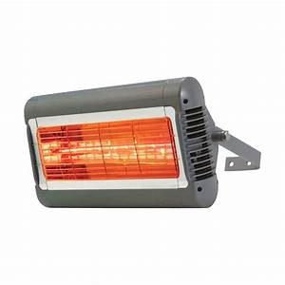

Fig. 3. Heater

Heater is used to remove water content in the wet waste and it is powered by external source of electricity.

* 1. Belt conveyor

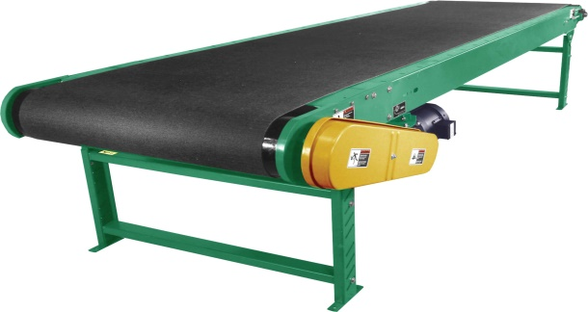

Fig. 4. Belt Conveyor

Belt conveyor system consists of two pulleys and are used to transfer food waste and is driven by battery. The wet food waste is fed to the belt conveyor allow it to dehydrate under the heater until it dries up. Switching on the belt conveyor, passes the food waste to the screw conveyor through hopper.

* 1. Screw conveyor

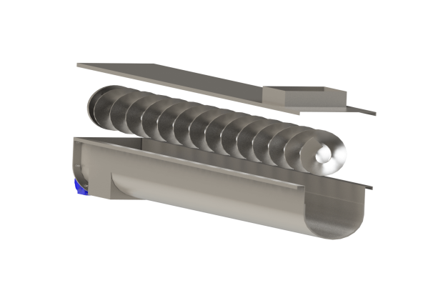

Fig. 5. Screw Conveyor

The food waste is heated in the screw conveyor with the help of heaters provided outside to the screw conveyer to remove the excess water content. The mixture of food waste and soil is evenly stirred in the screw conveyor and disposed through the disposal vent.

* 1. Gear box

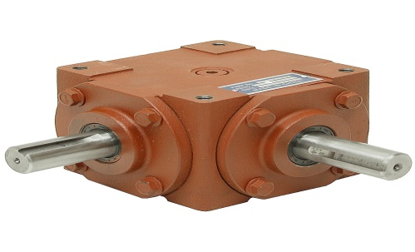

Fig. 6. Gear Box

Gear box is used to transmit the motion from motor to the screw conveyor.

* 1. AC motor

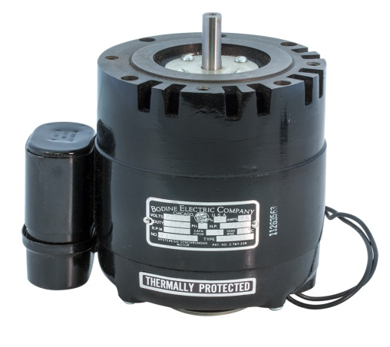

Fig. 7. AC Motor

AC motor is used to drive both belt and the screw conveyor. The conveyors are powered by the battery and the heaters are powered by the external source of electric supply.

* 1. Bearing

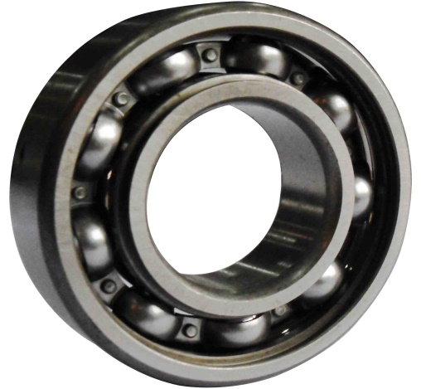

Fig. 8. Bearings

The pulleys of the belt conveyor and shaft of screw conveyor are rotated using bearings.

# WORKING

The wet food waste is fed to the belt conveyor. Allow it to dehydrate under the heater until it dries up. Switch on the belt conveyor to pass the food waste to the screw conveyor through hopper. The motors which are used to run the conveyors are powered by the battery. The heaters are powered by the external source of power supply. The food waste is again heated in the screw conveyor with the help of plate heaters provided outside to the screw conveyer to remove the excess water content. The soil is added to hopper to absorb the moisture. The mixture is evenly stirred in the screw conveyor and disposed through the disposal vent. The food waste comes out in the form of pellets.

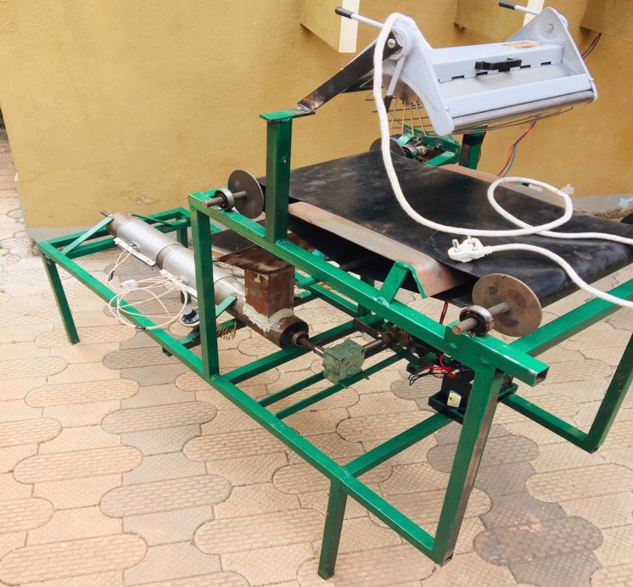

Fig. 9. Proposed wet food waste converter

# RESULT

The outcome of the proposed work can be used as manure for the plantation. The wet food waste can be preserved for a period of time and thus maintaining clean and hygiene environment. The work overcomes the problem of disposal of wet food waste.

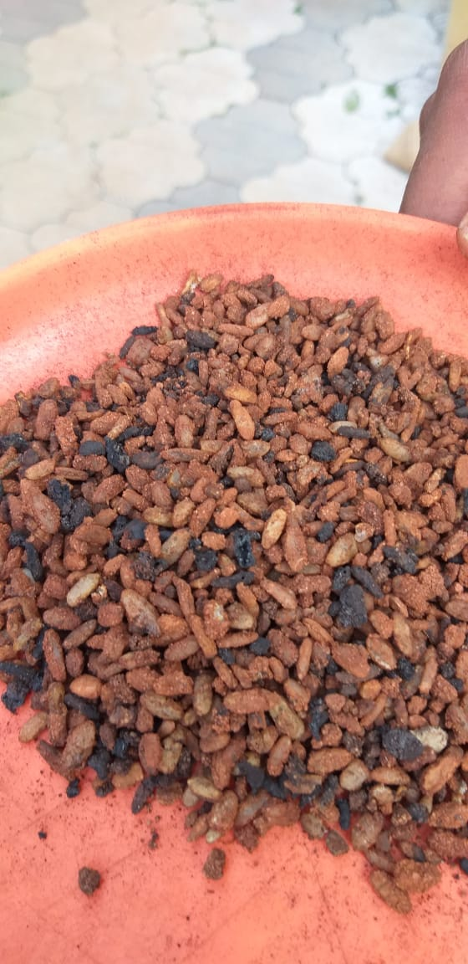

Fig. 10. Output of the work

# CONCLUSION

Disposal of wet food waste in the current day to day life can be made using the proposed machine so as to utilize the food waste as manure for plantations. Having preserving the same for a period of time would result in keeping the surrounding clean and hygiene.

In an identified apartment around the localities the major problem is to disposal of wet food waste. It has resulted in bad odour at home as it is kept open for few days as there is no mechanism to have the food waste getting disposed.

The proposed work can play a significant role in overcoming the problems that are mentioned above and thereby creates a clean environment in a place one live.

Also, the present work opens the door for research in chemical and agricultural engineering in terms of testing pellets for its nutritional value and its suitability for particular crops.

The project is aimed to contribute to the central govt. scheme of “Swachh Bharath Abhiyan” where each and every citizen of the nation is entitled to have a clean and hygienic environment.

# ACKNOWLEDGMENT

As we present the proposed work on “Fabrication of Wet Food Waste Converter for clean India Mission”, we take this opportunity to offer our sincere thanks to all those without whose guidance this paper might have remained a dream for us. We express our deepest gratitude and thanks to Mr. Karthik V, Assistant professor, Department of Mechanical Engineering, SMVITM, Bantakal, whose guidance and ideas channeled our conscientious endeavors towards the paper. We have been fortunate enough that Dr. Sudarshan Rao K, HOD, Department of Mechanical Engineering, SMVITM, Bantakal gave us the freedom, support and whole hearted coordination for the completion of the paper.

# REFERENCES

[1] Digvir S Jayas, “Food Dehydration”, *Encyclopedia of Agricultural Sciences* (1994), pp. 285-292.

[2] Yuqiao Jin, Juming Tang, Shyam S. Sablani, “Food component influence on water activity of low-moisture powder at elevated temperature”, *Food Science and Technology,* Vol. 112-2019-108257.

[3] Muhammad Bilal, [Hafiz M.N.Iqbal](https://www.sciencedirect.com/science/article/abs/pii/S0963996919302984#!), “Sustainable bioconversion of food waste into high-value products by enzyme actions”, *Food Research International,* Vol. 123, pp. 226-240, 2019.

[4] Peter M. Kopittke, Neal W. Menzies, Peng Wang, Brigid A. McKenna, Enzo Lombi, “Soil and the intensification of agriculture for global food security”, *Environmental International,* Vol. 132-2019-105078.

[5] Kit Wayne Chew, Shir Reen Chia, Yee Jiun Yap, Tau Chuan Ling, Yang Tao, Pau Loke Show, **“**Densification of food waste compost effects of moisture content and dairy powder waste additive on pellet quality”, Vol. 116, pp. 780-786, 2018.

[6] Larry V. Connell, “Conversion of organic waste material into fertilizer powder”, Pub. No:US 2007/0134376 A1, Jun14, 2007.

[7] Young-ik Choi, Byung-gil Jung, Nak-chang Sung, Young-rip Han, “Drying characteristics from mixture of food waste and sawdust by using microwave”, *J Mater Cycles Waste Management,* DOI 10.1007/s10163-014-0248-8.

[8] Vere Maffet, “Organic Waste Drying Process”, Pub. No: 775,673.

**Mr. Fardin Ahamed** was born in Udupi, Karnataka, India, in 1998. He has completed his schooling in St. John’s Academy, Shankarpura, Udupi, in 2014, and Pre – University education in Poorna Prajna PU College, Udupi, in 2016. At present, Mr. Fardin Ahamed is pursuing his final year mechanical engineering degree in Shri Madhwa Vadiraja Institute of Technology and Management, Bantakal, Udupi, Karnataka, India.

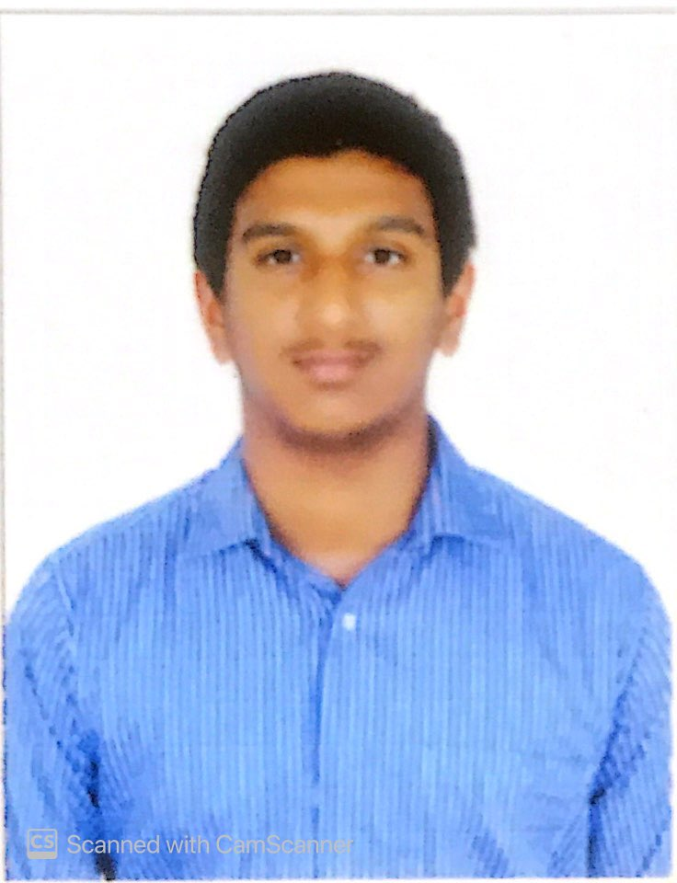**Mr. Mohammad Abrar** was born in Karnad, Mangaluru, Karnataka, India, in 1998. He has completed his schooling in Shri Vyasa Maharshi Vidya Peetha, Mulki, Mangaluru, in 2014, and Pre – University education in Vijaya PU College, Mulki, Mangaluru. At present, Mr. Mohammad Abrar is pursuing his final year mechanical engineering degree in Shri Madhwa Vadiraja Institute of Technology and Management, Bantakal, Udupi, Karnataka, India.

**Mr. Mohammed Affan** was born in Udupi, Karnataka, India, in 1998. He has completed his schooling in Christ King English Medium School, Karkala, in 2014 and Pre – University education in Mahatma Gandhi Memorial PU College, Udupi, in 2016. At present, Mr. Mohammed Affan is pursuing his final year mechanical engineering degree in Shri Madhwa Vadiraja Institute of Technology and Management, Bantakal, Udupi, Karnataka, India.

**Mr. Mohammad Fahim** was born in Udupi, Karnataka, India, in 1998. He has completed his schooling in Vidyanikethan Public School, Kaup, Udupi, in 2014 and Pre – University education in Poorna Prajna PU College, Udupi, in 2016. At present, Mr. Mohammad Fahim is pursuing his final year mechanical engineering degree in Shri Madhwa Vadiraja Institute of Technology and Management, Bantakal, Udupi, Karnataka, India.

**Mr. Karthik V** was born in Hosangady Village, Kundapur, Karnataka, India, in 1990. He received the Bachelor of Engineering degree in Mechanical Engineering, in 2013, and Master of Technology degree in Mechanical Engineering, in 2015, from Visvesvaraya Technological University, Belagavi, Karnataka, India.

This author became a Life Member of ISTE in 2015, a Senior Member of ISME in 2015.

Since 2015, he has been an Assistant Professor with the Mechanical Engineering Department, in Shri Madhwa Vadiraja Institute of Technology and Management, Bantakal, Udupi, Karnataka, India. His research interests include computer integrated manufacturing, precision manufacturing, rapid prototyping, and Robotics.