**Review on strength properties of cement concrete mixed with partial replacement of cement with granite powder and granite cutting waste water instead of potable water**

P.Charan Kumar1, T.Shantala2, M.Ravi Shankar3,

1 Assistant Professor, Department of Civil Engineering, SRIT, Ananthapuramu.

2 Assistant Professor, Department of Civil Engineering, SRIT, Ananthapuramu.

3 Assistant Professor, Department of Civil Engineering, SRIT, Ananthapuramu.

**Abstract: In our project we are finding the mechanical properties (like strength ductility, wear resistance etc) of concrete using M20 grade by partial replacement of cement with granite powder with 0%, 10%, 15%, 20% and using granite cutting waste water instead of potable water. Numerous tests such as compression test, split tensile, flexural qualities and acid (H2SO4 and HCL) curing tests are researched and these qualities are contrasted and the ordinary cement. Samples are prepared with the partial replacement of cement with 10%, 15%, 20% of granite powder and granite cutting waste water is used instead of potable water. The samples are tested for 7, 28 and 90 days by conducting the various tests like compression test, tensile and flexural strength test and Acid attack test (H2SO4, HCL) and compared with conventional concrete. Values obtained for different mix proportions of granite powder and cement are analyzed and contrasted with the strength features of mix. By this, we can know the strength properties of different mixtures. The mix proportion 3 has more compressive strength at 7 days when compared to conventional mix, so we can adopt this mixture 3 in the field. So that we can reduce the usage of natural resources and we can yield high strength concrete. The main purpose of the replacement is cost reduction, environmental protection, and usage of waste material in place of natural resources. Standard cube of 150x150x150 will be casted and tested for compression. Standard cylinder of 150mm diameter and 300mm height will be casted and tested for split tensility. Standard beam 500x100x100mm will be casted for flexural strength. Different shape specimens are casted and tested for 7 days and 28 days.**

***Keywords:* Metakaolin, Granite powder, granite waste water**

1. *T. Felixkala and P. Partheeban (2010)*

This paper looks at the chance of utilizing powdered granite as substitution of sand and partial supplanting of cement with fly ash, silica fume, super plasticizer and slag in concrete. The level of powdered granite included by weight was 0 - 100 in interval of 25 as a substitution of sand utilized in cement and cement was supplanted with 7.5% silica fume, 10% fly ash, 10% slag and 1% super plasticizers. Of all the 6 blends considered, concrete with 25% of granite powder (GP25) was seen as better than different blends.

1. *Dr. T. Felix kala (2013)*

This paper centers on the exploratory investigation of utilizing locally accessible powdered granite and partial supplanting of binder with concotions in the manufacturing of HPC with 28 days solidarity to limit of 65 MPa. The level of powder included by weight was 0 - 100% as a substitution of sand by an intervals of 25% utilized in cement and binder was supplanted with 7.5 % silica seethe, 10% fly ash and slag and the dose of super plasticizer included 1% by lump of cement. The most strength quality was accomplished in tests containing 25% powdered granite along with admixtures.

1. *C. H. Srinivasa, Dr. Venkatesh (2015)*

This project deals with the enhancement of powdered granite and its impact on fresh and solidified behavior of ready blend sample in partial substitution to binder and use of manufactured sand were investigated. In this study M20 grade concrete with different proportions like 5%,10%,15%,20%,25%,30%, of granite powder is prepared and is evaluated for properties like compression, tensile, flexural strengths at 7,14,28 days. This study shows that 20% replacement of granite powder will be ideal replacement with a compressive strength of 30.14 MPa.

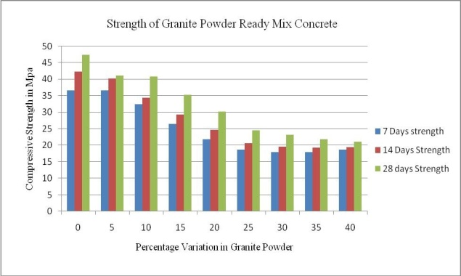

Fig 1: Strength of granite powder ready mix concrete

1. *Y.Yaswanth Kumar, C.M. Vivek Vardhan, A.Anitha (2015)*

Examination of Granite slurry (GS) was utilized as partial supplant extents differing from 5 - 20% by lump in concrete and tried for compression quality, tension, and flexural quality. It was seen that replacement of 10% of cement by granite slurry resulted in an increase in compression to 48 Mpa and tensile strength to 3.6Mpa and flexural strength to 4.6 MPa. This study concluded that use of granite slurry in place of cement is best choice as it reduces the cost and environmental pollution.

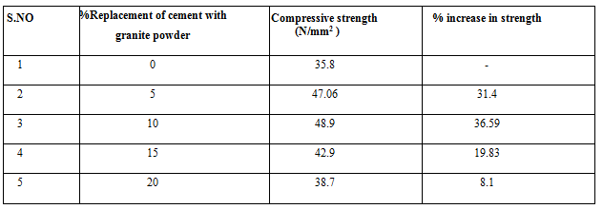

Fig 2: %Replacement of granite powder

1. *Dr. G. Elangovan (2015)*

In this investigation, the chance of utilizing granite dust powder in concrete production was inspected by contemplating the impacts of mixing of granite residue powder with cement on the presentation of fresh and solidified concrete. In this trial study, powdered granite was utilized in concrete as a cementitious substance as partial substitution. was done by portion of 5% - 20% by wt. of concrete. Compressive quality following 7 and 28 days curing was acquired. From the test outcomes it was discovered that concrete at the degree of 15% partial supplanting of cement with granite dust has better workability and high compressive quality of 7 and 28 days curing.

## *Mr. G. Raja, Mr. K. M. Ramalingam (2016)*

This project deals with the Trial investigation on partial supplant of aggregate by powdered granite in concrete. In this undertaking the substitution level of stone fines to fine total are 0 - 50 and 100 for M20 blend extents. Examples are tried following 28 days of curing, for compression quality, flexural and tension. The example threw with 40 % substitution of granite to fine aggregates invigorates higher when appeared differently in relation to control test.

## *Harjeet Singh, Dr. Hemant Sood (2017)*

The paper manages the impacts of expansion of different extents of powdered granite and polypropylene filaments on the traits of concrete in arrangement of M45 Grade of concrete. Here, inspects the compression, split tension and flexure quality of sample. Granite powder is utilized as supplanting of sand with extent of 10%, 20% and 30%. Fixed extent of Polypropylene fiber was included to the sample which is 0.25% of the heaviness of concrete. In the wake of playing out the trial, outcomes show that the greatest compression quality of cement having 20% extent of powdered granite shows upgraded features in referral to the ordinary M45 grade of cement.

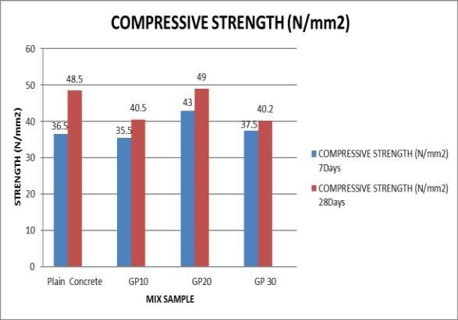

Fig 3: Compressive Strength of granite powder ready mix concrete

## *S.Sengottiyan, M.Muthumurugan, Mrs. U.Nandhini (2017)*

This project deals with concentrate on quality attributes of cement with partial substitution of concrete by powdered granite and sand with Quarry dust. In this project cement is filled with powdered granite in portions from 10%, 20%, 30% and sand from 15% to 40% in the M40 grade concrete. This project shows that 20% replacement of cement by powdered granite gives best result compared to other proportions.

## *S.S. Shinde Ashwini D Chavan,Amruta P. Bhosale, Dhanshree C. Gajankush Vaishnavi D. Dhage, Akshay A. Desai (2018)*

This project deals with the Study of impact of granite powder on concrete. The % of powdered granite included by lump to supplant sand by wt. was 0 – 50 by intervals of 10 and finally 100. This endeavor has been done because of the excessive climb in cost of sand and it’s constrained in handy. It is obviously observed that supplanting of 10% powdered granite with the stream sand expands the compression quality and tension of concrete and 20% substitution of powdered granite doesn't deliver increment in any quality however it assists with accomplishing a similar quality starting at plain concrete for example without including granite powder.

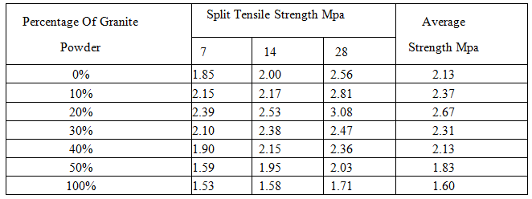

Fig 4: %Replacement of granite powder

1. *Koneti Vamsi, Rajarapu Bhushaiah, Gangavarapu Manohar, Shaik Mohammad, Rama Harshitha (2019)*

This project deals with the idea of partial substitution of cement and sand with powdered granite and saw dust. Examination of rock slurry and saw dust was utilized to fractional substitute in extents differing from 10%, 20%, and 30% by lump to cement in concrete and tried from compression quality, tension and flexure qualities. Concrete cubes estimating 150 x 150 x 150 mm were cast and their compressive quality, elasticity and flexure quality is assessment at 7, 14, 21, 28 days. It was seen that replacement at 10% of concrete by lump with granite powder was the top in expanding compression and flexural contrast with other proportions.

REFERENCES

1.Koneti Vamsi, Rajarapu Bhushaiah, Gangavarapu Manohar : Partial Replacement of Cement in Concrete with Granite Powder andFine Aggregate with Saw Dust, International *Research Journal of Engineering and Technology (IRJET)* ,Volume: 06 Issue: 03 Mar 2019 , www.irjet.net.

2. Harjeet Singh, Dr.Hemant Sood : Effect of Granite Powder and Polypropylene Fiber on Compressive, Split Tensile and Flexure Strength of Concrete at High Temperature, *International Research Journal of Engineering and Technology (IRJET)* ,Volume: 04 Issue: 07 | July -2017 www.irjet.net .

3.Mr. G. Raja, Mr. K. M. Ramalingam : Experimental Study on Partial Replacement of Fine Aggregate by Granite Powder in Concrete , *IJIRST –International Journal for Innovative Research in Science & Technology*| Volume 2 | Issue 12 | May 2016.

4.Y.Yaswanth Kumar, C.M. Vivek Vardhan, A.Anitha : Use of Granite Waste as Partial Substitute to Cement in Concrete , *Journal of Engineering Research and Applications , www.ijera.com ,*ISSN : 2248-9622, Vol. 5, Issue 4, ( Part -6) April 2015, pp.25-31.

5.Srinivasa. C.H., Dr. Venkatesh : Optimization of Granite Powder used as Partial Replacement to Cement in the Design of Ready Mix Concrete of M20 Grade using IS10262:2009, *ISSN: 2278-0181IJERT ,www.ijert.org,*Vol. 4 Issue 01,January-2015.

6.Dr.T. Felix Kala : Effect of Granite Powder on Strength Properties of Concrete , Research Inventy: International *Journal Of Engineering And Science* Vol.2, Issue 12 (May 2013), Pp 36-50, Www.Researchinventy.Com.

7.T. Felixkala , P. Partheeban : Granite powder concrete , *Indian Journal of Science and Technology* , Vol. 3 No. 3 (Mar 2010).

AUTHORS PROFILE



**P.Charan Kumar,** Assistant Professor in Department of Civil Engineering, SRIT engineering College Ananthapuramu,515002 India.

Mail ID: [pallacharan.civil@gmail.com](mailto:pallacharan.civil@gmail.com)



**T.Shantala,** Assistant Professor in Department of Civil Engineering, SRIT engineering College Ananthapuramu,515002 India.

Mail ID: ([shanthalas30@gmail.com](mailto:shanthalas30@gmail.com)



**M.Ravi Shankar,** Assistant Professor of Department of Civil Engineering, SRIT engineering College Ananthapuramu,515002 India.

Mail ID: [koutilya.shankar@gmail.com](mailto:koutilya.shankar@gmail.com)