**Review on Strength Properties of Concrete with Partial Replacement of Cement as Metakaolin by Using Natural and Recycled Aggregate**

1P.Charam Kumar, 2D.Lakshmi Shireesha, 3G.Ramanjineyulu

1Assistant Professor, Civil Department, SRIT Ananthapuramu.

2Assistant Professor, Civil Department, SRIT Ananthapuramu.

3Assistant Professor, Civil Department, SRIT Ananthapuramu.

***Abstract -* Concrete is a construction purpose material composed of cement, fine aggregates (sand) and coarse aggregates along with water which hardens with time. It has relatively great compressive behaviour than tensile quality. Metakaolin has pozzolan property. Metakaolin is developed by calcination of kaolin at a temperature of 650 – 800 0c. Metakaolin is obtained from industrial wastes. As metakaolin is cost effective, fine and pozzolanic in nature as well as utilizing as substitute for cement material. The mix proportion of the concrete is adopted as 1:1.5:3 for the M20 grade concrete. The partial supplant of cement by metakaolin with 5%, 10%, 15% and 20% by weight of cement is done and checked for compression, tensile, and flexural strengths and acid curing (HCl, H2SO4) for 7 and 28 days.**

***Keywords:* Compression, metakaolin, flexural strength**

*[1] Subodh Joshi, VenuMalagavelli etc. (2018)*

They partially replaced cement by metakaolin in concrete from 0 to 20% by weight. Concrete of 35MPa is used in the experimental investigation. The concrete is checked for compression, split tensile, flexural strengths and many non-destructive tests. By test results, it is concluded that performance of modified concrete is superior to normal concrete. The maximum of 10% can be replaced by metakaolin. The portion increase in compression, tensile and flexurals are 16.75, 7.1 and 7.88 respectively.

*[2] Mohit (2019)*

He experimented the replacement of cement by various substantial like fly ash, slag, silica based fume, metakaolin, egg outer shell dust, rice husk ash etc. is done and researched. Various experiments were operated to check physical related properties of cement, aggregate and admixtures. The physical tests like dry density, moisture osmosis and void content and mechanical related tests like compression and split tension examines are conducted for concrete. From the test, they noticed that there is a better performance in setting time, workability and durability. This concrete is good in tensile strength but not in compression.

*[3] Dr. K. Srinivasu, M.L.N. Krishna Sai, N. Venkata Sairam Kumar(2014)*

In this research on use of metakaolin in mortar and concrete, they used metakaolin as partial substitution for cement in concrete. Compression feature of 50MPa was structured by different rates of metakaolin substitutions of 5 - 20% in blend with 0% - 1.5% of pleated steel strands by volume of specimen. From results obtained, due to pozzolanic action of metakaolin it increased the strength and durability behaviour of concrete.

*[4] Mayuri A. Chandak, P. Y. Pawade (2018)*

Use of metakaolin is gaining a lot of significance in partial supplant of binder as it increased strengths and durability of concrete. Use of 25% of MK in cement replacement increases compression strength, tension, flexural and durability also. Water absorption is increased and leads to increase in density of concrete. In the manufacturing of acid resistant concrete numerous aspects such as chloride permeability, sulphate resistant showed good consequences. It enhances workability and finishing of concrete.

*[5] Sanjeev Salot, Hemant Sood*

The partial supplant of binder by metakaolin is done with usage of treated waste and potable water individually. They used 43 grade OPC with 0%, 6%, 9%, 12% and 15% of metakaolin replaced by portion of cement. The grade of sample is M35 and the comparative study of compression strength, flexural and tensile qualities is done. Experimental work showed the optimum limit for the improved performance of concrete at 12% MK. At 12% MK the increase in compression is 20.12% and 19.84% for TWW and PW respectively.

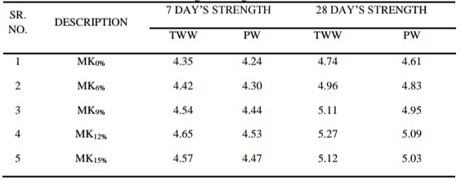

Fig.1 Variation in Split Tensile Strength with different proportions of metakaolin for M35 grade using OPC

*[6] Sunny A. Jagtap, Mohan N. Shirsath, Sambhaji L. Karpe (2017)*

They conducted examine to understand the impact of metakaolin on properties of sample. They partially replaced cement by metakaolin with 5 - 20% by lump of cement. M35 grade concrete design is adopted with a mix proportion of 1:1.69:2.28 for 0.42 water binder ratio. The compression and flexural were tested for 7 and 28 days. Obtained results concluded that the strength properties increase up to 15% supplant of MK.

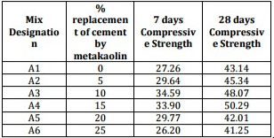

Compressive strength

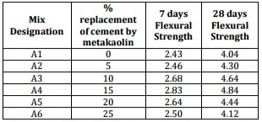

Flexural Strength

*[7] Dr. T. Felixkala, M. Narmatha (2016)*

The manufactured sample was casted for M60 grade of concrete with 5- 20% supplant of binder by metakaolin with even water binder ratio of 0.32. OPC of 53 grade cement, crushed stones of maximum size 20mm coarse aggregate and river sand passing IS sieve 4.75mm fine aggregate are used in the investigation. As a result of this investigation, the maximum strengths are occurred at 15% replacement by MK. At MK 15%, the increase in compression and flexural strengths at 28 days are 17.45% and 14.28% respectively.

*[8] Zubair Ahmad Khan, V S Sagu (2019)*

It is an investigation on the aspects of sample replaced by cement and natural sand by metakaolin and robo sand. The binder is replaced partially with metakaolin in varying percentages i.e. 0 - 20% by quantity of binder and natural sand with 50% of robo sand to get the different concrete mixes. The study was conducted for workability, compression, tension and flexure resistant at 7, 28 and 90 days. The optimum values of strengths are observed at 10% and 50% replacement of MK and robot sand respectively.

*[9] Shashikant Dewagan, Nidhi Gupta (2016)*

They conducted an exploratory analysis on stability of sample by using metakaolin and op. The investigation was done on M20 and M50 grades of concrete with MK about 5%, 10% and 20%, SF contents of 5% and 10%, FA content of 20% replacement by weight of cement. The water binder ratio is 0.3 for all pastes. They concluded that the workability and mechanical properties are increased with increase in percentage of MK.

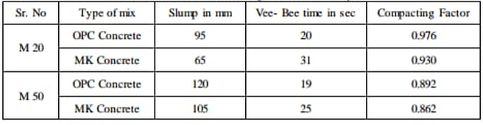

M20 and M50 Grade of Workability

*[10] Vivek. S, Prasanna. G etc. (2019)*

It is an exploratory analysis on concrete by supplant of cement by MK and kankar by pumice aggregates (igneous rocks). As the water content increases, the stability of concrete increases as well. The compression and tensile strengths are increased about 100% of that of nominal strengths by usage of MK and pumice. The optimum strengths are acquired at 20% MK and 35% of pumice aggregate.

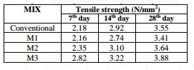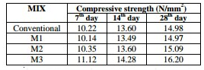

*[11] Abdelmelek Nabil, Eva Lubloy (2017)*

The different metakaolin dosages used for improving fire resistance by exposing to various temperatures. The metakaolin dosages are 0%, 3%, 6%, 9% and 12% by weight of cement are replaced. Temperature exposures are 50, 150, 300, 400, 500, 800 and 9000C. The results obtained concluded that at 9000C temperature the compression increases with increment in MK content.

*[12] Vandana P. Pandya, Iliyas U. Rasoolbhai (2015)*

They adopted M25 grade mix proportion 1:1:2 is fore casting and testing of cubes for compression strengths at 7 and 28 days. The metakaolin contents substituted in cement are 0%, 3% and 5% by quantity of binder and w/c ratio of 0.45 is constant. Minimum 10% of MK is to be used to completely achieve the requirements. On enhancement in portion of MK the compression resistance improves drastically.

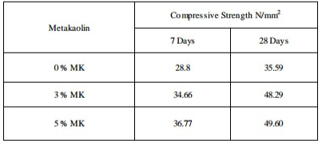

Results of Compressive Strength Test (Rice Husk Ash)

*[13] Ali M Mansor, Ramadan Edreis, etc. (2005)*Libyan MK is replaced by 0% - 30% of weight of cement. The water binder content of 0.5 is constant. The samples were cured for 3, 7, 28, 56 and 90 days. LMK replacement less than 15% are more workable than the higher percentages. For the mixtures having more than 15% LMK can be added with SP and made more workable.

*[14] AyobamiBusari, Joseph Akinmusuru, etc.**(2019)*

The investigation on strength and durable features of sample using metakaolin as a sustainable material gave the result that an increase in the percentage of metakaolin reduces the workability and hence the enhancing the admixtures. The mechanical related aspects of concrete improved when including 10 to 25% of metakaolin. The heat of hydration increases with increase in the amount of metakaolin.

*[15] Yan Wang, Yu Wang and Adel Al Menhosh (2016)*

The various extents of the mix two distinct polymers, metakaolin and recycled fiber fortification are tried. It was discovered that metakaolin caused an impressive decrease in workability and lessen the setting time of paste by 35-55%. The 20% substitution of concrete by MK increases sustainable 50% of compression strength. By inclusion of 5% polymer and 15% MK the concrete exhibits optimum properties.

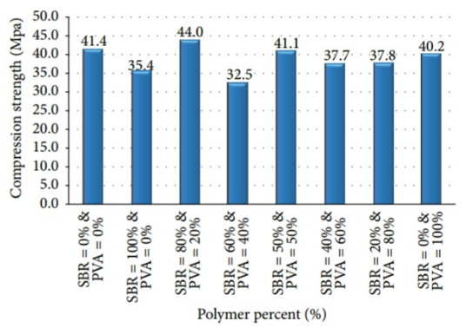

*[16] Vaishali. G. Ghorpade, H. Sudharsana Rao, etc. (2012)*

The durability of metakaolin and glass assisted better functioning concrete is investigated with 53 grade ordinary Portland cement. Fine aggregate is a river sand of zone II grading. The mix is M20 grade concrete. This MK mixed concrete resisted acid attack. The loss in compression strength is least as it is immersed in H2SO4 acid compared to HCl and MgSO4.

*[17] Bindu Biju, Imran H (2016)*

This is to study the metakaolin replaced concrete in a high performance concrete by experimentally testing M70 grade concrete. High performance concrete for M70 mix was developed with 28 days strength of 78.65N/mm2. In 10% replacement of MK the strength of specimens increased by 6% compared to control mix with further increases the strength was found to be decreasing.

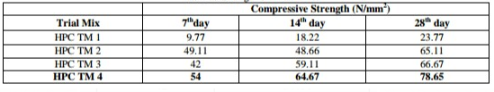

Strength of Trial mixes

*[18] R. Padmapriya, V. K. Bupesh Raja, etc. (2019)*

The experimental tests were directed to examine the effects on behavior of sample in partial supplant of sand and cement by steel based slag and metakaolin respectively. The hexagonal shaped specimens of side 120mm and 80mm height were casted. Compression, bending, tension related resistances, moisture absorption, acid and alkali attack examines were operated. Outcome shows optimal portion supplant of metakaolin and steel based slag is 10% and 20% respectively.

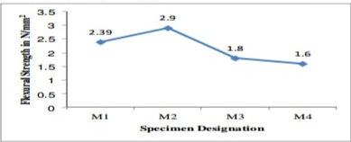

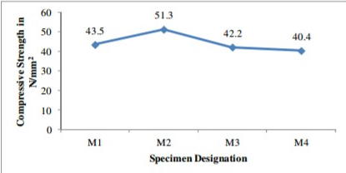

*[19] Pavankumar V, G. R. Krishnamurthy (2017)*

Exploratory analysis on hardness of test peice by supplant of binder and M-sand with metakaolin and steel based fiber respectively. The M70 grade concrete mix was designed. The compression, flexure and split tensile related aspects at numerous curing periods such as 7, 14 and 28 days examined. The metakaolin added to cement as substituent material by 0%, 10%, 20%, 30% and 40%. The maximum strength of concrete is obtained at 40% MK.

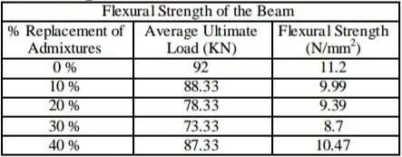

Flexural Strength Test

*[20] R. M. Sawant, Y. M. Ghugal (2015)*

They investigated on the use of metakaolin and optical fibre as admixtures in concrete by substitution. By substitution of cement with metakaolin about 10% to 15% by weight of cement and optical fibre about 1% to 3% by weight of cement resulted in increase of strengths, increased stable to chemical react and reduced alkali silica reactivity. It enhanced working capability, and reduces shrinkage. Metakaolin is useful in formation of high functioning, harden and lightweight concrete.

*[21] Satyendra Dubey, Rajiv Chandak, R. K. Yadav (2015)*

It is a test conducted the understand the impact of metakaolin on compression element of concrete. The cement is substituted with metakaolin by 5 - 15% by quantity of binder. OPC of 43 grade, fine aggregate as 4.75mm passing sand and coarse aggregate as 20mm and 10mm IS sieve passing broken stones are taken. M25 grade concrete mix with mix ratio of 1:1.87:3.32 and water binder portion of 0.5 were adopted. The compression strength at 28 days is optimum at 10% MK, increased by 21.3%.

*[22] C H Jyothi Nikhila, J D Chaitanya Kumar (2015)*

The partial supplant of binder with metakaolin in high strength concrete is investigated. M70 grade concrete with 0 - 30% Mk were tested for durability with H2SO4 and HCl of 0.5% and 1% concentrations. At 15% replacement of MK it is observed that the concrete attained its maximum compression strength when exposed to the acids for 28 days. At 1000C the compression strength is maximum and from that point it begins losing its stability with increase in temperature.

*[23] MemduhNas, Sirin Kurbetci (2018)*

In this work, the concrete containing metakaolin 5 - 20% by quantity of blend are tested for compression bending resistance, freeze-thaw and high temperature protections, slender coefficients and quick chloride penetrability properties. Water to binder ratio is maintained as 0.6 and all properties shown the maximum results at 20% MK

*[24] Kamaldeep Singh, Gurbir Singh Benipal (2015)*

A test conducted to understand the strengthening of concrete by using fly ash and metakaolin. The metakaolin is substituted with 10% and 15% by weight of cement. The compression, tensile, [flexuous](https://www.synonyms.com/synonym/flexuous), durability tests were conducted for 7, 14 and 28 days. From all outcomes it is concluded that at 15% substitution of cement by MK has optimum properties.

*[25] P. Dinakar, Pradosh K. Sahoo, G. Sairam (2013)*

It is an experimental investigation conducted to understand the effect of metakaolin level on the properties of stable concrete. Metakaolin mixtures with binder supplant of 5% 10% and 15% were designed for the target strength of 90MPa. The water binder ratio is 0.3. The compression strength was observed 106MPa at 10% substitution of MK. Even tensile strength, durability and resistance were as well followed the same trend. The metakaolin is useful in preparation of high strength concrete.

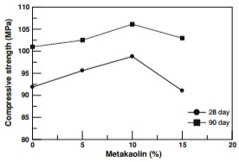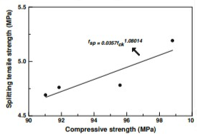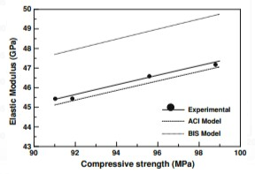

*[26] Merin Clara Mathan, Cinaya Tony (2016)*

The stability features of sample with metakaolin and methyl cellulose were tested. Methylcellulose is one of the bonding strength increasing material and can be used along with the metakaolin. The replacement levels were 10%, 15%, 20%, 25% and 30% (by weight) for metakaolin in M30 mix. At 20 to 25% replacement levels, the optimum values of compression, tensile, flexural and modulus of elasticity were obtained and thereafter the values started decreasing.

*[27] Jian Tong Ding (2002)*

Explored the either MK or SF on the working process, and protection from chloride entrance of cement were examined and thought about in this examination. For the given blend extents, MK offers preferred functionality over does SF. As the supplant level was expanded, the quality of the MK based sample expanded at all ages. The expansion in the strengthness was like that of SF based sample. The fuse of the both MK and SF in test sample can lessen the free drying and controlled shrinkages breaking width. The initial cracking showed up before in the SF-and MK-in cement can lessen the chloride dissemination rate essentially, with the SF solid working fairly.

*[28]Nova John (2013)*

Researched the binder substitution portions were 5 - 20% by quantity for metakaolin. The quality of all MK admixed sample blends aspired the stability improvement of concrete. Blend in with 15% metakaolin is better than all different blends. The expansion in metakaolin amount enhances the compression, tension and flexure qualities up to 15% substitution. The outcome supports the utility of metakaolin, as pozzolan substance for partial binder substitution in delivering high quality cement. The incorporation of metakaolin brings about quicker early age quality advancement of cement. The use of valuable metakaolin cement can make up for ecological, specialized and financial issues brought about by cement processing.

*[29]Dhinakaran (2012)*

Examined the quality increments by MK based sample is viable just initial time of cement and in drawn out the quality increment is just peripheral. The expansion in compression for MK based sample was more prominent particularly at more water binder proportions (i.e., 0.4 and 0.5) and subsequently progressively appropriate for higher w/c proportions. From investigations ideal level of MK was seen as 10% for all w/ proportions except for 0.32 and it was at 15%. The greatest compression quality of 59.25N/mm2 was observed at 0.4 w/c with 10% MK. Expansion of MK diminished the pH esteems, yet the decrease is irrelevant and are still above 11.5, which will be useful for keeping up the steel in a detached state itself. The profundity of penetration of chloride particles for MK concrete is a lot lesser than control concrete. The base pace of decrease of chloride penetration profundity for MK based sample were shown up as 78%, 38%, 25% and 25% for w/c proportions 0.32, 0.35, 0.40 and 0.50 separately. The most extreme pace of decrease was seen as 95% for 0.32 and 0.3ratios.

*[30]Shelorkar ajay (2013)*

Saw that compression state of Metakaolin related HGC increments with expansion in level of Metakaolin. Numerous compression quality examines of HGC with various Metakaolin substance of 4-8%. As the Metakaolin increments from 4- 8% the compression quality increments about 9.24 MPa, 12.98 MPa and 20.87 MPa for 4%, 6%, and 8 % Metakaolin separately. The expansion in compression because of the expansion of Metakaolin is expected to pozzolanic movement. The compression quality of HGC increments by 10.13 %, 14.24 % and 22.90% because of expansion of Metakaolin substance of 4 - 8 % individually in correlation with control solid examples of HGC. Numerous RCPT values in HGC for various extents of Metakaolin mixed cement. It has been seen that as the level of Metakaolin increment the porousness of solid reductions. Additionally, it was seen that estimations of quick chloride penetrability of HGC decline up to 1450, 1548.67 and 1684.70 coulombs for increment in contrast with control solid examples and rate decrease in porousness esteems in coulombs was 48.57 %, 51.88 % and 56.43% for Metakaolin substance of 4%, 6% and 8% separately.

*[31] Patil (2012)*

Examined compression of concrete increments with increment in HRM quantity till 7.5%. From that point of decrease in quality for 10 - 15% due overabundance measure of HRM lessens w/b proportion and deferral pozzolan action. Higher quality if there should arise an occurrence of 7.5% expansion is because of adequate measure of HRM accessible to respond with Ca(OH)2 which quickens moisture of concrete and structures CSH gel. Expansion of 7.5% high reactive metakaolin in concrete is the ideal rate improving the compression quality at 28th day by 7.73% contrasted with base blend sample and high reactive metakaolin in concrete is upgraded the protection from chloride assault. The compression of cement fused with 7.5% HRM is diminished distinctly by 3.85% as contrasted and the decrease of solidarity of control blend example is by 4.88%. The 7.5% expansion of great reactive metakaolin in concrete is additionally upgraded the protection from sulfate assault. Compression quality of cement fused with 7.5% HRM is diminished uniquely by 6.01% as contrasted and decrease in solidarity of plain blend by 9.29%. Current examination manages compression quality, split tension and flexural quality for concrete substitution by metakaolin based cement.

REFERENCES

1. Venu Malagaveli,SubodhJoshi- “Influence of Metakaolin in Concrete as Partial Replacement ofCement”-*InternationalJournal of Civil Engineering and Technology (IJCIET),* [www.iaeme.com/ijciet/issues.asp](http://www.iaeme.com/ijciet/issues.asp), Volume 9,Issue 7,pp. 105-111,Article ID: IJCIET_09_07_010.

2. Mohit-“Application of Sustainable Cement Alternatives in Concrete” –*International Journal of Engineering and Advanced Technology(IJEAT),*ISSN;2249-8958, Volume -9 ISSUE-1, October 2019.

3. Dr.K.Srinivasu,M.L.N.Krishna Sai, N.Venkata Sairam Kumar- “A Review on use of Metakaolin in Cement Mortar and Concrete”-*International Journal of Innovative Research in Science, Engineering and Technology*,An ISO 3297:2007 Certified Organization,volume-3,ISSUE 7,July 2014.

4. Mayuri A. Chandak, P.Y.Pawade- “Influence of Metakaolin in concrete Mixture”-*The International Journal of Engineering and Science(IJES),*ISSN(e):2319-1813 ISSN (P):23-19-1805,PP 37-41,2018.

5. Sanjeev Salot, Hemant Sood- “Effect of Partial Replacement of Cement With Metakaolin on Properties of Concrete Using Treated Waste Water”.

6. Sunny A. Jagtap, Mohan N. Shirsanth, Sambhaji L. Karpe- “Effect of Metakaolin on the Propeties of Concrete”- *The International Research of Engineering and Technology (IRJET)*,[www.irjet.net,volume](http://www.irjet.net,volume): 04 ISSUE:07 ,July – 2017.

7. Dr.T.Felixkala,M.Narmatha- “Metakaolin-The Best Material For Replacement of Cement in Concrete”- *IOSR Journal of Mechanical and Civil Engineering(IOSR-JMCE),*[www.iosrjournals.org](http://www.iosrjournals.org),volume 13,ISSUE 4 Ver. I (Jul. – Aug. 2016), PP 66-71.

8. Zubair Ahmad Khan, V S Sagu- “Investigation on The Properties of Concrete Replacing Cement and Natural Sand With MetaKaolin and Robo Sand Abstract”-*International Journal of Scientific Development and Reseach(IJSDR)-* [www.ijsdr.org](http://www.ijsdr.org),May 2019 IJSDR,Volume 4,Issue 5.

9. Shashilkant Dewangan, Nidhi Gupta- “Experimental Study on Strength of Concrete by Using MetaKaolin and op”-*IJARIIE-*ISSN(O)-2395-4396,[www.ijariie.com](http://www.ijariie.com),Vol-2 ISSUE-5 2016.

10. Mr.M.MohamedIlyas,Vasanthakumar.V,Prasana.G,Vivek.S,Tharmalingam.N- “Experimental Investigation on Concrete by Replacement of Metakaolin as Cement and Pumice Aggregates as Coarse Aggregates”- [*www.internationaljournalssrg.org*](http://www.internationaljournalssrg.org) *SSRG International Journal of Civil Engineering (SSRG – IJCE)* – Special ISSUE ICCREST March 2019.

11. Abdelmelek Nabil,Eva Lubloy- “Improved Fire Resistance By Using Different Dosages of MetaKaolin”-12th *Central European Congress on Concrete Engineering* 2017 Tokaj.

12. Vandana, P.Pandya,Iliyas U.Rasoolbhai-“Study on Standarad Concrete By Using MetaKaolin”- *International Journal of Advanced Engineering and Research Development*-Volume 2,Issue 1,January -2015.

13. Ali M Mansor,Ramadan Edries, Ahmed M M Hamed, Ruben Paul Borg- “Characterization of Libyan MetaKaolin and its effects on the mechanical properties of mortar” – *IOP Publishing*.

14. Ayobami BUSARI, Joseph AKINMUSURU- “ Strength and Durability Properties of Concrete using Metakaolin as a sustainable material: Review of Literatures”- *Internatinal journal of Civil Engineering and Technology(IJCIET),*Vol. 10,Issue o1, January 2019,PP. 1893-1902,Article ID: IJCIET_10_01_175.

15. Adel AI Menhosh, Yan Wang, and Yu Wang- “The Mechanical Properties of the Concrete using Metakaolin Additive and Polymer Admixture” *Hindawi Publishing Corporation*, http//dx.doi.org/10.1155/2016/1670615, Vol. 2016, Article ID 1670615, 6 Pages.

16. Dr.H. Sudarshan Rao, Dr. Vaishli. G.Ghorpade, Dr. H. N.Somasekharaiah- “Durability Studies on Metakaolin based Glass Fibre Reinforced High-Perfomance-Concrete”- *International Journal of Advanced Scientific Research and Technology*,Issue 2,Vol. 2(April 2012).

17. Bindu Biju, Imran H – “ Partial Replacement of Cement with Metakaolin in High Perfomance Concrete*”- international Journal of Innovative Research in Science, Engineering and Technology*, Vol. 5, Special Issue 14, December 2016.

18. R. Padmapriya, V.K.Bupesh Raja,V.Ganesh Kumar and J.Bala Murugan-“ Effeact on Properties of Concrete in Partial Replacement of Fine Aggregate by Steel Slage and Cement by Metakaolin, [*http://www.rasayanjournal.com*](http://www.rasayanjournal.com)*,* Vol. 12,No. 4, 1744-1751, Oct-dec 2019.

19. Pavan Kumar V, G.R. Krishnamurthy – “Experimental Study on Replacement of Cement with Metakaolin using M sand with Steel Fibre of M70 Grade of Concrete”-*International Journal of Science and Research(IJSR),* [*www.ijsr.net*](http://www.ijsr.net) ,Vol. 6,Issue 8, August 2017.

20. Prof. R.M.Sawant, Dr. Y.M. Ghugal – “ RecentTrend :Use of Metakaolin as Addmixture: A review” – *American Journal of Engineering Research(AJER),* [www.ajer.org](http://www.ajer.org) , Vol. 4, Issue 12,PP-08-14.

21. Satyendra Dubey, Rajiv Chandak, R.K.Yadav – “ Effect of Metakaolin on Compressive Strength on Concrete” – *International Journal of Engineering Research and Applications,* [www.ijera.com](http://www.ijera.com) , Vol. 5, Issue 6,(Part 4) June 2015,PP.80-82.

22**.** CH Jyothi Nikhil and J D Chaithanya kumar – “ Partial Replacement of Cement with Metakaolin in High strength Concrete” -*International Journal of Engineering Research and Science and Technology* 2015, [www.ijerst.com](http://www.ijerst.com) , Vol. 4,No. 4,November 2014.

23. Memduh Nas and Sirin Kurbetci – “ Durability Properties of Concrete Containing Metakaolin” – *Advance in Concrete Construction*, Vol. 6, No. 2 (2018) 159-175.

24**.** Kamaldeep Singh ,Gubir Singh Benipal – “ Strengthening of Cement Concrete using Fly ash and Metakoline: A Review” - *International Journal of Engineering Development and Research,* [www.ijedr.org](http://www.ijedr.org) , Vol. 3, Isssue 4, 2015.

25. P.Dinakar, Pradosh k. sahoo, and G. Sriram – “ Effect of MetakaolinContent on the Properties of High Strength Concrete” - *International Journal of Concrete Structures and Materials*, Vol. 7, No. 3, pp. 215-223, September 2013.

26**.** Merin Clara Mathan, Cinaya Tony – “ Strength Properties of Concrete Specimens with Metakaolin and Methyle Cellulose” - *International Journal of Science and Research(IJSR),* [www.ijsr.net](http://www.ijsr.net) ,Vol. 5, Issue 5, May 2016.

27. Sabir B.B, Wild S, Bai J, “Metakaolin and calcined clay as pozzolans for concrete :a review” *Cement and concrete composite* 23 (2001) pp.441-454.

28 . Jian-Tong Ding and Zongjin Li “Effects of Metakaolin and Silica Fume on Properties of Concrete” *ACI Materials* Journal/July- August2002,pp.393-398.

29. Badogiannis E, Papadakis V.G., Chaniotakis E, Tsivilis S, “Exploitation of poor Greek kaolins: Strength development of metakaolin concrete and evaluation by means of k-value” *Cement and Concrete Research* 34 (2004),pp.1035–1041.

30. Justice J.M, Kennison L.H, Mohr B.J., Beckwith S.L, McCormick L.E, Wiggins B., Zhang Z.Z, and Kurtis K.E, “Comparison of Two Metakaolins and a Silica Fume Used as Supplementary Cementitious Materials” SP- 228(Volume1&2) *Seventh International Symposium on Utilization of High-Strength/High Performance Concrete*, June(2005),SP228.

31 . NaikT.R.Singh, S.S and hossian,M.M (1995),”Properties of high performance concrete systems in corporating large amounts of high lime fly ash; *Construction And Building Materials*. Vol.9.No 4.Pp.195-204.

32 . M.B.Kumthekar, G.S.Vyas, N.T.Suryawanshi and M.B.More,” Techno-Economical Benefit of Metakaolin Over Microsilica in Developing High Performance Concrete”, *CE&CR* July 2007,pp.42-50.

33. Dinakar P,” High reactivity metakaolin for high strength and high performance concrete”, *The Indian Concrete Journal*, April 2011, pp.28-32.

AUTHORS PROFILE



**P.Charan Kumar,** Assistant Professor in Department of Civil Engineering, SRIT engineering College Ananthapuramu,515002 India.

Mail ID: [pallacharan.civil@gmail.com](mailto:pallacharan.civil@gmail.com)



**D.Lakshmi Shireesha,** Assistant Professor of Department of Civil Engineering, SRIT engineering College Ananthapuramu,515002 India.

Mail ID: [d.sirisha123@gmail.com](mailto:d.sirisha123@gmail.com)

  
**G.Ramajineyulu,** Assistant Professor of Department of Civil Engineering, SRIT engineering College Ananthapuramu,515002 India.

Mail ID: [gramunji@gmail.com](mailto:gramunji@gmail.com)