*Evaluation of mechanical properties of bamboo and banana fibre composites*

Sachindra Serigar a, Safwan Ahamed a, Sannith a, Vijeth Kumar a, Kiran Bhat b

a Students, Department of Mechanical Engineering, SMVITM, Bantakal Udupi.

b Assistant professor, Department of Mechanical Engineering, SMVITM, Bantakal Udupi.

**Abstract**― Natural Fibre Composites (NFC’s) nowadays are slowly replacing aluminum and other such metallic materials in automobile and aircraft industries. Interest is shown on NFC’s due to their advantages including low environmental impact and low cost. In this study a composite material is synthesized using long length banana and bamboo fibres reinforced with Epoxy, by hand-layup process. The specimens are prepared according to ASTM standards and mechanical testing was carried out. The composites with different weight fraction of epoxy i.e., 60% and 70% and 20% and 15% of weight fraction of banana and bamboo fibres were tested for tensile, flexural and impact strength. The composite with 60% epoxy having 20% fibres aligned at 0o/90o showed good mechanical properties.

**Index Terms**― Bamboo fibre, Banana fibre, Epoxy, Hand-layup process, Mechanical properties.

—————————— ◆ ——————————

**1 INTRODUCTION**

Over the last three-decade composite materials having major emerging materials. The number of applications of composite materials is steadily growing. Most of the composite materials are used in our daily life products. Composites have good strength to weight ratio, the present task is to make them cost effective. Many composite industries are manufacturing environmental friendly composite components by using innovative manufacturing techniques [1].

The composite industry begun to understand there is much business opportunities in commercial applications than in aerospace industry. This led to invention of glass, carbon, aramid fibre and polymer resin materials which are more useful for commercial purpose. High performance fibre reinforced polymers are used in armours to resist explosive impacts, fuel cylinders, windmill blades, industrial drive shafts. For most of the applications composites have replaced metals. Composites are extensively used for strengthening structures to make them seismic resistant. Properties of composite materials can be designed as per structural aspects.

A composite material is a combination of two or more materials which may have different physical or chemical properties arranged in suitable phases, with an interface separating them. The individual material has different property when compared to the composite. Composites have bulk phase called matrix which is continuous and dispersed phase called reinforcement which is non-continous [12].

Polymer Matrix Composites (PMC): Polymers are the most commonly used matrix materials. Generally mechanical properties of polymers are suitable for many structural aspects. By reinforcing other materials with polymers their strength and stiffness can be increased. Since the polymer matrix composites do not require high pressure and high temperature for processing and manufacturing equipments are simpler they became more popular for structural applications [3]. Two main types of polymers are: 1. Thermosets and 2. Thermoplastics

Thermosets have qualities such as a well-bonded three-dimensional molecular structure after curing. They decompose instead of melting on hardening. Simply changing the basic composition of the resin is enough to modify the condition suitably for curing and to determine the other required characteristics. They can be retained in a partially cured condition over extensive periods of time. Thus, they are most suited as matrix for advanced conditions. Thermosets find wide range of applications in the chopped fibre composites form particularly when a premixed or moulding compound with fibres of specific quality and aspect ratio happens to be starting material as in epoxy, polymer and phenolic polyamide resins.

Thermoplastics have one or two-dimensional molecular structure and they tend to at a higher temperature and show inflated melting point. Another advantage is that the process of softening at higher temperatures can reversed to regain its properties during cooling, enabling applications of conventional compress techniques to mould the compounds.

1.1Natural fibre reinforced composites

Fibres from natural resources are used in natural fibre composites. Mainly there are two types of fibres: natural fibres and synthetic fibres. Polymer composites containing vegetable fibres have gained attention in recent years. Due to high performance in mechanical properties, processing advantages, low cost, low density natural fibre polymer composites are gaining interest. Natural fibres are environmental friendly materials. They can be used as substitute for wood based materials in structural applications [8, 11]. Depending on extraction of fibre from various part of the plant, these fibres are classified into

1. Bast or stem fibres (jute, mesta, banana etc.)

2. Leaf fibres (sisal, pineapple, screw pine etc.)

3. Fruit fibres (cotton, coir, oil palm etc.)

Vegetable fibres mainly consist of cellulose fibrils embedded in lignin matrix. These cellulose fibrils are arranged along the length of fibre, these alignments have maximum tensile and flexural strengths. Natural fibres serve as good reinforcing agent for plastics, since they are strong, light in weight, abundant, non-abrasive, non-hazardous and inexpensive. To make useful structural composite materials vegetable fibres are reinforced with polymeric resin matrices.

1.2 Bamboo fibre

Bamboo fibre is a natural material which has high potential in textile industry. These are made from pulp of the plant, which is extracted from the bamboo plant’s stem and leaves. This fibre is available in abundance. They have high strength, biodegradable and renewable. Because of limited extraction of fibres from bamboo plant, research and investigation on bamboo fibres is limited. Bamboo fibres have good properties of moisture adsorption, moisture desorption, and air permeability [2, 4].

Extraction methods

Crushing: This is one of the mechanical methods. Roller crusher is used to cut raw bamboo into small pieces; Pin roller is used to get coarse fibre from small pieces. Then, they were boiled at 900 C for 10 h to remove fat and later dried in the rotary dryer. The coarse fibres are treated in dehydrator. Drawback of this method is short fibres are obtained, which become powdered after mechanical over-processing.

Degumming: Degumming process is a chemical method used to remove gummy and pectin content from the decorticated bamboo strips. Controlling the grade of bamboo degumming is essential to produce a long single fibre. Pectin and lignin need to be connected in the plant.

1.3 Banana fibre

Extraction process

Banana fibres are extracted from the pseudo stems of banana trees. The collected fibres is immersed in water for about 15 days. After that, the fibres are treated with 5% NaOH solution for nearly 4 hours. Followed by, the solution treated fibres are dried in an oven at 10500 C for 24 hours. After getting washed with the help of tap water, waste product of banana cultivation can be used to get banana fibre. It is a lingo-cellulose fibre [6].

1.4 Epoxy (binding agent)

Epoxy resin has great heat and chemical resistance characteristics. It helps in achieving higher shear strength values. Some features of epoxy are light weight, resistant to alkalis and acids, resists stress cracking and retains stiffness and flexibility [9].

Hardener (HY-951)

Hardener is a curing agent for epoxy. It is also called as catalyst, the substance that hardens the adhesive when mixed with resin.

1.5 Manufacturing process of composite materials

Manufacturing of composites means combining the polymeric resin system with the fibre reinforcement. Properties of composite material depend on orientation of fibres. So the fibres are aligned in desired directions in manufacturing process. To meet the specific design or manufacturing challenges many of the manufacturing process are developed like injection moulding. Selection of a method for a particular part, will depend on the materials, the part design and end-use or application.

1.6 Hand-layup process

In hand-layup process a mould is prepared in which epoxy resin is coated and then both the fibres are arranged in a specific angle of 0/90 degrees and 45/45 degrees and epoxy is coated above the fibres. Certain amount of load is subjected on the fibres and the fibre composite is removed from the mould after 24 hours [5, 7].

I. MATERIALS

In this study, Epoxy LY-556 is used as matrix material along with hardener HY-951. It was supplied by Herenba Instruments and Engineers, Chennai. Epoxy and hardener were mixed in the ratio of 10:1 [10]. Banana fibres and bamboo fibres

in 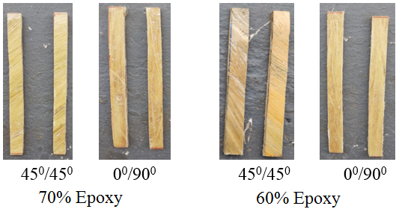long form of length 6 inches was procured from Shrilaxmi Group Cheprukpalli, Guntur, Andhra Pradesh. The density and tensile strength of banana fibre are 1.4 g/cm3 and 500 MPa respectively. The range of density of bamboo fibre are 0.6 to 0.8 g/cm3 and tensile strength ranges 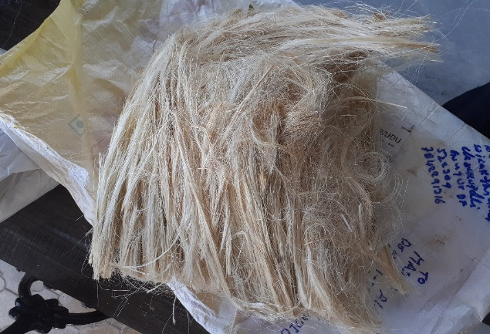from 140 to 800 MPa.

Figure 1: Bamboo fibre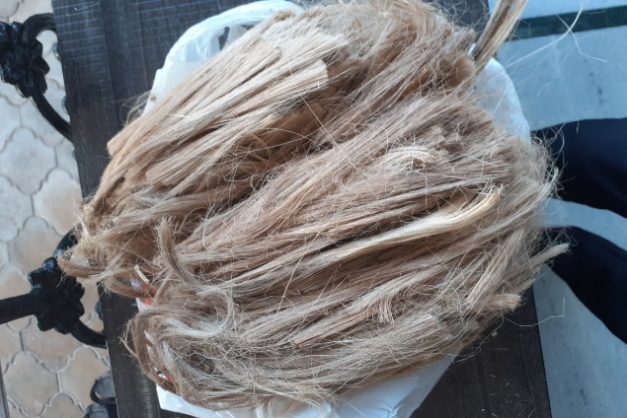

Figure 2: Banana fibre

II. PRODUCTION OF COMPOSITE

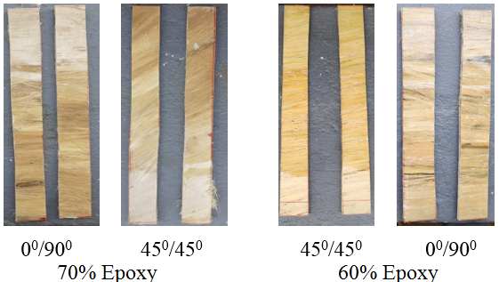 The complete work of production of composite was done at Shri Madhwa Vadiraja Institute of Technology and Management, Bantakal. Laminates were prepared by using hand-layup technique, by varying weight percentage of Epoxy 60% and 70%. The banana and bamboo fibres were taken in proportion of 15% and 20% of each respectively. Specimens were prepared as per ASTM standards, in the combination of Banana fibre, Bamboo fibre and Epoxy of 3mm thickness with a setting period of 24 hours.

Figure 3: Tensile test specimens

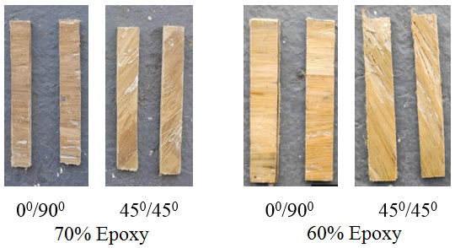Figure 4: Flexural test specimen

Figure 5: Impact test specimen

III. RESULTS AND DISCUSSION

A. Tensile test

The specimens were cut as per ASTM D3039 standard was tested in Zwick/Roell Z020 loadcell 20KN UTM. The plot of tensile strength v/s fibre weight % reveals that maximum tensile strength of 27.06 MPa is obtained in 60% Epoxy and 20% fibres (both banana and bamboo fibres) with 0/90 degrees of alignment. With the fibres alignment of 45/45degree minimum tensile strength of 3.3 MPa was obtained. So alignment of fibres with an angle of 0/90 degree shows higher tensile strength compared to 45/45degree alignment.

Figure 6: Variation of Tensile strength with increase in % wt of Fibre

The tensile strength of composite with 70% epoxy and 15% of fibres in both alignments were inferior compared to 20% of fibre addition. It is observed that as percentage of Epoxy increases tensile strength decreases. The decrease in strength is mainly due to the poor bonding between fibres and Epoxy.

B. Flexural Test

The specimens were prepared as per ASTM D790 standard was tested in Zwick/Roell Z020 loadcell 20KN UTM. The plot of Flexural Strength v/s fibre weight% reveals that maximum flexural strength of 74.23 MPa is obtained in 60% Epoxy and 20% fibres (both banana and bamboo fibres) with 0/90 degrees of alignment. With the fibres alignment of 45/45degree containing 70% epoxy minimum flexural strength of 20.46 MPa is obtained. So alignment of fibres with an angle of 0/90 degree shows higher flexural strength compared to 45/45degree alignment.

Figure 7: Variation of Flexural strength with increase in % wt of Fibre

The flexural strength of composite with 70% epoxy and 15% of fibres in both alignments were low compared to 20% of fibre addition. It is observed that as percentage of Epoxy increases flexural strength decreases. This can be attributed due to poor bonding between fibres and Epoxy.

C. Impact test

The specimens were cut as per ASTM D812 standard was tested in Zwick/Roell HIT 50P machine. The plot of Impact Strength v/s fibre weight % reveals that the maximum impact strength of 319 J/m is obtained in 60% epoxy and 20% fibres (both banana and bamboo fibres) with 0/90 degrees of alignment. With the fibres alignment of 45/45degree minimum impact strength of 159 J/m is obtained. So alignment of fibres with an angle of 0/90 degree shows higher impact strength compared to 45/45degree alignment.

Figure 8: Variation of Impact strength with increase in % wt of Fibre

The impact strength of composite with 70% epoxy and 15% of fibres in both alignments were low compared to 20% of fibre addition. It is observed that as percentage of Epoxy increases impact strength decreases.

When all three properties are combined and analysed, the 60% of epoxy with 20% fibre weight composite showed best results for tensile, impact and flexural strength compared to 70% epoxy with 15% of fibre weight composites.

IV. CONCLUSION

The evaluation of mechanical properties reveals that 60% epoxy with 20% fiber reinforced composite showed good mechanical properties compared to 70% epoxy with 15% fibre reinforced composites. As the epoxy percentage increases the strength of composites decreases.

V. References

[1]. Narayan Nayak, Walid Shaikh, Supreeth, Prashanta Nayak, Karthik, 2018. The effect of Sisal fibre on the mechanical properties of Polypropelene, ISSN 2229-5518.

[2]. Osorio, L., Trujillo, E., Van Vuure, A.W. and Verpoest, I., 2011. Morphological aspects and mechanical properties of single bamboo fibers and flexural characterization of bamboo/epoxy composites. Journal of reinforced plastics and composites, 30(5), pp.396-408.

[3]. Boopalan, M., Niranjanaa, M. and Umapathy, M.J., 2013. Study on the mechanical properties and thermal properties of jute and banana fiber reinforced epoxy hybrid composites. Composites Part B: Engineering, 51, pp.54-57.

[4]. Kalali, E.N., Hu, Y., Wang, X., Song, L. and Xing, W., 2019. Highly-aligned cellulose fibers reinforced epoxy composites derived from bulk natural bamboo. Industrial crops and products, 129, pp.434-439.

[5]. Kumar, N.V., Krishna, B.S. and Chandrika, N.S., 2019. Evaluation of properties of glass-banana-fiber reinforced hybrid fiber polymer composite. Materials Today: Proceedings.

[6]. Moshi, A.A.M., Madasamy, S., Bharathi, S.S., Periyanayaganathan, P. and Prabaharan, A., 2019, July. Investigation on the mechanical properties of sisal–Banana hybridized natural fiber composites with distinct weight fractions. In AIP Conference Proceedings (Vol. 2128, No. 1, p. 020029). AIP Publishing.

[7]. Gupta, A., Kumar, A., Patnaik, A. and Biswas, S., 2011. Effect of different parameters on mechanical and erosion wear behavior of bamboo fiber reinforced epoxy composites. International Journal of Polymer Science, 2011.

[8]. Saba, N., Alothman, O.Y., Almutairi, Z. and Jawaid, M., 2019. Magnesium hydroxide reinforced kenaf fibers/epoxy hybrid composites: Mechanical and thermomechanical properties. Construction and Building Materials, 201, pp.138-148.

[9]. Chee, S.S., Jawaid, M., Sultan, M.T.H., Alothman, O.Y. and Abdullah, L.C., 2019. Thermomechanical and dynamic mechanical properties of bamboo/woven kenaf mat reinforced epoxy hybrid composites. Composites Part B: Engineering, 163, pp.165-174.

[10]. Prabhu, R., Mendonca, S., D’Souza, R., Vas, J.P. and Bhat, T., 2019, March. Application of Taguchi techniques to study the effect of alkaline treatment and fiber length on mechanical properties of short bamboo fiber reinforced epoxy composites. In AIP Conference Proceedings (Vol. 2080, No. 1, p. 020019). AIP Publishing.

[11]. Biswas, S., Shahinur, S., Hasan, M. and Ahsan, Q., 2015. Physical, mechanical and thermal properties of jute and bamboo fiber reinforced unidirectional epoxy composites. Procedia Engineering, 105, pp.933-939.

[12]. Nagendra, P.S., Prasad, V.V.S., Padal, K.B. and Srikiran, S., 2019. Characterization of Banana Natural Fiber Nanocomposites by Thermal Analysis. In Recent Advances in Material Sciences (pp. 659-670). Springer, Singapore.