Multidirectional Forging of Binary Mg-Zn Alloy and its Performance

Anirudh Rao1a*, Aditya Kudva S1b, Ramesh S2c, Gajanan Anne1d

1*Department of Mechanical Engineering Shri Madhwa Vadiraja Institute of Technology and Management*

*2Department of Mechanical Engineering, NITK, Surathkal*

***Abstract*—Multi-directional forging (MDF) was applied to Mg-6%Zn alloy up to 5 passes successfully at 400˚C. Multi-directional forging (MDF) processed materials were characterized for microstructural analysis, mechanical properties and corrosion behavior. The microstructure was investigated using an optical microscope.The results showed a significant decrease in grain size up to 3.8 µm. The hardness of the Mg-6%Zn alloy was investigated using Vickers microhardness test. Microhardness of MDF processed 1st pass samples (74HV) is higher than that of the homogenized sample(48HV). The microhardness of 3rd pass MDF was the highest (86HV) due to grain refinement and decreased to (78HV) in the 5th pass. The corrosion behavior of the alloy was investigated using immersion study in simulated body fluid (SBF). After the corrosion study tests it was found that the corrosion rate of 5-pass MDF sample was 0.16 mg/cm2/d compared to that of the homogenized Mg-6%Zn alloy was 0.45 mg/cm2/d due to fine grain structure. The obtained results showed that as the number of MDF passes increases the micro hardness and corrosion resistance increased because of grain refinement and induced strain during the MDF process. The drastic grain refinement was observed in the MDF processed sample as compared to homogenized base material.**

**Keywords—**Multi-directional Forging; Magnesium alloys;

Microstructure; Mechanical properties; Corrosion behaviour.

__________________

15/06/2020

*Corresponding author.

E-mail address: aanirudh.16me015@sode-edu.in

bkudva.mech@sode-edu.in

c[ramesdmt@gmail.com](mailto:ramesdmt@gmail.com).

dgajanan.mech@sode-edu.in

# INTRODUCTION

A biomaterial is defined as “a material intended to interface with biological systems to evaluate, treat, augment or replace any tissue, organ or function of the body” and biocompatibility is defined as “the study and knowledge of the interactions between living and non-living materials” [1]. Metallic materials tend to have a major advantage as biomaterials due to their high mechanical strength and integrity[2]. In the case of load-bearing applications, metallic materials are more suitable compared to ceramics or polymers due to their high fracture toughness. Metallic implants made of stainless steel, Ti alloys, Co-Cr alloys are widely used in orthopedic applications to assist with the repair or replacement of the bone tissue, for example, plates, screws, and pins to fix fractures. These alloys possess good mechanical strength, which is required for load-bearing applications; however, their mechanical properties are not well-matched with those of natural bone tissue, leading to stress shielding effects that reduce stimulation of new bone formation and remodeling, eventually leading to implant loosening [3]. Hence, this prompted the development of biodegradable materials that could serve as a potential replacement as they have the desired property of naturally getting absorbed in the human body after the healing process of the fractured bone is completed. Most orthopedic implants have been used in fracture management devices and joint replacement [4]. Along with several advantages these tend to carry a certain number of limitations amongst which the most important one is degradation products produced due to corrosion and wear when exposed to the human body environment [5]. Polymers lack strength compared to their metallic counterparts. Among different metals, Magnesium (Mg) is mostly preferred as biodegradable metallic material owing to its low density (1.78g/cm3) and elastic modulus (45GPa), which are closer to that of human bone (density 1.8g/cm3); elastic modulus: (2–20GPa). Apart from the mechanical properties, the other main advantage of Mg is its superior biocompatibility property. Mg is the fourth abundant element present in the human body with about 21–28g on an average 70kg human being. The distribution of Mg in the human body is mainly concentrated in the bone (60%–70%) and the remaining in cells and blood vessels. Mg is also a part of more than 300 enzymatic reactions in our body. It helps to maintain normal muscle (a contraction of muscles), steady heart rhythm, healthy immune system, strong teeth and bones and transmits nerve impulses (neurological) [6–8]. Mg that gets degraded in the body will be first absorbed by the ileum and colon and will be flushed out of the body through the regular functioning of the kidneys. Thus for the above-said reasons, Mg is considered as one of the potential candidates as a metallic biodegradable biomaterial. Mg implants were used in vivo to secure fractures in early 1907 and were observed to undergo rapid corrosion due to the accumulation of excess gas under the tissue [9]. To overcome this high rate of corrosion different strategies like alloying, severe plastic deformation, surface modification is used by researchers. Mg alloys have become the primary focus of investigation for biodegradable implant applications [10]. Alloying and Severe Plastic Deformation is the most effective method to improve the mechanical properties of Mg. Several alloying elements like Aluminium(Al), Zinc(Zn), Manganese(Mn), Calcium(Ca), Strontium(Sr), and Rare Earth(RE) metals have been alloyed with Mg to improve its corrosion resistance and mechanical strength. Severe plastic deformation (SPD) techniques such as equal channel angular pressing (ECAP), Multi-Directional Forging (MDF) are effective ways to improve the strength of materials[13]. The SPD techniques lead to grain refinement of materials, resulting in strengthening based on the Hall-Petch relationship [14, 15]. SPD is used to induce large strain so that the ultra-fine grain structure is obtained. Moreover, it was reported that grain refinement attributed to the SPD techniques contributed to the improvement in corrosion resistance of some materials such as Mg-Zn alloy, Mg-Ca alloy, Mg-Sr alloy [16], [17], [18].

In this work, the aim is to develop a high strength Mg-based binary alloy with Zn as the alloying element. Therefore this study intends to subject the as-cast Mg-6%Zn alloy to homogenization and MDF and investigate its effect on microstructure and corrosion behavior.

# LITERATURE REVIEW

**Calcium (Ca)** It is known that addition of alloying elements to Mg is intended to modify its mechanical and corrosion properties. Gill et.al investigated Ca as an alloying element, calcium is generally added in small amounts to control the metallurgical properties by acting oxidation in the molten condition as well as acts as a grain refining agent (Michael and Avedesian, 1999). It is also beneficial for obtaining improved mechanical and corrosion properties compared to pure Mg when added in small percentages of 0.6-0.8% [17].

**Aluminum (Al)** is a common addition to Mg alloys as it is generally accepted to improve both the strength and corrosion resistance of the metal.[19]. Alloys containing Al generally possess a high-quality combination of mechanical properties, corrosion resistance, and die-castability [20]. Mg-Al alloys are extensively used in the automobile and aerospace industry. Biologically, Al toxicity in the body is detrimental to the body. In high doses, Al has been shown to cause neurotoxicity, with altered functions of the blood-brain-barrier [20].

**Strontium(Sr)** the solubility of Sr in Mg is about 0.11 wt%. It helps in grain refinement and enhances the corrosion resistance of Mg. Gu et al prepared hot rolled Mg-Sr binary alloys with a Sr content ranging from 1 to 4 wt% and found Mg-2Sr alloy exhibited the highest strength and the lowest corrosion rate. The in vivo results showed that the degrading as-rolled Mg-2Sr alloy promoted bone mineralization and peri-implant new bone formation without inducing any significant adverse effects[17].

**Zinc(Zn)** as an alloying element, Zn results in solid solution hardening with Mg and with other alloying elements, improves its strength and corrosion resistance [17]. Zn is commonly used as an alloying element for Mg alloys, and the yield strength of Mg alloys increases with its Zn content [20]. The solubility of Zn in Mg is about 6.2 wt%.[18] Zn is also an important macronutrient for humans and is involved in a wide range of physiological functions including protein synthesis, immune system regulation, and many enzymatic reactions.69,75. Of the commonly used alloying components, Zn is second only to Al in its ability to improve the strength of Mg alloys[19] it also can reduce the corrosion enhancing effects of all of the common impurities including Fe, nickel (Ni), and copper (Cu) reduces hydrogen gas evolution during biocorrosion[18][19] .

**Yurchenkoa, et al.** (2014) researched the effect of multiaxial forging (MAF) and mechanical properties of Mg-0.8 Ca alloy. Multiaxial forging with a continuous decrease of temperature from 450° to 250°C was successfully used to refine the coarse initial microstructure of Mg-0.8Ca alloy. After 9 cycles of forging with the final cycle performed at 250°C fine-grained structure with an average grain size of 2.1μm and a fraction of high angle boundaries of 69.3% was formed. Microstructural development during MAF was found to be governed by discontinuous dynamic recrystallization. Microstructure refinement was accompanied by a substantial increase in mechanical properties of the Mg-0.8Ca alloy. The yield stress increased about 4 times in comparison with as-cast and homogenized states, to 193.2 MPa and ultimate tensile strength increased more than 3 times, to 308.2 MPa. Ductility also increased about 2 times, elongation to failure after forging was 7.2%. [21]

**Ahmad Bahmani et al.** (2019) investigated corrosion resistance and strength of an Mg alloy using multi-directional forging (MDF). An Mg alloy 3.68Zn-1.74Al-0.65Ca-0.46Mn(wt%)was produced by extrusion followed by multi-directional forging for 9 passes with temperatures of 180, 220, 260 and 300° C and their mechanical properties and corrosion behavior were studied. Corrosion rates of the alloys using hydrogen evolution and weight loss study data of extruded and MDF samples in 3.5% wt NaCl solution saturated with Mg(OH)2 The corrosion rate decreased from 2.56(mm-year) for extrusion ally to 1.13(mm/year) for MDF300. Potentiodynamic polarization studies were carried out and corrosion rate increased from 0.39(mm/year) for extruded alloy to 0.72(mm/year) for MDF180 and again decreased to 0.28(mm/year) for MDF260 and again increased to 0.29(mm/year) for MDF300. After MDF the grain sizes decreased from 2.59μm for the extruded alloy to 1.87μm for MDF260 and increased to 2.39μm for MDF300. The hardness increased from 80.7HV for the extruded alloy to 107.2HV for MDF180 and decreased to 101.0HV for MDF300. The yield stress increased from 205MPa for the extruded alloy to 269MPa for MDF180 and decreased to 218MP for MDF260 and increased to 221MPa for MDF300. The compressive yield stress increased from 170MPa for the extruded alloy to 295MPa for MDF180 and decreased to 218MP for MDF260 and increased to 230MPa for MDF300.[22]

**Zhang et al.** (2018) investigated on Microstructure evolution and mechanical properties of AZ80 magnesium alloy during high-pass multi-directional forging. The testing material was a 15 mm thick commercial AZ80 magnesium alloy sheet. The specimen was heated for 5 min in a resistance furnace at a temperature of 673 K before forging. The MDF was performed 9 mm/s in the hydraulic testing machine with a controllable deformation speed. The tensile strength, yield strength, and elongation of AZ80 magnesium alloy have increased to a certain degree after the MDF. A homogeneous fine-grained structure was formed in the sample after 24 passes of deformation, and the average grain size was 0.73 μm which was about 48.5µm before processing. Tensile strength, yield strength, and elongation reached 333.8 MPa, 233.7 MPa, and 17.8%, respectively, which were 23.6%, 35.1%, and 154.2% higher than the initial sheets, respectively.[23]

Mg-Al is commercially available and is an extensively used alloy in aerospace and automobile industries. There has been wide research to use them for biomedical applications. However, some studies have reported that Al causes neurotoxicity in the human body. Hence the use of Al as an alloying element was ruled out for this study.

Elements like Ca and Sr are available in the human body however Zn was proven to be superior as an alloying element for both strength and grain refining ability.

For metallic materials, severe plastic deformation (SPD) techniques are considered as effective methods for refining the grain size. Among the SPD techniques, MDF is a simple and economic technique and can be used to produce bulk ultrafine-grained materials at an industrial scale.

# EXPERIMENTAL DETAILS

## 3.1. MATERIAL PREPARATION

Mg-6%Zn (wt.%) binary alloy was cast at 750-800℃ under control of 99% CO2 in an electrical resistance furnace using pure magnesium and Zinc granules as raw materials. Throughout the casting process, mechanical stirring was carried out to reduce impurities in the molten metal. The cast alloy was cut from the ingot and homogenization was carried out in a muffle furnace at 400℃ for 24 h. Chemical composition of cast alloys was determined using chemical spectroscopy method and found to be 6.18% (wt.%) Zn and balance Mg. Homogenized Mg-6%Zn binary alloy was subjected to MDF at a strain of 0.03 using a 60-ton universal testing machine. Before pressing, the die was heated up to 400℃ using electrical resistance heating coils. A schematic of MDF for the 3 passes (i.e., 1 cycle) is shown in Fig.3.3. Samples were first forged from the longest side, i.e., on X face. Then, it was rotated 90for the second pass and pressed on the Y face and similarly, for the third pass

*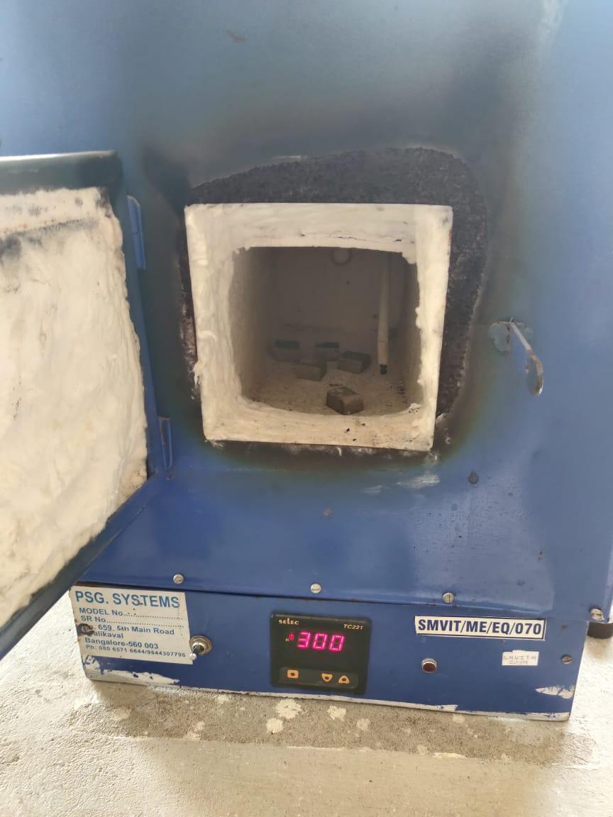 Fig 3.1 Muffle Furnace*

*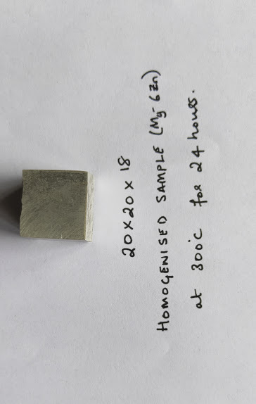 Fig 3.2 Homogenised Sample*

## 3.2 MICROSTRUCTURE

Microstructure characterization of homogenized and MDFprocessed Mg-6%Zn was carried out using an optical microscope (OM-Zeiss AX10. Samples were sectioned and mechanically polished sequentially from 100-grit up to 2000-grit SiC paper, and final polishing was done by diamond paste (0.25 µm) and, then, an acetic picral solution prepared with 70% ethanol, 20% distilled water, 10% acetic acid, 4.2 ml or mg of picric acid was used to etch the sample.

## 3.3 MECHANICAL PROPERTIES

Micro Hardness test was conducted using Vickers microhardness testing, where homogenized and MDF processed Mg-6%Zn alloy samples were sectioned in a transverse direction, and tests were carried out at a load of

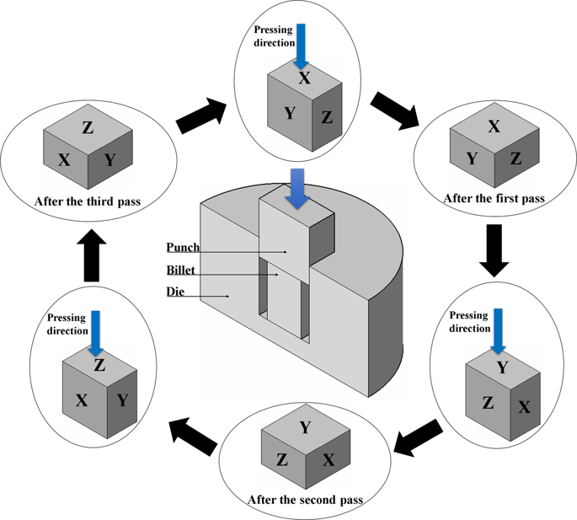

*Fig 3.3 Schematic representation of MDF upto 3 pass*

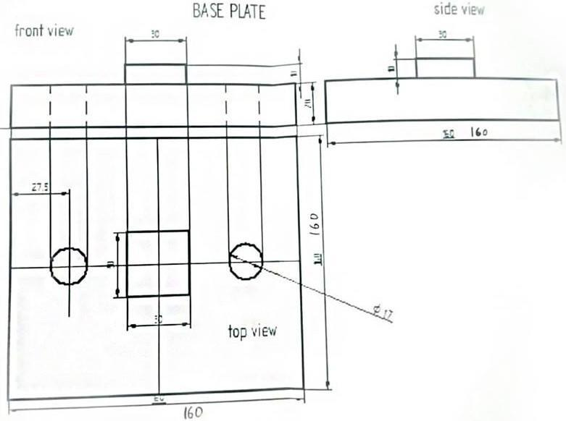(a)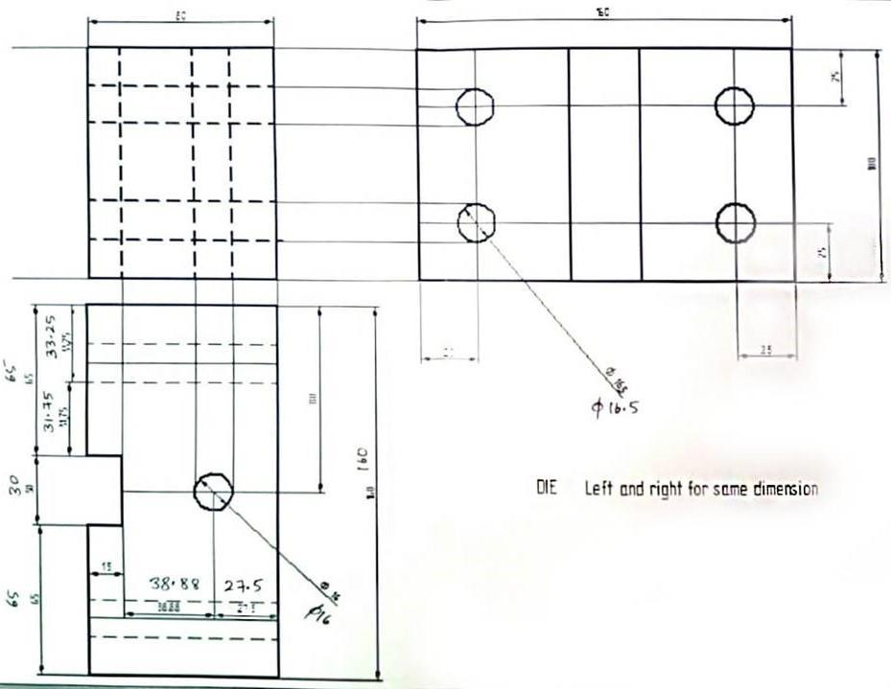

(b)

*Fig 3.2(a) and (b) MDF die design*

100 g for a dwell time of 11s using Omni-tech microhardness machine. A minimum of 5 indentations was taken throughout the surface to meet statistical reliability. The average microhardness was calculated and the error is expressed as the standard deviation of the total data set.

**Vickers number (HV) = 1.854(F/D2)**

Where F is the applied load (measured in kilograms-force). D2 is the area of indentation (measured in square millimeters).

## 3.4. CORROSION BEHAVIOR

3.4.1. IMMERSION TEST.

### 

It is well known that the overall corrosion reaction of magnesium in aqueous solutions at its corrosion potential can be expressed as follows:

Mg + 2H2O = Mg2+ + 2OH- +H2 (1)

This means that the dissolution of one magnesium atom generates one hydrogen gas molecule. In other words, the evolution of one mole of hydrogen gas corresponds to the dissolution of one mole of magnesium. Therefore, in theory, measuring the volume of hydrogen evolved is equivalent to measuring the weight-loss of magnesium dissolved, and the measured hydrogen evolution rate is equal to the weight-loss rate if both have been converted into the same units**.**

From reaction (1), it can be seen that hydrogen evolution is determined by the dissolution of magnesium. The corrosion products do not affect the relationship between the hydrogen evolution and magnesium dissolution. The hydrogen evolution rate directly reflects the corrosion rate of magnesium. Therefore, theoretically the corrosion rate of magnesium measured by hydrogen evolution should be very reliable.

The apparatus contains a beaker with simulated body fluid. A pipet which has a funnel-like structure at the top and a bulb at the bottom is inverted and placed inverted inside the beaker.

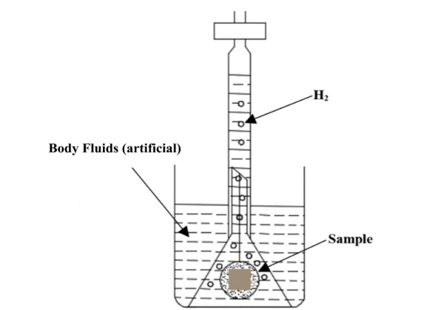

*Fig. 3.3 Hydrogen evolution apparatus*

Samples were fine polished and were immersed in simulated body fluid at room temperature for 5 days. Readings were taken every 10 hrs. Hydrogen evolution and pH of the solutions were recorded during the immersion test. Equation 2 is used to calculate the corrosion rate through hydrogen evolution

**PH = 3.65 Δ*w*/ρ**  (2)

where PH = corrosion rate through hydrogen evolution (mm/ year),

ρ= metal density (g/cm3), and Δw = weight loss rate (mg/cm2 /d).

One mol (24.31 g) of Mg metal corrodes for each mol (22.4 L) of hydrogen gas production. Therefore, the hydrogen evolution rate, VH (ml/cm2 /d), is related to the metallic weight loss rate as per equation 3:

**Δ*w* = 1.08 VH**  (3)

where VH = hydrogen evolution rate (mL/cm2 /day).

Testing specimens will be cut into 10mmX10mm dimensions and mounted with the help of acrylic powder and resins. After that will be mechanically polished sequentially up to 2000-grit SiC paper, and ﬁnal polishing was done by diamond paste (0.25 µm).

# RESULTS AND DISCUSSION

## 4.1 MICROSTRUCTURAL CHARACTERIZATION

### 4.1.1 OPTICAL MICROSCOPE

There was a huge decrease in grain size during the first pass when compared to other passes. The grain refinement can be observed clearly in the 3rd pass. The grain size is finer in the 5th pass when compared with 3rd pass MDF processed samples. Thus fine dispersion of alloying elements with increasing passes of MDF is observed.

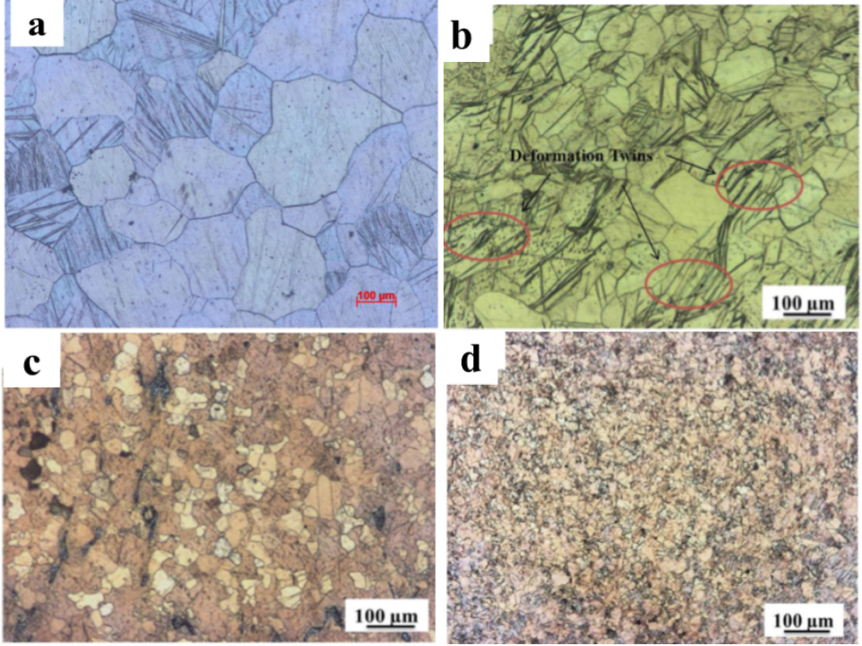

*Fig. 4.1 OM results of a) homogenized b)1st passMDF c)3rd passMDF d)5th passMDF samples respectively.*

From Fig 4.1, the first pass of MDF led to a large grain refinement due to the high rate of dislocation generation and found to be 72 µm Fig 4.1(b). After 3 passes of MDF, grain size reduced to 28 µm due to grain subdivision as shown in Fig. 4.1(c). Fig 4.1(d) shows an optical micrograph of 5-pass MDF-processed sample in which a uniform distribution of fine grains was observed compared to those in lower passes (1 and 3 pass) due to dynamic recrystallization occurring during MDF and the average grain size was observed to be 3.8 µm

## 4.2. MECHANICAL PROPERTIES

4.2.1 MICRO HARDNESS

Vickers Microhardness Test of homogenized, MDF 1,3 & 5 passes was conducted. Each sample was checked five times at different locations and the average of hardness values were recorded and error is expressed as the standard deviation of the total data set. **The various process parameters are mentioned in the table below**

|  |  |  |
| --- | --- | --- |
| **No. of Pass** | **Micro hardness (HV)** | **Cumulative Strain** |
| Homogenised | 48 | 0 |
| Pass 1 | 74 | 0.7 |
| Pass 3 | 86 | 1.36 |
| Pass 5 | 78 | 2.05 |

Table 4.1

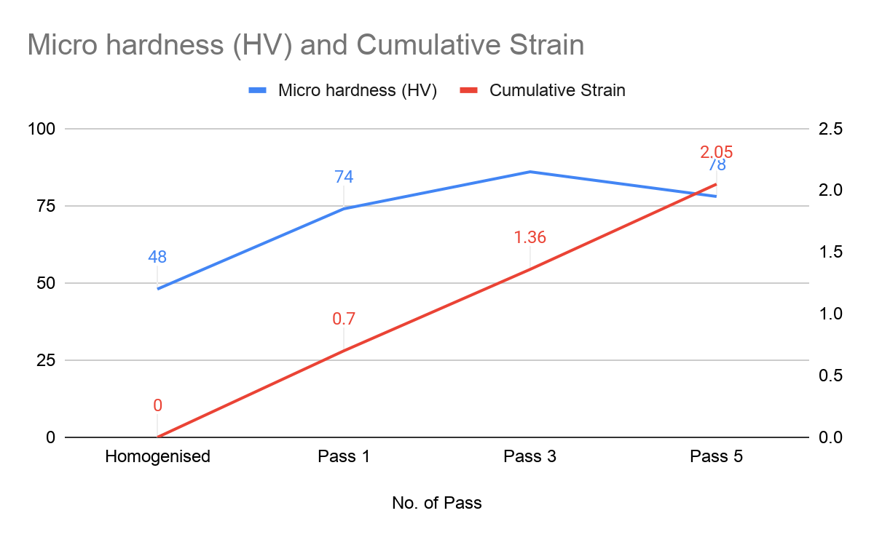

*Fig 4.2 Graph for No. pass vs Hv vs Cumulative strain*

From Fig 4.2 it can be observed that the microhardness of MDF processed 1st pass samples (74HV) is higher than that of the homogenized sample(48HV). It is evident that large strain hardening effectively took place during the first pass. Further, the hardness of the third pass(86HV) increased due to grain refinement, and the hardness during the fifth pass(78HV) decreased with further increase in grain refinement & softening of the material.

## 4.3 CORROSION BEHAVIOR

### 4.3.1 IMMERSION STUDY

A comparison of corrosion rates of MDF processed (Mg-6%Zn) alloy with cast-alloy and increasing passes of MDF measured by hydrogen evolution method is shown in Fig 4.3. **The various process parameters are mentioned in the table below**

|  |  |
| --- | --- |
| **Material** | **VH(ml/cm2/day)** |
| Homogenised | 0.45 |
| Pass 1 | 0.36 |
| Pass 3 | 0.19 |
| Pass 5 | 0.16 |

Table 4.2

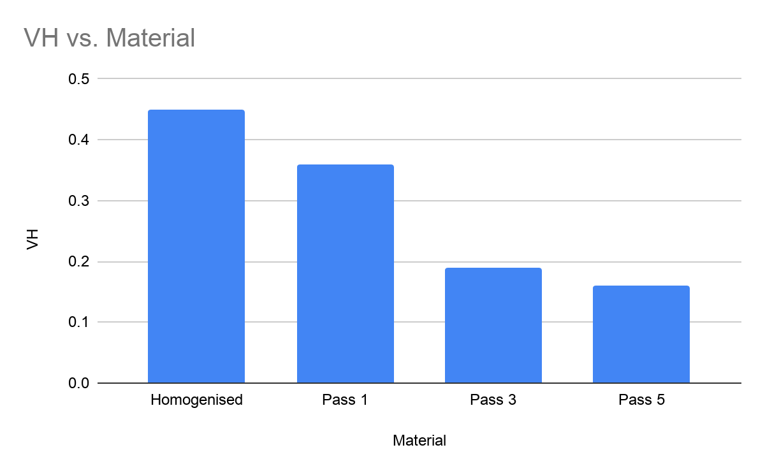

*Fig 4.3 Material vs Hydrogen Evolution*

From Fig 4.3 it can be observed that there is a sharp decrease in the evolution of hydrogen as the number of passes increases, the rate of evolution of hydrogen decreases drastically from 1st pass to 3rd pass, there is a decrease in corrosion rate with the increase in the number of MDF passes.

# CONCLUSION

* MDF was successfully carried out at 400˚C without any cracking up to 5 passes.
* A decrease in grain size for increasing passes of MDF was observed. The grain size became finer in the 5th pass when compared with the 3rd pass MDF processed sample. Thus fine dispersion of alloying elements with increasing passes of MDF is observed.
* The microhardness of MDF processed 1st pass samples (74HV) is higher than that of homogenized samples (48HV). Further, the hardness of the third pass increased, and the hardness during the fifth pass decreased with further increase in grain refinement & softening of the material.
* Corrosion rates of MDF processed (Mg-6%Zn) alloy is decreased with an increase in the number of passes due to grain refinement and softening of the material.

# REFERENCE

[1] D.F. Williams, Definitions in Biomaterials: Proceedings of a Consensus Conference of the European Society for Biomaterials, 1987.

[2]Magesh Sankar, Jithin Vishnu, Manoj Gupta, Geetha Manivasagam, Magnesium-based alloys and nanocomposites for biomedical application

[3] J. Nagels, M. Stokdijk, P.M. Rozing, Stress shielding and bone resorption in shoulder arthroplasty, J. Shoulder Elb. Surg. 12 (2003) 35–39, https://doi.org/10.1067/

Mse.2003.22

[4] M. Marlowe, J.E. Parr (Eds.), Modularity of Orthopedic Implants, American Society for Testing and Materials (ASTM), Pennsylvania, 1997.

[5] M.P. Staiger, A.M. Pietak, J. Huadmai, G. Dias, Magnesium and its alloys as orthopedic biomaterials: a review, Biomaterials 27 (2006) 1728–1734, https://doi.org/10.1016/j.biomaterials.2005.10.003.

[6] F. Pi-Sunyer, Obesity. Mod. Nutr. Heal. Dis. (1999) 1395–1414, https://doi.org/

10.1016/0738-3991(95)90004-7.

[7] R.D. Grubbs, M.E. Maguire, Magnesium as a regulatory cation: criteria and evaluation, Magnesium 6 (1987) 113–127. http://www.ncbi.nlm.nih.gov/pubmed/3306178,

[8] G.A. Quamme, Renal magnesium handling: new insights in understanding old problems. Kidney Int. 52 (1997) 1180–1195, https://doi.org/10.1038/ki.1997.443.

Magnesium-based alloys and nanocomposites for biomedical application 107

[9] J.J. Jacobs, J.L. Gilbert, R.M. Urban, Current concepts review—corrosion of metal orthopaedic implants corrosion of metal orthopaedic implants, J. Bone Joint Surg. 80 (2)(1998) 268–282.

[10] F. Witte, Reprint of: The history of biodegradable magnesium implants: a review, Acta Biomater. 23 (2015) S28–S40, https://doi.org/10.1016/j.actbio.2015.07.017.

[11] J.L. Nadler, S. Goodson, R.K. Rude, Evidence that prostacyclin mediates the vascular action of magnesium in humans, Hypertension 9 (1987) 379–383.

[12] M. Gawaz, I. Ott, A.J. Reininger, F.J. Neumann, Effects of magnesium on platelet aggregation and adhesion. Magnesium modulates surface expression of glycoproteins on platelets in vitro and ex vivo, Thromb. Haemost. 72 (1994) 912–918.

.

[13] R. Z. Valiev and T. G. Langdon, “Principles of equal-channel angular pressing as a processing tool for grain refinement”, Prog. Mater Sci., 51 (2006) 881-891.

[14] E. O. Hall, “The Deformation and Ageing of Mild Steel: III Discussion of Results”, Proc. Phys. Soc. Sect. B, 64 (1951) 747-753.

[15] N. J. Petch , “The Cleavage Strength of Polycrystals”, J. of the Iron and Steel Inst., 174 (1953) 25-28.

[16] Puneet Gill and Norman Munroe , “Review on magnesium alloys as biodegradable implant materials” 2012

[17] Nan Li, Yufeng Zheng, “Novel Magnesium Alloys Developed for Biomedical Application: A Review”, 2013

[18] R Radha, D Sreekanth, “Insight of magnesium alloys and composites for orthopedic implant applications – a review”, 2017

[19] Jemimah Walker,1 Shaylin Shadanbaz,1 Timothy B. F. Woodfield, Mark P. Staiger, George J. Dias ”Magnesium biomaterials for orthopedic application: A review from a biological perspective ”

[20]Dharam Persaud-Sharma , Anthony McGoron “Biodegradable Magnesium Alloys: A Review of Material Development and Applications”

[21] N Yu Yurchenkoa, N D Stepanova, G A Salishcheva, L L Rokhlinb, S V Dobatkinb “Effect of multiaxial forging on microstructure and mechanical properties of Mg-0.8Ca alloy” 2014

[22] Ahmad Bahmani & Srinivasan Arthanari & Kwang Seon Shin “Improved corrosion resistant and strength of a magnesium alloy using multi-directional forging (MDF)”, 2019

[23] Zhang R, Wang DJ, Yuan SJ. Eﬀect of multi-directional forging on the microstructure and mechanical properties of TiBw/TA15 composite with network architecture. Mater Des 2017;134:250–8.