An Engineering student’s viewpoint on the implementation of active learning techniques and modern tools for the teaching-learning process

Kishor Kumar Aroor, Prof. Dr. Thirumaleshwara Bhat.

*Shri Madhwa Vadiraja Institute of Technology & Management, Bantakal, Udupi.*

*Abstract*— Large number of graduates coming out of higher educational institutions, especially the technical institutions facing tough competition in the job market, which demands high quality education for preparing competitive graduates coming out of their institution. In view of this Accreditation by National Board of Accreditation (NBA) is a mandatory requirement for every technical institution in India. Accreditation by NBA is based on Outcome Based Education (OBE) practices. Active learning techniques and use of modern technology in teaching learning process are key components of OBE practice. The investigation on the above components carried out determined the level of implementation of active learning techniques and use of modern tools for teaching-learning process with student’s acceptance towards these techniques in Engineering Institute.

The study has been carried out in an Engineering College to investigate the level of implementation of active learning and modern tool usage has revealed a positive response from the stakeholders. The study also indicates that Active learning techniques such as summarizing, group discussion, quiz and usage of modern tools in the teaching learning process are very effective.

*Index Terms*— Active learning techniques, Outcome Based Education,

# INTRODUCTION

The progress of any country is directly related to the education system adopted. In recent decades, the number of technical higher educational institutions has drastically increased in the country. The huge number of graduates from these institutions every year has created a tough and competitive job market. Many industry experts are of the view that a considerable percentage of these candidates are unsuitable to be directly employed in the industrial sector. Hence institutions are required to undergo some process to conform to certain sets of service and operational standards. Outcome Based Education criteria is one such standard that are adopted by technical institutions with a view to get accredited by bodies such as NBA and NAAC. These accreditations showcase the institutions’ capabilities in developing candidates who will be better employable with lesser need of training in the industrial sector after graduation. An effective implementation of Outcomes-Based Education is the key factor for any program to become ready for accreditation.

The traditional methods of teaching have been in practice for many generations which is completely teacher centric in which many teachers have observed passive learning without much involvement of students in the classroom teaching. Hence, the faculty members face a lot of challenges with respect to effective involvement of students during classroom teaching. Due to the availability of enormous sources of online information related to various subjects, and due to the massive distractions that the students are facing in the form of social media, classroom teaching has become quite a challenge for the teaching faculty. Also, because of the changing academic atmosphere, student’s involvement should not be limited to just attending and listening to the class. There are other related aspects to classroom learning where a student can actively participate. To change the mindset of the students and to make the classes more interesting, certain techniques need to be adopted to increase their involvement in the classroom The recent trend witnessed a huge transformation in the teaching learning process compared to the traditional way of teaching. Due to the implementation of OBE, the focus has shifted from teacher centric to learner centric. Therefore, to ensure the effective implementation of OBE process, classroom teaching using modern tools are recommended. [1]

The modern teaching-learning process, under the Outcome Based Education system demands faculty members to set the learning objectives and methodologies for achieving those objectives, before delivering the subject content. They would also need to prepare an effective lesson plan wherein the student’s involvement will be high.

Recently, many faculty members have started to adopt active learning techniques in their everyday teaching learning-process to make learning effective. Many investigators have acclaimed that active participation of the students in the teaching learning process increases and supports their overall academic capability. Further, they have suggested that active learning techniques help the students to sharpen their skills and logical ability, enabling them to understand things on a better scale in comparison to the traditional way of teaching. [2] Even when it comes to the subjects related to engineering, some researchers conducted studies on active learning techniques and came to a conclusion that effective implementation of active learning techniques will improve student’s involvement and help facilitators to provide useful and refined information to learners.

The current generation students are raised in a digital world. For students, especially at the degree level, it is absolutely necessary to use technology in all aspects of their lives. This is why usage of digital tools in classroom is becoming more attractive. Using technology in the education field, to rouse the students’ curiosity increases their in-class engagement and leads to a better learning atmosphere. Presently, plenty of such digital tool options are available for faculty members to utilize. Some of them are listed below.

* Animated videos
* Google class room/canvas or other online classes for sharing notes, lecture videos or for conducting quizzes
* Online courses (Swayam-NPTEL etc.)
* Sharing of study material by the faculty members through their Blogs.
* Faculty members You Tube channels.

# Active learning approach for teaching learning process

Active learning can be defined as “Learning is enhanced by involving the student in activities and relationships, inside and outside the classroom”. (Asin1984). Plenty of the active learning techniques are available but the following seven different active learning techniques are considered for this study purpose.

1. Minute Paper

A one minute paper may be defined as a very short, in- class writing activity (taking or minute or less) in response to an instructor posed question, which prompts students to reflect on the day’s lesson and provide the instructor with useful feedback.

1. Verbal Quiz

Asking quiz questions related to their subject topics in their respective classes.

1. Think-Pair-Share

After defining the particular situation / problem / case studies with respect to the subject topics, faculty members ask students to form a pair and allow them to share their thoughts with each other and share the same with the other student pairs.

1. Flipped Learning

This is the method in which notes / study materials are given in advance, and the class hours are used only for solving problem based on the study materials that were provided earlier.

1. Summarizing

Asking the students to summarize the overall concept studied in a particular class hour.

1. Role-play

Role-play is a learning structure that allows students to immediately apply the content that they have studied into practice as they are put in the role of a decision maker who must make a decision regarding policy resource allocation or some other outcome.

1. Group Discussions

Asking students to form a group to work together and to achieve a common set of goals.

# objective of the study

Mainly, the following four research questions were addressed in this study:

1. The level of implementation of active learning techniques in the Engineering institute.
2. The level of implementation of modern technology with respect to teaching learning in the Engineering institute.
3. The extent of acceptance of active learning techniques by- the students of the engineering institute.
4. The extent of acceptance of modern technology by the students of the engineering institute.

# methods

Design of Research

This investigation used a descriptive technique of research in which quantitative data was gathered using survey questionnaires.

Participants

The study received a response from 242 engineering students belonging to Shri Madhwa Vadiraja Institute of Technology and Management, Bantakal, Udupi, Karnataka. SMVITM Bantakal is one of the prominent Engineering-institutions located in coastal Karnataka, affiliated to Visvesvaraya Technological University, Belagavi. This engineering college has got four different engineering programs namely, Civil Engineering, Computer Science and Engineering, Electronics and Communications Engineering and Mechanical Engineering. For getting better results, only the final year and pre-final year students of these programs were considered for data collection.

Instrument

Two sets of questions were prepared for data collection. The first set consisted of 15 questions, meant for measuring the implementation and the second set consisted of 11 questions, meant for measuring student acceptance. All these questions were validated by experts.

Statistical Measure

Weighted Average (WA) calculation was applied to associate the answers of the respondents to each question. Likert scale was used with values 5 to 1 corresponding to the given options; from strongly agree to strongly disagree. The computed average ratings were evaluated according to the following interval values; 4.00 - 5.00: Highly positive response; 3.00-3.99: Positive response and Less than 3.00: Negative responses. Also, satisfactory level and acceptance level in terms of percentage has been calculated.

# Results and discussions

Research question 1: The level of implementation of active learning techniques in the Engineering institute.

Table 1: Weighted mean and satisfactory level of implementation of Active learning techniques

|  |  |  |
| --- | --- | --- |
| **Active learning Technique** | **WM** | **Satisfactory level** |
| Minute Paper | 3.3 | 66% |
| Verbal Quiz | 3.5 | 70% |
| Think pair and share | 3.3 | 66% |
| Flipped class | 3.4 | 68% |
| Summarizing | 3.9 | 78% |
| Role Play | 3.3 | 66% |
| Group discussion | 3.6 | 72% |

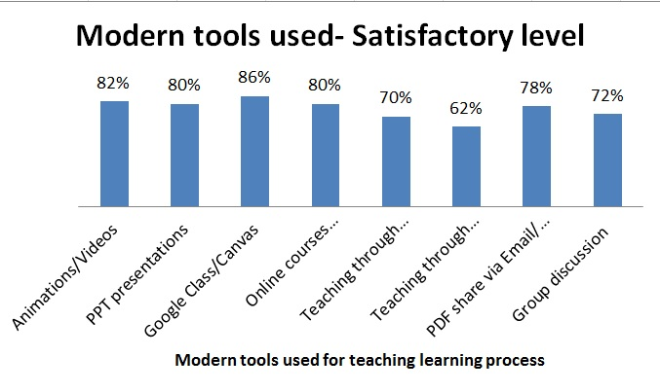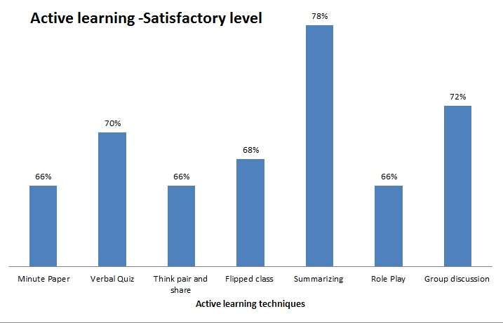

Figure 1: Graphical representation of satisfactory level of active learning technique.

The results on table 1 indicate that all the questions on implementation of active learning techniques, received positive response from students with Weighted Average more than 3.00, which indicates that all these techniques are practiced and implemented by faculty members of SMVITM. Meanwhile, no single active learning technique received Weighted Average of more than 4.00, which indicates that no single activity is highly implemented by the faculty members.

From the findings on Figure 1, it is evident that summarizing, group discussions and verbal quiz are the top three active learning techniques implemented in the institution which received a student satisfactory level of 78%, 72% and 70% respectively, followed by flipped class in the 4th place with 68 % satisfactory level. The remaining three activities, namely, Minute paper, Think pair and share, and Role play are the least implemented ones, with a satisfactory level of 66% .

Research question 2: The level of implementation of modern technology with respect to teaching-learning in the Engineering institute.

Table 2: Weighted Mean and satisfactory level of implementation of Modern tools for the teaching-learning process

|  |  |  |
| --- | --- | --- |
| **Modern tools used** | **WM** | **Satisfactory level** |
| Use of animations/ videos | 4.1 | 82% |
| Use of Power point presentation | 4 | 80% |
| Google class-room/ Canvas/-other online classes | 4.3 | 86% |
| Encourage for Swayam / NPTEL | 4 | 80% |
| Sharing of study material by the faculty members through their Blogs | 3.5 | 70% |
| Sharing information through YouTube and other channels | 3.1 | 62% |
| Sharing of PDFs through WhatsApp/ Email | 3.9 | 78% |

Figure 2: Graphical representation of satisfactory level of modern tools for the teaching-learning process

The result in Table 2 indicates that all the questions on the use of modern technology in teaching-learning, received positive response from students with a Weighted Average of more than 3.00, which indicates that all these modern tools are used by faculty members of SMVITM.Four of the modern tools, namely, Online classes (Google class/canvas), use of animations- / -videos , Power point presentation and the online courses like Swayam –NPTEL are highly implemented with a Weighted Mean of more than 4, where as the other three technologies are implemented with a a far lessor frequency.

It is quite evident from the findings of Figure 2 that Google class is implemented highly in the institution with a satisfactory level of 86% and teaching through YouTube got the least satisfactory level of 62%.

Research question 3: The extent of acceptance of active learning techniques by- the students of the engineering institute.

Table3: Student’s acceptance about active learning techniques.

|  |  |  |
| --- | --- | --- |
| **Active learning Technique** | **WM** | **Acceptance level** |
| Minute Paper | 3.9 | 78% |
| Verbal Quiz | 4 | 80% |
| Think pair and share | 3.8 | 76% |
| Flipped class | 3.8 | 76% |
| Summarizing | 4.1 | 82% |
| Role Play | 3.9 | 78% |
| Group discussion | 4.2 | 84% |

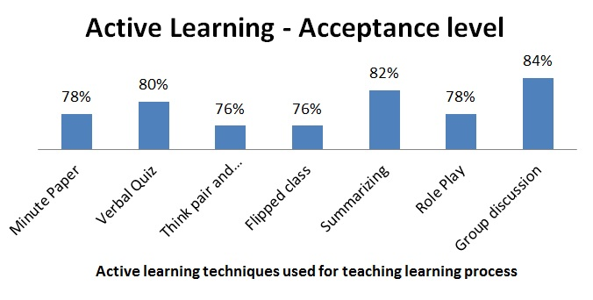

Figure 3: Graphical representation of student’s acceptance about active learning techniques.

The result in table 3 indicates that all the questions with regard to the extent of acceptance of modern technology in teaching-learning, received high positive response from the students with the Weighted Average being more than 3.50 for all the methods used, which indicates that the students accepted or liked all these modern tools which are used by the faculty members of SMVITM. Compared to the implementation level, student acceptance received more positive response from the students, which indicates that the students feel it’s required to implement all these active learning techniques in the classroom and they are comfortable with these activities.

From the findings in Figure 3, it is evident that the students acceptance is high for group discussions, summering and verbal quiz with an acceptance level of 84%, 82% and 80% respectively, which indicates that the students feel these three techniques are highly useful for them, whereas Think pair and share, and Flipped class got the least acceptance level, that of 76%, compared to all other techniques.

Research Question 4: The extent of acceptance of modern technology by the students of the engineering institute.

Table 4: Student’s acceptance about modern tools used

|  |  |  |
| --- | --- | --- |
| **Modern tools** | **WM** | **Acceptance level** |
| Use of animations/ videos | 4.3 | 86% |
| Google class room/ Canvas/ other online classes | 4.3 | 86% |
| Swayam/ NPTEL online courses | 4 | 80% |
| Blogs/ YouTube Channels | 3.9 | 78% |

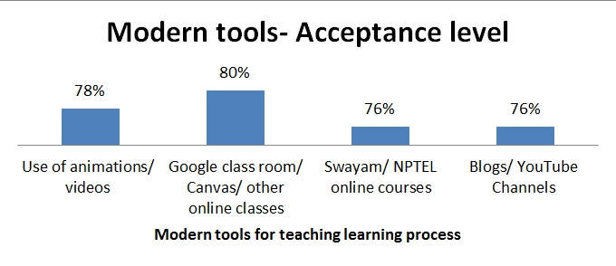

Figure 4: Graphical representation of student’s acceptance about modern tools used

From the findings in Table 4, it is evident that the students happily accept or like all the modern tools used for the teaching-learning process. Online classroom like Google class/Canvas and the use of animations/videos got the highest positive response with an acceptance level of 80% and 78 % respectively, by the students, and they feel that it will be quite useful for them/ for student community.

For all other technologies like online courses (Swayam-NPTEL), YouTube channel and Blogs, students given equal acceptance level of 76% , which means that as per students opinion these technologies are also useful for student community but lessor effect compare to above mentioned tools.

# Conclusion

The results acquired from this study with respect to the active learning technique reveals that various active learning techniques are implemented in the Institution, but not at a high level. Summarizing, Group discussion and Verbal quiz are implemented at the highest level in comparison with other techniques. Meanwhile, the same three active learning techniques received highest acceptance by the students. Hence, faculty members can think of implementing these three active learning techniques at a higher level for their routine classroom teaching-learning process. As per students’ opinion, other active learning techniques like Role-play, Minute paper, Flipped class, Think pair and share are also useful to them, whereas these techniques are implemented at a lesser level in the institute.

Respondents believed that almost all the modern tools listed in this study were highly implemented in the institute and all are well accepted by the students. Online class like Google class/canvas is the highly implemented with the highest student acceptance. Faculty members teaching via their YouTube channels and blogs got least vote but this could be improved further by using a different or more innovative teaching that attracts the students’ attention and curiosity. With this survey, it is clear that faculty members have started to adopt the active learning and modern tools for their teaching-learning process, which is one of the most important requirements for teaching current generation students. To add this, a lot of scope has been observed for further improvement in the implementation of these techniques in the institution.

References

[1] Anitha H M and Anusha N Rao, “Active learning techniques in Engineering Education,” IJRET. vol. 03, no. 11, pp. 462-465, Nov-2014.

[2] Grace A. Fayombo, “ Active Learning strategies and Student learning Outcomes Among Some University Students in Barbados,” Journal of Educational and Social Research. vol. 02 no. 9, pp. 79-89, Nov-2012. Doi: 10.5901/jesr.2012.v2n9p79

[3] Susanna Hartikainen, Heta Rintala, Laura Pylvas and Petri Nokelainen, “ The Concept of Active Learning and the Measurement of Learning Outcomes; A Review of Research in Engineering Higher Education,” Education Sciences, 2019,9,276; doi:10.3390/educsci9040276

[4] Dr. Tershia A. Pinder, Active Learning in Engineering: Perspectives from Graduate Student Instructors. Presented at 120th ASEE Annual Conference & Exposition, Frankly, WE DO GIVE A D*MN June 23-26, 2013.

[5] Michael Prince, “Does Active learning work? A review,” Journal of Engineering Education,93(3),223-231, July 2004.

[6] Daniel Lopez-Fernandez, Jose Miguel Ezquerrow, Jacobo Rodriguez and Jeff Porter, “Motivational impact of active learning methods in aerospace engineering students”, Elsevier,Acta Astronautica 165, 344-354, (2019).

[7] John R. Drake, “A critical Analysis of Active Learning and an Alternative Pedagogical Framework for Introductory information Systems Courses,” Journal of Information Technology Education: Innovations in Practice. vol. 11, pp. 39-51, 2012.

[8] Dimitrios, B., Labros, S., Nikolaos, K., Maria, K., & Athanasios, K. "Traditional Teaching Methods VS. Teaching through the application of the Information and Communication Technologies in the accounting field: Quovadis?” European Scientific Journal 9.28 (2013).

[9] Flipped class rooms, University of Queensland, http://www.uq.edu.au/tediteach/flipped-classroom/what-is-fc.html. Accessed on 27th October, 2014.

[10] D.Borsoto, D.Lesca, I.Maquimot, Mary Jean N.Santore, F.Simbulan and Angelita, “Status of Implementation and usefulness of Outcomes Based Education in the Engineering Department of an Asian University”, International Journal of multidisciplinary Academic Research,Vol.2.No.4 pp.14-25, 2014.

[11] Tang Howe Eng, Oriah Akhir and Senian Malie, “Implementation of outcome-based education incorporating technology innovation”, Procedia- Social and Behavioural Sciences 62, Elsevier , pp.649-655, 2012.

[12] T.A. Janardhan Reddy and P. Shrinivas Reddy, “Outcome Based Education- Some Initiatives”, Open Jornal of Social Sciences, Scrip.Org, pp.7-11, 2014.

[13] Dr.M.Senthil Kumar and Dr.P. Sivakumar, “Need for Curriculum reforms in Technical Education to achieve Outcome Based Education”, International Journal of Core Engineering & Management,Vol.2.Issue 5, pp.64-76, 2015.

[14] Odesma Darlymple, Srividya Bansal, Kavitha Elamparithi, Husna Gafoor and Sai Shetty, “Instructional Module Development (IMOD) System: Building Faculty expertise in Outcome – Based Coruse design”, 978-1-4673-5261-1/13, IEEE ,2013.

[15] Dr. Maniam Kaliannan and Suseela Devi Chandran, “Empowering students through outcome-based education (OBE)”, Research in Education No.87, pp.50-63, 2012.

|  |  |
| --- | --- |
| D:\Academics\1.SMVITM\4.office work and personal\my photos\passport copy.jpg1.jpg | **Kishor Kumar Aroor**  is currently working as a Senior Assistant Professor in the Department of Mechanical Engineering of Shri Madhwa Vadiraja Institute of Technology and Management, Bantakal, Udupi. He received the B.E degree in Mechanical Engineering and M.Tech degree in Engineering Management from the |
| Visvesvaraya Technological University, Belagavi and Manipal Institute of Technology, Manipal respectively. Currently he is pursuing Ph.D degree in the area of Outcome Based Education from the Visvesvaraya Technological University, Belagavi. He authored papers in 2 international journals. | |

|  |  |
| --- | --- |
| D:\Academics\2.P.hD\My Ph.D\Conference paper\THIRUMALESHWARA-BHAT-MECH-120x150.jpg | **Dr. Thirumaleshwara Bhat**  is currently working as the Principal of Shri Madhwa Vadiraja Institute of Technology and Management, Bantakal, Udupi, Karnataka, India. He completed his B.E and M.Tech degrees form Mysore University and Mangalore University respectively. He received his Ph.D degree |
| from Manipal Academy of Higher Education, Manipal.  With his vast teaching, research and Administrative Experience of more than three decades, he has published 12 papers in reputed National/International conference and 14 papers in National and International Journals. He has also guided four candidates in their research work and is currently guiding six research candidates for Ph.D program. His areas of interest are Advanced Materials and Manufacturing methods; outcome based education. | |