[1]

Implementing Sliding Mode Controller for a FOPDT System

K Praveen Shenoy*1, Ashwini T P2

*1*, 2Department of Mechatronics, Mangalore Institute of Technology & Engineering (MITE), Moodabidri*

*Abstract*—This paper demonstrates the implementation of a Sliding Mode Controller (SMC) for a First Order System with Time Delay (FOPDT). The transit time/ dead time compensation has been provided to minimize its effect on the related process. The SMC algorithm is implemented on the mathematical model of pilot conical tank system and closed loop system is observed for both servo as well as the regulatory response. The results are investigated for its efficacy and observations have been provided.

*Index Terms*—Conical Tank, Non-linear Process, SMC Controller, FOPDT, & FOPTD.

# INTRODUCTION

The sliding mode controller architecture provides better reliability in terms of system performance to provide stability and to compensate for model mismatch. This class of robust control is based on the intuition that the first order systems are generally easier to control even though they may be non-linear systems, in comparison to the nth-order systems [1-4]. This is mainly due to the controller’s ability to provide disturbance rejection and compensation for parametric variations, especially for first order systems dur to their simplicity in modelling and controller design. In process industries generally, high process complexity allows the mathematical simulation of such systems difficult [5-7]. Broad dynamics found in processes contribute to the implementation of reduced order models, such as FOPDT. Those versions can also be used for controller design and study of results on the machine. Yet, the models of reduced order in general, it gives rise to uncertainties particularly when operating in high frequencies due to uncertainties in modelling.

Uncertainties in closed loop system actions can cause unpredictable behaviour responses which cannot be compensated. Conventional linear controllers are not always capable to handle these uncertainties in particular time for nonlinear processes. The problems discussed above provide a need of robust controller configuration for the nonlinear uncertainties. Since SMC is insensitive to variations in parameters, and offers a high degree of robustness, the same is opted for controlling the parameters of a Conical Tank which has been discussed in further sections [8-10].

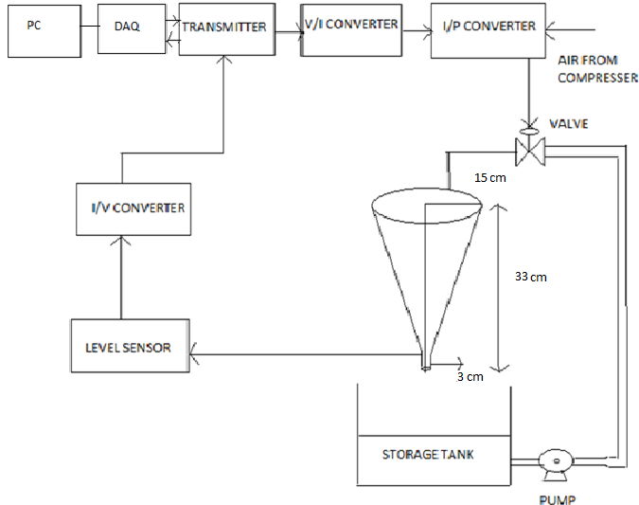

Fig 1: Conical Tank Setup

The conical tank level control device that is chosen for this paper is shown in fig. 1. The height of the tank is 33 cm with top diameter 0f 30 cm and Bottom Diameter of 3 cm. The motor used to pump the water has a rated RPM of 1500, with 24 m head and rated LPH of 1600.

The tank's conical shape makes the level phase nonlinear, as the rate of tank area change as level rises is nonlinear. The tank is based on dividing the total height into four 7 cm regions each. Using the black box modelling (Ziegler-Nichols 2-point method), the linearized model at 14 cm is obtained; the same is given in (1).

$$\begin{aligned}G\left(s\right)= \frac{0.925}{25.05s+1}e^{-1.1s} \#\left(1\right)\end{aligned}$$

The basic concepts of SMC are briefly explained in Section II of this paper followed by the control structure and its implementation in Section III. The controller tuning and discussion on results of this work is contained in Section IV followed by the conclusion.

# SLIDING MODE CONTROLLER CONCEPT

The key principle behind SMC is to limit the response of the process in a predefined surface and to converge the answer to the desired final value in finite time using a feedback control law [1-3]. The surface through which process response slides to its final value is called sliding surface, commonly referred to as s(t). There are two modes in SMC as reaching mode and sliding mode. Reaching mode: The trajectory of the system approaches the sliding surface area. The sliding mode comes after the reaching mode in which the trajectory of the system moves along the sliding surface and converges to the set point is called sliding board, usually referred to as s(t). SMC has two modes as reaching mode and sliding mode. Reaching mode in which trajectory of the system approaches sliding surface layer. The sliding mode comes after reaching mode in which trajectory of the system passes along the sliding surface and converges to a point fixed. In figure 2 an initial x0 state in the closed loop system and its trajectory moves towards the sliding surface and achieves the desired response [1, 4]. 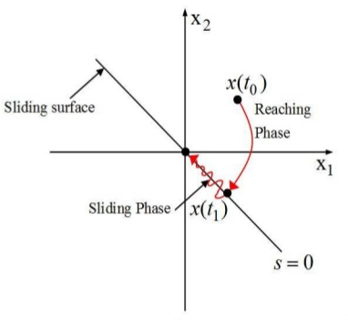

Fig 2: Sliding Mode Control

The primary phase in SMC design is the selection and interpretation of a sliding Function s(t). Generally, a proportional-integral-differential (PID) equation acting on the calculated error is selected as the sliding surface s(t)[1].When the system response accurately tracks the set point the error e(t) and its derivative becomes zero and the sliding function s(t) takes a constant value and the s(t) derivative becomes zero, and this condition is called a sliding condition given in (2) [1-2].

$$\begin{aligned}\frac{ds\left(t\right)}{dt}=0 \#\left(2\right)\end{aligned}$$

If the sliding function is specified, we initiate a control law u(t) which will carry the process performance or the output to the desired value and also satisfy the sliding condition set out in (2). The SMC control law consists of a continuous and discontinuous component, respectively as uc(t) and ud(t). The law on controls is shown in (3).

$$\begin{aligned}u\left(t\right)=u_{c}\left(t\right)+ u_{d}\left(t\right)\#\left(3\right)\end{aligned}$$

The continuous part of the control law uc(t) is defined as set point function r(t) and controlled variable x(t). The discontinuous component is a switching function that functions like a relay, which shows discontinuity around the sliding component. This section of the control law is responsible for regulation of variable structure with fast switching properties. Yet definitely while implementing, due to the time delay present in the closed loop device and actuator constraints, it is not often feasible to get high frequency switching controls and hence induce chattering in a steady state [1,3].i.e. Theoretically, a sliding mode control gives desirable servo reaction with chattering effect costs. The control law components uc(t) and ud(t) are presented in (4) & (5) respectively.

$$\begin{aligned}u_{c}\left(t\right)=f(x\left(t\right), r\left(t\right))\#\left(4\right)\end{aligned}$$

$$\begin{aligned}u_{d}\left(t\right)=K_{D}\frac{s(t)}{\left|s(t)\right|+δ}\#\left(5\right)\end{aligned}$$

KD is the parameter responsible for the rise time or in other words the magnitude of KD determines the aggressiveness of the regulated variable to enter the reaching mode. The output response is quicker as KD rises and there is also risk of overshooting. Chattering influence is balanced by the tuning parameter $δ$.

# SMC DESIGN

The control system employed for this function is seen in fig. (3) [1,5]. The Smith Predictor technique is used to compensate for the dead time scheme. The dead time in the processes causes the control problems and thus deteriorates the closed loop system output. For this specific control system, the principles of the SMC and the dead time compensator are merged. For this scheme a process model Gm(s) must be selected to compensate for the dead time present in the system. Because the impact of delay is minimized by means of the dead time adjustment from the closed loop method, the SMC control scheme can be conveniently configured.



Fig. 3: Sliding Mode Control Configuration

The sliding function that acts on the calculated errors is defined as shown in (7). ex(t) is the difference between the output of the set point and the output of the process model without dead time, $δ$ is the tuning parameter and e(t) is given in (6) where r(t) is the set point, xm(t) is the output of the process model with dead time and em(t) is the difference between the output of the process x(t) and the output of the process model xm(t).

$$\begin{aligned}e\left(t\right)=r\left(t\right)-x_{m}\left(t\right)-e_{m}\left(t\right)\#\left(6\right)\end{aligned}$$

$$\begin{aligned}s\left(t\right)=sign\left(k\right)[e_{x}\left(t\right)+λ\int_{0}^{t}{e\left(t\right)dt]}\#\left(7\right)\end{aligned}$$

The λ and KD tuning parameters are selected with the conditions defined in (8) and (9). The dead time associated with the process is t0 and the time constant of the process is τ. ($\frac{t}{τ}<1$)

$$\begin{aligned}λ≤\frac{t_{0}}{2τ} ;λ is assumed to be 0.03\#\left(8\right)\end{aligned}$$

$$\begin{aligned}K_{D}≥\frac{0.64}{\left|K\right|}\left(\frac{τ}{t_{0}}\right)\#\left(9\right)\end{aligned}$$

The control law on sliding mode is given in (10) below.

$$\begin{aligned}u\left(t\right)=\frac{τ}{K}[\frac{x_{x}\left(t\right)}{τ}+ λ\left[r\left(t\right)-x_{m}\left(t\right)-e_{m}\left(t\right)\right] \\ + K_{D}\frac{s}{\left|s\left(t\right)\right|+δ}\# \left(10\right)\#\end{aligned}$$

In (11) the parameter δ which affects the chattering effect is set. K is gain for the system.

$$\begin{aligned}δ=0.68+0.12KK_{D}λ \#\left(11\right)\end{aligned}$$

# CONTROLLER CONFIGURATION AND RESULTS

The process transfer function given in (2) is considered for the design and simulation experiments.

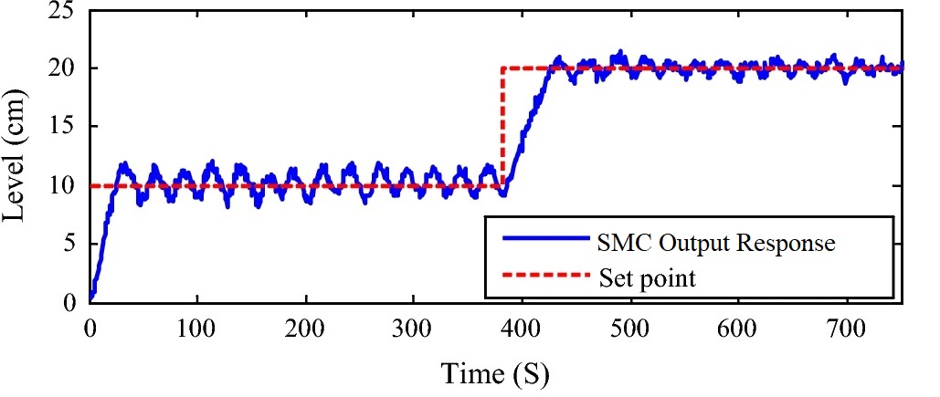

Fig 4: CLTF Response

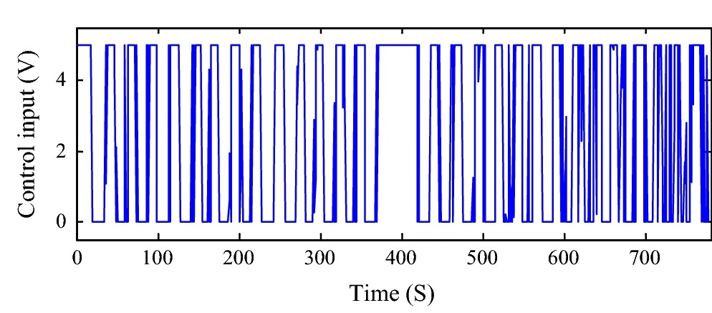

Fig 5: Controller Output

Illustration in Fig 4 and Fig 5 shows the conical tank device and SMC closed loop phase responses. The process operates well in nominal operating region (14 cm) with constant loads of 20 per cent positive and negative. For various KD values the closed loop response is simulated. It is observed that when the value of KD rises, the response of the device is faster with overshooting as the rise time is limited. Additionally, increasing the KD value causes the closed loop system to degrade performance. The parameters of the robust controller are obtained for λ=0.03. The SMC takes appropriate steps when the load is being added and provides strong rejection of the load.

The performance of closed loop system is measured in time domain and is given in Table 1. Closed loop gives satisfactory characteristics for the rise and time for settling. It can be shown that when the procedure is performed with the selected tuning parameter λ=0.03, there are substantial changes in the rise time and the settling time changes on all steps. However, the peak overshoot remains unchanged.

|  |  |
| --- | --- |
| **Time Domain Specification** | **Simulation Results** |
| Rise Time | 43 s |
| Settling Time | 112 s |
| Overshoot | 12 % |

Table 1: Time Domain Parameters

# CONCLUSION

In conical tank level control scheme, the sliding mode controller design with dead time compensation for the nonlinear system is introduced. SMC's zero dynamics property refers to control of processes, such as linear, nonlinear, and systems with uncertainty. The above-mentioned SMC offers adequate servo responses with cost-effective time domain requirements but has certain load rejection property. Because SMC decreases the order of the closed-loop function, application of SMC may be extended to uncertain systems of higher order too. Although SMC is insensitive to variations in plant parameters and offers good set point tracking, this work demonstrates the poor load-rejection capabilities of SMC.

References

1. K. D. Young, V. I. Utkin and U. Ozguner, "A control engineer's guide to sliding mode control", IEEE transactions on control systems technology, vol. 7, no. 3, pp. 328-342, 1999.
2. J.-J. E. Slotine and W. Li, Applied Nonlinear Control, Englewood Cliffs, NJ, USA: Prentice-Hall, 1991
3. O. Camacho, “Sliding Mode Control in Process Industry”, Instrument Engineer’s Handbook, Fourth Edition Florida, CRC Press, 2005, pp. 351-359.
4. V.I, Utkin, “Variable Structure systems with sliding modes”, Transactions of IEEE on Automatic Control, 1977, pp. 121- 222.
5. O, Camacho, Smith, C, “Sliding Mode Control: An approach to Regulate Nonlinear Chemical Processes”, ISA Transactions. 2000, pp. 205-218
6. C T, Chen, S T Peng, “Sliding Mode Control System for Chemical Processes”, Journal of process control 2005, pp. 515-530.
7. C, Li et.al, “Feed Forward Smith Predictor Sliding Mode Control Algorithm for a Class of First Order System with Integrator and Time Delay”, Proceedings of international Conference on Modelling, Identification and Control, Shanghai, China, June26-29, 2011, pp. 155-159.
8. B. B, Musumade et.al, “Design of Sliding Mode Controller to Chemical Processes for Improved Performance”, International journal of Control and Automation, Vol. 4, March 2011, pp. 15-31.
9. B. Friedland, Advanced Control System Design, pp. 148-155, 1996.
10. Rakesh, M K and Satheesh Babu, R and Thirunavukkarasu, I (2014) Sliding Mode Control with Dead Time Compensation for a Conical Tank Level Process. International Journal of Electronics & Communication Technology, 5 (2). pp. 244-247. ISSN 2230-7109

**K Praveen Shenoy**. Working as Assistant Professor at MITE, Moodbidri, he has MTech in Control Systems Engineering & B. Tech in Mechatronics Engineering. He is a life member of Indian Society of Technical Education (ISTE). Currently serving as Assistant Professor, his areas of research interests are robotics, automation, logic controllers, control theory, process control and machine learning.



**Ashwini T S**enior Assistant Professor in the Department of Mechatronics MITE, Moodbidri with over 12 years of teaching experience, pursuing Ph.D in Electronics Engg (Image Processing). She is also a Life Member of Indian Society for Technical Education and International Association for Engineers. A passionate teacher, her research interests are in the field of VLSI, Image Processing & Digital Electronics. She has published several research papers in Indexed Journals.

1. 1*K Praveen Shenoy is working as Assistant Professor in Department of Mechatronics at MITE, Moodabidri (e-mail: praveenks@mite.ac.in).

   2Ashwini T P is working as Senior Assistant Professor in Department of Mechatronics at MITE, Moodabidri (e-mail: ashwinitp@mite.ac.in).