Dhanush1, Deepak Achar2, Abhishek3, Ashwin M4, Ravinarayan R Rao5

1, 2, 3, 4-BE Students, 5-Assistant Professor,

*Department of Mechanical Engineering,*

*Shri Madhwa Vadiraja Institute of Technology and Management, Bantakal, Udupi*

**Design and Development of Modular Reversing System in Scooter for Physically Challenged People**

[1]

*Abstract*—In day to day life ordinary person can commute from one place to other with the help of two-wheeler or four-wheeler, but when it comes to physically challenged people it is difficult. According to the 2011 census there are 2.21 percent of the population are disabled in India. Two wheelers with retrofitting are the major commute system for physically challenged people. There are many types of retrofitted vehicles present in the market, but these systems partially serve the purpose. He/she will always need someone’s assistance to pull the vehicle from parking place. To overcome this problem a motor system with a ratchet mechanism is implemented along with a modular frame structure that can be detached when not used. This paper consists of implementing modular frame structure and a reversing system along with the shock absorber to reduce impact load from the roads for the assistance of the physically challenged people.

Keywords: Modular, Disabled, Frame structure, DC motor

# INTRODUCTION

The personnel transportation was very difficult from past many years for physically disabled people. Most of them use two wheelers with retrofitted arrangements of frame and wheels to balance the vehicle while riding. This system only balances the vehicle and does not assist the user in scenarios like reversing of the vehicle. Therefore, the disabled will face the problem while reversing the vehicle in sharp corners or in the parking place. This makes them depend on other people around them every time to pull the vehicle, and when nobody around them will create problem.

Generally, any type of design for assistive vehicle consists of a two-wheeler (most of the time gearless) and two assistive wheels on both the sides that used to balance the vehicle, along with the shock absorbers. Some of the other design includes replacing the rear wheel of the vehicle with a long shaft with two wheels on each side to balance the vehicle.

Many solutions are implemented over a period of time

to solve the problem of scooter reversing. Some of the solutions were to modify the transmission system by incorporating a reverse gear or a planetary gear to reverse the vehicle.

These modifications will do the job of reversing the vehicle but will cost very much, and this will void the warranty and leads to maintenance problems later on by the two-wheeler manufactures.

In some cases, if one person is disabled in a home then there will be scooter with retro fittings. And other family members might not able to use the assistive vehicle. Therefore, there is a need to create a system that can reverse the vehicle when needed and can be detached from the scooter when not needed or in case of periodic maintenance. This lead to create a modular reversing system in scooter for physically challenged people.

As the motor technologies improved over a period of time, high initial torque can be obtained from small DC motors with the help of gears. And the motor need not run while moving forward so a ratchet is utilized along with a DC motor of appropriate torque rating as the power transmission system in this project. This system is mounted on the swing arm which is then attached to the secondary removable frame. The primary frame is mounted on the foot floor of the scooter and it is fixed to the foot floor at any time. The secondary frame with other system can be attached with the help of fasteners when needed and can be detached when not. A shock absorber is used on each side to keep the system on ground and to absorb the impact load from the road.

# methodology

The first step in the process is to design the frame structure that connects the system with the scooter. The frame is divided into two parts, out of which one will be fixed to the foot floor of the scooter named as primary frame and another one will incorporate the swing arm, shock absorber assembly named as secondary frame which is connected to the primary frame when required and detached when not.

The Fig1 represents the flow chart of the overall process.

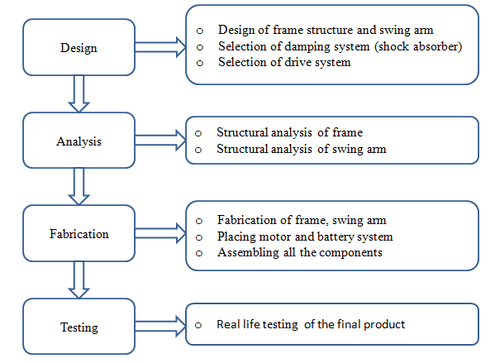

Fig1 Flow chart of the methodology

**2.1 Design of frame structure**

**2.1.1 Design of frame structure and swing arm:**

The aim is to create a frame structure that can sustain the loads in extreme condition, therefore already existing fastener points on the scooter was considered as the major load carriers and accordingly the design is carried out.

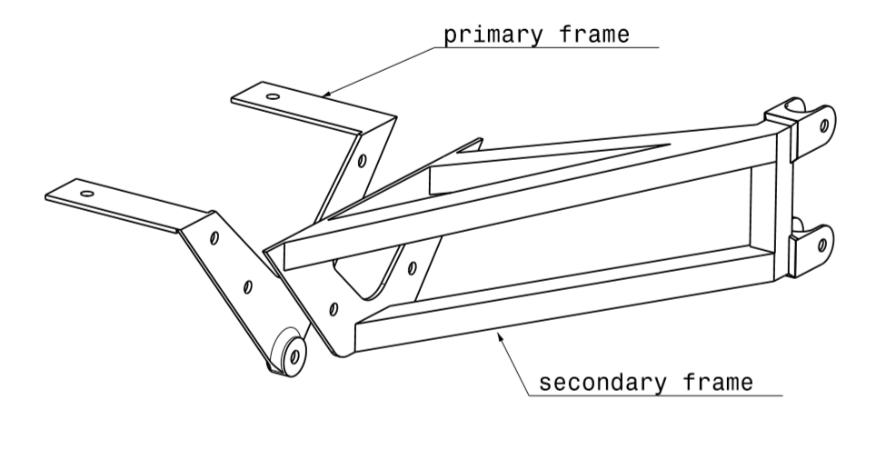

Fig 2 Design draft of frame structure

The primary frame is fixed to the scooter foot floor therefore it becomes a rigid structure. The secondary frame is designed like a rectangular tube and this will be connected to the primary frame with the help of fasteners.

Swing arm which is in a rectangular tube shape is mounted to the secondary frame. The swing arm will have the motor and ratchet arrangement as the transmission system at one end and the other end is fastened to the secondary frame. The shock absorber is connected between the swing arm and the secondary frame with the help of fasteners.

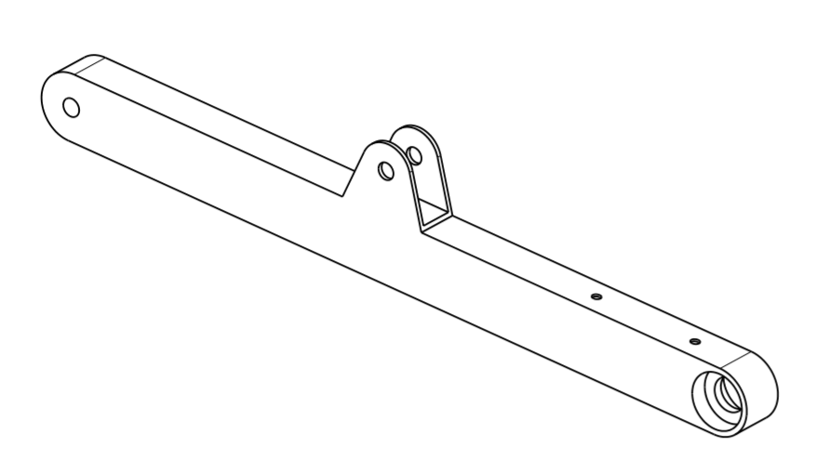

Fig 3 Design draft of swing arm

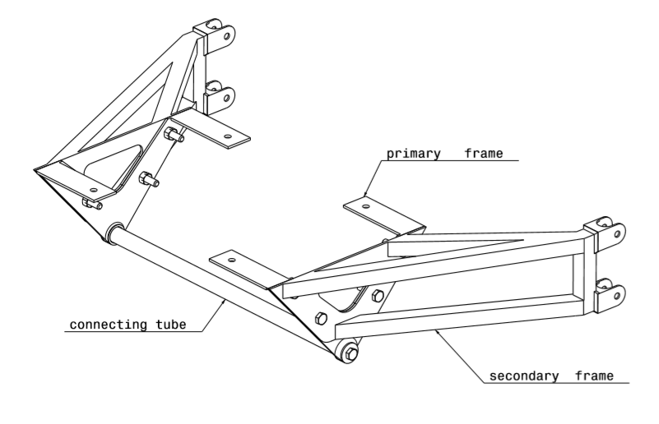

Fig 4 Front assembly of frame structure

There are many scooters available in the market, for this project TVS Jupiter scooter is selected and whole design is according to TVS Jupiter.

The average mass of the scooter and rider is given below

|  |  |
| --- | --- |
| The average mass of the scooter | 101Kg |
| Average mass of the rider | 60Kg |
| Total mass of the system | 161Kg |
| Overall mass of the system in terms of Newton(N) | 1579.41N |

Table 1 Mass distribution of scooter and rider

**2.1.2 Selection of the damping system (Shock absorbers)**

Following assumptions are made in the calculation

1. Maximum travel of the spring(δ)=60mm
2. Spring index(C)=7
3. Shear strength of the material of the spring(AISI-9255) =430Mpa

For above given data certain parameters of springs are calculated.

From the calculation we got these values for spring parameters

Stiffness of the coil, K = 26.235N/mm

Shear stress factor, Ks = 1.0714

Number of coils, n=8.81

Free length of the spring, lo ≥145.425mm

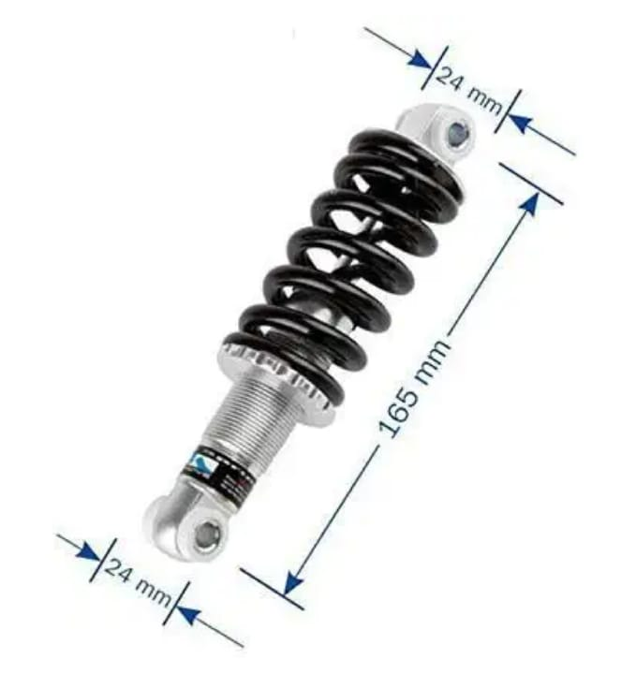

Fig 5 Shock absorber

**2.1.3 Selection of the drive system**

There are many motor drive systems; DC motors are the most prominent out of all for this application. Proper calculation is carried out to find the required motor specification.

Force required to pull the vehicle,

F=Ma

Where, M=Overall mass

a= Acceleration for pulling the vehicle

The speed with which the scooter will be pulled is set to 2kmph. To cover the distance of 1.5 times the length of the scooter, time required will be 4.9875secs.

Acceleration a=dv/dt

Substituting the values, a=0.1127m/s²

The force value is F=177.99N

Since two motors are used this force is shared between them =88.99N

Torque T=F×R

Where R= Radius of motor shaft =4mm (For most of the dc motor)

T=88.99×0.04=3.5Nm

Considering a FOS of 2 we get T=7Nm for a single dc motor

Generally, this amount of initial torque is available in bigger sized motors. To get the required torque out of a small motor, a square gear dc motor is selected.

We are using MFC-555 12V 30RPM square gear motor which has a stalling torque of 80kg-cm i.e. around 7.845Nm of torque on each motor.

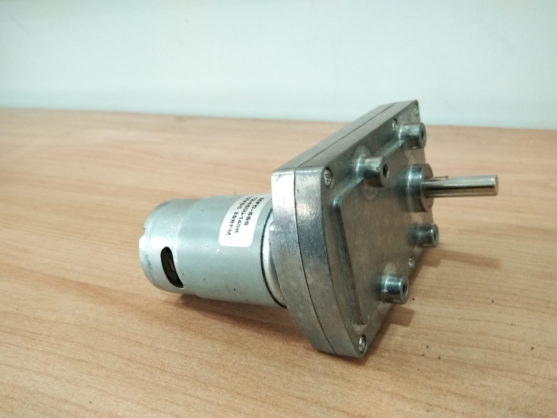

Fig 6 Square gear DC motor

The final drive shaft of the motor will be pointing outwards, which is changed to point inwards so that the overall package of the drive system will be compact.

**2.2 Analysis of frame structure**

Total mass of the system is 1579.41N. Approximately 1600N is considered for analysis along with 1.5 FOS. The design and analysis are carried out in CATIA V5 software. The material of frame and swing arm is AISI 1020 steel with yield strength of 370Mpa. The von mises stress obtained is under the yield strength of the material with the value of 251Mpa for secondary frame structure and 339Mpa for swing arm. The maximum displacement obtained in secondary frame and swing arm is 0.506mm and 3.61mm respectively.

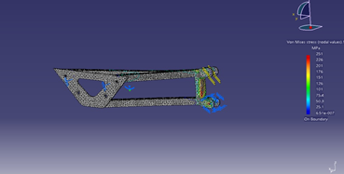

Fig 7 Von mises stress in secondary frame

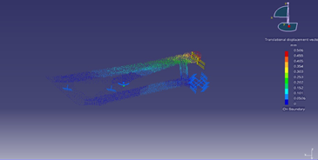

Fig 8 Displacement in secondary frame

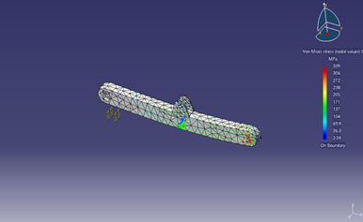

Fig 9 Von mises stress in swing arm

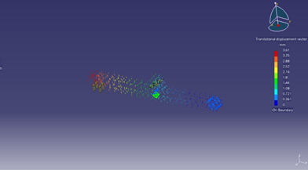

Fig 10 Displacement in swing arm

**2.3 Fabrication of the system**

**2.3.1 Fabrication of frame structure**

Frame structures are fabricated according to the design. For the primary frame structure, AISI 1020 mild steel material is used. This primary mount will be fixed to the scooter foot floor mount using fasteners.

Next secondary frame structures are fabricated. Secondary frame structure has three rectangular tubes welded together to mild steel plate. This secondary frame is connected to primary frame with fastners.

A connecting tube is implemented under the scooter which connects two primary frame structure, making it has a single rigid structure.

**2.3.2 Fabrication of swing arm**

Swing arm is made of rectangular tube of mild steel, one end is connected to the secondary frame mount and on another end, motor and drive system is mounted. A notch a welded at the swing arm which connect shock absorber with another mount on secondary frame. There are two of these swing arms on both side of the scooter.

**2.3.3 Drive system**

Motor is fixed to the swing arm end with fasteners. A circular solid piece with centre hole is welded to the swing arm end. An outer shaft is press fitted to that circular piece. Two bearings are also press fitted for smooth working. To that shaft we connected the motor shaft. The output shaft is welded to a circular plate, that plate will be connected to the wheel. A ratchet is welded in between outer shaft and circular plate to get a motion to the motor in one direction.

When the motor starts rotating it will rotate the outer shaft, in connection it rotates the circular plate and wheel, when the vehicle moving forward ratchet will free the rotation of motor from wheel rotation.

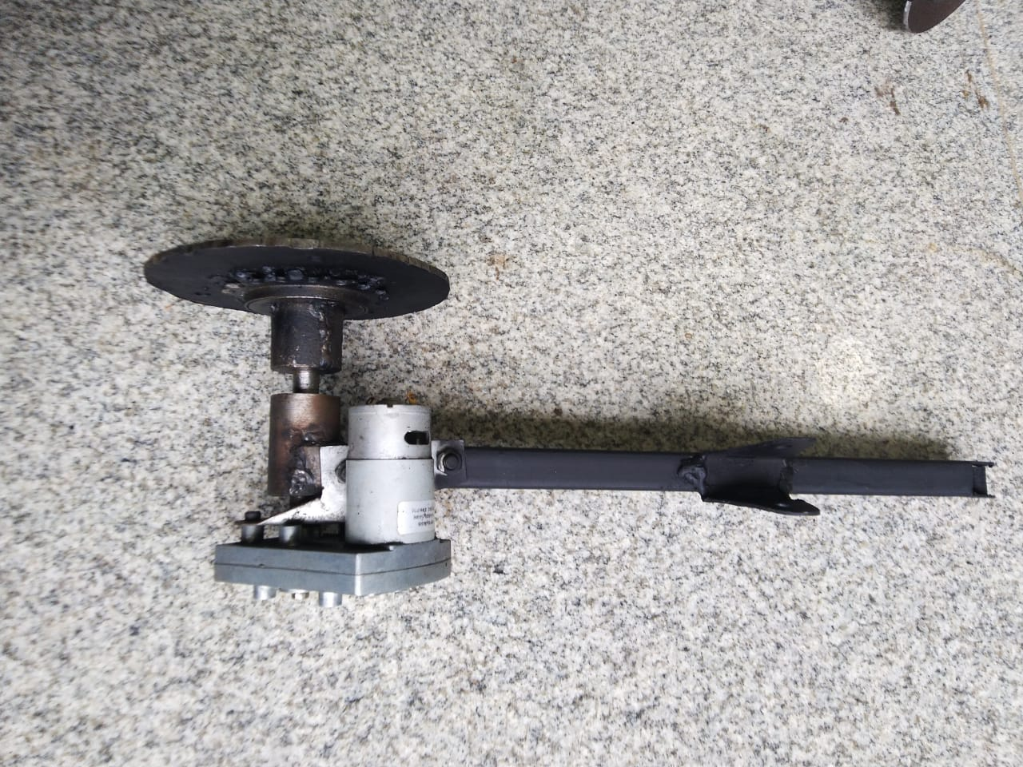

Fig 11 Fabricated swing arm and drive system

**2.3.4 Motor actuation**

The power to the motors comes from the scooter battery. Two motors are connected parallel across the battery. We provided a push button to actuate motors near the handle.

When the push button is actuated, power from scooter battery is transferred to the two motors. Two motors start to rotate, since the motor is geared there will be high torque developed near the motor output shaft. This high torque of the motors pulls the entire scooter in reverse direction. The two motors will be rotating until push button is released. When push button is released, power cut off from the battery takes place and the motor stops rotating.

**2.3.5 Final assembly of the system**

The design of entire system is done in Catia V5 software.

Figure 12 shows the virtual assembly of the system.

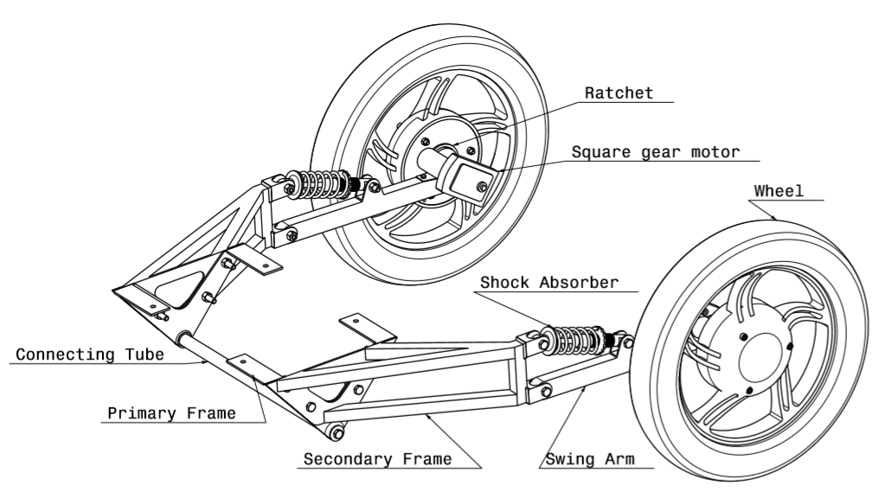

Fig 12 3D model of assembled system

Figure 13 shows the actual fabricated system which is retrofitted to the TVS Jupiter scooter.

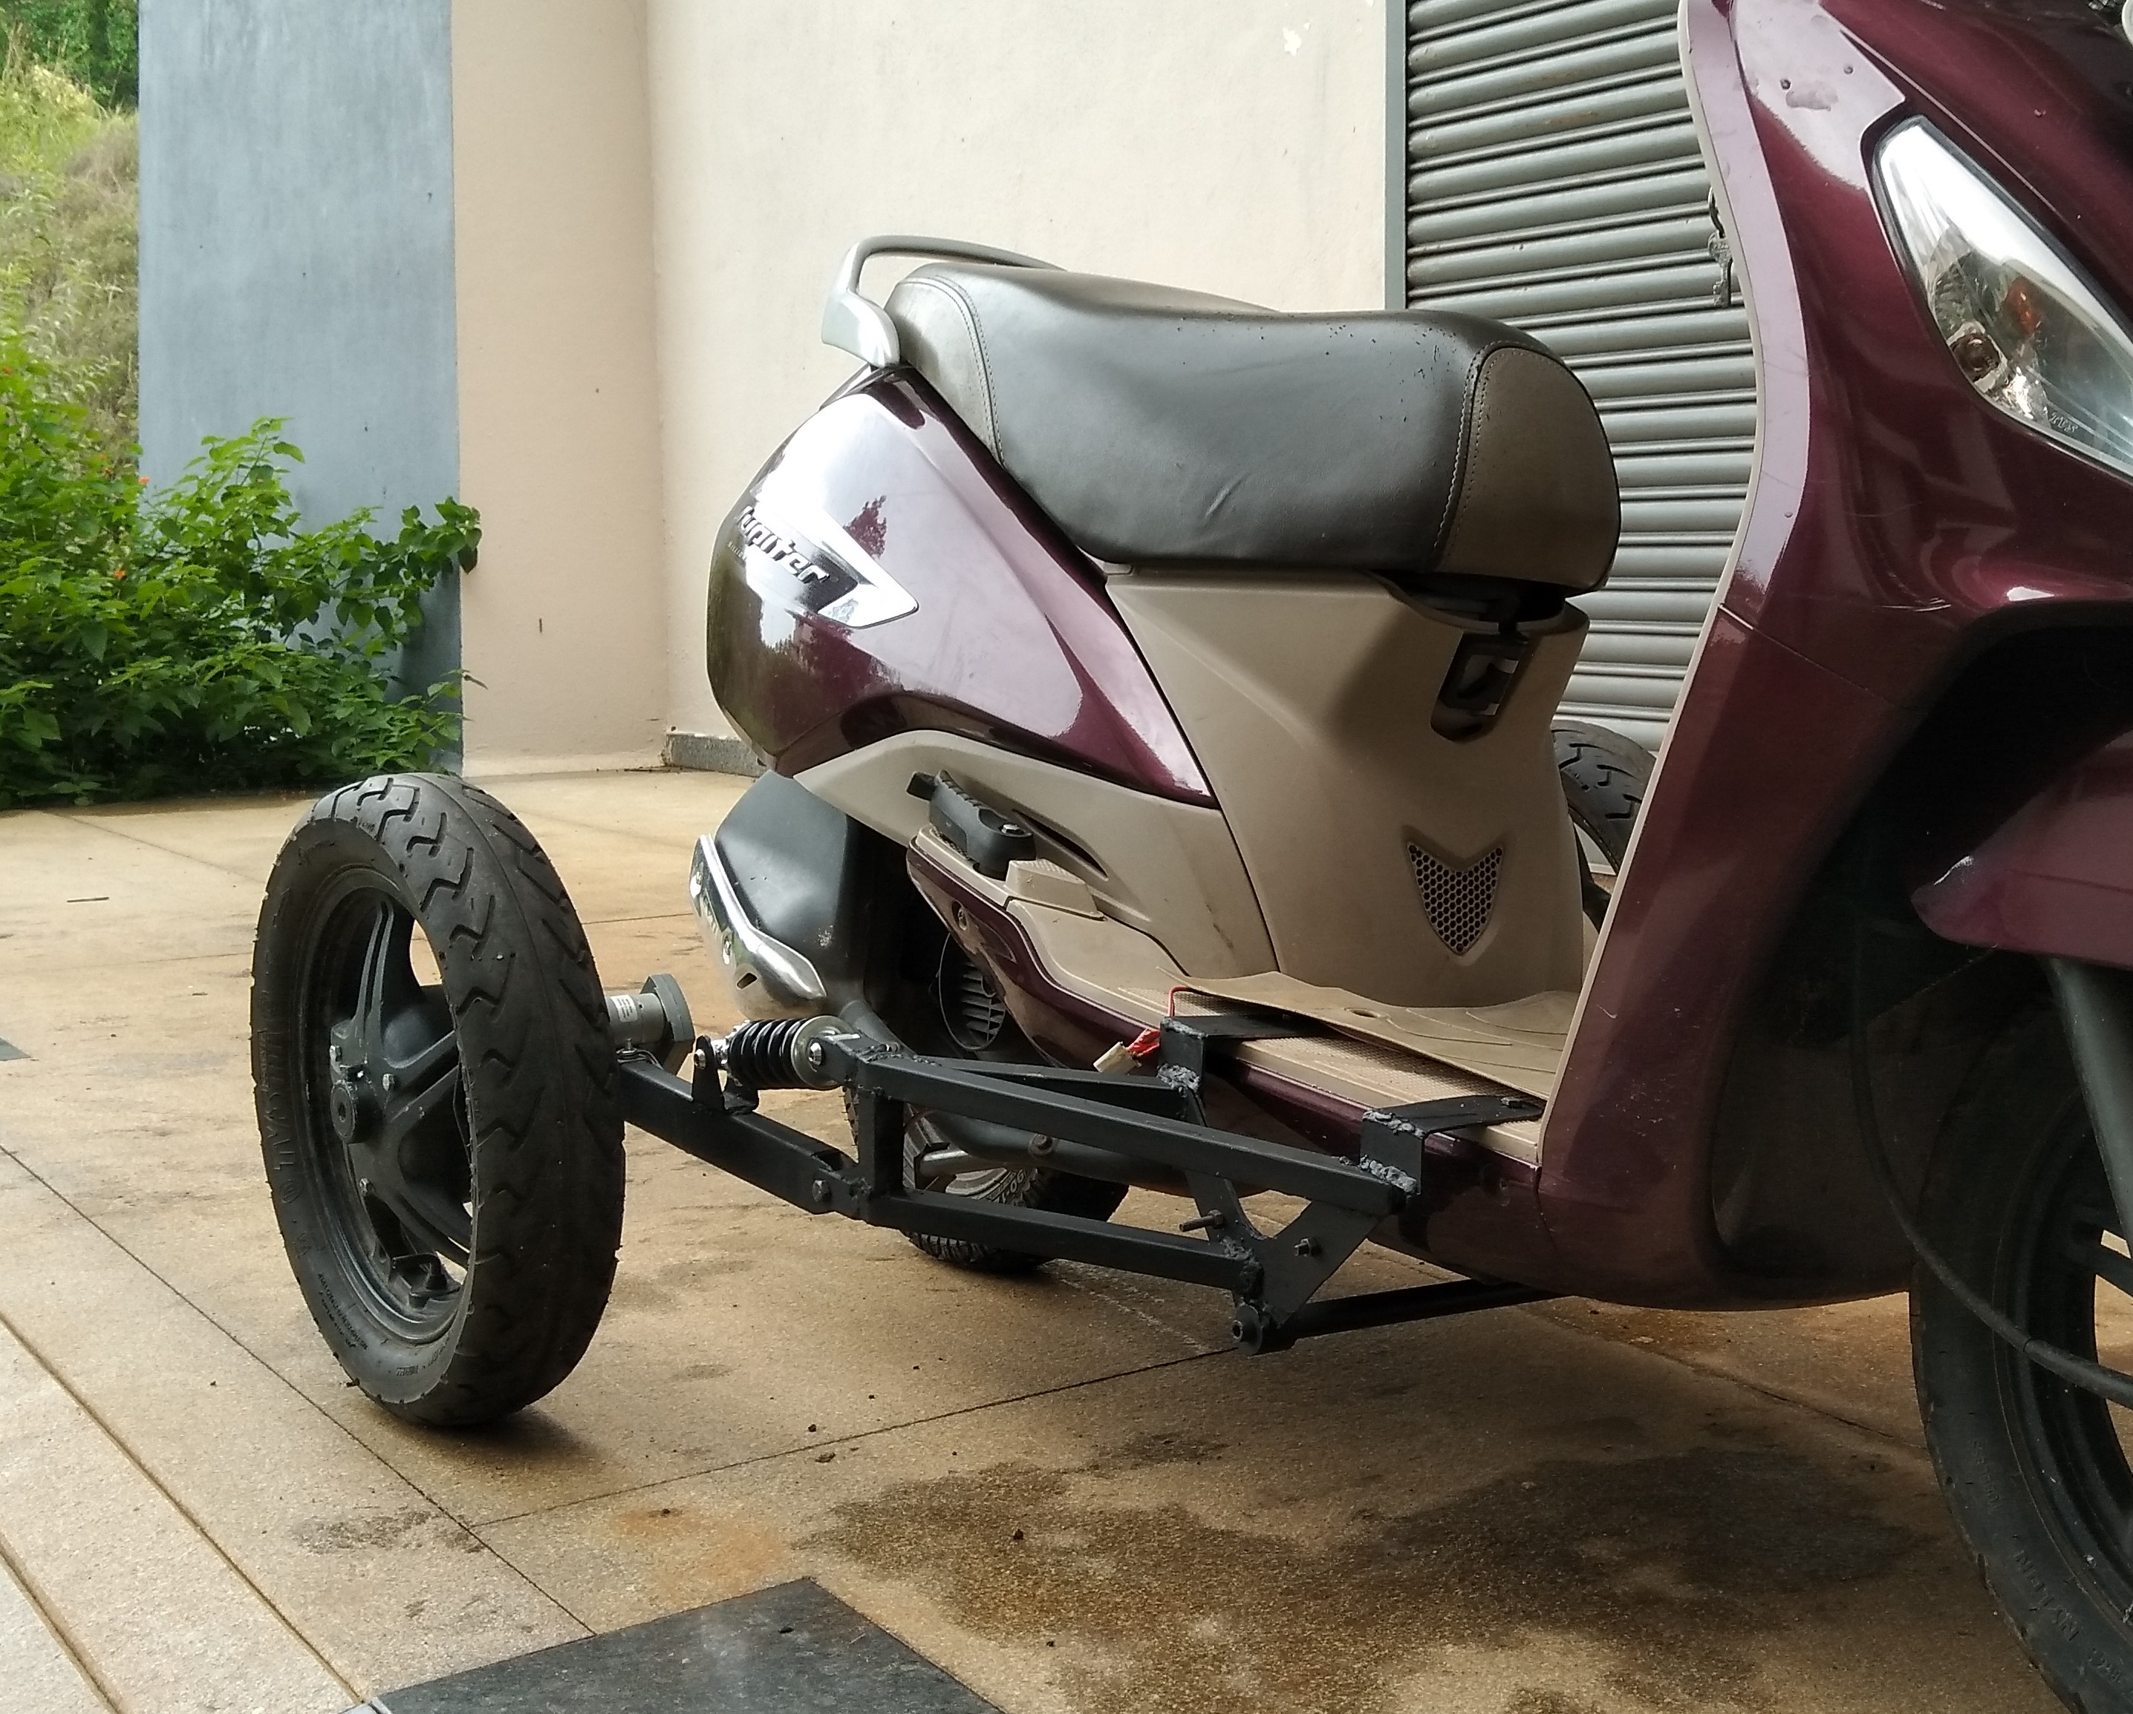

Fig 13 Final assembled system retrofitted to the TVS Jupiter

**2.4 Testing**

The fabricated system is retrofitted to scooter and tested in real-life scenario.

The two square gear motor pull the scooter with much ease. The two frame structures are strong enough to hold the weight of scooter and rider. From the testing, this system is stable in reverse motion.

During forward motion, scooter and the modular system both are stable in inclined and rough road condition.

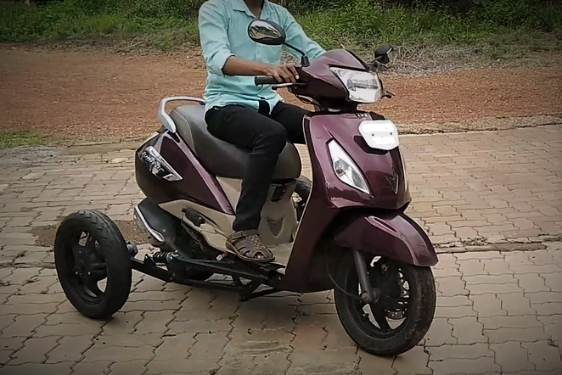

Fig 14 Testing of the scooter in real life scenario

1. Results
2. The Von Mises stress obtained from stress analysis of the frame is 251Mpa that is within the yield strength of the material (370Mpa).
3. Suitable shock absorbers are used based on the calculation.
4. MFC-555 12V, 30RPM DC motor with 80kg-cm (7.845Nm) torque is used for the system.
5. The overall weight of the system is around 15 kg that is much lesser than the traditional assistive system.
6. The developed system is stable in real life scenario.
7. Future scope
8. Modifying the developed system to be even more stable at high speed and in rough road condition.
9. Modifying this system so that it can be retrofitted to any scooter.
10. The system is further modified to be lighter and more robust.
11. Conclusion

High torque motors reverse the scooter in much easier way and the reverse motion is stable in straight and curved path. The system provides a good comfort level for rider and also the system is stable in inclined and rough condition during forward motion. The overall weight of entire system is less than the traditional assistive system. From the analysis and testing we got to know that whole frame structure is stable. The overall cost of the fabricated system is reasonable compared to other assistive system used in the scooters which are available in market.

1. Reference

1) C.P. Venkatesh, U. Rajesh, N. Hari Sudhan, SuginElankavi. R, Pavan Kumar. K. B. Review on “Modified Vehicles for Differently Abled People”. International Research Journal of Engineering and Technology (IRJET) Volume: 05 Issue: 10 Oct 2018. e-ISSN: 2395-0056, p-ISSN: 2395-0072

2) B. Deepak, M. Arun Baby, J. Brinthkhanna, Robin Raju4 K. Prince. “Reverse Motion Setup for Two-Wheeler of Physically Challenged People”, International Journal for Research in Applied Science & Engineering Technology (IJRASET). ISSN: 2321-9653; IC Value: 45.98; SJ Impact Factor: 6.887 Volume 6 Issue III, March 2018.

3) Rutuja Deshmukh, Prof.Sumant S. Patil, Prof. Amol Kokare. “Design and Transmissibility Investigation of Shock Absorber Test Rig”. IJSART - Volume 3 Issue 8 –August 2017.

4) Sanjay Raj, Nimil. K. B, Stevin Wilson, Arunkumar. C. V, Amal Unnikrishnan, Jaison. K. A. “Reverse gear mechanism in two wheelers for physically handicapped people”, International Journal of Advanced Engineering and Global Technology, Vol-06, Issue-02, 2018, ISSN No: 2309-4893

5) Aadya B. Son, Abhijith B. A., Lekshmi R. S., Sarath K., Robin David &RanjeeshSugathan, “Design and Fabrication of Hand Operated Reverse Gear Mechanism in Two - Wheelers for Physically Challenged People”. International Research Journal of Engineering and Technology (IRJET), Volume: 05 Issue: 04 | Apr-2018, e-ISSN: 2395-0056 p-ISSN: 2395-0072.

6) Subramanian Rajendran, “Design of Reverse Gear Mechanism in Two-Wheeler for Physically Challenged Person”. Journal of Advance Manufacturing System & Technology, Volume 1 Issue 1, July 2016.

7) Roselle Thoreau, “The impact of mobility scooters on their users. Does their usage help or hinder?”. The accessibility Research Group, University of London, 20 April 2015

8) Chandrasekar. S, Sri Nandhini. S, Ranjitha. R, Kavin, T. E, “Enhanced physically challenged scooters with automatic balancing wheel adjustment”, Asian Journal of Convergence in Technology, Volume 5 Issue 1.

9) B. Sathish Kumar, Vinod K. Banthia, Alok Kumar Ray, “Design of three-wheeler vehicle for physically challenged people”, SASTECH Journal, Volume 12, Issue 1, April 2013.

10) Ajit A. Mohekar, Savita V. Kendre, Tanmay N. Shah, Prof. P. D. Sonawane, Prof. Dr. S. T. Chavan, “Design of an Innovative Retrofitted Tricycle for Disabled person”, International Journal of Advance Research in Science and Engineering, Volume 4 issue 7, July 2015.

11) Sreehari K U, Sibin Sunny, Joshua A J, Swaran Joseph, Swaran Joseph, “Reverse Gear Mechanism in Two-Wheeler for Handicapped People”, International Journal of Applied Engineering Research, Volume 14 number14, 2019.

12) Kazi Samir P, Diwan AltmanshI, Kolekar Amol V, “Design and Fabrication of Reverse Gear System for Handicapped Person Vehicle”, Volume 13 issue1, march 2017.

1.