[1]

Influence of Multi Directional Forging on Biodegradable Mg-Zn-Mn alloy

Aafaque A Siddique1a*, Karthik S1b, Manoj Moolya1c, Niranjan1d, Shamanth V2e, Gajanan Anne1f

*1Department of Mechanical Engineering Shri Madhwa Vadiraja Institute of technology and Management, Bantakal*

*2Department of Mechanical Engineering*

*Reva University, Bangalore*

***Abstract*—** **Multi-directional forging (MDF) was applied to Mg- 4%Zn-0.5%Mn alloy up to 6 passes successfully at 300˚C. MDF processed materials were characterized using micro-structural analysis, mechanical properties and corrosion behaviour. The micro-structural analysis was investigated using optical microscope and average grain size found to be 6.6 µm. The hardness of the Mg- 4%Zn-0.5%Mn alloy was investigated using Vickers micro hardness test. The higher hardness was found in 4th pass of MDF sample (90±6 HV), which is 1.5 times higher compared to homogenized sample (60±2 HV). The corrosion behaviour of the alloy was investigated using Immersion study by using stimulated body fluid (SBF). Lower corrosion rate was found in 6th pass of MDF process (0.32 mm/year). As the number of MDF passes increases the material property was enhanced and corrosion rate decreases due to grain** **refinement during MDF process.**

***Keywords*—**Multi-directional Forging; Magnesium alloys; Microstructure; Mechanical properties; Corrosion behaviour.

# INTRODUCTION

Metallic orthopaedic implants have been used as bone substitutes, fixatives and stabilization devices for fractured bones, ligament and tendon repair. Mg alloys are gaining interest for biomedical applications particularly for temporary orthopaedic fixation implants [1].In that aspect, there is a huge demand for Mg alloys owing to their unique properties such as strength to weight ratio and low density, Where it plays essential roles in metabolic pathways as enzyme catalysts in cell structure and function and in bone formation and growth by promoting calcium deposition. Mg alloys are potential candidates for degradable load bearing implant materials due to their excellent biocompatibility, degradability [2].

Severe plastic deformation(SPD) technique is considered one of the useful methods of grain refinement, resulting in strengthening of material based on the Hall-Petch relationship [3].SPD is used to induce large strain so that the ultra-fine grain structure is obtained [4].SPD have been reported to improve the corrosion resistance of the magnesium alloys such as element alloying, mechanical processing and surface treatment.Typically, zinc is one of the most abundant nutritionally essential element in the human body and also zinc can improve the corrosion resistance and mechanical properties of Mg alloys through a solid solution hardening mechanism [5,6].In recent years in manufacturing field enables scientists and engineers to fabricates Mg and its alloys with much higher corrosion resistance and improved mechanical properties by controlling grain size, distribution of precipitates have a significant influence on the corrosion behaviour.

Multi-directional forging (MDF) is the one of the severe plastic deformation process and it is more versatile technique because it can be scaled relatively easily to produce large bulk samples and the process is readily amenable to simplification [7,8].While the bulk material of the biomedical device is often important for integrity and mechanical success,the device is at the interface with biology [9,10]. In the present study our aim is to develop high strength good corrosion resistance Mg- 4%Zn-0.5%Mn alloy by MDF process.

# EXPERIMENTAL METHOD

2.1 Material Preparation

For casting of magnesium first, a stainless steel crucible was preheated to 690–700 °C. Pure Mg ingots with a purity of 99.95% were melted in the stainless steel crucible. While blowing argon (Ar) gas into the crucible at a flow rate of 6 L/min. When the Mg ingots reached approximately 720 °C, preheated metallic Zn and Mn were added and the mixture was stirred slightly to facilitate reaction between alloying elements. Throughout the melting of Mg and the addition of Zn and Mn, Ar gas was used continuously to protect the alloy from oxidation. The melted mixture was then held at 690–700 °C for 30 min, DE-slagged at 720 °C. Throughout the casting process, mechanical stirring was carried out to reduce impurities in the molten metal.

2.2 Homogenization

Homogenization treatment is a process which improves undesirable second phases, eliminate micro-segregation and improve micro-structure uniformity. Homogenization treatment is also used to control grain size and precipitate of Mg-4%Zn-0.5%Mn alloy. The cast alloy will be cut from the ingot with a dimension of 25 mm × 24 mm × 13 mm and homogenization will be carried out in a muffle furnace at 300˚C for 24 hours.

2.3 Mufti-directional forging (MDF)

A schematic of MDF for the 3 passes is shown in the figure 1. Samples were first forged from the longest side i.e. on X face. Then it was rotated 90˚ for the second pass and pressed on the Y face and similarly for the third pass.

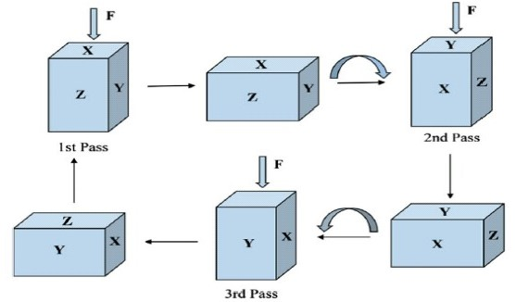

Fig 1 : Steps involved in MDF process

Multi-directional forging process was carried out in MDF die. Along with universal testing machine for application of load . Homogenized Mg-4%Zn-0.5%Mn sample is heated at 300˚C for 10 minutes after that it is placed in a die. Die will be maintained at 300˚C with the help of heating coil, temperature controller and thermocouple. The samples were forged in the longest side of the axis by rotating the sample 90° for each pass. Pressing of the sample was done in X direction and height of the sample reduced by 5mm with each pass. After each pass specimen was heated at 300˚C for 10 minutes. The strain imposed by die for each pass was calculated as per equation Ɛ=ln(ho/h) and the strain rate was calculated based on ram speed.

Where ho and h, are initial and final height of the specimen.

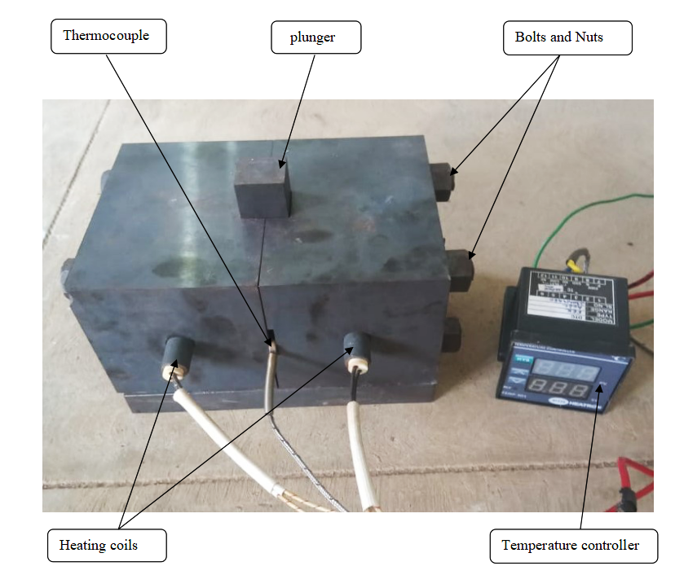

Fig 2 : Experimental MDF die setup

## Characterization

* + 1. Optical microscope

The micro-structure of the specimen were characterized by using image analyser inbuilt software (BIOVIS materials plus) designed mainly for physical and metallographic applications. The image from an optical microscope can be captured by normal, photosensitive cameras to generate a micrograph. Testing specimen were sectioned and mounted with the help of acrylic powder and resins. After that will be mechanically polished sequentially up to 2000-grit SiC paper, and ﬁnal polishing was done by diamond paste (0.25 µm) and then, acetic picral solution was used to etch the sample and blow with hot air. Picral solution will be prepared with 70% ethanol, 20% distilled water, 10% acetic acid, 4.2 ml or mg of picric acid[8].

* + 1. Vickers micro hardness

Hardness is resistance to indentation, scratching and cutting of material. The Vickers hardness test can be performed on both micro-macro scales with a maximum test load of 10grams. Testing specimen were sectioned and mounted with the help of acrylic powder and resins. After that will be mechanically polished sequentially up to 2000-grit SiC paper, and ﬁnal polishing was done by diamond paste (0.25 µm). A minimum of 5 indentations were taken throughout the surface to meet statistical reliability. The average micro hardness was calculated using the formula

Vickers number (HV) = 1.854(F/D2)…………………(1)

Where F is the applied load (Kg/N).

D2 is the area of indentation (mm2).

* + 1. Immersion study

The hydrogen evolution rate directly reflects the corrosion rate of magnesium. The volume of hydrogen evolved is equivalent to measuring the weight-loss of magnesium dissolved, and the measured hydrogen evolution rate is equal to the weight-loss rate . The hydrogen evolution rate directly reflects the corrosion rate of magnesium. The apparatus contains a beaker with simulated body fluid (SBF). A pipet which has a funnel-like structure at the top and a bulb at the bottom is shown in the Figure 3.

.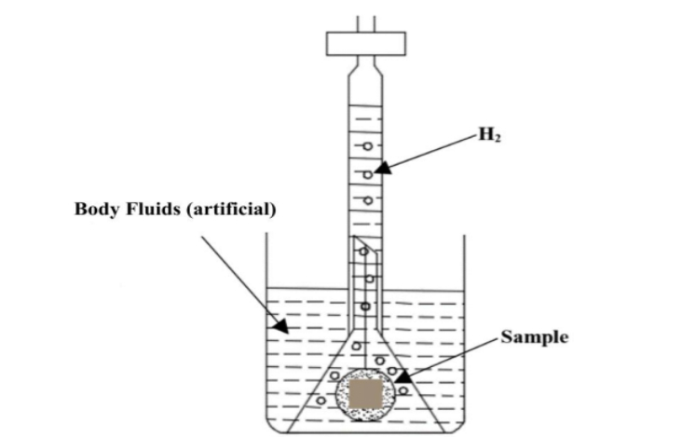

Fig 3 : Hydrogen evolution apparatus

Testing specimen will be cut into 10mm*10mm dimensions. After that will be mechanically polished sequentially up to 2000-grit SiC paper, and ﬁnal polishing was done by diamond paste (0.25 µm). Corrosion rate will be calculated using the formula

PH = 3.65 Δw/ρ………………………………….(2)

Where PH = corrosion rate through hydrogen evolution

(mm/ year),

ρ= metal density (g/cm3), and

Δw = weight loss rate (mg/cm2 /d).

Δw = 1.08VH……………………………………(3)

Where VH = hydrogen evolution rate (mL/cm /day).

# RESULT & DISCUSSION

3.1 Multi-directional forging

The samples were subjected to MDF at a temperature of 300 °C using a UTM testing system. The die was heated to the target temperature and stabilized before the introduction of the sample. Once the MDF die achieved the desired temperature a period of 5 min was allowed to elapse before the starting of the MDF process. This time was enough for the sample to reach the temperature of 300 °C.Then, the sample was forged with average load of 15.8KN and equivalent strain of 0.03 was achieved in each pass of MDF.The process was carried out successfully up to 6 passes.softening of the sample was observed during the 6th pass.

3.2 Optical microscope

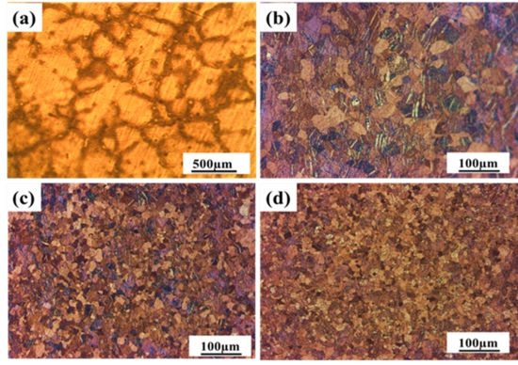

Fig 4 : Shows OM results of a) Homogenized b)1st pass MDF c) 4th pass MDF d) 6th pass MDF samples respectively

Figure 4 shows optical microscope images of homogenized and different passes of MDF processed samples.The grain size of homogenized samples found to be 280 µm as shown in figure 4.

A huge decrease in grain size was observed in the first pass MDF processed sample compared to homogenized sample. As the number of passes increases grain size decreases as shown in figure 4(b to d). The grain size became more finer in 6th pass when compared with 4th pass MDF processed sample. Thus fine dispersion of alloying elements with increasing passes of MDF is observed.The average grain size of 6th pass MDF processed sample was found to be 6.6 µm.

3.3 Vickers microhardness test

Vickers micro hardness values of homogenized and different MDF processed samples are tabulated in table no.1. Each sample was checked five to six times at different locations and averages of hardness values were recorded and error is expressed as the standard deviation of the total data set. Vickers micro hardness results were shown in the table below.

|  |  |  |
| --- | --- | --- |
| No. of passes | Micro hardness (HV) | Cumulative strain Ɛ |
| HS1 | 60±2 | 0 |
| MDF1 | 77±4 | 0.23 |
| MDF2 | 84±4 | 0.52 |
| MDF4 | 90±6 | 1.05 |
| MDF6 | 77±3 | 1.61 |

Table 1 : Vickers micro hardness test

Micro hardness vs. Number of passes

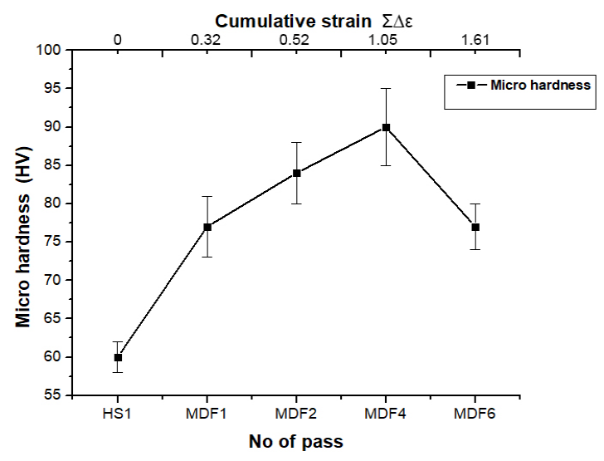

Fig 5 : Micro hardness plot

From the figure it can be observed that micro hardness of MDF processed 1st pass sample (77HV) is higher than that of homogenized sample (60HV). It is evident that large strain hardening effectively took place during the 1st pass. Further the hardness of 2nd,4th passes increased due to grain refinement. The higher hardness was observed in 4th pass MDF processed sample(90±6 HV) due to higher cumulative strain as well as grain refinement. 4th pass MDF processed Mg- 4%Zn-0.5%Mn alloy exhibited 33% better than the homogenized sample.

3.4 IMMERSION STUDY

The hydrogen evolution of homogenized and different MDF processed sample as shown in table 2.

Table 2 : hydrogen evolution test result

|  |  |
| --- | --- |
| No. of passes | Corrosion rate (mm/year) |
| HS1 | 2.72 |
| MDF2 | 0.45 |
| MDF4 | 0.40 |
| MDF6 | 0.34 |

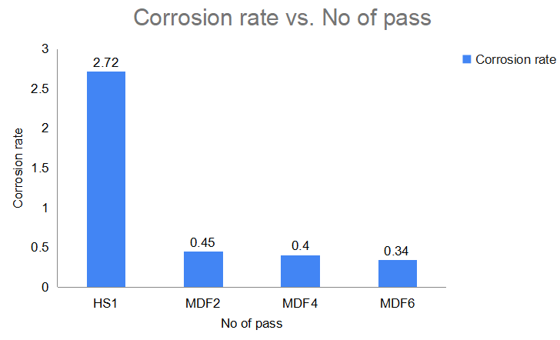

Fig 6 : corrosion rate vs No. of pass

From the figure 6, it can be observed that there is a sharp decrease in corrosion rate during the first pass of MDF compared to homogenized alloy.Higher percentage of grain refinement occur in 1st pass as compared to the MDF processed sample.Corrosion rate was calculated using equation no.2.Same is tabulated in table number 2 and respective graph shown in figure no.6.Corrosion rate of 2nd,4th and 6th pass MDF processed sample was found to be 83%, 85% and 87% decreased to homogenized sample.Better corrosion resistance was observed in 6th pass Mg-4%Zn-0.5%Mn alloy due to fine grain structure of the sample.

# CONCLUSION

Mg-4%Zn-0.5%Mn alloy was subjected to MDF process up to 6 passes successfully at 300℃ and following results were observed.

* As the number of MDF passes increases the grain size decreases as revealed in Optical micro structural analysis. The average grain size of the 6th pass MDF process sample was found to be 6.6 µm.
* The micro hardness of the Mg-4%Zn-0.5%Mn alloy samples increases as the number of MDF passes increased due to strain hardening and grain refinement process .The higher micro hardness was observed in 4th pass MDF sample (90±6 HV) which is 1.5 times higher than the homogenized sample (60±2 HV) and decreased further with increase of MDF passes.
* Higher corrosion resistance was observed in 6th pass MDF processed sample which is 0.8 times better than homogenized sample due to higher grain refinement.

Acknowledgment

The authors gratefully appreciate the support of department of mechanical engineering NITK, suratkal for providing various testing facilities for our work.

## REFERENCES

1. Peng wan, lili tan, ke tang, Surface modification on biodegradable magnesium alloys as orthopaedic implant materials to improve the bio adaptability, Material science and technology, 2015, 1-18.
2. Soha A., Abdel-Gawad, Madiha A. Shoeib, Corrosion studies and microstructure of Mg-Zn-Ca alloys for biomedical applications, Material Science and Technology, 2018, 108-116.
3. Hui Pan, kung pan, fengzhen cai, feng ge, cheng man, xin wang, zhongyu cui, Effect of alloyed Sr on the microstructure and corrosion behaviour of biodegradable Mg-Zn-Mn alloy in Hanks’ solution, Corrosion Science, 2019, 1-18.
4. Claudio l.p.silva, Ana celeste oliveira, Cintia g.f.costa, Terence g.langdon, Effect of severe plastic deformation on the biocompatibility and corrosion rate of pure Magnesium, Journals of Material science, 2016, 1-30.
5. Kai Yana, Huan Liub, Na Fengc, Jing Bai d,Honghui Chenga, Jingjing Liua, Fuyu Huanga, Preparation of a single-phase Mg–6Zn alloy via ECAP-stimulated solution treatment, Journal of Mg and Alloys, 2019, 305-313.
6. Heczel, F. Akbaripanah, M.A. Salevati, R. Mahmudi, Á. Vida, J. Gubicza, A comparative study on the microstructural evolution in AM60 alloy processed by ECAP and MDF, Journals of Alloys and Compounds, 2018, 1-37.
7. Hao Huang, Jing Zhang, Microstructure and mechanical properties of AZ31 magnesium alloy processed by multi-directional forging at different temperatures, Material science & Engineerings, 2016, 1-12.
8. S.Ramesh, Gajanan Anne, H.Shivananda Nayaka, Sandeep Sahu, M.R.Ramesh, Investigation of dry sliding wear properties of multi-directional forged Mg-Zn alloys, Journal of Magnesium and Alloys, 2019, 444-455.
9. Fang-fang Cao, Kun-kun Deng, Kai-bo Nie, Jin-wen Kang, Hao-yi Niu, Microstructure and corrosion properties of Mg-4Zn-2Gd-0.5Ca alloy influenced by multidirectional forging, Journals of Alloys and Compounds, 2018, 1-57.

[10] Hiromi Miuraa, Wataru Nakamurab, Masakazu Kobayashia, Room-temperature multi-directional forging of AZ80Mg alloy to induce ultrafine grained structure and specific mechanical properties, Procedia Engineerings, 2018, 535-539.

1. 15/06/2020

   *Corresponding author.

   mail address: a[aafaque.16me001@sode-edu.in](mailto:aafaque.16me001@sode-edu.in) ,

   b[karthik.16me039@sode-edu.in](mailto:karthik.16me039@sode-edu.in) ,

   c[Manoj.16me043@sode-edu.in](mailto:Manoj.16me043@sode-edu.in) ,

   d[Niranjan.16me051@sode-edu.in](mailto:Niranjan.16me051@sode-edu.in) ,

   e [Shamanth053@gmail.com](mailto:Shamanth053@gmail.com) ,

   f[gajanan.mech@sode-edu.in](mailto:gajanan.mech@sode-edu.in) .