Pesticide Spraying System Using Wired Drone

Sahil Khaleel1, Zihaad Akbar Ali2, Shashank3, Swaroop Inna4, Vijendra Bhat5

*Shri Madhwa Vadiraja Institute of Technology and Management, Udupi, Karnataka, India.*

***ABSTACT***

***Indian Agriculture is one of the most important sectors in the country's economy. Agriculture in itself produces more than 18.5 percentage of their gross domestic generation of the country. Indian Agriculture provides over 8.5 percentage of their entire exportation of the Indian economy. To be able to secure better return and to control the diseases on plants, pesticides are sprayed through sprayers, therefore sprayers are essential part of agriculture. The system of sprayers has drawbacks dents of pesticides, like non-directed spray and can be hazardous to operator in order to overcome these disadvantages we have developed the notion of drone sprayer That we'd solve the issue to a maximum degree. The designed and planned project would utilize a quad copter that's operated via remote control with a device. This sprayer will have advantage like regular spray, reduced labor involvement in performance etc.***

***KEYWORDS:*** *Agriculture, Pesticides, Sprayer, Quadcopter*

1. INTRODUCTION

Unmanned aerial vehicle a Quadcopter is easy to a great deal of flexibility, and control for sensing apparatus that are mounting. Thus, quadcopters are utilized for agriculture functions such as fertilizing, planting, crop dusting and other field associated farming or husbandry tasks. However, these quadcopters have downsides, low payload and short flight period (typically 20 minutes or less), caused by a decline in efficacy, generally. To solve this problem, we suggest to utilize a tether. The limits of its operation time are removed once the batteries aren't mounted onto the quadcopter. Generators or the heavy batteries are placed on the ground and is joined via appropriate cable.

This drone is designed on trees such as Palm, Coconut and Areca trees. In this scenario the tethered length should be more than 10 meters. In these circumstances, a problem of drop cannot be

negligible to keep the flight altitude of the quadcopter caused by electrical resistance of the tether. As a result, the choice of tether is very important for growth of quadcopter system with electricity system that is feeding.

1. COMPONENTS
2. BRASS NOZZLE

This brass nozzle has been selected for high durability and light weight. The spray settings have been set to withstand a pressure of 9 bar from the pump. The weight of the nozzle is approximately 8 grams.

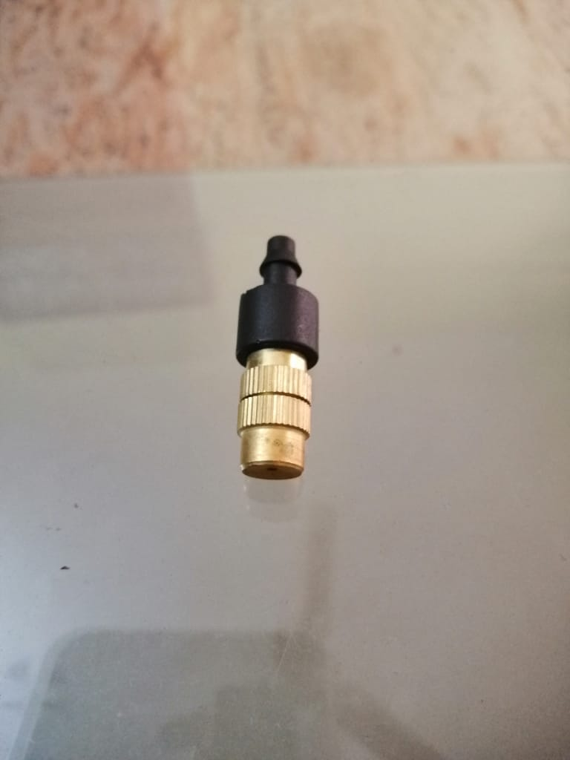

Fig 1 BRASS NOZZLE

1. SILICON WIRE

A 10 feet long silicon wire with copper core, weighing about 1.1kg is used to supply power to the drone. This specific wire provides higher heat resistance and higher flexibility.

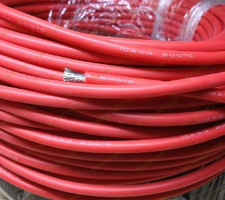

Fig 2 SILICON WIRE

1. DIAPHRAGM PUMP

A 12V diaphragm pump provides a head of 4-5 meters, pressure of 9 bar which is sufficient to spray pesticides to 1 trees of 10 meters height.

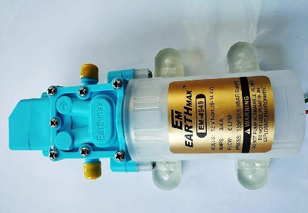

Fig 3 DIAPHRAGM PUMP

1. PNEUMATIC PU TUBE

Polyurethane tubes are generally very flexible and have a higher resistance to burst pressure. This 10-foot-long tube weights 0.42 kilograms.

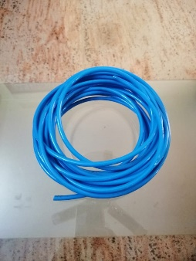

Fig 4 PNEUMATIC PU TUBE

1. NOZZLE HOLDER- ABS PLASTIC

A 3D moulded nozzle holder is made up of abs plastic to provide more rigidity while spraying and have lesser weight compared to other metals or non-metals.

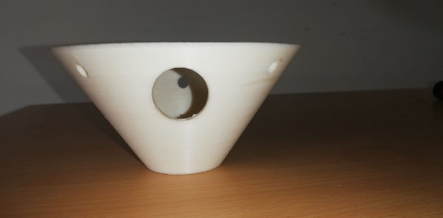

Fig 5 NOZZLE HOLDER

1. MODEL

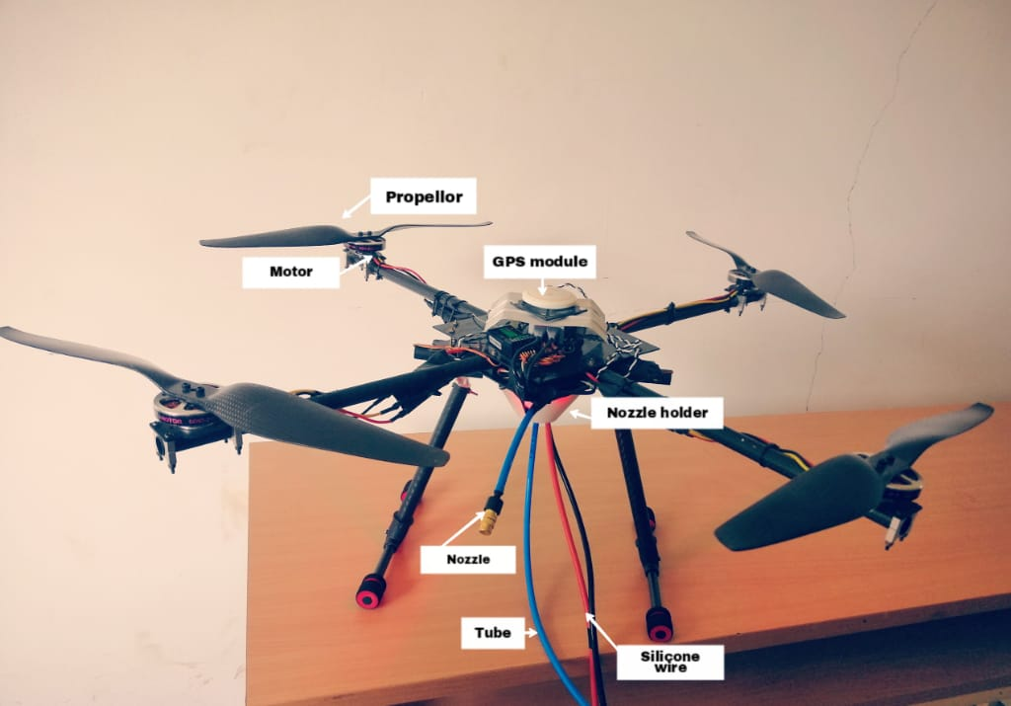

1. WORKING

The nozzle is held on to the drone by a 3D printed nozzle holder which also directs the wire and the tube to the ground preventing it from getting tangled while flying the drone. Both the battery supply as well as the pesticide tank is placed on the ground, the power is transmitted to the drone by silicon wires. Giving the drone an endless flight time. The pesticide is carried to the nozzle assembly using a 12V diaphragm pump through a Pneumatic tube. These modifications reduce the weight of the drone which thus increases the efficiency and allows the drone to spray for a larger duration.

The semi-autonomous drone is controlled by 6 Chanel transmitter and also consists of GPS device which helps in attaining the stability of the drone. The drone is directed precisely to the top of the tree and then the pump is turned on which sprays the pesticide on the required section of the tree ensuring minimal wastage of the pesticides.

Once the spraying operation is completed the retractable landing gear ensures a safe landing of the drone even in tough terrains.

1. RESULTS AND DISCUSSION

Fabrication of a wired drone with capability for spraying on coconut and areca grooves. The drone flies to a height of 15mt and sprays the pesticide to the trees. The selected pneumatic tube and silicon wire supplies the pesticide and power required to the drone. The designed spraying system has a distance coverage of 3ft from the tip of nozzle.

1. ADVANTAGES

* Capacity and weight of the batteries are on the ground hence the overall payload increases
* Environmentally friendly treatment non-combustible fuel usage
* Adaptation to precision farming systems collection of field state data
* Does not affect the ground
* The all-day round work can be organized.

1. LIMITATION

* High costs for materials and equipment, screws, sprayer frame made of light materials.
* High precision for control and positioning.
* Ecological hazards for finely dispersed spraying aerosol are blown away by wind.

1. CONCLUSION

The technology allows improvement of useful weight of the drone, working time and processing efficiency by supplying the pesticide and electricity from the ground. This will reduce the prices for fuel and lubricants, improves the quality and speed of spraying and let the spraying of pesticide at windy. A semi-autonomous drone can be used for spraying on coconut and areca grooves.

The results obtained in this paper can be used for increasing the efficiency and stability of the drone.

1. ACKNOWLEDGEMENT

We take this opportunity to thank our Lecturers and our guide who provided constant encouragement and made it possible for us to take up challenge doing this project. We are grateful to Prof. Vijendra Bhat for his technical support, valuable guidance, encouragement and consistent help. He is constant source of inspiration and information for us. Last but not least, we are thankful to our entire staff of mechanical department for their timely help and guidance at various stages of the project.

REFERENCES

[1] Theerapat Pobkrut, et al., “Sensor Drone for Aerial Odor Mapping for Agriculture and Security Services”, 2016.

[2] S Meival M.E, et al., “Quad copter UAV based Fertilizer and Pesticide Spraying system”, Vol. 1, Issue no. 1, 2016 February & page 8-12.

[3] P Govinda Raju, et al., “Solar Operated Pesticide Sprayer”, ISSN: 2348-9510

[4] Dhiraj N Kumbhare, et al., “Fabrication of Automatic Pesticides Spraying machine”, Vol. 3, Issue no. 4, 2016 April.

[5] Kiran C H, et al, “Fabrication of Multipurpose Pesticide Sprayer”, Vol. 5, Issue no. 5, 2018 May.

[6] Todd Michael Whitaker, et al., “Tethered Unmanned Aerial Vehicle Fire Fighting System”, 2015 August.

[7] Robert L Dahlstrom, “Indoor and Outdoor Aerial Vehicles for Painting and Related Applications”, 2015 March.

[8] Joshi Dhruv Bharatbhai, “Automatic Agriculture Pesticide Spraying Vehicle”, Vol. 5, Issue no. 4, 2017.

[9] Seiga Kiribayashi, et al., “Modeling and Design of tether powered Multi-copter”, 2015 October.

[10] Burema, et al., “Aerial Farm Robot System for Crop Dusting, Planting, Fertilizing and other Field Jobs”, 2014 October.

AUTHORS PROFILE



**1. Sahil Khaleel,** Student, Dept. of Mechanical Engineering, Shri Madhwa Vadiraja Institute of Technology and Management, Bantakal



**2. Zihaad Akbar Ali,** Student, Dept. of Mechanical Engineering, Shri Madhwa Vadiraja Institute of Technology and Management, Bantakal



**3. Shashank,** Student, Dept. of Mechanical Engineering, Shri Madhwa Vadiraja Institute of Technology and Management, Bantakal



**4. Swaroop Inna,** Student, Dept. of Mechanical Engineering, Shri Madhwa Vadiraja Institute of Technology and Management, Bantakal



**5. Mr. Vijendra Bhat,** Assistant Professor Dept. of Mechanical Engineering, Shri Madhwa Vadiraja Institute of Technology and Management, Bantakal