Seat Actuated Parking Brake Using Rack and Pinion

Prajath P Sherigar1, Sushan P Poojary2, Sanath B Shetty3, Preran P Shetty4, Mallya Ananth Mohan5

*Shri Madhwa Vadiraja Institute of Technology and Management, Udupi, Karnataka, India.*

***ABSTACT***

***Brake is among the protection devices of an auto. A typical car consists of two kinds of brakes, for retarding vehicle speed when in motion, one, and another for keeping the vehicle in place while still. Much of the preceding is critical once the vehicle is parked on the slope. It's essential before beginning the vehicle, to disengage the handbrake. The conventional hand brake mechanism remained in operation though the car was driving due to control of the hand brake lever. This caused the ineffectiveness of these brakes, and they failed to serve their purpose. To be able to solve the downsides of this modern method, we've introduced launch system and a universal parking brake. The Brakes are actuated using the Rack and Pinion arrangement and Solenoid.***

***KEYWORDS:*** *Brake, Universal Parking Brake, Rack and Pinion, Solenoid, Seat.*

1. INTRODUCTION

The hand brake disengagement and involvement are done with a rack & pinion arrangement. The conventional hand brake system is operated and uses cables and a hand lever for operation. In the time of involvement, the hand lever has been pulled up, making a pressure on the cable which generates. Disengagement of the pawl from the ratchet is accomplished, by clicking on the button built-in on the flip side. This conventional system arrangement can't be automatic, and only requires actuation. Therefore, the system making it feasible to automate the functioning of the machine and we have designed eliminates the usage of pawl and ratchet mechanism. Solenoid which engages the handbrake in various predefined problems and releases and made use of rack and pinion mechanism together with spring.



Fig 1 CONVENTIONAL HAND BRAKE

1. METHODS
2. METHODOLOGY

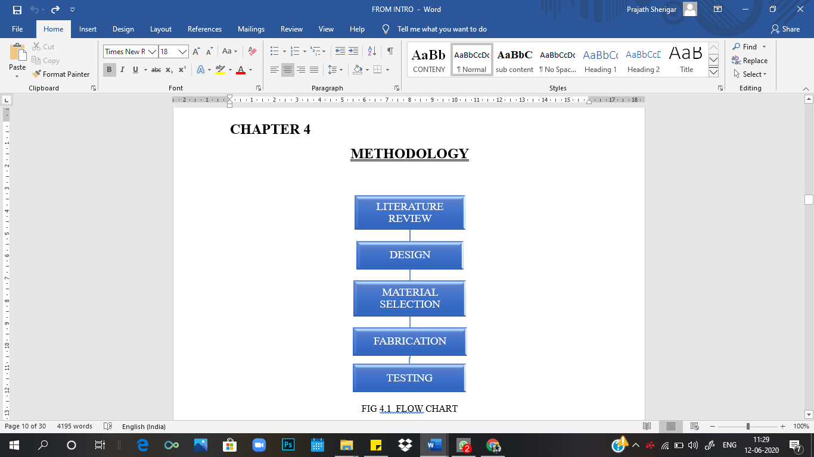

1. COMPONENTS
2. CAR AND CAR SEAT

In this project the car is used so the fabrication and testing of the brakes can be done, the seat the car is removed and altered according to the required design. Along with the seat the hand brake setup is also alter for the working of the parking brake.

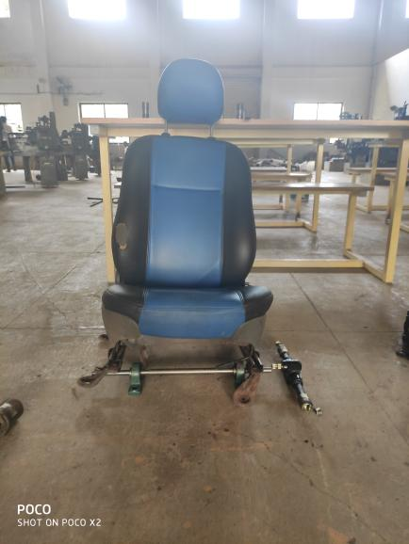

Fig 2 CAR SEAT

1. SPRING

In this Project we are using the spring from the suspension of Bajaj Pulsar Bike. That is much nearer to the spring constant required for the effective working of the Parking brakes.

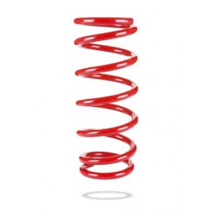

Fig 3 VARIABLE SPRING

1. RACK ANDPINION OF STEERING ASSEMBLY

The function of a steering system is to convert the rotary movement of the steering wheel in driver's hand into the angular turn of the front wheels on road.

Therefore, we can use the same function for the actuation for the parking brake with the help of rack and pinion and a component for the winding of the cable.

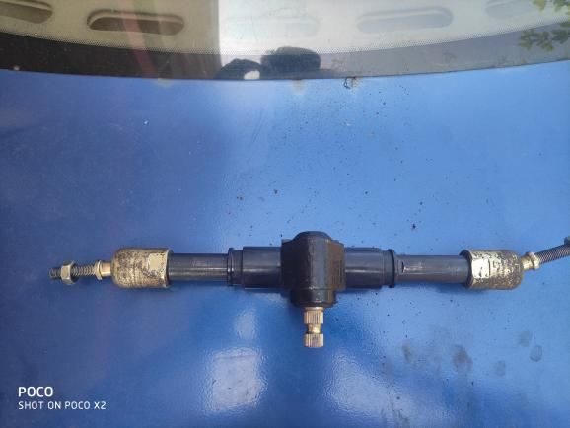

Fig 4 RACK PINION/ STEERING ARRANGEMENT

1. PILLOW BLOCK BEARING SCREW

This is used to hold the shaft and provide free rotary motion to seat.

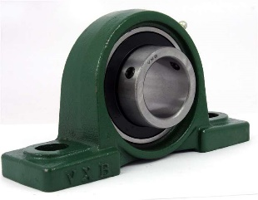

Fig 5 PILLOW BLOCK BEARING SCREW

1. SHAFT

The shaft is used for transferring of the motion form the seat to the cable of the hand brake. The

shaft is made of Mild Steel that is turned in the lathe machine for specific dimension.

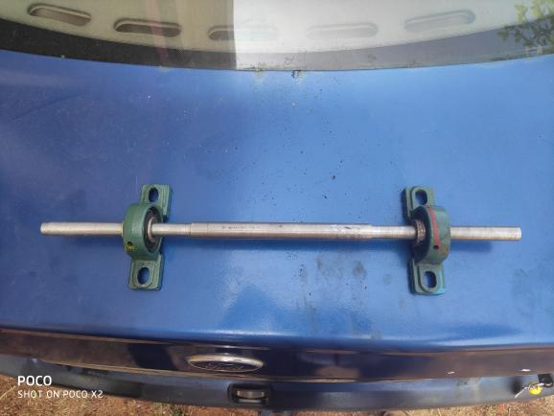

Fig 5 SHAFT

1. LIMIT SWITCH

The limit switch is used for the safety purpose. To check whether the position of the seat and the brake are in the correct position.

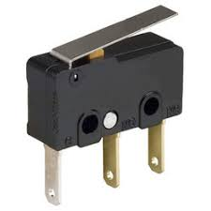

Fig 6 LIMIT SWITCH

1. SOLENOID LOCK

The solenoid lock is used for the locking of the seat and spring when the car is movement of locked in place before the ignition is started or the brake pedal is released back before the movement of car is needed.

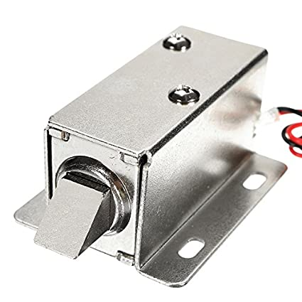

Fig 7 SOLENOID LOCK

1. MODEL

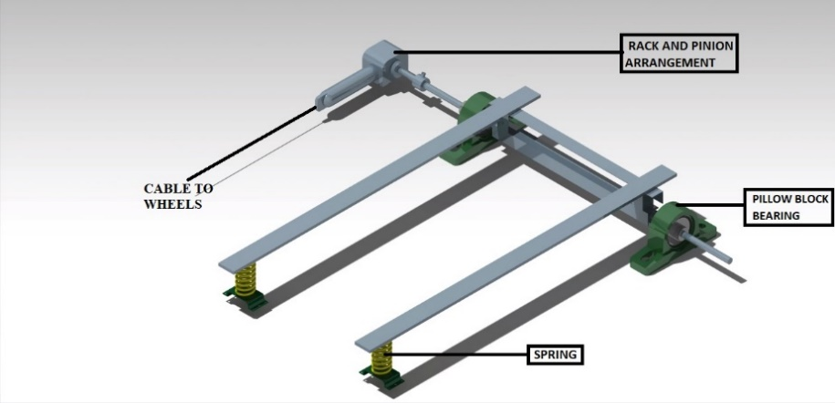

1. WORKING

The Shaft together with the pillow block bearing twist is welded with the Angle Plate (Patti) across some distance from the centre. The Angle Plate is welded beneath the seat in the front of the seat. The shaft is coupled with the pinion of steering assembly. The Rack is linked to the cable of the parking Brake. The spring is put in the back end of the seat.

After the person sits on the seat the rotary motion (angular displacement) of the shaft is move to the pinion, here the rotary motion is converted into linear movement by the rack and it releases the brake.

And, once the person gets up from the seat the rotary and the movement are made by the spring that pushes the seat from beneath, and the brake is going to be disengaged.

There is a brake pedal which will act accordingly into the engagement and disengagement of the brakes and many parts like solenoid.

The manual Hand brake will also be given with all the Automatic Braking. There is an emergency the manual braking can be used.

|  |  |  |  |  |  |
| --- | --- | --- | --- | --- | --- |
| **SEAT** | **SOLENOID LOCK** | **PEDAL BRAKE** | **IGNITION** | **PARKING BRAKE** | **WHEEL** |
| **Up** | **On** | **Free** | **Off** | **Engage** | **Rest** |
| **Up** | **On** | **Pressed** | **Off** | **Engage** | **Rest** |
| **Down** | **Off** | **Pressed** | **On** | **Disengage** | **Running** |
| **Down** | **On** | **Free** | **On** | **Disengage** | **Running** |

1. BRAKING CONDITIONS
2. RESULTS AND DISCUSSION

The braking of the vehicle sometimes happens at the selection of body burden between 60-120kg, as designed. We used the variable spring, as we needed compression of spring using the selection of weight and tension of spring for powerful braking. Because there shouldn't be actuation of the chair when the driver is not in the chair or at the vehicle the minimum weight is kept.

1. ADVANTAGES

* Low cost
* Very compact.
* Emergency stop and start is possible.
* Sensing can be easily done using sensors.
* Reduces the manual interaction.
* Increasing number of sensors in various different places can help and improve this system by engaging the handbrake and disengaging it in different conditions.
* Very fast engagement and disengagement as possible and there is no lag in operation of the handbrake.
* The issue of pulling and pushing the hand lever and applying force to the hand lever is completely removed or taken away
* In new designed parking brake system, we get more free space available at the front side of the driver’s cabin.
* New designed parking brake system has complete automatic operation for easy drivability and safety.
* As more space available at the front side of the driver’s cabin, we can introduce a new seat or a child seat as case in the smaller cars.

1. LIMITATION

* In case of failure of the Rack and Pinion system, the whole hand brake system would fail.
* Use of limit switches and solenoid means the load created on the battery will be more.
* It is bit difficult to retrofit it to a current existing car model.
* The actuation may depend upon the weight of the individual.
* In case of leakage in the pneumatic cylinder the handbrake mate disengages and the vehicle me start moving if it is parked on slope.

1. CONCLUSION

Brake while parking is triggered with the assistance of rack and pinion and solenoid lock according to a set of conditions. The seat transfers the movement. The rack and pinion get disengagement and engages brake and triggered is done by spring tension. The use of hand brake system can be eliminated using this system and the error occurring due to operator can be eliminated. It may clearly be observed that this system is completely fool proof and we may use this method in automobiles even at the lower price range because this system isn't extremely costly.

An automatic handbrake was developed for engaging and disengaging handbrake. This also functions as a park help lessen the driver error. Automating the handbrake, it reduces the chance for the driver to drive the vehicle with handbrake.

We eliminated the error while working on the machine, which operator could induce and have reduced the manual load. This will increase the life span of shoes and brake pads. This also help in engaging the handbrake thus lessen the accidents brought on by rolling of vehicle when parked.

1. ACKNOWLEDGEMENT

We take this opportunity to thank our Lecturers and our guide who provided constant encouragement and made it possible for us to take up challenge doing this project. We are grateful to Prof. Mallya Ananth Mohan for his technical support, valuable guidance, encouragement and consistent help. He is constant source of inspiration and information for us. Last but not least, we are thankful to our entire staff of mechanical department for their timely help and guidance at various stages of the project.

REFERENCES

1. D. L. Shinde, et al., Automatic Engagement and Disengagement of Handbrake System Using Pneumatic system, Volume 5 Issue VI, June 2017.
2. S. Thivagar, et al., Automatic Hand Brake System, Volume 4, Issue 1, January-February, 2016.
3. Amit B. Maske, et al., Design & Analysis of Parking Brake System of Car, Vol. 5, Issue 7, July 2016.
4. Jacob Shibu Samuel, et al., development of Automatic Hand Brake System, Volume 3, Issue, 11 April 2017.
5. Akash D. Singh, et al., Automatic Hand Brake System, Volume 5 Issue 03 Mar-2018.
6. John G. Fontaine, et al., Automatic Parking or Emergency Brake System for Motor Vehicles, Oct. 22, 1974.
7. Walter J. Pleier, et al., Automatic Seat Brake, Sep. 26, 1978.
8. Donald E. Broman, et al., Seat-Brake Including Lockout, Oct. 16, 1984.
9. Donald W. York, et al., Seat Safety Brake Control System, Jan. 29, 1974.
10. William Van Smith, et al., A safety brake system for a vehicle, Apr. 4, 1972.
11. Richard A. Peebles, et al., Worked on Boat Safety Apparatus, Apr. 30, 1974.

AUTHORS PROFILE

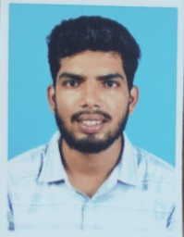

**1. Prajath P Sherigar,** Student, Dept. of Mechanical Engineering, Shri Madhwa Vadiraja Institute of Technology and Management, Bantakal

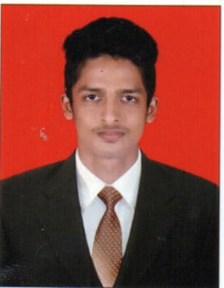

**2. Sushan P Poojary,** Student, Dept. of Mechanical Engineering, Shri Madhwa Vadiraja Institute of Technology and Management, Bantakal

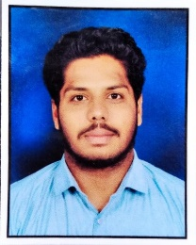

**3. Sanath Kumar B,** Student, Dept. of Mechanical Engineering, Shri Madhwa Vadiraja Institute of Technology and Management, Bantakal

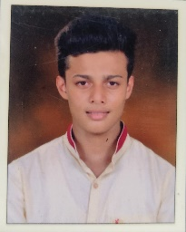

**4. Preran P Shetty,** Student, Dept. of Mechanical Engineering, Shri Madhwa Vadiraja Institute of Technology and Management, Bantakal



**5. Mr. Mallya Ananth Mohan,** Assistant Professor Dept. of Mechanical Engineering, Shri Madhwa Vadiraja Institute of Technology and Management, Bantakal