Hand Gesture Recognition System For

Physically Disabled

Sakshi V Kamath1

sakshikamath28@gmail.com

Vijayatha Nayak1

vijayathanayak9480@gmail.com

Vidisha P Shet1

vidisha.p.shet@gmail.com

Tanushree Anchan1

tanushreeanchan@gmail.com

Praveen M Naik1

mr.praveen.m.naik@gmail.com

1 Department of

Computer Science and Engineering

Shri Madhwa Vadiraja Institute of Technology and Management, Bantakal-574115, Udupi

***Abstract*—** **Physically disabled people are equally important as normal people of the society but they have not yet received the same opportunities as others in the society. Whenever the physically disabled person want to communicate, it was done through sign language which was difficult for a normal people to understand. So, it is very important for the normal people to figure out the sign language made by the disabled person through the hand gesture.**  **Here there is a concentration given to track the human hand gestures using natural human computer interface. Earlier there was no particular model for the betterment of the physically disabled persons. If they want to communicate, it was to be done by normal hand movements. Where it was very difficult for the other person to judge the real outcome and even it was very difficult to the person to convey. There are certain techniques being used to convey these messages. But there is no respective portable device which can be used by the people.**

1. INTRODUCTION

We can say that most of us are fortunate enough to be born without any disabilities. We can say physical impairment as a disability is the one that limits physical capacity of people to move or make some movements and coordinate some actions or either performing some physical activities. There exist some difficulties in one or more fields which may be performing physical and motor tasks or performing independent movement or performing daily living activities. Physical Impairment can be addressed as a problem in body function or structure of the body. It can be said as an activity limitation which may be a problem faced by a person while performing day to day work. Therefore, we say that disability is one of the phenomena which may be reflecting in a complex condition which in turn is responsible for reflecting an interaction that exists between the factors of a person’s body and the factors of the society where the person lives. The physically impaired people are unable to perform tasks sort of a commoner . So here there is an attempt to build a tool where it tries to captures hand gestures of the people using DIP and convert it to language which might be understood by normal people. Here it's associated with static also as motion recognition of hand movements of the people and provides the respected output. The obtained data is compared with trained data set present, and if data set obtained isn't matched with trained dataset then it'll ask to repeat or process it once more . Once it's matched, the result are going to be given as voice or text message to the people. Differing types of Gesture Recognition included are Hand and Arm Gesture Recognition: Here the gesture recognition procedure includes a set of hand poses and sign languages to be made. The Hand gesture technology can be said as the one which allows the functioning of complex machines to be performed using only a series of fingers and hand movements and thereby eliminating the needof physical contact existing between the operator and the machine. Body Gesture Recognition: Here the gesture recognition involves full body movements. Different types of Gestures are: Gesticulation: It is a mechanism that is said to have spontaneous movements of hands and arm that accompany along with the speech. Language like Gesture: Gesticulation that is combined into a spoken statement and there is replacement of a specific word. Pantomimes: Gesture that will depict an object or an action that is performed with or without consideration of speech in context. Emblems: These are Similar gesture like representation for example V for victory, thumps up and various other gestures. Sign Languages: Linguistic systems which already define a standard set of data for example American sign language. There are some few hand gestures which are being used by the people as shown in the figure.

Fig. 1. Common gestures being used 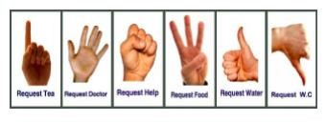

1. METHODOLOGY

In the beginning of the process we acquire the image by capturing the image of hand through a webcam. Then that particular image which contains the hand gestures undergoes through some series of steps so that necessary features of the gestures can be extracted. Then this gesture which is extracted is made to have comparison with the features that are being stored in the trained dataset. If that particular extracted gestures matches with those gestures present in the trained dataset, then it will display the output with respect to the gesture which is made and message regarding the gesture is given in terms of text or voice format. If incase the extracted gesture does not

match with the trained data then an error message is displayed

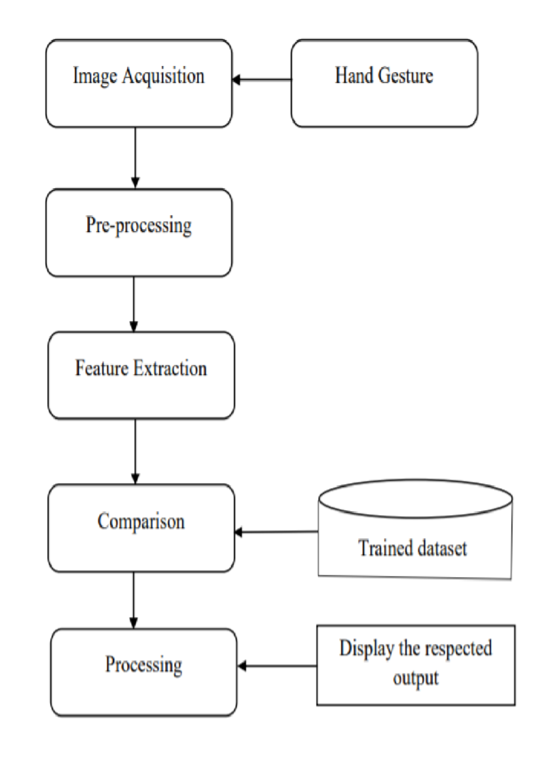

Fig. 2. Methodology for Hand Gesture Recognition.

Image Acquisition: This can be said as one of the most efficient techniques for the retrieval of an image from some kind of source which will be usually a source based on hardware for doing with the processing task. This can be said as the first step that is taken into consideration in the sequence of workflow because, without consideration of an image, no processing task is can be made possible. The most probable method for the Image Acquisition can be achieved is by making use of digital photography with usually a digital camera being present but other methods can also be considered. The Image Acquisition technique includes set of steps such as compression, processing, and displaying of the images. The image/frames of a particular person trying to convey the message using hand gesture can be obtained by using a web camera. Here there consists of pre-captured image dataset which includes different hand gestures and it contains more than 100 images of each gestures in different angle. There consists of training and testing

dataset where each image is of size 64X64

Pre-Preprocessing: There is a need to satisfy and reduce the computational effort that is needed for the processing task, preprocessing of an image taken from the camera is highly important to be done. Pre-processing can be defined as a set of procedure of formulating the data for another process. The main objective considered here for the pre-processing process is to transform the obtained data into a form such that it can be more effortlessly and effectively be processed. Preprocessing can also be told as some progressive improvement occurring in the image data that is responsible for suppressing unwanted distortions that has occurred or is responsible for enhancing some additional features of the image which are more important for the further processing to be done. Apart from these considerations, numerous factors included such as environment, lights, background of the image, hand and body position and orientation of the signer, parameters and focus of the camera has an impact on the result dramatically. Preprocessing is mainly said to include following steps such as Read the image, resize that particular image, remove noise from the image to be processed, Segmentation and Morphology techniques to be used for further processing of the image (smoothing edges).

Feature Extraction: This is the process where certain feature of an image having the region of interest is detected and that particular feature is represented for further processing. This particular feature extraction technique employs a methodology which is found to be very useful when there is a need to decrease the number of resources that might be required for processing to be performed without any loss of important content or some kind of compatible information. This technique also is efficient enough to decrease the amount of data redundancy being present for a given set of searches being performed. It is a part of the data reduction technique where an input data given is transformed into relevant features. One of the important aspects considered for feature extraction mechanism is to determine and classify exactly which features are important. If the particular features which are extracted are chosen carefully there is an expectation that the set of features present will be extracting the most important information that is required from the data given input so as to perform the required set of tasks.

Comparison: In in this step whichever hand gesture image is being extracted is compared with that of the image that are stored in the trained dataset by making use of some suitable matching techniques. By making use of techniques such as neural algorithm, the comparison is being done between the image that is being processed with that of the image present in the trained data sets.

Processing and display of the output: If the extracted gestures match with that of the trained data being present, then it will display the output with respect to the gesture which is made and message regarding what the gesture is conveying. The gesture is given as output in terms of text and voice format. If incase the extracted gesture does not match with the trained dataset being present then an error message or not found message is displayed.

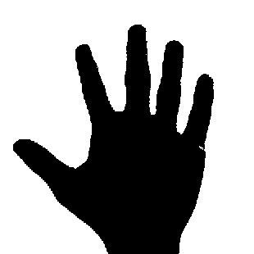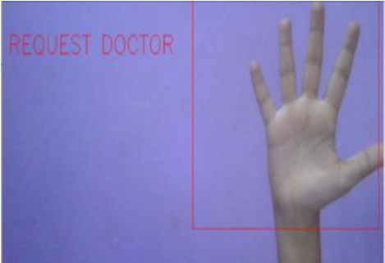

Fig. 3. Image Capturing and Segmentation

The networks are trained with the database ”Hand Gesture Dataset”. The database has 500 processed images of 64 x 64 pixels each image. Convolutional neural network architectures are developed, each convolutional neural network receives as input neurons. All networks were trained and simulated using the Python programming language and using libraries such as keras, scikit-learn and others. For the corresponding hand gesture image shown by the disabled person, Firstly the output will be in the form of text format which is then converted to speech with the help of the GTTS library in python programming which will help in converting to voice.

**ALGORITHM:**

**Step 1:** Capture the image from the webcam.

**Step 2:** After the capturing of the image it will undergo a series of steps, such as segmentation, converting the image to gray scale etc.

**Step 2.1**: Segmentation: The aim is to segment the region of interest from the obtained image. Where foreground is extracted from the background**.**

**Step 2.2:** Removal of noise present in that image.

**Step 2.3:** Convert to the gray scale image.

**Step 3:** By using neural algorithm, the comparison is done between the processed image with trained data sets. **Step 4:** If the image matches with the trained data set then it will give the output in the form of text or voice. **Step 5:** If the image is not matching with the respected trained dataset then it won’t recognize the gesture**.**

**CNN ALGORITHM:**

**Step 1: Convolution Operation**

The first building block in our plan of attack is convolution operation. In this step, we will touch on feature detectors, which basically serve as the neuralnetwork's filters. We willalso discuss feature maps, learning the parameters of such maps, how patternsare detected, the layers of detection, and how the findings are mapped out.

**Step 1(a): ReLU Layer**

The second part of this step will involve the Rectified Linear Unit or ReLU. We will cover ReLU layers and explore how linearity functions in the context of Convolutional Neural Networks.

**Step 2: Pooling**

In this part, we'll cover pooling and will get to understand exactly how it generally works. Our nexus here, however, will be a specific type of pooling; max pooling. We'll cover various approaches, though, including mean (or sum) pooling. This part will end with a demonstration made using a visual interactive tool that will definitely sort the whole concept out for you.

**Step 3: Flattening**

This will be a brief breakdown of the flattening process and how we move from pooled to flattened layers when working with Convolutional Neural Networks.

**Step 4: Full Connection**

In this part, everything that we covered throughout the section will be merged together. By learning this, you'll get to envision a fuller picture of how Convolutional Neural Networks operate and how the "neurons" that are finally produced learn the classification of images.

III. RESULT

We have developed a system such that at first, we capture the gesture made by the person through the web camera that is shown through a window and then perform some necessary processing after which we detect the hand gesture image only by eliminating other background. Then we collect the hand gesture and store them in the dataset and then perform prediction of the data by comparing the image that is shown in the window with corresponding image in the dataset. If there is a match between these images then it will display the respective message that has been already stored. We have also developed another additional feature that is whenever there is an emergency, an emergency mail/message is sent to the respective family or friend whenever the ‘h’ or ‘m’ key has been pressed.

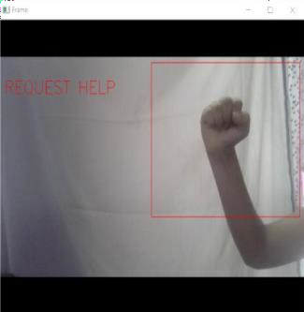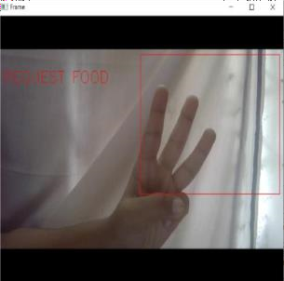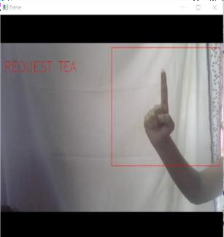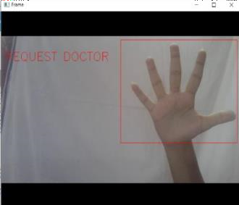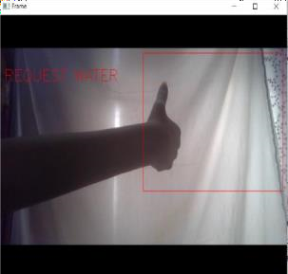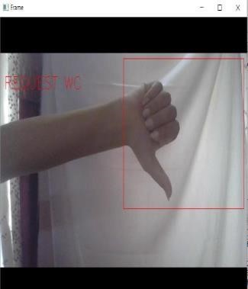

Fig. 4. Hand gestures predicted by the System

Fig. 5

.

Emergency Mail sent to the family when key

‘

h

’

is

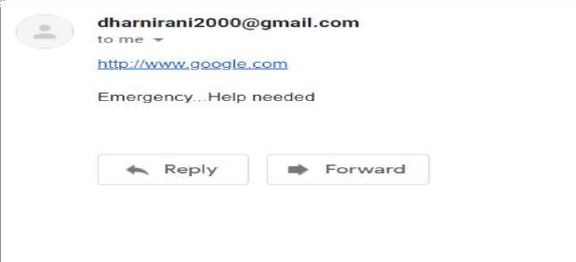

Pressed

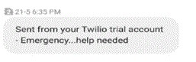

Fig. 6. Emergency Message sent to the family when key ‘m’ is pressed

IV. CONCLUSION

Sign language can be considered as a useful tool for the easy communication that can exist between the deaf or mute community people and the normal people. Yet we can say that there exists a communication barrier between these communities of people in the society. The main aim here is to lessen the communication gap that exists between the deaf and mute community people and the normal world. There is also aim in translating sign language into speech for normal understanding to the people. Here much focus is given on the type of prototype being used so as to check for the feasibility existing and also be able to recognize the sign language making use of the concept of neural network. With the consideration of various situation, the deaf and mute people can use this particular gesture recognition system to accomplish certain set of operations on sign language and that particular sign is being recognized and is converted into format of spoken words so that normal people could be easily able to understand what the other person is trying to convey. The main feature which is being considered here is that the presence of gesture recognizer which is used here is a standalone system, which is found relevant in day to day life.

REFERENCES

1. G.Vijaya Kumar, Dr.Y.Padma Sai, V.Naveen Kumar, A.Prathibha, ”Hand Gesture Recognition Using Accelerometer for Disabled”, International Journal of Science, Engineering and Technology Research (IJSETR), Volume 3, Issue 12, December 2014.

1. P. Kanchana Devi, A. Raji1 and G. Srinivasan, “Gesture Recognition for Physically Challenged”, Indian Journal of Science and Technology, Vol 9(16), DOI: 10.17485/ijst/2016/v9i16/87950, April 2016.

1. Vaishali S.Pande, “Labview Based Hand Gesture Recognition for Deaf and

Dumb People”, International Journal of Engineering Science Invention (IJESI),

ISSN (Online): 2319 – 6734, ISSN (Print): 2319 – 6726 www.ijesi.org ||Volume 7 Issue 4 Ver. V|| April 2018 || PP 66-71.

1. A.Jency Doss and A.Ramya,” Hand Gesture Recognition System For Physically Impaired People”, International Journal of Advanced Research in Management, Architecture, Technology and Engineering (IJARMATE) Vol. 3, Special Issue 2, April 2017.

[5] Amarjot Singh, John Buonassisi, Sukriti Jain, “Autonomous Multiple

Gesture Recognition System for Disabled People”, I.J. Image, Graphics and Signal Processing, 2014, 2, 39-45 Published Online January 2014 in MECS (http://www.mecs-press.org/)DOI:10.5815/ijigsp.2014.02.05.

[6]Swapnil D.Badgujar, Gourab Talkudar, Omkar Gondhalekar, mrd.S.Y.Kulkarni, “Hand Gesture Recognition System”, International Journal of Scientific and Research Publications, Volume 4, Issue 2, February 2014 1 ISSN 2250-3153.

[7] Mr.R.Jagadish, R.Gayathri, R.Mohanapriya, R.Kalaivani and S.Keerthana,

“Hand Gesture Recognition System for Deaf and Dumb Persons”, Indo-Iranian Journal of Scientific Research (IIJSR) Volume 2, Issue 1, Pages 139-146, January-March 2018. [8]Aruljyothy.S,Arunkumar.S,Ajitraj.G,YayadDamodran.D,Jeevanantham.J,D

r.M.Subba, “Hand Gesture Recognition Using Image Processing for Visually

Impaired and Dumb Person”, International Journal of Advanced Research in Computer and Communication Engineering ISO 3297:2007 Certified Vol. 7, Issue 4, April 2018.

1. D.Vishnu Vardhan,Penchala A Prasad,” Hand Gesture Recognition Application for Physically Disabled People”, International Journal of Science and Research (IJSR) ISSN (Online): 2319-7064 Impact Factor (2012): 3.358.

1. T Suchitra, Dr. R Brinda, “Hand Gesture Recognition Based Auto Navigation System for leg Impaired Persons”, International Journal of Advanced Research in Electrical, Electronics And Instrumentation Engineering

(An ISO 3297: 2007 Certified Organization) Vol. 6, Special Issue 2, March 2017.