The Future of Noiseless Automotive Communication: Geo-Horn

Rizwan M A#1, Vaishnavi P N#2, Ramanath Kini M G*3

#*Department of Electronics and Communication Engineering,*

*Coorg Institute of Technology, Kodagu, India*

*1rizwan7298@gmail.com*

*2vaish372@gmail.com*

*\*Assistant Professor, Department of Electronics and Communication Engineering*

*Coorg Institute of Technology, Kodagu, India*

*3mgramnathkini@gmail.com*

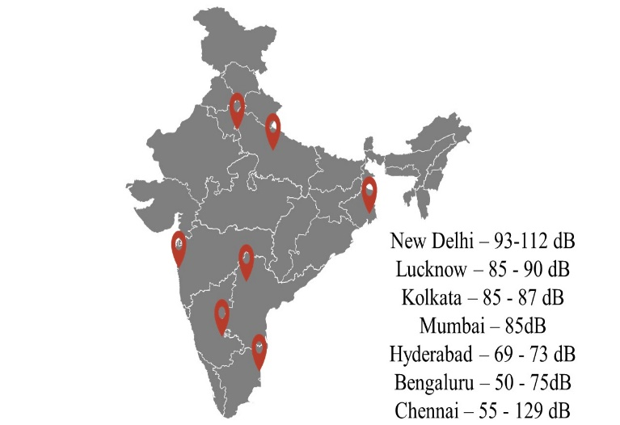*Abstract*— **In today's world, the vehicular horn remains unruly with no developments and is a large benefactor of noise. Yet, it is impossible to eradicate the horn in emergencies and untoward incidents. There is a desperate need for a solution. In this paper, we design an on-board apparatus which implements horn from the host vehicle to the leading vehicle remotely uninterrupted to the external environment integrated with geofencing technology as the center of activation.**

*Index Terms*— **Automotive horn, Noiseless, Geofencing, Wireless communication**

# **INTRODUCTION**

Noise is a never-ending wrong created by the society that requires restraint. One of the prime reasons for disruption and affliction in the twenty-first century is the noise generated by Vehicular Horn. The mechanism of honking is generously provided in vehicles of every standard, scale and industry. Noise displaces the physical and cognitive well-being including the spiritual health, overpowering the equilibrium between psychological and social characteristics. Considering the ever-increasing ailments caused by honking [14], it raises the dire need for a sustainable and economically viable solution. Honking is the quandary of every city, state and nation. Consequently, absent-minded drivers expect to stop others by honking, while others honk to prove their presence on the road. Furthermore, conditions worsen during traffic because reckless drivers manifest impatience and unawareness. The best answer is to abandon honking and eliminate horn in automobiles without exception. But is it viable? Is the elimination of horn a viable solution?

The objective of honking helps drivers prioritize emergencies and disabled pedestrians. It is moreover an effective means of communication, stopping a series of unfortunate events. Another objective is to call the driver’s attention. This builds a contradiction in using the horn, making it an unavoidable evil. The plight is more threatening in urban areas becoming highly populated in the past few decades. It has, in turn, resulted in the rapid growth of vehicle population generating a substantial addition in traffic and distressing

Fig 1.1 Noise in cosmopolitan cities of India

noise pollution. High decibel noise caused by honking acts as an environmental pest. How can we overcome the shortcomings of the conventional honking system and annihilate the danger associated? The proposed model is a noiseless system where the host driver signals the vehicle’s approach to the leading driver uninterrupted to the external surroundings with geofencing as the chief constituent.

The remainder of this paper is structured as follows. Section 2 presents a comparison of related research works to design a noiseless geo horn in the wireless domain. Section 3 deals with the system composition and framework followed by the algorithm used for functioning. Finally, Section 4 concludes the paper.

# **Related work**

In this section, we introduce certain existing research works attempted to design a noiseless horn in the wireless domain and how our contribution differs from the below-mentioned models.

The authors in [11], [12] present a comprehensive method of using Infrared or Radiofrequency waves for transmission and reception to lessen noise pollution. Authors in [12] proposed that IR communication is faster and more reliable at after successfully testing the IR and RF communication between two automobiles. In [11] they implemented a liquid crystal display (LCD) to depict information and Peripheral Interface Controller (PIC) micro-controller controls the functioning of the model. The research in [10] focuses on RF communication generating a radiofrequency signal travelling around a distance 40- 60 meters. On reception it produces a beep sound where the sound is audible to the driver uninterrupted to external environment. The research in [9] focuses on IR communication for a pollution-free horn, producing a sound not greater than 60 decibels.

Comparably, the authors in [7] present a system to control the horn intensity in a vehicle with infrared communication, based on the running status of the vehicle. At high speed, the horn intensity is high, and vice versa. The authors in [8] prioritized the intensity of the horn with a global positioning system. The model performs obstacle sensing to detect closer vehicles, and the location tracker sends corresponding signals to the controller, and the intensity of the horn varies. The GPS detects the latitude and longitude to determine whether it is a hospital or a silent zone. Authors in [2], [13] introduced a vehicular Ad hoc network (VANET) to overcome sound pollution caused by automobiles. In [13] horn makes use of the ad hoc network to transfer wireless data to notify drivers. On reception, it alerts the driver with vibrations from a device attached to the steering, similar to how the conventional horn notifies a driver. A VANET uses cars as nodes to form a network [2]. In the system composition of [2], the transmitter signals the receiver. On the receiver end, the buzzer generates a sound and an acknowledgement is sent. If it does not receive the acknowledgement, it uses a conventional horn. The research in [1] uses a handshake mechanism for communication where a vehicle first captures the image of the number plate of the leading vehicle and sends a request signal. The request signal reaches every vehicle near the source vehicle and the target vehicle transmits an acknowledgement. If it is positive, the vehicle can overtake and stores the GPS location, date, and time in its memory for later use.

# **Materials and Methods**

In contrast with the mentioned research works, the contribution of this paper is fourfold:

3.1 The aspect of geofencing for automobile horn is a first and the functioning of the horn entirely relies on the same

3.2 In areas with low cell phone range and less pollution, the conventional horn automatically activates.

3.3 We provide an interrupt to the horn through the software program, interrupting the current process and responding to the horn.

3.4 We provide a mechanism where it automatically switches to conventional horn on sensing rain droplets.

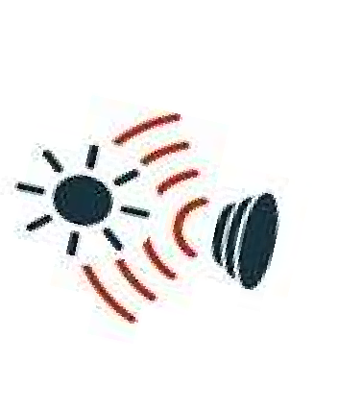

**Central Computer Module**

Relay Switch

Horn Switch

Conventional Horn

Ultrasonic sensor

Infrared Receiver

Infrared Transmitter

Buzzer Module



GPS

Outside Geofenced Boundary Operation

Within Geofenced Boundary Operation

Visual Indicators

Fig 3.1 Architectural Framework of the system

The horn transmits sound as electrical signals to the intended vehicle using Infrared Wireless Technology. Vehicles are mounted with an infrared transmitter and receiver to perform noiseless honking. The notion of the infrared transmitter is to transmit an infrared signal, the signals bounce from the exterior of the vehicle to be received by the infrared receiver parked on the bumper of the succeeding vehicle. The nature of the noiseless honking system will be disrupted granted that omnidirectional wireless technologies are used. The reason for using infrared waves as means of transmission compared to other wireless technology standards used for exchange of data between fixed and mobile devices over short distances is because infrared devices operate in line-of-sight mode where transmission and reception functions efficiently only in the absence of obstacles [6]. Bluetooth communication obligates pairing of devices and impairs the objective of noiseless horn if two vehicles fail to pair. Bluetooth, moreover, works over short distances. Wireless Fidelity (Wi-Fi), on the other hand, compels prior connection establishment in Wi-Fi highways and is ineffective in areas with low bandwidth or no Wi-Fi. Infrared devices are ordinarily energy efficient. It is liable because the vehicle transmits signal primarily to the intended driver and no other driver must receive the same.

As addressed in the Introduction, geofencing technology is the **center of activation**. To understand the theory of geofencing, we will scrutinize each element blended with this technology. Geo-fencing is a pragmatic boundary defined by the Global Positioning System [4]. The virtual boundary defined by the GPS can be termed the geofence [4]. To ensure a precise geofence, all automobiles are installed with a Global Positioning System (GPS). In an environment where cell phone towers are omnipresent, urban environments provide a conclusive geofence reaching anywhere from 22 to 45 miles [5], whereas, in farm areas, there aren’t many towers and accuracy can reach a few miles.



r

**C**

Geofenced boundary

Fig 3.2 Geofence within a city

The geofence is enclosed over a city or town as described in the above figure. **C** is set to cover the landscape of the entire city and **r** is the radius from the center C and varies from place to place. If the map is larger and non-uniform, two or more circles with a smaller radius is enclosed. The foremost apparatus designed to determine the location is the Global Positioning System (GPS). With the influence of technology over automobiles, most cars have inbuilt GPS navigation systems. The design reinforces the GPS to serve as a tracker and provide geographic coordinates. The geofence is built within the code, and the GPS must be powered up constantly. The got coordinates and preset coordinates estimate the distance using the Haversine formula. The preset coordinates differ concerning user preferences. After the distance estimation, an analysis of discrepancy in the estimated range and the preset threshold is completed. On condition that the estimated distance is equal to or less than the threshold, the noiseless horn activates.

An electrically operated relay switch is installed to control the potency of the horn switch based on the geographical coordinates by opening or closing contacts with another circuit. It is designed to such a degree, when the current is applied to the relay, the horn circuit is thorough, enabling the horn to function. If the relay fails, the horn remains inactive. The horn is assigned the highest priority among all interrupts. On pushing the horn switch, it signals the processor and requests to interrupt current operations. It is beneficial in emergencies and traffic collision.

When the horn is pressed to a designated vehicle, the relay authenticates if the vehicle is in the geofence and switches to the silent horn, subsequently transporting current to the IR transmitter. On receiving abundant current, the IR transmits infrared radiation shaped as modulated bit stream to the IR receiver. At the receptive head of the designated vehicle, the receiver gains the bit stream.

On completion of ideal reception, the receiver triggers the buzzer module on the indicator panel. The buzzer produces a honk notifying the driver. The receiver further triggers the ultrasonic sensor. The ultrasonic sensor measures the distance using ultrasonic waves having frequencies beyond audible spectrum. A Liquid Crystal Display (LCD) is connected to display the varying levels of distance measured by the ultrasonic sensor. If the preceding vehicle is relatively near the leading vehicle, there can be an obstruction which is overcome by notifying the driver over an LCD. Rain and fog drastically degrade the performance of Infrared and Ultrasonic communication and result in a steep decline of meter range. Rain sensors safeguard the transmitter and switches the relay to normally closed mode and purpose as the conventional horn.

The central computer module regulates the whole operation of the horn design. The prototype uses AT Mega 328 as the central controller.

**ALGORITHM:**

1. Transmitter Mode

If in geofenced boundary?

Switch relay to normally closed mode

Switch relay to normally open mode

Check for horn input?

Conventional Horn Active

Transmit IR CODE

YES

YES

NO

NO

A

Fig 3.2 Transmitter flow illustration

Step 1: If the automobile is within the geofenced boundary go to Step 2, else go to Step 4.

Step 2: Switch the relay to normally open mode

Step 3: Check for a horn key interrupt. If yes, vehicle intends to overtake the default, and transmit the Infrared code.

Step 4: Switch the relay to normally closed mode.

Step 5: The conventional horn is activated.

1. Reception Mode

Step 1: Check if an infrared code is received. If yes, go to Step 2, else wait until received.

Step 2: Check if rain sensor is activated. If yes, switch the relay to normally closed mode, else go to Step 3.

Step 3: Activate the ultrasonic sensor

Step 4: Display the LED and buzz the buzzer inside the vehicle.

YESS

A

Is rain sensor activate??

Check if IR code received?

Activate Ultrasonic sensor

Display in the LCD and buzz the buzzer in the vehicle

NO

YES

Fig 3.3 Receiver flow illustration

# **Conclusion**

Implementing the Geo-Horn integrates a soundless traffic state and aids the pedestrians and animals within the vicinity. The addressed system is uniform, pragmatic and economically feasible in large scale production. Beyond everything, the design ensures absolute signaling without jeopardizing the environment and contributes an interpreted solution to degrade noise to a large extent for a thriving planet.

References

1. R. Kapoor, R. Birok and D. S. Manoj, “Soundless Horn and Remote Patroller,” 2014 IEEE International Conference on Vehicular Electronics and Safety, Hyderabad, 2014, pp. 112-116.
2. Umare, Sonal & Mahule, Gaurav & Chandra, Prateek & Jaiswal, Rajesh & Tembhurkar, Manish. (2015). Car Convoy Communicator: Active Control Noise Reduction in Vanet Using Wireless Sensors. International Journal of Advanced Research in Computer Science and Software Engineering (ISSN: 2277-128X). 5. 380-387.
3. Suryana, Anang & Reynaldi, Farenza & Pratama, Firman & Ginanjar, Gilang & Indriansyah, Indra & Hasman, Deni. (2018). Implementation of Haversine Formula on the Limitation of E-Voting Radius Based on Android. 218-223. 10.1109/ICCED.2018.00050.
4. Sarah K. White (December, 2017) What is geofencing? Putting location to work Available: www.cio.com/article/2383123/ geofencingexplained.html
5. Bert Markgraf, how far can a cell tower be for a cellphone to pick up the signal. Available: smallbusiness.chron.com/far-can-cell-tower-cellphone-pick-up-signal-32124.html
6. Al-Nassar, Suha & Hatem, Haraa & Shehab, Jinan. (2018). Design and Implementation of Infrared (IR) Communication System. 29-33. 10.26367/DJES/VOL.11/NO.3/5.
7. Karhale Shivraj Narayan, Akshay Uttam Bhalerao, Vishal Shivaji Chaudhari, Mr. Prashant S.Bibave. “*Proposed System-Automatic Vehicle Horn Intensity Control System”,* Volume 7, Issue V, International Journal for Research in Applied Science and Engineering Technology (IJRASET) Page No: 3870-3872, ISSN: 2321-9653, www.ijraset.com
8. Babu, Mr. (2019). Design and Development of Smart Horn Automation System using GPS. International Journal for Research in Applied Science and Engineering Technology. 7. 1263-1266. 10.22214/ijraset.2019.3228.
9. Akashata.Samarth, Baljit Kaur Saini, Preeti Vats, Sarvesh Vaidya, 2015, In Vehicle Pollutionless Horn, International Journal of Engineering Research & Technology (IJERT) ISSN: 2278-0181
10. Manjuladevi.G, Sivaranjani.P, Divya.K, Suresh.A. 2019. RF BASED WIRELESS HORN SYSTEM FOR VEHICLES AND DEAF PEOPLE INTIMATION WITH NOISE CONTROLLER. International Journal of Advanced Technology in Engineering and Science. Page No. 86-94. ISSN: 2348-7750 (Volume 7 Issue 3)
11. E. Hossain, N. Mamun and M. F. Faisal, “Vehicle to Vehicle Communication Using RF and IR Technology,” 2017 2nd International Conference on Electrical & Electronic Engineering (ICEEE), Rajshahi, 2017, pp. 1-5.
12. A. Aziz and M. S. Hossain, “Inherent Inter-Vehicle Signaling Using Radio Frequency and Infra-Red Communication,” 2012 UKSim 14th International Conference on Computer Modelling and Simulation, Cambridge, 2012, pp. 211-215.
13. Vikas Sharma, Snehal Aware, Prof. Pragti Goel. 2017. SOUNDLESS HORN USING AD-HOC NETWORK (VANET). International Research Journal of Engineering and Technology (IRJET) Page No: 2837-2840. e-ISSN: 2395 -0056. Volume: 04 Issue: 06
14. Roy, Tanmay Kumar & Mukhopadhyay, Arup & Ghosh, Sadhan & Majumdar, Gautam. (2010). Honking -Its Influence on Noise Pollution. 30. 653-658.
15. The Better India. (September 2018) Available: https://www.thebetter india.com/158979/horn-decibel-level-lower-delhi-news
16. Science Page News. (February, 2020) Available: https://www.sciencepagenews.com/2020/02/10/mumbai-police-finds-a-new-way-to-stop-honking-drivers
17. DT Next. (April, 2016) Available: https://www. dtnext.in/News/City/2016/04/26111858/Deafening-silence-on-air-horns-in-TN.vpf
18. Lucknow Pulse. (July, 2016) Available: http://lucknowpulse.com/say-no-to-honking-lucknow
19. The Economic Times. (June, 2019) Available: https://m.economictimes.com/news/politics-and-nation/noise-pollution-rises-in-two-areas-marked-as-silence-zones-in-bengaluru/articleshow/69870252.cms
20. The Times of India. (October, 2008) Available: https://timesofindia.indiatimes.com/city/kolkata/Kolkatas-killer-noise/articleshow/3592220.cms
21. Telangana Today. (September, 2019) Available: https://telangana today.com/hyderabad-horn-not-ok-please