**ELECTRICAL CHARACTERISATION OF SISAL REINFORCED POLYPROPYLENE COMPOSITES**

Shreyas Shetty1, Srajan K Kotian2, Vishal Kunder3, Sukesha 4, Mr. Ganesh Kalagi5, Mr. Narayan Nayak6

Department of Mechanical Engineering SMVITM, Bantakal, Udupi, India

_________________________________________________________________________________

**Abstract**

**In recent years, the natural fibres have been more attractive. The natural fibres are technically enhanced by amalgamating with plastics. Types of natural fibres which can be used along with plastics are coir, luffa, hemp, jute, sisal and banana. The objectives of this experiment are to evaluate the suitability of producing fiber composites using sisal fibers. This study deals with the preparation of sisal fiber composites by using hot compression technique in which good interfacial adhesion is generated by a combination of fiber modification and matrix methods. Initially the sisal fibers were treated in order to improve resin fiber interfacial bonding. The treatment agent used were Sodium hydroxide. The dielectric properties, such as dielectric constant of sisal natural fibers reinforced with polypropylene were studied with different fiber loadings. The dielectric constant was lower for composites consisting of fibers subjected to alkaline treatment due to the increased hydrophobicity of fibers. When the weight percentage of sisal fiber was increased in the composites, the dielectric constant was found to increase. It is evident that types of polymer have little influence on the dielectric properties of the composites.**

***Keywords:*** Fibers, composites, sisal, polypropylene, Natural fibers.

**1. Introduction**

Polymers are commonly used in electrical and electronic industries as housings or assemblies. The most desirable combination of characteristics such as simplicity of fabrication, light weight, low cost, and excellent insulation properties have made plastics one of the most suitable materials for electrical and electronics applications. Fiber reinforced plastic materials not only act as effective insulators, but also provides mechanical support for field carrying conductors. The need for lighter materials has led to the increase use of polymer composites. Lightweight and high-performance polymeric materials, in many applications, have already replaced steel as major structural materials. However, there are more compelling reasons why the new materials are gaining dominance.

The continuing development and increasing sophistication of technology, and the desire for a higher standard of living by people in the so-called developing countries are now drawing on world resources at an alarming rate. Short fiber reinforced–composites are finding ever increasing applications in engineering and in consumer goods. They can offer a unique combination of properties, and they are more economical than are competing materials. Incorporation of fibrous reinforcements in polymer matrices leads to high performance composite materials having very good mechanical properties and at the same time suitable for electrical and electronics applications. They can be used as connectors, terminals, industrial and household plugs, switches, and printed circuit boards.

Materials made from two or more constituent materials with significantly different physical or chemical properties which remain separate and distinct at the macroscopic or microscopic scale within the finished structure. Natural fibre composites combine plant-derived fibers with a plastic binder. The natural fibre component may be wood, sisal, hemp, coconut, coconut, luffa, flax, jute, abaca, banana leaf fibres, bamboo, wheat straw or other fibrous material, and the binder is often recycled plastic mainly polypropylene. In most case the reinforcement is harder, stronger and stiffer than the matrix. The reinforcement in fibres are usually particulate. Particulate composites have dimensions that are approximately equal in all direction.

Natural cellulose fibers have been frequently used as the reinforcement component in polymers to add the specific properties in the final product. With increasing awareness towards sustainable product design and the rising trends in its demand, natural based fiber materials are once again gaining popularity to replace synthetic fiber in the fabrication of composites. Natural cellulose fibers from different bio-renewable resources have attracted the considerable attraction of research community all around the globe owing to their unique intrinsic properties such as biodegradability, environmental friendliness, easy availability, flexibility, easy processing and impressive physiomechanical properties. Bio-composites are competitive with synthetic composites such as glass–polypropylene and glass–epoxies, and gaining attention over the last decade. Natural plant fibers are renewable, non-abrasive and reduce health and safety concerns while handling. In addition, they show excellent specific mechanical properties, low cost, low density and enhanced energy recovery compared to traditional glass and carbon fibers. This favorable price-performance ratio, in combination with a marked environmentally friendly character, is crucial for their acceptance in large volume engineering markets.

In the past few years, the natural fiber reinforced composite materials have received a significant amount of attention in the automotive, construction and packaging industries. However, their electric applications have become popular only recently. The natural fiber reinforced composite materials have been used as dielectric materials in microchips, parts of transformers, terminal, connectors, switches, circuit boards, etc. Therefore, studies of dielectric properties of natural fibers reinforced composite materials are very important. In this study, sisal fiber was used as reinforcement in raw and surface modified form with the polypropylene to make sisal reinforced polypropylene composite. The surface modification of these fibers was carried out by using sodium hydroxide (NaOH). The dielectric properties of the composites have been analysed with special reference to effects of fiber loading and fiber ratio.

**2. MATERIALS AND METHODS**

**2.1 Fibre preparation**

It is obtained from sisal plant. The plant, known formally as Agave sisalana. These plants produce rosettes of sword-shaped leaves which start out toothed, and gradually lose their teeth with maturity. Each leaf contains a number of long, straight fibers which can be removed in a process known as decortication. During decortication, the leaves are beaten to remove the pulp and plant material, leaving the tough fibers behind.

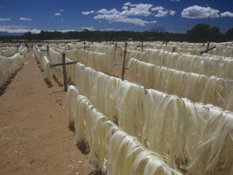

Figure 1: Sisal fiber

**2.2 Alkali treatment of fibre**

Discontinuous fibre is used to fabricate the natural fibre composites. First the natural fibres are cleaned in the distilled water. The cleaned natural fibres are dried in the sunlight. The dried natural fibres are again cleaned by chemical cleaning process. In Chemical cleaning process the 10% sodium hydroxide is mixed with 90% distilled water. The dried natural fibres are dipped in the diluted sodium hydroxide solution. It is again dried in sun light. The dried natural fibres are particulates. The particulate sisal is used to fabricate the reinforced polypropylene composites.

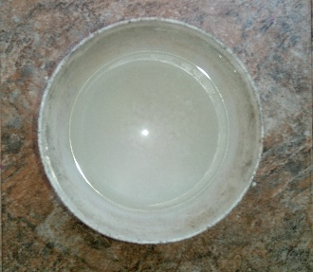

Figure 2: 10% NaOH Solution

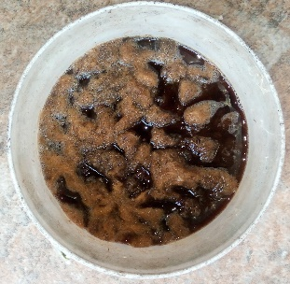

Figure 3: Sisal dipped in 10% NaoH Solution

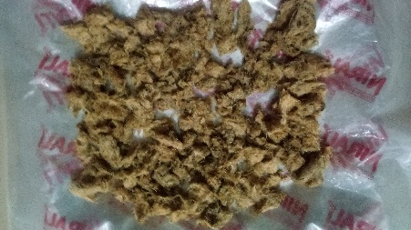

Figure 4: Dried fiber

**2.2 Preparation of matrix**

The polypropylene (PP) used in the study was the products of the Titan Polymer, Malaysia Sdn. Bhd. The types of PP selected was PP with a melt flow index of 24. All PP were in pellet form. In the plastics industry, PP is normally used for manufacturing appliances, house wares, toys, and containers.

**2.3 Preparation of composites specimen**

Hot compression moulding was used to fabricate polypropylene reinforced with sisal fiber composites. The composites were fabricated by varying the weight fraction of fibers, ranging 10wt%, 20% and 30wt%. The polypropylene and sisal were weighted to the required proportion. The polypropylene and sisal were mixed and loaded into a mould. The hot press was pre-set at 150°C and at a pressure 6.8 MPa. The mould was placed between the lower and the upper jaws of the hot press and compressed for about 30 minutes. After 30 minutes the mould was cooled down using water as the coolant. The mixture was then placed in the mould, making sure that the mould cavity was properly filled and sufficient pressure was applied. The composite was then left to cure for about 24 hours at room temperature. The mould was later opened to remove the composites.

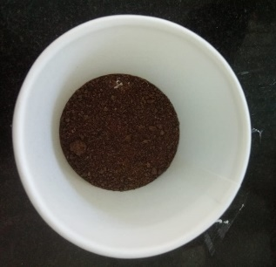

Figure 5: Sisal fiber Powder form

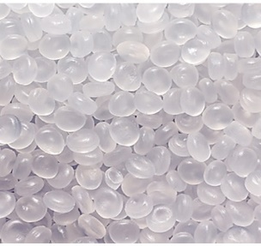

Figure 6: Polypropylene

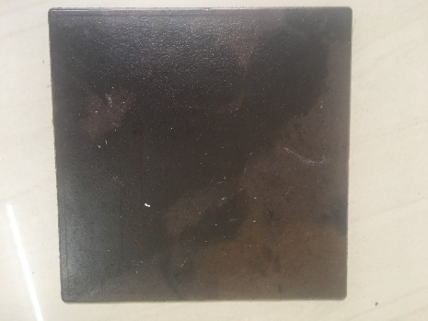

Figure 7: Composite

**2.4 Testing of composites specimens**

The dielectric properties of the composite specimens were measured with Quadtech Precision RLC meter. The test can be conducted at different frequencies, often between the 10Hz and 2MHz range. The measurements were done in accordance with ASTM D-150-10 standard. The sample must be flat and larger than the 50mm (2 in) circular electrodes used for the measurement. A sample is placed between two metallic plates and capacitance is measured. A second run is made without the specimen between the two electrodes. The ratio of these two values is the dielectric constant.

**2.5 Dielectric Constant**

Dielectric Constant is used to determine the ability of an insulator to store electrical energy. The dielectric constant is the ratio of the capacitance induced by two metallic plates with an insulator between them to the capacitance of the same plates with air or a vacuum between them. It is a measure of material’s ability to become polarized and to store charge when an external electric field is applied to it through parallel plates acting as a capacitor. The dielectric constant of a material depends upon the polarizability of the material. If there is high polarizability of the molecule, dielectric constant will be high. The dielectric constant of a polymeric material depends on dipole, atomic, polarization, electronic and interface. Dielectric constant of an insulation material is an important parameter since it provides valuable information about its dielectric strength.

**3. Results and Discussion**

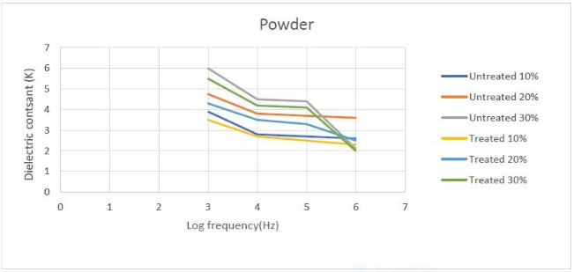

Figure 8: Dielectric constant (K) vs Log Frequency (Hz) for powder

The graph above shows, the change in the dielectric constant (K) and the log frequency (Hz) of the powder used, so when the Treated 10% powder is used, for the frequency 3-4hz the value of dielectric constant decreases from 3.5-2.7 and for the frequency 4-5 Hz there is a decrease in the dielectric constant from 2.7 to 2.8 and for frequency 5-6 Hz the dielectric constant decreases from 2.5 to 2.3. For untreated 10%, for the frequency 3-4 Hz the value of dielectric constant varies from 3.9-2.8 and for frequency 4-5 Hz the dielectric constant varies between 2.8 and 2.7, for frequency 5-6 Hz the dielectric constant decreases from 2.7 to 2.6. For treated 20% , for the frequency 3-4 Hz the dielectric constant decreases from 4.3 to 3.5 , for frequency 4-5 Hz the dielectric constant varies from 3.5 to 3.3 and for frequency 5-6 Hz the dielectric constant decreases from 3.3 to 2.5 .For untreated 20% , for the frequency 3-4 Hz the dielectric constant decreases 4.75 to 3.8 and for frequency 4-5 Hz the dielectric constant varies in between 3.8 to 3.7 and for frequency 5-6 Hz the dielectric constant decreases from 3.7 to 3.6 . For treated 30% , for the frequency 3-4 Hz the dielectric constant decreases from 5.5 to 4.2 for frequency 4-5 Hz the dielectric constant varies from 4.2 to 4.1 and for frequency 5-6 Hz the dielectric constant steeply decreases from 4.1 to 2.For untreated 30% , for the frequency 3-4 hz the dielectric constant decreases from 6 to 4.5 for frequency 4-5 Hz the dielectric constant varies from 4.5 to 4.4 and for frequency 5-6 Hz the dielectric constant steeply decreases from 4.4 to 2.1.

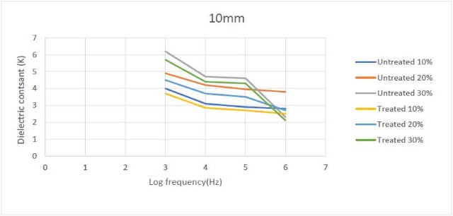

Figure 9: Dielectric constant (K) vs Log Frequency (Hz) for 10mm

The graph above shows, the change the dielectric constant (K) and the log frequency (Hz) of the 10mm used , so when the Treated 10% ,10mm is used for the frequency 3-4hz the value of dielectric constant decreases from 3.7-2.85 and for the frequency 4-5Hz the is a decrease in the dielectric constant from 2..85 to 2.7, for the frequency 5-6Hz the is a considerable decrease in the dielectric constant from 2.7 to 2.5 .When the Untreated 10% ,10mm is used for the frequency 3-4hz the value of dielectric constant decreases from 4-3.1 and for the frequency 4-5Hz the decrease in the dielectric constant from 3.1 to 2.9 and for the frequency 5-6Hz the is a considerable decrease in the dielectric constant from 2.9 to 2.8. For treated 20% , for the frequency 3-4 Hz the dielectric constant decreases from 4.5 to 3.7 for frequency 4-5 Hz the dielectric constant varies from 3.7 to 3.5 and for frequency 5-6 Hz the dielectric constant decreases from 3.5 to 2.7. For Untreated 20% , for the frequency 3-4 Hz the dielectric constant decreases from 4.9 to 4.2 for frequency 4-5 Hz the dielectric constant varies from 4.2 to 3.95 and for frequency 5-6 Hz the dielectric constant decreases from 3.95 to 3.8. For treated 30% , for the frequency 3-4 Hz the dielectric constant decreases from 5.7 to 4.4 for frequency 4-5 Hz the dielectric constant varies from 4.4 to 4.3 and for frequency 5-6 Hz the dielectric constant steeply decreases from 4.3 to 2.1. For Untreated 30% , for the frequency 3-4 Hz the dielectric constant decreases from 6.2 to 4.7 for frequency 4-5 Hz the dielectric constant varies from 4.7 to 4.6 and for frequency 5-6 Hz the dielectric constant steeply decreases from 4.6 to 2.3.

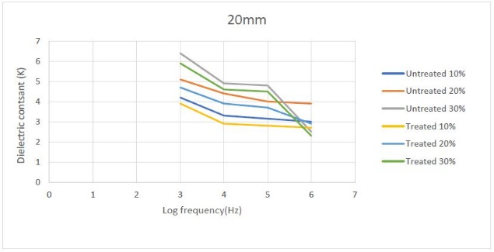

Figure 10: Dielectric constant (K) vs Log Frequency (Hz) for 20mm

The graph above shows, the change the dielectric constant (K) and the log frequency (Hz) of the 20mm used , so when the Treated 10% ,20mm is used for the frequency 3-4 Hz the value of dielectric constant decreases from 3.9-2.9 and for the frequency 4-5Hz the is a decrease in the dielectric constant from 2.9 to 2.8, for the frequency 5-6 Hz the is a considerable decrease in the dielectric constant from 2.8 to 2.7. When the Untreated 10%, 20mm is used for the frequency 3-4hz the value of dielectric constant decreases from 4.2-3.3 and for the frequency 4-5Hz the decrease in the dielectric constant from 3.3 to 3.15 and for the frequency 5-6 Hz the is a considerable decrease in the dielectric constant from 3.15 to 3. For treated 20% , for the frequency 3-4 Hz the dielectric constant decreases from 4.7 to 3.9 for frequency 4-5 Hz the dielectric constant varies from 3.9 to 3.7 and for frequency 5-6 Hz the dielectric constant decreases from 3.7 to 2.9. For Untreated 20%, for the frequency 3-4 Hz the dielectric constant decreases from 5.1 to 4.4 for frequency 4-5 Hz the dielectric constant varies from 4.4 to 4 and for frequency 5-6 Hz the dielectric constant decreases from 4 to 3.9. For treated 30% , for the frequency 3-4 Hz the dielectric constant decreases from 5.9 to 4.6 for frequency 4-5 Hz the dielectric constant varies from 4.6 to 4.5 and for frequency 5-6 Hz the dielectric constant steeply decreases from 4.5 to 2.3. For Untreated 30%, for the frequency 3-4 Hz the dielectric constant decreases from 6.4 to 4.9 for frequency 4-5 Hz the dielectric constant varies from 4.9 to 4.8 and for frequency 5-6 Hz the dielectric constant steeply decreases from 4.8 to 2.5.

**4. Conclusions**

From the experimental study we can conclude that, plastic itself is dense for making electrical insulators so, the Sisal Fibre which is exceptionally durable with a low maintenance and minimal wear and tear, can be reinforced with the plastic to increase the density and increase the comparative strength of the material being used. It was also seen that dielectric constant values decreased with an increase in the frequency for all the hybrid composites. The maximum values of dielectric constant in the lower frequency region were attributed to the interfacial polarization. The dielectric constant, dissipation factor and loss factor increased with increasing fiber content because of an increase in the number of polar groups, which led to high orientation polarization. The increase in dielectric constant, dissipation factor and loss factor were more apparent with a fiber content of 30wt%. This fiber can also have its extended use in mechanical fields.

**5.Reference**

* 1. C. Y. Lai et al, Mechanical and Electrical Properties of Coconut Coir Fiber-Reinforced Polypropylene Composites, Polymer-Plastics Technology and Engineering, 44: 619–632, 2005.
  2. M. Sakthivel et al, Production and characterization of luffa/coir reinforced polypropylene composite, Procedia Material Science 5(2014) 739 – 745.
  3. Elammaran Jayamani et al, Comparative Study of Dielectric Properties of Hybrid Natural Fiber Composites, Procedia Engineering 97 (2014) 536 – 544.
  4. Chhatrapati Parida et al, Dielectric Response of Luffa Fiber - Reinforced Resorcinol Formaldehyde Composites, American Journal of Materials Science 2015, 5(1): 1-8.
  5. Mohamed Hamdy Gheith et al, Flexural, thermal and dynamic mechanical properties of date palm fibre reinforced epoxy composites, J Mater Res Technology, 2019;8(1):853-860.
  6. K. Murali Mohan Rao et al, Fabrication and testing of natural fibre composite: Vakka, sisal, bamboo and banana, Materials and Design 31 (2010) 508-513.
  7. M. K. Gupta et al, Tensile and flexural properties of fibre reinforced epoxy composite: A comparison between unidirectional and mat form of fibre, Procedia /material Science 5 (2014) 2434-2439.
  8. Nehal Uppal et al, Synthesis and characterization of short sisal ﬁbre polyester composites, Bull. Mater. Sci. (2019) 42:132.
  9. Navin Chand et al, Effect of sisal fibre orientation on electrical properties of sisal fibre reinforced epeoxy composites, composites: Part A 36 (2005) 594-602.
  10. Govardahan Goud et al, Mechanical and electrical performance of Roystonea regia/glass fibre reinforced epoxy hybrid composites, Bull. Mater. Sci., Vol. 35, No. 4, August 2012, pp. 595-599.
  11. A Triki et al, Correlation between mechanical and dielectric properties of Alfa / Wool / Polymeric hybrid fibres reinforced polyester composites, Materials Science and Engineering 48 (2013) 012008.
  12. P.V. Joseph, the thermal and crystallisation studies of short sisal ﬁbre reinforced polypropylene composites, Composites: Part A 34 (2003) 253–266.

**Author Profile**

* + - 1. **Shreyas Shetty,** Student, Dept. of Mechanical Engineering, Shri Madhwa Vadiraja Institute of Technology and Management, Bantakal



* + - 1. **Srajan K Kotian,** Student, Dept. of Mechanical Engineering, Shri Madhwa Vadiraja Institute of Technology and Management, Bantakal



* + - 1. **Vishal Kundar,** Student, Dept. of Mechanical Engineering, Shri Madhwa Vadiraja Institute of Technology and Management, Bantakal
      2. **Sukesha,** Student, Dept. of Mechanical Engineering, Shri Madhwa Vadiraja Institute of Technology and Management, Bantakal



* + - 1. **Ganesh Kalagi,** Assistant Professor, Dept. of Mechanical Engineering, Shri Madhwa Vadiraja Institute of Technology and Management, Bantakal



* + - 1. **Narayan Nayak,** Assistant Professor, Dept. of Mechanical Engineering, Shri Madhwa Vadiraja Institute of Technology and Management, Bantakal