DIP TECHNIQUES TO DETECT SKIN CANCER

Ali Naveed1 Akhilesh Shastry1 Gauriprasad Kamath1 Keerthan Acharya1 Venugopala Rao A.S*

Shri Madhwa Vadiraja Institute of Technology and Management

**Abstract**

In recent times, skin cancer has become one of the most dangerous forms of cancer found in humankind. Skin cancer can be found in a variety” of forms, such as melanoma” and” squamous cell carcinoma, of which melanoma is the most” unpredictable. Early detection of melanoma cancer can help with treatment. Computer vision plays an important role in medical image diagnosis and has been demonstrated by many existing systems. In this paper, we offer software using image processing techniques for detecting melanoma skin cancer using image processing tools. The input to the system is an image of the skin and then analyzed to make conclusions about the existence of” skin cancer, using novel image processing techniques. For image segmentation and facilitation steps, check the Lesion Image Analysis tool for various melanoma parameters such as disparity, border, color, diameter, (ABCD), PCA, etc. by texture, shape, and size analysis. Based on the extracted features the image is classified as normal skin and melanoma cancer lesion.

**INTRODUCTION**

**Skin Cancer:**

Skin cancer is a life-threatening disease. The skin consists of three (3) basic layers. Skin cancer begins in the outer layer, made up of the first layer of squamous cells, the second layer of basal cells, and the inner or third layer of melanocyte cells. Squamous cells and basal cells are sometimes called non-melanoma cancer. Non-melanoma skin cancer is always responsible for the treatment and rarely spreads to other skin tissues. Melanoma is more dangerous than other types of skin cancers [1]. According to the National Cancer Institute, approximately 87,110 new melanomas will be diagnosed in 2017 and approximately 9,730 people will die from melanoma. Melanomas are 20 times more common in whites than African Americans. Overall,” the life expectancy of melanoma was approximate”2.6% (1 in 38) for whites, 0.1% (1 in 1,000) for” blacks, and 0.58% (1 out of 172) for Hispanics. The” risk” of melanoma increases with age. When diagnosed, the average” age of people is 63. However, melanoma is not common among people under the age of 30. In fact, it is one of the most common cancers among young people (especially young women). If it is not detected at an early stage, it can quickly invade the surrounding tissue and spread to other parts of the body. Biopsy” is the official diagnosis of skin cancer. A biopsy is a procedure to collect tissue or tissue samples from a patient's body so that it can be analyzed in the laboratory. This is an uncomfortable method. The biopsy method takes a lot of time for the patient and the doctor because it takes a lot of time for testing. A biopsy is performed to remove the skin tissue (skin cells) and the sample undergoes a series of laboratory tests. The disease spreads to other parts of the body.

**Concepts Of DIP:**Image processing techniques are used for raw images obtained from cameras or” 1satellites, space” probes, and sensors mounted on planes or taken in normal life for various applications. Various methods of image processing have been developed over the last five decades. Several techniques have been developed to improve the images obtained from the unmanned spacecraft, space exploration, and” military observation aircraft. Image processing systems have become popular due to the easy availability” of powerful personal computers, large-sized memory devices, and graphics software. Image processing is used in a wide variety of applications, including remote sensing, medical imaging, textile, materials science, military, film industry, document” processing, and graphic arts. The simplest steps” in image processing are” image scanning, storage, enhancement” and interpretation.

A block diagram of digital image processing techniques is shown in Figure 1.

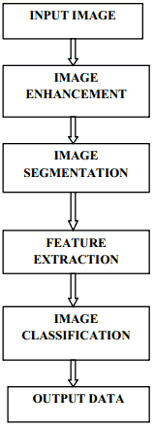

Figure 1:Digital Image Processing Techniques

Image Processing is given two methods as follows:

**Analog Image Processing:**

Analog image” processing refers to the transformation of an image through electricity, such as a television image. The television” signal is the voltage level that changes in amplitude to indicate brightness through the” image. By separating the signal electrically,” the displayed” image can be changed. Brightness and contrast” controls on TV sets work to adjust the amplitude and context of the video signal, resulting in a change in the brightness, darkness, and brightness of the displayed image.

**DIP(“Digital Image Processing”):**

Here, the digital computer is used to” process the image. The image is converted to a digital” form and then processed using the digital conversion method. It is defined as the numerical representation of objects in a series of operations to achieve the desired result. It starts with the image and produces the same edited version. So, this is the process of dragging one image into another. Digital image processing refers to the processing of a” two-dimensional picture by a digital computer. In the wider context, it refers to the digital processing of any two-dimensional data. A digital image is a series of real numbers” represented by a limited number of bits. The main goal of digital image processing techniques is to preserve its versatility, duplication, and true data accuracy.

The classification of image processing methods is given below

1. Image” representation.

2. Image” preprocessing.

3. Image” enhancement.

4. Image” analysis.

5. Image” compression.

**1.Image Representation:**

The image is defined” as in the "real world" is considered to be a function of two real variables, such example, f(x,y) with f as the amplitude of the image at the” real coordinate position (x,y). An” image processing operation” typically defines a new image in terms of an existing” image. The effect of digitization is given” in the following figure**.**

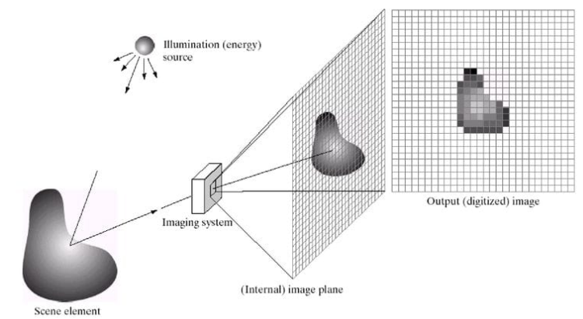

Figure 2:Digital Image Representation

**Image Preprocessing:**

Preprocessing suggests that different images of the same tissue type can have different levels of signal intensity. Preprocessing tasks usually involve the operations required before big data analysis and data extraction and are generally classified as radiometric or geometric corrections. Radiometric corrections include sensor manipulation and data manipulation to detect unwanted sensors or atmospheric noise, non-brain tones, and switching between two images to detect accurately reflected or emitted radiation. To refer to itself, there is some noise in pre-processed images that must be removed for further processing of the image. Image noise is more common in image areas with lower noise levels, such as shadow areas or undoing actions. There are many types of sounds, such as salt and pepper sounds, film grains. All of these sounds are eliminated using the algorithm. In many filters, medium filters are used.

**Image enhancement:**

Image enhancement techniques can be categorized into two main types:

1. Direct spatial domain methods pixels.

2. Methods of frequency domains that work on the Fourier transform of the image.

**1.Special Domain Type:**

The pixel value with the coordinates (x, y) of the enlarged image is the result of some operation on the pixel in the vicinity of the (x, y) of the F 'input image. F. The surroundings are of any size, but in general, they are rectangular. There are two approaches to the spatial domain.

**1.1. Grayscale manipulation**

Operator T is one of the easiest forms of operation. when operating only in the vicinity of the 1x1 pixel of the input image, i.e. F’(x, y) which is called grayscale transformation or mapping. The simplest form of the case is the threshold, where the intensity profile is changed by a phase function, activated at the selected threshold value. In this case, any pixel with a gray level above the threshold of the input image is mapped to 0. Other pixels are mapped to 255 in the output image.

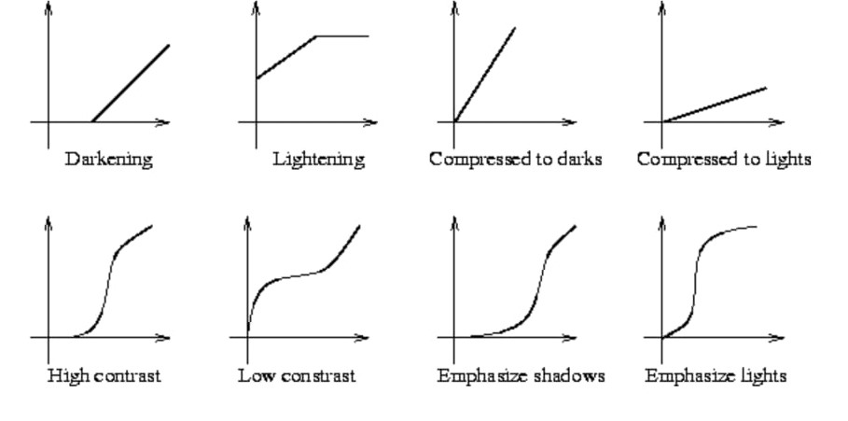

Figure 3:Gray Scale Transformations

**1.2 Histogram Equalization**

Histogram equations are common techniques to increase the appearance of images. Suppose we have a dark image. Its histogram is then pushed to the lower end of the greyscale, and all image details are compressed to the dark end of the histogram. If we can raise the gray level at the dark end to produce an evenly distributed histogram, the image will be clear. .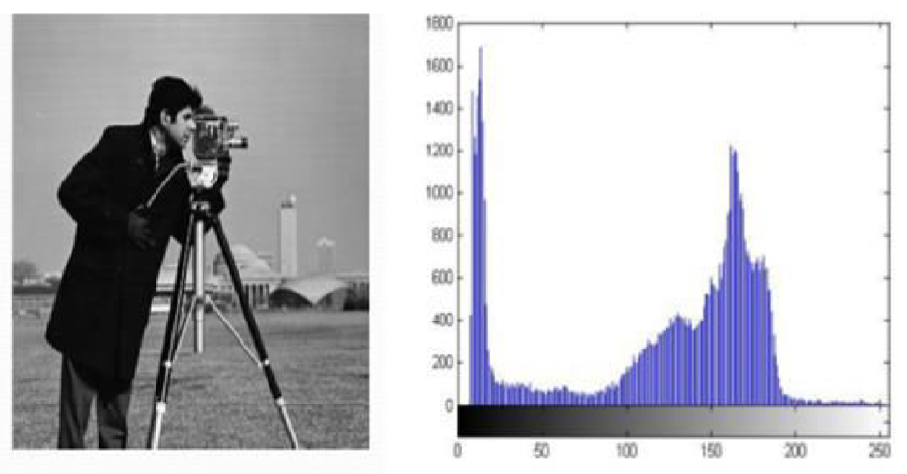

Figure 4: The image of a man and its histogram, the equalized versions. Both the images are quantized to 64 grey levels.

**2.Frequency domain methods**

Image enhancement in the case of the frequency domain is easy and simple. Fourier transform of the image is increased, the result is multiplied by a filter, and perform an inverse conversion to create a better image. The idea of ​​sharpening the image by reducing or increasing the size of high-frequency components is intuitively easy to understand. However, computationally, these operations are very efficient because they are determined by small spatial filters in the domain. It is important to understand the concepts of frequency domain and focus on the spatial domain can lead to unpredictable correction methods.

**2.1 Image Filtering**

Low pass filtering involves removing high-frequency parts of the image. This will blur the picture. The ideal low-pass filter handles all low-frequency frequency components and eliminates all high-frequency frequency components. But, ideal filters can have two problems: staining and ringing. These problems are usually caused by the relative spatial domain filter size, which has a” large number of denials. Frequency domain-like filters, such as smoother transformation, yield better results

Butterworth filter, Gaussian filter, Median filter, etc.

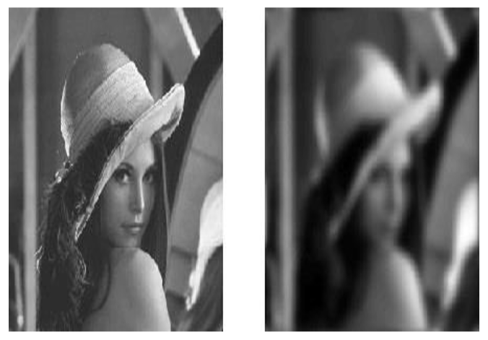

Figure 5: Transfer function from the original

image to a blurring image.

**Image Analysis**

Image analysis methods take out information from various images by using semi-automatic or automatic techniques known as scene analysis, image description, image interpretation, pattern recognition, automated or semi-automatic techniques. Image analysis changes from other types of image processing” techniques, such as enhancement or restoration, in which the result of the image analysis technique is numerical output” rather than an image.

**Image Compression**

The purpose of” image compression is to reduce the size of digital images to save storage space and transmission time. Lossless compression is preferred over high-value materials such as technical images, symbols, and high-value materials such as medical scans or image scans created for archival purposes. Lacy techniques are particularly suitable for natural images, such as photographs, where a slight loss of fidelity is” acceptable to achieve a significant reduction in rate. Lossy compression, which makes an imperfect difference, is called blind lossless. Run-length encoding, Huffman encoding, and Lempel Jive encoding techniques for harmless image compression. Transform coding such as DCT, wavelet transformation is implemented after quantization, and loss coding can be described as a method for harmless image compression. A typical compression pattern is shown in the figure.

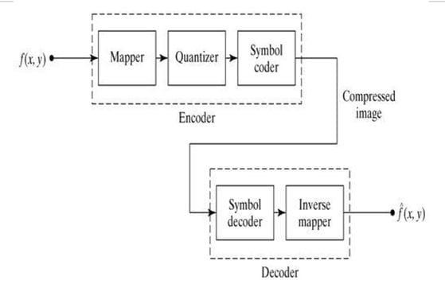

Figure 6: General Compression Model

**Techniques involved in Digital Image Processing**

**Preprocessing Techniques for Hair Removal**

**1.Dull Razor(hair removal):**

Dull” razor software is used to digitally remove hair from dermoscopic images. The purpose of a lethargic razor is to remove” dark thick hair. As such, it does not remove” thin or light hair. Dull razor has three stages: identifying hair pixels, replacing such pixels with non-hair pixels (interpolation), and smoothing the result. In that scheme, hair-like structures are” identified using their” gray levels and checked to see if their length and width are close to the hair. Bilinear interpolation replaces child-like identity structures” with non-child like pixels. The resulting image is sensitive to increase the change in the locations of the transformed space.

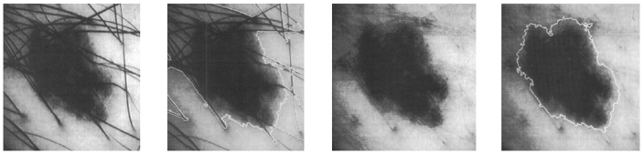

Figure 7: Hair removal and segmentation using

DullRazor

**(a) image before hair removal.**

**(b) segmentation before hair removal.**

**(c) image after hair removal.**

**(d) segmentation after hair removal.**

**2. E-Shaver(Hair Removal):**

It” covers the difference of the skin and the gray levels of the hair for identifying the hair in a picture. If gray level hair is different from the skin or injury, the e-shaver can find darker and lighter colored hair.

Like Dull razor, e-shaver also has three steps: identifying hair pixels, identifying and smoothing hair pixels with non-hair pixels. However, the procedures used to identify hair picks and replace them with non-hair pixels differ from those used in the dull razor.

**2.1. Detection of hair pixels**

For” hair picks detection, edge detection methods can be used to” identify thin structures. By doing this, the performance of the four simple edge detectors is the Laplacian Previte Filter, the Sobel Filter, the Laplacian” Operator, and the Gaussian” Operator. The test to select one of the top edge detectors” is to obtain the max” signal-to-noise ratio as the number of correctly identified hair pixels for the number of wrongly identified non-hair pixels. Defined. Non-zero pixels, hair” pixels, and non-hair pixels noise in the output of the filter. The resulting ratio”is used to compare the performance of the” ratio detectors.

**2.2. Replacement of hair pixels with non-hair pixels**

The boundary selected might not be correct for all the images, and it is impossible to find the exact location of the hair border because of the noise and shadow effect on the image. To” overcome this problem we consider an area for pixels space. The trial and error method is used to define a neighborhood of 5 pixels for all the boundary pixels” across all orientations. For interpolation, a copy of the primary image is made, in which” the child's pixels are replaced” with the average gray level values” of the image's background. Then, many averages are performed in the 3x3 window on the secondary image. The” recurrence” average” is the same as the neighborhood expansion. After averaging 3, the obtained mask is multiplied to the resulting image, which limits the size of the” neighbors. By repeating the process, the gray level of the child's pixels reaches the gray level” of the neighboring pixels. Then, the hair pixels are added” to the main image by taking the pixels from the image.

**2.3. Smoothing**

The average is done to remove the remaining background of the hair that is removed on the image. Sensitivity is not required and can leave no damage to the background and image quality. Used to get a good image to reduce the fringe effects caused by the hair removal process.

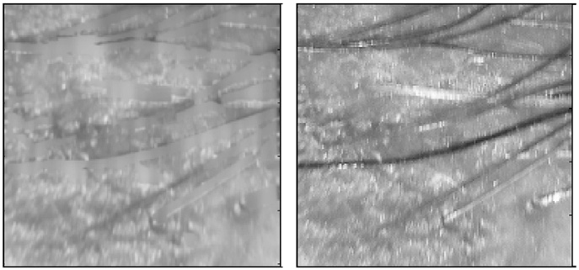

Figure 8: Image to the left is obtained after implementing E-Shaver to the image on the right

**Other Preprocessing Techniques :**

Gray Scale Conversion: Filtering techniques used for noise removal methods such as power spectra and blur filter area units. It is straightforward to check that there are 2 different elements in the Wiener filter, the AN transverse filter half and the noise-sensitive half. Although it eliminates noise with compression operation (low pass filtering), it does not completely de-convolve through inverse filtering (high pass filtering).

Image resizing: Image resizing is a very important role in image format technology, in order to expand and reduce the size of a given image. Image interpolation can be divided into 2 other ways, namely image sampling and upscaling, which is important to resize the information once a particular communication or output is matched. Although broadcasting low-resolution versions is more economical for the user, the first high-resolution estimation is also required to display the final visual information. It is imperative to accurately resize AN information in many applications, starting with many shoppers' products for critical tasks between the medical, safety, and defense sectors. The nearest neighbor iteration technique was applied in this section to the concert of the elements of the image sizing technique. Immediate neighborhood implementation

The technique makes the final method for processing pictures at any time. Generating speed generally Would like to compare methods of error calculation. 2 Additional methods usually use field unit bi-linear and bi-cubic interpolation.

Noise Removal: Image noise is underlined due to the random variation of brightness or color data in photographs made by medical devices or scanners. Image noise during image acquisition is generally considered undesirable by the product. The noise is usually underlined because the uncertainty during the signal is caused by random fluctuations. There are several reasons for these fluctuations in the field unit. All medical pictures have some visual noise. The presence of noise provides a picture of Spotted, granular, textured, or icy forms. There are many types of sounds and the most common noise seen in medical pictures is described below.

Salt and Pepper: Salt and Pepper Image Conversion Technique Field unit is commonly used as a field of image noise removal technique. It represents itself in every way that it has white and black pixels. Salt and pepper sounds come into the picture where there is a rapid infection, and defective switches are turned off. This is called "sudden noise" or "spike noise".

Gaussian: The mathematical noise joint that connects the probability density operator (pdf) of the classical distribution is referred to as the joint distribution. In Gaussian noise, each part of the image is modified by (usually) tactile from its original value.

Shot or Poison: Small noise, otherwise known as Poison noise, is the main noise in the lighter elements of the image. The picture sensing element usually causes the applied mathematical quantum fluctuations to vary in the range of gauge gauges at a given exposure level; This noise means photon shot noise.

Spectacle: Spectacle noise is a granular noise that is inherent and decaying in the standard of active measurement systems. Radio Detection and Radiolocation Measuring Device Measuring system. and an artificial aperture radar diagram. This type of noise is sometimes seen in unheard-of medical devices.

**Image Enhancement**

**Some filtering methods:**

Wiener: Wiener filtering makes the best degree of associate degree between inverse filtering and noise sensitivity. It eliminates additive noise and stain at the same time. Wiener filtering is perfect in terms of mean squares. Error. In other words, it reduces the mean square. Error in inverse filtering and noise-sensitive method. Wiener filtering is a linear approximation of the first image. The procedure is dedicated to a random framework. The principle of orthogonality means that the Wiener filter in the Fourier domain is expressed as follows:



Medium: The median filter operates in a rectangular field. This will change the size of the images during filter operation based on certain conditions as given below. Each output pixel has an average value of 3-by-3 surroundings around the corresponding pixel in the input images. However, zeros overlap the edges of the images. The output of the filter is a single value, which converts the current pixel value (x, y) to the position where S is concentrated at that time. The following notation is used.

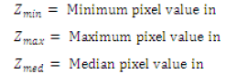



An intermediate filter is used to smooth the edges and preserve the images without blurring the sound reflected by the two-dimensional signals. This is particularly suitable for augmenting MRI images. The average filter performs spatial processing to determine which pixels in the image are affected by the impulse noise. The average filter classifies the noise by comparing pixels with each pixel of its neighboring pixels image. Adjust the scope of the comparison along with the size of the surroundings. By not being associated with a structurally similar pixel, the pixel is separated from its neighbors, labeled as impulses. These noise pixels are replaced by the pixel value of neighboring pixels that have passed the noise labeling test.

Gaussian: Gaussian filtering plays a very important role in both theory and application. Gaussian filtering is the most commonly used image filtering technique, where weights are defined as WAP



Gaussian smoothing local filter method. As the image reflected by the algorithm, the Gaussian filter is well known on smooth images, resulting in significant loss of detail, especially sharpness. Gaussian smoothing is a Gaussian smoothing local filter method. As the image reflected by the algorithm, the Gaussian filter is well known on smooth images, resulting in significant loss of detail, especially sharpness. Gaussian has a smooth low-pass filter, which suppresses high-frequency frequency information, including noise and edges while preserving low-frequency frequency components of the image, which do not vary much. In other words, the filter obscures everything that is smaller than the image's characteristic.

Contrast improvement

Contrast means the difference between the maximum and minimum pixel intensity. The principle of drawing a histogram of an image is to increase the contrast



The minimum and maximum pixel intensity per formula must be multiplied by the grayscale. In our case the image is 8bpp, so the gray level is 256. The minimum value is 0 and the maximum value is 225.

**IMAGE SEGMENTATION**

Image segmentation is the initial or front end processing of image compression. The efficiency of the partitioning process is its speed, good size matching, and good size connectivity with its partitioning result. Segmentation refers to the process of identifying and separating the surface and areas of digital units that correspond to structural units. The partition also depends on the various features of the image. It could be color or texture.

**2.SEGMENTATION ALGORITHMS**

Segmentation algorithms have been developed for segment images; They are based on two basic characteristics: incompatibility and similarity. Dissatisfaction-based segmentation and subdivision are performed based on a sudden change in the intensity level or gray level of the image. In similarity-based groups the pixels which are similar in some sense, it includes approaches like thresholding, region growing, and region splitting and merging.

**3.CLASSIFICATION OF SEGMENTATION TECHNIQUES**

Segmentation can be classified into the following categories.

1. Segmentation by Edge Detection
2. Segmentation by Thresholding
3. Segmentation by Region-based
4. Segmentation by Feature-based Clustering

**3.1 Segmentation by Edge Detection**

In the process of image segmentation, the primary step is to locate the edge. It divides an image into an object and its background. Edge detection divides the image by looking at the intensity of the image or changes in pixels. Gray histograms and gradients are two main methods for detecting an edge in image segmentation. Edge detection operators are divided into two categories, first-order derivative operators and second-order derivatives operators. Second-order operators produce reliable results. Connie Edge Detector is the second derivative operator.

**Canny edge detector**

Initially, an image was taken and it is sectioned using Connie Edge Detection Technology. For this, the first image is converted from RGB to gray. The first step is to filter out any noise in the original image and try to identify any edge. Gaussian filters are used in the CANI algorithm. It can be calculated using a simple mask.

After smoothing the image and eliminating the noise, the next step is to take the gradient of the image and find the edge strength. Then, the absolute gradient estimated at each point is found by plotting the gradients in the x-direction column and the y-directional gradients in the other direction. After finding the edge strength, the direction of the edge using the gradient of x. And y references. Non-maximal suppression is used to determine the edge in the direction of the edge and when any pixel value is pressed it is set equal to 0, which is not considered the edge. This gives a thin line on the output image.

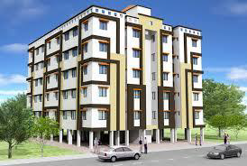

Figure 9: Original image

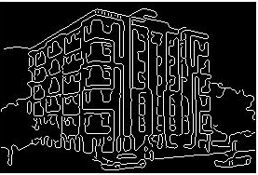

Figure 10: Segmentation using edge detection

**3.2 Segmentation by Thresholding**

One of the simplest methods in a segment is based on the image intensity level and is called Threshold Based. Thresholding can be applied globally or locally. Global Throttling separates object and background pixels using threshold values ​​and binary splits to segment the image. Local Thresholding is also known as Adaptive Thresholding. The threshold value in this method depends on the image based on the local characteristic of the subdivided regions in the image. Histogram thresholds are used to divide a given image; There are some preprocessing and post-processing methods required for threshold segmentation. The main threshold methods proposed by various researchers are the mean method, the p -tail method, the histogram dependent technique, the edge maximization technique, and the visualization technique.

**Segmenting Using Adaptive Thresholding**

The original image is broken by Adaptive Thresholding. For this, the first image is changed from RGB to Gray. Local custom partitioning in this is based on the maximum and minimum method and is used to set the threshold value. The size of the rows and columns of this image can be found. The threshold value is determined by obtaining the maximum pixel size of the image and the minimum pixel size of the image.

This result is the initial threshold value. This threshold value is then divided by the basic thresholding technique using the image, as the pixels in the threshold follow one section and the other follows the other. This process is repeated until the boundary value does not match the pixel value. The threshold values ​​for each section are also repeatedly obtained. An image is segmented using the adaptive threshold technique.

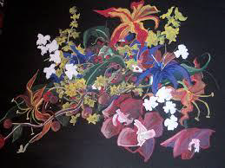

Figure 11: Original image

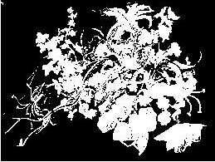

Figure 12: Segmentation using Thresholding

**3.3 Segmentation by Region-based**

In this method, pixels of the same object are grouped for partitioning. The threshold technique is associated with region-based segmentation. The area where the partition is to be found must be closed. Area-based segmentation is also known as equity-based segmentation. There is no difference in the absence of edge pixels in sections based on this region, the boundaries for the partition are marked. After detecting changes in color and texture, the torrent flow is transformed into a vector. From this, the edges can be found for further separation.

**Single Seeded Region Growing**

The given input image is broken using the single-seeded region incremental method. This method can be obtained using a single seed. A single seed or pixel is taken, and all the pixels associated with this seed form the area using the same seed. The input image is read using the image reading function. The position of the seed point is given, if it is not given, it is selected at random. In this, the maximum intensity distance implemented is 0.2 by default. The region is redefined by comparing all the unrelated neighboring pixels of the region. The difference between the intensity value of the pixel and the mean of the area is used as a measure of similarity.

The region is redefined by comparing all the unrelated neighboring pixels of the region. The difference between the pixel intensity and the area average is used as a measure of similarity. The pixel with the smallest difference measured is assigned to the corresponding area.



Figure 13: Original image

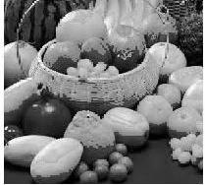

Figure 14: Segmentation Using Region Growing

This process stops when the intensity difference between the regional average and the new pixel is larger than a certain threshold (t). Finally, the output image is given by combining the two regions. The fragmented image is formed using a single seed region.

**3.4 Segmentation by Feature-Based Clustering**

**Based Clustering**

Clustering is the process of organizing groups based on their characteristics. A cluster usually consists of a group of identical pixels in the same region and differs from other regions. Synonyms such as cluster analysis, automatic classification, numerical classification, botrology have been converted to data clustering and double values. Using this, row and column values ​​are obtained. Then the number of groups that can be formed is given to five. Resizing and displaying. The index creates five primary arrays to store cluster values and tiles for three different colors. The primary sequence consists of groups. Finally, different groups are displayed.

S**egmenting By K Means Clustering**

The fourth partitioning technique used in this work is k means clustering algorithm. In this method, first, the image is read and displayed using the image reading function. The color is modified to create a test image from the original image. Again image values ​​are typological analysis. Images can be grouped based on their content. Clustering techniques are generally divided into hierarchical algorithms and partial algorithms. In content-based clustering, pixels are grouped based on heritage properties such as size, texture, and so on. Various clustering techniques are used. The K-means algorithm and the fuzzy C-means algorithm are the most used.

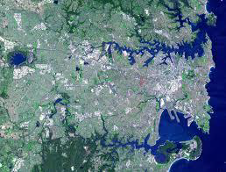

Figure 15: Original image

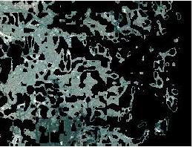

Figure 16: Segmentation Using Clustering

**Image Feature Extraction**

The huge amount of data generated has grown multiple times with millions or trillions of data sets generated every day with internet and social media. Feature extraction is a critical task that involves a huge amount of data as input and transforming it into an optimal feature set. Feature extraction starts from an initial set of measured data and builds derived values(features) intended to be informative and non-redundant, facilitating the subsequent learning and generalization steps, and in some cases leading to better human interpretations.

Feature Extraction basically uses texture, color, and shape feature extraction methods.

**2.1 Texture Feature Extraction**

Human visual systems use texture for Image recognition and interpretation. Textures are complex visual patterns composed of entities or sub-patterns that have characteristic brightness, color, slope, size, etc. Texture can be regarded as a similarity grouping in an image.

**2.2 Spatial and Spectral Features :**

Depending on the domain from which the texture feature is extracted, textures are classified into spatial texture feature extraction methods and spectral texture feature extraction methods. Spatial texture features are extracted by computing the pixel statistics or finding the local pixel structures in the original image domain, whereas spectral transforms an image into the frequency domain and then calculates features from the transformed image.

**2.3 Texture Analysis**

Texture analysis is the characterization of regions of an image by their texture content. Texture analysis attempts to quantify intuitive qualities described by terms such as rough, smooth, silky, or bumpy as a function of the spatial variation in pixel intensities. For example, smooth texture areas, the range of values in the neighborhood around a pixel will be a small value; in areas around rough texture, the range will be larger. The standard deviation of pixels in a neighborhood gives the degree of variability of pixel values in that region. Texture analysis is used in remote sensing, automated inspection, medical image processing, etc. Texture analysis is used to find the texture boundaries, called texture segmentation

Approaches to texture analysis are usually categorized as

* Structural,
* Statistical,
* Model-based and
* Transform

**Approaches for Feature Extraction**

## **Geometry Based Approach**

Geometry-based approaches extracted features using geometric information such as relative Positions and sizes of the face components. In geometric based approach Local Features and their geometric relationships are analyzed. Nevertheless, these techniques require threshold, which given the prevailing sensitivity, may adversely affect the achieved performance. In this approach comparison of the input images with the set of the template is done and the set of the template is constructed using statistical tools like PCA, LDA, and ICA.

The main features of the Melanoma skin Lesion are its Geometric Feature. Hence, we propose to extract the Geometric Features of segmented skin lesions. Here, we used some standard geometry features (Area, Perimeter, Greatest Diameter, Circularity Index, Irregularity Index).

From the Segmented image containing only skin lesions, the image blob of the skin lesion is analyzed to extract its geometrical features.

The Different Features extracted are as follows:

Area (A): Number of pixels of the lesion.

Perimeter (P): Number of edge pixels.

Major Axis Length or Greatest Diameter (GD): The length of the line passing through lesion centroid and

connecting the two farthest boundary points.



where n is the number of pixels inside the lesion, and (xi, yi) is the coordinates of the ith lesion pixel.

Minor Axis Length or Shortest Diameter (SD): The length of the line passing through lesion blob centroid and connecting the two nearest boundary points.

Circularity Index (CRC): It gives the shape uniformity.



Irregularity Index C (IrC):



Irregularity Index D (IrD):



1. **Colour Segmentation Based Approach**

Mostly all the images contain background color which can be considered as noise.. After getting the image from the skin color the binarization of the image is taken, and the gray-scale image is obtained. After grayscale conversion, it is necessary to apply the suitable threshold to eliminate the hue and saturation. This approach is limited because of the background noise.

1. **Appearance Based Approach**

The appearance-based approach represents the ace in terms of several raw intensity images. When we apply the feature extraction method it is necessary to keep the important features as it is when recognizing the face. Example of this approach is PCA, LDA, or ICA. The main advantage of this approach is it keeps the important features as it is and removes the redundant features.

1. **Template Based Approach**

In this approach compare the set of images with the template and the set of templates are constructed using statistical tools like PCA, LDA, and ICA.

**Feature Extraction Methods**

## **PCA based method**

Principal component analysis (PCA) is a mathematical procedure that is used to convert a set of observations of possibly correlated variables into a set of values of uncorrelated variables called principal components and it is referred to as a linear method. The main idea of PCA (Karhunen-Loeve expansion) is to find vectors that best account for the variation of the images in the entire image space. Generally, PCA is used to reduce the dimension of a fused image. This method is mainly used as dimension reduction which finds vectors and a group of Eigenfaces is extracted from the original image. These vectors are called Eigen-vectors. Linear combinations obtained using Principal components are called Eigenface. Compute the covariance matrix M

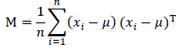

## **LDA based Method:**

LDA is an enhancement to PCA Constructs a discriminant subspace that minimizes the scatter between images of the same class and maximizes the scatter between different class images. The between-class scatter matrix Vb, within-class scatter matrix Vw and the projective matrix P are defined as follows:

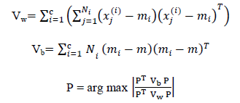

|  |  |
| --- | --- |
| |  | | --- | |  | |

Where mi and Ni are the mean face and sample number in an individual image class respectively, xj is the jth sample in the ith class. For recognition, the linear distance function is computed as: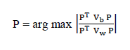

While taking class discriminatory information at that time perform dimensionality reduction. When classes are separated seek to find direction. Due to variation in illumination and expression, LDA is more capable of distinguishing image variation.

## **Independent component analysis**

ICA aims to find independent, rather than uncorrelated image decomposition and representation. This method separates non-Gaussian distributed features. This method is the enhancement of PCA which leads to a discriminant analysis criterion.

## **Kernel PCA**

To increase the capability of PCA Scholkopf et al. have developed a nonlinear PCA called kernel PCA. In this method first nonlinear mapping is applied to the input and then for the resulting feature subspace, it solves a linear PCA.

## **Gabor wavelet**

This method is biologically motivated and used as a linear filter which uses Gaussian kernel function modulated by a sinusoidal plane wave and the kernel function is denoted by:

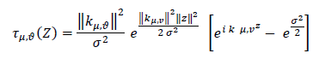

Where Z = (*x, y*) is the point with horizontal and vertical coordinates x and y, u and v are orientation and scale of Gabor kernel respectively, sigma is the standard deviation of Gaussian, k is wave vector, and || || is the norm operator.

## **Local Binary Pattern**

This is the most powerful method which describes the image as a texture and it is mainly divided into three different features which are: pixel level, region level, and global level. This method assigns the label to each pixel by the 3*3 neighborhood of each pixel and assigns the one pixel as a center pixel with the threshold and that label of the histogram is used as texture. LBP is most widely used because of its unique feature and less computation time.



Where xc represents the gray value of central pixel and xp represents the grey value.

1. **ABCD method**

This section presents and discusses in detail the methods used to extract the four features asymmetry (A), border irregularity (B), color (C), and diameter (D) from the segmented lesion. According to the characteristics of the ABCD rule, each extracted feature plays a distinctive role with its associative weight to calculate the total dermoscopy score (TDS).

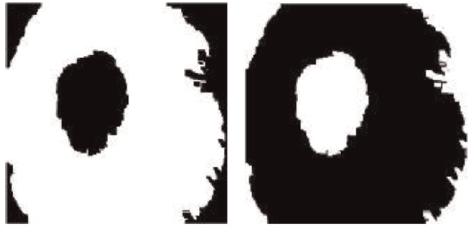

Figure 4:Afterr implementing otsu’s method and its complement

**1 Asymmetry**

To calculate asymmetry, firstly, the skin lesion is converted into grayscale values. Secondly, it is rotated vertically and horizontally partitioned into two equal halves. Finally, two methods called Entropy and Bi-fold are implemented, and their calculated average value is assigned as an asymmetry score of the segmented lesion.

The entropy is a statistical measure of randomness that can be used to characterize the texture of the grayscale image as described by the following:



where p contains the histogram counts of intensity values.

The bi-fold method is the symmetry obtained by overlapping the two vertical (left vs. right) and horizontal (upper vs. lower) parts along the principal axes of the inertia. The non-overlapped is then compared with the total area of the lesion as follows:



where A is the non-overlapping area between the original and reflected masks and A is the area of the original mask.

**2 Border irregularity**

From the binarized ROI obtained after segmentation, the border irregularity index or compactness index is calculated as follows:

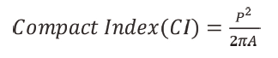

where P is the perimeter and A is the area of the lesion.

The border irregularity index (BIScore) is calculated as follows:



**3 Color feature**

The existence of white, black, red, light-brown, dark-brown, and blue-gray colors in the true colored lesion is needed to be examined. Assume that the images used present the lesion that is needed to be examined for the six candidate colors’ appearance. The color score is increased by 1 if the distance between the examined pixel’s value in the lesion and each color reference is below or equal to the precalculated threshold value.

Six RGB codes are chosen as reference points for each color used.

The distance of each pixel in the lesion and color reference is calculated by using the following Euclidean distance:



where k = 1, 2, …, 6 and (i, j) is the pixel’s position in the lesion.

**4 Diameter**

The number of pixels of the greatest diameter or major axis length of the segmented lesion is transferred into millimeter-scale as follows:

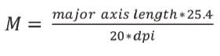

where dpi is the dots-per-inch which equals 96.

Finally, the calculated values of the four extracted features are multiplied by their weights to receive the total dermoscopic score (TDS). The TDS is calculated by the following equation:



**IMAGE CLASSIFICATION**

1. **Artificial Neural Network**

The model of the neural network is similar to the human” nervous system. Like humans learn information through experience and practice or by training, to build human-like actions in machines we use artificial intelligence,” and the neural network model uses the principle of artificial intelligence, which is why it is called an artificial neural network. The artificial neural network is guided by a data set. This dataset may be known to us when ANN is trained in a supervised manner and learns precisely and quickly about the pattern” in the dataset. And Trained ANN is used to identify the patterns it's being” trained for. But if we don't know the dataset beforehand then we use the unsupervised training. The neural network is made up of neurons which are correlated to convert inputs into” useful output.

The ANN has its application in many fields some are

mentioned here:

* Character Recognition
* Fault detection
* Speech detection
* Product detection

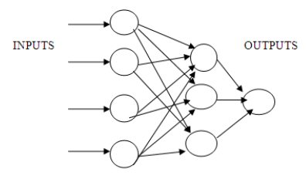

**2. Support Vector Machine**

Support vector machines are used for regression and classification in the field of supervised” learning. But it's popularly known for grouping. In this, each object or item is represented by a point in the n-dimensional space. The” importance of each attribute is indicated by a unique coordinate. Then the objects were divided into groups by finding the hyper-plane as shown in the figure.

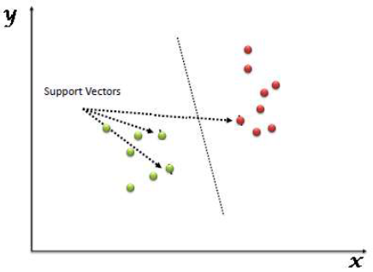

The diagram shows support for Vectors representing each item's coordinates. The SVM algorithm is an excellent choice for separating the two classes.

**3. Decision Tree**

Decision trees also use supervised learning algorithms and are used for classification purposes. Decision trees are valid in both situations which are continuous and categorical output and input variables. In the DT” algorithm, a major point of difference within input variables is used to classify the dataset samples into homogeneous sets.

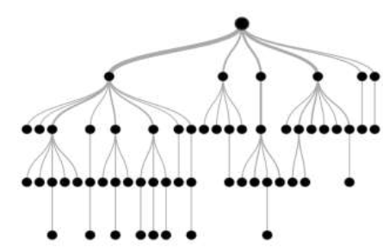

Decision trees are classified by variable according to their target.

The following are:

1. Continuous decision tree with variable

2. Categorical Variable Tree Decision

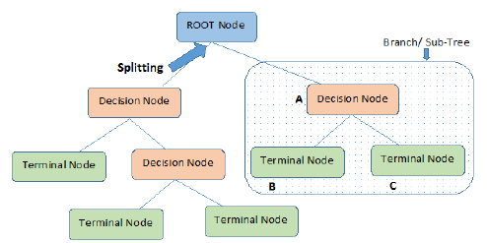

**4. K-NN**

K-NN is also a classifier for the category of supervised learning algorithms. We know the targets of supervised learning, but the path to the target is not understood.”Recognizing” the forms of machine learning nearest to the neighbor is the perfect example. Let us remember that there are many clusters of labeled samples.”Objects” of the same identified clusters or groups are of a homogeneous kind. Now if under one of the labeled groups an unlabeled item needs to be labeled. Now it's easy to classify K-nearest neighbors, and the best algorithm that has a record of all available” classes will perfectly classify the new item on the basis of the largest number of votes cast for k neighbors. KNN is one of the alternatives to” classify an unlabeled object into defined class in this way. Choosing the no. of nearest neighbors or, in “other words, calculating the k value plays” an important role in determining the designed model's efficiency. The precision and efficiency of the k-NN algorithm” essentially” assessed by the determined K value. Because of noisy data, a greater number for k value has an advantage in reducing the variance.

Advantage: The KNN is an unbiased algorithm and has no assumption of the data that is being considered. Its simplicity and ease of implementation plus efficiency make it very popular.

Disadvantage: The k-NN does not construct models because it does not include the” abstraction method. Prediction of the element takes a long time. It takes a lot of time to plan data and build a robust device.

## **5. Radial Basis Function**

The RBFN is a neural feed-forward network and a local network that is learned in a“supervised way. RBFN performs a linear combination as input-output nonlinear mapping. RBF separates the class distribution by locating the radial base function. The radial base feature of the network has one hidden layer. The distance between the input and weight of each hidden unit activation” function is the distance between the arguments. Most conveniently used RBF output function is a Gaussian function given as follows: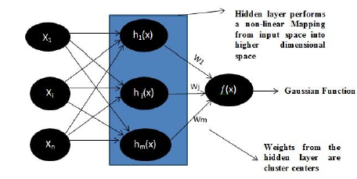

## **6)** **Multi-layer feed-forward**

Multilayer Feed-Forward network consists of multiple layers. They have used a Multi-layer feed-forward network which consists of multiple layers to increase the recognition performance rate. This architecture has an input” and output layer with one or more intermediary layers called hidden layers which are also known as Hidden Neurons. Before direction input to the hidden layer, intermediate computations are carried out at the hidden layer.

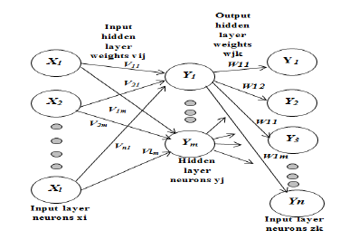

## **7) Self-Organizing Map (SOM) classifier**

Kohonen Self Organizing Map (KSOM) has the property of clustering data that retains the input vector topology, meaning that even data with minor changes is clustered in nearby areas. Because of this property, the facial expression data is better classified, because similar data are clustered with the small change.

## The algorithm is summarized as follows:

1. *Initialization*: Choose the random values for the initial weight vector **w**i (0), *i* = 1, 2… *l*. Where *l* total number of neurons and these neurons are in the lattice.

2. *Sampling=* Draw a sample **x** from the input space. Then vector **x** is presented to the lattice. The dimension of the vector **x** is similar to the *m*.

3. *Similarity matching*= find the best-matching unit (neurons) i(**x**) at time-step *n* by using minimum-distance criterion.

5.*Updating=* use the update formula to set the weight vector of all the excited neurons

6. *Continuation*= Repeat step 1 until no changes are seen in the feature map

## **8)** **Fisher’s linear discriminant analysis**

FLDA is an LDA-based approach for machine learning, statistics, and pattern recognition to find a linear” combination of functions that distinguishes two or more groups of objects. FLDA is used to reduce the functions to a” manageable number prior to classification. Linear combinations obtained with FLD are called Fisher faces because each of the new dimensions in linear pixel combinations



**Related Works:**

The study conducted by numerous researchers in this section is as follows:

**J Abdul Jaleel [2013]:**

Proposed skin detection based on Maximum Entropy Threshold. The various detection processes include gathering dermoscopic images, filtering images for hair and noise reduction, segmenting images using Maximum Entropy Threshold.

The computer-Aided detection system is a classification system that uses imaging methods and software to differentiate malignant melanoma from benign melanoma. This” approach” uses digital image processing technologies and Artificial Intelligence for classification.

The detection system begins by providing information. The output is photographs dermoscopic that are in digital format. Such images often contain hairs, which will reduce classification efficiency.

So hairs and noises” like that should be removed. This is done through pre-processing techniques for the image. The hair is eliminated very easily by using the medical software' Dull Razor.'

These are eliminated” by filtering in the event of any further noises present. The Quick Median Filtering approach used here is.

Features extracted through the use of Gray Level Co-occurrence Matrix(GLCM) and Artificial Neural Network(ANN) classification. Back-Propagation The Network Neural (BPN) is” used for classification purposes. It classifies the given data set into cancerous or non-cancerous[2].

**M.Chaitanya Krishna [2016]:**

This model uses segmentation as different clustering techniques. Skin cancer detection using SVM is essentially known as the image detection method for cancer cells.

The detection of skin cancer is done using GLCM. Gray Level Co-occurrence Matrix (GLCM) is used to derive features from an image that can be used to identify it. Input to” the proposed system is dermoscopic images. It is a kind of a magnifier used to take pictures of skin lesions (part of the body).

The aim of pre-processing is to enhance the image data, reducing unnecessary artifacts, and enhancing certain essential image features for further processing of images.

The pre-processing image requires three main things:

(1)Gray Scale” Conversion.

(2)Noise Reduction.

(3)Image Enhancement Features” can be extracted using the ABCD (Asymmetry Index” Border Index Diameter) method[3].

**A.A.L.C. Amarathunga [2015]:**

To detect skin disease, this method used a rule-based and forward chaining approach.

The proposed system” allows users to recognize skin diseases of children on the internet, and to provide useful medical advice. The skin disease was predicted and diagnosed using different data mining classification algorithms (AdaBoost, BayesNet, MLP, and NaiveBayes).

This study introduces the development of a program for the diagnosis of skin” diseases that allows users to recognize human skin diseases and provide guidance or medical treatment in a very short space of time.

For the detection of skin disease, this system uses techniques such as” image processing and data mining. The image of skin disease is taken and the image must be subjected” to specific preprocessing for noise removal and enhancement.

Image segmentation is done using threshold values at once. Lastly, data mining tools are used to classify skin disease and give users medical treatments or guidance.

The expert program” shows 85 percent accuracy in disease detection for Eczema, 95 percent for Impetigo, and 85 percent for Melanoma.

It works only” for three skin conditions (eczema, impetigo, and melanoma)[4 ].

**Nikita Raut, Aayush Shah, Shail Vira, Harmit Sampat[2018]:**

In order to examine the skin sore and identify it as benign or melanoma, various non-invasive procedures are suggested. Each parameter is evaluated with the aim of using the feature values to determine what kind of skin” cancer it is: a collection of images, preprocessing, segmentation, extraction of features, and classification.

Such techniques have been shown to be more effective, less painful and less costly than the medical detection techniques: ABCD rule-based detection-Asymmetry (A), Border (B), Color(C), and D (Diameter) asymmetry index is used to assess the object's degree of symmetry. This is” done through the horizontal or vertical division of” the image. The border is dark, ragged, and distorted with melanoma. The indices of compactness is used to assess boundary irregularities.

Color-Unlike the harmless mole, melanoma is not uniform in color. Standardized” Euclidean distance between each pixel is used to assess appearance uniformity Diameter-The melanoma lesion is greater than 6 mm. The picture diameter is found equivalent to 6 mm[5 ].

**Ihab Zaqout[2019]:**

This paper aims to build a prototype capable of segmenting skin” lesions and classifying them in dermoscopic images based on ABCD law.

The proposed work is divided into four different stages: (1) pre-processing, filtering and contrast enhancement techniques, (2) segmentation, thresholding, and statistical properties are determined to locate the lesion, (3) extraction features, and (4) classification.

Asymmetry is determined by combining the results from the two methods measured: entropy and bi-fold.

Border irregularities are determined by averaging the statistical scores from the eight segmented lesion segments. Color” characteristics are determined between the presence” of six candidate colors: white, black, red, light-brown, dark-brown, and blue-gray. The description of the four derived characteristic scores is multiplied by their weights to yield a total dermoscopy” score (TDS). The system is implemented in MATLAB and the dataset used consists of 200” dermoscopic images[6].

**S. Gopinathan[2016]:**

Proposes an otsu segmentation technique that filters out the entire image” of the lesion. The Boundary Tracing algorithm is used for better segmentation.

Stolz algorithm is used” for classification, and results are viewed as tables and graphs.

The filters used in this case are Gaussian noise with 0.5 standard deviations. Sanjay Jaiswar et al have provided a method of” pre-processing after image.

The threshold-based segmentation techniques, clustering techniques, and edge-based detection are used. And the feature extraction functions like ABCD and TDS are determined. The proposed work” can provide users with data encryption & authentication. In the” near future, a more open and user-friendly system is being proposed[7].

**Saudamini S. Jivtode[2013]:**

Suggested a system for which Dull Razor filtering is done to eliminate hair and air” bubbles in the image, convert to gray image, improve contrast, noise filtering, segmentation” using Max entropy threshold. Gray Level Co-occurrence Matrix (GLCM) is used as a feature extraction technique. Image” classification using SVM and ANN classifiers is introduced.

Once again, melanoma samples are grouped into 3 groups using the ANN classifier, namely Superficial Spreading Melanoma, Nodular Melanoma, and Lentigo Maligna Melanoma.

It is a powerful tool for” extracting image features by mapping the probabilities” of the gray level co-occurrence dependent on pixel spatial relations in various angular directions.

This proposed plan can provide” better diagnosis and precision than traditional clinical screening and biopsy testing, since” it uses texture-based examination and classification[8].

**A S Deshpande[2016]:**

Pre-processing the image by using a median filter to eliminate the noise.

GLCM is used and SVM assigns classification.

The Gray” Level Co-Occurrence Matrix (GLCM) is then used for detection” of textural characteristics. The textural features extracted are energy, homogeneity, entropy, contrast, correlation, prominence of the cluster shade, correlation measurement” of variance” information, dissimilarity.

Then Skin cancer diagnosis is performed using Support Vector Machine (SVM). Skin lesions in the selected region do not have” similar characteristics. Therefore SVM will perform better. SVM is used to assess whether skin cancer or” skin allergy is present.

Eventually, measuring the parameters such as Mean Square Error (MSE) and Peak” Signal to Noise Ratio (PSNR) should check the efficiency of the proposed system. And also the percentage region of infected skin is measured by SVM[9].

**Ruchika Sharma[2016]:**

Suggested methods of segmentation including edge detection, thresholding, area dependent, clustering-based.

The unsupervised learning” algorithms like KMeans clustering & Fuzzy C-means are also used to segment. ANN.

First of all, we have to” define the k number of clusters in the k-means algorithm. There is a random selection of the k-cluster center. Then distance is considered between each pixel and each center of the cluster. The pixel that has” a minimum distance is allocated to a cluster, otherwise, it is moved to the next cluster and in many iterations, it is completed.

Fuzzy c-means (FCM) technique, due to its robust uncertainty characteristics, is” one of the most effective methods used in image segmentation and also can retain much more information than hard segmentation.

The implementation of the fuzzy” theory keeps more knowledge from the original image in image segmentation, rather than using other rough segmentation methods.

This work shows the comparison of all the methods available for segmentation[10].

**Ebtihal Almansour and M. Arfan Jaffar[2016]:**

The system proposed uses two types of texture function and contrasts it with the state-of-the-art method. Two types of texture characteristics were used for the melanoma and”non-melanoma classification. First local information was obtained as a texture attribute by Local Binary Pattern (LBP) on various scales, and Gray Level Co-Occurrence Matrix (GLCM) at different angles.

Both features are robust due to LBP's invariant scale property and GLCM” features rotational invariant property. Regional data of different color channels were integrated into six different color spaces such as RGB, HSV, YCbCr, NTSc, CIE L*u*v, and CIE L*a*b by four different moments collected. The classification GLCM and” SVM is used. The approach proposed was compared with state-of-the-art methods and showed improved performance in comparison with current methods.[11].

**Future Scope:**

With the implementation of such a system with individual features as well as combined features it has been shown that the proposed methodology can deliver an optimal solution” for melanoma cancer detection. As the future scope of study in this Existing computerized dermoscopy techniques lays marginal or no emphasis on depth” for diagnosis. The author’s particular work, the depth estimation technique proposed in this technique is naïve. Depth estimation performance is evaluated” on ISIC: Melanoma project dataset and data obtained from literature published. Though good performance is reported, improvement of the estimation technique is always an open issue. The future of the work presented here is to identify depth estimation errors using clinical data and devise new techniques to minimize errors. Authors welcome dermatologists” researchers to”158 undertake collaborative research to develop the proposed system further considering clinical data. Refined and improvised classification and feature selection methods can be tried and” tested. Also since Machine Vision (MV) is a continuously” evolving concept, evolutionary computing techniques can be used for performance enhancement.

**Conclusion**

In the past few decades, the incidence of malignant melanoma as a lethal form of skin cancer has risen considerably. Malignant melanoma is the deadliest type of skin” cancer that, however, can be treated successfully, if detected early. Early” intervention will lead to better” survival rates. Since clinical observation of melanoma” is subject to human error, early detection can be” enhanced by utilizing an automated process. Although there” are many developments in imaging technology like dermoscopy, they have limitations. A physician’s diagnosis is looked upon as a primitive gateway for patients from the dermatology department. Since the diagnosis of melanoma is not an” easy process in its early stages, the dermatologist should be trained as an expert. Moreover, since visual examination may not provide exact results, computer” based diagnosis systems are beneficial for both experts and physicians with less experience. It can be” useful to take the information received by the computer into account for a final and precise” decision. For this purpose, physicians need this automated system to be more reliable and accurate than” what has been presented so far

This paper gives an important contribution to this research area for several” reasons. First, it is a study that combines the research being done related to all the steps needed for developing” an automatic diagnostic system for skin cancer detection and classification. Second, it presents knowledge that helps the researchers judge” the importance of high-level feature extraction and proper feature selection methods which need more effort for making the correct diagnosis of melanoma. Third, it” proposed a framework that highlights the importance of developing benchmarks and” standard approaches for model validation which is generally overlooked.

Well-designed studies are needed to ascertain which design features and analysis” procedures are likely to lead to a good model. At this time, there are no computers that can replace an experienced clinician's intuition. Nonetheless, logic” dictates that with proficient training and programming, automated systems will eventually match, if” not exceeded, clinical diagnostic accuracy. The refinement” of current approaches and” development of new techniques will help in improving the ability to diagnose skin cancer and” achieving our goal of significant reduction in melanoma mortality” rate.

**References**

[1] Santosh Achakanalli & G. Sadashivappa,” Statistical Analysis Of Skin Cancer Image –A Case Study “, International Journal of Electronics and Communication Engineering (IJECE), Vol. 3, Issue 3, May 2014.

[2] J Abdul Jaleel, Sibi Salim, Aswin.R.B,” Computer-Aided Detection 01 Skin Cancer”, International Conference on Circuits, Power and Computing Technologies, 2013.

[3] M.Chaitanya Krishna, S.Ranganayakulu, “Skin Cancer Detection and Feature Extraction through Clustering Technique”, InternationalJournal of Innovative Research in Computer and Communication Engineering, Vol. 4, Issue 3, March 2016.

[4] A.A.L.C. Amarathunga,” Expert System For Diagnosis Of Skin Diseases”, International Journal Of Scientific & Technology Research, Volume 4, Issue 01, 2015.

[5] Nikita Raut, Aayush Shah, Shail Vira, Harmit Sampat,” A Study on Different Techniques for Skin Cancer Detection”, International Research Journal of Engineering and Technology (IRJET),e-ISSN: 2395-0056,p-ISSN: 2395-0072, Volume: 05 Issue: 09 | Sep 2018.

[6] Ihab Zaqout,” Diagnosis of Skin Lesions Based on Dermoscopic Images Using Image Processing Techniques”, DOI: http://dx.doi.org/10.5772/intechopen.88065.

[7] S.Gopinathan 1, S. Nancy Arokia Rani2The Melanoma Skin Cancer Detection and Feature Extraction through Image Processing Techniques-(IJETTCS)Volume 5, Issue 4, July - August 2016 ISSN 2278-6856.

[8] Saudamini S. Jivtode1, Amit Ukalkar2 “ Neural Network-Based Detection of Melanoma Skin Cancer” International Journal of Science and Research (IJSR) ISSN(Online): 2319-7064 5.

[9] A.S.Deshpande 1, Gambar Amruta M 2 “Automated Detection of Skin Cancer and Skin Allergy” IJARCSMS Issn:2321-7782 6.

[10] Ruchika Sharma*, Dr. Pankaj Mohindru, Dr. Pooja Review of Segmentation Techniques for Melanoma Detection Volume 6, Issue 7, July 2016 ISSN: 2277 128X International Journal of Advanced Research in Computer Science and Software Engineering.

[11] EbthihalAlmansour and M.ArfanJaffar “Classification Of Dermoscopic Skin Cancer Images Using Color And Hybrid Texture Features” IJCSNS International Journal of Computer Science and Network Security, VOL.16 No.4, April 2016.

[12] P.Prathusha 1, S.Jyothi 2 “Feature Extraction Methods: A Review” International Journal of Innovative Research in Science, Engineering and Technology, DOI:10.15680/IJIRSET.2017.0612078

[13] Ihab Zaqout “Diagnosis of Skin Lesions Based on Dermoscopic Images Using Image Processing Techniques” DOI:<http://dx.doi.org/10.5772/intechopen.88065>

[14] 1Rama Gaur 2Dr. V.S. Chouhan “Classifiers in Image processing” International Journal on Future Revolution in Computer Science & Communication Engineering June 2017, Available @ http://www.ijfrcsce.org

[15] Shivangi Jaina, Vandana Jagtapb, Nitin Pisea,b,**”Computer-aided Melanoma skin cancer detection using Image Processing”DOI: 10.1016/j.procs.2015.04.209 Available online at [www.sciencedirect.com](http://www.sciencedirect.com)

[16] Pooja Kamavisdar1 , Sonam Saluja2 , Sonu Agrawal3”A Survey on Image Classification Approaches and Techniques”International Journal of Advanced Research in Computer and Communication Engineering Vol. 2, Issue 1, January 2013

[17] Gaurav Kumar, Pradeep Kumar Bhatia “A Detailed Review of Feature Extraction in Image Processing Systems ”2014 Fourth International Conference on Advanced Computing & Communication Technologies, DOI 10.1109/ACCT.2014.74

[18] Dr.S.Kannan Vairaprakash Gurusamy G.Nalini “REVIEW ON IMAGE SEGMENTATION TECHNIQUES” Available online at https://www.researchgate.net/publication/273127438

[19] Enakshi Jana* Dr.Ravi Subban*, S. Saraswathi “Research on Skin Cancer Cell Detection using Image Processing” IEEE International Conference on Computational Intelligence and Computing Research,978-1-5090-6621-6/17/$31.00 ©2017 IEEE

[20] Ramandeep Kaur, Gagandeep, Parveen Kumar, Geetanjali Babbar ”An Enhanced and Automatic Skin Cancer Detection using K-Mean and PSO Technique ”International Journal of Innovative Technology and Exploring Engineering (IJITEE), DOI: 10.35940/ijitee.I1101.0789S19

[21] Sameena Pathan1, Vatsal Aggarwal1 K. Gopalakrishna Prabhu2, and P.C. Siddalingaswamy1” Melanoma Detection in Dermoscopic Images using Color Features” Biomedical & Pharmacology Journal, March 2019

[22] MANU GOYAL 1, AMANDA OAKLEY 2, PRIYANKA BANSAL 1, DARREN DANCEY 1, AND MOI HOON YAP “Skin Lesion Segmentation in Dermoscopic Images With Ensemble Deep Learning Methods”, Digital Object Identifier 10.1109/ACCESS.2019.2960504

[23] Lequan Yu, Student Member, IEEE, Hao Chen, Student Member, IEEE, Qi Dou, Student Member, IEEE, Jing Qin, Member, IEEE, and Pheng-Ann Heng, Senior Member, IEEE” Automated Melanoma Recognition in Dermoscopy Images via Very Deep Residual Networks ”,IEEE TRANSACTIONS ON MEDICAL IMAGING, DOI 10.1109/TMI.2016.2642839

[24] Sameena Pathana, K. Gopalakrishna Prabhub, P.C. Siddalingaswamya,”Automated detection of melanocytes related pigmented skin lesions: A clinical framework”,Biomedical Signal Processing and Control https://doi.org/10.1016/j.bspc.2019.02.013

[25] Kimia Kiani, Ahmad R. Sharafat “E-shaver: An improved DullRazors for digitally removing dark and light-colored hairs in dermoscopic images”Computers in Biology and Medicine,doi:10.1016/j.compbiomed.2011.01.003

[26] SAMAN RIAZ 1,2, ALI ARSHAD 1,2, AND LICHENG JIAO3 , (Fellow, IEEE)”A Semi-Supervised CNN With Fuzzy Rough C-Mean for Image Classification ”Digital Object Identifier 10.1109/ACCESS.2019.2910406

[27] WANNENG SHU1 , (Member, IEEE), AND KEN CAI “A SVM Multi-Class Image Classification Method Based on DE and KNN in Smart City Management”Digital Object Identifier 10.1109/ACCESS.2019.2941321

.