Efficient Image Processing Technique for Authentication of Indian Paper Currency

# Rencita Maria Colaco1, Rieona Fernandes1, Pooja Acharya1, Reenaz1 and Sowmya S2 Department of Computer Science and Engineering

Shri Madhwa Vadiraja Institute of Technology and Management, Bantakal

## *Abstract* Now a days due to the development in color printing technology the rate of counterfeit notes is increasing. This is a massive problem which is faced by almost all the countries. According to the research country like India has been facing this problem badly. Due to the highly advanced technology that is adopted by the counterfeiters it is becoming hard to track the counterfeiters. This has been resulted in becoming a very critical problem. The issue of fake currency has been increased due to this. The only one solution for this problem by a common man is to detect the fake currency by using the fake currency detector machine. This paper gives the complete methodology of fake note detector machine. By using the applications of effective image processing techniques we can find out whether the notes are fake or not.

**Keywords: Segmentation, Edge detection, Feature extraction, Grayscale conversion, pre-processing.**

1. INTRODUCTION

The burning question all over the world is a counterfeit currency. In the last fiscal on the account of frauds the banks have lost Rs.16,789 crores. According to the Reserve Bank "The amount lost on account of frauds during 2016-17 was Rs. 16,789 crores”. As per the fraud monitoring report submitted by banks and financial institutions. The distribution of Fake currency even contributes to the growth of terrorism and it acts as life to terrorism. Now the notes are printed with high accuracy using laser printer. But few years back printing was done in the print houses[10]. The Crime Investigation Department(CID) says that even when the currency are printed with high accuracy by putting some effort they can be detected.

The fake currency Detector machine is the solution for this rising problem which can be used by a common man. Since this kind of detecting machines are available only in banks and are not affordable by common man, the most effective method to stop counterfeiting can be the widespread use of counterfeit detection tools/software that are easily available and are efficient in terms of cost, reliability and accuracy. Taking into consideration of the overall scenarios, the common man need a solution to find out whether the currency is fake or not so that the value of currency is not lost.

This paper explains the method that has been followed in order to implement the fake note detector machine by the means of Image processing. Different operations can be performed on an image so that an enhanced version of the original image can be obtained. The technique used to do so is called Image Processing. An image can be processed in two ways namely, analog image processing and digital image processing. Analog image processing is generally used for acquiring the hard copy of the image such as photographs, banners and printouts. A digital image can be manipulated on a computer by applying various types of algorithms. By performing various available operations on the image, the resulting image can be enhanced as required on the computer[8]. There are 10 fundamental stages of digital image processing, which includes image acquisition, image restoration, image enhancement, color image processing, compression, wavelets and multiresolution processing, object recognition, morphological processing, segmentation, representation and description[8]. The result may be obtained in any of these stages. The number of steps the process requires increases when the complexity of the image processing task increases.

In our project we are detecting the authenticity of the currency notes with the help of a software tool, OpenCV and various hardware tools, which include an 8MP raspberry Pi camera, raspberry pi 3 B+ and a LCD display, to display the result.

1. RELATED WORK

The staffs of the bank are specially trained to detect the currency, but the problem occurs when the notes are circulated in the markets. The note moves from one hand to another without even knowing whether they are original or fake. In order to solve these problems the note recognition tools are developed using image processing techniques. MATLAB is used for the processing of the currency. The camera is mounted on the machine which will scan the note and based on the character recognition, the image is segmented and the result can be obtained[1].

Due to the advancement in printing technology and scanning, it is been difficult to predict whether the note is fake just by looking at it. Trying to detect the changes and similarities manually, becomes time consuming. Hence automated process is required in such situation. Many techniques are being used in MATLAB and feature extraction has been done using HSV colors space[2].

If the common man without knowing goes to bank and try to deposit the money, and the money is detected to be fake in the counter machine, then that man will be blamed and he has to pay for the loss. Therefore the techniques are used in MATLAB to detect. First the image is captured, then the red, blue and green components are split. Test image is taken and its red, blue and green components are split. Based on the threshold value which is considered 40% compare both the original or test image.[3]

The currencies of different country are different and it’s difficult to distinguish between original and fake. Here the technique uses MATLAB. The first step is to identify the currency. Then the currency is converted to gray scale, threshold is considered 30% and then it is converted to binary image. The total number of objects are counted and compared [6].

The counterfeit problem of currency is a worldwide problem. The process of detecting is done by comparing the original note with the test image. The process is, after the image is captured, it is sent for smoothening using gaussian filter, then the magnitude gradient and direction are measured, the image will be undergone through non-maxima suppression and edges are detected in canny algorithm. Then the characteristics of original image is compared with test image for results[9].

III. FEATURES CONSIDERED

There are various security features that are considered in the Indian currency but we considered only some of the features. For 1, 10, 20 and 50 rupees note features considered are Mahatma Gandhi portrait at the center, Ashoka pillar, security thread, guarantee clause, denominational numeral with rupees symbol, Denomination Numeral in Devanagari. For 100, 200, 500 and 2000 rupees currency features considered are Mahatma Gandhi portrait at the center, Ashoka pillar, security thread, guarantee clause, denominational numeral with rupees symbol, Denomination Numeral in Devanagari, bleed lines and Identification marks.

1. *Portrait Mahatma Gandhi at the center*

The intaglio printing of portrait of Mahatma Gandhi at the center of the currency.

1. *Ashoka pillar*

The Ashoka pillar image is present at the right side of currency.

*C. Security Thread*

The security thread is present at the left side of watermark which has "RBI” and "Bharat” written continuously on it, when it is held against light.

*D. Guarantee Clause*

Guarantee clause consists of governor’s signature with promise clause which is printed in intaglio and is to the right side of Mahatma Gandhi portrait

*E. Denominational numeral with rupees symbol*

It will be printed in fluorescent ink.

*F. Denomination Numeral in Devanagari*

The denomination numeral in Devanagari script is present on the left side of Mahatma Gandhi portrait.

*G. Bleed Lines*

Bleed lines are the protruded oblique lines that are present on the sides of currency.

*H. Identification Mark*

Identification mark is present on the 50 rupees and above notes in different shapes in different notes.

*I. See through register*

The small floral design printed both on the front (hollow) and back (filled up) of the currency in the middle of vertical band next to the water mark has an accurate back to back registration. In the case of fake currency the design will be seen just as a simple floral design.

*J. Latent image of denomination numeral*

On the obverse side of the denomination, a vertical band on the right side of Mahatma Gandhi’s portrait contains a latent image showing the respective denominational value in numeral. The latent image is visible only when the currency is held horizontally at eye level. In case of fake currency it’s not visible.

*K. Micro Lettering*

This feature appears between the vertical band and Mahatma Gandhi portrait . It contains the word ‘RBI’ and the denominational value in micro letters. In the case of fake currency the micro letters are not printed correctly.

IV. METHODOLOGY

Fig 1 shows the overall flow of the data around the different components of the machine. The user will input the currency to be tested, based on the dimension of currency, the machine should identify the denomination of which currency is given as input. Then the processing of test currency is carried out.

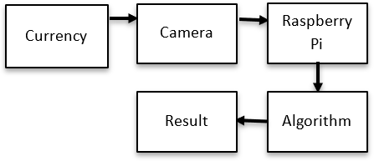

Fig. 1. Dataflow of the machine

Fig 2 shows the overall algorithm of the proposed methodology. In the methodology the first step is image acquisition where the image is captured using 8MP raspberry pi camera. The acquired image is then processed, using OpenCV. The next step is segmentation of the acquired image. Then the edges of image are detected by edge detection using canny edge detection algorithm. The resulting image from edge detection is then sent for feature extraction where each of the significant features is extracted from original image. These extracted features are then compared with the features of test image, based on the threshold value of intensities of white pixels, the comparison is done and the detection of the currency is fake or not is conducted and the result is obtained.

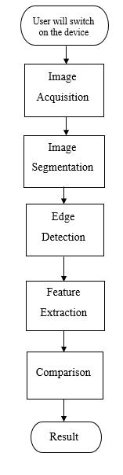

Fig. 2. Methodology of Fake Currency Detection

*A. Image Acquisition*

The image of the currency under the light is captured with the help of Raspberry Pi camera. This camera is controlled with the help of Raspberry Pi that receives the commands from OpenCV. This is the basic step in image processing techniques[7]. Fig 3 shows the result of image acquisition.

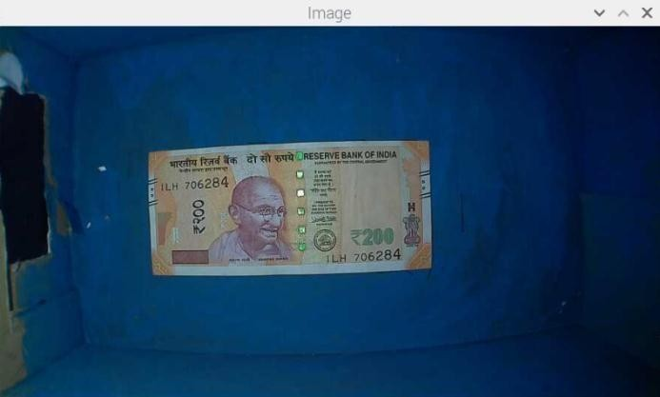

Fig. 3. Result of image acquisition

1. *Segmentation*

Image segmentation is a demanding and important process of image processing. This method is used to categories an image which has the same features into meaningful parts or pixels [4]. With respect to some of the characteristics, the pixels in a region are similar. The characteristics may be texture, color or intensity. So the main goal of this method is to represent images in easily understandable and meaningful ways. This method partitions images into many segments that have similar attributes or features. Segmentation partitions the image into useful segments.

These methods are used in: Medical imaging i.e., radiology, medicine, radiography, x-ray, and diagnostic technique; Content-based image retrieval and Recognition Tasks etc. Image segmentation can be categorized into two different segmentation types: Local segmentation and Global segmentation[4]. Depending upon the features of images, it can be categorized as Discontinuity detection based approach and Similarity detection based approach. Fig 4 shows the result of image segmentation.

In the image segmentation there are four things that take place.

* 1. Grayscale Conversion

RGB image is a constituent of red, green and blue colors where it is an array of M*N*3 triplet at a specified spatial position. A single layered image is the gray scale image which is fundamentally M*N array whose are scaled to denote intensities. Converting the color images to grayscale has little impact on recognition performance in the case of image recognition.

Fig. 4. Segmentation of the image

* 1. Binarization

After the conversion of image to grayscale the image is converted into a binary format, consisting of black and white pixels only. That is, the information is reduced from 256 shades to 2 shades.

* 1. Find largest continuous region

Using this binarized image, four points are located such that a rectangle is formed. The rectangle forming the largest continuous region is chosen and sent for cropping.

* 1. Cropping

The last step in image segmentation is cropping. Here the foreground is separated from the background. This is done such that only the part of image that we want to process (foreground) is cropped. Fig 5 shows the result after cropping is done.

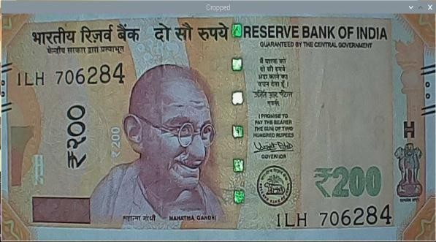

Fig. 5. Cropped image of 200 note

1. *Edge detection*

The Canny edge detection technique is considered to be one among the most powerful methods for edge detection. In the Canny algorithm there are many sub steps such as noise reduction, finding intensity gradient, non-maximum suppression and hysteresis thresholding[5]. Canny edge detection algorithm has the following 5 steps:

* In order to smooth the image and also to reduce the noise, Gaussian filter is applied.
* The image‟s intensity gradients are calculated.
* 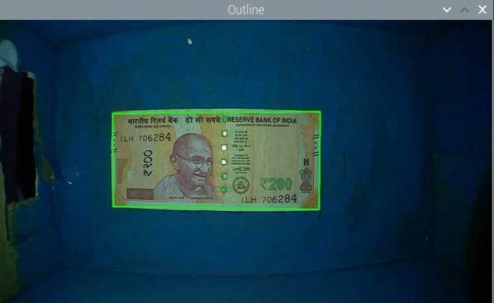In order to dispose the spurious response to edge detection, the application of non- maximum suppression is carried out.
* Double threshold is applied with the intentions of finding the potential edges.

Tracking edge by hysteresis: This step finalizes the detection of edges. This is done by suppressing all the other edges that are weak. These edges should also not be connected to strong edges. cv2.Canny() is the function used in OpenCV to detect the edges. Fig 6 shows the result of edge detection.

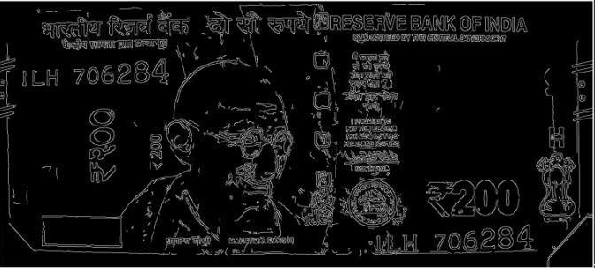

Fig. 6. Result of edge detection

1. *Feature Extraction*

In the feature extraction each feature of currency are extracted based on the features for the respective currency. We are considering different amount of features for each denomination. We consider 5 features for rupee 1, 7 features for rupees 10 and 20, 8 features for rupee 50, 11 features for rupees 100 and 200 and 12 features for rupees 500 and 2000 where at least the minimum number of features should match in order for that currency to be deemed original. The minimum number of features that needs to be matched correctly are 3 for rupee 1, 5 for rupees 10,20 and 50, and 8 for rupees 100,200,500 and 2000. The intensity of each feature is measured by counting the number of white pixels. This is the important step because the detection of currency is completely grounded on it. countNonZero() function is used to count the pixel value.

1. *Comparison*

This is the last step of this process here the features extracted from original currency are compared with features extracted from testing currency. After the features are extracted from original currency the white pixels are calculated an recorded. Then the features of testing currency are extracted and their respective white pixels are calculated.

Now the calculated pixels (count) of both original and tested currency are compared by providing a liberty of 18%, this is because the currency might not be in the best condition.

1. *Result*

The features are compared based on the intensities of the features (pixel count). Based on the number of matched features, the results are obtained on whether the currency is original or fake. Fig 7, Fig8 shows the results for the detection of currency.

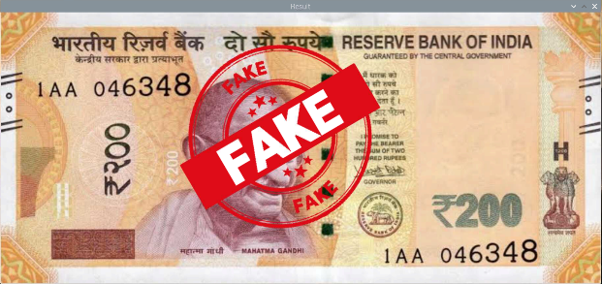

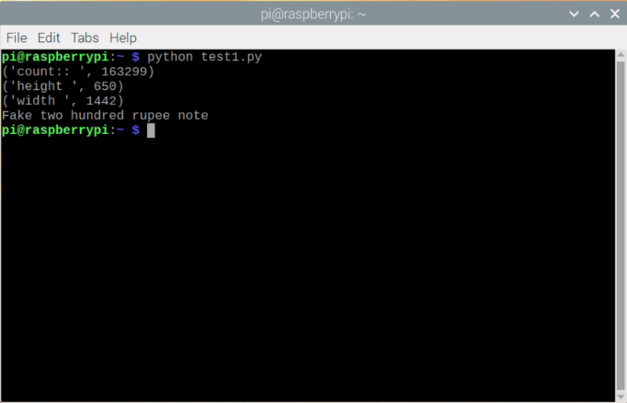

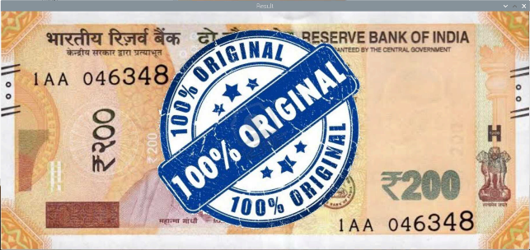

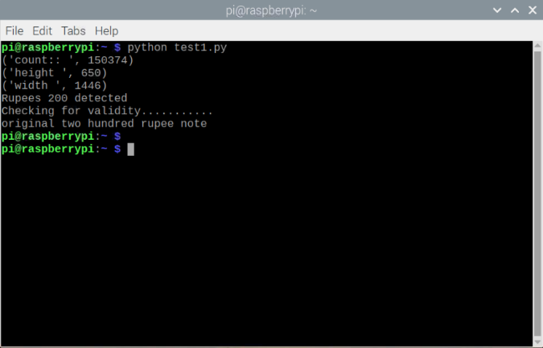

Fig. 7. Result saying whether the note is fake or original.

V. CONCLUSION

There are different methods to detect whether the currency is fake or not, but all methods use some common steps. They are Image acquisition, edge detection, segmentation, grayscale conversion, binarization. The tool chosen to do the computations in most of these papers is MATLAB, but we ended up using OpenCV along with python as our programming language. A set of features are considered which distinguish the original currency from the counterfeit ones in order to make comparisons and decide the result. These features include identification marks, see through register, optical variable ink, currency color code, security threads, watermark, latent image and micro- lettering and some of them.

We are aware that these types of fake currency detection machines are used in banks and shops to help identify the fake currency, but a common man who does not have these resources falls prey to this. Our aim is to provide a low cost system with less computation time where the decision making is done within seconds. The complete methodology should work for Indian denomination 1, 10, 20, 50, 100, 200, 500 and 2000 and the extraction of features should be effective, even if the test image sizes are different when compared to reference image. Here the extraction of features should be effective, even if the test image size slightly differ when compared to reference image. It would be easy to use to the general public, very portable and affordable.

REFERENCES

1. Mohd Mudassir Mohd Ismail*, Mr. Ashutosh. B. Makone “ An Automated Recognition of Fake or Destroyed Indian Currency Notes Using Image Processing” *International journal of engineering sciences & research technology,* ISSN: 2277-9655,

October 2014

1. Binod Prasad Yadav, C. S. Patil, R. R. Karhe, P.H Patil “An automatic recognition of fake Indian paper currency note using MATLAB” *International Journal of Engineering Science and Innovative Technology,*

Vol 3, Issue 4, July 2014

1. D. Alekhya, G. DeviSurya Prabhu, G. VentakaDurga Rao “Fake Currency Detection Using Image Processing and Other Standard Methods” *International Journal of Research in Computer and Communication Technology”,* Vol 3, Issue 1,

January 2014

1. Shiping Zhu, Xi Xia, Qingrong Zhang, Kamel Belloulata “An Image Segmentation Algorithm in Image Processing Based on Threshold Segmentation”

*National Science Foundation,* grant No. 60675018

1. Mohamed A. El-Sayed “A New Algorithm Based Entropic Threshold for Edge Detection in Images” *International Journal of Computer Science* Issues, Volume8, No.1,September 2011.
2. Kiran Swami, Kshitija Murumkar, Dr. Premanand Ghadekar, Yash Solanki “Currency recognition and fake currency identification using image processing” *International journal of Advance Research, Ideas and Innovation in Technology,* Vol 5, Issue 3, 2019
3. Vikash Kumar Mishra, shobhit Kumar “Image Acquisition and Techniques to Perform Image Acquisition” *SAMRIDDHI-A Journal of Physical Sciences, Engineering and Technology ,* Vol. 9, Issue 1,

Feb 2017

1. Rishabh Singh, Saurabh Singh, Deepak Sharma3, Rashmita Mohapatra, Pranay Rao “Counterfeit Currency Detection and Classification*” International Journal of Innovative Research in Science, Engineering and Technology,* Vol. 6, Issue 11, November 2017
2. Muhammad Akbar, Awaluddin, Agung Sedayu, Aditya Andika Putra, Setyawan Widyarto “Original and Counterfeit Money Detection Based on Edge Detection” *International Conference on Instrumentation, Communication, Information Technology and Biomedical Engineering,* November 7th-8th, 2013