Mobile Data Protection Using AES Algorithm

Prateek R K, Sharan, Shreyas Prabhu, Varun Tendulkar, Priyanka

Department of Computer Science and Engineering,
Shri Madhwa Vadiraja Institute of Technology Management, Bantakal

Abstract— The term ‘Mobile security’ consists of protecting personal and business information which is stored on and sent via mobile devices. Mobile security also involves reducing various types of risks. It even refers to protecting mobile devices and the data that is present in it in the case of various kinds of data theft, unauthenticated access or even sudden or accidental erasing of data of the mobiles. In the current world mobile security is significant as it directly influences the trust among users and other entities and on the reliability of mobile phones therefore there is a need for a way to store various kinds of sensitive data and a secure way to retrieve it.

Introduction

Mobile devices are much needed nowadays and are one of the widely used one. It represents various features and elegance in one small pack and is a very effective way of communication. More than billions of people all round the world use cell phones. Some studies suggest that some countries in the European continent have more cell phones than the people living there. This means that the number of cell phones in the particular region was more than the number of people in that region. Besides having different features in the cell phones, it gave poor people in developing countries access to legal services and health options.
The term ‘Mobile security’ consists of protecting personal and business information which is stored on and sent via mobile devices. Mobile security also involves reducing various types of risks. It even refers to protecting mobile devices and the data that is present in it in the case of various kinds of data theft, unauthenticated access or even sudden or accidental erasing of data of the mobiles. In the current world mobile security is significant as it directly influences the trust among users and other entities and on the reliability of mobile phones therefore there is a need for a way to store various kinds of sensitive data and a secure way to retrieve it.
The existing system of the mobile data protection system allows cell phone users to store their confidential information on the irrespective cell phones without worrying about its safety and confidentiality even if it gets lost or damaged. The particular system is developed so that users can use the system to store the sensitive data and avoid the data getting leaked to their adversaries. This project focuses mainly on encrypting the data and storing it so that it can be kept in a confidential and safe way. The encryption of the data is done using the cipher which uses the key that is actually present on a server. Now when the mobile device gets lost or damaged, it automatically sends the report to the server for which server reacts by deleting the key so that the encrypted data can never be decrypted again.
The proposed system aims to provide security to user’s confidential data stored in their mobile phone using encryption and decryption. Users can simply enter their credentials such as username and password to get access to the data from anywhere at any location. Even if the mobile is lost, users can still access their data from the irrespective positions. Due to storing the data in database in encrypted format, the data is safe and even if the attacker hacks the database he or she might not be able to understand the encrypted data. This way security with accessibility is enhanced when compared with the existing system.

- Literature Review

The analysis and research made in encryption decryption techniques and also the results already published is taken into account for the various parameters of the project and for the extent of the project. There are several techniques in which data is encrypted decrypted, of which a suitable one is to be chosen. This is done considering the parameters involved in the implementation of the project. The real world implementation involves the management of data and information, user friendly interfaces, security functions etc.
The emerging technology which has become hottest research area nowadays is nothing but Cloud computing. The cost needed for the computing was reduced because of its ability. Security has resulted as the main difficulty which is blocking the disposing of cloud platform. This is because cloud computing will store all of the resources along with the data within the open platform. Although, cloud computing is very effective as well as promising, there arises a lot of challenges with respect to the security of the data as there is no environs of the information for the user of the cloud. The paper [1] has proposed a compound architecture which includes the private cloud. This is an open stack that is meant to deploy IAAS architecture as well as supply tools in order to manage and to create virtual machine by utilizing already existing resource. It implements a model supported using RSA. Since the proposed architecture relies on RSA the encryption and decryption process is way slower than other algorithms like AES. This proves to be an excellent advantage given RSA is way costlier to compute in terms of cipher text bytes than AES.
The paper [2] provides a brief overview of all the challenges regarding the requirements that are conflicting with respect to the encryption scheme of data. The operation of encryption or decryption must be efficient for all of the appropriate users since it must be computationally infeasible for attackers to obtain the original data from mobile devices. In order to address this particular difficulty, the research proposed a completely unique approach or scheme known as Self encryption (SE) scheme. Here the keystream will be generated by retrieving the n bits which is based on the unique pin as well as nonce of the user in a pseudorandom way. This can be possible only if the data is treated as the binary bit stream. The keystream length which is taken as n, is reliable as well as flexible and thus it is based on the requirement of the security. Using this type of keystream the bit stream which had remained is also encrypted. It is difficult for designers to hypothetically analyze and understand how the cipher scheme holds well against physical attacks. The paper presents a prototype to handle this problem, but with possible weaknesses because it relies on expectations of not being susceptible to attacks. The issues related to the performance is considered within the scope of real time applications rather than considering the security as well as safety requirements. This is often not very reliable as real applications include factors that will primarily threaten the safety of the system.
In the paper [3] the author presents the main objective of database security is nothing but providing security to the data in order to avoid sensitive or private information loss. In order to alleviate the accidental loss or the loss that occurred intentionally in the mobile phones, the encryption process is strongly taken into consideration. There are two types of encryption algorithms which are asymmetric as well as symmetric encryption algorithm. Here asymmetric algorithm is very comprehensive based on its computations when compared with symmetric encryption algorithm. The most reliable cipher which is proven is none other but AES stream cipher. The author had also discussed on the demand or challenge to design an entirely new algorithm used for encryption for a researcher such that it must perform much more effectively when compared with existing algorithms used for encryption. It must also satisfy the conditions based on the usage of resources available. Advanced Encryption Standard encryption algorithm is highly reliable and is secure. Hence it is known as one of the top ciphers.
In the paper [4] the author provides two different forms of cryptography 1) Symmetric key cryptography (secret key cryptography) 2) Asymmetric key cryptography (public key cryptography). In this paper the author presents the comparison of two algorithms which are AES and RSA. The AES algorithm is the secret or private key cryptography whereas the RSA algorithm is public key cryptography. Both the algorithms that are considered are very efficient. This paper presents the features as well as the comparison of both the algorithms. The thorough study proves that the RSA algorithm solves the problem of key agreement and key exchange that is usually generated in secret key cryptography algorithms the confidentiality gets affected badly. So a detailed analysis is done so that one can compare the features and choose the best algorithms out of those two. Hence both the algorithm AES and RSA differ from each considering various features of it as shown in Table 1.

Table 1: Android Architecture[4]
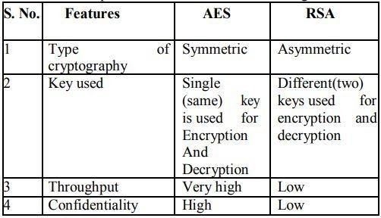

In this paper [5] the produced system enables the user to perform it on android platform so that the file can be encrypted before transferring over the network.This encrypting algorithm can be used for all types of files such as docx, image, video, pdf etc. The algorithm that is used for encryption and decryption is the AES algorithm. The term encryption means making the data unreadable so that it cannot be accessed by other people who are not related to the file.There are various other algorithms too which can be used for encryption such as DES, 3DES, Blowfish etc. In DES algorithm the key size is too small, whereas in 3DES, key size is more but as we know higher the key size lower is the performance.Therefore the AES algorithm is widely used because of its collectively many advantages. The main feature along with the enhanced security is the increased speed. The AES algorithm is so fast that it can be used or implemented on any platform be it a small device or a big one. This is reasonable why many of the applications use the AES algorithm for encryption and decryption and it is really fast in the Android phones.
The paper [6] highlights the security issues in low cost mobile.There are various cell phones coming each and every day and the cost of the phones are high due to which many people cannot have access to it. But there are various phones which have low cost too but only limited features. Having low cost phones are good which provide decent functionality but it cannot provide good security. Therefore there is an application that is created called Mobile self encryption that can be installed on the cell phones so that the users can keep their data safe without having to worry about its confidentiality. Due to the rapidly growing mobile user population, it is a challenging task to keep up privacy of our mobile data it this approach. In case if a mobile device has been stolen or lost it’s very simple to access confidential data without efforts. In existing system, we simply store our data without any security and if our mobile get lost then hacker can hack our data using powerful cryptanalysis tool.
Then it is very challenging to store our confidential data in our mobile phone. Encryption is used for securing files from thefts. AES algorithm is mostly used for encryption scheme. Approaches to encryption are endpoint encryption, file and folder encryption email encryption. With AES being one of the top ciphers, its usage in encryption and decryption of data only adds to the level of security of the system. The constant and wide use of wireless networks and cellular phones has affected the lifestyle of the people significantly. There are various challenges for data security along with the efficiency and convenience of the device and data access.
In the context of lightweight cryptography for smart phones security application, the author compares two block ciphers, AES and PRESENT [7]. This was the first comparison between AES and PRESENT ciphers by using smart phone as a computing platform. PRESENT is the first ultra-lightweight cipher being planned and for symmetric encryption the standard provided is AEC cipher. In this paper, the author has considered several aspects such as consumption of voltage, memory usage and execution time for the purposes of comparisons. Using the android built in tools, the two of the block ciphers were executed through many experiments being conducted in a low-cost smart phone. Conclusion from the results is that, the performance of AES is better for general purpose encryption even if PRESENT (block-to-block) provides best results. The reason was that even though PRESENT is better, its block size is smaller, whose results needs to process twice as many blocks as AES requires to encrypt or decrypt the similar quantity of data. By the author’s experiment it can be noted how in processing speed AES outperforms both versions of PRESENT by approximately 25%.
In the paper [8] the author presents a study about the Symmetric Block cipher, which is nothing but a core element. Symmetric Block cipher is used to provide authentication, confidentiality of the message and integrity of the data. For this purpose it is used to build protocols as well as cryptographic communication. The selection of appropriate cryptosystem as well as its parameters is affected by many of the drawbacks in software and hardware resources. The cryptosystem performance was evaluated in various cases using several parameters of the variable such as size of the key, cipher, size of the plaintext and number of threads and parallelization that has been provided by multicore CPU was analyzed by the author. The various symmetric block cryptosystem are 3DES, DES, AES which is on the android platform and this platform on the smart phone devices is known for its widespread facilities. The tests performed by the author shows the cases wherein some benefits were brought by the cryptographic algorithms based on multithreading but only up to eight threads. By this paper, the conclusion is that AES cryptosystem’s implementation in order to provide information security based on the platform of android is more accurately approved by the author.
In paper [9] the author presents a research on application development based on android platform. The free and open system which is based on Linux is called as Android. It’s main application is in mobile terminals, such as panel computer as well as smart phones. Open Handset Alliance developed it which is the combination of greater than thirty transportable companies, mobile phone companies as well as technology companies. In order to increase the best user experience and allow developers to be more convenient with the development of software, Android provides best quality services. Thus Android is used to develop mobile applications because it will have more functions that are best and more convenient. This paper shows the Android platform’s architecture which consists of methods as well as classes used in development. An example to propose the Android program development as well as design is to draw the audio or video file procurement including analysis, development, design of the program etc. Here applications can run parallel because Android will have an multi tasking platform. The android is capable of producing notifications which attracts attention of the people when the android is executing in the background. There are four layers in the architecture of Android. They are- system operating library layer, application layer, Linux kernel layer and application framework layer. Applications are nothing but the programs that are executed in the virtual machine and written in java language. The author showed the android program development and design for video or audio attainment supporting the architecture of android. The author’s program will accurately analyze the attainment and then play the audio as well as video files with fast execution speed and better experience of the user after the test.
In paper [10], in order to provide the data security in mobile phones, author proposed a Self Encryption scheme. The changes in our living style are due to the massive use of wireless networks as well as the mobile phones. There arise new challenges in providing security to the private data with best efficiency and great convenience in these mobile phones. The operations of the cryptography must be very effective such that it must be impossible for attackers to decrypt the data computationally and battery drain must also be minimized according to the author. The confidential or sensitive data as well as private data are separated and stored in a distributed way using a framework introduced by author. This paper proposed a completely unique storage scheme as well as data encryption in order to provide solution to this challenge. A keystream is generated by extracting bits randomly from the stream and the data must be treated as a binary bit stream. This can be done using author’s self encryption scheme. User’s security requirement is the main concern with respect to the length of the keystream. After encrypting the bit stream, the ciphertext was placed on the mobile device and the keystream was placed separately. Thus this made the author’s approach computationally infeasible to decrypt the original data stream from the ciphertext only.
In the implementation of the project, AES algorithm is used for the encryption and decryption of data. This data includes files with formats of docx, pdf along with images, videos, audios, etc.

- Implementation

A. Android
Google developed the mobile operating system ie, the Android operating system. It was meant to be primarily used for touchscreen devices, cell phones, tablets etc.By finger movements similar to common motions like pinching, tapping and swiping, users can manipulate mobile devices by its design. Google also employs Android software that is used in televisions, cars, and wristwatches employed by google, with a unique interface for each.
Android, Inc., a software company first developed this operating system. It is located in Silicon Valley, it was then acquired by Google in 2005.
Android is packaged with proprietary software when sold on handset devices, though the Android source code is released in an open-source format. This is to help advance open standards all over across mobile devices.
It is an open source, Linux-based software stack which was created for a wide array of devices.

B. Firebase
Fire base is a web developing and app developing software that helps the users develop the web/apps in a faster way and easier way. Firebase is a Backend-as-a-Service(BaaS) that started as a YC11 start-up. It then grew up into a next-generation app-development platform on GCP that is Google Cloud Platform .Firebase is a real-time database that allows users to store a list of objects in the form of a tree. Google Firebase is Google backed application development software which allows developers or users to develop Android, IOS, and Web apps
C. Web
Web application development is the process of developing the application that resides well on the remote server and is delivered to the user over the internet on his/her devices. A web application does not require users to download any web apps from the playstore or the internet.The users can use the web application using any network.The internet browsers like internet explorer ,chrome allows users to interact or open the web applications.
D. AES Algorithm
Whenever the term cyber security comes into action we see that there is an AES algorithm associated with it. This is because the AES algorithm has achieved a great significance and is considered as standard for encryption and decryption. The AES algorithm is one of those algorithms which is a fast and secure way of encryption which can be used to keep or store our data in a secure way. We see the same algorithm used various different kinds of applications such as Whatsapp and WinZip etc .
AES is the algorithm that is more likely to be more than 6 times faster than the DES algorithm. DES was one of the strongest ciphers but having the key size less it needed to be replaced. As the computing power of computers kept on increasing, it was easier for the attackers to get to know of the key by key search attack. 3DES was later designed to overcome these challenges but was later found to be too slow for it.
The features are
    - It is a symmetric key and symmetric block cipher
    - the data is of 128-bit data and the key size varies from 128,192 or 256 bit keys
    - Found to be faster and stronger than 3DES
    - It can be implemented in the basic programming languages such as C and Java

E. Methodology
In this section we will discuss about our proposed system and how it can be used in mobile data protection. There are two types of application- a web portal and an android application. The proposed system will enable the user to protect their data without having to worry about data theft or loss or even the device loss.
Figure 1 shows the overall working of the android application. Below are the steps of how the process takes place.
Step 1: Firstly if the customer or the user is not registered with this mobile application, the user needs to connect or register with it. If the user has the account registered, then the user will just have to login with their own username and password or credentials.
Step 2: After logging in, the user will setup keys for different sections of the application and these keys will be stored in the database.
Step3: The user will then select a particular section which he wishes to enter.
Step 4: The user will have to enter the key associated with that particular section.
Step 5: If the key entered by the user is correct then, the user can view the list of data items present in that section. If the key entered was invalid, a message will be sent to the user regarding invalid key.
Step 6: The user can either choose to add a new item to the section that should be encrypted, the user will have to browse through the list of items stored in the mobile and select the item and get it encrypted, or the user can choose a particular item to view the decrypted form.
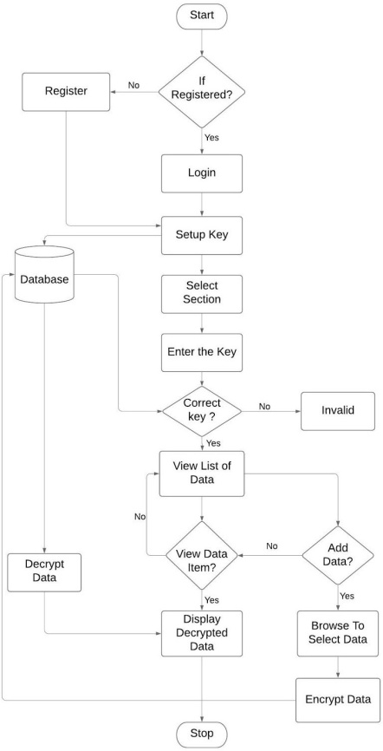
Figure 1: Working of the application
The web portal has to play an important role. If the mobile device is lost, the user can log into the web portal mark the status as lost. If the device is found again then user can mark the status as found.
Figure 2 shows the working of web portal. Below are the steps of how the process takes place.
Step 1: The user has to login with his/her registered user name and password.
Step 2: The default status is set to none. The status is used to depict whether the device is lost or not.
Step3: If the status is set to device lost by the user, the application is made inaccessible.
Step 4: If the status is set to device found by the user, the application is made accessible and status is set to default.

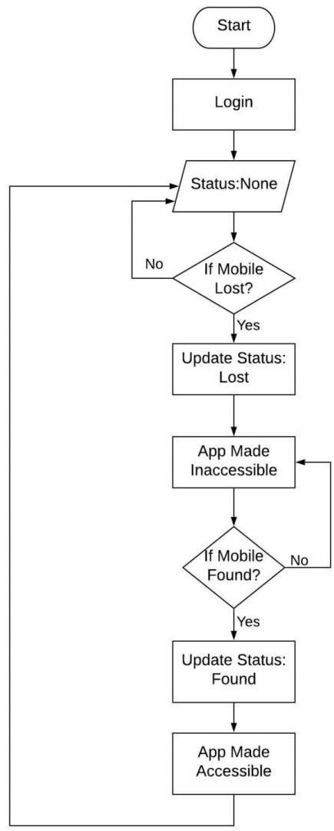

Figure 2: Working of the web portal

- Conclusion

Cell phone security or the mobile security includes securing both private or personal and organization or business data that is stored on the database and which is transmitted from one mobile device to another. The data in certain systems is stored in the cloud in encrypted form using certain algorithms such as RSA which prove to be not efficient when compared to others such as AES which provides higher confidentiality of data.

References
[1] Santosh Kumar Singh , Dr. P.K. Manjhi , Dr. R.K. Tiwari, “Data Security using RSA Algorithm in Cloud Computing” International Journal of Advanced Research in Computer and Communication Engineering ISO 3297:2007 Certified Vol. 5, Issue 8, August 2016.
[2] Mitesh Parmar, Summedh Kharat, Nilesh Palve, Chetan deokate, Prof. Yogesh shahare, “Mobile Self Encryption Techniques”, International Journal for Research in Engineering Application & Management (IJREAM) ISSN : 2454-9150 Vol-03, Issue-12, Mar 2018.
[3] Dr. Roselin Selvarani and Dr. T. N. Ravi, “A Review on the role of Encryption in Mobile Database Security”, International Journal of Application or Innovation in Engineering & Management (IJAIEM), Volume 3, Issue 12, December 2014 ISSN: 2319 – 4847
[4] Shaili Singhal, Dr. Niraj Singhal, “A Comparative Analysis of AES and RSA Algorithms”, International Journal of Scientific & Engineering Research, Volume 7, Issue 5, May-2016, ISSN: 2229-5518
[5] Suchita Tayde , Asst. Prof. Seema Siledar, “File Encryption, Decryption Using AES Algorithm in Android Phone”, International Journal of Advanced Research in Computer Science and Software Engineering, Volume 5, Issue 5, May 2015 ISSN: 2277 128X
[6] Ms. N.S.Gurdhalkar, Ms. S.S.Gurdhalkar, Ms.P.D.Belhekar, Ms.J.S.Mane, Prof. T.R.Shinde,” Mobile Self Encryption”, International Journal of Advanced Research
[7] Lara-Nino, Carlos Andres, Morales-Sandoval, Miguel and Diaz-Perez, “An evaluation of AES and PRESENT ciphers for lightweight cryptography on smartphones”.
[8] Krešimir Grgić, Zoran Kovačević, Višnja Križanović Čik,“Performance Analysis of Symmetric Block Cryptosystems on Android Platform”. 978-1-5386-2101-1/17 ©2017 IEEE
[9] SHAO Guo-hong1, “Application Development Research Based on Android Platform”, Year of publication 2014.
[10] Yu Chen and Wei-Shinn Ku, “Self-Encryption Scheme for Data Security in Mobile Devices”, 978-1-4244-2309-5/09/$25.00 ©2009 IEEE.

 

