**Design and Numerical Analysis of Friction Stir Processing Tool for Magnesium Alloy Based Surface Composites**

Lingaraj Ritti1, Thirumaleshwara Bhat2,

*Shri Madhwa Vadiraja Institute of*

*Technology and Management, Bantakal, Udupi*

*Abstract*—Friction stir process is a solid-state process in which the grain refinement of the base material will take place below the recrystallization temperature. The surface composites are produced by mixing the reinforcement particles on the surface layer of the base material at a certain thickness by using a suitable reinforcement strategy which improves the surface properties of the composites. The success of the process depends on the tool shoulder design, and pin design. In the present work, an attempt has been made to design a suitable tool by using analytical models based on the torque capacity of the motor used in the Computerized milling machine. The tool shoulder diameter of 20 mm is obtained based on the yield strength of the tool material, and the taper pin average diameter of 4 mm is obtained based on the maximum shear strength of the tool material with suitable safety factor. The axial and transverse forces in the process are determined by an analytical method. The axial force-induced during the plunging phase is 28.7kN on the contact surface of the tool shoulder and in travelling phase the maximum transverse force-induced is 3kN at the pin side of the tool. The structural stability and the reliability of the tool are studied by structural and fatigue analysis using ANSYS software. The result shows that the negligible deformation and stresses induced during the process are less than the yield strength of the tool material, and the tool endure 14×103cylces of fatigue load-induced during the process.

*Index Terms*—Friction Stir Process (FSP), Tool, Magnesium Alloy, Structural and Fatigue analysis, ANSYS software

# INTRODUCTION

I

n recent years metal matrix surface Nano/micro composites are used potentially in automobile and aerospace industries to produce lightweight and durable, components and increase fuel efficiency and to reduce environmental pollution. In surface metal matrix composites, aluminium, magnesium, and copper are widely used as base metals and ceramic particles, oxides of micro/Nano size particles are used as reinforcements. Magnesium is one-fourth times lighter than that of steel and two-third than that of aluminium which offers applications in lightweight components of automobile and aerospace industries, but magnesium has some limitations such as poor hardness, poor wear resistance and also it is a very reactive metal which restricts the use of Mg alloys, to overcome these limitations and to enhance the mechanical and tribological properties Nano reinforcement particles are imposed on the surface of the Mg metal matrix[1].

To fabricate surface Nano/micro composites different liquid phase techniques like laser beam treatment, electron beam irradiation and plasma spraying are available. In these methods, the inter-reaction occurs in between the matrix and reinforcement particles, which intern forms detrimental phases. To eliminate this problem reinforcement particle needs to be imposed on the surface of the base matrix below the recrystallization temperature, by using solid-state Friction Stir Process (FSP), Friction Stir Process is derived from Friction Stir Welding (FSW) which was developed by The Welding Institute in 1991, by using Friction Stir Process the grain refinement in the microstructure of the base material and mixing of the Micro/Nanoparticles on the surface layer of the base material at certain thickness can be achieved which improves the surface properties, like hardness and wear resistance [2].

In Friction Stir Process a tool having shoulder with pin is used to process the material is as shown in Fig 1. During FSP, the friction between the contact surface of the rotating tool and the base material leads to the generation of heat, which makes the base material soft and it undergoes plastic deformation and hence the grain size refinement in the microstructure takes place. The stirring action of the tool pin mixes the reinforcements in the base material. As the tool traverse in the desired direction, the material forged below the tool shoulder and forms a stirred zone resulting in surface composites. The stir zone of the processed material determines the properties of the synthesized surface composites [3].

The friction stir processing technology is still not known solution, especially to use in the industries. The research work carried out on laboratory has shown that microstructure and its associated physical and mechanical properties of the modified materials are attractive, and the same technology can be competitive with currently used methods. The literature review reveals the few gaps in research on surface composites via FSP route such as fabrication of defect-free composites, tailoring microstructures, development of durable and cost effective tools, and understanding on the strengthening mechanisms [4].

# Analytical Model

## Tool Design

The success of the FSP process depends on the design of the FSP tool. The tool consists of two design features, the shoulder and a pin. Several pin geometries such as threaded cylinder, a threaded cylinder with flattened sides proposed in the literatures [7] [35]. The rotating pin forces the material to flow around the pin and to mix. The shoulder applies a thrust force/pressure on the material to constrain the plasticized material around the pin, generates heat through friction and plastic deformation in a relatively thin layer under the shoulder surface. Tool geometry significantly affects the energy input, deformation pattern, plunge force, travelling force, microstructures and mechanical properties of surface composites and other important aspects of FSP tool design are tool material selection, geometry and load-bearing ability.

In the successful solid-state FSP process, the forces/ torque is enough to stir the plasticized material, and influence tool, base material and process parameters. As a consequence, an improper combination of the parameter results in insufficient deformation, stirring action and defects. For a given set of parameter, the force and torque variation is monitored for the better surface process and helps to find a relationship between torque variation in defective and defect-free surface composite fabrication.

## Tool Material Selection

During FSP the torsional and bending moments are exerted on the tool, hence, the tool experiences normal and shear stresses with the thermal effects. In the present work, H13 tool steel used as tool material, since many researchers, H13 tool steel was used as a tool material which is more suitable for processing aluminium and magnesium alloys with micro/Nano surface composites. According to AISI standards, the mechanical properties of the tool material and base material Magnesium alloys are given in Table 1[6].

. 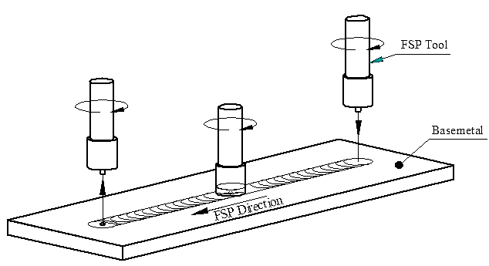

Fig. 1. Friction stir process

## Tool Shoulder Design

The tool shoulder diameter is found based on the principle of maximum utilization of supplied torque for traction and for the tool rotational speeds [15], of 600 rpm, 800 rpm, 1000 rpm, and 1200 rpm as tabulated in Table 2 by “(1)”, with a suitable factor of safety as follows.

Table.1

AISI Mechanical properties of H13 tool steel and Magnesium alloy [6]

|  |  |  |  |  |  |
| --- | --- | --- | --- | --- | --- |
| Materials used | Yield strength  (MPa) | Yield Shear strength  (MPa) | Modulus of elasticity  (GPa) | Ultimate tensile strength  (MPa) | Density  (Kg/m3) |
| H-13 tool steel | 1380 | 796.74 | 215 | 1590 | 7800 |
| Magnesium alloy | 130-165 | 95.263 | 45 | 220-330 | 1800 |

.

The torque equation is given by [5],

$T=ф r \left(τ_{t} dA\right)=τ_{t}\int_{0}^{R_{S}}{2πr2dr}=\frac{2πR_{s}^{3}τ_{t}}{3}$ (1)

The suitable factor of safety is calculated based on the yield strength of tool material to the shear strength of the processing material, in ordered to avoid yielding of the tool material during the processing of base material. The tool shoulder experiences 80% of the forces in the process, therefore, in tool shoulder design, 80% of the safety factor considered and the remaining safety factor for pin design.

The estimated shoulder diameters vary from 16 mm to 20 mm, but in literature [15], for high carbon steel tool and AZ31B magnesium alloy (6.0mm & 1.5mm thick) workpiece material, the tool shoulder  diameter of 18 mm and 24 mm taken to process the material, the possibility of Increase in the tool shoulder diameter beyond 18mm but less than 24 mm, a defect-free processed zone observed for variation in the process parameters in 6mm thick plate, therefore, in the current research work the tool shoulder of 20 mm diameter adapted to produce defect-free magnesium alloy based surface composites by FSP.

## Tool Pin Design

During the FSP process, as the rotating tool moves in the desired direction, the friction between the contact, surfaces generate the heat, and the torsional as well as bending moments are exerted on the tool pin. Hence, the tool pin experiences normal and shear stresses as well as the effect of temperature in the process. For instance to design the tool pin the effect of temperature is neglected. Since the rise in the temperature makes the base metal softer and the tool will experience less shear force compared to shear force at room temperature. Stress calculation for the pin is of great importance since the FSP process fails due to tool pin failure. The pin designed with low safety factor subjected to static or fatigue failures. The high design safety factor considered is enough to avoid severe tool deformation; hence, the safety factor of 3 adopted for the tool pin design.

To know the induced stresses on tool pin, consider a schematic of distributed force on the tool pin and its cross-section S-S, as shown in Fig 2, where q(z) is the applied shear force on the infinitesimal length (dz) of length[16].

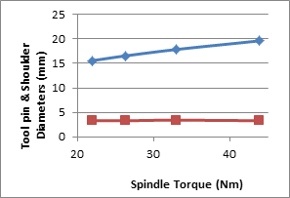

. Fig. 3. Tool pins and shoulder diameters vs Spindle torque

For point A, at Z distance from the pin root, the bending moment and normal bending stresses calculated by using the following equations.

$M_{y}=\int_{0}^{l}{z q\left(z\right)dz}$ (2)

$σ_{B}=\frac{M_{y}x}{I_{yy}} = M_{y}\frac{\left(r cosθ\right)}{I_{yy}}$ (3)

$σ_{B} =\frac{4 cosθ }{πr^{2}}\int_{0}^{l}{z q\left(z\right)dz}$ (4)

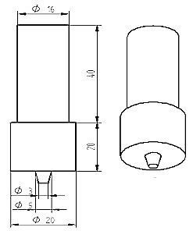

Fig. 4. Dimensions of the FSP tool

.

Where $I_{yy}$ r, x and θ are the second moment of area, pin radius, the normal distance of point A from the y-axis and the angle in polar coordinate respectively.

The shear force distribution on the tool pin calculated by using the following equation.

$τ_{B}=4\frac{\sin^{2}θ}{3πr^{2}}\int_{0}^{l}{q\left(z\right)dz}$ (5)

The torsional shear stress calculated by using the following equation.

$τ_{T}=\frac{ 2M_{T}}{πr^{3}}$ (6)

Where MT is the sticking component of the total required torque in the process

Based on the maximum yield shear strength of the tool material and shear stress-induced on the tool pin during the process with a safety factor of 3, the diameter of the tool pin is determined by ‘(7)’[16].

The tool shoulder and average pin diameters for different rotating speeds and torques are shown in Table 2. The tool shoulder diameter, as well as torque on the tool, decreases as speed increases as shown in Fig 3.  The dimensions of the tool based on the shoulder and pin diameters are shown in Fig 4.

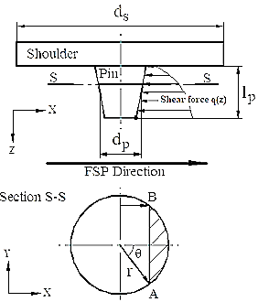

Fig. 2. Shear force distribution along the pin length

$$τ_{max}=$$

$\sqrt{{\left(\frac{σ_{B}}{2}\right)}^{2}+{(τ_{T}+τ_{B}sinθ)}^{2}+{{(τ}_{T}cosθ)}^{2}}$ (7)

Table 2

Shoulder and avg pin diameters for different speeds and torque

|  |  |  |  |
| --- | --- | --- | --- |
| Speed (rpm) | Torque (Nm) | Shoulder  diameter  (mm) | Average  Pin diameter  (mm) |
| 600 | 43.91 | 19.64 | 3.31 |
| 800 | 32.93 | 17.85 | 3.42 |
| 1000 | 26.35 | 16.57 | 3.31 |
| 1200 | 21.96 | 15.59 | 3.31 |

.

# Analytical Prediction of Tool Force

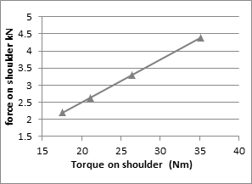

Fig. 5. Force vs. Torque acting on tool shoulder

The force acting on the tool during the process, determined for the designed tool. The actual force acting on the tool shoulder and pin during FSP is considered at plunging phase and travelling phase.

## Force on tool in plunging and travelling phase

The force acting on the tool shoulder and pin tip during plunging are shown in Table 5. The force acting on tool, determined based on the yield shear strength of the base material processed by using the following equations.

$F_{S}=π \left(d_{s}^{2}-d_{p}^{2}\right)\frac{τ_{y}}{4}$ (8)

$F_{p}=π d_{p}^{2}\frac{τ_{y}}{4}$ (9)

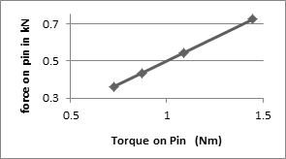

Fig-6: Force vs. Torque acting on Pin tip

The force acting on the tool shoulder during the travel obtained based on the friction between the contact surface and the force due to the torque. The friction between the shoulder surface and base metal generates the heat and it makes the base metal soft and reduction in the shear strength of the base metal and thus the tool experience a less force as it experiences a force in plunging phase.

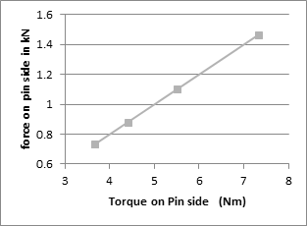

Fig. 7. Force vs. Torque acting on Pin side

According to Coulomb friction law, the frictional force on tool shoulder and on the pin tip is given by the following equations. [7],

$F_{fs}=µF_{as}$ (10)

$F_{fp}=µF_{ap}$ (11)

$F_{as}=π (d_{s}- d_{p}) h τ_{y}$ (12)

$F_{ap}=π \frac{d_{p}^{2}}{4}σ_{y}$ (13)

Table 4

Total force on tool in travel

|  |  |  |  |
| --- | --- | --- | --- |
| Speed  (rpm) | Total force on shoulder  (kN) | Total Force on pin tip  (kN) | Total Force on pin side  ( kN) |
| 600 | 5.4028 | 0.834 | 2.9722 |
| 800 | 4.3048 | 0.653 | 2.6055 |
| 1000 | 3.6468 | 0.544 | 2.3857 |
| 1200 | 3.2078 | 0.472 | 2.2391 |

.

Where $F_{as}$ and $F_{ap}$ are the axial force acting on tool shoulder, and on the pin tip respectively [29], μ = 0.42, and h is depth of plunge.

The force acting on the pin side is given by,

$F_{pside}=ф σy dA$ (14)

Table 3

Torque and force acting on tool shoulder, pin tip and pin side

|  |  |  |  |  |  |
| --- | --- | --- | --- | --- | --- |
| Torque on shoulder  (N-m) | Torque on pin  (N-m) | Torque on pin side  (N-m) | Force on shoulder (kN) | Force on pin tip (kN) | Force on pin side  (kN) |
| 35.128 | 1.449 | 7.333 | 4.391 | 0.7245 | 1.4666 |
| 26.344 | 1.087 | 5.499 | 3.293 | 0.5434 | 1.0999 |
| 21.08 | 0.869 | 4.400 | 2.635 | 0.4348 | 0.8801 |
| 17.568 | 0.725 | 3.667 | 2.196 | 0.3623 | 0.7335 |

.

Where $σ_{y}$ and $τ_{y}$ are the temperature dependent yield and shear strength of the base metal, $dA=\frac{πd_{p}L_{p}}{2}$ is the projected arc of the tool pin.

The torque on tool shoulder, pin tip and on pin side determined by using the following equations [35], and corresponding values are given in Table 3.

$M_{t shoulder}=\frac{πτ\left(d_{s}^{3}-d_{p}^{3}\right)}{12}$ (14)

$M_{t pintip}=\frac{πτ\left(d_{p}^{3}\right)}{12}$ (15)

$M_{t pinside}=\frac{πτd_{p}^{2}l_{p}}{2}$ (16)

The force on tool shoulder, pin tip, and pin side determined by using the following equations, and corresponding values are given in Table 3.

$F_{S due to torque}= \frac{M_{t shoulder}}{\frac{\left(d_{s}-d_{p}\right)}{2}}$ (17)

$F_{pin tip due to torque}= \frac{M_{t pin tip}}{\frac{d_{p}}{2}}$ (18)

$F_{pin side due to torque}= \frac{M_{t pin tip}}{l_{p}}$ (19)

The force variation with the torque on tool shoulder, pin tip and on pin side is as shown in Fig 5, Fig 6, and Fig 7.respectively.

The force acting on the pin side is given by,

$F_{pside}=ф σy dA$ (20)

Where $σ_{y}$ and $τ_{y}$ are the temperature dependent yield and shear strength of the base metal, $dA=\frac{πd_{p}L_{p}}{2}$ is the projected arc of the tool pin.

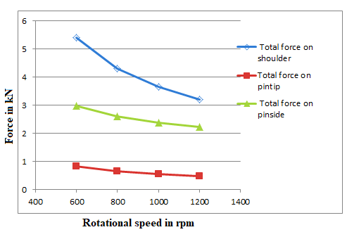

Fig. 8. Total Force on tool vs. Tool rotational speed in travelling

.

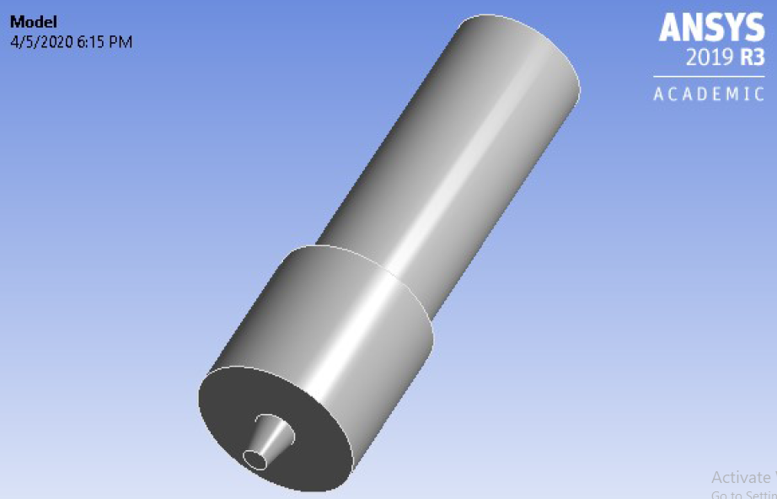

Fig. 9. FSP tool geometry

.

The total force on the tool during travel is the summation of force due to friction between the contact surface and force due to torque. The total forces acting on the tool tabulated as given in table 4. The force acting on the tool during travel decreases with the increase in the tool rotational speed, due to increase in the tool speed, the torque on the tool decreases and intern reduces the force acting on the tool as shown in Fig 8.

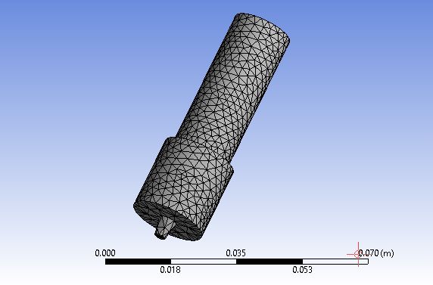

Fig. 10. Meshed model of FSP tool

.

The maximum force acting on the tool during plunging phase and travelling phase are tabulated in Table 5. From Table 5, it is clear that the force acting on the tool during the plunging phase is more and it is due to the impact of the tool on base metal and resistance offered by the base metal to the tool in the axial direction. The magnitude of the plunging force acting on the tool plays an important role in the design of a tool, and these force values are considered in stress analysis of a tool to check the stability and reliability of the designed tool.

Table 5

Maximum forces acting on tool during FSP

|  |  |  |  |  |
| --- | --- | --- | --- | --- |
| Forces acting on tool at rotational speed of 600 rpm | | | | |
| Force during plunging | | Force during travelling | | |
| Shoulder contact surface force  (kN) | Pin tip force  (kN) | Shoulder contact surface force  (kN) | Pin tip force  (kN) | Pin side force (kN) |
| 28.734 | 1.197 | 5.4028 | .0. 83404 | 2.9722 |

.

# NUMERICAL ANALYSIS

## MODEL DESCRIPTION

The solid model of the designed FSP tool is as shown in Fig 9 the tool model created by using ANSYS workbench. The tool has a shoulder diameter of 20mm and taper pin has diameters of 5mm and 3mm, with 5mm pin length. The suitable shank diameter and length are taken as per the standards of tool holder using in CNC milling machine. The tool model is meshed with SOLID87 3-D 10 node tetrahedral structural element of quadratic displacement behavior. The meshed model has 3360 Elements and 6730 nodes with element size of 2.0 mm as shown in Fig 10. The element is defined by ten nodes having three degrees of freedom with temperature at each node. The element also has some other properties such as plasticity, creep, swelling, stress stiffing, large deflection and large strain capabilities.

## Static stress analysis

The static structural analysis performed to check the structural stability of the designed tool by estimating the deformations and stresses induced in the tool. The analysis is carried out by applying suitable boundary conditions and loads on the tool. The displacement and cylindrical constraints are imposed on the shank of the tool to resemble like a tool holder that holds the tool shank firmly during the process. The rotating tool experiences the force due to torque and friction in the tool travelling phase and the axial thrust force during the plunging phase. The forces are applied on the contact surface of the tool shoulder, pin tip and on the projected area of the tool pin. The force exerted on the shoulder and the tool pin tip are high in the plunging phase, therefore, to perform static stress analysis, the axial thrust force acting on the shoulder and the tool pin tip are considered in both the plunging phase and in the travelling phase.

The FSP process consists of several phases, each phase has some time period and there is relative motion between the tool and the workpiece. In the first plunge phase, the rotating tool plunged vertically into the workpiece. The plunge phase followed by the dwell phase, in this phase, the rotating tool is held steady on the workpiece. The mechanical interaction, due to the relative motion between the rotating tool and the stationary workpiece, produces heat by friction and material undergoes plastic deformation. This heat dissipates into the surrounding material, the temperature rises and the material softens. After these two phases, the real process initiated by moving the tool relative to the workpiece. When the desired distance is covered, the tool pulled out of the workpiece, leaving behind an exit hole as a footprint of the tool [12].

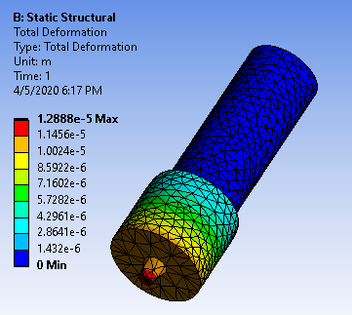

Fig. 12. Total deformation in FSP tool

.

The FSP tool in travelling phase experiences a frictional force and the force due to torque, as well as a rise in the temperature. The analysis performed by considering both frictional force and force due to torque on the shoulder, pin tip and at the pin side with temperature effects. The total force acting on the tool during travelling phase is given in Table 4, are applied on the tool along x-axis opposite to the FSP direction.

## Fatigue analysis of tool

Fatigue failure occurs due to crack formation and propagation. A fatigue crack will typically initiate at a discontinuity in the material where the cyclic stress is a maximum. Discontinuities can arise because of:

### Design of rapid changes in cross-section, keyways, holes, etc. where stress concentrations occur

### Elements that roll and/or slide against each other under high contact pressure, developing concentrated subsurface contact stresses that can cause surface pitting or spalling after many cycles of the load.

Various conditions that can accelerate crack initiation include residual tensile stresses, elevated temperatures, temperature cycling, a corrosive environment, and high-frequency cycling.

The three major fatigue life methods used in design and analysis are the stress-life method, strain-life method, and linear-elastic fracture mechanics method. These methods attempt to predict the life in, number of cycles to failure, N, for a specific level of loading. Life of 1 ≤ N ≤ 103 cycles is generally classified as low-cycle fatigue, whereas high-cycle fatigue is considered at N > 103 cycles. The stress-life method, based on stress levels only, and it is the least accurate approach, especially for low-cycle applications. However, it is the most traditional method, since it is easiest to implement for a wide range of design applications, has ample supporting data, represents high-cycle applications adequately [10].

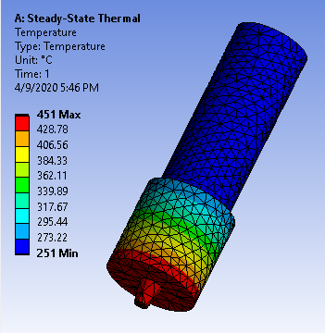

Fig. 11. Temperature distribution in FSP tool

.

# Results and discussions

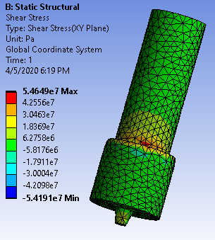

Fig. 15. Shear stress distribution in XY Plane

.

## Thermal analysis

In the plunging phase of the FSP process, the rotating tool pin slowly plunges into the base material, until the tool shoulder touches the surface of the base material, during this process, the rise in temperature is less, and hence the temperature effect in stress analysis is neglected, and the temperature increases once the tool starts moving along the base metal. The rise in temperature is due to the friction between the rotating tool and the base metal, and it generates the heat and makes the base material soft and it undergoes plastic deformation. The temperature range in the tool during the FSP process considered as mentioned in the literatures [32][35]. The steady-state thermal analysis of tool is carried out with the temperature range of 2510C to 4510C the temperature distribution on the tool is as shown in Fig 11. The rise in temperature during process induces the thermal stresses in the tool and the strength of the tool material decreases and leads to the failure of the tool material during the operation, hence, the effect of temperature considered in the stress analysis of the tool in travelling phase.

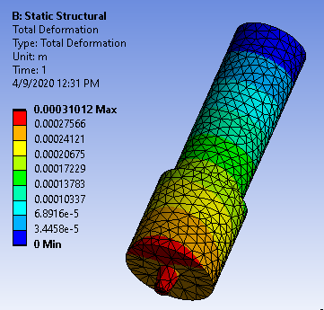

Fig. 16. Total deformation of the tool in travelling

.

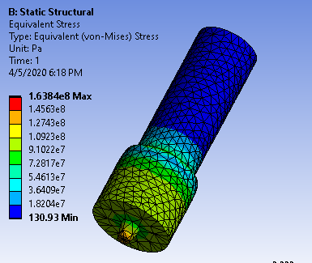

Fig. 13. Von Misses Stress distribution in FSP tool

.

## Static Stress analysis

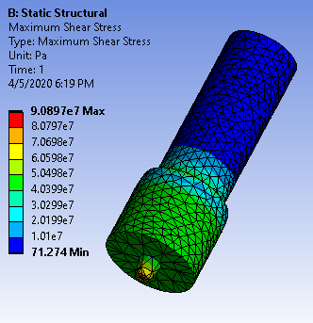

Fig. 14. Maximum Shear Stress distribution

.

The stress analysis of the tool in plunging phase without temperature effect shows the negligible deformation and the minimum stress at critical sections even though the tool experiences the maximum force in plunging phase. The Table 6 shows the minimum, maximum and average deformation, equivalent von misses stress and shear stresses in the tool during the plunging phase. The Fig 12 shows the tool deformation at pin tip, shoulder contact surface and in the shoulder are of 12.88µm, 11.45µm and 10 to 1.4 µm respectively.

The maximum deformation occurs in terms of microns; hence, the deformation due to the axial thrust force on the tool is neglected and there is no yielding of the tool during the plunging phase.

The stress plot shown in Fig 13 for tool in plunging phase indicates that the maximum equivalent Von Misses stress of 163.84MPa near the tool pin tip and 91MPa to 36.4MPa throughout the length of the tool shoulder. The maximum shear stress is 90.89MPa at the tool pin tip and the shoulder experiences the shear stress of 40MPa to 20MPa as shown in Fig 14. The Shear stress in XY plane is 54.65MPa near the shank and the tool shoulder intersection as shown in Fig 15. The induced normal stresses and shear stresses are much below the yield strength and shear strength of the tool material, hence no yielding of the tool during the plunging phase.

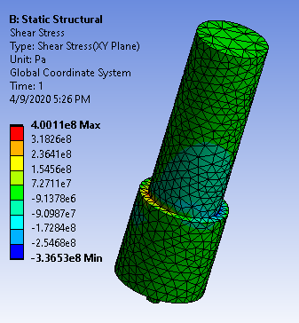

Fig. 19. Shear stress distribution (XY Plane) in FSP tool

.

Table 6

Deformation and stresses induced in FSP tool during plunging phase.

|  |  |  |  |  |
| --- | --- | --- | --- | --- |
| Particulars | Total deformation  (mm) | Equivalent von misses Stress  (MPa) | Maximum Shear Stress  (MPa) | Shear Stress  (MPa) |
| Min | 0 | 130.93 e-6 | 71.274 e-6 | -54.191 |
| Max | 0.0129 | 163.84 | 90.897 | 54.649 |
| Avg | 0.0075 | 46.216 | 23.919 | 0.43881 |

.

The stress analysis of tool in travelling phase is carried out with the effect of temperature. The Fig 16 shows the maximum deformation of 0.31mm near the pin tip and at the contact surface of the shoulder at advancing side of the tool.

The Fig 17 shows the equivalent Von Misses stress distribution in the tool. The tool pin tip and pin side experiences stress of 9.479MPa and 237.9MPa respectively. The tool shoulder experiences the stress of 9.48MPa to 352MPa, and at the intersection of tool shank and the shoulder experiences maximum stress of 1037.7MPa, due to the abrupt change in the cross-section of the tool shank.

`Table 7

Deformation and stresses induced in FSP tool during travelling

|  |  |  |  |  |  |
| --- | --- | --- | --- | --- | --- |
| Particulars | Total deformation  (mm) | Equivalent von misses Stress  (MPa) | Max  Shear Stress  (MPa) | Shear Stress  (Pa) | Safety factor |
| Min | 0 | 9.4795 | 5.432 | -336.53 | 1.37 |
| Max | 0.31 | 1037.7 | 580.23 | 400.11 | 15. |
| Avg | 0.147 | 500.69 | 257.62 | -1.8391 | 5.2 |

.

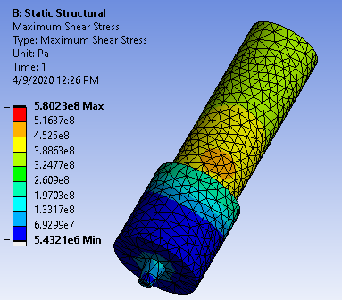

Fig. 18. Max Shear Stress distribution of FSP tool in travelling

.

The maximum shear stress distribution of the tool is as shown in Fig 18. The tool shoulder and pin experiences the shear stress of 5.4MPa to 133MPa. The tool shank experience shear stress of 452.5MPa. The Fig 19 shows the shear stress distribution of the tool along the XY plane. The tool shoulder and the shank intersection experience the maximum shear stress of 400MPa along the reheating side of the tool.

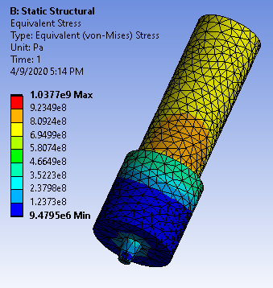

Fig 17. distribution of Equivalent Von Misses stress in tool during travel

According to maximum shear stress theory the stress tool safety factor varies from 1.37 to 5 and 5 to 15 at tool pin and at the tool shoulder respectively as shown in the Fig 20. The stress analysis results reveals that the induced stresses are lower than the yield strength and the yield shear strength of the tool material; hence no yielding of the tool in travelling phase.

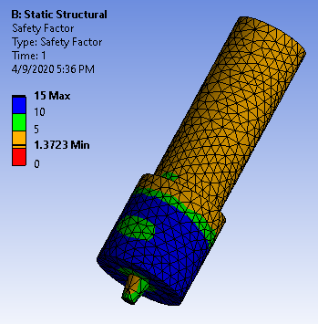

Fig. 20. Safety Factor of FSP tool in static loading

.

The minimum, maximum and average normal stresses, shear stresses and safety factor of the tool during travelling phase are shown in the Table 7.

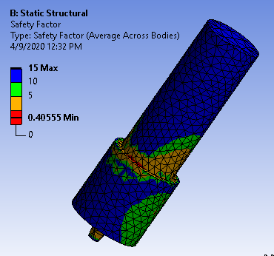

Fig. 22. Safety Factor of FSP tool in fatigue loading

.

## Fatigue analysis

The fatigue analysis of tool carried out by considering the zero-based loading condition and stress life method to determine the fatigue strength and the fatigue life of the tool under the action of fatigue loads [8]. The Soderberg fatigue failure criterion is used to predict the fatigue life or number of cycles to fatigue failure for the FSP tool during the operation. The Fig 21 shows the fatigue life of tool at different sections of the tool and the Fig 23 shows the S-N curve under the fatigue loading, it is clear that the number of cycles or the fatigue life of the tool is 14734 cycles for 100% loading condition. The safety factor is 0.41 at the shank and the shoulder intersection of the tool and it vary from 1 to 5 at tool pin and 5 to 15 at tool shoulder as shown in Fig 22. The fatigue analysis results are tabulated as shown in Table 8.

Table 8

Fatigue life and safety factor of FSP tool

|  |  |  |
| --- | --- | --- |
| Particulars | Life  (cycles) | Safety  Factor |
| Min | 14734 | 0.40555 |
| Max | 1.e+006 | 15. |
| Avg | 9.9193e+005 | 10.274 |

.

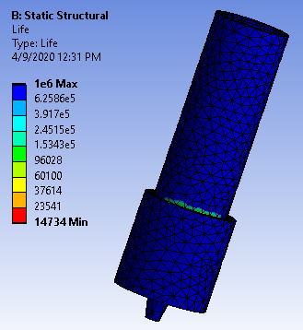

Fig. 21.Fatigue Life of FSP tool

.

# Conclusions

The suitable FSP tool is successfully designed for the existing vertical CNC milling machine to fabricate magnesium alloy based surface composites by friction stir process, from the present work, the following conclusions are drawn,

1. The tool material H13 tool steel used with the tool shoulder diameter of 20mm and the average pin diameter of 4mm to fabricate the defect-free surface composites.
2. The forces acting on the tool during the process are found using analytical models, the maximum force acts on tool in plunging phase and on pin-side, the maximum force acts in travelling phase.
3. The static stress analysis in plunging and travelling phase shows that the negligible deformation in the tool shoulder and the pin, and the induced normal and shear stresses are less than the yield strength and yield shear strength of the tool material, hence no yielding of tool in the process.

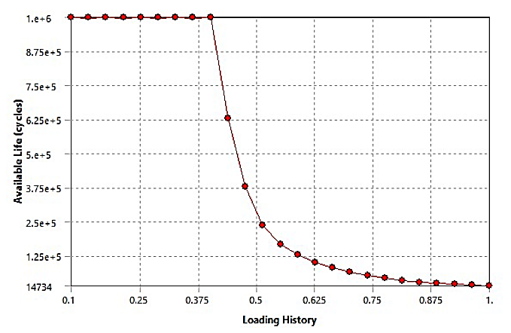

Fig. 23.S-N Curve

.

1. The fatigue analysis of tool indicates that the minimum tool life is 14734 cycles, and the safety factor varies from 1 to 5 at tool pin and 5 to 15 for tool shoulder, and 0.4 at the shank and shoulder intersection. The safety factor 0.4 is increased by providing fillet with a suitable radius, by reducing stress concentration due to abrupt change in the cross-section.

references

1. Mihriban O. Pekguleryuz, Karl U. Kainer and A. Arslan “Fundamentals of magnesium alloy metallurgy” Edited by Kaya Woodhead Publishing Limited, 2013 Oxford Cambridge Philadelphia New Delhi
2. Dadashpour M A. Mostafapour R. YEŞIlDAL, S. Rouhi, “Effect of process parameter on mechanical properties and fracture behavior of AZ91C/SiO2 composite fabricated by FSP” http://dx.doi.org/10.1016/j.msea.2015.12.103
3. Marek Stanisław Węglowski Friction stir processing – State of the art archives of civil and mechanical engineering 18 (2018) 114 – 129
4. Sandeep Ratheea, Sachin Maheshwaria, and Arshad Noor Siddiqueeb Issues and strategies in composite fabrication via friction stir processing: A review Materials and Manufacturing Processes, 33:3, 239-261
5. A. Arora, T. DebRoy, H.K.D.H. Bhadeshia “Back-of-the-envelope calculations in friction stir welding – Velocities, peak temperature, torque, and hardness.” Acta Materialia 59 (2011) 2020–2028.
6. Mohammad Iqbal, Yunus, Kanwarjeet Singh, Gaurav Arora and Ranganath M Singariϯ “Comparative Study on the Effect of Nitriding and Microwave Coating on Microstructure, Hardness and Wear of AISI H13 Tool Steel”. International Journal of Current Engineering and Technology E-ISSN 2277 – 4106, P-ISSN 2347 – 5161.
7. Hao Su, Chuansong, “Determination of the traverse force in friction stir welding with different tool pin profiles” Science and Technology of Welding and Joining, DOI: 10.1080/13621718.2018.1512738
8. C.B. Jagadeesha, “Analysis and design of friction stir welding tool” J Mech Behav Mater 2016; 25(5–6): 179–182
9. A. Razal Rose, K. Manisekar, V. Balasubramanian “Effect of axial force on microstructure and tensile properties of friction stir welded AZ61A magnesium alloy” Trans. Nonferrous Met. Soc. China 21(2011) 974-984.
10. Budynas−Nisbett “Fatigue Failure Resulting from Variable Loading,” in “*Shigley’s Mechanical Engineering Design*,” 8th ed... McGraw−Hill Primis online. 2008. pp. 258-309
11. P. Shahi and M. Barmou “Force and torque in friction stir welding Chapter” August 2014 DOI: 10.1533/9780857094551.459
12. Li, W., Shi, S., Wang, F., Zhang, Z., Ma, T. and Li, J. (2012) 'Numerical Simulation of Friction Welding Processes Based on ABAQUS Environment,” Journal of Engineering Science and Technology Review 5 (3) (2012) 5(3), pp. 10-19.
13. Sanjeev N.K*1, Vinayak Malik2, H. Suresh Hebbar1 “Effect of Coefficient of Friction in Finite Element Modeling of Friction Stir Welding and its Importance in Manufacturing Process Modeling Applications” Int. Journal of Applied Sciences and Engineering Research, Vol. 3, No. 4, 2014.
14. Z. Zhang & Q. Wu “Analytical and numerical studies of fatigue stresses in friction stir welding” Int J Adv Manuf Technol (2015) 78:1371–1380.
15. S.Ramesh Babu, S.Pavithran, M. Nithin, B.Parameshwaran, “Effect of Tool Shoulder Diameter during Friction Stir Processing of AZ31B alloy sheets of various thicknesses” Procedia Engineering 97 ( 2014 ) 800 – 809.
16. A. Arora, M. Mehta, A. De, T. DebRoy, “Load bearing capacity of tool pin during friction stir welding” Int J Adv Manuf Technol (2012) 61:911–920
17. Akash Gupta, Prabhjot Singh, Piyush Gulati, Dinesh Kumar Shuklad “Effect of Tool rotation speed and feed rate on the formation of tunnel defect in Friction Stir Processing of AZ31 Magnesium alloy,” Materials Today: Proceedings 2 (2015) 3463 – 3470.
18. Dehong Lu n, YehuaJiang, RongZhou “Wear performance of nano-Al2O3 particles and CNTs reinforced magnesium matrix composites by friction stir processing,” Wear 305(2013)286–290.
19. A. Arora,a A. Deb and T. DebRoy “Toward optimum friction stir welding tool shoulder diameter,” Scripta Materialia 64 (2011) 9–12.
20. K. Kumar , C. Kalyan , Satish V. Kailas & T. S. Srivatsan “An Investigation of Friction During Friction Stir Welding of Metallic Materials,” Materials and Manufacturing Processes, 24:4, 438-445,
21. V. S. Gadakh, A. Kumar, And G. J. Vikhe Patil “Analytical Modeling of the Friction Stir Welding Process Using Different Pin Profiles,” April 2015 / WELDING JOURNAL 115—124s.
22. Z. Zhang, Q. Wu, and H.W. Zhang, “Computational methods on tool forces in friction stir welding,” ICCM2014 28-30th July, Cambridge, England.
23. Fadi Al-Badour, Nesar Merah, Abdelrahman Shuaib, Abdelaziz Bazoune Coupled Eulerian Lagrangian “finite element modeling of friction stir welding processes,” Journal of Materials Processing Technology 213 (2013) 1433– 1439.
24. Elhadj Raouache, Zied Driss, Mohamed Guidara, Fares Khalfallah, “Effect of the Tool Geometries on Thermal Analysis of the Friction Stir Welding,” International Journal of Mechanics and Applications 2016, 6(1): 1-7.
25. B. Meyghani, M. Awang, S. Emamian and Nor M. Khalid, “Developing a Finite Element Model for Thermal Analysis of Friction Stir Welding by Calculating Temperature Dependent Friction Coefficient,” 2nd International Conference on Mechanical, Manufacturing and Process Plant Engineering. 2017.
26. Bahman Meyghani and Mokhtar Awang, “Developing a Finite Element Model for Thermal Analysis of Friction Stir Welding (FSW) Using Hyperworks,” Advances in Material Sciences and Engineering,2020
27. Huseyin Tarik Serindag, Binnur Goren Kiral “Friction Stir Welding of AZ31 Magnesium Alloys –A Numerical and Experimental Study,” Latin American Journal of Solids and Structures 14 (2017) 113-130.
28. R.S. Mishra, Sumit Jain, “Friction stir processing of magnesium alloys used in automobile and aerospace applications,” Int, Journal of Research in Engineering and Innovation Vol-1, Issue-4 (2017), 54-62.
29. Sattar S. Emamian & Mokhtar Awang & Farazila Yusof & Mohammadnassir Sheikholeslam & Mehrshad Mehrpouya “Improving the friction stir welding tool life for joining the metal matrix composites,” The International Journal of Advanced Manufacturing Technology (2020) 106:3217–3227.
30. Bahman Meyghani, Mokhtar B Awang, Raoof Gholami Mian Poshteh, Mohammadsadegh Momeni, Saeid Kakooei and Zakaria Hamdi, “The Effect of Friction Coefficient in Thermal Analysis of Friction Stir Welding (FSW),” Materials Science and Engineering 495 (2019) 012102.
31. M. B. ĐURĐANOVI, M. M. MIJAJLOVIĆ,D. S. MILČIĆ, D. S. STAMENKOVIĆ, “Heat Generation During Friction Stir Welding Process” Tribology in industry, Volume 31, No. 1&2, 2009.
32. P. Asadi, R.A. Mahdavinejad, S. Tutunchilar “Simulation and experimental investigation of FSP of AZ91 magnesium alloy”, Materials Science and Engineering A 528 (2011) 6469– 6477.
33. G. Padmanaban, V. Balasubramanian, “Selection of FSW tool pin profile, shoulder diameter and material for joining AZ31B magnesium alloy – An experimental approach” Materials and Design 30 (2009) 2647–2656.
34. Z Zhang, Z Y Wan,” Predictions of tool forces in friction stir welding of AZ91 magnesium alloy” Science and Technology of Welding and Joining 2012 VOL 17 NO 6 495-500.
35. H Schmidt, J Hattel, J Wert,” An analytical model for the heat generation in friction stir welding” Modelling Simul. Mater. Sci. Eng. 12 (2004) 143–157.

**Lingaraj Ritti.** Born on 04 March, 1987 in Ranebennur, Karnataka India. Completed BE in Mechanical Engineering in 2009, and obtained M.Tech in Design Engineering in 2012 from Visvesvaraya Technological University. Belagavi.

From 2013 to till date working as an Sr, Assistant Professor in the Department of Mechanical Engineering at Shri Madhwa Vadiraja Institute of Technology and Management Bantakal Udupi. Research interests are topology optimization, finite element analysis, design and manufacturing and currently doing research work on surface Nano-composites by friction stir process.

**Thirumaleshwara Bhat** was received the B.E. in Industrial and Production Engineering from Mysore University in and secured 7th rank and M. Tech in Advanced Manufacturing, from the Mangalore University, and the Ph.D. degree in composite materials at Manipal Academy of Higher Education, Manipal.

From 1989 to 1996 He served as a lecturer in SNM Polytechnic Moodabidri, and from 1996 to 2006 worked as an Sr. Lecturer/Asst. Professor in M.I.T, Manipal, and from 2006 to 2014 he became the Professor & Head of the Mechanical Engineering and also served as dean QA from 2014-2015 at SJEC Mangalore. From 2015 to till date Heading Shri Madhwa Vadiraja Institute of Technology and Management Bantakal Udupi. He is the author of more than 14 articles, and published more than 12 papers in Notional/International conferences. His research interests include Advanced Materials and Manufacturing methods; Outcome based education. Guided four candidates in their research work (Both M.Sc. (Engg) and Ph.D.). Currently guiding six research Ph.D. candidates.