**CLASS MONITORING SYSTEM USING VOICE RECOGNITION**

Vasundhara, Lekhana, Manisha Suvarna, Pruthvija U Shetty, Krishna Kumar P

***Abstract:* As time passes new concepts comes into existence and replaces the old methods. Voice recognition is one such concept which is present in most of the areas. But in reality, teaching organization is behind in adapting this technology. Most of the teaching organization follows the old technologies such as taking attendance in a paper sheet or uploading the attendance to server by marking attendance in excels sheet and all. All these methods which consume time and it need lots of patience for the lecturer to do the same. And also, now a day’s students are more annoying and they disturb the class during the presence of lecturer. Also, they will make lots of noise in the absence of lecturer. So, our project is based on voice recognition for class monitoring which includes student attendance and noise control. It helps the lecturer in administrating the students by taking the attendance and noise control in the class with better efficiency. This is because the students always cheat with their attendance by signing on behalf of their friend who did not attend class and a greater noise if the lecturer is on leave or not able to take the class due to some constraints. In this project, voice biometric is used as a medium for student to mark their attendance and controlling the class with the warning. Cheating among students will be prevented because like fingerprints, each voice is different and even class is monitored in an easy way.**

**Vasundhara ,** Electronics and Communication, SMVITM,Udupi (email: [1998vasundara@gmail.com](mailto:1998vasundara@gmail.com))

**Lekhana,** Electronics and Communication, SMVITM, Udupi (email: [lekhanakotian778@gmail.com](mailto:lekhanakotian778@gmail.com))

**Manisha Suvarna,** Electronics and Communication, SMVITM, Udupi (email:[suvarnamanisha00@gmail.com](mailto:suvarnamanisha00@gmail.com))

**Pruthwija U Shetty ,** Electronics and Communication, SMVITM,Udupi (email:[pruthvijasmg.2016@gmail.com](mailto:pruthvijasmg.2016@gmail.com))

**Krishna Kumar P,** Electronics and Communication, SMVITM, Udupi (email: [krishnakumar.ec@sode-edu.in](mailto:krishnakumar.ec@sode-edu.in))

I.INTRODUCTION

In the modern world every one wish to lead smart life and every individual prefers to lead it in a secured manner. Majority of the people are addicted for smart technologies such as smart phones, smart security cameras, home automation etc. For securing personal privacy we may use different technologies but the better and the best one is biometrics.

Biometrics is physical or behavioural human characteristics that can be used to digitally identify a person. It has the ability to make authentication faster, easier and more secure than other technologies because they are considered unique to the individual. Biometrics can be categorized in to two parts. The first one is Physical biometrics which includes fingerprints, hand scan, facial recognition etc. And the second one is Behavioural biometrics which uses behavioural characteristics such as voice signature, keystrokes etc. Biometrics mainly helps to reduce fraud activity by identifying the right person at the right time. For example, think about a workspace where proxy attendance can be marked or else buddy punching is done. At that time biometrics technology keeps the track of the time and attendance of each employee which helps to find the frauds. So, it increases organizational efficiency by making workforce more accurate, reliable and punctual.

We are using one of these biometrics i.e. voice recognition for the class monitoring purpose. Voice recognition is nothing but recognition of the sound which mainly relies on features influenced by vocal cord, emotional status of the person while speaking, tone, pitch etc. Voice recognition can also be called as speaker recognition which is divided in to two categories. Speaker dependent voice recognition is the first one which is influenced by candidate’s particular choice characteristics.

II.METHODOLOGY

The main idea of our project is to build model that can monitor system. This idea can be divided in to two separate parts. Where the first part mainly involves attendance system and the second part includes class monitoring using voice recognition.



**Fig1: Block diagram of proposed attendance system**

Both training and testing phases involves several steps: A) Collecting the voice samples, B) Feature extraction, C) pattern matching.

1. *Collecting the voice samples*

The voice samples of each students are collected.

1. *Feature extraction*

Feature extraction is used to reduce the dimension of the input vector by maintaining the perceptive power of the signal. It results in extraction of specific features. Mainly these features carry the characteristics of the useful information regarding speech. The different features such as power, pitch, and vocal tract configuration from the speech signal can be extracted. Here we used Mel Frequency Cepstral Coefficients(MFCC) technique for speech feature extraction.

The MFCC feature extraction technique includes windowing the signal, applying the DFT, taking the log of the magnitude, and then warping the frequencies on a Mel scale, followed by applying the inverse DCT(Discrete cosine transform). MFCC have 39 features. The feature count is small enough to force us to learn the information of the audio.12 parameters are related to the amplitude of frequencies. It provides us the enough frequency channels to analyse the audio.

## Pattern Matching

The easy way to recognise speaker is by comparing the voice sample of the speaker with stored data base. For the comparison purpose we use Euclidean distance method which is used to calculate the distance between reference voice samples with the stored one. If the distance calculated is minimum then the speaker is identified successfully

If points **p** = (p1, p2) and **q** = (q1, q2) then the distance is given by

Dist((p1,p2),(q1,q2)) = $\sqrt{{\left(p1 – q1\right)}^{2}+ {\left(p2 – q2\right)}^{2}}$

For the second part of the project we use the same concept except MFCC and pattern matching. The block diagram for the class monitoring system is shown in Fig2. First voice sample of each student is collected and stored as database. During Class monitoring the voice signal is continuously extracted and the voice features are collected and the analysis done each time.



**Fig2: Block diagram for class monitoring system**

We are comparing one of the feature, amplitude with the threshold value (amplitude value beyond one level). After comparison if it exceeds the threshold value we are going to keep the count for n number of times. If the count goes beyond n value then the system is going to warn the students by giving a audio message.

III.RESULTS

Speaker recognition is done using the feature extraction technique with the help of MFCC algorithm and pattern matching technique which is shown Fig3.

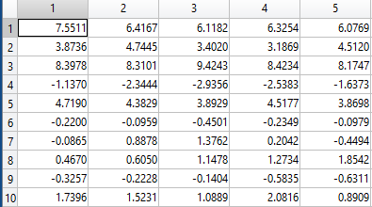

**Fig3:** **Output of MFCC algorithm**

After the identification of each student, attendance is automatically uploaded to the Excel sheet which helps to keep the attendance record in the system which avoids the manual method followed for taking attendance. This is shown in below figure.

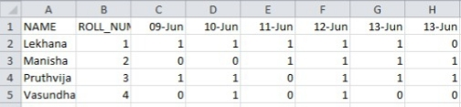

**Fig4: Attendance uploaded in Excel sheet**

While doing the class, if students talks or disturbs the class for the long duration of time then the designed system gives the warning message in the audio format to keep maintain silence.

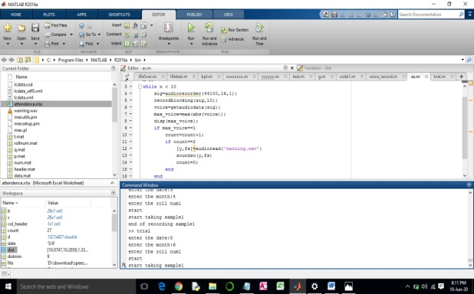

**Fig5: Code written for class monitoring system**

Speaker recognition is done using the feature extraction technique with the help of MFCC algorithm and pattern matching technique. After the identification of each student, attendance is automatically uploaded to the Excel sheet which helps to keep the attendance record in the system which avoids the manual method followed for taking attendance. While doing the class, if students talks or disturbs the class for the long duration of time then the designed system warns the students to keep quite. This helps the lecturer or the teacher to monitor the class in an easy way during the presence or in the absence of the particular lecturer/teacher.

Biometrics is physical or behavioural human characteristics that can be used to digitally identify a person .One of the biometrics i.e. Voice recognition is used for student attendance system and for class monitoring system which avoids cheating among students because, each voice is different and even, class is monitored in an easy way.

In this project we have proposed simple class monitoring system using voice recognition. The system is accurate in recognizing a student by his/her voice and also stores the attendance based on it. While two or more person simultaneously answering the attendance the system may not be able to mark the attendance properly. Our future work is related to more accuracy and to overcome the above problem with an efficient way. And also in case of class monitoring, we have to focus on the voice recognition of individual students while multiple students are talking. And the system must warn the student by identifying the particular student who is disturbing the class in an efficient way. If she/he ignores the warning message automatic attendance detection can be implemented in future works.

IV.CONCLUSIONS AND FUTURE WORK

In this project, voice biometric is used as a medium for student to mark their attendance and controlling the class with the warning message.

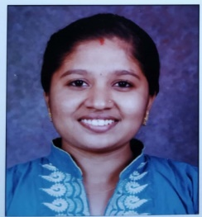REFERENCES

1. C.J Perera, S. Sumathipala, B.H. Sudanatha “Victim Detection Using UAV with **On-board Voice Recognition System*”***, ISBN: 978-1-5386-9245-5/, IEEE,2019.
2. Akanksha Singh Thakur, Namrata sahayam “**Speech recognition using euclidean distance**”, ISSN 2250-2459, ISO 9001:2008 certified journal, March 2013.
3. 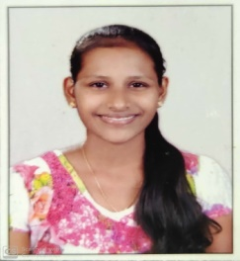Om Prakash Prabhakar, Naveen Kumar Sahu “**Performance improvement of human voice recognition system using Gaussian mixture model**”**,**ISSN:2319-5940, International journal of advanced research, January 2014.
4. Hairol Nizam Mohd., Mohd.Zmzuri Ab Rashid, Zalina Kamis “**Biometric Voice Recognition in security system**”, ISSN:0974-6846, Indian journal of science and technology, February 2014.
5. 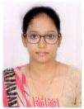J. Dhalia, Sweetlin, V.Aswini ,R.Dhanusha “**Speech Based Attendance Application Register**” *,*ISBN:978-1-4673-9802-2/,IEEE,2016
6. Anjali Bala, Abhijith kumar, Nidhika Birla “**Voice command recognition system based on MFCC and DTW**”, International journal of Engineering science and Technology,7335-7342, 2010
7. 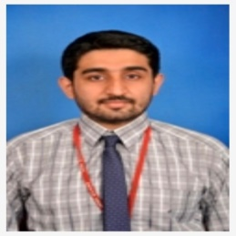Gulmira K.Berdibaeva, Oleg N. Bodin, Kasymbek A “**Pre-processing voice signals for voice recognition systems**” 18th International conference micro/nano technologies and electron devices EDM 2017.

AUTHORS PROFILE

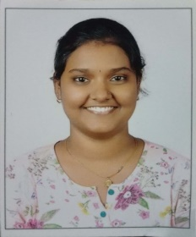

**Vasundhara,** student in the department of Electronics and Communication Engineering at Shri Madhwa Vadiraja Institute of Technology and Management, Bantakal

**Manisha Suvarna,**student in the department of Electronics and Communication at

Shri Madhwa Vadiraja Institute of Technology and management, Bantakal

**Lekhana,** student in the department of

Electronics and Communication at Shri Madhwa Vadiraja Institute of Technology and Management, Bantakal

**Pruthvija U Shetty,** student in the department of

Electronics and Communication at Shri Madhwa Vadiraja Institute of Technology and Management, Bantakal

**Krishna Kumar P,** has done his B.E. degree in Electronics and

MTech in Digital Electronics and communication. He is a Professor of Electronics and Communication Engineering. He has teaching experience of 7 years. His areas of interest are Signal Processing, Image Processing, and Antenna and Propagation.He also owns membership of MISTE.