

**CROP FIELD MANAGEMENT BASED ON IOT USING RASPBERRY PI**

**Divya Gurunath Shet, M Sowmyashree, Meghana G, Noopura, Ms. Sowmya Bhat**

**Department of Electronics and Communication Engineering, Shri Madhwa Vadiraja Institute of Technology and Management, Bantakal – 574115.**



**CROP FIELD MANAGEMENT BASED ON IOT**

**USING RASPBERRY PI**



**Abstract**

**Sustainability of Agriculture is important during the soil degradation, scarce water resource and climate change. Improving the efficiency of water use and its productivity practiced by farmers are not sufficient nowadays. We can get solution by making use of several real time experiments. By using our project it can problems like monitoring of water, soil degradation etc. In our project, by using Pi it can monitor all other application like GSM, digital sensor and DC motor with pump. The device digital sensor provides you better solution in accurate level measurement and automatic processing water levels.** **By using GSM it can send the information about moisture content to the field owner since field owner cannot monitor the water content every time. A digital sensor measures the moisture content in the soil and is accessed through Pi. Soon after sensing the moisture content, by using dc Motor we can make water to flow to field, if the content of moisture is low and at the same time the message is sent to the field owner.** . **We can also use led and buzzer to indicate moisture content, also DTH sensor and LCD to display temperature and humidity. Thus our project helps the farmers to yield even when there is water scarcity.**

**Keywords: GSM, Raspberry Pi, Digital sensor, DTH sensor, DC motor, LCD.**



**Introduction**

In India the major source of income is from the field of Agriculture. It alone contributes for about 22% of the country’s income. Farmers can select the required crop for their field with the use of appropriate fertilizers for their crop. The major reason for the decrease in the yield is due to the diseases which are present in the plants. Due to the disease there will also be reduction in the quality of the products [1].As the technology is growing up, it can be implemented in the agriculture too. The use of IOT in agriculture provides solution to all the problems faced in the traditional agriculture method. Controlling the field condition is a tedious task. By the use of wireless system in the field of agriculture various issues can be solved [2].

Till now the identification of disease was done manually, in all of these techniques the digital domain is widely being used. The use of digital system gives intuitive judgement. The early judgement of disease makes the farmers to avoid losses. The agriculture will provide good result in return. The use of non-applicable fertilizers can be avoided. In most of the case the disease symptoms are seen in the parts of leaf, stem and the fruit. In this system we are develop a system that detects the disease present in the plant leaf [3].



**Methodology**

The moisture content and humidity and temperature are measured using Soil Moisture Sensor and DHT11 Sensor respectively. This data is fed into Raspberry Pi to monitor the water level. Raspberry Pi compares the given data with saved data and gives the result. Based on Raspberry Pi result it will decide the water quantity that should be given to field using motor. Motor runs only when

the water content is less than the value of threshold in the soil. A Water level Sensor is used to measure the water level in the tank to reduce the overflow of water. The information about the field’s water content is also sent to the field owner using GSM module as shown in Fig.2. As an implementation we are using pH sensor and Robot for better growth of plants. The pH value of picture is measured by pH sensor without human intervention to the field to yield more productivity.



Fig.1: Block Diagram of the System

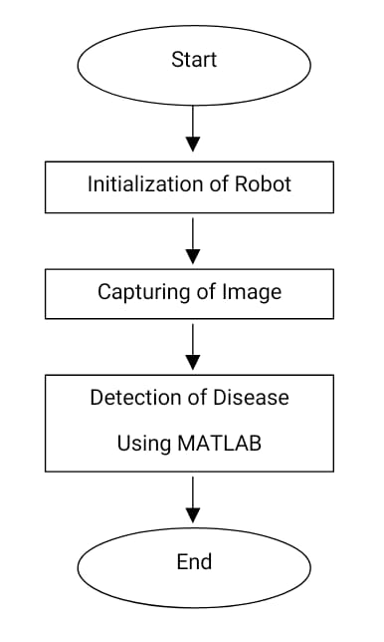

Fig.3: Flow Chart for Detection of Disease

A Pi cam is used to capture the diseased plant picture without human intervention to the field to yield more productivity as shown in Fig.3. Robots are used to help the entire system of crop productivity.

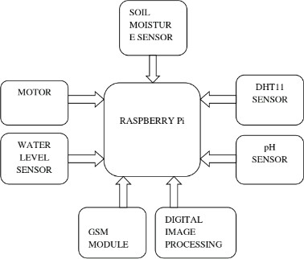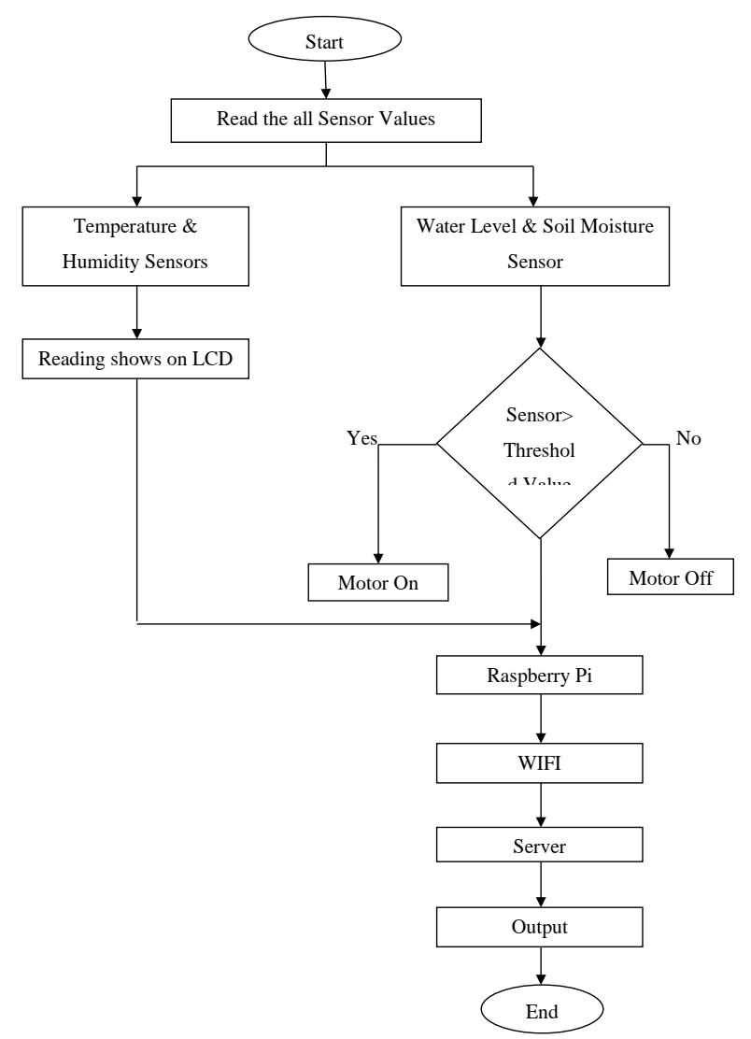

Fig.2: Flow Chart for Soil Reading

**Software/Hardware requirements**

**VNC Viewer:**

It is remote control software program which controls the pc with network connection. We can transmit the keyboard and mouse occasions from one device to another, by way of the assist of network.

**DHT11 Sensor:**

It is a sensor, which reports the humidity and temperature value in air.

**Soil Moisture Sensor:**

It monitors the moisture content of the soil on the basis of electric resistance, dielectric content or interaction with neutrons as a proxy for the moisture content.

**GSM Module:**

It is used to establish communication between devices. It compresses and digitizes data and sends it down through a channel, each having its own timeslot, with two other streams of user data.

**Raspberry Pi:**

It is a regular motive pc based totally on Linux Operating System which handles hardware components.

**Pi Camera Module:**

It is a transportable mild weight digital camera that supports Raspberry Pi. By the usage of the MIPI camera serial interface protocol it communicates with Pi. It is normally used in computing device learning, surveillance projects, or in photo processing.

**100 RPM Motor:**

It is a fantastic lower priced DC geared motor. It consists of steel gears and pinions to make certain longer lifestyles and higher put on and tear properties. On hardened steel spindles polished to a mirror end the gears are fixed. In a plastic bushing the output shaft rotates and a plastic ring is covered from outside. Gearbox is sealed and utilized with lithium grease and it does now not require any maintenance. From inner the motor is screwed to the equipment box.

**Aluminum Composite Panels:**

They are made up of Aluminum Composite Material (ACM) and are flat panels with two thin coil-coated aluminum sheets bonded to a non-aluminum core. It is used to make robot body.

**MATLAB:**

It enables us to operate intensive duties quicker than with typical programming languages such as C, C and so on computationally.

**IMAGE PROCESSING**

Here the image is converted into digital form and performing some operations on it. It helps in getting enhanced image. By using image processing, the basic steps are shown in figure.

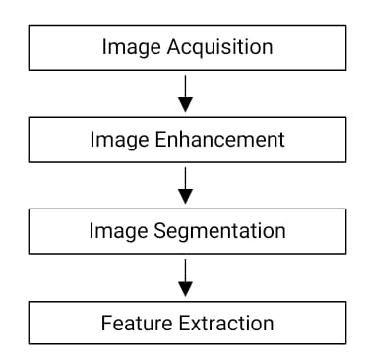

Fig.4 Block Diagram for Plant Disease Detection and Identification

**Image Acquisition**

It means capturing the images with the help of digital camera and it will be in RGB form. Generally, it involves pre-processing, such as scaling etc.

**Image Enhancement**

It adjusts an photograph so that the end result is greater suitable for a in addition application. Example includes:

* Brightening of an out of focal point image.
* Highlighting the edges.
* Improving distinction of an picture and eliminating noise

**Image Segmentation**

It includes subdividing of an image into large number of small parts. By performing this one, we can identify following things:

* + - Finding particular shapes, lines, or circles in an image
* In an aerial photograph, identifying roads, cars, or buildings.

The clustering of segmented images uses K-means Clustering Algorithm and Otsu’s Classifier. Before clustering, the RGB image is converted into ‘Lab’ refers to radiance layer ‘L’, chromaticity. Layer ‘a’ (Color falls along the red-green axis) and chromaticity layer ‘b’ (Color falls along the blue- yellow axis). The Lab color model helps in easy clustering of subdivided images.

**K-means Clustering Algorithm**

1. Input image is loaded.
2. Convert the input RGB image into L*a*b color space.
3. To the agricultural science RGB image feature Pixel Counting technique is extensively applied.
4. Using K-mean method the variant colors are clustered.
5. Between two objects the Euclidean distance is found.
6. Based on its estimated variant cluster-centre each pixel is labeled under clusters.

**Otsu’s Classifier**

To perform clustering based an image threshold is done by Otsu’s Classifier. This algorithm says that an image will have two classes of pixels and it constitutes bi-modal histogram. The optimum threshold is calculated by isolation of their combined spread/intra-class variance.

**Feature Extraction**

Identification of an object is done by Feature Extraction. The Feature means, it is a function of one or more measurements, specifying quantifiable property or significant characteristics of an object. In an algorithm, if the input data is very large to be processed and it is suspected to be redundant. Then the original image is converted into a reduced set of features. The plant disease

detection use color, texture, morphology, edges etc. as the features. The infected areas in plants can also be detected using Feature Extraction.

**Results**

Robot is made for yielding better results compared to previous versions. By using Pi Camera Module, we are able to capture a picture of affected plant and the constructed robot is shown below:

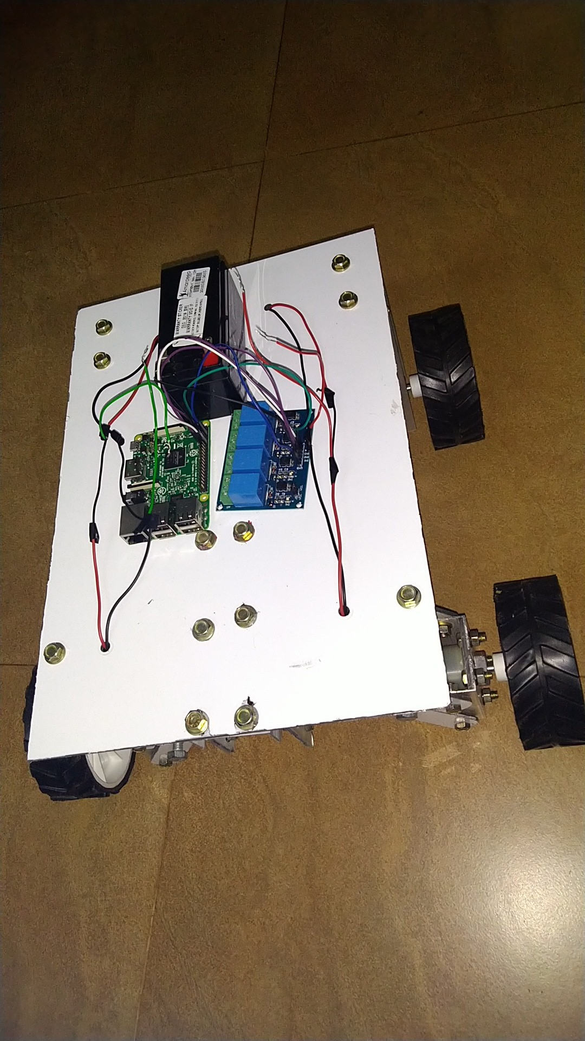

Fig.5: Constructed Robot

In our project we apply image processing technique using MATLAB on the input image. Whenever a plant leaf containing disease appears corresponding disease is detected by the use of K-means clustering algorithm and Otsu’s Classifier as shown in Fig.6. This method gives appropriate result and also it takes less amount of time when compared with the other methods.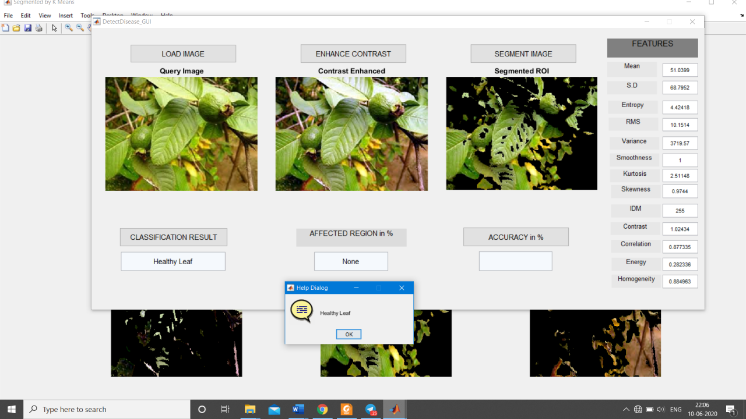

Fig 6: Detection of Plant Leaf Disease





**Conclusion**

We have designed this system to help the farmers to improve their crop production in a modern way. This system is user-friendly and it introduces latest technology into agriculture. Smart agriculture can be achieved by the Intelligent Management

System. Reducing the water consumption is a big challenge for the farmers. So this Automated Irrigation System having DHT11 sensor and soil moisture sensor helps the farmers to reduce water consumption in digital way. The motor will ON/OFF automatically based on the values obtained from the sensors which automatically monitor irrigation. Robots monitor the entire system by moving around the field. Plant disease is the major factor that has lead to series of losses to farmers. Here plant detection is done by using image processing. ANN methods can be used for the classification of disease in plants. Image processing enhances the plant image and performs image segmentation and feature extraction is used finally to detect the disease of the plants. Hence this smart system is proposed to monitor the agriculture which improves yield and it also saves time since no human intervention is needed.



**Future Scope**

Each crop requires different variety of fertilizers. When the field needs fertilizer, we can spray automatically without the help of human being. But in this system we cannot analyze the required fertilizer that is needed for each and every variety of crops. Also, we can put in force net primarily based photo processing technique. In the case of web based totally picture processing, classification of algorithm will be carried out in the cloud itself. Real time monitoring of the information will be there if we use the cloud platform .



**Reference**

1. Dr. Dhiraj Sunehra, “Web Based Smart Irrigation System Using Raspberry Pi”, *International Journal of Advanced Research in Engineering and Technology* , 10 (2), 2019, pp 55-64.
2. Mrs.T.Vineela, J. NagaHarini, Ch.Kiranmai, G.Harshitha, B.AdiLakshmi “IoT Based Agriculture Monitoring and Smart Irrigation System Using Raspberry Pi”*International Research Journal of Engineering and Technology* (IRJET) e-ISSN:2395-0056
3. Agraj Aher, Janhavi Kasar, Palasha Ahuja, Varsha Jadhav “Smart Agriculture Using Clustering and IoT ”*International Research Journal of Engineering and Technology* (IRJET) e-ISSN: 2395-0056
4. Manasa Sandeep, C. Nandini, Bindu L, Champa P, Deepika K H, Anushree N “IoT Based Smart Farming System” *International Research Journal of Engineering and Technology* (IRJET) e-ISSN: 2395-0056
5. Wahidur Rahman, Elias Hossain, Rahabul Islam, Harun-Ar-Rashid, Nur-A- Alam, “Real-time and Low-cost IoT Based Farming Using Raspberry Pi” *Indonesian Journal of Electrical Engineering and Computer Science* Vol.17, No.1, January2020, pp.197~204
6. Rajendra Akhil Kumar, Gone Sri Vaishnavi, Pilli Sathavardhana Rao, Diwakar. R.Marur “Crop Monitoring Using Visual Sensors and IOT”*SSRG International Journal of Electronics and Communication Engineering* (SSRG – IJECE ) –Volume 4 Issue 4 – April 2017
7. Priyanka G. Shinde, Ajay K. Shinde, Ajinkya A. Shinde, Borate S. P. “Plant Disease Detection Using Raspberry PI By K-means Clustering Algorithm” ISSN (Online): 2347-2820, Volume -5, Issue-1, 2017
8. Athira P. Shaji “Raspberry Pi Based Real Time Monitoring of Agriculture & Irrigation Using IOT” IJEDR 2018 | Volume 6, Issue 2 | ISSN: 2321-9939
9. Dr V Anandkumar, Kalaiarasan T R , Dr.S.Balakrishnan “IoT Based Soil Analysis and Irrigation System”*International Journal of Pure and Applied Mathematics* Volume 119 No. 12 2018, 1127-1134
10. National Farmers Union report. (Feb 2017) Contributions of UK agriculture. [Online]. Available:https://[www.nfuonline.com/assets/93419](http://www.nfuonline.com/assets/93419)
11. S. R. Nandurkar, V. R. Thool, R. C. Thool, “Design and Development of Precision Agriculture System Using Wireless Sensor Network*”, IEEE International Conference on Automation, Control, Energy and Systems (ACES)* , 2014
12. IoT Applications in Agriculture, January 2018, [online] Available: https://[www.iotforall.com/iot-applications-in-agriculture/.](http://www.iotforall.com/iot-applications-in-agriculture/)
13. Nikesh Gondchawar, R. S. Kawitkar, "IoT based Smart Agriculture*", International Journal of Advanced Research in Computer and Communication Engineering* , vol. 5, no. 6, pp. 2278-1021, June 2016.
14. R.C.Gonzalez, R.E.Woods, “Colour Image Processing”, in Digital Image Processing, 3rd ed., Pearson Education, Delhi, India, 2009, ch. 6, sec. 7, pp 465-466
15. Shilpa M N, Maya J, Megha N, Meghana R, Nisarga V, “Crop Field Management Based On IoT Using ARM7”,ISSN: 2566-932X, Vol. 2, Issue 2, May 2018 

