DESIGN AND FABRICATION OF TECHNO-ECONOMICAL INCINERATOR USING SOLAR ENERGY

S Manoj1, Rakshith Shetty R2, Rajesh K S3, Shreyas4, Mallya Ananth Mohan5

*Shri Madhwa Vadiraja Institute of Technology and Management, Bantakal, Udupi, Karnataka, India.*

**ABSTRACT**

***Human activities create waste, and it's the way these wastes are handled, stored, collected and disposed of, which may pose risks to the environment and to public health. The management of solid waste is a crucial concern in developing and emergency conditions, e.g. those of an assembly or gathering, where solid waste management infrastructure and services are far away from achieving basic standards in terms of hygiene, efficient collection and disposal. Heaps of sanitary napkins with an outsized amount of disease causing bacteria on them pose a big threat to the hygiene within the surrounding area.*** ***By using the Incinerator, we can avoid the spreading of pathogenic diseases which is caused due to normally disposed napkins. A Solar Incinerator is a waste disposal machine used to burn the used sanitary pads and used diapers completely using solar energy. By using Fresnel lens as solar concentrator it is possible to generate temperature up to 800 degrees Celsius which is enough to dispose the sanitary wastes and also disintegrate the toxic flue gases which are formed due to Incineration.***

**Keywords**: Fresnel Lens, Incinerator, Focal length.

1. INTRODUCTION

Incineration may be a waste treatment process that involves the combustion of organic substances contained in waste materials. Incineration and other heat waste treatment systems are described as “thermal treatment”. Incineration of waste materials converts the waste into ash, flue gas and warmth. The ash is mostly formed by the inorganic constituents of the waste and may take the form of solid lumps or particles carried by the flue gas. The flue gas must be cleaned of gaseous and particulate pollutants before they are dispersed into the atmosphere.

Incineration is also used for disposal of used sanitary pads and diapers to avoid spreading of any pathogenic diseases.  In the process of incineration (at very high temperatures usually about 800 °C.), the waste is converted to ash, which is sterile, since at such high temperatures, almost all pathogens are also destroyed. But for proper disposal of the sanitary napkins it consumes great amount of electricity. Therefore, by solar means it is cheaper and easier to achieve incineration.

1. LITERATURE REVIEW

**Gang Wang, et al.** researched on a replacement quite band-focus Fresnel lens solar concentrator. Here they tested the optical efficiency and spectral concentrating uniformity of the band-focus Fresnel lens and compared the result with the results of linear type Fresnel lens. Monte Carlo Ray Tracing Method (MCRT) was employed for the spectral concentrating simulation of the band-focus solar concentrator. The results show that both the spectral concentrating uniformity and optical efficiency of the band-focus Fresnel lens were better than those of the linear one.

**Vinod Kumar, et al.** made the research on design considerations of Fresnel lens and its effect on various efficiencies, reflectance, transmittance and associated losses. The research was done by comparing the above parameters of the lens thereupon of the parabolic reflectors. The results showed that more over the sharing of cost of reflectors in CSP is high, and Fresnel lens could also be a promising alternative to deal with the shortcomings of reflector and to scale back the LCOE.

**James G. Zippay** features a patented literature on a Kotex incinerator system. He manufactured a portable Kotex incinerator comprising a heating chamber having reflecting surfaces for reflecting and concentrating heat to burn the Kotex. There’s further provided a removable tray for removing debris and a hood assembly with cooperative filter elements for eliminating undesirable odours and fumes emanating from the chamber. This literature gives detailed information about the materials utilized in construction of the incinerator chamber.

**J. L. Graham, et al.** performed a laboratory study using concentrated radiation to destroy hazardous organic wastes. The intensity of simulated radiation & therefore the exposure temperature was varied for a series of test materials employing a specially designed system designated the Thermal/Photolytic Reactor System (TPRS). Examination of those destruction profiles show roughly an element of two increase within the high-temperature destruction when the test compound was simultaneously exposed to 57 suns.

**Grzegorz Wielgosinski** studied the mechanism of dioxin formation in thermal processes, first and foremost in combustion processes. As per his research the methods for limiting the emission of dioxins from technological processes could also be divided into two groups: primary and secondary methods. Among the first methods, the matter of crucial importance is to avoid the presence of chlorine in thermal processes. Subsequent factor of importance is temperature. Dioxins aren't as persistent of chemical compounds as they're widely considered to be, and that they are decomposed at a temperature of 700 °C.

**A. Mukherjee, et al.** researched on various sources that contains the precursors of PCDD/Fs and its formation mechanism during the combustion process. And also researches were conducted to seek out out the effective methods to scale back dioxin formation during incineration. The results showed that the Selective catalytic reduction (SCR) or Selective Catalytic Oxidation (SCO) is alternate effective thanks to reduce the concentration of dioxins to below 0.1 ng I-TEQ/m3.

1. METHODOLOGY
2. METHODS

LITERATURE REVIEW

DESIGNING THE MODEL

MATERIAL SELECTION

FABRICATION

TESTING

1. DESIGNED MODEL
2. FABRICATION METHOD
3. FABRICATION OF LENS FRAME AND LENS SUPPORT

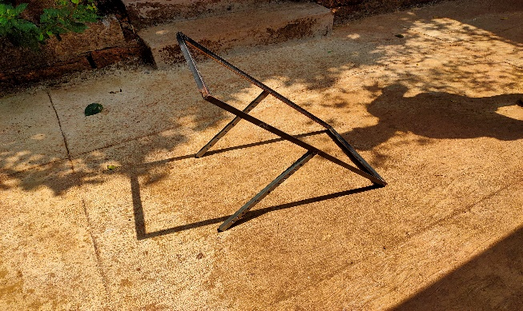

Fig.1 Lens Frame unmounted

The Fresnel lens made of thin film foldable type material therefore to obtain the full potential of the lens under the sun it is stretched and adhered to the ¾ inch angle frame. The lens frame is welded to two ¾ inch square tube in a perpendicular manner.

1. INCINERATOR CHAMBER

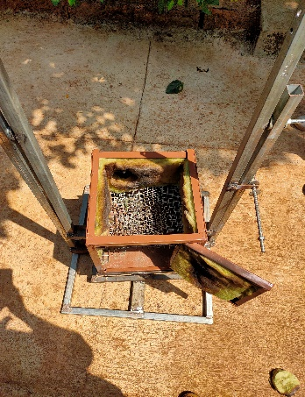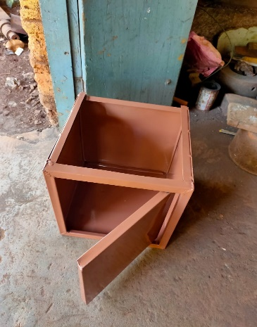

Fig.2 Unmounted Chamber Fig.3 Mounted Chamber

The GI sheet of 1ft*6ft is used to manufacture the Incinerator chamber.The chamber comprises of ½ inch wire mesh at the bottom and an ash tray.The Chamber is made to support a heat resistant glass at the top for complete enclosure of the chamber and an exhaust fan is fixed at the rear end of the chamber.Chamber is thermally insulated with the help of Glass wool.

1. EQUIPMENT BASE

Fig.4 Equipment Base

The base of the equipment is constructed using 1 inch and ¾ inch square tube.

It consists of two type of bases:

Primary base: It is a rigid base constructed using a 1-inch square tube.

Secondary base: It is constructed using a ¾ inch square tube. The secondary base can be tilted 360 degrees at any given time since it is welded to the primary base with 2 ball bearing.

1. LOCKING MECHANISM

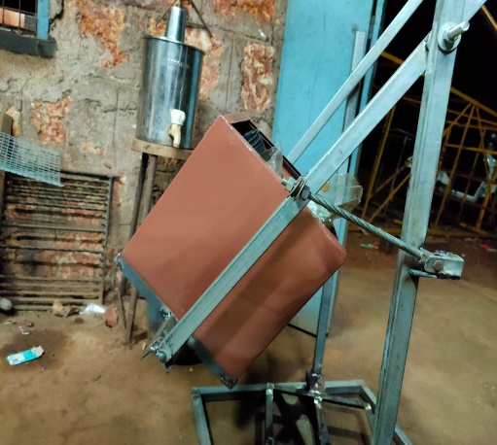

Fig.5 Locking Mechanism

The locking mechanism is used constructed using a 10mm bolt and nut.

The locking mechanism helps to keep the axis of the chamber and the lens collinear up to 55 degree angles in one direction. The bolt head is welded to the outer vertical support and is free to rotate about the head.

1. EXHAUST FAN MOUNTING

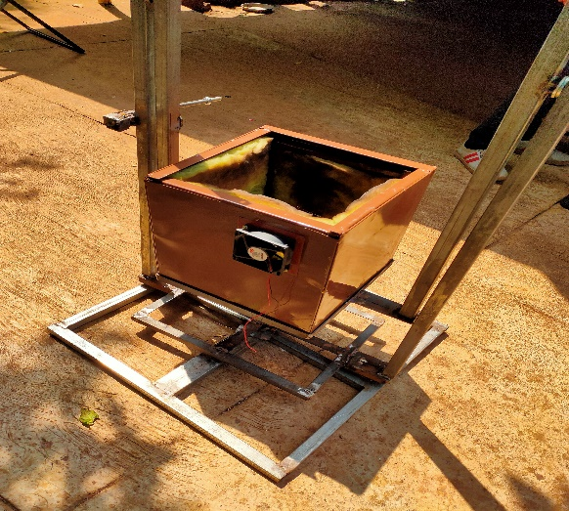

Fig.6 Exhaust fan

The 12V DC exhaust fan is used at the top rear end of the chamber. The fan is mounted to the chamber using two 4mm screws. Two 12V batteries are used operate the exhaust fan.

1. 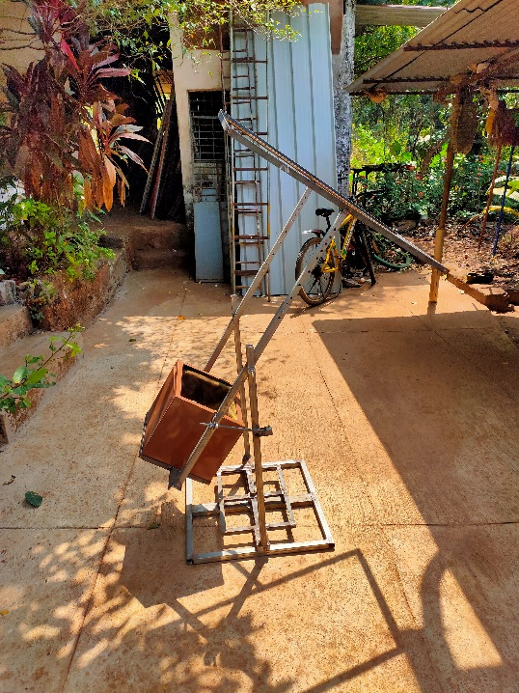FINAL FABRICATED MODEL

Fig.7 Final model

1. WORKING

The whole equipment is fabricated in such a way that the Fresnel lens’s focal point meets the curved bottom of the tungsten wire mesh inside the chamber. If the obtained focal length does not meet the curved portion of the mesh, then the height of the lens frame can be adjusted by moving it up and down and locking it at the required height where required condition is obtained.

The bolt and nut locking mechanism helps to lock the equipment at different angles facing the sun. It is possible to lock equipment up to 55° to the vertical.

Used sanitary napkins are placed inside the incinerator chamber once the frame is adjusted. While placing the napkins one should remember to cover the lens since it is very dangerous to work while the lens is exposed the sun.

While the incineration is under progress the exhaust fan is switched ON. The flue gases from the chamber is directed to the Filter through a hose pipe. Inside the filter the Electrostatic Precipitator collects the smoke and gives of fresh air to the atmosphere. And the collected smoke will be disposed separately.

1. RESULTS AND DISCUSSIONS
2. FOCAL LENGTH TEST

Focal length of the lens according to the description provided by the seller = 730mm.

Obtained focal length during the test = 1000mm and 1cm spot.

Obtainable focal length by adjustment = 730mm to 1080mm.

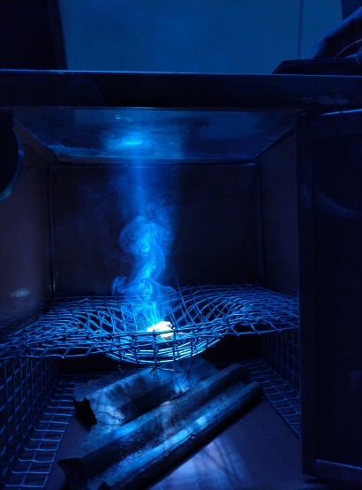

Fig.8 Focal length test

1. CALCULATION OF THE LOCKING ANGLE

Azimuth angle of sun (Elevation to the ground) during 11 am to 3pm = 75 degrees to 140 degrees to the horizontal.

Total angle covered by the sun till 3pm = 140 degrees.

Angle provided w.r.t vertical support in one direction (cw or ccw) = 140-90 = 50(+5) degrees to the vertical.

Rate of change of Azimuth angle of the sun per hour = 16.25 degrees.

1. INCINERATION RESULTS

State of the napkin used: Dry state.

Time during test: 2.30pm.

Angle of inclination of the equipment = 41.11 degrees to the vertical.

No. of napkins used: 1

Temperature obtained at the F.P: 733 degrees Celsius.

Time taken for complete incineration: 4 minutes and 40 seconds.

1. ADVANTAGES

* Cheaper to manufacture compared to commercially available electric incinerators.
* One-time investment since solar energy is a renewable energy source.
* Incineration can be done at higher temperature up to 800 °C. Where as in case of electric incinerator the incineration can be done at the maximum temperature of 300 °C.
* Can be automated easily using sensors like solar tracker and a servo motor.
* Lower maintenance cost
* Higher rate of incineration compared to electric incinerators.

1. LIMITATIONS

* Usage is whether dependent.
* Cannot be accessed all the time in a day.
* During incineration temperature cannot be controlled like in an electric incinerator.
* Filtration of flue gases is still a big challenge till this day.

1. CONCLUSION

The temperature obtained in the process satisfies the waste incineration condition i.e. The incineration of the napkin should be done at least at the temperature of 300 °C. From our project we can conclude that incineration can be done in a faster and effective way by using a Fresnel lens with solar energy application. By comparison we can also conclude that this is the best economical method to manufacture an incinerator.

1. ACKNOWLEDGEMENT

We take this opportunity to thank our Lecturers and our guide who provided constant encouragement and made it possible for us to take up challenge doing this project. We are grateful to Prof. Mallya Ananth Mohan for his technical support, valuable guidance, encouragement and consistent help. He is constant source of inspiration and information for us. Last but not least, we are thankful to our entire staff of mechanical department for their timely help and guidance at various stages of the project.

REFERENCES

1. W.L. Gabbert, Equipment for the Collection of Fly Ash, Dust, Soot and Smoke from the Flue-fed Incinerator, 1954, Vol. 4, pp. 119-123.
2. Nevin K. Hiester, et al. Economic factors in Furnace design, 1957.
3. Eugene Loh, et al. Heat Flux measurements at the Sun Image of California Institute of Technology Lens Type Solar Furnace, 1957.
4. James G. Zippay, Sanitary Napkin Incinerator, 1970.
5. J. L. Graham, et al. Solar Thermal/Photolytic Destruction of Hazardous Organic Waste, 1987, Vol. 12, pp. 303-310.
6. Grzegorz Wielgosinski, The Reduction of Dioxin Emissions from the Processes of Heat and Power Generation, 2011, Vol. 61, pp. 511-526.
7. Satoko Ishii, et al. Risk assessment study of Dioxins in Sanitary Napkins produced in Japan, 2014, Vol. 70, pp. 357-362.
8. Pao Chen Hung, et al. Pilot Tests on the Catalytic Filtration of Dioxins, 2014, Vol. 48, pp. 3995-4001.
9. Vinod Kumar, et al. Fresnel lens: A promising alternative of reflectors in concentrated solar power, 2015, Vol. 44, pp. 376-390.
10. Gang Wang, et al. Design and optical analysis of the band-focus Fresnel lens solar concentrator, 2016, Vol. 102, pp. 695-700.
11. Mukherjee, et al. A Review on Technologies of Removal of Dioxins and Furans from the Incinerator Flue gas, 2016, Vol. 35, pp. 528-540.
12. Berman A, et al. Natural and Sustainable Raw Materials for Sanitary Napkin, 2017, Vol. 7

AUTHORS PROFILE

1. **S Manoj,** Student, Dept. of Mechanical Engineering, Shri Madhwa Vadiraja Institute of Technology and Management, Bantakal.
2. **Rakshith Shetty R,** Student, Dept. of Mechanical Engineering, Shri Madhwa Vadiraja Institute of Technology and Management, Bantakal.
3. **Rajesh K S,** Student, Dept. of Mechanical Engineering, Shri Madhwa Vadiraja Institute of Technology and Management, Bantakal.
4. **Shreyas,** Student, Dept. of Mechanical Engineering, Shri Madhwa Vadiraja Institute of Technology and Management, Bantakal.
5. **Mr. Mallya Ananth Mohan,** Assistant Professor, Dept. of Mechanical Engineering, Shri Madhwa Vadiraja Institute of Technology and Management, Bantakal.