[1]

Performance Study of Fin Type Absorber using

Solar Parabolic Dish

1Bhaskar Kulkarni 2Sunil B Lakkundi

*1,2. Assistant Professor, Department of M. E., Vivekananda College of Engg. & Tech., Puttur*

*Abstract*—In the present work a Fin Type Absorber is used to absorb the heat with the help of solar parabolic disc concentrator which converts solar energy in to heat and same can be used for domestic and commercial applications. With use of manual Tracking Solar Parabolic Disc Concentrator some experiments were conducted. Results were tabulated and studied. During analysis it is observed that a fin type absorber gives higher temperature than the absorber without fin. Maximum temperature 260o C is obtained for air heating with fins , between 10.30 am - 2.30 pm. The temperature obtained from fin type absorber gives good results for especially domestic applications.

*Index Terms*—*Fin type absorber, Domestic heating purposes, Solar Parabolic Disc Concentrator.*

# INTRODUCTION

Power is most important requirement in the present days. The world is depend on fossil fuels largely, more than 60% of world requirement is fulfilled by coal itself. Also fossil fuel resources are depleting fast and it is found that they will exhaust within 50 years [1]. India has a huge potential for renewable energy sources like Solar Energy, Wind Energy etc. But only 9% of total power generation is harnessed using renewable energy sources. India has second highest population and its demand for power is also very high. Therefore, there is a necessity to reduce the use of electricity for certain applications.

The solar radiation has peak energy of more than 1300 watts per square meter which strikes the earth’s atmosphere. It is diminished by absorption and reflection. The clouds principally, reflect 25% back into space [2]. The atmosphere absorbs another 23%. This absorption is selective with ozone strongly absorbing ultraviolet wavelengths, and carbon dioxide and water strongly absorbing infrared wavelengths. This leaves just 52% to hit the earth’s surface.

Out of this amount 90% is absorbed and 10% is reflected back to space. This power of sun can be harnessed by using different solar energy extracting devices and converting that into desired form of energy for domestic and industrial purposes. Solar concentrating systems are able to serve properly with a temperature range of 800-2500C [4], taking advantage of their sun light focusing characteristic and high thermal and optical performance.

A Bi-axial Manual Tracking Solar Parabolic Disc Concentrator was fabricated and the performance testing is done with Fin type absorber. The above system can be used when the solar rays are at high intensity, usually between 10.30 am to 2.30 pm. The heat generate using this system can be used for domestic applications like water heating, space heating and agricultural drying thus reducing the dependency on electricity for domestic purposes.

# Literature Review

Many researches have been done on solar applications and its equipment’s. Many modifications and innovations are made on these equipment’s for the efficient performance. In this regard, majority of the researchers have published their work in different media. A review of the literature is very much necessary to carry out further research in this area. Therefore, a review was conducted through some online search, journal papers textbooks etc. to identify and understand the different methods of extraction of solar energy and converting it into heat energy.

By literature review, it was found that Parabolic Concentrators fulfils all the basic requirements which are essential for efficient performance of solar appliances. A comparison between parabolic trough and parabolic dish concentrators [1] shows that dish concentrators are 3-5% more efficient than trough concentrators. For both parabolic trough and parabolic dish concentrators, the proper selection of reflective material for the dish/ trough is very essential.

With respect to the reflective material, studies have been done on different reflective materials like glass, Stainless steel sheet, aluminium foil etc. Upon review, Stainless steel [5] was chosen as the best option which fulfilled all the basic requirements needed for optimum performance. Similarly, review was done on various concepts which can be used for domestic applications.

# System Componets

Important system components are mentioned below

**3.1 Reflector**

28-gauge Stainless Steel sheet is used as reflector material. 12 sheets are cut to the shape of frustum of cone to match the shape of frame as shown in figure 3. The sheets are bolted to the frame. The reflector reflects and concentrates the solar ray’s incident on it on to the receiver fixed to the frame. The parabolic shape enables the solar ray’s incident on reflector to concentrate at a point on receiver as shown in Figure 1.

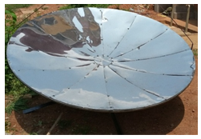

**Fig. 1: Stainless steel as reflector material**

**3.2 Fin type Absorber:**

Aluminium is used as receiver material. It has high thermal conductivity. Its diameter is 0.3m. The Fin type is Absorber placed at the focal point. The Aluminium Mug heats up due to concentrated rays. As shown in Figure 2 below.



**Fig. 2: Fin type Absorber**

# Working

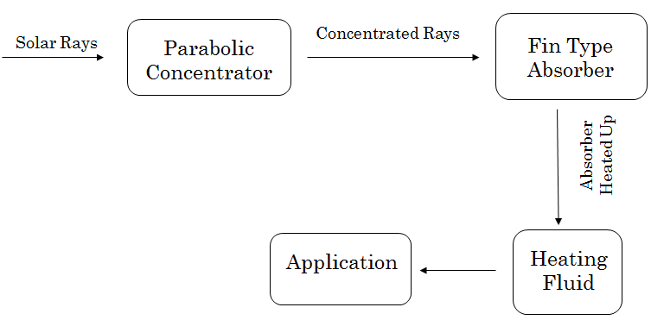

**Fig. 3: Working Process**

The solar ray’s incident on parabolic concentrator gets reflected and concentrated on to a Fin type Absorber. Air is passed over receiver through closed passage. Air takes up the heat by forced or free convection and becomes hot. The hot air is passed to an application setup. After use, an outlet is provided for exit of air.

# Results & Discussion

Experiments were carried out using the fabricated solar disc parabolic concentrator, during the experimentation solar intensity, temperature of hot air and absorber temperature were determined by using probe and infra-red thermometer.

**CASE 1:-Plate with Fin at Top & Flat Bottom**

Table 1: Readings for Plate with Fin at Top &Flat Bottom

|  |  |  |  |
| --- | --- | --- | --- |
| Sl.  No. | Time  (min) | Temp. of Lower Side Without Fin  (℃) | Temp. of Upper Side With Fin  (℃) |
| 1 | 5 | 95 | 113 |
| 2 | 15 | 103 | 116 |
| 3 | 25 | 137 | 144 |

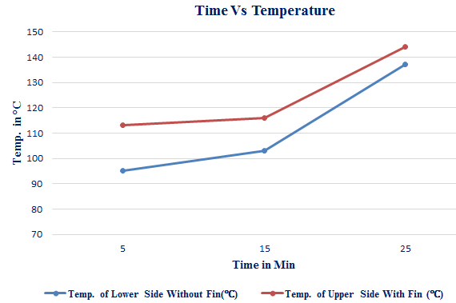

**Fig. 4: Temperature of Air with Fin at Top and Flat Bottom Absorber**

From Figure 4 shows the change in hot air temperature with time from the temperature readings, as shown in Table 1. It can be observed that temperature at upper side with fin is more than the temperature at lower side without fin. It is mainly due to fins provided at the top side is holding more heat due to more area and also heat trap is taking place between the fins due to radiations rays emitted by fins are falling on each other .as heat is continuously provided heat is stored in the fins, but at the bottom side no storage of heat takes place. This is clearly shown in Figure 6.

**CASE2:-Plate with Fin at Bottom & Flat Top**

Table 2: Readings for Plate with Fin at Bottom &Flat Top

|  |  |  |  |
| --- | --- | --- | --- |
| Sl.  No. | TIME  (min) | Temperature at lower With Fin(℃) | Temperature at upper Without Fin(℃) |
| 1 | 5 | 225 | 109 |
| 2 | 15 | 168 | 93 |
| 3 | 25 | 142 | 90 |

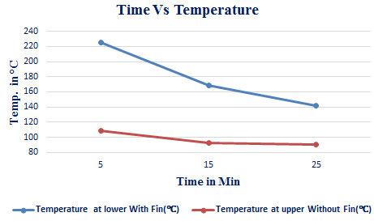

**Fig.5: Temperature of Air with Fin at Bottom and Flat Top Absorber**

It can be observed from the graph that temperature with fin at bottom is more than temperature at the top side for the flat plate, As shown in Table 2. Due to more area at the bottom and also heat trap between the fins, there is less heat loss hence temperature increases. As there is no fins at the top side less heat is absorbed at the top side. This is clearly shown in Figure 5.

**CASE 3: Plate with Fin at Top and Bottom Side**

Table 3: Readings for Plate at Top and Bottom with Fin

|  |  |  |  |
| --- | --- | --- | --- |
| Sl.  No. | TIME  (MIN) | Temperature at lower With Fin (℃) | Temperature at upper With Fin (℃) |
| 1 | 5 | 106 | 99 |
| 2 | 15 | 111 | 100 |
| 3 | 25 | 146 | 113 |

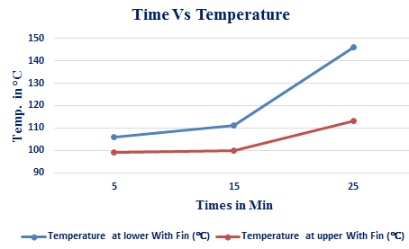

**Fig. 6: Temperature of Air with Fin at Both Top and Bottom Side of Absorber**

It can be observed by the temperature readings that by providing fins at the both side there is a increase in both heat absorption by fins at the bottom side and as well as heat transferred to top side ,As shown in Table 3, Larger area at both sides is heated to high temperature due to less heat loss. This is clearly shown in Figure 6.

**CASE 4: Water Temperature Tested Without & With Fin Absorber**

Table 4: Readings for Water Temperature Tested Without & With Fin

|  |  |  |  |
| --- | --- | --- | --- |
| Sl.  NO. | TIME  (min) | Temperature  (Without Fin)  (℃) | Temperature  ( With Fin)  (℃) |
| 1 | 5 | 44 | 54 |
| 2 | 15 | 59 | 67 |
| 3 | 25 | 69 | 89 |

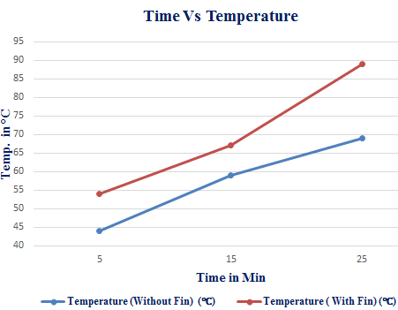

**Fig. 7: Temperature of Water without Black paint applied to Absorber**

It can be observed very clearly that providing fins at both side increases the rate of heat absorption by bottom side as well as heat transfer to top side due to reduced heat loss due to radiation and convection. This is clearly shown in Figure 7.

**CASE 5: Oil Temperature Tested In Without & With Fin Absorber**

Table 5: Readings for Oil Temperature Tested Without & With Fin

|  |  |  |  |
| --- | --- | --- | --- |
| Sl.  No. | TIME  (min) | Temperature (Without Fin)  (℃) | Temperature (With Fin)  (℃) |
| 1 | 5 | 143 | 135 |
| 2 | 10 | 172 | 166 |
| 3 | 15 | 174 | 176 |

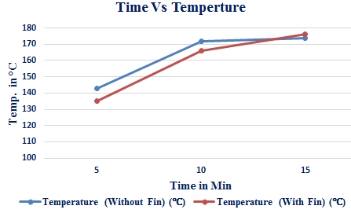

**Fig. 8: Temperature of Oil without Black paint applied to Absorber**

It can be observed very clearly that providing fins at both side increases the rate of heat absorption by bottom side as well as heat transfer to top side due to reduced heat loss due to radiation and convection. This is clearly shown in Figure 8.

**CASE 6: Air Temperature Tested In Black Painted Without & With Fin**

Table 6: Readings of Black Painted Cylindrical Aluminium Vessel for Air without & With Fin

|  |  |  |  |
| --- | --- | --- | --- |
| Sl. No. | TIME  (min) | Temperature (Without Fin  (℃) | Temperature (With Fin)  (℃) |
| 1 | 5 | 54 | 56 |
| 2 | 15 | 67 | 77 |
| 3 | 25 | 89 | 104 |

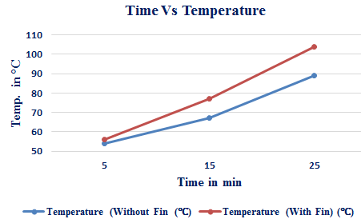

**Fig. 9: Temperature of Air with Black paint applied to Absorber**

It can observed that the rate of heat absorption increases significantly due to increase of absorptivity due to black colour coating. Temperature reading obtained is highest after black colour coating. This is clearly shown in Figure 9.

**CASE 7: Water Temperature Tested In Black Painted Without & With Fin**

Table 7: Readings of Black Painted Cylindrical Aluminium Vessel for Water without & With Fin

|  |  |  |  |
| --- | --- | --- | --- |
| Sl. No. | TIME  (min) | Temperature  (Without Fin)  (℃) | Temperature  (With Fin)  (℃) |
| 1 | 5 | 69 | 80 |
| 2 | 15 | 100 | 98 |
| 3 | 25 | 100 | 102 |

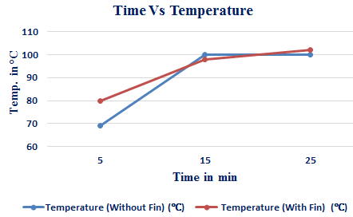

**Fig. 10: Temperature of Water with Black paint applied to Absorber**

It can be observed that the rate of heat absorption increases significantly due to increase of absorptive due to black colour coating. Temperature reading obtained is highest after black colour coating. This is clearly shown in Figure 10.

**CASE 8: Oil Temperature Tested In Black Painted Without & With Fin**

Table 8: Readings of Black Painted Cylindrical Aluminium Vessel for Oil Without & With Fin

|  |  |  |  |
| --- | --- | --- | --- |
| Sl. No. | TIME (min) | Temperature (Without Fin)  (℃) | Temperature (With Fin)  (℃) |
| 1 | 5 | 46 | 81 |
| 2 | 15 | 55 | 110 |
| 3 | 25 | 66 | 116 |

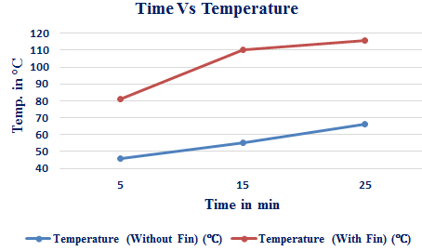

**Fig. 11. Temperature of Oil with Black paint applied to Absorber**

It can observed that the rate of heat absorption increases significantly due to increase of absorptive due to black colour coating. Temperature reading obtained is highest after black colour coating. This is clearly shown in Figure 11.

# Conclusion

By using this setup, the experiments are conducted in the month of November to May and achieved satisfactory results.

Based on the results carried out he following conclusions are drawn.

* Parabolic solar dish concentrator shows good performance on heating of air (max temp. 1600C to 2600 C at focal point).
* Fin type absorber are more efficient and absorbs more heat.
* Temperature above 1000C is achieved inside the absorber.
* The drying time is reduced.
* Generation of hot air mainly depends on the solar radiation intensity and total sunshine hour, in this study, maximum productivity and temperature is achieved in time between 11am-2pm.
* Parabolic dish concentrator has better system efficiency.

References

[1] Muhyiddine J Radi and Saffa Riffat, “Medium temperature concentrators for solar thermal applications” Institute of Sustainable Energy Technology, University of Nottingham, Nottingham NG7 2RD, UK.

[2] “Thermal Study of Solar Parabolic Concentrator”, *IOSR Journal of Mechanical and Civil Engineering (IOSR-JMCE),* e-ISSN: 2278-1684, p-ISSN: 2320–334X PP 118-123, [www.iosrjournals.org](http://www.iosrjournals.org).

[3] P K Nag, “Heat and Mass Transfer”, Second Edition, Published by Tata McGraw-Hill Publishing Company Limited, 7 west Patel Nagar, New Delhi 110008, ISBN No. 0-07-0606536.

[4] G.D Rai, “Non- Conventional Energy Sources”, Fourth Edition, Khanna Publishers, ISBN No. 81-7409-073-8.

[5] Tadahmun Ahmed Yassen, “Experimental and theoretical study of a parabolic trough solar collector,” in Anbar Journal for Engineering Sciences, 3rd April 2012, Volume 5, pp 109-125.

[6] A. R. El Ouederni, M .BenSalah, F . Askri, M. Ben Nasrallah and F. Aloui, “Experimental study of a parabolic solar concentrator”, Revue des Energies Renouvelables, Vol. 12 (2009), pp 395 – 404.

[7] Umesh Toshniwal and S. R Karale, “A review paper on Solar Dryer”, International Journal of Engineering Research and Applications (IJERA), ISSN: 2248-9622,Vol. 3, Issue 2, March- April 2013, pp.896-902.

[8] Prof. S. S. Bhansali, Sonali Nagargoje, Suraj Wasadeand Amol Kanwale “Solar Dryer System”, International Journal of Research In Science & Engineering (IJRSE), Volume 1, Issue 3, e-ISSN: 2394-8299, p-ISSN: 2394-8280.

1.