**AN ENERGY EFFICIENT STREET LIGHT SYSTEM**

**Gudinho Diana Minine1, Pratiksha Prabhu2, Soumya Bhandary3, Sushmitha4, Archana Priyadarshini Rao5**

*Students1,2,3,4 of the Department of Information Science and Engineering, Canara Engineering College*

*Assistant5 Professor, Dept. of ISE, Canara Engineering College*

**ABSTRACT**: ***This project focuses on one of the many ways in which piezoelectric materials can be used to produce electrical energy. A well-designed energy-efficient street light system should permit traffic and pedestrians to travel with great visibility in safety and comfort while reducing cost and energy consumption. This project requires an LDR to detect day or night. In this system, we put into light the piezoelectric effect in which certain materials have the ability to build up an electrical charge from having pressure and strain applied to them. This system is focused on the applications of auto street light for transportation facilities using that energy. When the roads are engineered with piezoelectric technology, the energy produced by the pressure of moving vehicles is captured by piezo sensors and converted into electrical charge by a Piezoelectric Transducer (PZT), then the energy is stored and used as an energy generation source. This energy source can be used for auto street lighting as a source of roadside power generation units. The power is generated as a result of pressure due to the movement of vehicles on the road to control street lighting on highways and also automating their process. It provides a sustainable solution in terms of environment, economy and social needs.***

***Keywords- Piezoelectric transducer(PZT), LDR***

1. **INTRODUCTION**

This system is focused on the applications of auto street light for transportation facilities using electrical energy. Power has been a critical part of our lives from the time it was developed in the country. Power is characterized as a set of physical wonder connected with the stream of charge. As we all know, street lights are one of the main city’s assets that provide safe roads and enhanced security in homes as well as city centers. There are many alternate methods by which electricity can be generated. In the past few decades, there were few streets in a town or city, street lamps and management control was relatively simple, but as the country developed into a well-off society, and with urbanization, the number of streets in the town increased rapidly. So the control and management of street lights became a problem. At present, street lamps are under manual control, a control switch set in each of the street lamps, it is also called as the first generation of the original street light control, which is inefficient and a waste of manpower. A huge amount of electrical energy is wasted. The highly discussed topic in the present situation in Science and Technology is ”Energy conservation and reduction of the workforce”. The existing prototypes should be improvised in the manner of low power consumption, which is a major priority. Especially in developing countries like India. In rural areas vehicle movement is less so the need for full intensity street light is less.

One such system is to change the resistance by using the light-sensitive device to control street lamps that lights up automatically in the evening after dark and turns off automatically in the morning. In this project, in one of the cases, the street light turns on when the light intensity is decreased along with the motion of the vehicles or the pedestrian using IR sensors where the street lights glow for a few seconds, so the energy wastage is reduced and the street light glows automatically. This system is mounted with IR sensors which are used to detect movement. These systems are installed on either side of the road in such a way that they are vulnerable to external factors and natural calamities. The combination of LDR and the piezoelectric sensors would predict the movement on the roads as well as the density of vehicles on the roads, which may increase the efficiency of energy conservation operation. The vehicles moving on the road tend to the vibration of the piezoelectric material placed below the road due to deformation, caused by the pressure of vehicle passing. The possibilities of damage are reduced considerably as they are mounted under the road. This lays down our project of the automated street light system based on IoT and piezoelectric effects.

**II. LITERATURE SURVEY**

There have been many studies done in the area of smart street light systems to provide an easy and efficient method to control street light and automate their process. The following are a few studies that we have referred to.

*Intelligent Street-Light System using Arduino UNO* [1] The purpose of this work is to describe the Intelligent Street Lighting (ISL) system, an approach to accomplish the demand for flexible public lighting systems. The present system is like, the street lights will be switched on in the evening before the sun sets and they are switched off the next day morning after there is sufficient light on the roads. This project gives the best solution for electrical power wastage. Also, the manual operation of the lighting system is completely eliminated. In this project, sensors used are Light Dependent Resistor (LDR) to indicate a day/night time and photoelectric sensors to detect the movement on the street. The Arduino Uno is used as a brain to control the street light system.

In their system, the use of LASER and photoelectric sensors for detection and movement of vehicles whereas in our system we are using piezoelectric transducers for motion detection as well as density measurement.

*Zigbee based Street Light Control System:* The Development of Street Light Control System based on Zigbee[2] is given by S.H. Jeong. This paper suggests a new method that is ZIGBEE and to increase the efficiency of the street lighting system sensors are used. A combination of sensors is used to control the system to achieve maximum efficiency of the street lighting system. To check the state of street lamps ZIGBEE transmitter’s information or data use point to point. It uses a control terminal and thus immediate actions can be taken if required which monitor and control the condition of street lights which is installed beside the street. Control systems can be used to switch the lights ON/OFF. Using communication channels the local information status can be monitored through the control system. On/Off status information, energy-saving mode status, control group status information and information related to safety, etc is the status information which is monitored. For control command transfer and status information between the streetlight control system and street light control remote terminals in which each light pole is installed, it uses various communication protocols and communication media. As communication media, wireless or power lines are generally used.

In our system, the Street light control system can save maintenance time and costs and which can improve the safety level.

*Remote Street Light Monitoring System:* Remote street light monitoring system is proposed to overcome the already proposed technologies which are complex and time-consuming. To observe the current population and the increase in traffic, this system perfectly matches all the requirements. Remote streetlight monitoring system based on wireless sensor networks [3] is proposed by Gong Siliang. It controls streetlight according to light intensity and Sunrise and Sunset Algorithm. This controls reasonable adjustment and seasonal Variation. We can control street lights because this system also can run in controlled mode with the use of a display monitor terminal. In addition, the system contains a digital temperature-humidity sensor for monitoring the streetlight Real-time, temperature and humidity. Because this system is equipped with the high-power relay output and can be widely applied in all places such as streets, stations, mining, schools, and electricity sectors and so on. This system is especially proposed for urban areas. A sensor node, controller center, and the remote terminal system are the gadgets used to form this system. The sensor nodes are installed in each pole of the lamp to monitor each lamp pole, remote terminal unit for performing the entire task from the remote places. In our system, we use wired technology for better speed and connectivity. There is no specific algorithmic-based methodology.

*LED street lighting system [4]:* Proposed by Gustavo W. Denardin. For modern-day street lighting systems, the use of LED is very convenient and economical because LED has a longer life when compared to other lighting systems because of its higher luminous efficiency and higher CRI. In this control network consumption of distributed power systems, automatic disconnection of the street lighting system, as well as management cost, is less than the others and it observes to control and monitor the information of each street lighting unit. A wireless sensor network based on the IEEE 802.15.4TM standard is employed in order to meet the system requirements. To make the system more scalable, system handling is based on geographic routing strategy.

The system which is used is not externally powered when compared to our system which is powered by the pressure sensors. We use the NodeMCU which is built-in with the Wi-Fi module that helps connect to the Internet.

*Intelligent Street Light System using RF Transmission[5]*: The proposed prototype of intelligent street light can detect daylight and vehicles and vary the intensity of the LED-based street lamps as per the traffic flow. It can also help in monitoring of street light systems and fault detection through RF wireless technology. If the intelligent street light is designed and installed in the cities, then a lot of power can be saved and this will also minimize the cost of maintenance over traditional wired systems. The system is versatile and can be extended as per user needs.

Our system uses the technique of pressure generated electricity, hence the use of a large number of sensors is omitted. The distinctive feature of our project is the provision of a web interface to monitor the entire system.

**TABLE 1:ANALYSIS AND COMPARISON OF DIFFERENT TECHNIQUES**

|  |  |  |
| --- | --- | --- |
| Paper | Merits | Demerits |
| Intelligent Street Light System using Arduino UNO | 1. Scalability is high.  2. Deployment is easy. | A semantic point of view  is not defined. |
| Zigbee based street light control  system | 1. Save more energy.  2. Reduces manual  work. | Design is complex. |
| Remote streetlight  monitoring system | 1. Consume power.  2. Scalability is high. | Cannot self localized. |
| LED Street Lighting  system | Consumes more power. | Regular maintenance. |
| Intelligent Street Light System using RF transmission | Uses RF wireless technology. | A large number of sensors are used. |

**III. METHODOLOGY**

**a. System Architecture Design:**

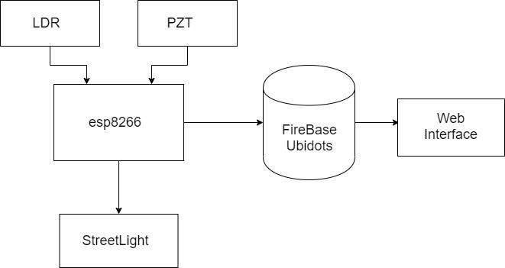

Fig. 1: Architectural design

An architecture description is a formal description and representation of a system, organized in a way that supports reasoning and behavior of the system. The above figure represents the architectural design of the system where PZT and LDR are connected through the ESP8266 module to control the street light. The switching on and off of the street light is sent from the NodeMCU to the street lights. The data collected by the ESP8266 is captured in the Firebase and sent over to Ubidots and then to the web interface for the controller.

**b. Use Case Diagram**

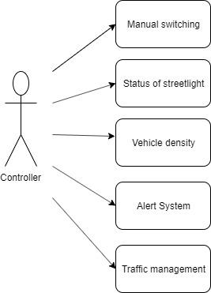

Fig. 2: Use Case diagram

Use case diagram is a list of action or event steps, typically defining the interaction between a role and a system, to achieve a goal. As seen in the above UML use case diagram the actor is a human, who can make choices through the interface and get the desired result. The above Use case diagram shows what are the facilities and functions which the controller has access to. The properties like calculating vehicle density, the status of street lights are available for controllers. He/She can manually switch on/off the system as well as the street lights. An alert system has been designed to warn the controller about the vehicle moving on a prohibited road.

**III. IMPLEMENTATION**

**a. Complete Flow diagram**

The flow diagram represents the whole flow of the system. The LDR output is sent to the NodeMCU, then a condition is checked whether the light intensity is more than the system will be off or else it will be on. Another condition is being checked i.e. if any movement occurs then the system will turn the street lights on with full intensity and if the vehicle moves in a prohibited road then the street lights will be on with low intensity blinking lights. All these activity data will be sent to the Firebase where the controller can control the system.

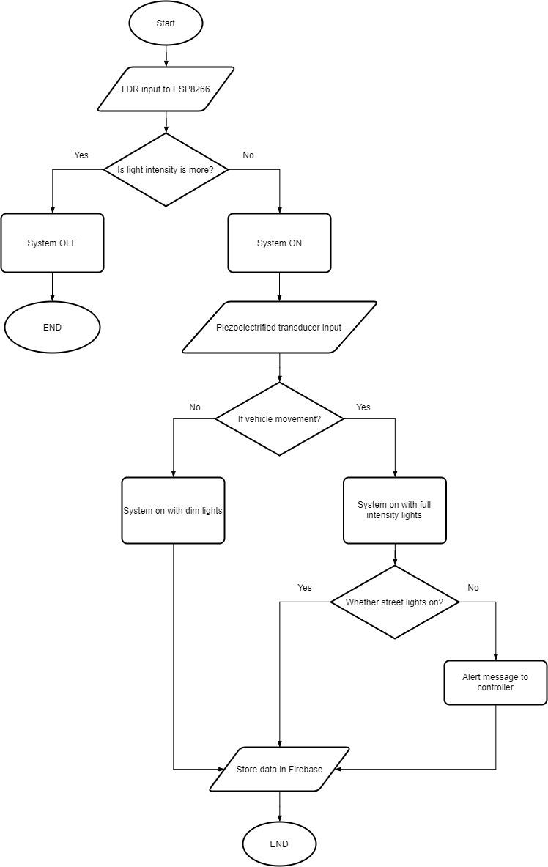

Fig. 3: Complete Flow Diagram

**IV. EXPECTED OUTCOME**

**A. Controller Registration**



Fig. 4: Registration for Controller

Fig. 4 shows the page wherein the controllers who are assigned need to first register themselves before logging into the browser.

**B. Controller Login**



Fig. 5: Login for the controller

Fig. 5 shows the login page for the controller on a web browser. This is the page for the person who is assigned as the controller of a specific area. Any unauthorized user cannot login for controlling the system.

**C. Light Status on browser**



Fig. 6: Checking the light status

Fig. 6 shows the light status of StreetLight 1 that is turned on automatically as the night falls. Similarly, it can check the status of other street lights connected to the system.

**D. Manual Mode of System**



Fig. 7: Manual mode of checking

Fig. 7 shows the light status in the manual mode of the system. This depicts that the project supports both automatic and manual modes of conduction.

**V. CONCLUSION**

The above framework serves the purpose of switching ON/OFF the street lights automatically or through the manual mode of operation. The pressure generated from the tires of vehicles on the surface tends to store the charge in the batteries which in turn glow the lights. Further integration with technologies like Machine Learning and Image Processing can detect which vehicle passes over the surface. This system basically is focused on providing the necessary functions of controlling the streetlight over the web and in being fully automated.

**REFERENCES**

[1] “Intelligent Street-Light System using Arduino UNO” International Journal of Recent Trends in Engineering & Research (IJRTER) Special Issue; March - 2017 [ISSN: 2455-1457]

[2] “Design Techniques of Distributed Photovoltaic /Energy Storage System” Zilong Yang, Zhuo Chen, Lidong Guo, Yuanyuan Chen, Xinke Huang, Yibo Wang Solar Thermal Technology and Photovoltaic System Laboratory, Institute of Electrical Engineering, Chinese Academy of Science, Beijing, China 2017.

[3] “Intelligent Street Lighting System Using Gsm” International Journal of Engineering Science Invention ISSN (Online): 2319 – 6734, ISSN (Print): 2319 – 6726Volume 2 Issue 3 March 2013

[4] “Automatic Street Light Intensity Control and Road Safety Module Using Embedded System” International Conference on Computing and Control Engineering (ICCCE 2012), 12 & 13 April 2012.

[5] “A New Streetlight Monitoring System Based On Wireless Sensor Networks” IEEE 2010

[6] “Wireless internet lighting control system”, Budike, E.S. Lothar (Power web Technologies), US patent 7,167,777, Jan 23, 2007.

[7] “Generation and Storage of Electric Energy from Piezoelectric Materials” IEEE 2017