**DEVELOPMENT OF CLASSIFICATION OF RICE DESEASE USING IMAGE PROCESSING TECHNIQUE**

M Sachin Mr.Nidheesh P Dept.Electronics &Communication Engineering Dept.Electronics&Communication Engineering Coorg institute of Technology Coorg institute of Technology Ponnampet,India-571216 Ponnampet,India-571216  sachinm096@gmail.com [nidheesh2005@gmail.com](mailto:nidheesh2005@gmail.com)

**Abstract**-Currently, rice disease caused by various weather disorders and pests are serious problems. In this research, we develop a system to classify healthy rice plant and diseased rice plants by processing images from rice planted in paddy field. Rice blast is one of the most limiting factor in rice yield the purpose of the study is the timely and rapid diagnosis of rice blast based on image processing technique in field technique. Color images are prepared using image processing technique and improved by KNN algorithm by K-means was used to classify images in lab color space to detect diseases spots on rice leaves. Otsu method was used to perform an automatic threshold of images based on shape or to reduce grey level in binary images. Finally, to determine the efficiency of design algorithm, sensitivity, specificity and overall accuracy were examined.

Keywords-rice, blast disease, image processing, k-means algorithm, KNN algorithm

**1.INTRODUCTION**

Grains are used as a material for staple foods that obtain energy necessary for daily life for many people because of their ease of cultivation and high preservability. Wheat, rice, and maize are called the world's three largest cereals, and production is particularly high in the world.

In scientific terms, rice is called Oryza Sativa. It is one of the most important and strategic crops and it is the food of more than two third of the population of the world. Rice is considered as a healthy and nutritious foodstuff, and now it provides 50% of the world's agricultural production and 20% of the energy needed by humans

There are more than 40 types of diseases in rice the damage caused by disease is easy to spread.Both occur due to the influence of molds and pests caused by moisture. Among them disease called “rice blast” is the most damaging disease.

Rice blast is the most devastating rice disease in the world, causing the loss of 10 percent to 30 percent of the planet’s crop every year. Blast is one of the most important limiting factors in plant performance. The maximum sensitivity to the blast disease is observed at the sprouting stage, that is when the rice plant starts to appear above the surface of the ground. Even resistant varieties are susceptible to this disease during the formation of flowering organs. Symptoms of the disease on the leaf appear first in the form of burned water points and then turn into rhombus shaped spots of 1–3 cm in length which are tipped at the end. The spots are gray in the center and dark brown in the margin. Considering the significance of the topic, it is very important to use the science of machine vision and image processing techniques, which today play a major role in precision agriculture. The machine vision, as a powerful and reliable tool, has been widely used in various industries, especially in agriculture. The main use of machine vision and image processing in agriculture involves controlling the status of agricultural land, precision agriculture, controlling and supervising plants at the planting stage and controlling and monitoring the quality of agricultural products at the postharvest stage. The main reason for the ever increasing expansion of the machine vision and image processing science in various branches of agricultural science is that in addition to identifying the shape, color, size and texture of the objects, these systems can also extract the numerical and quantitative characteristics of these objects. Nowadays, rapid development of computer processing technologies and creation of related software makes it possible for us to benefit from the advantages of artificial intelligence, the application of artificial neural networks and other algorithms that to some extent copy human brain functions, to solve problems in systems.

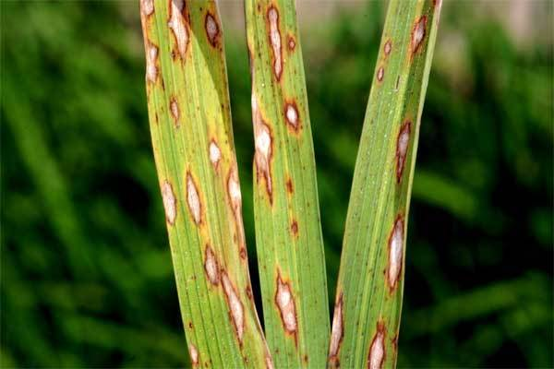

Figure 1

Figure 1 shows the image of the rice blast. A brown spot- like pattern appears on the leaf of the blast, and the symptom is clearly.

**2.MATERIALS AND METHODOLOGY**

**2.1 Field imaging and preparation of the images**

Canopy color images of rice fields were prepared in RGB space by a PHANTOM 4 ADVANCED quadcopter, equipped with a 12‐mega pixel digital camera. The velocity of the quadcopter in rice fields was 0.5 m/s and its distance from the bushes was 90cm (FIGURE 1).

**2.2 Preprocessing image**

Image processing started after the imaging stage was completed. To process images, an application was coded in MATLAB R2012a. After the images were invoked by the program, the preprocessing of the images began. Because the images were large and this reduced the speed of the analysis and processing of images, the images were converted to 256 × 256 pixels so that the computing machine could perform image analysis in the shortest possible time. Improving the resolution of an image to better diagnose the disease and to raise the ability to diagnose the healthy surfaces from the diseased ones. Therefore, the designed algorithm could better detect the disease on the plant leaf.

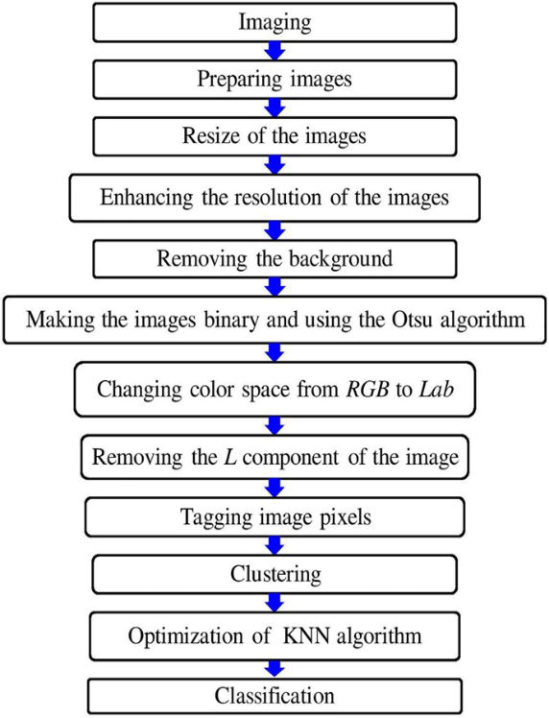

FIGURE 2

**2.3 Image processing**

In this step, the separation algorithm was performed using the histogram profile extraction to remove the probable background in the received images. The received images included rice bushes, stems, and green leaves and mud. In this algorithm, the original image first split into three components: red, green, and blue and then the rice plant was removed from the background of the image.

**2.4 Final processing**

To perform segmentation, the received images must be transferred to the color space independent of the device. In a color space independent of the device, the coordinates used to determine the color determine the same color, regardless of the device used, and a color dependent device is the space in which the resulting color depends on the equipment used to produce it .Therefore, in this study, Lab color space was used which is widely used in machine vision. The three dimensions of this color space are relative to red, purple or green, and its position relative to the yellow and blue.

The color space of the Lab turned into a color space suitable for machine vision due to its resistance to color variations.

Lab color space is able to describe all colors visible by the human eye and is used as an independent color model. The Lab color space is derived from the original XYZ color space. After removing the background of the images, the K‐means method was used to segment images. Moreover, to remove the luminance effect, the component of the images was also deleted and the clustering algorithm was applied only to the components. The basis of clustering in the algorithm designed was squared Euclidean distance. In this algorithm, the Otsu method was used to carry out an automatic histogram of the threshold of images based on the shape or reduction of gray surface in binary images.

After converting the color space from RGB to Lab, the colors obtained from the previous step were clustered using the K-means method. In this algorithm (clustering algorithm), the colors which were similar to each other in the image were placed in a certain number of clusters up to a certain distance, and each of the clusters was the final result. To use this method, the number of clusters and the spacing of each cluster from the other should be determined. For this purpose, relation (2) was used:

ab = double lab_he: 1 ,2,3;

nrows = size ab: 1;

ncols = size ab, 2;

ab = reshape ab, nrows ∗ ncols=2;

ncolors = 3;

Σcluster idx clustercenterΣ =

kmeans .ab,

ncolors*distance, sqeuclidean,replicates

After specifying the clusters and spacing, an image was labeled by cluster index. Labeling of pixels using the results of the K‐means method for each part of the image shows a cluster index.

After executing the image labeling algorithm, the next step is to obtain clustered images. This stage is the main step in the rice blast disease diagnostic algorithm. The image of the diseased parts, the healthy parts of the plant, and pixels that do need to be processed will be obtained. Each of these images is a kind of cluster of the original image.

Segmented_images = cell 1, 3;

rgb_label = repmat (pixel_labels, 1 1 3;

for k = 1:ncolors)

color = he;

color (rgb_label ∼= k) = 0;

segmented_images {k} = color;

After clustering, classification turn arrives. KNN should be improved for the following reasons

1.The KNN algorithm is slow since it reviews all the instances each time.

2.The algorithm is vulnerable to dimensionality.

3.The algorithm is sensitive to irrelevant and correlated attributes

4.A wrong choice of the distance or the value of k degrades the performance.

The KNN algorithm is improved as follows and the classification operation begins:

K-means algorithm is used to form clusters, and the classification will be based on the centers of this new set of clusters. Thus, classifying a new instance into one of the k clusters instead of comparing it to the initial n instances divides the computation time of the algorithm by k/n. Finally, the distance between a given instance and the center of each cluster is restricted to significant attributes and weighted by their reliability coefficients.

**3. RESU.LTS AND DISCUSSION**

In this research, with the improvement of KNN algorithm by K-means, a new, quick and accurate method for diagnosis of rice disease was developed using image processing. The results of this study showed data type of images changed from uint 8 type to double data type. Rewar, Singh, Chhipa, Sharma, and Kumari (2017), and Al Bashish, Braik, and Bani‐Ahmad (2011) also used double images to diagnose various plant diseases under controlled, laboratory conditions and their input images were RGB.Moreover, the Lab color space enabled us to separate the colors in the image and, using the K-means clustering algorithm, identify the diseased locations and the spots that have changed color on the rice leaf. The K-means method is one of the data mining techniques used in machine vision. Clustering is an uncontrolled learning method that does not rely on predefined categories or specific features as objectives, and places instances with the same amount of data together in one group.

The objective function in the K-means clustering was calculated using equation:

J = "xj − c"2

where xj − c is the measure of the distance between the points that the dynamic range of gray surfaces should be increased to determine the damaged parts of the rice leaf. Therefore, the numeric and cj is the center of the jth cluster. In the designed algorithm, at first K points were selected as the centers of the clusters. Then each sample data were attributed to the cluster whose center had the smallest distance to that data. Finally, the average of the points belonging to each cluster was assigned to one cluster and for each cluster; a new point was calculated as the center.

**3.1 Accuracy of the designed algorithm**

Two criteria of identification number and quality of blast spots were used to assess the ability and accuracy of the proposed algorithm.

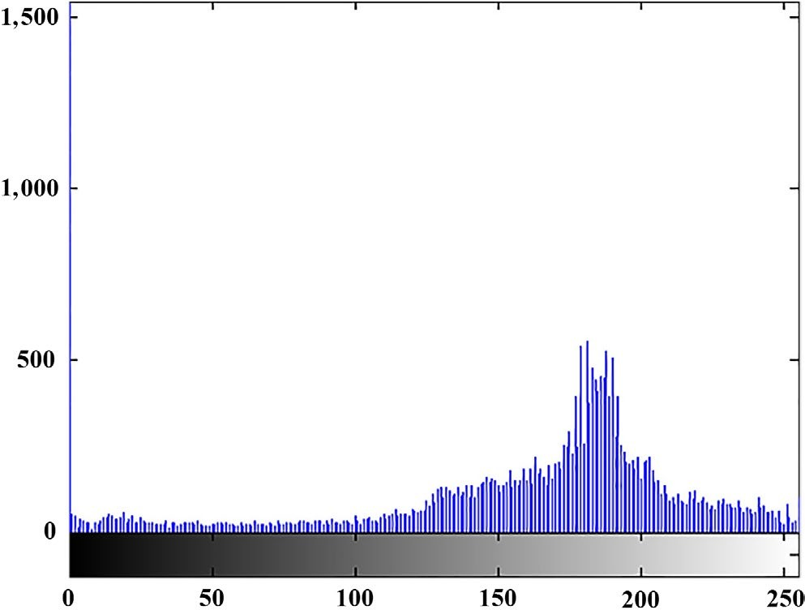

FIGURE 3

|  |  |  |  |
| --- | --- | --- | --- |
| **Output** | **determining the diseased spots** | **Number of disease spots** | **pixels other than the diseased spots** |
| Number of diseased spots | 20 | 460 | 0 |
| The quality of determin- ing the diseased spot | 480 | 40 | 0 |
| Pixels other than the diseased spots | 0 | 0 | 500 |

**TA B L E 1** The results of testing 500 sample images to determine the number and quality of blast spots

**4. CONCLUSION**

The results of this study showed that image processing and machine vision have a high potential for determining blast disease in rice plant under field conditions. Moreover, the KNN, machine learning method improved by K-means can be used as an effective diagnostic mechanism for the disease. This method is faster and less expensive than other methods and it is also nondestructive. The observations carried out show that the accuracy of the new method of machine vision is at an acceptable level and the results of this method can be relied upon. Besides that, by carefully managing the fields and by the timely prevention of the rice blast spread in the northern fields of the country, it is possible to avoid the overuse of chemical pesticides resulting in increased production costs, environmental pollution, and reduction in production per hectare.

REFERENCES

Al Bashish, D., Braik, M., & Bani‐Ahmad, S. (2011). Detection and clas- sification of leaf diseases using K-means-based segmentation and. Information Technology Journal, 10(2), 267–275.

Al‐Saqer, S. M. (2012). A robust recognition system for pecan weevil using artificial neural networks. American Journal of Applied Sciences, 9(9), 1347–1353.

Ashkani, S., Rafii, M. Y., Shabanimofrad, M., Ghasemzadeh, A., Ravanfar,

S. A., & Latif, M. A. (2016). Molecular progress on the mapping and cloning of functional genes for blast disease in rice (Oryza sa‐ tiva L.): Current status and future considerations. Critical Reviews in Biotechnology, 36(2), 353–367.

Azarmdel, H., Mohtasebi, S. S., Jafari, A., & Muñoz, A. R. (2019). Developing an orientation and cutting point determination al- gorithm for a trout fish processing system using machine vision. Computers and Electronics in Agriculture, 162, 613–629. https://doi. org/10.1016/j.compag.2019.05.005

Bakar, M. A., Abdullah, A. H., Rahim, N. A., Yazid, H., Misman, S. N., & Masnan, M. J. (2018). Rice leaf blast disease detection using multi‐ level colour image thresholding. Journal of Telecommunication, Electronic and Computer Engineering (JTEC), 10(1–15), 1–6.

Jahanbakhshi, A., Ghamari, B., & Heidarbeigi, K. (2017). Assessing acoustic emission in 1055I John Deere combine harvester using statistical and artificial intelligence methods. International Journal of Vehicle Noise and Vibration, 13(2), 105–117. https://doi.org/10.1504/ IJVNV.2017.087906

Jahanbakhshi, A., & Kheiralipour, K. (2019). Carrot sorting based on shape using image processing, artificial neural network, and support vector machine. Journal of Agricultural Machinery, 9(2), 295–307. (In Persian). https://doi.org/10.22067/jam.v9i2.70579

Kahar, M. A., Mutalib, S., & Abdul‐Rahman, S. (2015). Early detection and classification of paddy diseases with neural networks and fuzzy logic. In Proceedings of the 17th International Conference on Mathematical and Computational Methods in Science and Engineering, MACMESE (pp. 248–257).

Kaveh, M., Jahanbakhshi, A., Abbaspour‐Gilandeh, Y., Taghinezhad, E., & Moghimi, M. B. F. (2018). The effect of ultrasound pre‐treatment on quality, drying, and thermodynamic attributes of almond kernel under convective dryer using ANNs and ANFIS network. Journal of Food Process Engineering, 41(7), e12868. https://doi.org/10.1111/ jfpe.12868

Khosravi, V. (2006). The Relationship Between The Amount Of Silica in The Flag Leaf and The Percentage of Cluster Blast Contamination in Different Rice Cultivars. Research report. Publications Rice Research Institute

– Department of mazandaran. P. 25. (In Persian).

Kubat, M. (2015). An introduction to machine learning, Vol. 681. Cham: Springer.

Kumar, K. K., Poovannan, K., Nandakumar, R., Thamilarasi, K., Geetha, C., Jayashree, N., … Balasubramanian, P. (2003). A high through- put functional expression assay system for a defence gene confer- ring transgenic resistance on rice against the sheath blight patho- gen, Rhizoctonia Solani. Plant Science, 165(5), 969–976. https://doi. org/10.1016/S0168‐9452(03)00271‐1

Peyman, S. H., Bakhshipour Ziaratgahi, A., & Jafari, A. (2016). Exploring the possibility of using digital image processing technique to detect diseases of rice leaf. Journal of Agricultural Machinery, 6(1), 69–79. (In Persian).