Effect of Land use and Land cover on soil properties of Puttur Taluk

Sowmya NJ1, Apoorva2Deviprasad2, Anunaya2,Kiran 2Prasad Pujar3

Abstract

The study on land use and land cover is important to know the impact of it on climate change, soil properties and socio-economic changes. Many studies reported that land-use changes can contribute to soil degradation and deterioration of soil physical and chemical properties. Hence in this study, an attempt is made to know the impact of land-use changes on soil properties. After land use land cover study, soil samples were taken from a soil depth of 15 cm. For these soil samples, the soil properties such as pH, Organic Carbon, Electrical Conductivity, dry density, nitrogen and potassium were analyzed. The result shows that soil properties of urban land significantly have large variation compared to forest land. The study concludes that land-use changes have a negative impact on soil properties of the study area.

Key words: LULC, soil properties

I. INTRODUCTION

The existing feature on the earth’s surface is called Land cover and the utilization of land resources is called land use. Land Use and Land Cover (LULC) change are due to urban growth and change in vegetation etc. The increasing populations have a serious impact on infrastructure thereby on the economy of the country. The conversion of natural forest land to other land-use forms, stimulate soil erosion and lead to a reduction in soil quality with modified soil structure (Chen et al. 2001). It is also found that land-use changes result in changes in chemical, physical and biological properties of soil (Houghton et al 1999). The knowledge on LULC is important for sustainable land management because, land degradation impacts on water and soil quality, public health, and biodiversity(Bajocco et al 2012). The difference in soil properties among LULCs is more significant on 0-15 soil depth than on 15- 30cm soil depth. (Gebrekidan et.al 2014).

1 Professor, Dept of Civil Engg. VCET, Puttur [sowm.shyam@gmail.com](mailto:sowm.shyam@gmail.com),

2 B.E Students, Dept of Civil Engg. VCET, Puttur apoorvaramesh516@gmail.com

3 Asst Professor, Dept of Civil Engg. VCET, Puttur

The bulk density values of all LULC were found to be statically significant concerning the land use types. Soils with higher SOM such as forest soil have a lower bulk density (Ceyhun and Hüseyin 2017). Soil characteristics such as soil organic matter, total porosity, aggregate stability and bulk density are negatively affected by tillage practices. Transformation of natural forest into cultivated land decreases especially organic matter which effects on soil physical, chemical properties and its function of natural forest system( Kizilkaya and Dengez 2010). The conversion of natural forest to farmland reduces the silt contents, moisture content, organic matter, organic carbon, total nitrogen, available phosphorus, pH, cation exchange capacity and exchangeable bases, but increases bulk density, electrical conductivity, exchangeable acidity and sand content significantly (Tellen and Yerima 2018). The land use is a dominant factor controlling the differences in soil properties (Katerina and Tomas 2019). Therefore, there is a need to assess the effects of land use/cover changes on soil properties in Puttur taluk of Dakshina district.

II OBJECTIVE

The objective of the study is to determine the impact of land use and land cover changes on selected soil properties of Puttur Taluk.

III STUDY AREA

The study area Puttur is located in the southern part of India and East of Karnataka State. Puttur is one of the five taluks of Dakshina Kannada district.Puttur taluk is lying in between 750 5’ to 750 40’ E longitude and 12030’ to 120 55' N latitude. According to Census 2011 information, there are 59,569 houses in about 67 villages and the total population is about 2,87,851. The study area receives a high rainfall of more than 4m and the temperature ranges from maximum 390C to minimum 20.80C. The average annual temperature in Puttur taluk is 26.8 °C. The most soil in the Puttur taluk is of a lateritic type which characterized by high iron and aluminium content. People of this area grow areca nut, coconut, cocoa, banana, cashew, paddy and many varieties of fruits and vegetables.

IV. METHODOLOGY

Resourcesat2, LISS-4 images of 5.8m multispectral of the study area are purchased from NRSC Hyderabad are analyzed using ArcGIS 10.7 and ERDAS Imagine 2019 software. Using visual interpretation method, classification of the image was done for individual classes like agriculture, mixed forest, water bodies, built-up area, barren land and river bed. The results are cross-checked by using Google earth and random ground truth data taken by GPS. The results of the change detection of the study area are shown in Table 1. Every 20-25 samples are collected from each land use at 15cm depth. All sampling points are identified using GPS at the field. Core cutter method is used to determine the density. Flame photometer, spectrophotometer and PUSA STRF meter are used to determine soil nutrients,

V. RESULTS AND DISCUSSION

LULC map of the study area for the year 2019 is shown in Figure 1. It is clear from Table 1 and Figure 1 that water bodies covered 1.07 per cent and mixed forest-covered 40.8 per cent.

**Table 1. Classification Details of LULC of the year 2019**

|  |  |  |  |  |
| --- | --- | --- | --- | --- |
| Classification | Interpretation | Description | Area in km2 | % Area |
| Water Bodies | Those pixels reflecting dark blue to light blue. | This area covers ponds, lakes, drains,Sea, river etc. | 10.98 | 1.07 |
| Mixed Forest | Those pixels exhibits dark greencolour . | Scattered plants and forest | 417.44 | 40.86 |
| Agricultural Land | Pixel reflection of all light green in colours. | Land under crops, plantations etc. | 523.22 | 51.22 |
| Built-Up Land | Those pixels reflect light to dark red colour. | Residential, commercial, industrial, transportation and other facilities | 39.46 | 3.86 |
| Barren Land | Pixel represents light brown colour | Areas with no vegetation | 27.25 | 2.67 |
| River Bed | Pixel reflects light to dark maroon colour. | This covers natural course of riverbed | 3.24 | 0.32 |
|  |  |  | 1021.6 | 100.0 |

It could be observed that agricultural land covered 51.22 per cent, Built-up land includes buildings, roads and tourist places covered 3.86 per cent and 2.67 percent of land is uncultivated. The river bed covers 0.32 per cent of the area which depends on rainfall and water utilization. 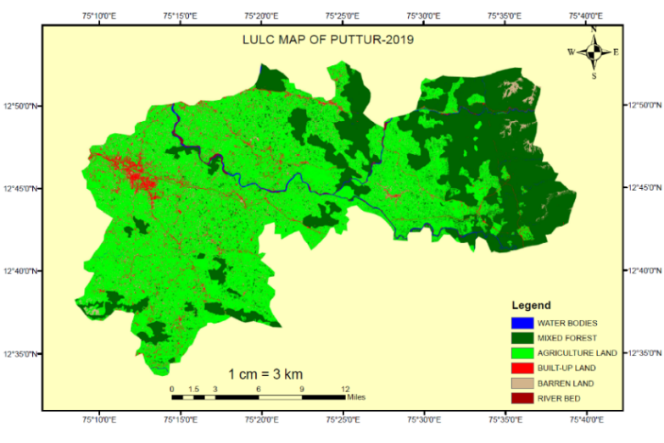

**Figure 1**. **LULC of the study area in the year 2019**

To analyze the nutrients of soil samples collected a box plot data analysis method i.e., box and whisker plot method is used.

With the use of a box plot, it is possible to compare the different datasets. Figure 3 shows the pH values of the different land uses which varied significantly from 6.63 to 3.98. it shows that the soil of the study area is acidic type.

The soil PH is a little higher in agricultural land than soils of other LULC classification types. Soil pH value was slightly higher for the agricultural land as compared with that of the barren land indicates the utilization of fertilizers in the study area, which shows that soil property will change due to land use. From Figure 4 it is clear that urbanization reduces OC. Higher amounts of soil OC were observed in mixed forest and barren land.

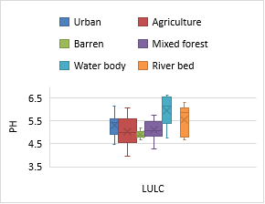

**Figure 3 Soil pH for different LULC** 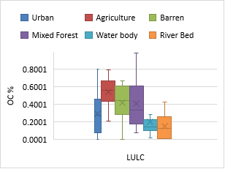

**Figure 4 Organic Carbon for different LULC**

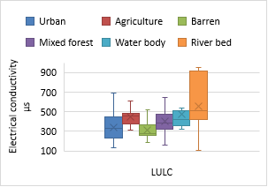

**Figure 5 EC for different LULC**

The values of EC were significantly greater in the river bed soil and soil with vegetation. It is clear from Figure 5 that Electrical Conductivity (EC) of urban land and barren land decreases as compared to the mixed forest and little higher in agricultural land. It shows that vegetation plays a role in the change of EC.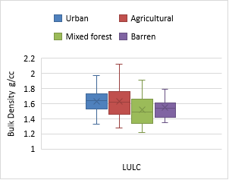

**Figure 6 Dry density for different LULC**

The EC at the study site varies between 107.2µs to a maximum value of 947.5µs. The soil collected from the river bed shows higher EC than other all types of soil. The land-use changes increase the dry density of soil, which indicates the compaction of soil affects the moisture content and air voids present in the soil. The median of land uses shown in Figure 6 indicates that density is less in forest land than other land use.

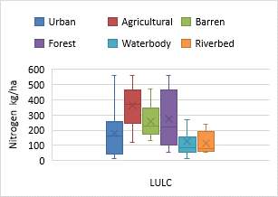

**Figure 7 Nitrogen for different LULC**

Figure 7 indicates that the Nitrogen content of the soil shows variation among the land use types. The nitrogen decreased from forest to barren land and urban land in that order. The amount of nitrogen available in the river bed and soils below the water bodies are very less. The available potassium content ranged from 22.4 kg/ha to 150.08kg/ha. Figure 8 indicates that there is no significant relationship between different land uses. The median of all land use indicates that forest land is having higher potassium content compared to other land use except urban land. The potassium content of urban soil is little higher than forest land.

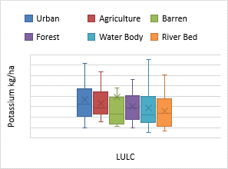

**Figure 8 Potassium for different LULC**

VI CONCLUSIONS

The present study helps to identify how LULC change effects on soil properties. The study shows the nearer value of soil properties of agricultural land and forest land of the study area, which may be due to traditional farming. The major variations are observed between forest land and urban and barren land in the order. This research clarifies that Land use change reflects urbanization which has a negative impact on soil characteristics.

.*ACKNOWLEDGEMENT*

Authors are thankful to Vision Group of Science and Technology (VGST), Karnataka for funding this research work.

*REFERENCES*

1. BajoccoS, A. De Angelis , L. Perini , A, Ferrara L and Salvati (2012)” The Impact of Land Use/Land Cover Changes on LandDegradation Dynamics: A Mediterranean Case Study“ , Environmental Management,49: DOI 10.1007/s00267-012-9831-8 , pp 980–989
2. Ceyhun Gol and HüseyinYilmaz(2017) “ The Effect of Land Use Type / Land Cover and aspect On Soil Properties at the Gökdere catchment in Northwestern Turkey”,Izvorniznanstveničlanci – Original scientific papers, Šumarski list, 9–10, pp 459–468.
3. Chen G, Gan L and Wang S(2001) ” A coparative study on the microbiological characteristics of soil under different land use conditions from Karst areas of southwest China”, Chinese Journal of Geochemistry,Vol20,No1,pp52-58.
4. GebrekidanWorku, Amare Bantider and HabtamuTemesgen(2014)”Effects of Land Use/Land Cover Change on Some Soil Physical and Chemical Properties in Ameleke micro-Watershed, Gedeo and Borena Zones, South Ethiopia”. Journal of Environment and Earth Science, ISSN 2224-3216 (Paper) ISSN 2225-0948 (Online) Vol.4, No.11,pp13-24
5. Houghton R A, Hacker J L and Lawrence K T “The US carbon budget: contributions from land use change”, Science, Vol 285,pp 574-578.
6. Katerina Zajícovaand TomasChuman(2019) “Effect of land use on soil chemical properties after 190 years of forest to agricultural land conversion”,Soil and Water Research, 14(3): 121–131.
7. Tellen Valentine Asong and Yerima﻿ Bernard P. K (2018)” Effects of land use change on soil physicochemical properties in selected areas in the North West region of Cameroon” Environ System Research 7:3, <https://doi.org/10.1186/s40068-018-0106-0>, pp1-29.
8. RadvanKizilkaya and OehanDengiz(2010)” Variation of land use and land cover effects on some soil physico-chemical characteristics and soil enzyme activity”, Zemdirbyste –Agriculture, Vol 97, No2, ISSN 1392-3196, pp 15-24.