**CHARACTERIZATION OF RESIDUAL CHEMICALS IN IRRIGATED SOIL FOR IMPROVING FERTILITY RATE AND CROP YIELD**

**Shridhar Yallurkar1, Sandeep Nayak2, Prashantha Achar3**

*1Research Scholar, Civil Engineering department,Anjuman Institute of Technology and Management Bhatkal Karnataka, India-581320. Email: shridharmy@gmail.com*

*2Professor, Vivekananda college of Engineering and Technology Puttur- Mangalore****.***

***-****Karnataka India- 574225. Email:* [*sandeejn1@gmail.com*](mailto:sandeejn1@gmail.com)

*3 AssistantProfessor, Vivekananda college of Engineering and Technology Puttur- Mangalore****.***

***-****Karnataka India- 574225. Email: pkpura@gmail.com*

*Abstract*—In agriculture, a soil test is the analysis of a soil sample to determine nutrient and contaminant content such as macro nutrients and micro nutrients. Tests are usually performed to measure the expected growth potential of a soil. Soil test measures fertility, indicates deficiencies that need to be remedied and determines potential toxicities from excessive fertility and inhibitions from the presence of non-essential trace minerals. To undertake this study, four different areas have been selected to collect the soil samples from paddy field. Two villages namely Kadavinakatta and Shirali located in Bhatkal taluka of Uttar Kannada district from Karnataka state and two villages Meenangadi and Ambalavayal located in Sultanpatry taluk in Wayanad district of Kerala state were selected purposely considering their location, geographical similarities, proximity to cropland and the distance from the coast. During the study period soil samples have been collected as per the standard procedure, tested in laboratory and analyzed for macro and micro nutrients. Results indicate that there is a marked variation in nutrient and contaminants in soil.

***Key words: Nutrients, contaminant, fertility, trace elements, soil,NPK, macro elements, micro elements.***

# **INTRODUCTION**

M

an’s perception of soil varies according to how it is used, and so it is difficult to give a single correct definition for an agriculturist, the soil can be defined as the place where there is an interaction takes place between plants and organism. It also provides nutrients, water, and oxygen to the plant as well as space and support for the root system (Singh, 2011). The soil just like the atmosphere and water contains different forms of life. The living organisms in the soil provide vegetation to protect the soil, supply nutrients to the plant, support roots to blind particles, mix soil component and process nutrients. The soil has a complex structure. It can be described as a three-phase system composed of solids (organic and inorganic matter), liquids (especially water) and gases (mainly nitrogen, oxygen, and carbon dioxide).

Plants require nutrients to grow and develop, much the same as people. This brings to mind the same “you are what you eat” and it is the same with plants. Poor feeding and low nutrient level will be resulting from poor or diminished growth and low food, flowering and growth production these nutrients include carbon, nitrogen, calcium, hydrogen, phosphorus, magnesium, oxygen, potassium, sulphur, iron, zinc, chlorine, manganese, boron, copper and molybdenum. These nutrients, present in both chemical and organic fertilizer come in two major categories, macro elements, and microelements. Microelements are referring to the mean elements that are required by the plant for its basic functioning. These main elements are:

• Oxygen and hydrogen can be found readily available in water as well as the air,

• Nitrogen and carbon are abundantly formed in most of the organic soil,

• Potassium and phosphorous which can also be found in organic soil,

Among these macro elements, carbon, which is obtained from carbon dioxide of the air, oxygen, is obtained from air, water and hydrogen., These are the basic elements required by the plant to build its cell structure. Thus, it is most fortunate that these elements are the most commonly found elements and are required by all living creatures, therefore it is seldom that you need to provide additional carbon, oxygen or hydrogen. Potassium, phosphorous and nitrogen, on the other hand, are usually lacking and supplements of this need to be provided for the plants (Zarei, E., et al.,2004). Micro elements act as a “multivitamin” for plants. The microelements of plants are made up of iron (Fe), Zinc(Zn), manganese(Mn), Boron(B), Molybdenum(Mo) and Copper(Cu) (Muhammad Sajid et al., 2011).

1.**1 OBJECTIVES OF THE STUDY**

* Analysis of soil samples from the study area to assess the macro elements and micro
* elements present in the soil sample,
* Determining the suitability of the soil for agricultural activities.
* To evaluate the fertility of soil based on NPK value in relation to pH.

# **STUDY AREA**

To undertake this study, four different sampling sites, two from Karnataka and two from Kerala state have been selected to collect the soil sample from the paddy field. They include Kadvinakatta (latitude 130 12′ 25″N, longitude 74022′ 26.5″E) and Shirali (latitude 1302′ 0″N, longitude 740 32′ 5″E) of Bhatkal taluk in Uttar Kannada district of Karnataka state (Fig. 9.1). Also Ambalavayal (latitude 120 6′ 13.64″N, longitude 78022′ 27.19″E) and Meenangadi (latitude 120 32′ 54.6″N, longitude 780 12′ 38″E) located in Sultanpatry taluk in Wayanad district of Kerala state were selected purposely considering their homogeneity in terms of rainfall, climate, soil structure, location, geographical similarities, proximity to cropland and the distance from the coast. Soil samples collected from the selected location have been analyzed during the summer season at an interval of 15 days.

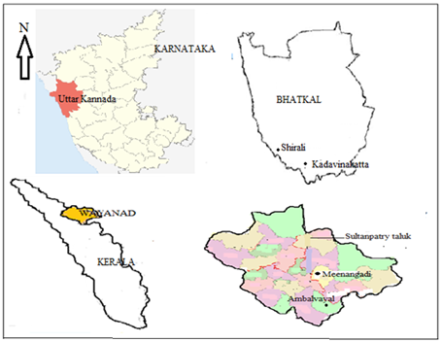

Fig. 1 Study area

# **METHODOLOGY**

Collection of soil samples from the field is the first step in soil sampling. Sample can be collected by making a V-shaped hole by digging to the required depth. From this hole, a slice is cut approximately 2.5-3.0 cm thick. Both sides of the slice must then be trimmed leaving a 3.0 cm strip, which is then put it in a clean container. A similar procedure is repeated to obtain a sufficient number of samples for the analysis purpose. This process is to be repeated several times until a sufficient number (15-20) of subsamples to make are preventative sample is acquired. Now soil samples are poured into a container for through mixing by breaking all clogs and lumps present in the soil (Jen Hshuan Chen., 2006). If the samples are not dried, they should be kept in a cool or frozen space or air-dried at room temperature within 12 hours of extraction. Put labels and attach a record to the sample. The record will assist in the interpretation of the results and this should include information on the following:

* Type of soil
* Yield records
* Re planted or virgin soils
* Previous crop grown on the same piece of land.
* Nutrition history of the crop when it was fertilized, what type of fertilizer was used and what rates were used.

Not all of the fertilizers applied are absorbed by the plant, much is left as a residual and this can account for some abnormally nutrient contents in soil samples upon analysis.

The selected soil samples are collected from Kerala and Karnataka. NPK test is conducted within first 15 cm depth. The availability of micronutrients (Iron, manganese, zinc, copper, boron, calcium, magnesium and sulphur) is tested at about 15 to 45 cm depth. Dry the collected sample under shade. Crush the soil clods lightly with wooden pestle. Sieve using a stainless steel 2 mm sieve and discard plant residues gravel and other foreign matter retained on the sieve. If the gravel content is substantial, it has to be recorded. For certain types of analysis (e.g. organic carbon) it is necessary to grind the soil further so as to pass through 0.5 mm sieve. Soil testing on regular bases is an important part of nutrient management.

# **RESULTS AND DISCUSSION**

The macro elements which control the steady growth and are responsible for getting better yield namely pH, Nitrogen, Phosphorous, Potassium and micro elements such as zinc, sulphur, copper, manganese, magnesium, calcium and iron. These elements are briefly discussed here.

Table 1 Results of the soil sample analysis at different locations of the study area.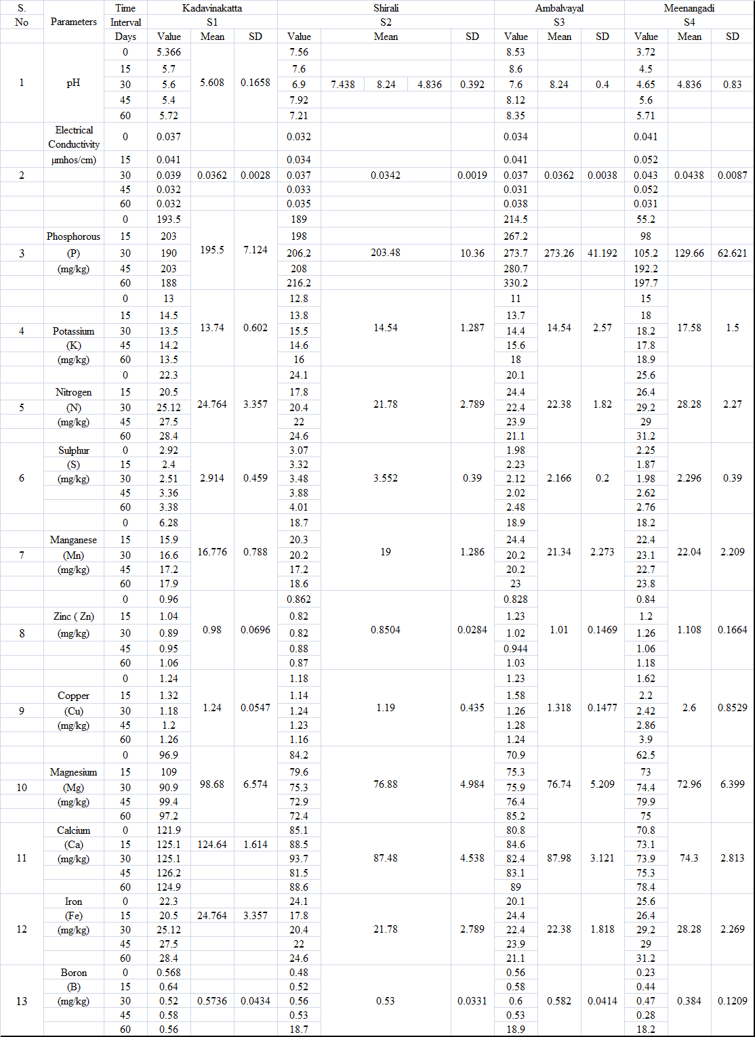

## **A. pH concentration in the soil sample**

The yield of the crop depends on different soil properties. pH is one of the important parameters which affects the productivity of the soil. For better fertility, the ideal range of pH sho

uld be 6.5 to 10. The pH depends on soil composition and type of soil. At Kadavinakatta (S1) the average value of pH is 5.6, which is quite less. It indicates that the soil in this area is acidic in nature. However, there is a gradual increase in pH is taking place due to the continuous use of chemical fertilizer to increase crop yield. Similarly, at Shirali (S2) and Ambalvayyal (S3), the pH value is in the ideal range of 7.40 and 8.24 respectively. This shows that the soil in these regions is alkaline in nature, which is good for plant growth. At Meenangadi (S4) the average pH of the soil is only 4.38 which is highly acidic in nature. Also, there is a marked variation in the pH as time progresses. Fig. 2 represents a variation of pH at different places using a statistical technique (box plot). From the box plot, it is evident that the variation of pH is less at place S1 with respect to days. Also, the standard deviation is 0.16 indicating less variation with days, hence pH is consistent.

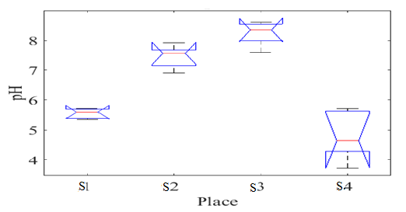

Fig. 2 Variation of pH during the crop period at study area

## **B**. **Nitrogen concentration in the soil sample**

Nitrogen is a key element in many of the processes needed to accelerate growth. It is particularly important to carry out photosynthesis. The findings of the study indicate that nitrogen is deficient in quantity at all four locations. With a decrease in nitrogen content, the yield of the crop will decline drastically. Hence there is a need to increase the nitrogen content by applying natural manure, vermicompost etc. Fig. 9.3 represents the availability of nitrogen content at selected locations using a statistical technique (box plot,Theodordis S., 2006).

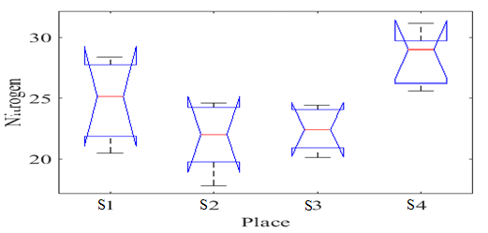

Fig. 3 Variation of Nitrogen during the crop period at study area

## **C. Phosphorus concentration in the soil sample**

Phosphorus is one of the most essential macro elements of soil which plays an important role in the growth of a plant. Soil investigations in the study area indicate that at Kadavinakatta (S1) and at Shirali (S2), average phosphorus content was 195.50 mg/kg and 203 mg/kg respectively. It is gradually increased at the later stage due application of chemical fertilizer. However, at Ambalvayal (S3), the soil contains sufficient phosphorous about 273 mg/kg at an incremental order. This may be due to the fact that farmers in this area are practicing organic farming. The findings of the study also indicate that at Meenangadi (S4), the minimum value of phosphorous content is only 55.2 mg/kg. So, there is an acute shortage of phosphorous in this field. However, there is a sudden increase in its content takes place at Meenangadi due to the excessive use of chemical fertilizer. Fig. 9.4 represents the variation of phosphorous at different locations with a statistical technique (box plot).

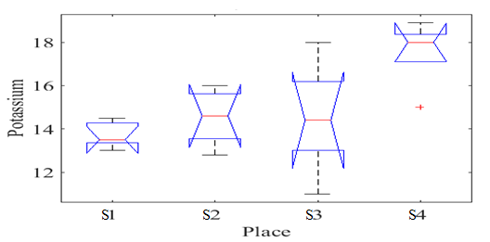

Fig. 5 Variation of Potassium during the crop period at four selected sites

## **D**. **Potassium concentration in the soil sample**

Potassium is another important element which contributes to the development and healthy growth of the plant. Plants lows in potassium are stunted in growth and provide lower yield. It is found that minimum potassium content of 13.74 mg/kg is found at Kadavinakatta and a maximum of 17.58 mg/kg at Meenangandi. Potassium can be increased by adding manure, compost, and wood ash. Fig. 9.5 represents the variation of potassium at different locations with statistical technique (box plot).

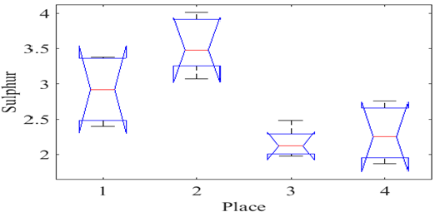

Fig. 7 Variation of sulphur during the crop period at study area

## **E. Sulphur concentration in the soil sample**

Sulphur plays an important role in the formation of various structural components such as amino acids, proteins, vitamins and enzymes and is essential to produce chlorophyll in the plant. Results of the present study indicate that sulphur content in the selected sample varies from 2.166mg/kg to 3.552 mg/kg which is quite less from a fertility point of view.

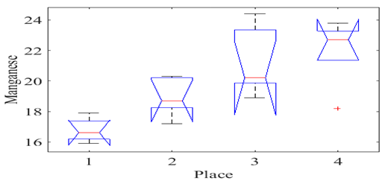

Fig.8 Variation of manganese during the crop period at four selected sites

## **F. Manganese concentration in the soil sample**

Manganese plays an important role in activating enzymes for photosynthesis, respiration, and nitrogen metabolism in the plant. In neutral or alkaline soil-plant usually shows manganese deficient symptoms. Similarly, in acidic soil excess manganese content increases toxicity in soil. In the present study, Manganese content in the soil is in the range of 16 mg/kg to 22 mg/kg at selected locations.

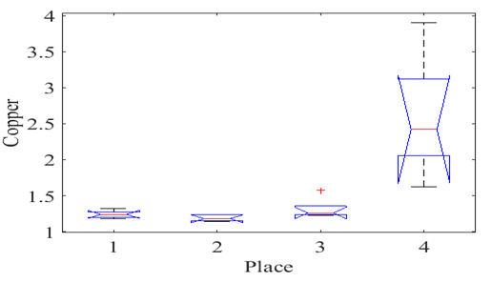

Fig. 9 Variation of copper during the crop period at four selected sites

## **G. Copper concentration in the soil sample**

Copper is generally accumulated in the roots zone of plants and plays an important role in the metabolic activities of the plant. Generally, organic soil is deficient in copper. The excessive copper content in the soil causes toxicity in plants. The results of the present study indicate that copper content in the tested soil sample is negligible. Hence there is a need to supplement the copper content in the soil to improve the fertility of soil and health of a plant. Fig. 9.9 represents the variation of copper concentration at different locations using a statistical technique (box plot).

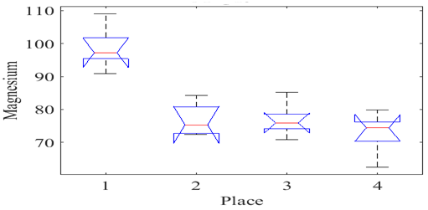

Fig.10 Variation of magnesium during the crop period at four selected sites

## **H. Magnesium concentration in the soil sample**

Magnesium is a critical structural component of the chlorophyll molecule and is necessary for the functioning of plant enzymes to produce carbohydrates, sugars, and fats. It is used for fruit and nut formation and essential for the germination of seeds. Deficient plants appear chlorotic, show yellowing between veins of older leaves; leaves may drop. Magnesium is leached by watering and must be supplied when feeding. Results indicate that that the magnesium content in the selected samples is in the range of 73mg/kg to 99mg/kg which is quite satisfactory.

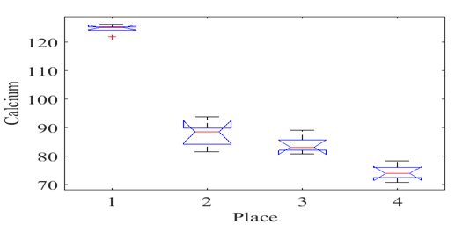

Fig. 11 Variation of Calcium during the crop period at four selected sites

## **I. Calcium concentration in the soil sample**

Calcium activates enzymes, is a structural component of cell walls, influences water movement in cells and is necessary for cell growth and division. Some plants must have calcium to take up nitrogen and other minerals. Calcium is easily leached. Calcium, once deposited in plant tissue, is immobile (non-translocatable) so there must be a constant supply for growth. The results of the present study indicate that maximum calcium content is found in Kadavinakatta soil, whereas the least calcium content was found in Meenangadi soil.

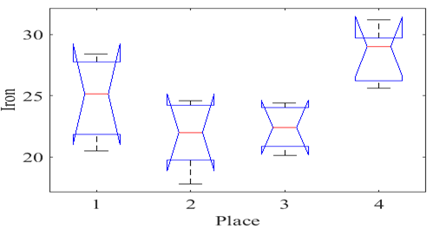

Fig. 12 Variation of Iron during the crop period at four selected site

## **J. Iron concentration in the soil sample**

Iron is an important constituent which acts as a catalyst for various enzyme function and for photosynthesis process. It is particularly providing essential nutrients for young plants. Iron is generally present in the lower portion of the soil structure which is slowly lost by leaching. When the soil is a highly alkaline effect of iron will be minimum. Iron content in the soil can be increased by applying acid nutrient in soluble form to the soil. In the study area iron content at all the selected locations is satisfactory.

Table 2 General Recommendation of NPK

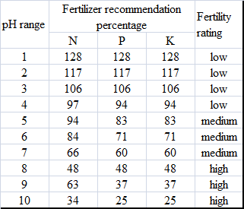

# **Conclusion**

Nutrient management plays a major role in intensive cropping systems for increasing the crop yield by maintaining ideal soil health for sustainable production. For the soil samples at Kadavinakatta (S1), pH lies in the range of 5.3 to 5.7. Based on pH, the fertility rate of nitrogen is 94%, whereas, with reference to phosphorus and potassium, the fertility rate is 83%. Hence the rating is medium. For soil samples at Shirali (S2), pH was in the range of 6.9 to 7.9. According to (Watanabe and Olsen, 1965), the fertility rate of nitrogen is 66 to 48 % and for phosphorous and potassium the fertility rate is in the range of 60% to 48%. So, the rating is medium to high.

For soil samples at Ambalavayal (S3), the pH range is between 7.6- 8.6. The fertility rate of nitrogen is 66-48%, whereas with reference to phosphorus and potassium the fertility is 60-48%, hence the rating is very high. However, for soil samples at Meenangadi (S4), pH is very low, in the range of 3.7 to 5.7. Soil is highly acidic in nature. Here the fertility rate of nitrogen is 106-94 % and that of phosphorus and potassium is 106-83%, hence the rating is very low.

The finding of the study reveals that sample collected from Kadavinakatta and Shirali have got medium fertility rate considering, Nitrogen, Phosphorous, and Potassium. This may be due to the use of chemical fertilizers along with organic fertilizers during both the Kharif and Rabi seasons. Other parameters like Boron, Sulphur, Manganese, Zinc, Copper, etc. has only very less effect on fertility rate as compare to major constituents like NPK, hence it will not have an appreciable impact on the yield of crops.

The finding from the study also reveals that the soil samples collected from Ambalavayal (S3) have got a higher fertility rate. This may be due to organic farming practices adopted by the farmer in this region.

However, the soil samples collected from Meenangadi (S4) has a lower pH and lower fertility rate considering macronutrients. Hence it is necessary to

take corrective measures to preserve the fertility of the soil in this area.

**VI. References**

1. Abou El-Magd MA, El-Bassiony M, Fawzy ZF (2006), “ Effect of organic manure with or without chemical fertilizer on growth, yield and quality of some varieties of Broccoli plants”,J Applied Sci Res. 2(10): 791-798
2. Brady NC, Weil RR (2002). “The Nature and Properties of Soil”,. 13th edition. Pearson Education Inc, Prentice Hall publications.
3. Chen J (2006), “The combined use of chemical and organic fertilizer and biofertilizer for crop growth and soil fertility”, Taipai Food Fort Technology, 17: 1-9.
4. Changming Yang, Linzhang Yang, Zhu Ouyang (2004) “Organic carbon and its fractions in paddy soil as affected by different nutrient and water regimes”,science direct, Geoderma 124(2005)0133-142.
5. KanuMurmu, Dillip Kumar Swain and Bijoy Chandra Ghosh(2013) “Comparative assessment of conventional and organic nutrient management on crop growth and yield and soil fertility in tomato-sweet corn production system” AJCS 7(11):1617-1626.
6. Lindsay, W.L. and Norvell, W.A. (1978). “Development of a DTPA soil test for Zinc, Iron manganese and cooper”. Soil Sci. Soc. J. 42: 423-428.
7. Muhammad Sajid, Aqeel Ahmad, Muhammad Ashrafb, Mumtaz Hussain (2011), “Phytotoxic effects of nickel on yield and concentration of macro- andmicro-nutrients in sunflower (helianthus annuusL.) achenes”Journal of Hazardous material 185(2011) 1295-1303
8. R. Ordonez Fernandez, P. Gonzalez Fernandez “Soil properties and Crop yields after 21 years of directdrilling trials in Southern Spain, Archives of Agronomy and soil science 58(1), 185-189.
9. Sharma K. L. Mandal, K. Srinivas (2005) “Long-term soil management effects on crop yields andsoil quality in a dryland alfisol”, Soil and Tillage research 83(2),246-259
10. Shuman, L.M. and Welch, R.M. (ed.) Micronutrients in agriculture, soil science society of America, Madison, Wisconsin, USA.
11. Singh S.S, (2011), “Fertility and Nutrient Management” third edition, Kalyani Publishers Ludhiana.
12. Uthavakumari 2013, Micronutrient revolution helping wetlands too, TOI, Mangalore 25, 2013, p- 4.
13. Vladimir Ignatieff (1952), “Efficient use of Fertilisers”, food and agriculture organization of the UN, Leonard Hill Ltd London.
14. Watanabe, P.S. and Olsen, S.R.(1965). “Test of an ascorbic acid method for determining phosphorous in water and NaHCO3 extracts form soil”. Soil Sci.Soc.Am.Proc.29: 677-678.
15. Zarei, E. M. Khah, G. Mohammadi and S. Petropoulos(2011), “Assessment of growth and yield components following the application of different biological fertilizers on soyabeancultivation*”*AJCS 5(13):1776-1782.

**Prof. Shridhar Yallurkar** was born at Karwar, Karnataka in the year 1968. He received his B.E. degrees in civil engineering from the Karnataka University Dharwad and Master degree in Environmental engineering from Vishvesvaraya Technological university Belagavi. Recently he has submitted his Ph.D. thesis in the area of Water resource Engineering to Vishvesvaraya Technological university Belagavi.

From 1990 to till date, he has a teaching experience of 30 years in the field of civil engineering at different capacities. Presently he is working as a Associate professor in the department of civil engineering at Anjuman Institute of Technology and Management Bhatkal.