**SELF PURIFICATION AND MINERALISATION OF WATER BODIES**

Vijeth.P.A1,Sowmya NJ2, Yogesh DS3

1 Student, Dept of Civil Engg, Vivekananda College of Engg and Technology,Puttur

2. Professor, Dept of Civil Engg, Vivekananda College of Engg and Technology,Puttur

3. Asst. Professor, Dept of Civil Engg, Vivekananda College of Engg and Technology,Puttur

Email: [vijeth2399@outlook.com](mailto:vijeth2399@outlook.com). sowm.shyam@gmail.com

*ABSTRACT*

Self purification is the process in which balance restoration of the aquatic environment takes place through simultaneous participation or in some sequence of the physical and chemical factors, biological, hydraulics and morphological characteristics of the river. Rapid urbanization and population growth have led to the exploitation of the water resources, thus polluting the rivulets and streams running through it. In this project, an attempt has been made to study the characteristics of selected water bodies. Various laboratory tests are carried out on water samples to establish the self-purification phenomenon of the selected water bodies. The study shows that minerals such as manganese, sulphur and silica along with temperature and flora have their role in self purification of water.

Key words: Self purification, minerals

*I. INTRODUCTION*

Water is a transparent, colourless, chemical substance, which is one of the main constituent of Earth’s stream, lakes, oceans. Water is one of the most important substances on earth. All plants and animals must have water to survive. Water is one of the most essential elements for all living beings, without water no life forms will exist. Since 75% of the human body is made up of water, we require water to stop dehydration. But now a day’s water is getting polluted which is purified and mineralised by some chemical processes which would cost a lot. Bramhananda and Nidhi (2017) concluded that higher productivity of non-rainy season might be due to the comparatively higher pH, total alkalinity, total hardness, chloride and nutrient content during the same season.

Navanita et al (2016) conducted a survey on the self purification process on Bahini- Bharalu river, the project work started from Zoo road and ended at Bhootnath via G.S road and Bharalumukh . The results obtained showed that BOD, COD, DO are in good agreement with the self purification phenomenon. Shivalli and Giriyappanavar (2015) revealed that Dissolved oxygen, Turbidity, and Nitrate were the most affecting factors for the computed Water Quality Index(WQI) values. Maria et al. (2013) compared the properties of two major temple tanks reveal that temple tank was highly disturbed due to anthropogenic activities. The reasons behind the disturbance were mainly due to washing, bathing and discharge of temple wastes by the visitors and temple priests into the temple tank. Another reason is stagnancy of the water in the temple tank due to the blockage of its inlet and outlet by encroachments. In this study the physical and biological properties of selected water bodies are studied to know mineral role in self purification of the water. Based on results and references, appropriate conclusions have been drawn.

*II OBJECTIVES*

The objectives of the study are,

* Identification and study of minerals which influence the properties of water.
* Study on physical factors responsible for self purification of holy water.

***III STUDY SITE DETAILS***

**Mujungavu**

Mujungavu Temple is in Manjeshwar, Kasaragod district, Kerala State, India located 9 km away from Kasaragod City. The average depth of the water body(pond) is 1.5m and soil is of Laterite type. The people here believe that the water of this pond is as holy as the divine water of the spot from where River Kaveri manifests . Scores of people have pledge for the quality of this holy water, stressing that taking bath here after offering rice and horse gram seeds, rids one of skin-related ailments. Many vouch for the veracity of this belief out of their own experience.

**Malla Durgaparameshwari Temple**

The Mallam Durga Parameshwari Temple is located in Muliyar Village near Bovikanam, in Kasargod District of Kerala. The Mallam Durga the average depth of water is 1m. Soil type found here is generally laterite. The holy water present here is flowing water.

**Narahari Parvata**

The Narahari Pravatha Sadashiva Temple is situated on the top of Narahari Hill near Melkar which is about 30 Kms from Mangalore city and 4 Kms from BC Road, Bantwal on the National Highway connecting Mangalore and Bangalore. The average depth of aquifer water is 1.2m.

**Karinja Temple**

Karinja Temple is located at a height of about 1000 feet from sea level in the midst of lush green Kodyamale hills. Karinjeshwara is a popular pilgrimage centre and an upcoming tourist spot of Dakshina Kannada District. The temple is about 15 Kms from BC Road and about 40 Kms from Mangalore city and on Bantwal - Dharmasthala State Highway . The average depth of aquifer water is 2m and the soil is of laterite.

**Bendrutheertha**

Bendru Theertha is a natural hot water spring in South India. It is located at a distance of about 15 kilometres from Puttur town in the Dakshina Kannada district of Karnataka. It is one of the less known natural wonders of Karnataka. The average water depth is 2.5m and the soil is of laterite type. The water source here is confined aquifer. The hot water of Bendru Theertha is a better solvent than cool water. The water is considered to be effective for healing a variety of diseases, especially skin related problems, such as eczema, allergic rashes, etc.

**Kodippadi**

Kodippadi Janardhana temple is located at Kodippadi Road, Kudipadi, Puttur iin Dakshina Kannada, Karnataka State, India . The average depth of water is 1m. Soil type found here is laterite and the pond water healing a variety of diseases.

*IV RESULT AND DISCUSSION*

The water samples from selected site are collected and tested to determine its minerals. Sulphur acts as anti aging agent, Magnesium prevents body odder and acts as anti allergic. Silica maintains hair, skin and nail health, enhances the bone health and helps in detoxification. Zinc works to clear skin by taming oil production and may be effective in controlling the formation of acne etc. Copper improves skin roughness, clarity, fine lines, wrinkling, and overall photodamage. pH is another important factor that controls the quantity of minerals and other. Hence the influence of factors like temperature and sunlight, average depth of water body and presence of minerals on selected water bodies are determined. Table 1 shows the results of various tests conducted.

**Table 1 Results of water tests**

|  |  |  |  |  |  |  |  |  |
| --- | --- | --- | --- | --- | --- | --- | --- | --- |
| Sl no | Parameters in ppm | Malla | Bendru theertha | Kodippadi | Narahari parvatha | Karinja | Mujungavu | Permissible limit |
| 1 | Dissolved oxygen | 5.2 | 5.4 | 5.2 | 3.6 | 4.2 | 3.8 | 8 |
| 2 | pH | 7.2 | 6.2 | 6.8 | 7.5 | 7.4 | 6.7 | 6.5-8.5 |
| 3 | Zinc | BDL | BDL | BDL | BDL | BDL | BDL | 5 |
| 4 | Copper | BDL | BDL | BDL | BDL | BDL | BDL | 0.05 |
| 5 | Selenium | BDL | BDL | BDL | BDL | BDL | BDL | 0.01 |
| 6 | Sulphur | 6.53 | 9.29 | 8.63 | 14.09 | 6.74 | 7.81 | 25 |
| 7 | Magnesium | BDL | BDL | 1.843 | 5.550 | BDL | BDL | 30 |
| 8 | Silica | 7.43 | 7.59 | 6.58 | 20.29 | 3.76 | 5.37 | 2 |

From the study it’s found that the minerals such as Zinc , Copper and Selenium are below detachable limit indicates that there is no influence of these on water purification. Dissolved oxygen accounts for the amount of oxygen present in water which effects the minerals present in water. Dissolved oxygen presence in Malla, Bendruteertha and Kodippadi are more than 4ppm indicates the environment supports aquatic life and at other sites its level is low. pH is another important factor that controls the quantity of minerals and other things. In the acidic medium the minerals tend to oxidise and becomes useless. This also governs the amount of oxygen in water as pH increases DO decreases which reduces the self purification ability of water. The results of pH, indicates that the water is satisfying the drinking water standards. 2018.

The quantity of Dissolved oxygen available in stream water is more in cold temperature than in hot temperature. Also, as the activity of microorganisms is more at the higher temperature, hence, the self-purification will take less time at hot temperature than in winter. Algae produces oxygen in presence of sunlight due to photosynthesis. Therefore, sunlight helps in purification of stream by adding oxygen through photosynthesis. Fig 1 shows the sample data of temperature collected.

The temperature variations from September 2017 - April 2018 are studied. The temperature variations in different month such as September 2017 to April 2018 are almost similar in Dakshina kannada region, except few month such as February. The minimum temperature is in the biginingof February and in the month of March maximum temperature was reported. As per the information collected it is clear that the temperature variation in the all the study sites is almost same.

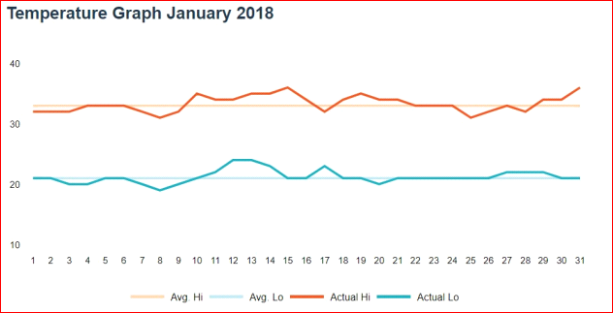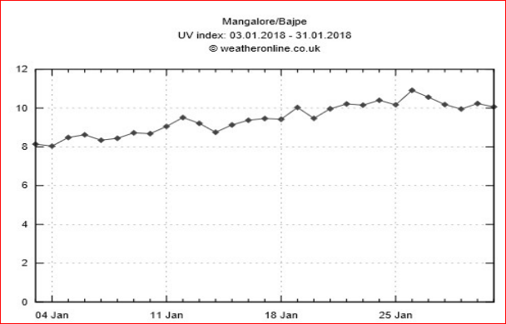

Fig. 1 Temperature variation January 2018 Fig. 2 UV index variation January 2018

In addition to temperature UV index variation between August 2017 to April 2018 are studied. Fig.2 shows UV index variation January 2018. From the data it’s seen that the value of UV index varies from 12% to 8%. Initially the values decrease in the months October and November and almost constant in the month of December and then again increase from the month of January. It is clear that temperature and UV index variation in all sites are showing similar trend indicates that these may have an important role in self-purification.

From the field observation it is clear that the natural flora of the region has its impact on the water body. The beliefs of people that throwing copper or any other pooja items into water results in good fortune but the test results shows that copper is under detectable limit. Topographical features of the water body plays its role in purification. All these study sites comes under western ghats, and the area covered is with trees like Neem, Banyan,Areca nut, Mango,Coconut and other medicinal plants. The impact and properties of fauna on water may also have influence on the properties of water along with the people’s belief, which may have influence on water purification.. Natural process of water cycle also plays a role in purification, the impurities left behind by evaporation, settle down the sediment.

*V CONCLUSIONS*

From the results of the tests conducted and references looked into, the following conclusions have been drawn.

* As per the studies conducted on various samples of holy water collected from different sacred places has important minerals such as manganese, sulphur and silica.
* The physicochemical parameters of water shows that DO of all the samples has major impact on self purification of water compared to other parameter.
* A part of self purification is done by agitation of water by Biological activities of the aquatic animals, and impact of water ripples onto the land or rock mass surrounding it, creating foam formation, which in turn takes out impurities.

*ACKNOWLEDGEMENT*

Authors are thankful to students Vidyasagar P, Parinkumar M Nirmal , Prathik G U, Vaibhav Prasad K of Civil Engineering Department ,VCET Puttur in completing the project work..

*REFERENCES*

* Bramhanand Shukla and Nidhi Upadhyay(2017), “Limnological study of Hanuman temple pond of Shahdol municipality, M.P”, International Journal of Zoology Studies, Volume 2; Issue 5; ISSN: 2455-7269,pp 27-30
* Navanita Das, Chinmoy Jyoti Saikia, Jyotimoy Sarma, Dimpal Deka, and Chintumani Deka(2016) “Study Of Self Purification Phenomenon Of Bahini-Bharalu River”, International journal of latest trends in Engineering and Technology(IJLTET), Vol.6 Issue 4, pp 596-603
* P. B. Shivalli, and B. S. Giriyappanavar(2015), “Application of NSF-WQI for the assessment of water quality of two temple tanks of karnataka, India.” Journal of international academic research for multidisciplinary, Impact factor 1.625, ISSN: 2320-5083, volume 3, Issue 2, pp 221-226
* P. Maria Pushpam, V. Umayoru Bhagan and A. Kumaraswamy (2013),“Comparative Analysis of Physicochemical Parameters of Two Famous Temple Tanks in Kanyakumari District, S. India”, International Journal of Latest Trends in Engineering and Technology (IJLTET), Vol. 2 Issue 2 , pp 235-240 .
* IS 10500 : 2012 Drinking Water — Specification (Second Revision) Amendment No. 1 June 2015.
* [https://www.accuweather.com](https://www.accuweather.com/)/ en /in/ mangalore/188760/month/188760?view=table
* https://www.weatheronline.in/Karnataka/Mangalore/UVindex.htm
* S.A.Ostroumov “Biomachinery for maintaining water quality and natural water self-purification in marine and estuarine systems: elements of a qualitative theory” pp111-118
* Fisenko, A.I. (2006). Natural purification of rivers and creeks through froth (foam) formation process Research Journal of Chemistryand Environment, 10 (1), March, pp.24-29 . <https://arxiv.org/pdf/1305.1255>