Study on the Effect of Partial Replacement of Recycled Plastic Aggregates in Concrete

Pavan T S1, Sowmya NJ2, Pavan Nayak C3, Pavan kumar H S3, Sachin ShivanandGouda3

***Abstract***

**Coarse aggregate is the main material contributes to its role in the strength of the concrete structure. The recent increasing population increased concrete structure, thereby increased consumption of concrete ingredients. All over the world to reduce the impact of natural aggregates on the geology of the earth, many researchers tried to use waste materials in concrete. In this paper also an attempt is made to examine the use of a recycled waste plastic aggregates in a concrete mix by partial replacement. A paired comparison test was carried out examining two different partial replacements of Cement Plastic Concrete (CPC) mixes against a plain concrete control sample. This paper investigates the effect of the replacement of normal weight Coarse Aggregate by recycled Coarse Plastic Aggregates (CPA)at 0%, 25% and 50% on the compressive strength including bonding and cracking.**

***Key words*: CPC, compressive strength**

I INTRODUCTION

The major part of the construction industry is based on concrete formed by mixing of cement sand and aggregate in the presence of water. Concrete is highly consumptive material in the world and in which aggregate contributes 70-80% of its total volume. To reduce the depletion of natural resources and scarcity of land for the dumping of waste materials, many studies have been carried out. On the other hand, plastic is a highly useful material because of its strength and durability. Due to non-decomposable problems of plastic, disposal has become a serious problem/ treats in all over the world. Many kinds of research have been conducted to utilize waste plastic in different forms. To provide strength to concrete and mortar, recycled waste plastic was replaced as coarse aggregate partially by **Dweik et al.,** (2018) ranged from 0% to 60% and investigated its behaviour in concrete. The results indicated that replacing sand with ground Melamine Formaldehyde (MF) resulted in lightweight concrete with 30% replacement showed the increase in 47% of strength to the weight ratio of concrete. 1final year BE student. Dept of Civil Engg. VCET, Puttur

[pavanthambanda10@gmail.com](mailto:pavanthambanda10@gmail.com)

2Professor, Dept of Civil Engg. VCET, Puttur. [sowm.shyam@gmail.com](mailto:sowm.shyam@gmail.com)

3B.E Students, Dept of Civil Engg. VCET, Puttur

**Kaushik et al.,** (2017) experimented by replacing coconut shell as Coarse aggregate in concrete. They concluded that the replacement of coconut shell with that of coarse aggregate up to 40% gives 65% of compressive strength of conventional concrete.**Nathan et al.,** (2015) experimented by replacing plastic as fine aggregate in concrete. The 10% replacement level only showed a 15% loss of compressive strength at 28 days compared to the control. The tensile strength test showed that the 10%,20% and 30% replacement increments were stronger in tension compared to the control and a significant decrease in heat absorption and a minor decrease in heat transfer. **Shafigh et al.,** (2012) concluded that the compressive strength, density and modulus of elasticity decreases whereas workability and water absorption increase by the percentage of Oil palm shell (OPS) substitution increases. Result of study shows that there is a possibility of producing lightweight concrete using more than 40% OPS in High Strength Concrete (HSC) mix and saves in the self-weight of about 28 %. Hence This project has been undertaken to study the use of recycled plastic waste material in concrete and give solution to plastic disposal problems and to find alternate coarse aggregates for the construction sector.

II OBJECTIVES

To study the use of plastic in construction following objective is considered.

1. To determine the properties of hardened concrete mixed with different percentage of re-cycled coarse plastic aggregates.

III MATERIALS AND METHODOLOGY

The entire work is focused on the effect of recycled plastic aggregate on hardened properties of M40 grade of concrete. Locally available coarse aggregate with the downsizing of 20mm and river sand was used as ingredients for concrete. Ultra tech Ordinary Portland cement (OPC) of 43 grade and potable waters were used. To reduce the problems causing due to disposal of plastic, “Mukhra” is the plastic recycler/machine developed at VCET, Puttur melts the crushed plastic without causing any pollution to the environment. In this plastic recycler, the granulated waste plastic is fed into the barrel from the hopper. The fed plastic moves down through the hopper and enters into the barrel compartment through the mouth of the barrel. While traversing through the barrel the waste plastic gets melted, by the time it reaches the end of the conveyor it will be completely melted with the help of four band heaters placed each of 750Watt, 750Watt, 350Watt and 150Watt respectively. The melted plastic then enter into the nozzle from where it will be pressurized into the die. Finally, the product taken from the die produces a 20mm size plastic aggregate is used to mix in concrete. The die is prepared such that the produced plastic aggregates having rough surface as shown in Figure 1. 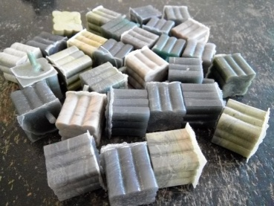

Figure 1 Recycled plastic coarse aggregate

Test was conducted for individual coarse aggregate and plastic coarse aggregate. The results show that the load carried by the plastic aggregate is more than (Table 1) natural coarse aggregate. Hence in this study, an attempt is made to study the behaviour of recycled plastic aggregate up to 50% replacement including 25%. Mix design(M40) was done using 10962-2008 with the C:FA: CA proportion is 1:1.64:2.3 and 50mm slump. The 10x10x10cm moulds were cast; de-moulding was done after 24 hours of casting and cured for 7 and 28 days in an open curing tank.

IV RESULTS AND DISCUSSIONS

Properties of recycled plastic aggregate (20mm) was determined by the following tests (Table 1) mentioned. The specific gravity of recycled plastic aggregate is about three times lesser than that of the conventional coarse aggregate.

***Compressive test on Coarse Plastic Concrete (CPC)***

Compressive strength tests for cubes were performed to determine the characteristics of concrete cubes. Figure 2 represents the formation of cracks and scales before failure at its ultimate load.

In this study, an attempt is made to use the coarse plastic aggregate up to 50%. The study shows that an increase in the percentage of the recycled plastic aggregate reduces the strength of concrete.

.

**Table1: Tests on Cement Plastic Concrete in-gradients**

|  |  |  |
| --- | --- | --- |
| Material | Tests conducted | Results |
| Cement | Specific Gravity | 3.15 |
| Consistency | 31% |
| Finess | 7% |
| Initial setting time | 30 minutes |
| Fine aggregate | Specific Gravity | 2.64 |
| Gradation | Zone II |
| Coarse aggregate | Specific gravity | 2.67 |
| Water absorption | 1.2% |
| Impact test | 13.14% |
| Compressive strength | 3kN |
| Recycled coarse plastic aggregates | Specific gravity | 0.9 |
| Water absorption | 0% |
| Impact test | No significant changes |
| Compressive strength | |  |  | | --- | --- | | Load (kN) | Change in  Dimension  (mm) | | 0 | 20 | | 5 | 18.2 | | 10 | 15 | | 15 | 13.5 | |

Table 2 and Figure 3 shows the compressive strength of concrete for 7 days. Results obtained from CPC is compared with that of control mix of M40 grade. Since each Coarse Plastic Aggregate (CPA) carries a higher load than single natural aggregate.

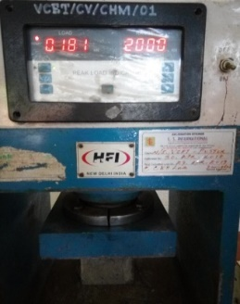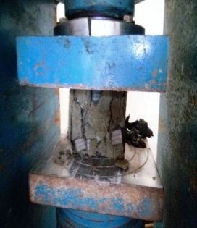

Figure 2 Failure of CPC at Ultimate load

Table 2 Compressive strength of cubes after 7 days of curing

|  |  |
| --- | --- |
| Percentage of CPC | Compressive strength in N/mm2 |
| 0% | 34.6 |
| 25% | 22.5 |
| 50% | 17 |

***Photographic investigation of bonding***

The photographic investigation was carried out on failed cubes to analyse the binding of aggregates and cement.

Figure 3 The compressive strength of CPC

Figure 4 represents the photographic views of 0%, 25% and 50 % replacement of coarse aggregates by CPC. By comparing the cubes of the various proportion of CPC it’s clear that bonding of aggregate influences the compressive strength of concrete. It can be observed from Figure 4.(b) and (c) that the aggregates are observed to be free of cement and sand.

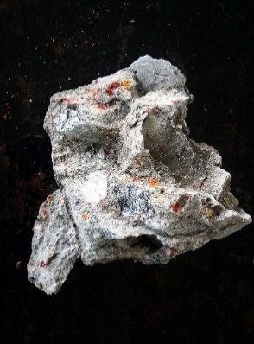 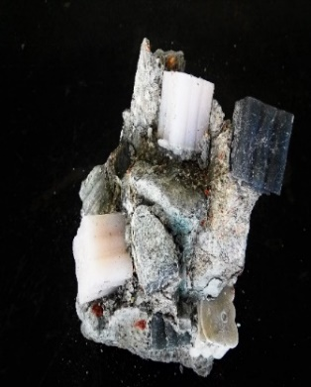

a)0% b)25% 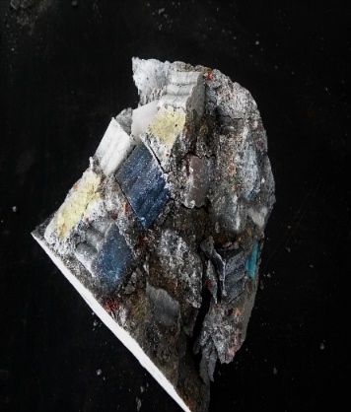

c) 50% of CPA

Figure 4 Photographic view of the samples

The cube with natural aggregates shows higher bonding (Figure 4.b) than the cube with 25% and 50% indicates plastic aggregates have weak bonding with mortar/ concrete mix.

***Visual interpretation of cracking***

Cracking pattern of cubes is studied by the visual interpretation which reflects the idea of the behaviour of concrete characteristics based on the intensity of cracking. From Figure 5 it is clear that the intensity of cracking increases with the increase in percentages of coarse plastic aggregates. Increase in CPA proportion decreases the compressive strength of the cubes with increased cracks.

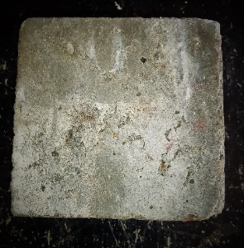 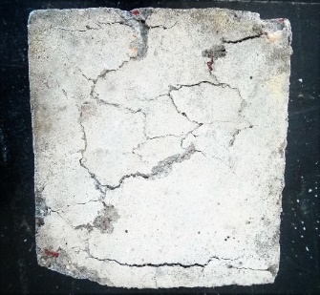

a) 0% CPA (b) 25% CPA 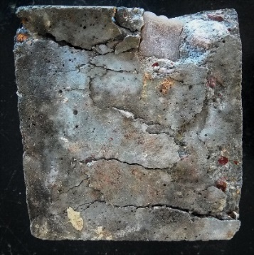

(c) 50% CPA

Figure 5 Cracking pattern sample

*V CONCLUSIONS*

By the analysis of the study, it is concluded that as the percentage of recycled coarse aggregate increases compressive strength also decreases. The decrease in compressive strength is mainly due to bonding between plastic aggregate and cement concrete mix. Further study on CPC will explain the behaviour of the CPA.

REFERENCES

1. Hasan S. Dweik , Mohamed M. Ziara& Mohammed S. Hadidoun (2018)“Enhancing Concrete Strength and Thermal Insulation Using Thermoset Plastic Waste”,International Journal of Polymeric Materials.<https://doi.org/10.1080/00914030701551089> .pp 635-655
2. Kaushik, Rahul Kelkar, Sudhakar Singh and MayureshKhajanwadkar . (2017) “Replacement of Coarse Aggregate by Using Naturally Available Materials", International Journal of Engineering Research & Technology, Vol. 6 Issue 04.Published by :http:// [www.ijert.org](http://www.ijert.org), pp 404-406.
3. Chien-chungchen, nathanjaffe, matt koppitz, 4wesley weimer, 5albert polocoser “concrete mixture with plastic as fine aggregate replacement”, International Journal of Advances in Mechanical and Civil Engineering, ISSN: 2394-2827 Volume-2, Issue-4, pp 49-53.
4. Shaﬁgh P., M. Z. Jumaat, H.B.Mahamud (2012) “Effect of Replacement of Normal Weight Coarse Aggregate with Oil Palm Shell on Properties of Concrete” , Arab J Sci Eng ,research article - civil engineering. 37DOI 10.1007/s13369-012-0233-2 pp:955–964.