Secured product delivery UAV based Windcopter

**Sushmitha1, Rashmitha2, Sneha3, Priyanka dsouza4, Ms. Renita Pinto5**

1,2,3,4 Dept of. Electronics and communication, Shri Madhwa Vadiraja Institute of Technology and Management, Udupi, India

5Assistant Professor, Dept of. Electronics and communication, Shri Madhwa Vadiraja Institute of Technology and Management, Udupi, India

**Abstract— Wind copter is a Quadcopter, which is commonly known as Drone.** **Due to rise in demand for commercial deliveries within cities, companies are facing problem in case of home delivery because of heavy traffic in road transport. Drones will solve the problem by exploring the transport opportunities in vertical dimension above the road. This paper discusses about the design of scalable delivery drone which includes flight efficiency, energy consumption, noise and safety, that are the key parameters in delivery viability. This paper also discusses about the design and implementation of quadcopter-based UAV system for delivery operation using a camera.**

**Keywords**—Quadcopter, Flight controller (Pixhawk), camera, GPS, Electric speed controller, keypad matrix, Raspberry pi.

# INTRODUCTION

A Wind copter is an Unmanned Aerial Vehicle (UAV). They are the aircrafts with no on-board crew or passengers. They can be automated ‘drones’ or remotely piloted vehicles (RPVs). They can fly for long periods of time at a controlled level of speed and height and have a role in many aspects of aviation. It is an aircraft lifted and propelled by 4 horizontal rotors; each rotor consists of 2 rotor blades. Quadcopters are classified as rotor crafts or a rotary-wing aircraft to distinguish them from fixed-wing aircraft because the quadcopter derives its source of lift from the rotor blades rotating around a mast. They belong to a larger category of aircrafts defined as multicopters have various names based on number of propellers mounted on a craft. There are mainly 4 types of drones on the basis of aerial platform (1) Multi rotor Drones, (2) Fixed wing rotor, (3) Single rotor Helicopter (4) Fixed wing Hybrid VTOL.

We are using 4 propellers to lift the body of drone that comes under Multirotor drones. Under Multi rotor again there are few types based on number of rotors, there are (1) Tricopter (3rotors), (2) Quadcopter(4rotors), (3) Hex copter (6 rotors), (4) Octocopter (8 rotors). Out of these we are using Quadcopter that is having 4 rotors. Drones can be using different sources such as Battery, Solar energy, laser, hydrogen fuel-cells etc. In this paper we discuss a UAV (quadcopter) with the camera and payload delivery of around 5Kg using pre-programed flight controller.

# METHODOLOGY

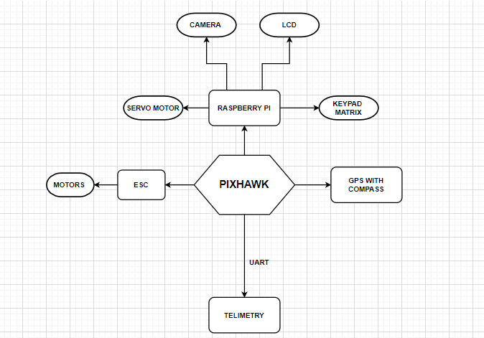

We are using Pixhawk which is a latest version of flight controller which consists of 32-bit ARM CortexM4 high-performance processors which can run in NuttX RTOS real-time operating system. GPS is used for the location tracking, telemetry is used for the communication between the ground station and the drone, camera is used for monitoring the drone.

A box is built with the dimension of 8.5*7 inches on which lock, keypad matrix, LCD display is mounted. This box is used to place the product that need to be delivered. This box dimension can be changed according to the requirements and also weight lifting capacity of the drone. Locking system is implemented by using a servo motor. Keypad matrix is used in order to enter the OTP provided to the customers and LCD displays the entered OTP. These devices are controlled by Raspberry pi.

Before sending the drone out for delivery the valid OTP is sent to the customer. Then the information like customer’s location

and OTP are fed into the drone. Then the drone is ready to take off for the delivery. We can track the path using GPS installed in the drone and camera is used to monitor it. Once the drone reaches the location it asks the customer to enter the OTP provided to them. It will be displayed on the LCD display. If there is any error in the entered OTP it will show the error and will ask to enter the OTP again. Only when the OTP is perfect the box will get unlocked and customer can remove the object or the courier present inside the box. There will be maximum of 3 trials, after 3 trials one cannot enter the OTP and the OTP becomes invalid. Then they need to customer care number sent along with the OTP. And the new OTP is sent to the customer. Once the product is delivered drone returns to the company.

1. RESULT AND DISCUSSION

We have built the Drone where Pixhawk has been initialized for a typical drone operation. Using the GPS module, the location of the customer is located. And the along with the location OTP is fed into the Raspberry pi. Then the drone takes off and is sent to the customer’s location.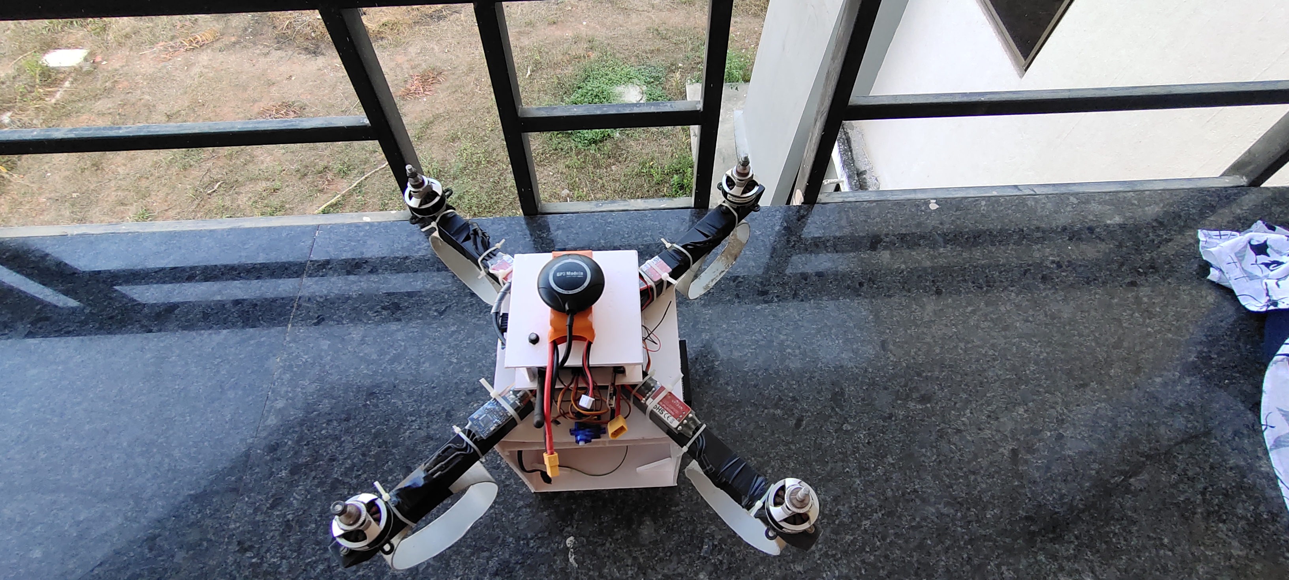

# CONCLUSION

The Quadcopter discussed in this paper is capable of carrying objects that weigh around 5Kg. This type of drone helps in easy delivery of objects to the customers without compromising on security

REFERENCES

1. Castillo, Lozano & Dzul, “**Modelling and Control of Mini-Flying Machines**,” © 2005 Springer
2. Gabriel M. Hoffmann, Haomiao Huang, Steven L. Waslander, “**Quadrotor Helicopter Flight Dynamics and Control:Theory and Experiment**” AIAA.
3. Setting Manual for Black or Blue version (Atmega168) [On-line]. Available: http://www.kkmulticopter.kr/?modea=manual [March 29, 2014]
4. GSM modem interfacing with microcontroller 8051 for SMS [On-line]. Available: <http://www.zembedded.com/gsm-modem-interfacing-withmicrocontroller-8051-for-sms-control-of> industrial-equipment’s [March 29, 2014
5. Michael Russell Rip, James M. Hasik, “**The Precision Revolution: GPS and the Future of Aerial Warfare**,” Naval Institute Press. p. 65. ISBN 155750-973-5. Retrieved January 14, 2010
6. Michael Leichtfried, Christoph Kaltenriner, Annette Mossel, “**Hannes Kaufmann Autonomous Flight using a Smartphone as On-Board**” ACM 978-1- 4503-2106, MoMM2013, 2-4 December, 2013
7. David Roberts, “**Construction and Testing of a Quadcopter,**” California Polytechnic State University, San Luis Obispo, CA, 93407, June, 2013.