Monitoring and Predicting the Project Progress using Earned Value Analysis: A case study in Mangaluru
Akshaya Krishna N¹, Pushparaj Naik²
¹ Assistant Professor, Civil Engineering Department, Mangalore Institute of Technology and Engineering Moodabidri,, Karnataka, India
²Assistant Professor, Civil Engineering Department, NMAM Institute of Technology, Nitte, Karnataka, India
Address
¹akshayakrishna@mite.ac.in , 2pushparajmanai@nitte.edu.in,

Abstract — Considering the various challenges existing in construction activities, the earned value tool has a lot of theoretical and practical significance. The entrepreneurs, project managers and experts can apply this technique to minimize the problems arising in the construction field. This paper focuses on monitoring and predicting the project progress using earned value technique. In order to prepare schedule and estimation easily, Primavera P6 software is used.
Keywords— Earned value, Scheduling, Primavera, Planned cost, Tracking, Actual cost.
- Introduction
Construction Industry plays a vital role in economic growth of the country and it is one of the leading sectors in India. All construction activities need systematic initial planning, proper aligned path of progress so as to gain effective output or product .In spite of proper monitoring and control during the stages of ongoing works, there may be deviations from scheduled pre-planned dates. It may occur due to non- availability of skilled labourers for respective works at the right time, unexpected issues such as damage to equipments due to unawareness of handling procedures and technical aspects by labourers which in turn affects the financial issues.
For any ongoing project the main input is the proper planning of cash inflow and outflows. It is achieved by proper pre-planning of future work. A long term duration project requires high monetary inputs as to proceed without any occurrence of major hindrance during course of project. A small variation in cost factor input may lead to a huge change at the time of completion of Project. In order to avoid variation of costs various bench marks or target destinations are to be set in the scheduled activity list of the project. Once a set of activities are completed it has to be cross checked with the pre-existing estimated cost in terms of amount of money spent for the respective works and also the duration of time taken by each activity in order to finish it.
It is easy to handle small projects since the duration required and budget spent is less when compared to mass construction projects. It is true that costs of raw materials are spectacularly increasing day by day for which costs are to be properly planned and controlled. Hence to handle mass construction projects earned value management is indeed helpful for proper progress of work and also to analyse futuristic variations in terms of both money and time.
- Objectives
- To schedule the activities with interlinked relationships required for the project using Primavera P6.
- To assign required resources for a particular work on time.
- To estimate the total cost of project with respect to duration, schedule and total number of critical activities in the project.
- To track progress and performance of ongoing works so as to prevent delay and over running of budget cost.
- To identify cost and schedule variance arising in the project.
- To forecast the futuristic cost needed for upcoming activities of work towards the completion of project.
- Earned Value Analysis
Earned value analysis is an effective statistical tool that is used to measure progress and performance of various works which are carried out to complete the project on stipulated time [1]. It combines schedule, cost and work forming a single integrated system, so as to enable futuristic budget and completion time of the project [2].
  - Earned value terminologies
Earned value analysis consists of three main fundamental key parameters i.e. Planned value (PV), Actual value (AV) and Earned value (EV) [3].These are the measurable factors used to analyze and measure the progressiveness and performance of the ongoing project.

- Planned value (BCWS)
Planned value is also called Budgeted cost of work scheduled [3]. It is the total budgeted cost value that has to be spent for various individual activities accordingly over the entire project. It gives an approximate statistical value that is required as a part of financial investment for the project. The planned value cost will be spent accordingly as per the scheduled work progress with respect to time.

Planned value = Budget at completion × schedule % complete [4].

- Actual cost (ACWP)
The cost spent over all the works which are completed up to a monitoring day. It is also called actual cost of work performed in the project [4]. It includes direct and indirect costs of the project. Direct costs are those expenses which can be directly expressed in terms of final product or service. Indirect costs are the site related cost such as housekeeping staffs, departmental stores, first aid facilities, office charges, workshops etc.

- Earned value (BCWP)
Earned value is also called as budget cost of work performed [4]. The quantity of work physically accomplished requires certain amount of budget. The budgeted figures are the part of estimated cost. The actual cost incurred and earned value goes hand in hand but need not be same always. Earned value may be more or less than budgeted figures (planned value). The reason may be due to decline in labor efficiency effectiveness, power supply problems, wastage of materials during shifting from one floor to other.

Earned value = Budget at completion × performance % complete [4].
  - Earned value performance indicators
- Cost Variance (CV)
It is used to check the variation between work value achieved and actual project cost. Hence one can easily identify whether the project is running below or over the actual cost.
Cost variance = Earned value - Actual Cost [5].
From the above formula three cases can occur
- If cost variance is negative it indicates that work value gained is less than actual cost.
- If cost variance is positive it indicates that work value gained is more than actual cost.
- If cost variance is zero it indicates that the work value gained is equal to actual cost.

- Schedule Variance (SV)
It is used to scrutinize the variation between the ongoing schedule project and proposed planned schedule. It determines whether the project is ahead or behind the planned schedule.
Schedule variance = Earned value – Planned value [5].
From the previous formula three conditions can occur
- If the schedule variance is positive then the ongoing project is ahead from the planned schedule.
- If the schedule variance is negative then the ongoing project is behind the planned schedule.
- If the schedule variance is zero then the ongoing project is as per planned schedule.
- Cost performance index (CPI)
It is the ratio of work value accomplished to the actual cost incurred during an ongoing project. It signifies the cumulative cost efficiency of the project. Mathematically it can be expressed as ratio of earned value to actual cost.
Cost performance index = Earned value / Actual cost [5].
From the above formula three conditions arise which are as follows
- If CPI is < 1 then the actual cost spent is more than work value achieved
- If CPI is > 1 then the value of work accomplished is more than actual cost
- If CPI =1 then the actual cost spent is equal to work value achieved

- Schedule performance index (SPI)
It is the ratio of work value accomplished to the planned schedule. It implies how efficiently we have processed various activities in the project by consuming the time as per planned schedule data.
Schedule Performance Index = Earned value / Planned value [5].
From the above formula three conditions arises which are as follows
- If SPI is <1 then the ongoing project is behind planned schedule which shows poor performance.
- If SPI is >1 then the ongoing project is ahead planned schedule which shows good performance.
- If SPI = 1 then the ongoing project is as p.er targeted planned schedule.
  - Earned value forecasting indicators
- Estimate at completion (EAC)
It is used to calculate the forecast budget required for the project to complete by comparing the performance of present status of the project. It is defined as the ratio of budget at completion to the cost performance index.
Estimate at completion = Budget at completion / Cost performance index [6].
- Estimate to complete (ETC)
It is the budgeted value required to complete the remaining quantity of work excluding the cost already spent on the project. Estimate to complete is obtained by subtracting actual cost from estimate at completion.
Estimate to complete = Estimate at complete – Actual cost [6].
- Time estimate at completion (TEAC)
It is the additional time required to complete the project in addition to planned schedule.
Time estimate at completion = Schedule at completion / Schedule performance index [7].
- Variance at completion (VAC)
It is a parameter which is used to calculate the variation of cost at time of completion of the project.
Variance at Completion (VAC) = BAC – EAC [7].
From the above formula two conditions arises which are as follows
- If VAC is positive then it indicates that the project cost is under budget.
- If VAC is negative then it indicated that the project cost is over budget.
- Methodology
Any construction project involves abundant number of activities which have to be accomplished in systematic order as to reach the final stage of the project. In spite of continuous monitoring by the project managers during progress, there might occur certain issues and uncertainties in the site such as rise of water table during excavation, malfunctioning of equipment’s due to wear and tear of parts, improper construction method all leads to the delay of project. The issues have to be rectified as soon as possible for smooth functioning of the project and these issues should be highlighted as a documentary part of the project so that it will not occur again in future.
In this project Primavera P6 software is used to analyse, monitor and measure the progress of the project and also to perform earned value analysis of the project. Flow order of methodology followed in the project.
- Creation of a new project
- Creation of calendar
- Define work breakdown structure
- Define Activities
- Defining relationships
- Defining activity durations
- Creation of resources
- Creation of baseline
- Updating the schedule
- Tracking the project
- Preparation of report

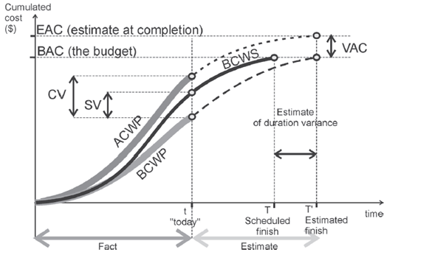

Fig. 1 Earned value curve representing over budgeted cost
and behind the schedule.
- Case Study
A residential apartment building “MAGNUM SKY VILLA” at M.G. Road Mangalore is considered as a part of application. The building consists of B+G+11 floors comprising one flat in each floor with total area of 3750 square feet. Bill of quantities, daily progress reports and rate analysis are collected initially which are needed to calculate earned value parameters such as earned value, actual cost, performance indicators and forecasting indicators.
In order to prepare schedule for the project, estimated cost details was required which was procured from construction site. Later Master schedule plan was prepared with all available data in Primavera P6 software. Table I given below shows the Project cost details of Magnum sky Villa apartment Mangaluru.
TABLE I
PROJECT COST DETAILS
Description | Details
Client | Citadel developers Mangaluru
Architects | Upalekar Sadekar Mumbai
Contractor | Mahabala constructions Mangaluru
Structural consultants | Vimal anil Mangaluru
Project Management consultants | The Planners Mangaluru
Total Estimated budgeted cost value | Rs.16,34,13,511.30
Total duration | 18 months
Preliminary works | Rs.66,17,719.8
Structural works | Rs.3,75,84,895
Masonry and finishing works | Rs.43,52,550.0
Plastering works | Rs.86,24,790
Electrical works | Rs.75,00,000
Plumbing and sanitary works | Rs.75,00,000
Finishing and Miscellaneous works | Rs.9,12,33,556.5

- Results and Discussions
In order to determine the progress and performance of the construction project it is continuously monitored and tracked at the end of every month using earned value analysis method in Primavera software P6.Table II and Table III given below shows the earned values and its respective parameters of consecutive months obtained from Primavera software.

TABLE II
Monetary values obtained from primavera in consecutive stages of tracking
EVM Parameter | November  2017 | December  2017
Budgeted Total Cost | Rs1.33 crores | Rs.1,33 crores
Planned Value Cost | Rs33.93lakhs | Rs.62.55 crores
Actual Cost | Rs34.12 lakhs | Rs.59.74 lakhs
Earned Value Cost | Rs34.18 lakhs | Rs.62.40 lakhs
CPI | 1.00 | 1.04
SPI | 1.01 | 0.99
Estimate to complete | Rs99.72 lakhs | Rs.71.54 lakhs
Estimate at completion | Rs.1.33crores | Rs.1,31 crores
Cost Variance | Rs.5,794.49 | Rs.2.66 lakhs
Schedule Variance | Rs.25,273.97 | Rs.-14,634.2*
Variance at completion | Rs.9,669.97 | Rs.8,898.69
Schedule % complete | 25.33% | 46.7%

TABLE III
Monetary values obtained from primavera in consecutive stages of tracking
EVM Parameter | January  2018 | February  2018
Budgeted Total Cost | Rs.1,33 crores | Rs.1,33 crores
Planned Value Cost | Rs.93.30 crores | Rs.1.27crores
Actual Cost | Rs.1.06 crores | Rs.1.28 crores
Earned Value Cost | Rs.1.06 crores | Rs.1.27 crores
CPI | 0.99 | 0.99
SPI | 1.14 | 0.99
Estimate to complete | Rs.27.40 lakhs | Rs.5,68 lakhs
Estimate at completion | Rs.1.334 crores | Rs.1.337 crores
Cost Variance | Rs. -4,309.95* | Rs.-25,491.7*
Schedule Variance | Rs.1269 lakhs | Rs-7,770.46*
Variance at completion | Rs.-4,350.47* | Rs.-25,532.3*
Schedule % complete | 69.94% | 95.8%
*Negative value in cost variance indicates work value accomplished is less than actual cost incurred, schedule variance indicates project is behind the schedule and variance at completion indicates inflation of actual project cost from budgeted cost.
From Table III at the end of February 2018 following points can be highlighted.
- Cost Variance was found to be negative value of Rs.25, 491.79 which implies that the amount of work value accomplished was less when compared with actual cost that was to be incurred in the project.
- Schedule Variance also showed a negative value of Rs.7, 770.46 implies that the construction project was lagging behind the planned schedule.
- Cost and Schedule Performance index factor was found to be 0.99 reveals that worth of work value finished was slightly less in comparison with actual cost that is been spent in the project and also rate of performance of project is moderately less when compared to planned schedule.
- As on 1st March 2018, 95.8% of structural works was finished and an estimate of Rs.5.68 lakhs is required for the completion of project.

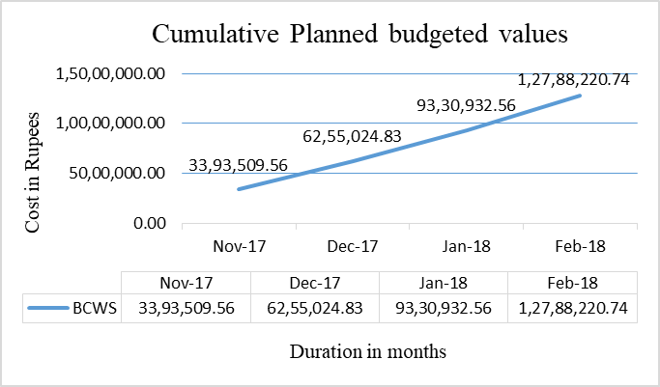
Fig. 2 Graphical representation of cumulative planned budgeted cost
Report preparation and inference based on earned value parameters

The above Fig. 2 shows cumulative planned cost spent in the construction project for various activities as scheduled from November 2017 up to February 2018.
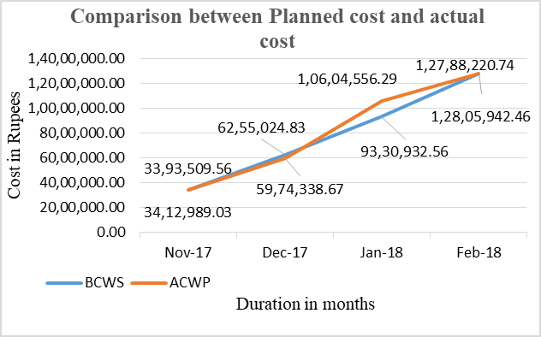

Fig. 3 Comparison between planned and actual cost incurred in the construction project
Fig. 3 shows comparison between planned cost and actual cost incurred in the project. In Nov 2017, Actual cost increased by Rs.19, 479 when compared to Planned cost due to increase in work value or earned value in the project. In Dec 2017 actual cost decrease by Rs.2, 80,686 when compared with planned cost because of decrease in cost of construction materials and man power consumption. Further in Jan 2018 and Feb 2018 there was increase in Actual cost of work performed by Rs.12.73 lakhs and Rs 17,700 respectively due to increase in cost of man power and also increase in procurement of RMC from plant.

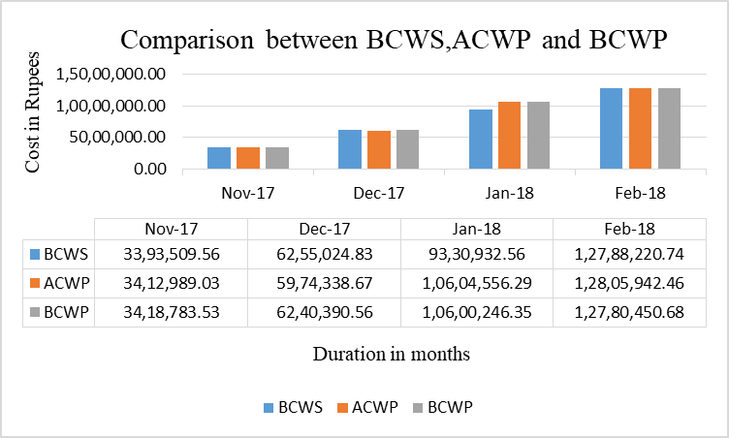

Fig. 4 Comparison between planned cost, earned value and actual cost incurred in the project

The above Fig. 4 shows the overall variation of planned cost, actual cost, earned value from November 2017 to February 2018.
- Conclusions
Earned value management undertakes a crucial role in handling construction project so that it can be processed smoothly with fewer obstacles in turn without affecting chain linked activity completion dates. This paper has focussed on cost and scheduled parameters are highly relevant to clients, contractors and project management consultants involved in the project. The following points can be highlighted from this paper.
- The cost variation between earned value and actual cost can be reduced by proper planning of cost estimates further it has to be cross checked frequently and systematically during the course of the project.
- Schedule variation between earned and planned schedule are computed and analysed. The causes for dissimilarities are found through graphical reports at the end of month and performance factors are determined. From the above values future costs can also be predicted for the completion of the project.
- Earned value analysis amalgamates three inputs at a time i.e. scope, cost and schedule which helps a project manager for ease decision making process in various stages of project.
- Bench mark can be set in primavera software in terms of baseline and it is used a target point for contractors, sub-contractors in order to finish all the activities within the given stipulated time and prevent further delay in the project.
- The variation in cost and schedule can be easily identified by graphical and tabular form from primavera software so that in future the fluctuations of actual cost from planned cost can be minimised by proper monitoring and tracing the project.
- Project progress and execution of the work mainly depends on handling the contractors and their workers. In order to control sub-contractors to finish on time, earned value technique act as an effective tool for both project management consultant and client.
- Delay in the progress of work increases in construction cost activities in turn affecting client profit shares. Hence proper observation is required in order to control the project to run smoothly without any hindrance to the project.
Acknowledgment
I express my sincere gratitude to Mr.Shivprakash Project Team Leader CADD Centre Mangaluru for training me in primavera Software. I am grateful to The Citadel Developers, Mangaluru for giving me an opportunity to undergo my Project at Magnum Villa Apartment Mangaluru. I am Thankful to Mr.Ravi Shankar, Mr.Sudheer K Project Management consultant for their valuable suggestions.

References

[1].Akshay R Manohar and Rakshith Kumar Shetty “Project Performance Evaluation through Earned Value Analysis “International Journal of Innovative Research in Science, Engineering and Technology vol. 5, Special Issue 9,May 2016

[2].Andrew Fernans Tom and Sachin Paul “Project Monitoring and Control using Primavera” International Journal of Innovative Research in Science, Engineering ‘”and Technology vol.2, issue 3, March 2013.

[3].Sandhya Suresh and Ganapathy Ramasamy N “Analysis of Project Performance Using Earned Value Analysis” International Journal of Science, Engineering and Technology Research Volume 4, Issue 4 2015.

[4].www.projectengineer.net/planned-value-earned-value-analysis/

[5].Chiranjeevi D S, Dr. G. Narayana and Rajeeva S J “Analysis on cost, schedule and tracking of residential project by earn value management method using primavera P6” International journal of innovative research in technology Vol. 4, Issue 3 ,pp. 46-60 ,2017

[6].Mohamed Marzouk and Mohamed Hisham “Implementing Earned Value Management using Bridge Information Modelling” KSCE Journal of Civil Engineering vol. 18, No. 5 / July 2014.

[7] Shaik Mohammad Masood, Devanand and Harsha “An Analysis on Resource Planning, Cost Estimation and Tracking of Project by Earned Value Management” International Journal of Engineering and Innovative Technology Vol 4, Issue 4, pp. 42-48 October 2014

